Figures
Figure 1. Interrelations between context and social and personal resources (Hobfoll et al., 1990, p. 469).
High stress conditions representing a situation in which individual and social resources are consumed by the context
Low stress conditions representing a situation in which individual resources suffice to deal with the context

Personal Resources

Environmental
Context
Social Resources

Figure 2. Proposed theoretical framework.
SEA
ROE

Emotional Intelligence

H4c,d
H4a,b
*H7
Incivility
*H8
H1
Revenge
Irritation
*H9
H3a,b
H5
H6

Vertical
Solidarity
H2

* Interaction effects (H7–H10)

Figure 3. Simple slope analysis of the interaction effect of irritation and revenge.
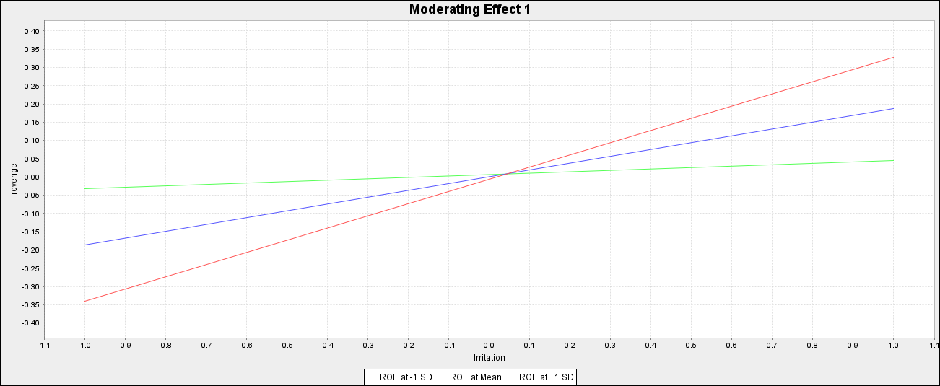
Figure 4. Simple slope analysis of the interaction effect of ROE and revenge.
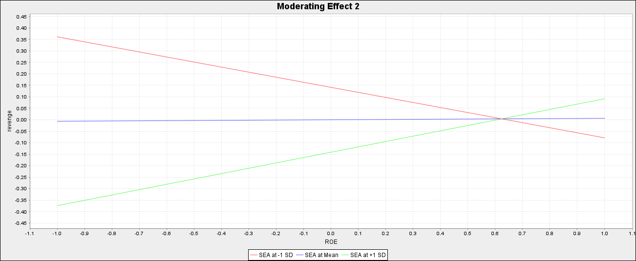

Figure 5. Simple slope analysis of the interaction effect of incivility and revenge.
