Figure 1: An Illustration of Hobfoll et al. (1990). P. 469
High stress conditions representing a situation in which individual and social resources are consumed by the context
Low stress conditions representing a situation in which individual resources suffice to deal with the context

Personal Resources
Environmental
context
Social Resources

Figure 2. The theoretical structure of the proposed framework.
SEA
ROE

Emotional Intelligence

H4c,d
H4a,b
H7
Incivility
H8
H1
Revenge
Irritation
H9
H3a,b
H5
H6

Vertical
Solidarity
H2

*Interaction effects (H7-H10)

Table 1. Result summary for measurement models

Reflective Variables | Convergent Validity | Internal Constituency Reliability | Discriminant Validity
 | AVE | Cronbach's Alpha
 | > 0.50 | > 0.70 | HTMT  Confidence Interval Does Not Contain 1
Irritation | 0.575 | 0.893 | Yes
Vertical Solidarity | 0.498 | 0.771 | Yes
ROE | 0.808 | 0.921 | Yes
SEA | 0.834 | 0.806 | Yes
Revenge | 0.738 | 0.911 | Yes

*AVE >0.49 is close enough to be accepted (Hair et al., 2016, p. 113)
Table 2. Significance analysis of the direct effects
 | Direct Effect | t Value | p Value
Incivility->Irritation | 0.428 | 6.455 | 0.000
Incivility- > Revenge | 0.233 | 2.797 | 0.005
Irritation->Revenge | 0.187 | 2.314 | 0.021
Moderating effect 1 | -0.148 | 2.336 | 0.020
Moderating effect 2 | 0.226 | 3.543 | 0.000
Moderating effect 3 | -0.154 | 2.593 | 0.010
ROE-> Irritation | -0.231 | 2.992 | 0.003
Solidarity-> Revenge | -0.120 | 1.978 | 0.048

Figure 3. simple slop analysis of the interaction effect
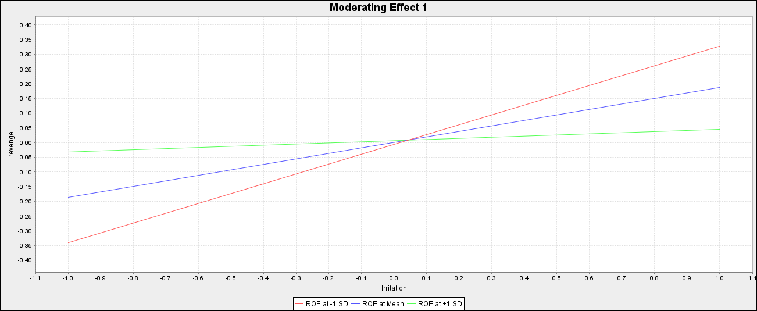
Figure 4. simple slop analysis of the interaction effect
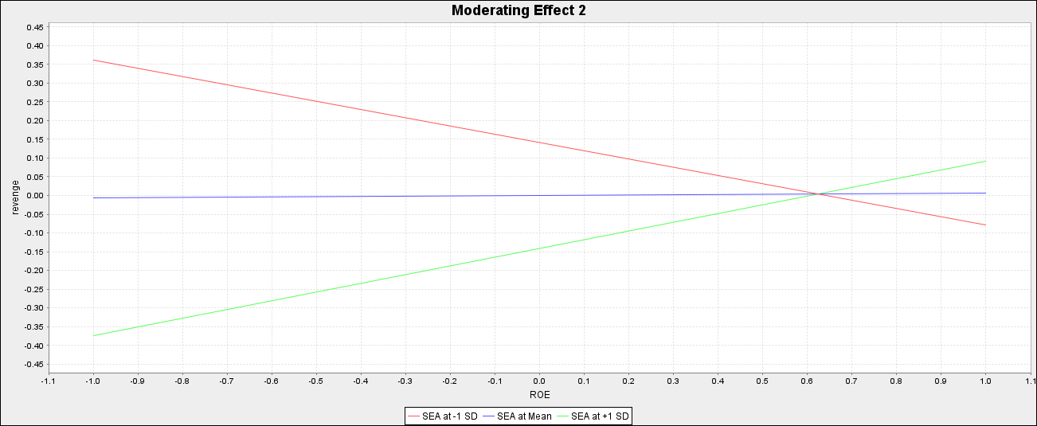
Figure 5. simple slop analysis of the interaction effect
