FINAL VERSION FOR TRANSLATION

Writing My Chapter

A Bar/Bat Mitzvah Journey

The National Library of Israel

Mazel Tov!

**You are embarking on a journey!**

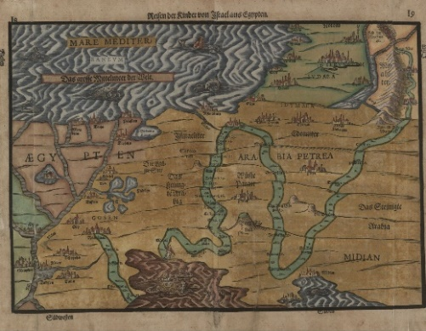

🔗[Map of the Desert Journey, Heinrich Bunting, 1585](https://web.nli.org.il/sites/NLI/English/digitallibrary/pages/viewer.aspx?docid=EDU_XML_ENG002368411&presentorid=EDU_XML_ENG&searchurl=https%3A%2F%2Fweb.nli.org.il%2Fsites%2Fnlis%2Fen%2Feducation%2Fpages%2Fresults.aspx%23%3Fquery%3Dlsr16%2Cexact%2CPrimary+Source%26query%3Dany%2Ccontains%2Cmap+exodus%26institution%3DNNL%26vid%3DEDU_XML_ENG%26loc%3Dlocal%2Cscope%3A(EDU_XML_ENG)%26sortField%3Dlso04%26indx%3D1%26bulkSize%3D8)

Today you are entering adulthood and beginning your journey as an independent member of the Jewish people! This milestone is an opportunity to explore different aspects of Jewish culture and identity, as you embark on your personal journey toward becoming Bar/Bat Mitzvah. According to Judaism, the life cycle includes different stages, each with its rituals and customs, based on multiple layers of scripture and tradition, deeply rooted in Jewish history, and infused with Jewish values.

* Where do we begin exploring our diverse and rich heritage?
* What topics should we study in depth when reaching the age of 12 or 13?
* How can we forge a personal connection to these traditions, even those that seem unfamiliar?
* What can the past teach us about ourselves, about the community we live in, and the issues we grapple with in the present?
* How can we create for ourselves a meaningful and long-lasting experience?

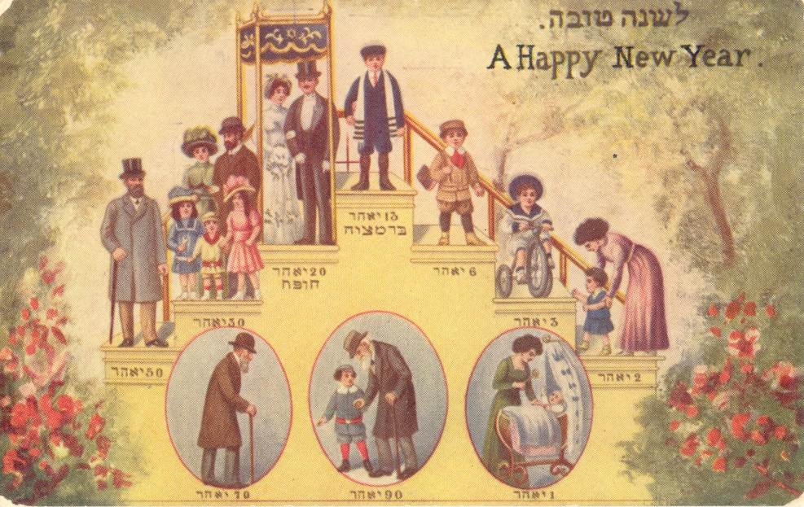

🔗 [Shana Tova Card, New York, 1910](https://web.nli.org.il/sites/NLI/English/digitallibrary/pages/viewer.aspx?docid=EDU_XML_ENG700344420&presentorid=EDU_XML_ENG&searchurl=https%3A%2F%2Fweb.nli.org.il%2Fsites%2Fnlis%2Fen%2Feducation%2Fpages%2Fresults.aspx%23%3Fquery%3Dlsr16%2Cexact%2CPrimary+Source%26query%3Dany%2Ccontains%2Cshana+tova%26indx%3D17%26institution%3DNNL%26vid%3DEDU_XML_ENG%26loc%3Dlocal%2Cscope%3A(EDU_XML_ENG)%26sortField%3Dlso04%26bulkSize%3D8)

⍰According to the text, what are the different stages in the Jewish life cycle?

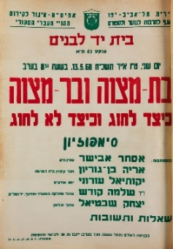⍰ Why do you think that the Bar/Bat Mitzvah is depicted as the height of the Jewish milestones represented in this postcard?

Tel Aviv, 15 Iyyar 5728, 13.5.68

Bat Mitzvah and Bar Mitzvah

How to Celebrate and How Not to Celebrate

Symposium

🔗[Bar and Bat Mitzvah - How to Celebrate 1968](https://web.nli.org.il/sites/NLI/English/digitallibrary/pages/viewer.aspx?docid=EDU_XML_ENG700322931&presentorid=EDU_XML_ENG&searchurl=https%3A%2F%2Fweb.nli.org.il%2Fsites%2Fnlis%2Fen%2Feducation%2Fpages%2Fresults.aspx%23%3Fquery%3Dlsr16%2Cexact%2CPrimary+Source%26query%3Dany%2Ccontains%2Cbar+mitzvah%26institution%3DNNL%26vid%3DEDU_XML_ENG%26loc%3Dlocal%2Cscope%3A(EDU_XML_ENG)%26sortField%3Dlso04%26indx%3D1%26bulkSize%3D8)

⍰ What do you think about the title: "How to Celebrate and How Not to Celebrate"?

**Discussion Prompts:**

* What elements of Bar/Bat Mitzvah celebrations are familiar to you?
* Why do you think it is traditionally celebrated at the age of 12/13?
* What are other milestones of adulthood? How are they different now from in the past?
* What other coming of age ceremonies do you know of in other cultures and how do they differ from ours?
* What is the significance of this milestone for parents in contrast to children?

**Activity Ideas:**

1. Use this Canva template we designed for youto create a personalized scrapbook that will accompany you as you explore elements of Jewish culture, reflect on your personal connection to them, share your thoughts, and document the process.
2. Create a [“word cloud”](https://wordart.com/) that represents the multiple facets of your identity (place of birth, hometown, hobbies, favorite foods, role in family, gender, interests, etc.)
3. Create a timeline of your life with the milestones you have already experienced and write why they were meaningful to you.

CHAPTER 1: “You Are Cordially Invited”

**Exploring Identity and Community**

Bar and Bat Mitzvah celebrations are an opportunity to gather as a community and share this meaningful event together. In this chapter, we will explore the themes of identity and community through the lens of Bar and Bat Mitzvah invitations of the past.

"אִם אֵין אֲנִי לִי, מִי לִי? וּכְשֶׁאֲנִי לְעַצְמִי, מָה אֲנִי? וְאִם לֹא עַכְשָׁיו, אֵימָתַי?"

“If I am not for myself, who will be for me? And being only for myself, what am I? And if not now, then when?” (Pirkei Avot 1:14)

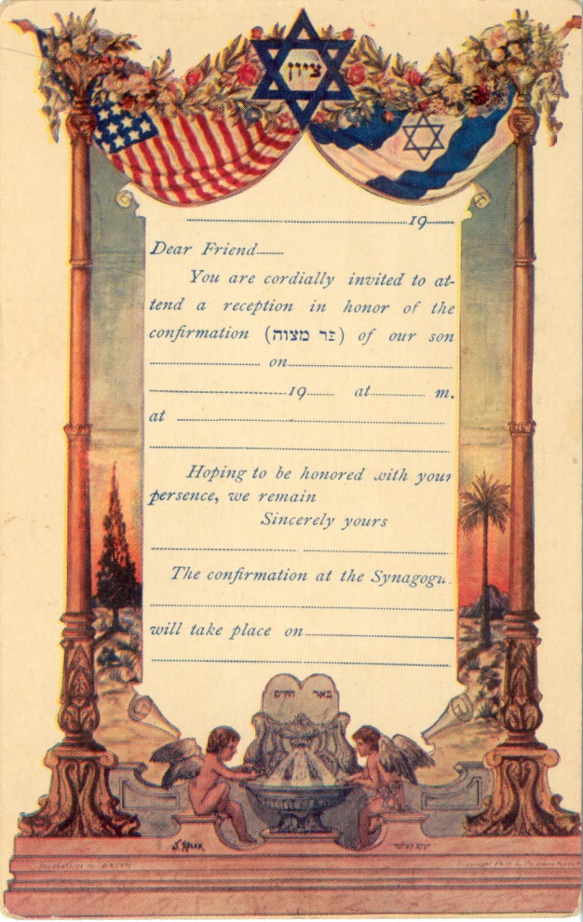

🔗 [Bar Mitzvah Invitation, United States, Twentieth Century](https://web.nli.org.il/sites/NLI/English/digitallibrary/pages/viewer.aspx?docid=EDU_XML_ENG700345182&presentorid=EDU_XML_ENG&searchurl=https%3A%2F%2Fweb.nli.org.il%2Fsites%2Fnlis%2Fen%2Feducation%2Fpages%2Fresults.aspx%23%3Fquery%3Dlsr16%2Cexact%2CPrimary+Source%26query%3Dany%2Ccontains%2Cbar+mitzvah+inviatation%26institution%3DNNL%26vid%3DEDU_XML_ENG%26loc%3Dlocal%2Cscope%3A(EDU_XML_ENG)%26sortField%3Dlso04%26indx%3D1%26bulkSize%3D8)

Bar Mitzvah Invitation, United States, Twentieth Century

⍰ What do the two flags in this invitation symbolize?

⍰ How would you feel about using a set template for your invitation?

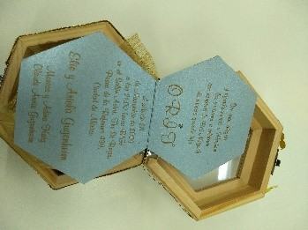

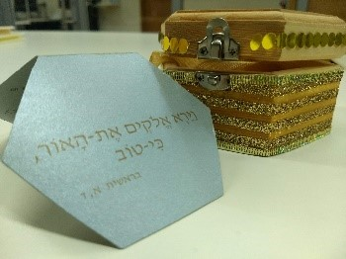**Bat Mitzvah invitation inside wooden box with flashlight, Mexico City 2009**

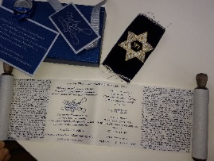

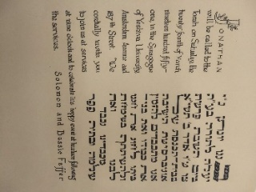

**Bar Mitzvah invitation printed on a "Torah scroll"", Mexico City 2007**

**Bar Mitzvah invitation, New York, 1951**

**Discussion Prompts:**

* What can we learn about the personal identities of the celebrants and their communities from their invitations?
* Is it usually the parents or the children that decide who to send invitations to? Whose event is it? How can you find a balance between the two?

**Activity Ideas:**

1. Design your own Bar/Bat Mitzvah invitation incorporating language and symbols that reflect your own identity and the communities you belong to.
2. When writing a guest list, you need to take into consideration all of your various community circles (for example: neighbors, classmates, family, childhood friends, teammates, etc.). In your scrapbook, fill in each concentric circle, starting with the names of the communities closest to you and expanding out.

CHAPTER 2: Save the Date!

**Exploring the Jewish Calendar**

The unique rhythm of the Jewish calendar unifies the Jewish community while distinguishing it from other communities. In this chapter, we will explore the theme of sacred time in the Jewish calendar and holidays.

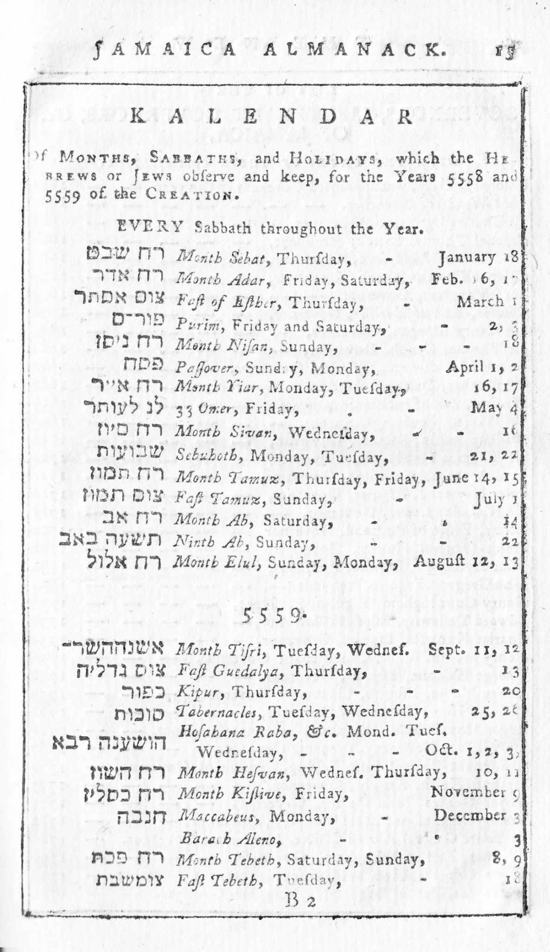"לַכֹּל זְמָן וְעֵת לְכָל חֵפֶץ תַּחַת הַשָּׁמָיִם"

For everything there is a season and there is a time for everything under the sky" (Kohelet 3:1)

🔗 J[ewish Calendar from Jamaica, 1798](https://web.nli.org.il/sites/NLI/Hebrew/digitallibrary/pages/viewer.aspx?docid=NNL03_EDUSP3990&presentorid=NLI_EDU&searchurl=https%3A%2F%2Fweb.nli.org.il%2Fsites%2Fnlis%2Fhe%2Feducation%2Fpages%2Fresults.aspx%23%3Fquery%3Dlsr16%2Cexact%2C%D7%A4%D7%A8%D7%99%D7%98+%D7%9E%D7%A7%D7%95%D7%A8%26query%3Dany%2Ccontains%2C%D7%9C%D7%95%D7%97+%D7%A9%D7%A0%D7%94%26institution%3DNNL%26vid%3DNLI_EDU%26loc%3Dlocal%2Cscope%3A(NNL_EDU1)%26sortField%3Dpopularity%26indx%3D1%26bulkSize%3D10)

⍰ Do you recognize any of the dates or festivals in this 18th century almanac from Jamaica?

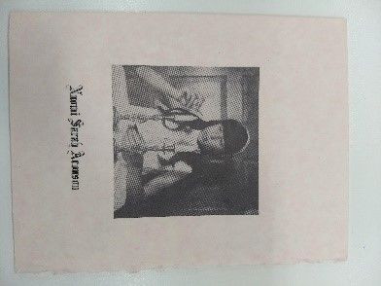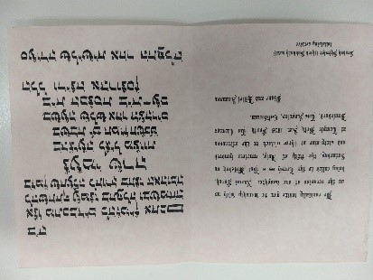

**Bat Mitzvah Invitation, California, 1969**

According to Naomi’s invitation, her bat mitzvah took place on Shabbat, as is common, and was symbolized by the picture of her lighting the Shabbat candles on the front page of the invitation.

⍰ The “[Sabbath Manifesto](http://sabbathmanifesto.org)” presents ten key principles designed to help people slow down and bring the spirit of Shabbat into their lives: 1) Avoid technology, 2) Connect with loved ones, 3) Nurture your health, 4) Get outside, 5) Avoid commerce, 6) Light candles, 7) Drink wine, 8) Eat bread, 9) Find silence, 10) Give back.

Which items on this list are you most drawn to and why?

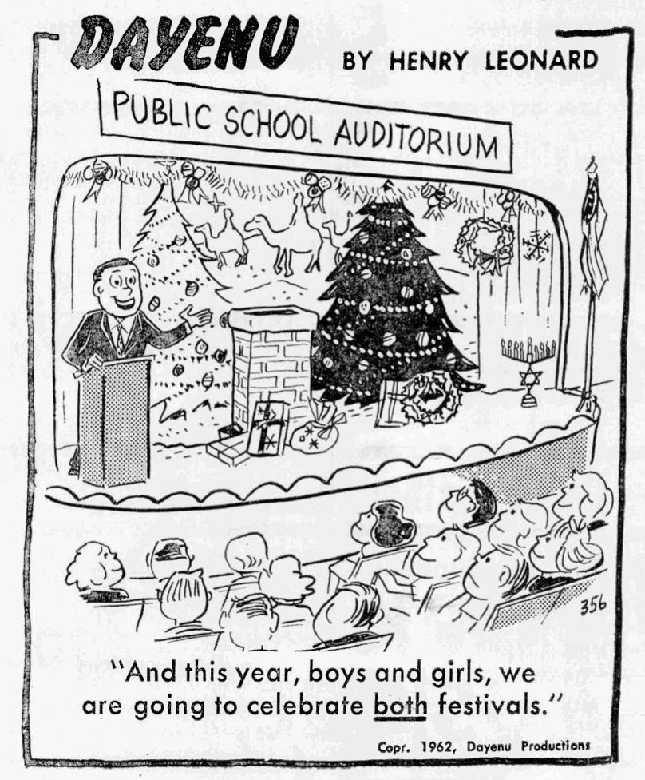

🔗 [Dayenu Cartoon, 1962](https://web.nli.org.il/sites/NLI/English/digitallibrary/pages/viewer.aspx?docid=EDU_XML_ENGSP1082&presentorid=EDU_XML_ENG&searchurl=https%3A%2F%2Fweb.nli.org.il%2Fsites%2Fnlis%2Fen%2Feducation%2Fpages%2Fresults.aspx%23%3Fquery%3Dlsr16%2Cexact%2CPrimary+Source%26query%3Dany%2Ccontains%2Cchristmas%26institution%3DNNL%26vid%3DEDU_XML_ENG%26loc%3Dlocal%2Cscope%3A(EDU_XML_ENG)%26sortField%3Dlso04%26indx%3D1%26bulkSize%3D8)

* This cartoon is a commentary on the so-called “December dilemma.” Have you experienced any conflicts between the traditional Jewish calendar and the Gregorian one? Which calendar do you feel more connected to?

**Activity Ideas:**

1. What custom or act symbolizes the meaning of Shabbat for you? Take a photo of it to include in your scrapbook.
2. Draw a cartoon that expresses the conflict/balance between the traditional Jewish calendar and the Gregorian one.
3. Using the [hebcal.com](https://hebcal.com/) date converter, determine the date of your Hebrew birthday and add it to your scrapbook.
4. Which Jewish holiday are you? Take this [Personality Quiz](https://merkazruach.nli.org.il/english/personality-quiz-2) to find out!

CHAPTER 3: Called to the Torah

**Exploring Traditional Rituals**

In this chapter, we will explore traditional rituals that are associated with the Bar and Bat Mitzvah ceremony, including reading from the Torah and putting on *tallit* and *tefillin*. Traditionally these rituals take place in the synagogue and signify the transition of a child into adulthood and active participation in the community. It is from this age onward that children become accountable for their actions and are considered “Bar/Bat Mitzvah,” literally, one who is subject to *mitzvot* (religious laws).

"וְשִׁנַּנְתָּם לְבָנֶיךָ וְדִבַּרְתָּ בָּם ... וּקְשַׁרְתָּם לְאוֹת עַל יָדֶךָ וְהָיוּ לְטֹטָפֹת בֵּין עֵינֶיךָ. וּכְתַבְתָּם עַל מְזוּזֹת בֵּיתֶךָ וּבִשְׁעָרֶיךָ."

"Thou shalt teach them diligently unto thy children… and bind them for a sign upon thy hand, and they shall be for frontlets between thine eyes. And thou shalt write them upon the door-posts of thy house, and upon thy gates." (Deuteronomy 6:6-9)

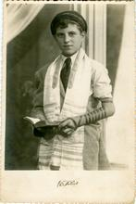

🔗 [Avraham Sheifeld,Romania, 1945](https://web.nli.org.il/sites/NLI/English/digitallibrary/pages/viewer.aspx?presentorid=EDU_XML_ENG&docid=EDU_XML_ENGSP1308)

⍰ When and where do you think this photograph was taken? Why?

Does the photograph look staged or spontaneous?

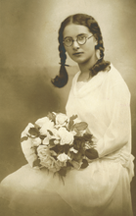🔗 [Vera Tomanic’s Bat Mitzvah, Osijek,1930](https://web.nli.org.il/sites/NLI/English/digitallibrary/pages/viewer.aspx?presentorid=EDU_XML_ENG&docid=EDU_XML_ENGSP1309)

⍰ How does this Bat Mitzvah photo differ from the Bar Mitzvah photo above?

In her testimonial, Vera Tomanic explains: “My father, Pavao, was very religious. Every morning he put on *tefillin* and prayed. My mother Elza was not religious to the same degree, but our family marked all the Jewish holidays, and every Friday we lit candles.”

⍰Why were differences in religious observance between men and women, boys and girls, common during this time period?

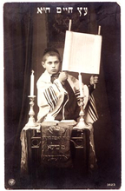🔗[Medric Milu, Romania, 1930](https://web.nli.org.il/sites/NLI/English/digitallibrary/pages/viewer.aspx?presentorid=EDU_XML_ENG&docid=EDU_XML_ENGSP1310)

“There is a street in Iasi in the area where we lived that was called just like that: the Synagogues Street. A lot of synagogues were there, separate synagogues according to trade: the Tailors’ Synagogue, the Publicans’ Synagogues, and the Grand Synagogue...In my childhood and even later, when I was 15 or 16, my father would take me with him to Friday and Saturday evening prayers. When others would go outside to play football, I had to go to the synagogue. But this is how I learned everything that is to know about Judaic tradition.”

⍰ What role does the synagogue play in your life and your parents life? Is the synagogue still the center for Jewish community life?

**Discussion Prompts:**

* Synagogue is also referred to as shul (school in Yiddish), temple, *beit kenesset* (house of gathering), and *beit tefila* (house of prayer). What are the different meanings and connotations of each of these terms?
* [“Tefillin Barbie”](https://jwa.org/node/22322) was created to challenge the notion that *tallit* and *tefillin* are “male” garments. What is your reaction to this image? What is your custom?
* Both Torah scrolls and *tefillin* can only be made using special scrolls made of animal leather and written by trained scribes with a feather quill. Why do you think all of these requirements are maintained at a time when mass printing is readily available?

**Activity Ideas:**

1. Browse [NLI](https://merhav.nli.org.il/primo-explore/search?query=any,contains,ritual%20objects%20judaica%20NNL&tab=unified_tab&search_scope=uni&vid=NLI&lang=en_US&offset=0) or [The Center for Jewish Art](https://cja.huji.ac.il/browser.php) to research one Jewish ritual object (examples: tallit, tzedakah box, mezuzah, shofar, sukkah, chanukiah, yad, tzitzit, kippah, kiddush cup, Elijah cup, seder plate, Torah scroll, havdalah set). Create a photo gallery in your scrapbook of items from different time periods and styles. Include a museum label that describes your own connection to the item and your interpretation of it. Here is a cool example of a very special *mezuzah*: [Mezuzah from Space](https://www.nli.org.il/en/archives/NNL_ARCHIVE_AL004035189/NLI)
2. Inside both [*tefillin*](https://en.wikipedia.org/wiki/Tefillin) and [*mezuzot*](https://en.wikipedia.org/wiki/Mezuzah) are scrolls containing sacred text. If you were to create a text that would be hidden away as a reminder and inspiration, what text would it be? Add it to your scrapbook!
3. Play our [“Shul Crawl”](https://merkazruach.nli.org.il/english/clue-hunt) to learn more about synagogues around the world!

CHAPTER 4: Reading in Hebrew?!

**Exploring Language**

Hebrew is considered the holy language of Jewish tradition, the language in which the Bible and many other Jewish texts are written. However, many Jews are not fluent speakers or readers of ancient Hebrew. In this chapter, we acknowledge the challenges of learning Hebrew while exploring its significance for Jewish culture and peoplehood and reflecting on its potential for connecting Jews all over the world.

"עשרים ושתים אותיות חקקן, חצבן, שקלן, והמירן. צרפן וצר בהם נפש כל היצור ונפש כל העתיד לצור"

"He formed, weighed, transmuted, composed, and created with these twenty-two letters every living being, and every soul yet uncreated." (Sefer Yetzira, Chapter 2)

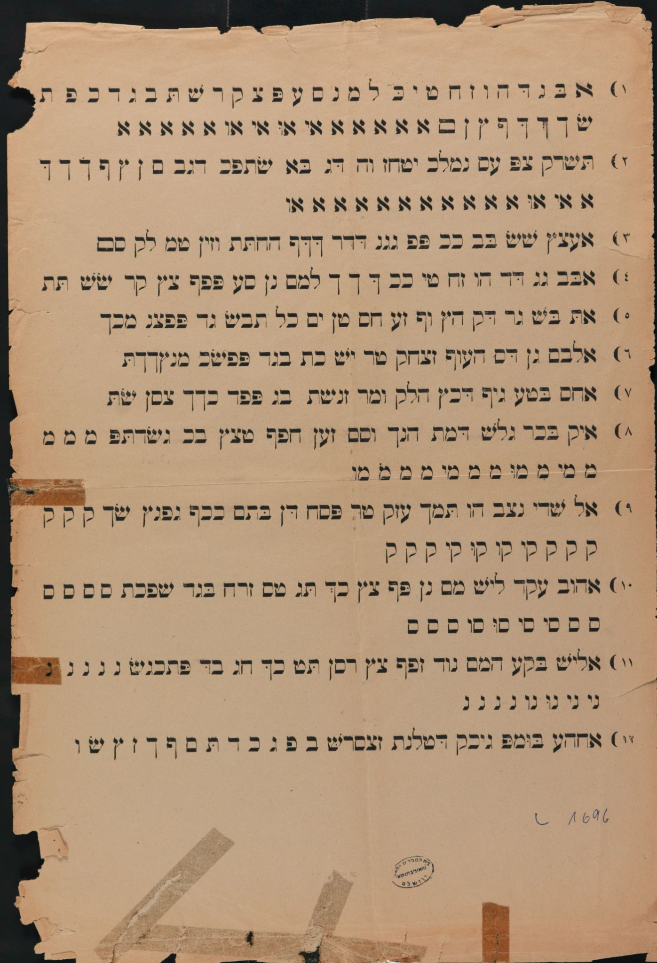

🔗[Hebrew Alphabet: A Practice Page to Learn Hebrew, Baghdad, 1920](https://web.nli.org.il/sites/NLI/English/digitallibrary/pages/viewer.aspx?docid=EDU_XML_ENG001223061&presentorid=EDU_XML_ENG&searchurl=https%3A%2F%2Fweb.nli.org.il%2Fsites%2Fnlis%2Fen%2Feducation%2Fpages%2Fresults.aspx%23%3Fquery%3Dlsr16%2Cexact%2CPrimary+Source%26query%3Dany%2Ccontains%2Chebrew+letters%26indx%3D17%26institution%3DNNL%26vid%3DEDU_XML_ENG%26loc%3Dlocal%2Cscope%3A(EDU_XML_ENG)%26sortField%3Dlso04%26bulkSize%3D8)

⍰ Did you also have a workbook like this for learning the Hebrew letters?

Click [here](https://blog.nli.org.il/en/writing_lesson/?_gl=1*dtkvlh*_ga*MjA5NTE1NDU0MS4xNjEzNTQ4MjI1*_ga_8P5PPG5E6Z*MTYyMzkzMzAzNC4zMzMuMS4xNjIzOTM1NzQ1LjMz&_ga=2.18780986.209603314.1623827154-2095154541.1613548225) to read more about how Jewish children learned to write a thousand years ago!

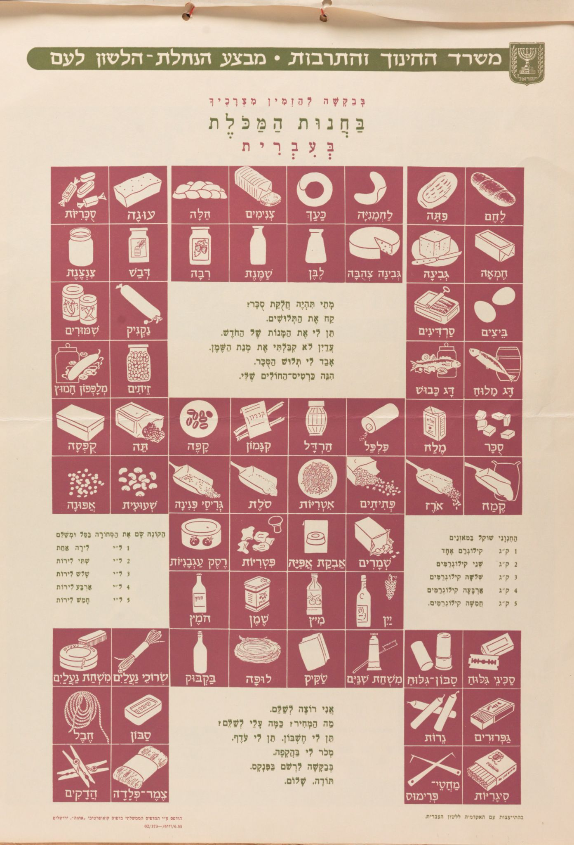

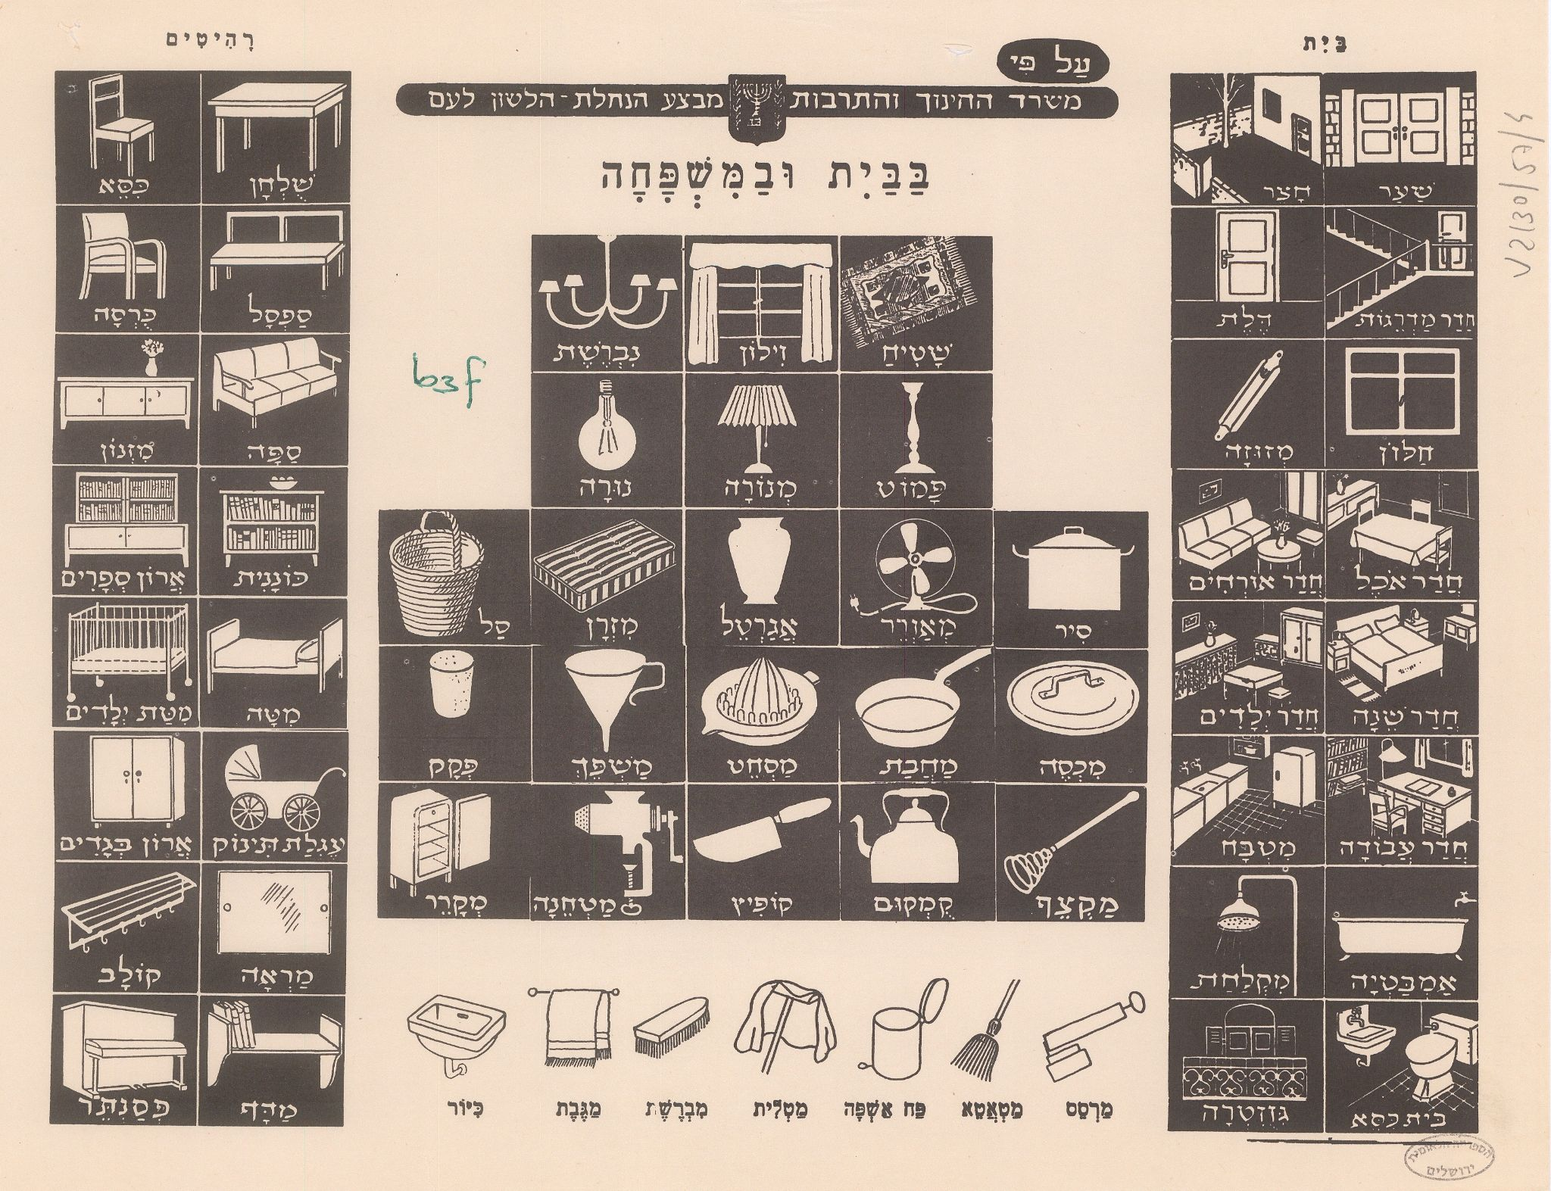

🔗[Posters for Learning Hebrew](https://web.nli.org.il/sites/NLIS/en/Education/Pages/itemPage.aspx?ItemID=EDU_XML_ENGSP368), 1950s

⍰ Do you know any of these words in Hebrew?

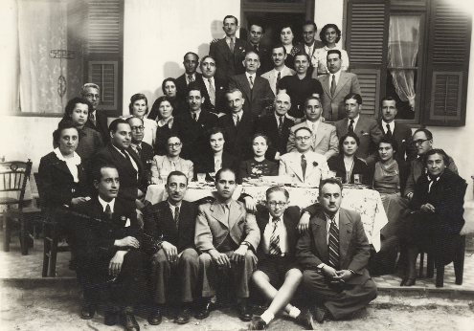

🔗 [Photo from Mario Modiano’s Bar Mitzvah, Greece, 1939](https://web.nli.org.il/sites/NLI/English/digitallibrary/pages/viewer.aspx?presentorid=EDU_XML_ENG&docid=EDU_XML_ENGSP1311)

“What I remember more vividly from my bar mitzvah is the hard time I had trying to learn enough Hebrew to be able to read the text. I had a teacher who came home and taught me how to parrot the text from the Torah that I was supposed to read at the service in the synagogue. I very much regret that I never really learned Hebrew.”

⍰ Can you relate to Mario’s sentiment? Why or why not?

**Discussion Prompts:**

* Why do you think the study of Hebrew has always been so important to Jewish communities? Below are a number of reasons people give for the importance of teaching and learning Hebrew. Which do you agree/disagree with? Are there other possible reasons?

1. Access to Jewish texts in the original
2. Connection to the State of Israel
3. Competence in Jewish ritual life
4. Common connection with Jews around the world

* Why do you think Hebrew is typically so central to the Bar Mitzvah ceremony? Can reading texts in Hebrew be meaningful even if you do not actually understanding their meaning?

**Activity Ideas:**

1. Often the child’s name is prominent in their invitation and sometimes the Hebrew letters of their name are highlighted in a biblical verse or incorporated in the design. Design a logo with your Hebrew name that reflects its family history, meaning, or connection to a Jewish text.
2. Create a 30-second video with your own reasons for learning Hebrew.
3. Watch this video of [Victoria Hanna's Aleph-bet song](https://youtu.be/Bl1epz3tSSA) that highlights the physical pronunciation of each sound and letter. Do you know any other Aleph-Bet songs? Add your favorite one to your scrapbook!

CHAPTER 5: Say a Little Prayer

**Exploring Personal Prayer**

In this chapter, we will explore our personal connection to prayer and spirituality.

"וַאֲנִי תְפִלָּתִי לְךָ ה' עֵת רָצוֹן אֱלֹהִים בְּרָב חַסְדֶּךָ עֲנֵנִי בֶּאֱמֶת יִשְׁעֶךָ."

“And I am a prayer, to you, Holy one, in my time of need in all your grace, answer me.” (Psalms 69:14)

|  |  |
| --- | --- |
| ​There is still a white sail on the horizon  Opposite a heavy black cloud  All that we seek – may it be  ​And if in the evening windows  The light of the holiday candles flickers  All that we seek – may it be  May it be, may it be – please – may it be  All that we seek – may it be.  (Translation from the final version) | **https://lh4.googleusercontent.com/wNahCg7jFTmIWzwS593MKNzJ9ZUornHugXKGWUQdrH6Ij0CQo1VQU96MYXWat2ThIovQe8uq-aWyxXy0Hq7WJRiiYeT0FWRRHaxTig6PwsW655gOk87-RApmGOLk6BoHAv6gtpSM**  🔗[Draft of Naomi Shemer’s “Lu Yehi](https://web.nli.org.il/sites/NLI/English/digitallibrary/pages/viewer.aspx?docid=EDU_XML_ENG003368682&presentorid=EDU_XML_ENG&searchurl=https%3A%2F%2Fweb.nli.org.il%2Fsites%2Fnlis%2Fen%2Feducation%2Fpages%2Fresults.aspx%23%3Fquery%3Dlsr16%2Cexact%2CPrimary+Source%26query%3Dany%2Ccontains%2Clu+yehi%26institution%3DNNL%26vid%3DEDU_XML_ENG%26loc%3Dlocal%2Cscope%3A(EDU_XML_ENG)%26sortField%3Dlso04%26indx%3D1%26bulkSize%3D8)”, 1973  ⍰ Naomi Shemer’s prayer is associated with the Yom Kippur war. What is the connection between crisis and prayer? |

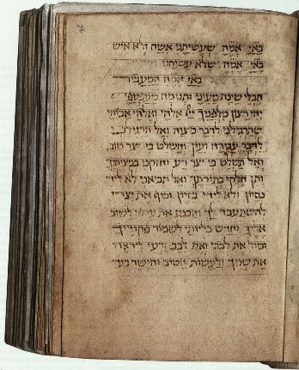🔗[Women’s Siddur, 1480](https://web.nli.org.il/sites/NLI/English/digitallibrary/pages/viewer.aspx?docid=EDU_XML_ENG000043061&presentorid=EDU_XML_ENG&searchurl=https%3A%2F%2Fweb.nli.org.il%2Fsites%2Fnlis%2Fen%2Feducation%2Fpages%2Fresults.aspx%23%3Fquery%3Dlsr16%2Cexact%2CPrimary+Source%26query%3Dany%2Ccontains%2Citalian+siddur%26institution%3DNNL%26vid%3DEDU_XML_ENG%26loc%3Dlocal%2Cscope%3A(EDU_XML_ENG)%26sortField%3Dlso04%26indx%3D1%26bulkSize%3D8https://web.nli.org.il/sites/NLI/English/digitallibrary/pages/viewer.aspx?docid=EDU_XML_ENG000043061&presentorid=EDU_XML_ENG&searchurl=https%3A%2F%2Fweb.nli.org.il%2Fsites%2Fnlis%2Fen%2Feducation%2Fpages%2Fresults.aspx%23%3Fquery%3Dlsr16%2Cexact%2CPrimary+Source%26query%3Dany%2Ccontains%2Citalian+siddur%26institution%3DNNL%26vid%3DEDU_XML_ENG%26loc%3Dlocal%2Cscope%3A(EDU_XML_ENG)%26sortField%3Dlso04%26indx%3D1%26bulkSize%3D8)

“​Blessed are You, Lord our God, King of the Universe, who has made me a woman not a man”

⍰ Why did women in the 15th century have special prayer books? Do you think that there is a difference between male and female prayer?

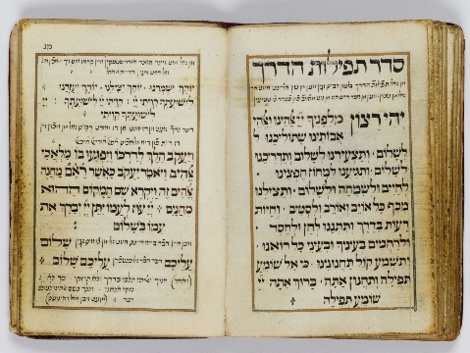

🔗[Wayfarer’s Prayer, Amsterdam, 1743](https://web.nli.org.il/sites/NLI/English/digitallibrary/pages/viewer.aspx?docid=EDU_XML_ENG000063222-1&presentorid=EDU_XML_ENG&searchurl=https%3A%2F%2Fweb.nli.org.il%2Fsites%2Fnlis%2Fen%2Feducation%2Fpages%2Fresults.aspx%23%3Fquery%3Dlsr16%2Cexact%2CPrimary+Source%26query%3Dany%2Ccontains%2Cprayer%26institution%3DNNL%26vid%3DEDU_XML_ENG%26loc%3Dlocal%2Cscope%3A(EDU_XML_ENG)%26sortField%3Dlso04%26indx%3D1%26bulkSize%3D8)

⍰ Have you ever been on a journey and prayed to arrive safely at your destination?

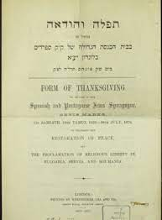🔗[Bevis Marks Thanksgiving Prayers, 1878](https://web.nli.org.il/sites/NLI/English/digitallibrary/pages/viewer.aspx?docid=EDU_XML_ENG990018095120205171&presentorid=EDU_XML_ENG&searchurl=https%3A%2F%2Fweb.nli.org.il%2Fsites%2Fnlis%2Fen%2Feducation%2Fpages%2Fresults.aspx%23%3Fquery%3Dlsr16%2Cexact%2CPrimary+Source%26query%3Dany%2Ccontains%2Csynagogue%26indx%3D33%26institution%3DNNL%26vid%3DEDU_XML_ENG%26loc%3Dlocal%2Cscope%3A(EDU_XML_ENG)%26sortField%3Dlso04%26bulkSize%3D8#%7C0)

⍰This prayer booklet from the Bevis Marks Spanish and Portuguese Synagogue was written to celebrate the restoration of peace and the proclamation of religious liberty in Bulgaria, Serbia, and Romania (Treaty of Berlin, July 13, 1878). What is the connection between thanksgiving and prayer?

**Discussion Prompts:**

* Use one word to describe your relationship with prayer.
* Do you think that prayer should have a set formula or be spontaneous and individual?
* Do you ever use methods such as yoga, music, journaling, mindfulness, or meditation as a way of being attentive to your needs, inner thoughts, reflections, and hopes?

**Activity Ideas:**

1. Compose your own version of “Lu Yehi” (Let It Be) or use the same structure but change the stanzas to reflect your own wishes, hopes, and prayers.
2. Today some people (both men and women) say the blessing traditionally said only by women but eliminate any reference to gender by saying: “sh’asani kirtzono” (you made me according to your will). Jewish artist Hillel Smith used this phrase to illustrate a gay pride [mural](https://hillelsmith.info/kirtzonomural/). Why do you think he chose these words? Design your own street art expressing a blessing or prayer that is close to your heart.
3. It is traditional to put a note in the Kotel (Western Wall) with one’s prayers. If you were to write a note, what would it say? Stick it in your scrapbook!

CHAPTER 6: Smile for the Camera!

**Exploring Family**

It is through our family that we establish our first connection with the world and our primary relationships. Our family members are a central part of our lives (for better or for worse!) and have a huge impact on our identity. In this chapter, we will explore the importance of family in our lives and learn about our roots.

"זְכֹר֙ יְמ֣וֹת עוֹלָ֔ם בִּ֖ינוּ שְׁנ֣וֹת דֹּר־וָדֹ֑ר"

"Remember the days of old, Consider the years of ages past" (Devarim 32:7)

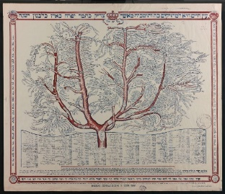🔗 [Family Tree of Hasidim](https://web.nli.org.il/sites/NLI/English/digitallibrary/pages/viewer.aspx?docid=EDU_XML_ENG990018619090205171&presentorid=EDU_XML_ENG&searchurl=https%3A%2F%2Fweb.nli.org.il%2Fsites%2Fnlis%2Fen%2Feducation%2Fpages%2Fresults.aspx%23%3Fquery%3Dlsr16%2Cexact%2CPrimary+Source%26query%3Dany%2Ccontains%2Cfamily+tree%26institution%3DNNL%26vid%3DEDU_XML_ENG%26loc%3Dlocal%2Cscope%3A(EDU_XML_ENG)%26sortField%3Dlso04%26indx%3D1%26bulkSize%3D8)

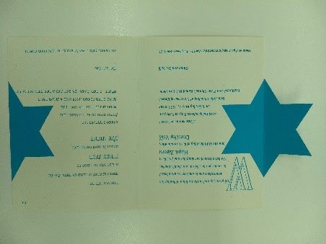  
  
  
  
  
  
  
  
Hagit and Dorothy Wolk Bat Mitzvah Invitation, 1995

**(Ephemera Collection, the National Library of Israel)**

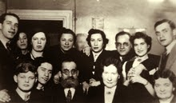 🔗 [Family photo from Wacek Kornblum’s Bar Mitzvah, Poland 1939](https://web.nli.org.il/sites/NLI/English/digitallibrary/pages/viewer.aspx?presentorid=EDU_XML_ENG&docid=EDU_XML_ENGSP1312)

In his testimonial, Wacek says “Everyone wanted to be in that photo; they were pushing themselves... I had a non-religious bar mitzvah.The family came to our house and we ate something. My parents were anti-religious.“

⍰ Why would someone have a bar mitzvah with no religious content? What other meaning could the milestone have in a family?

**Discussion Prompts:**

* The image of a tree is used to represent the spiritual family of the Hasidic movement. Why do you think trees are typically used as a symbol of family and ancestry?
* According to Hagit’s invitation, she shared her Bat Mitzvah with her 80-year old grandmother. What was your grandparents’ relationship to Judaism and what was their bar or bat mitzvah experience?
* In his testimonial, Wacek Kornblum said: “Everyone wanted to be in that photo; they were pushing themselves...I had a non-religious bar mitzvah. The family came to our house and we ate something. My parents were anti-religious.” Why would someone have a bar mitzvah with no religious content? What other meaning could this milestone have for a family?

**Activity Ideas:**

1. Your Bar/Bat Mitzvah is a perfect time to do a family history project! Use [The National Library of Israel's guide](https://web.nli.org.il/sites/NLIS/en/Education/Pages/itemPage.aspx?ItemID=EDU_XML_ENGSP853&_ga=2.266130767.1138097065.1549181657-309257122.1531049077) to help you create your own family tree.
2. Print your favorite family photos of all time with corresponding captions and add them to the photo reel in your scrapbook.

CHAPTER 7: Trip of a Lifetime

**Exploring Israel**

Some families choose to celebrate their child’s Bar/Bat Mitzvah with a trip to or celebration in Israel.In this chapter, we will explore our connection to Israel and think about other adventurous activities that could be part of the celebrations.

"לִבִּי בְמִזְרָח וְאָנֹכִי בְּסוֹף מַעֲרָב"

"My Body in the East, My Heart in the West." (Yehuda Halevi)

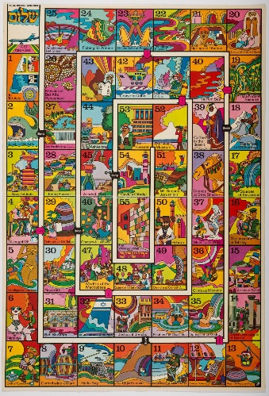🔗[El Al Board Game](https://web.nli.org.il/sites/NLI/English/digitallibrary/pages/viewer.aspx?docid=EDU_XML_ENG700106536&presentorid=EDU_XML_ENG&searchurl=https%3A%2F%2Fweb.nli.org.il%2Fsites%2Fnlis%2Fen%2Feducation%2Fpages%2Fresults.aspx%23%3Fquery%3Dlsr16%2Cexact%2CPrimary+Source%26query%3Dany%2Ccontains%2Chebrew+letters%26indx%3D9%26institution%3DNNL%26vid%3DEDU_XML_ENG%26loc%3Dlocal%2Cscope%3A(EDU_XML_ENG)%26sortField%3Dlso04%26bulkSize%3D8)

⍰ This El Al advertisement includes 55 Israeli sites and attractions. How many of these are familiar or meaningful to youin some way?

|  |  |
| --- | --- |
| https://lh4.googleusercontent.com/QNymcTLcw0G_MdIS0mc0zNqPdWfFBGGjEI8scI7wyXe2TiCXFq7rf45Nb6d_BdM_QZ7cCaZ_lBVWRs02-0N5B5cRDboSLjMNyzOCKh1OHUGc6DX7MTVmiC75gYk07JqX0Rd8odIj  🔗[Bar Mitzvah, Bat Mitzvah at Sea](https://web.nli.org.il/sites/NLI/English/digitallibrary/pages/viewer.aspx?docid=EDU_XML_ENG700071858&presentorid=EDU_XML_ENG&searchurl=https%3A%2F%2Fweb.nli.org.il%2Fsites%2Fnlis%2Fen%2Feducation%2Fpages%2Fresults.aspx%23%3Fquery%3Dlsr16%2Cexact%2CPrimary+Source%26query%3Dany%2Ccontains%2Cbar+mitzvah+israel%26institution%3DNNL%26vid%3DEDU_XML_ENG%26loc%3Dlocal%2Cscope%3A(EDU_XML_ENG)%26sortField%3Dlso04%26indx%3D1%26bulkSize%3D8) | The Zim company invites you to celebrate your bar mitzvah/bat mitzvah at sea on board one of our cruise ships, "Moledet," "Dan," "T. Herzl" -- together with your family.  It is so worthwhile to take the opportunity to combine a holiday cruise to broaden your horizons about other countries and peoples with the enjoyment for the whole family of celebrating the bar mitzvah/bat mitzvah on the deck of a ship.  As a bar mitzvah/bat mitzvah gift, the Zim company will give you a 50% discount on the price of a round- trip cruise.  Your travel agent and Zim branches in Haifa, Tel Aviv, and Jerusalem will be happy to wish you a mazel tov and send you additional details.       Bye for now! |

**Discussion Prompts:**

* What do you think is the ideal location or destination for a Bar/Bat Mitzvah trip?
* How do you define your connection to Israel? How is it different from your connection to your home country?
* What other adventures and activities would you like to experience this year?

**Activity Ideas:**

1. Create an itinerary or a travel brochure for a Bar/Bat Mitzvah trip to Israel. Include what sites you will visit, where you will sleep, what you will eat, who will join you, what experiences you want to have, etc.
2. Write a letter to a friend, a family member, or a peer in Israel, asking them any questions you have about Israel and telling them how you feel about Israel.

CHAPTER 8: Words of Wisdom

**Exploring Scripture and Torah Study**

Over the centuries, Jewish thinkers have been in constant dialogue with the texts that preceded

them through commentary and interpretation (also referred to as *midrash*). Every generation and every individual are invited to offer their interpretation and to take an active role in the grand conversation by tying current events, dilemmas, and existential questions to the chain of discourse that is so central to Jewish culture. It is the combination of these diverse, multigenerational voices that create the ever-changing story of the Jewish people. In this chapter, we will explore our connection and contribution to this shared endeavor.

**"שִׁבְעִים פָּנִים לַתּוֹרָה"**

**“**There are seventy faces to the Torah" (Numbers Rabbah 13:15)

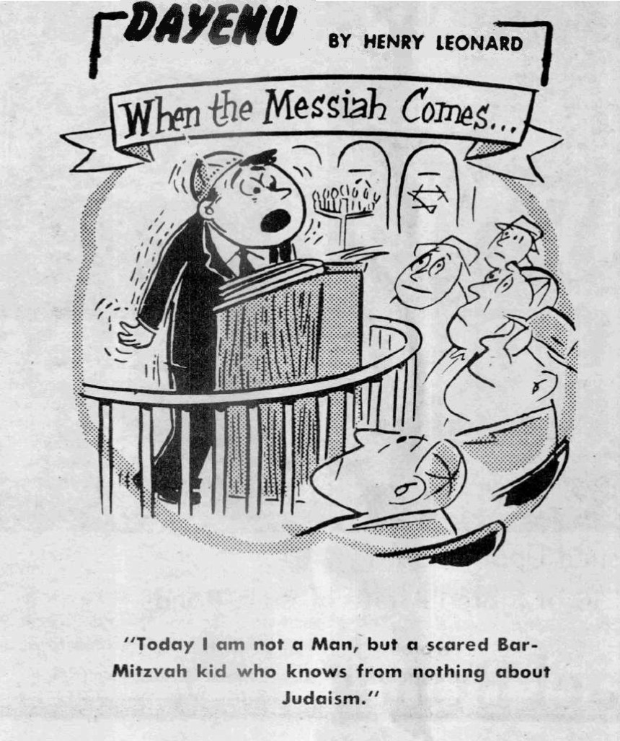

🔗[Bar Mitzvah Speech Cartoon](https://web.nli.org.il/sites/NLI/English/digitallibrary/pages/viewer.aspx?docid=EDU_XML_ENGSP1074&presentorid=EDU_XML_ENG&searchurl=https%3A%2F%2Fweb.nli.org.il%2Fsites%2Fnlis%2Fen%2Feducation%2Fpages%2Fresults.aspx%23%3Fquery%3Dlsr16%2Cexact%2CPrimary+Source%26query%3Dany%2Ccontains%2Cbar+mitzvah%26institution%3DNNL%26vid%3DEDU_XML_ENG%26loc%3Dlocal%2Cscope%3A(EDU_XML_ENG)%26sortField%3Dlso04%26indx%3D1%26bulkSize%3D8)

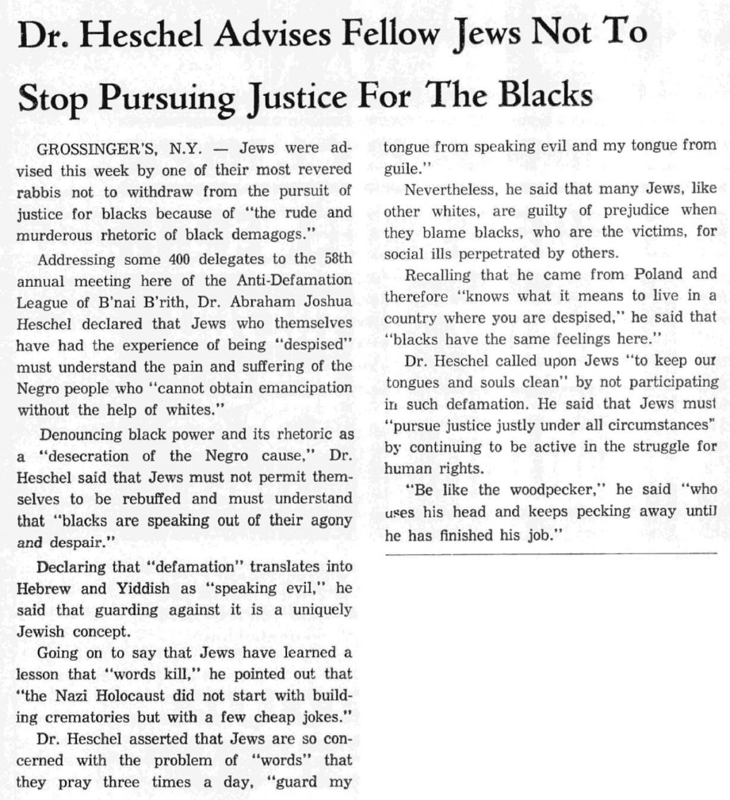

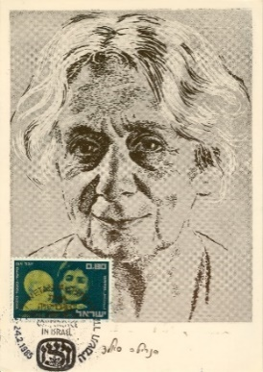🔗[Dr. Heschel, *Chicago Sentinel*](https://web.nli.org.il/sites/NLI/English/digitallibrary/pages/viewer.aspx?docid=EDU_XML_ENGSP224&presentorid=EDU_XML_ENG&searchurl=https%3A%2F%2Fweb.nli.org.il%2Fsites%2Fnlis%2Fen%2Feducation%2Fpages%2Fresults.aspx%23%3Fquery%3Dlsr16%2Cexact%2CPrimary+Source%26query%3Dany%2Ccontains%2Cspeech%26institution%3DNNL%26vid%3DEDU_XML_ENG%26loc%3Dlocal%2Cscope%3A(EDU_XML_ENG)%26sortField%3Dlso04%26indx%3D1%26bulkSize%3D8), 1971

In a speech Henrietta Szold delivered on the radio in 1940 in honor of her 80th birthday, she remarked:

“You can see the many incredible changes that have occurred over the eighty years of my life, however, one thing has stayed consistent, untouched by the hand of time. As in the past, today there are generous men and women who do good deeds. Today, as in the past, educated men and women express great ideas. Today, as in the past, active men and women work and create. Today, as in the past, we, the people of the Jewish nation, cultivate the spirit and aspirations which have served as the foundations of our life since we became a nation. The human soul stands forever; it just finds new and better paths to the soul of the other.”

⍰Read about [Henrietta Szold's amazing life story](https://web.nli.org.il/sites/NLIS/en/Education/Pages/itemPage.aspx?ItemID=EDU_XML_ENGSP369) and choose one accomplishment of hers that speaks to you.

🔗[Yako Izidor Yaakov, Bulgaria, 1933](https://web.nli.org.il/sites/NLI/English/digitallibrary/pages/viewer.aspx?docid=EDU_XML_ENGSP909&presentorid=EDU_XML_ENG&searchurl=https%3A%2F%2Fweb.nli.org.il%2Fsites%2Fnlis%2Fen%2Feducation%2Fpages%2Fresults.aspx%23%3Fquery%3Dlsr16%2Cexact%2CPrimary+Source%26query%3Dany%2Ccontains%2Cyako%26institution%3DNNL%26vid%3DEDU_XML_ENG%26loc%3Dlocal%2Cscope%3A(EDU_XML_ENG)%26sortField%3Dlso04%26indx%3D1%26bulkSize%3D8)

“My bar mitzvah was an exciting day for me. I was 13 years old. It was quite hard preparing for the speech I had to deliver. At that time there was a literature teacher in Ruse who wrote very nice speeches on demand, 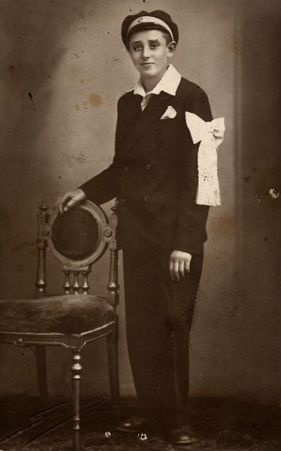and I had to learn the speech she wrote for me by heart; there were a lot of foreign words, which meant I could not understand it and I found it very hard to remember it.”

* ⍰ Yako Izidor Yaakov recollected working hard to memorize the speech that his literature teacher wrote for him, which included many foreign words that he did not understand. What do you think the content of a Bar/Bat Mitzvah speech should be? Do you think that you should write your speech on your own?

**Discussion Prompts:**

* In Hebrew, a speech about Torah or Judaism is referred to as a *dvar Torah* (a word of Torah) or a *drasha* (an interpretation) and typically begins with a philosophical or linguistic question on some aspect of the Torah’s laws or narrative. What topic, law, or story in Judaism do you have questions about?
* In his famous 1963 speech “[Religion and Race](https://www.blackpast.org/african-american-history/1963-rabbi-abraham-joshua-heschel-religion-and-race/),” Rabbi Abraham Joshua Heschel evoked multiple biblical verses and stories to make his argument for civil rights. Why do people evoke ancient texts when talking about contemporary issues?

**Activity Ideas:**

1. Use the template in your scrapbook to compose a Bar/Bat Mitzvah speech.
2. [This](https://jwa.org/media/i-have-dream-talmud-page) Talmudic analysis of Martin Luther King’s famous “I have a dream” speech highlights his many references to biblical and rabbinic concepts. Choose a verse from the *Tanach* (Bible) or another Jewish text you feel connected to. Answer the following questions: What most interests me about this text? How do I feel about what the issue the text refers to? How do I make sense of the traditional commentaries on this text? How does this text relate to me and my world today?

CHAPTER 9: Time to Party!

**Exploring Jewish food**

Food, eating, and cooking have always played an important role in Jewish life, law, and culture. There are detailed laws of Kashrut, various blessings before and after eating, symbolic holiday foods, and local Jewish cuisines. Every Jewish life cycle events are celebrated with a festive meal (referred to as *seudat mitzvah*). In this chapter, we will explore the role that food plays in the Jewish experience.

"וְאָכַלְתָּ וְשָׂבָעְתָּ וּבֵרַכְתָּ"

“You shall eat, and be satisfied, and bless” (Deuteronomy 8:10)

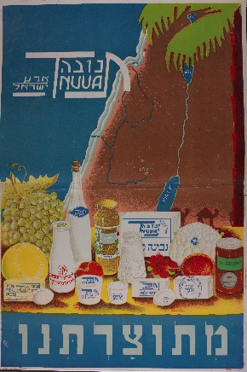  
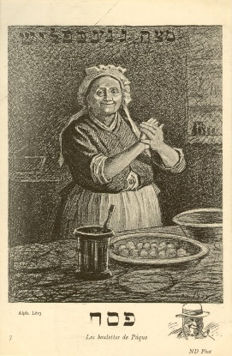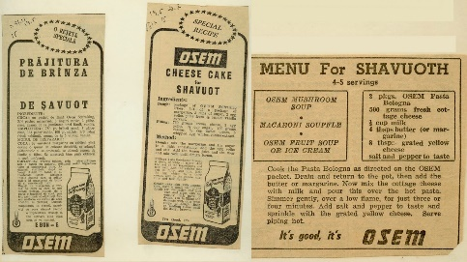

🔗[Osem cheesecake for Shavuot recipe](https://web.nli.org.il/sites/NLI/English/digitallibrary/pages/viewer.aspx?docid=EDU_XML_ENG700249704&presentorid=EDU_XML_ENG&searchurl=https%3A%2F%2Fweb.nli.org.il%2Fsites%2Fnlis%2Fen%2Feducation%2Fpages%2Fresults.aspx%23%3Fquery%3Dlsr16%2Cexact%2CPrimary+Source%26query%3Dany%2Ccontains%2Crecipe%26institution%3DNNL%26vid%3DEDU_XML_ENG%26loc%3Dlocal%2Cscope%3A(EDU_XML_ENG)%26sortField%3Dlso04%26indx%3D1%26bulkSize%3D8) (Israel)

🔗 [Tnuva Advertisement, 1930s](https://web.nli.org.il/sites/NLI/English/digitallibrary/pages/viewer.aspx?docid=EDU_XML_ENG700115256&presentorid=EDU_XML_ENG&searchurl=https%3A%2F%2Fweb.nli.org.il%2Fsites%2Fnlis%2Fen%2Feducation%2Fpages%2Fresults.aspx%23%3Fquery%3Dlsr16%2Cexact%2CPrimary+Source%26query%3Dany%2Ccontains%2Cfood%26indx%3D41%26institution%3DNNL%26vid%3DEDU_XML_ENG%26loc%3Dlocal%2Cscope%3A(EDU_XML_ENG)%26sortField%3Dlso04%26bulkSize%3D8)

[🔗Matzah Balls, Kneidlach, and Matza Gnepflish, France 1903](https://web.nli.org.il/sites/NLI/English/digitallibrary/pages/viewer.aspx?docid=EDU_XML_ENG700344097&presentorid=EDU_XML_ENG&searchurl=https%3A%2F%2Fweb.nli.org.il%2Fsites%2Fnlis%2Fen%2Feducation%2Fpages%2Fresults.aspx%23%3Fquery%3Dlsr16%2Cexact%2CPrimary+Source%26query%3Dany%2Ccontains%2Cmatzah%26institution%3DNNL%26vid%3DEDU_XML_ENG%26loc%3Dlocal%2Cscope%3A(EDU_XML_ENG)%26sortField%3Dlso04%26indx%3D1%26bulkSize%3D8)

🔗 [Bukharan Kashrut Stamp](https://web.nli.org.il/sites/NLI/English/digitallibrary/pages/viewer.aspx?docid=EDU_XML_ENGSP979&presentorid=EDU_XML_ENG&searchurl=https%3A%2F%2Fweb.nli.org.il%2Fsites%2Fnlis%2Fen%2Feducation%2Fpages%2Fresults.aspx%23%3Fquery%3Dlsr16%2Cexact%2CPrimary+Source%26query%3Dany%2Ccontains%2Ckosher%26institution%3DNNL%26vid%3DEDU_XML_ENG%26loc%3Dlocal%2Cscope%3A(EDU_XML_ENG)%26sortField%3Dlso04%26indx%3D1%26bulkSize%3D8#EDU_XML_ENG700426723)

**Discussion Prompts:**

* Do you think there is such a thing as Jewish cooking? What makes something a “Jewish” food?
* Do you think that it is important for Jewish celebrations such as a Bar/Bat Mitzvah to be kosher? Why or why not?
* In addition to the many rules of *kashrut*, Judaism has numerous blessings to say before and after eating. What is the purpose of so many blessings?

**Activity Ideas:**

1. Ask your parents or grandparents for the recipe of a food that was an essential part of their family celebrations. Try to make the recipe yourself and include it in your scrapbook along with any stories or memories associated with it.
2. Create a collage of foods that you associate with your family, religion, holiday, or celebrations.
3. The many Jewish laws relating to food may encourage more mindful eating. In your scrapbook, make your own list of rules for mindful eating.

CHAPTER 10: Tzedakah and Tikkun Olam

**Exploring Jewish Values**

In Judaism, all moments of celebration require us to consider those with less fortunate circumstances. This milestone is an opportunity to explore what financial or social contributions we can make to improving the world. In this chapter we will explore values of charity, compassion and helping others – values that are central to Jewish culture.

"לֹא עָלֶיךָ הַמְּלָאכָה לִגְמוֹר וְלֹא אַתָּה בֶן חוֹרִין לִבָּטֵל מִמֶּנָּה."

"It is not your duty to complete the work, but neither are you free to desist from it." (Pirkei Avot 2:21)

|  |  |
| --- | --- |
| 🔗[Bar Mitzvah Donation to KKL-JNF, 1938](https://web.nli.org.il/sites/NLI/English/digitallibrary/pages/viewer.aspx?docid=EDU_XML_ENGSP558&presentorid=EDU_XML_ENG&searchurl=https%3A%2F%2Fweb.nli.org.il%2Fsites%2Fnlis%2Fen%2Feducation%2Fpages%2Fresults.aspx%23%3Fquery%3Dlsr16%2Cexact%2CPrimary+Source%26query%3Dany%2Ccontains%2Cbar+mitzvah%26institution%3DNNL%26vid%3DEDU_XML_ENG%26loc%3Dlocal%2Cscope%3A(EDU_XML_ENG)%26sortField%3Dlso04%26indx%3D1%26bulkSize%3D8)  **https://lh3.googleusercontent.com/irtEQt_MugHGWE6_Zy63qY3VoXB5W7-1PjWomEHap0D8sVE5s3SXM2neufA2UDjXlz9RWCk_CUMNU33ZFyLWjEa7O2VdjR0l64rqf8NbFKqMSFmH32YMedLlANXv0drR-7d5v_4J** | Keren Kayemet L'Yisrael (Jewish National Fund)  Jerusalem  City: Tel Aviv  Date: 14 Sivan 5698  To: The esteemed WIZO member Mrs. Kesselman and her husband  Our warm blessings are extended to you on the occasion of your son Aryeh's bar mitzvah.  May he be a loyal son to our nation and our land and may you merit to see, together with him, the rebirth of Israel on its land.  With Regards,  WIZO members of Ramat Gan |

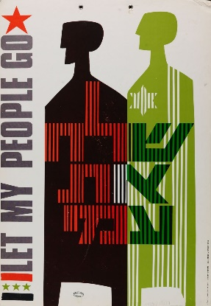  
🔗[Let my People Go Poster, 1971](https://web.nli.org.il/sites/NLI/English/digitallibrary/pages/viewer.aspx?docid=EDU_XML_ENG700327666&presentorid=EDU_XML_ENG&searchurl=https%3A%2F%2Fweb.nli.org.il%2Fsites%2Fnlis%2Fen%2Feducation%2Fpages%2Fresults.aspx%23%3Fquery%3Dlsr16%2Cexact%2CPrimary+Source%26query%3Dany%2Ccontains%2Clet+my+people+go%26institution%3DNNL%26vid%3DEDU_XML_ENG%26loc%3Dlocal%2Cscope%3A(EDU_XML_ENG)%26sortField%3Dlso04%26indx%3D1%26bulkSize%3D8)

**Discussion Prompts:**

* Donating to JNF is an example of a charitable donation given in honor of a Bar/Bat Mitzvah instead of a gift. How do you feel about this practice? Would you be disappointed or grateful for such a gift? Would your reaction depend on the cause donated to?
* Between the 1960s and 1980s, it was common in America for a Bar/Bat Mitzvah child to “twin” with a Jewish child in the Soviet Union who was not able to celebrate their own Bar Mitzvah due to religious oppression. If you were to create a twinning program today, who would you twin with?

**Activity Ideas:**

1. Create a fundraising page for an organization that matters to you (you can use a site like [depositagift.com](https://www.depositagift.com)).
2. Design a poster or infographic about a social cause that is important to you.
3. A creative way to add a *tzedakah* or *tikkun olam* component to a celebration is to decorate the tables at a celebration with “*tzedakah* centerpieces.” These include items such as flowers, books, or canned foods which are later given as donations. What would you put in your *tzedakah* centerpieces? Document it in your scrapbook!

**CHAPTER 11: At The Friends’ Table**

**Exploring Friendship**

Friendships are one of the primary relationships in our lives. Beyond companionship, fun and meaningful memories, friends provide each other with love, support, and guidance. In this chapter, we will explore the meaning of friendships in our lives.

" טוֹבִים הַשְּׁנַיִם מִן הָאֶחָד, אֲשֶׁר יֵשׁ לָהֶם שָׂכָר טוֹב בַּעֲמָלָם. כִּי אִם יִפֹּלוּ, הָאֶחָד יָקִים אֶת חֲבֵרוֹ, וְאִילוֹ הָאֶחָד שֶׁיִּפּוֹל וְאֵין שֵׁנִי לַהֲקִימוֹ. "

“Two are better than one because they have a good reward for their labor. For if they fall, the one will lift up his fellow; but woe to him that is alone when he falls, for he has not another to help him up” (Kohelet 4:9-10).

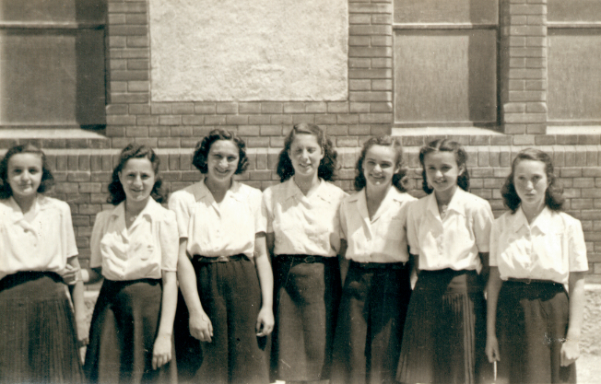

[🔗 Group confirmation (Ruth Greif), Brasov 1940s](https://web.nli.org.il/sites/NLI/English/digitallibrary/pages/viewer.aspx?docid=EDU_XML_ENGSP1313&presentorid=EDU_XML_ENG&searchurl=https%3A%2F%2Fweb.nli.org.il%2Fsites%2Fnlis%2Fen%2Feducation%2Fpages%2Fresults.aspx%23%3Fquery%3Dlsr16%2Cexact%2CPrimary+Source%26query%3Dany%2Ccontains%2Cbat%26indx%3D17%26institution%3DNNL%26vid%3DEDU_XML_ENG%26loc%3Dlocal%2Cscope%3A(EDU_XML_ENG)%26sortField%3Dlso04%26bulkSize%3D8)

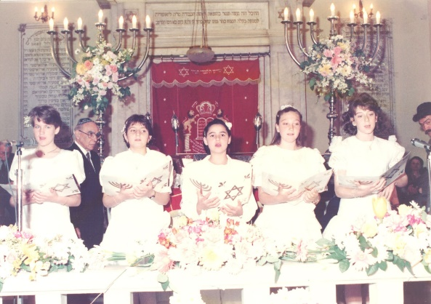

🔗 [Group Bat Mitzvah, Monastirioton Synagogue,Greece, 1990](https://web.nli.org.il/sites/NLI/English/digitallibrary/pages/viewer.aspx?docid=EDU_XML_ENGSP915&presentorid=EDU_XML_ENG&searchurl=https%3A%2F%2Fweb.nli.org.il%2Fsites%2Fnlis%2Fen%2Feducation%2Fpages%2Fresults.aspx%23%3Fquery%3Dlsr16%2Cexact%2CPrimary+Source%26query%3Dany%2Ccontains%2Cbat+mitzvah%26institution%3DNNL%26vid%3DEDU_XML_ENG%26loc%3Dlocal%2Cscope%3A(EDU_XML_ENG)%26sortField%3Dlso04%26indx%3D1%26bulkSize%3D8)

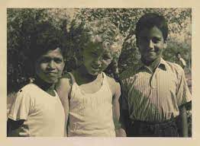

🔗 [Children at a Youth Village, 1957](https://web.nli.org.il/sites/nli/hebrew/digitallibrary/pages/viewer.aspx?docid=EDU_XML_ENG003430705&presentorid=EDU_XML_ENG&searchurl=https%3A%2F%2Fweb.nli.org.il%2Fsites%2Fnlis%2Fen%2Feducation%2Fpages%2Fresults.aspx%23%3Fquery%3Dlsr16%2Cexact%2CPrimary+Source%26query%3Dany%2Ccontains%2Cyouth+aliyah%26institution%3DNNL%26vid%3DEDU_XML_ENG%26loc%3Dlocal%2Cscope%3A(EDU_XML_ENG)%26sortField%3Dlso04%26indx%3D1%26bulkSize%3D8)

**Discussion Prompts:**

* What is the added value of celebrating a Bar/Bat Mitzvah with a group of peers? What are the disadvantages?
* What are the three most important qualities you look for in a friend?
* What are three qualities you bring to relationships as a friend?
* If you have lost a friend, what was the reason for the “break-up”?
* How have your ideas about friendship changed, as you have gotten older?

**Activity Ideas:**

1. Write a “Friend Wanted” advertisement in the newspaper. Be sure to include all the qualities you would look for in a friend
2. Dedicate a page in your scrapbook to your best friend or to a group of friends. Include photos, memories, and quotes.
3. Write or draw a metaphor expressing what friendship means for you. Start with the words: “Friendship is like…”

CHAPTER 12: Thank You, Thank You!

**Exploring Gratitude**

Once the Bar/Bat Mitzvah celebration is over, there is still one more task that needs to be done: the thank you notes! In this chapter, we will explore the value of gratitude through the practice of letter writing.

“Who is rich? Those who rejoice in their own portion.” [–Pirket Avot 4:1](https://reformjudaism.org/gratitude-what-does-judaism-teach-us) אֵיזֶהוּ עָשִׁיר? הַשָּׂמֵחַ בְּחֶלְקוֹ

|  |  |
| --- | --- |
| https://lh5.googleusercontent.com/wrAaKmou5tdoWYe2glVDWoC8Eyufg9i6Gv7ZOovUhopT8EMk1YszJKowEofBnEzvgHd8wEM23STivcOgvS9hCrzSeeRzFzMGS3avPzaDyH-uyapb_j3TqCVqXojOA9dWXPugp3EX🔗[Hannah Senesh Letter to her Brother, 1944](https://web.nli.org.il/sites/NLI/English/digitallibrary/pages/viewer.aspx?docid=EDU_XML_ENGSP152&presentorid=EDU_XML_ENG&searchurl=https%3A%2F%2Fweb.nli.org.il%2Fsites%2Fnlis%2Fen%2Feducation%2Fpages%2Fresults.aspx%23%3Fquery%3Dlsr16%2Cexact%2CPrimary+Source%26query%3Dany%2Ccontains%2Csenesh+letter%26institution%3DNNL%26vid%3DEDU_XML_ENG%26loc%3Dlocal%2Cscope%3A(EDU_XML_ENG)%26sortField%3Dlso04%26indx%3D1%26bulkSize%3D8) | My dear George,  I send you again a short letter to make you know, that I am quite OK and that's all. I guess all my acquaintances and relatives are cross with me, that I never write and are perhaps even angry with me. Please try to explain the situation if possible, if not they will forgive me later.  …  I get your letters with great delay but sooner or later they reach me, and I am always ever so glad to hear about you. Thousands of kisses to you and warm greetings to friends.  From Hanna.  ⍰ Have you ever waited anxiously to hear from someone? How did you feel when you finally received their message? |
| https://lh3.googleusercontent.com/H3nroCPtst40QZyiEkLGHSRRIMrpeI4TypQXkhs4hEGYdnUXjYWJ3iXNwC9GUwL_WT3w3bcXXw0siYj1VuJMWl9IGGttT2AER1BzmCtIHBJgk5UpL5l9KY5whxf-wc1bqBzIRS82🔗[Letter from Alfred Dreyfus to his Wife, Lucie, January 31, 1895](https://web.nli.org.il/sites/NLI/English/digitallibrary/pages/viewer.aspx?docid=EDU_XML_ENG003560223&presentorid=EDU_XML_ENG&searchurl=https%3A%2F%2Fweb.nli.org.il%2Fsites%2Fnlis%2Fen%2Feducation%2Fpages%2Fresults.aspx%23%3Fquery%3Dlsr16%2Cexact%2CPrimary+Source%26query%3Dany%2Ccontains%2Cdreyfus+letter%26institution%3DNNL%26vid%3DEDU_XML_ENG%26loc%3Dlocal%2Cscope%3A(EDU_XML_ENG)%26sortField%3Dlso04%26indx%3D1%26bulkSize%3D8)  ⍰ Dreyfus writes that "The letters are an echo of you all, an echo of your affection". Does this statement resonate with you? | January 31, 1895  My Dear Lucie,  At long last the happy day has come when I can write to you. I was counting the days! I haven’t received your news since the letter was given to me last Sunday. What frightful suffering! Every day that I received a letter from you, I felt happiness. The letters are an echo of you all, an echo of your affection warming my poor frozen heart. I read your letter three or four times, I soak in each word until the written words turn into spoken words and I can hear your voice close to me....  Embrace everyone for me. Kisses to my darlings.  I hug you and love you,  Alfred |

**Discussion Prompts:**

* Handwritten letters are no longer a common practice. Can you think of reasons why handwritten letters could still be important in our day and age?
* Like letter writing in general, writing actual thank you notes has become a rarity (when you can just send a thank-you emoji instead!). Do you think sending thank you notes is still a relevant practice?
* Have you ever sent or received a handwritten letter? If so, what was its impact?
* What is the opposite of gratitude?

**Activity Ideas:**

1. In this [story](https://www.aish.com/f/mom/A-Special-Bat-Mitzvah.html), the Bat Mitzvah girl wrote thank you notes to every guest *before* her celebration, not for their presents but rather as a way of expressing what the particular guest meant to her. Compose a handwritten letter to a relative, friend, or teacher expressing gratitude for the specific ways in which they have enhanced your life.
2. Ask a relative, teacher, or friend to write you a handwritten letter for the occasion of your upcoming Bar/Bat mitzvah. You can scan a copy and place it in your scrapbook.
3. Create a gratitude gallery in your scrapbook presenting people and things you are grateful for.

CHAPTER 13: Write Your Own Chapter!

**Adding My Piece to the Puzzle**

As you complete this journey, we invite you to document your Bar/Bat Mitzvah experience and share it! The story of the Jewish people is perpetually being written, and Jewish culture is constantly evolving and changing. Throughout this journey you have learned about various aspects of Jewish history, tradition, and identity. But history is not only in the past, it is happening right now!

"וְלֹ֥א אִתְּכֶ֖ם לְבַדְּכֶ֑ם אָנֹכִ֗י כֹּרֵת֙ אֶת־הַבְּרִ֣ית הַזֹּ֔את ... כִּי֩ אֶת־אֲשֶׁ֨ר יֶשְׁנ֜וֹ פֹּ֗ה עִמָּ֙נוּ֙ עֹמֵ֣ד הַיּ֔וֹם לִפְנֵ֖י ה' אֱלֹהֵ֑ינוּ וְאֵ֨ת אֲשֶׁ֥ר אֵינֶ֛נּוּ פֹּ֖ה עִמָּ֥נוּ הַיּֽוֹם", אֵלּוּ הַנְּפָשׁוֹת שֶׁעֲתִידִין לְהִבָּרְאוֹת.

“I make this covenant not only with you but with those who are standing here with us this day and with those who are not with us here this day. (Deuteronomy 29:14)” - From this we learn that the souls of future generations were also included in the covenant at Sinai (Midrash Tanhuma, Yitro 11:1)

⍰ On which words in the biblical verse does the Midrash base its interpretation?

⍰What do you think it means that all future souls were present at Sinai?

⍰How might this connect to the idea of “writing your own chapter”?

**Share your Bar/Bat Mitzvah experience now so that others can learn about it in the future!**

After you submit the following form with your primary source, you will receive a personalized certificate of participation in the NLI Bar/Bat Mitzvah Program.

**LINK TO FORM**