**Abstract**

On the margin of New Jersey Atlantic continental shelf, an underwater biological chorus is reported and suggested to be generated by a fish. The chorus happened every night for more than a month during the SW06 experiment. The frequency band of the chorus is between 150 Hz and 4.8 kHz, with the maximum within the band between 1450 and 2000 Hz. And there are remarkable peaks at frequencies of 500, 725, 960, 1215, 1465, 1700 and 1920 Hz. Compared with the background noise level without chorus, the intensity of chorus can be 20dB above in maximum’s band. The chorus appears at sunset, and reaches strongest within an hour. After that, it weakens slightly, then gradually becomes strong, and reaches strongest again before sunrise. Then it quickly weakens and disappears. The characteristics of the frequency domain, as well as the time of occurrence related with sunlight strongly, are the same as the sound produced by underwater animals. The intensity of chorus weakens along across­shelf path going shoreward. So the chorus originates from the margin of the continental shelf, rather than the coastal zone usually considered. The sound signal of chorus has one type only. Duration of each burst is about 0.0087 seconds, and contains two pulses. Each pulse contains several cycles. The time interval between the two bursts is 1.5 to 1.9s and not fixed. The duration of each signal is from tens to hundreds of seconds, that means, the number of bursts that each signal contains varies widely. Although it is impossible to determine the vocal specie, the characteristics of the chorus including in the low frequency the low sound source level, the single type of sound signal, the short duration, and the multiple peaks in the frequency domain are all the same as the general characteristics of fish sounds.

**INTRODUCTION**

Ocean noise is the background sound field, which is continuous and ubiquitous. Noise sources in the ocean are diverse, including man-made and natural sources. Among them, underwater biological sounds are important instantaneous noise. Especially in biological gathering areas, such as coral reefs, biological sounds could become an important part of the local soundscapes. There are many marine animals that can produce sound, including marine mammals, invertebrates, and fish (Coquereau et al., 2016; Gervaise et al., 2019). Bio-noise has diversity in time domain, frequency domain and space. (Etter, 2018). When three or more animals have calls that overlap or are produced in rapid succession, this pattern of vocalizing is referred to as a chorus (Greenfield and Shaw 1983) (Greenfield and Shaw, 1983; McCauley and Cato, 2016; Cato, 1978; Rice et al., 2017; D'Spain and Batchelor, 2006; the phenomenon where large numbers of animals call simultaneously over sustained periods of time). For example, fish usually vocalize at night, forming a chorus. When a large number of fish vocalize together, individual voices will cover up each other, which will cause a significant increase in noise level in a relatively wide frequency band within a few hours (Erbe et al., 2015). This makes fish chorus the dominant component of ocean noise.

Since at least 19th century, there have been reports in the scientific literature that marine animals can create sounds. The vigorous research on underwater biological noise began in World War II and has been for decades (D’ Spain and Batchelor, 2006; Kasumyan, 2008). The first seminar on marine bioacoustics in 1963 further promoted the development of the research about biological noise (Kasumyan, 2008). However, the current reports on biological sounds, except marine mammals (Erbe et al., 2017), invertebrates and fishes are mainly located in shallow sea areas, such as coral reefs and coastal waters or shallow continental shelf (Freeman et al., 2014; Sánchez-Gendriz and Padovese, 2017b; McCauley and Cato, 2016; Archer et al., 2018). After an anatomical survey in the 1950s, the understanding about the importance of sound communication in deep-sea fish ecology improved. Based on research, it is further assumed that sound production should be common in bottom fishes on the continental slope. (Marshall, 1954; Marshall, 1967; Wall et al., 2014) Since then, in different non-coastal waters, there have been some reports on the observation of the sound produced by deep-sea fish. Fish can also produce sound on the margin of the continental shelf and in the deep sea, but the chorus produced by fish that has a greater impact on the soundscapes of the ocean is rarely reported in literature. McCauley and Cato (2016) believes that this is probably due to the lack of sampling or the inability to determine the source of the sound, not because of the lack of chorus (Mann and Jarvis, 2004; McCauley and Cato, 2016).

In the Atlantic Ocean, the sound of deep-sea fish has been observed in some different deep-sea areas. Mann and Jarvis (2004) recorded a biological sound. It is located in the Tongue of the Ocean off Andros Island, Bahamas and the sound was localized to 548–696 m depth, where the bottom is 1620 m. According to that the sound is pulsed and relatively low frequency, they think it may be a sound produced by deep-sea fish. Rountree et al. (2012) obtained a 24-hour record on the seafloor in 682 m of water in Welkers Canyon located south of Georges Bank, by using the deep-water autonomous underwater listening system (DAULS). The experiment recorded a large number of biological sounds. In addition to several types produced by certain cetaceans and dolphins, there are at least 12 unique unidentified sounds, which are believed to be produced by fish or cetaceans. Carrico et al. (2019) used Ecological Acoustic Recorders (EARs) to observe the biological sounds which were bottom-moored on the Condor seamount at an approximate depth of 190 m, 5-10 m from the seafloor, and at a depth of 36 m in Princesa Alice bank, on the seafloor. Azores has a wealth of fish species. Among them, only 20 species from 14 families present have been reported and at least 79 species from 24 families are potential sound producers.

In the Canadian waters of the Northeast Pacific, the sound of deep-sea fish was observed by using the North East Pacific Time-Series Undersea Networked Experiments project (NEPTUNE) Canada, part of the Ocean Networks Canada Observatory. The system is located on the floor close to 1000 m off the west coast of Vancouver Island close to 1000 meters below the sea The system also has 3 NEPTUNE-Canada cameras (Širović, 2012; Doya et al., 2014; Wall et al., 2014). In addition to baleen whales and odontocetes, there are a large number of broadband pulse signals, which may be produced by fish. Among these signals, in addition to the known Sablefish (Anoplopoma fimbria), there are a lot of unknown sounds. Wall et al. (2014) present 32 possible sources, and it is not certain each signal is originated form which fish. Doya et al. (2014) believe that the biological sound here does not have a day-night or tidal-based rhythms.

In California waters of the Pacific Ocean, there have been several reports on non-coastal biological noise. In this sea, in addition to the individual sound produced by fish, the fish chorus also exists. McDonald et al. (2006) conducted long-term continuous observations in the waters of the West of San Nicolas Island, California, at a depth of 1090 meters. The experimental location is the same as the experiment in the 1960s, which can be used to compare the changes of the deep-sea ambient noise. The experiment in the 1960s observed a diel pattern of 10-20 dB variation in the frequency band from 80 to 300 Hz, but McDonald et al. (2006) did not observe the diel pattern. From the comparison of the sound pressure spectrum level of 315 Hz in the two experiments, the sound pressure spectrum level in 2003-2004 is higher than that in 1964-1965, even when the noise is stronger at night. It is possible that the strong noise background masks the diel pattern, or the strong noise background disturbs the sound of fish which relates with reproductive and predatory behaviors and worsens the living environment which greatly reduces the richness of the fish to result in the disappearance of the diel pattern. Although no diel pattern in fish chorus have been observed, there are some occasional “fish bumps” or brief impulsive sounds of unknown. Also, the sounds of cetaceans in 15-20Hz are observed. D’ Spain and Batchelor (2006) deployed the a large-vertical-aperture, 131-hydrophone, 2D billboard array at a depth of 175 meters located 35 km southeast of San Clemente Island where biological chorus was observed. The energy of chorus is in two broad spectral peaks centered around 1.5 and 5 kHz. The biological chorus appeared with sunset and disappeared with the sunrise. No individual biological sound was observed. They think it is not a local voice, but from the 43-Fathom Spot 2km away. Its depth here can even exceed 75m, and it is a popular Southern California fishing spot. Therefore, the sources of the sound cannot be recognized, and could be marine mammals, a number of fishes, some invertebrates, or a combination of them. Širović et al. (2009) recorded sounds at 14 locations in the Gulf of Southern California with Passive-acoustic recordings to study the sound of rockfish. The sea depth ranged from 44 meters to 160 meters, including 43-Fathom Spot where the duration is longest. The fish sounds at 43-Fathom Spot are in the low frequency band (less than 900Hz). Mostly of them is individual sounds and no chorus was observed. That means the chorus reported D’ Spain and Batchelor (2006) may be from 43-Fathom Spot. Reshef et al. (2018) conducted 12 years of passive observations at 18 locations in the Gulf of Southern California. Two important chorus were observed in the frequency bands 100-200Hz and 400-800Hz. The signals were present at lower intensities at the offshore sites than the inshore sites. Then the chorus should propagate from the offshore sites to the offshore sites or the abundance of fish at offshore sites is low. Pagniello et al. (2019) reported the five kinds of fish chorus observed along the coast by using Wave Glider. And they think that the second type of chorus is the same as the 400-800Hz chorus in Reshef et al., (2018).

In the surrounding waters of Australia, fish choruses have been observed in the deep sea area several times. Cato (1978) observed some biological choruses at different locations in the tropical waters near Australia. The depth of the experimental areas is 35m, 640m and 1000m, and within 6km from experimental areas, shallow water with coral reefs exist. The source of biological chorus may be marine fishes or sea urchin in shallow sea. The instantaneous choruses ware also observed. These choruses were composed of intense clicking sounds, apparently from sperm whales. Kelly et al. (1985) reported a 400-600 Hz biological chorus at night in three deep water sites. Three sites are 250km, 700km and 900km from the Australian coast in depths of 1500–5500m. it is believed that the sound is produced by Croakers, fish of the family Sciaenid in shallow coastal waters. However, because the sound intensity of fish is usually low and the propagation distance is limited, it is low possibility that the individual sound can be observed at a site 250km offshore. Erbe et al. (2015) reported the marine soundscape of the Perth Canyon at 430–490 m water depth, 70 km offshore from the coast of Perth. Biological sound is an important composition of soundscape. Whales dominates seasonally at low (15–100 Hz) and mid frequencies (200–400 Hz), and fish or invertebrate choruses dominates at high frequencies. In the Perth Canyon, choruses in 1000– 2500 Hz likely due to fish are seen at night all year round. The unknown hump at 600 Hz could be another type of fish or invertebrate chorus. McCauley and Cato (2016) think that the most likely source of the chorus at 2kHz in Perth Canyon is the fishes of the family Myctophidae foraging in the water column. They also think some sporadic choruses exist from other Australian shelf slope locations.

The fish sounds are abundant in coastal zone, shallow and deep waters. As for the fish chorus, they are not commonly reported on margin of the continental shelf and deep waters. However, if the chorus appears, it will become the dominant component of ocean noise in a relatively wide frequency band for some time. The purpose of this paper is to report a novel fish chorus appearing on margin of the continental shelf and describe the characteristics of the chorus. The fish chorus is located on the margin of New Jersey Atlantic shelf. The producer of chorus is not from the coastal zone, and different from the biological sounds of the American Atlantic coast.

**METHODS**

The Shallow Water 2006 experiment (SW06) was performed in New Jersey Atlantic shelf （approximately 100 miles east of the New Jersey coast）and it lasted from mid-July to mid-September in 2006 (Newhall et al., 2007). There were totally 62 acoustic and oceanographic moorings deployed in SW06 experiment. They were in a 'T' geometry and created an along shelf path along the 80 meter isobaths and an across shelf path starting at a depth of 600 meters and going shoreward to a depth of 60 meters. Among the moorings, five Single Hydrophone Receiving Units (SHRU) were deployed. They are positioned on the across shelf path in the sequence of SHRU2, SHRU1, SHRU3, SHRU4 and SHRU5 and the depths are 107 m, 85 m, 83 m, 67 m and 65 m respectively. The details are shown in Fig.1. The hydrophones of SHRUs are all deployed 7 meters above the bottom.

The sampling frequency of the SHRUs is 9765.625 Hz, the flat passband of SHRUs is 4424 Hz and the -3 dB frequency is 4785 Hz, the passband ripple is 0.005 dB and the sensitivity is 170 dB re 1 μPa per 1 volt. The duration of SHRUs are different: the recording of SHRU2 started at 14:18 on Jul 26 and ended at 08:25 on Aug 31, the recording of SHRU1 started at 11:07 on Jul 26 and ended at 05:22 on Aug 31. The recording of SHRU3 started at 20:41 on Jul 28 and ended at 14:32 on Sep 2. The recording of SHRU4 started at 14:42 on Jul 29 and ended at 09:14 on Sep 3. The recording of SHRU5 started at 19:04 on Jul 29 and ended at 13:25 on Sep 4. The time used in this paper is Universal Time Coordinated（UTC）. The local time can be converted by subtracting 4 hours from UTC. (Newhall et al., 2007)

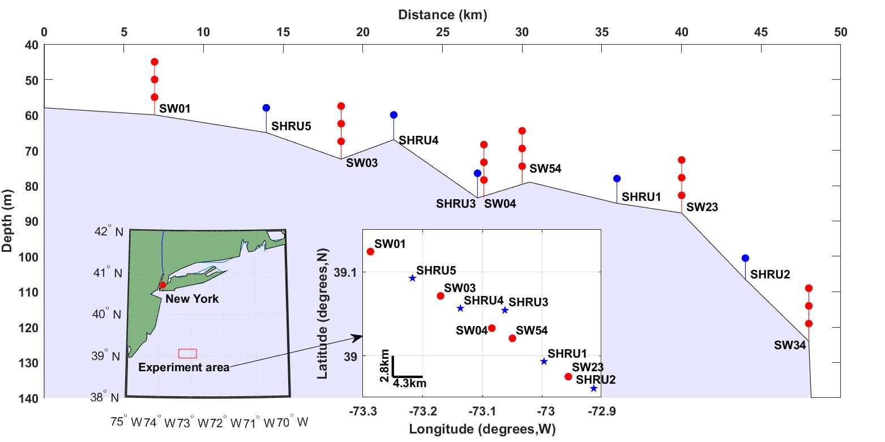

Fig.1 The experiment area and the depth of SHRUs.

All data is processed using MATLAB software (The MathWorks, Inc.). In order to understand characteristics in frequency domain, Fourier transform is performed on the noise data to obtain the power spectral density (PSD). In the computationalprocess, the data is not selected, and various signals and unknown interference exists. When calculating PSD, each segment has 8192 points for Fourier transform with gate window. The PSD has 50% overlap. The frequency resolution in the frequency domain is 1.192 Hz. After that, they can be averaged in different lengths of time. It has the ability to distinguish variations on different noise over time (McCauley and Cato, 2016). On the basis of PSD, the spectral probability density (SPD) is calculated as normalized histograms of the decibel levels in each frequency bin. SPD can be used to evaluate the tonal contribution of different components of marine noise. The percentiles can also be obtained by revealing the underlying noise level distribution. (Merchant et al., 2013; Archer et al., 2018)

**RESULTS**

In the experimental site, all the soundscapes recorded by SHRUs showed periodic variation with a period of one day. The noise intensity in this area increases with sunset and weakens with sunrise. At night, there are a lot of indistinguishable noise signals, which is a kind of biological chorus. The characteristics of the chorus in the frequency and time domains and the distribution in time and space are obvious and stable.

The PSD of the noise is calculated and averaged for one hour to obtain a spectrogram of the variation of the noise field. The time-frequency distributions of the noise recorded by SHRU2 from July 26 to July 31 and from August 26 to August 31 are shown in Fig. 2. It is evident that the sound field varies with a diel pattern. Of course, it can also be found from the Fig. 2 that the acoustic signals emitted in this experiment. For example, the signals at 300 Hz and 400 Hz are emitted several minutes every half an hour, and after averaging in an hour, it is continuous in Fig. 2.

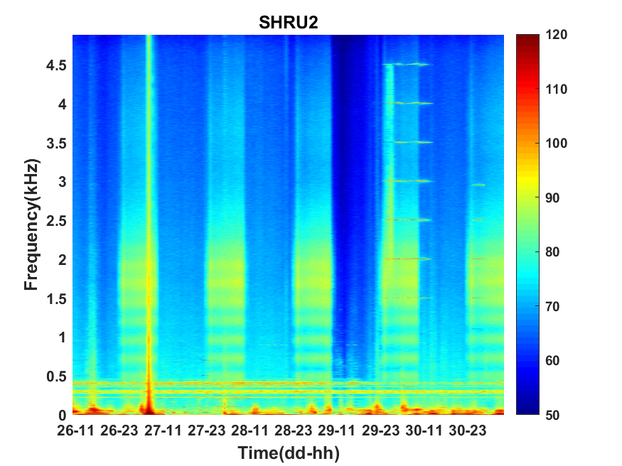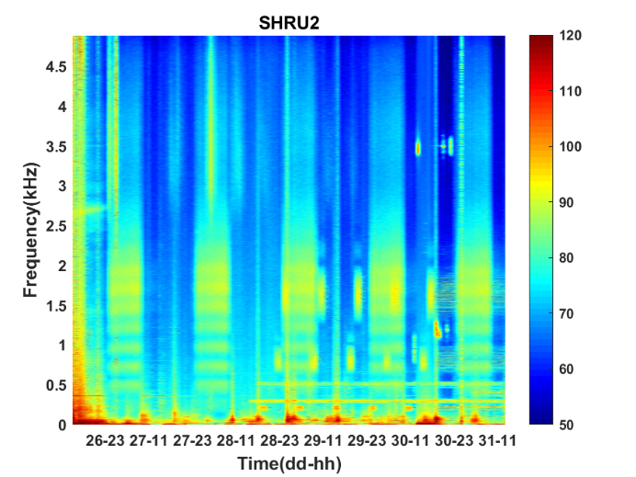

Fig.2 The spectrogram of the noise recorded by SHRU2. Left: from July 26 to July 31. Right: from August 26 to August 31

Then select the 1280 seconds noise data separately in the daytime and at night on August 28 to calculate PSD. The method is the same as above, but it is not averaged. The time-frequency distributions of the noise in the daytime and at night are shown in Fig. 3. Average the PSD in Fig. 3 and the results of the energy distributed in frequency domain are shown in Fig. 4. At night, the soundscape becomes significantly stronger when the frequency is higher than about 150 Hz. It reaches the strongest at around 1700 Hz and can be about 20 dB up compared with the soundscapes in the daytime. In addition, the chorus in frequency domain also has an evident characteristic that there are spectral peaks at frequencies of 500, 725, 960, 1215, 1465, 1700 and 1920 Hz. The difference between adjacent peaks is 220 to 255 Hz, which is not exactly uniformly distributed.

Calculate the SPD with one-hour averaged PSD. The result is shown in Fig. 5. The frequency interval is 1.192 Hz, and the histogram bin width is 1 dB. It can be seen from Fig. 5 that above 150 Hz, the SPD distribution of each frequency has the pattern with double peaks. Similar to the spectrum distribution in Fig. 4, these two peaks correspond to the distributions of different soundscapes during the day and night. The distribution of chorus at night is more concentrated and dens, while the distribution of noise in the daytime is more scattered. Below 150 Hz, there are no double peaks. It can be also found that the black curve fluctuates violently in some frequency bands. They are corresponding to the existence of signals emitted during the experiment, such as 300 Hz and 400 Hz.

Due to the limitation of sampling frequency, it is not known for noise above 4.8 kHz. However, as can be seen from Fig. 4, the energy of noise at night is still higher than that during the day when the frequency is higher than 4.8 kHz. Therefore, it is likely that the chorus still has energy at high frequencies. Considering that chorus has weakened with frequency increasing after 2 kHz and the intensity of gap between the chorus at night and the noise in the daytime decreases, the chorus above 4.8kHz has less energy and should not matter.

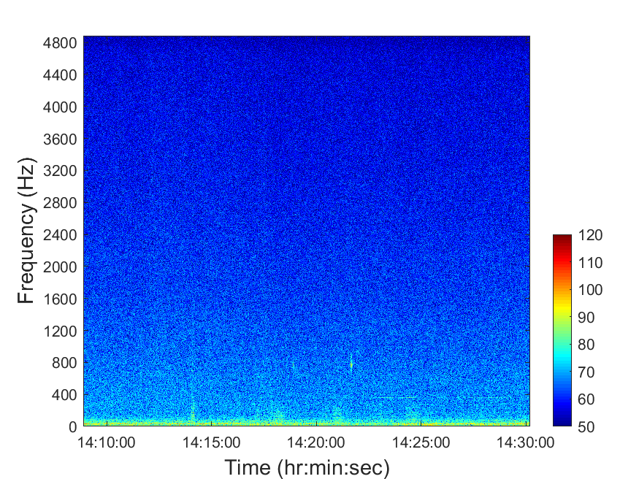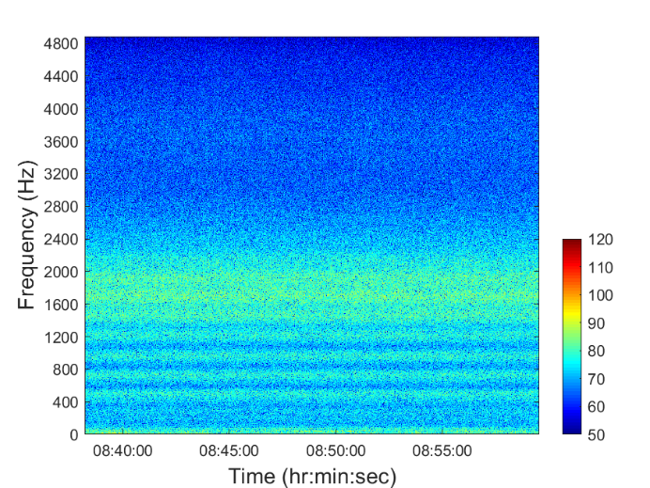

Fig. 3 The spectrogram of 1280s noise on August 28. Left: in the daytime. Right: at night.

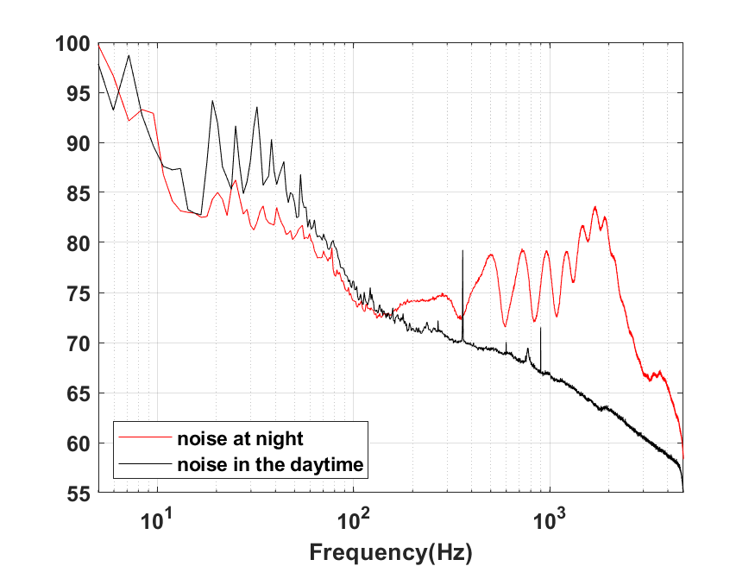

Fig. 4 The PSD of noise at night and in the daytime

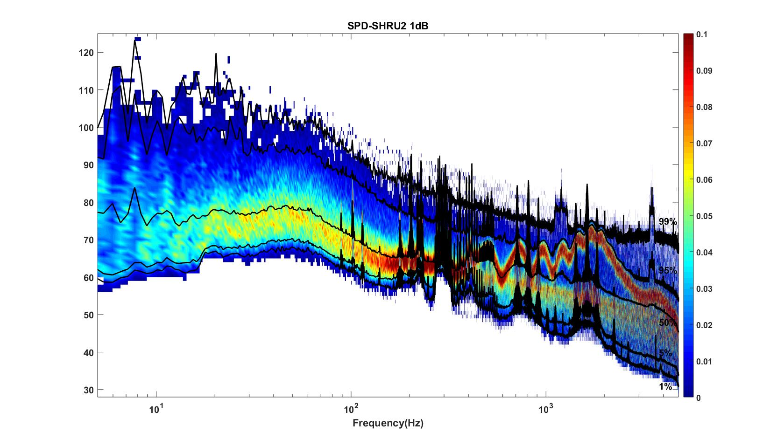

Fig. 5 The SPD with one-hour averaged PSD with frequency interval 1.192 Hz and histogram bin width 1 dB

As shown in Fig. 4, the intensity from 1450 to 2000 Hz is the strongest of chorus. Therefore, during the whole experiment, the variation of sound intensity from 1450 to 2000 Hz is calculated. The results of the five SHRUs are shown in Fig. 6. The horizontal axis represents time (UTC), from July 27 to September 2, 2006. As shown in Fig. 6, it can be clearly seen that the sound intensity varies in one-day period. The time when the noise chorus appears and disappears does not change much every day. It becomes stronger around 00:00, and disappears around 10:00 every day, and these time is consistent with the time of sunrise and sunset at experiment site. During the experiment at given site, the night becomes longer, which means that the sunset becomes earlier and the sunrise becomes later. If the appearance of chorus is related to sunshine, the appearance and disappearance of chorus will also change with the change of sunrise and sunset. Because the intensity of chorus at the site of SHRU2 is the strongest, find out the time when chorus appears and disappears every day from the noise data recorded by SHRU2. Then compare with the corresponding the time of sunrise and sunset each day. The result is shown in the left of Fig.7. At the same time, calculate the variations of noise intensity at night on July 27 and August 27 when the chorus appears and disappears. The result is shown in the right of Fig. 7. Sunset is 20:14 on July 27 (00:14, July 28, UTC) and sunrise is 05:53 on July 28 (09:53, July 28, UTC). Sunset is 19:36 on August 27 (23:36, August 27, UTC) and sunrise is 06:22 on August 28 (10:22, August 28, UTC). The time of sunset and sunrise is the time of the Atlanta city, close to the experimental site. The time of sunrise and sunset is from the website Time and Date.

Considering that the background noise level is variable, the start time and end time of chorus are not easy to determine. Then as a reference, choose the time when chorus reaches the strongest around sunset as the start time, and when the intensity begins to decline around sunrise as the end time. It corresponds to the two moments with the strongest sound intensity in the right of Fig.7. Therefore, in the left of Fig. 7, chorus starts after sunset and ends before sunrise. As shown in the left of Fig.7, we can know that the start and end time of chorus changes every day, and it is consistent with the change of sunrise and sunset. So it can be inferred that chorus appears with sunset and disappears with sunrise. From the right of Fig.7, it is easy to find that the intensity of the chorus quickly reaches the strongest at the beginning, but it drops slightly soon, and then decreases to the weakest in about an hour. Then it gradually becomes stronger, reaches the strongest before sunrise, and then quickly disappears.

In addition to variations in time, it is also easy to find from Fig. 6 that the spatial distribution of chorus intensity. The intensity of chorus is the strongest at SHRU2 and the weakest at SHRU5. Choose the chorus on August 7, which the interference is less, to calculate the intensity at night and average it. The intensity is 80.1 dB at SHRU2, 76.6 dB at SHRU1, 71.0 dB at SHRU3, 68.7 dB at SHRU4, and 63.4 dB at SHRU5. Combined with Fig. 1, it can be found that the intensity of chorus at chorus becomes weaker along across­shelf path going shoreward. That is, the closer to the coast, the lower the chorus intensity. That means that the source of chorus is not evenly distributed throughout the whole experimental area, and the source of chorus is mainly from the margin of the continental shelf or even the deep sea, not the coastal zone or the continental shelf.

H:\shru\Computation by Zhang\pictures\NI_Diurnal_Varition_SHRU.tif

Fig. 6 The intensity of SHRUs varies during the experiment

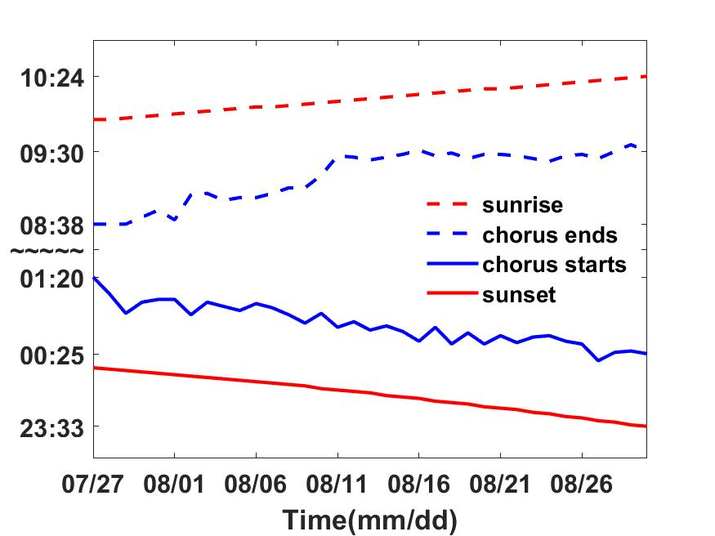H:\shru\Computation by Zhang\pictures\Compare_July28_Aug28_SHRU2.tif

Fig. 7 Left: variations of the start and end time of chorus and the time of sunrise and sunset. Right: variations of noise intensity at night on July 27 and August 27 recorded by SHRU2

At site of SHRU2, chorus is relatively strong, and the individual signals of chorus can be recognized in time domain. Remark, that at about 3:50 am on August 7, 20-second noise in time domain is shown in Fig. 8. In 20 s, there are 12 strong bursts, characterized by time interval ~1.5-1.9 seconds, which is not stable. In bigger scale the first stronger burst is shown in the middle panel. Each burst of the signal is about 0.0087 seconds and contains two pulses. Each pulse contains several cycles and the second pulse is weaker than the first one. In addition to SHRU2, individual signals can also be seen at SHRU1, however, it is weaker than SHRU2. As for SHRU4 and SHRU5, it is basically difficult to recognize an individual signal. In Fig. 8, only 20 seconds of data which contains 12 bursts are shown. In fact, the signals can last for tens of seconds to hundreds of seconds, and the duration varies. In this experiment, only one type of signal is observed. And no other types of biological signals or other sounds produced by other animals is found. It may be because they are covered up.

The 12 bursts in Fig. 8, are cut to calculate the spectrum, and average. The length of each burst is 92 samples (about 0.0094 seconds). At the same time, the noise that an individual signal cannot be distinguished (such as the noise between 0.38 s and 0.39 s) is cut calculate the spectrum. And compared with the spectrum of noise in the daytime shown in Fig. 4, the results are shown in Fig. 9. Through comparison, it is found that the noise without distinguishing an individual signal at night is also stronger than that in the daytime. The energy distribution in the frequency domain is the same as the noise signal, but the intensity is weaker. That means that chorus is continuously present at night. And the signals are covered by each other so that they cannot be distinguished in the time domain. The duration of an individual burst is very short, and it appears only once every 1.5 to 1.9 seconds. The chorus is continuous in the time domain. Therefore, the number of noise sources is very large, so that the signals could be covered by each other all the time. The distance between SHRU1 and SHRU2 is about 4.1 km. At SHRU2, a strong individual signal can be recognized, and at the corresponding time, the corresponding individual signal cannot be found at SHRU1. So the sound intensity produced by the fish is weak and cannot propagate in a long distance. However, the chorus distributes in a wide range, so the spatial distribution of noise sources should also be wide. It is a chorusing behavior of a collection of animals and not just one animal.

H:\shru\Computation by Zhang\the comparision of signal in time domain\The nosie signal in time domain.tif

Fig. 8 The noise of SHRU2 in time domain

H:\shru\Computation by Zhang\the comparision of signal in time domain\Compare the frequency domain.tif

Fig. 9 The compare of noise of SHRU2 in frequency domain

**DISCUSSION**

According to the results, the noise exists at night only and has a strong relationship with the sunlight. The noise appears with the sunset and disappears with the sunrise, with a diel pattern. Furthermore, the frequency band of the sound is also consistent with that of biological sounds, so the most likely source of the noise is marine animals. Biological sounds are often associated with behaviors such as predation, courtship, reproduction, warning or attack, communication and navigation. Some sounds are made actively by marine animals themselves, and some are generated by impacts between marine animals and water flow or water surface.

In the ocean, many species of marine animals can vocalize, including marine mammals, invertebrates, and fishes (Coquereau et al., 2016; Gervais et al., 2019). Among the species that can vocalize, invertebrates and fish are mainly able to produce chorus. In addition, sometimes marine mammals could vocalize together, such as the communication of cetaceans, in the shallow or deep sea (McCauley and Cato, 2016).

Marine mammals can produce sounds when they are communicating and navigating. The movements, such as foraging and impacting on the water surface, can also make sounds (Tyack and Clark, 2000; Au, 1993; Dunlop et al., 2008). Erbe et al. (2017) reviewed the sounds produced by marine mammals in Australia and Antarctica, including whales, dolphins, Sea Cows, and Carnivores. All sounds can be grouped into three classes, constant-wave (CW) tones, frequency-modulated (FM) sounds and broadband pulses. Mellinger and Clark (2003) pointed out that mammalian vocalizations in the North Atlantic Ocean are basically the same as that in other regions. However, there are some differences. The specific frequency, the duration and repetition interval features are different. The frequency of different sound types of mammals is very wide, ranging from a few Hz to more than 100 kHz (Havera et al., 2018). The duration and type of vocalization of mammals are quite different from the chorus in our paper, so the chorus should not be produced by marine mammals.

Many species of invertebrates can produce sounds, such as shrimp, and the frequency of vocalization is relatively high. Coquereau et al. (2016) measured 20 species of invertebrates along the coast of Northeast Atlantic Ocean and 8 of them can produce sounds, including sea urchins, shrimp and spider crabs. The peak frequency of these invertebrates is above 3 kHz, and some can reach above 50kHz. Buscaino et al. (2011) measured acoustic behaviour of the European spiny lobster *Palinurus elephas* in the water tank. Signal duration, number of pulses per signal, pulse rate, bandwidth, peak intensity, and peak frequency were measured. All of them are very different from the chorus in our paper. For example, the peak frequency is 19.52 kHz. For snapping shrimp, they are widely distributed which are found typically at depths less than a few tens of meters and have an approximate geographic range of ±40° latitude (Bohnenstiehl et al., 2016; Au and Banks, 1998). And snapping shrimp are a widespread family of Caridean shrimp comprising over 600 species (Lillis and Mooney, 2016), which is an important source of marine biological noise. The sound of snapping shrimp has a wide range of frequency band, and mainly is in high frequency, generally from a few to tens of kilohertz. In the time domain, the duration of an individual signal is relatively short, less than 1 millisecond (Au and Banks, 1998; Freeman et al., 2014; Bohnenstiehl et al., 2016; Lillis and Mooney, 2016). According to the analysis of sounds recorded in the water of New Zealand (Radford et al., 2010), the frequency band of sound produced by the sea urchin is 800 to 2500 Hz, and the peak is between 1000 and 1200 Hz. However, the frequency band in Soars et al. (2016) is higher, from 2.3 to 9.2 kHz. Because the band of the sound produced by sea urchins in the tropical water is higher than that in the temperate water, and the duration and frequency band of sound are dependent on the size of sea urchin. However, the sound of the sea urchin in frequency domain is gently changing, and no several peaks are formed. In the time domain, each burst only has one pulse which has two pulses in the chorus in our paper (Radford et al. 2008). Because the characteristics of sounds of invertebrates in frequency and time domain are quite different from that of chorus in this article, the possibility of chorus produced by invertebrates is very low.

The number of fish species is large. More than 25,000 species have been found (D'Spain and Batchelor, 2006). Among them, over 800 species from 109 families worldwide are known to be soniferous (Fish and Mowbray, 1970; Kaatz, 2002; Rountree et al., 2006; Kasumyan, 2008; Slabbekoorn et al., 2010; Parsons et al., 2016b; Carrico et al., 2019). With the progress of research, the number is increasing and we do not fully know all the vocal fishes now. Fishes are known to produce sounds using five mechanisms (Kaatz, 2002). Vocalization is often associated with courtship, reproduction, warning, etc. (Kasumyan, 2008; Popper and Hawkins, 2019; Rogers et al., 2020) Compared with other organisms, vocal ability of fishes is weak (Kasumyan, 2008). Usually the main energy is only in low frequency, below 1-2 kHz (Kasumyan, 2008). There is only one type of sound signal in our paper, which is very simple it has a series of bursts. Each burst contains two pulses. As shown in Fig. 8, the energy is also concentrated at low frequencies. More importantly, there are spectral peaks which are relatively evenly distributed in frequency domain for some fishes. The frequency spacing between spectral peaks is called pulse repetition frequency. It is the inverse of time between pulses triggered by muscle contractions (Oppenheim and Schafer, 2004; McCauley, 2012; Parsons et al., 2013; Parsons et al., 2016a; Parsons et al., 2016b; Sánchez-Gendriz and Padovese, 2017a). In our paper, the time between pulses is about 0.0043s and the inverse is 233, which is consistent with the interval of the spectral peaks. In addition, the fish chorus commonly occurs at night time, and a large number of fish come and vocalize together, which could greatly increase the broadband noise for a few hours (Cato, 1978; McCauley, 2012; Parsons et al., 2013; Erbe et al., 2015). The general characteristics of fish sounds are low frequency and short in duration (Fish and Mowbray, 1970; Amorim, 2006; Kasumyan, 2008, Wall et al., 2014). The characteristics of fish sounds are similar to those of the chorus in our paper, so it should be produced by fish.

Because the chorus is produced by fish, some sounds of fishes commonly reported are searched to find the source of the chorus. **Weakfish** (sciaenid family) (Connaughton et al., 2000; Connaughton et al., 2002; Mann, and Grothues, 2009); **tigerfish** (Therapon jarbua), **toadfish** (Opsanus tau), **midshipman** (Porichthys notatus), long-horned **sculpin** (Myoxocephalus octodecimspinosus) and **sea robin** (Prionotus carolinus) (Schneider, 1967; Fine, 1978; Bass and Baker, 1991; Connaughton et al., 2000; Rogers et al., 2020); **damselfish** (Pomacentridae) (Mann et al. , 2008); **croakers** (Sciaenidae) (Mann et al., 2008; Mann, 2016 ); **drums** (Sciaenidae) (Mann et al., 2008; Mann, 2016 ); **haddock** (Gadidae or cod)) (Mann et al. , 2008); **Haddock** (Melanogrammus aeglefinus) (Casaretto et al., 2015); **Batrachoididae** (family name called toadfish, or "frogfish), oyster toadfish (Opsanus tau) (Bass and Baker, 1991; Fine, 2001; Mann, 2016 ; Rice et al., 2017; ); **groupers** (Epinephelidae) (Mann, 2016); **Black drum** (Pogonias cromis), **red drum** (Sciaenops ocellatus), **silver perch** (Bairdiella chrysoura) (Rice et al., 2017); **Atlantic croaker** (Micropogonias undulatus), **striped cuskeel** (Ophidion marginatum) (Mann, 2009); **Nassau** **Grouper** (Rowell et al., 2018); all of these fish are different from the chorus in our paper. Some sounds of fishes in a family are also reported, such as Family Sciaenidae (Croakers and Drums) (Ramcharitar et al., 2006), Drum fishes (Sciaenids) and Codfishes (gadids) (Rountree et al., 2006), and no same sound is found. On the website Fishbase (Froese and Pauly, 2019), there are 90 kinds of fish sounds. In addition to the sea, there are also freshwater fish, and the same sound has not been found either. The website Rodney Rountree's Homepage on Fish Ecology (Rountree, 2019) also introduces a variety of fish sounds, but they are not the same. Although many literatures have been consulted, the same fish sound has not been found. So the chorus may be a new sound, which needs us to investigate further.

From the spatial distribution, the intensity of chorus is the strongest at SHRU2 and the weakest at SHRU5. In other words, the closer to the coastal zone, the weaker the intensity. At SHRU5, it is already very weak, so the area is closer to the coast than SHRU5, the chorus would probably disappear. Because the source level of the fish sound is weak and the sound signal cannot propagate over long distances, the fish should distribute throughout the experimental area. According to the spatial distribution of chorus, it can be inferred that the closer to the coast, the less the abundance of fish. In the experimental area, the intensity of chorus at SHRU2 is the strongest, which also means that the abundance of fish is the highest. Then, from SHRU2 toward the deep sea, how the chorus is distributed, and how deep it disappears, cannot be known. However, it can be known that the source of fish chorus is not from the coastal zone, but the margin of the continental shelf and maybe the continental slope or deep sea. Now, the existing biological noise reported along the Atlantic coast of the United States is different from the chorus in our paper, which also indicates that the fish does not exist in the shallow sea. In mid-Atlantic Ocean off the southern New Jersey coast, biological sound sources are mainly produced by three kinds of fishes (Atlantic croaker (Micropogonias undulates), weakfish (Cynoscion regalis), and striped cusk-eel (Ophidion marginatum)) (Mann and Grothues, 2009). Cusk-eels have a strong peak in calling at dusk and a small peak in calling at dawn. It also lasts all night and the intensity varies. In the western Gulf of Maine, a remotely operated vehicle (ROV) has been used to investigate the vocalization of marine fish (Rountree and Juanes, 2010). Sixteen species of fishes and one squid were observed. Ten of them can produce sound, including Atlantic cod (Zemeckis et al., 2019). The Estuarine soundscapes are dominated by the sounds produced by invertebrates at 2-23kHz, such as shrimp in Pamlico Sound, North Carolina, in the southeastern USA (Lillis et al., 2014). There are spectral peaks in the 200-300Hz and 450-600Hz frequency bands. Lillis et al (2014) think that the sounds should be produced by fish, and it is from the oyster toadfish (Opsanus tau). In addition, there are other soniferous fishes, such such as weakfish (Cynoscion regalis), pigfish (Orthopristis chrysoptera), silver perch (Bairdiella chrysoura), Atlantic croaker (Micropogonias undulates). In the off the coasts of Georgia and eastern Florida, the fish chorus is dominated by Black drum (Pogonias cromis) and toadfish (Opsanus sp.). In addition, red drum (Sciaenops ocellatus), silver perch (Bairdiella chrysoura) and unidentified calling species also occur to produce sounds (Rice et al., 2017). And in tropical nearshore habitats in the Florida, choruses also exist. high frequencies and low frequencies at 300Hz both occur. Butler et al. (2016) believes that the low frequency sound should be produced by toadfish and high frequency sound should be shrimp. All of the biological sounds from the Atlantic coast zone of the United States are not the same as the fish chorus in our paper, so the source should be different. In addition, a one-day observation was made at the location of Welkers Canyon on the continental slope. The sea depth of the experiment site is 682 meters, which is located in northeast of our experiment site. A large number of biological sounds are also observed here, including various cetaceans and at least 12 unknown sounds produced by cetaceans or fish. However, no chorus has been found, and the biological sounds observed is different from the fish chorus in our paper (Rountree et al., 2012).

Although the characteristics of the chorus are known from the SW06 experiment, the source can only be speculated to be produced by a fish, and it is not known which fish it is. The intensity of chorus can be 20dB stronger than the sound background in the local ocean. It can last all night, which has a great impact on the environment of sound field. Therefore, further detection is necessary. It can also promote our understanding of local ecosystems and biological sounds.

**CONCLUSIONS**

On the margin of New Jersey Atlantic continental shelf, a new biological chorus is suggested to be generated by a fish. The chorus happened every night for more than a month, and this chorus was recorded by 5 SHRUs. The frequency band of the fish chorus is 150 Hz to 4.8 kHz, with the maximum band between 1450 and 2000 Hz. And there are obvious peaks at frequencies of 500, 725, 960, 1215, 1465, 1700 and 1920 Hz. Compared with the background noise level without chorus, the intensity of chorus can be 20dB above in maximum band at SHRU2. The chorus happens at night. It appears at sunset and disappears at sunrise. It reaches strongest within one hour after sunset. After that, it weakens slightly, then gradually becomes strong, and reaches strongest again before sunrise. Then it quickly weakens and disappears. Among the five SHRUs, the intensity is the strongest at SHRU2 and the weakest at SHRU5, it weakens along across­shelf path going shoreward. In other words, the closer to the coast, the lower the chorus intensity. At SHRU5, it is already very weak, so the area is closer to the coast than SHRU5, the chorus would probably disappear. Because the source level of the fish sound is weak and the sound signal cannot propagate over long distances, the fish should distribute throughout the experimental area. According to the spatial distribution of chorus, it can be inferred that the closer to the coast, the less the abundance of fish. In the experimental area, the intensity of chorus at SHRU2 is the strongest, which also means that the abundance of fish is the highest. The intensity of chorus at SHRU2 is the strongest among five SHRUs, but it is not sure if it is the strongest in the sea. Because maybe with the sea deeper and the farther away from the coast, chorus may become stronger. Chorus has only one type of the signal, and its characteristics are relatively stable. Each burst is about 0.0087 seconds, and contains two pulses. Each pulse contains several cycles. The time interval between the two bursts is 1.5 to 1.9s and not stable. The duration of each signal is about tens to hundreds of seconds, that is, the number of bursts that each signal contains varies widely. The distance between SHRU1 and SHRU2 is about 4.1 km. At SHRU2, a strong individual signal can be clearly recognized. At the corresponding time, the corresponding individual signal cannot be found at SHRU1. It indicates that the sound intensity produced by the fish is weak and cannot propagate in a long distance. However, the chorus distributes in a wide range, so the range of chorus sources is relatively large, and the number is relatively large. The chorus sources, fish, exist in the entire experimental site. The spatial distribution of the abundance of the fish is consistent with the spatial distribution of chorus.

A large number of individual animals can gather to produce chorus which are mainly invertebrates and fish. Marine mammals also sometimes can vocalize together. The sounds produced by marine mammals can be grouped into three classes and the frequency band is very wide, ranging from a few Hz to more than 100 kHz. There are many species of invertebrates that can vocalize, but the sounds of invertebrates are relatively in high frequency. The frequency band of the sea urchin's sounds is the same as the chorus in our paper, but no spectral peaks exist in the frequency domain and each burst only contains one pulse in the time domain. The energy of chorus in our paper is mainly at low frequencies Its characteristics are one type of signal, short duration, and multiple spectral peaks. These characteristics are the same as the characteristics of fish sounds. So the most likely source of chorus is fish.

After comparing the sounds of many fishes, the same sound with the fish chorus has not been found. However, not all the fish sounds are checked, so it is not sure whether it is an unknown fish sound. The biological sounds reported on the Atlantic coast of the United States is different from the fish chorus. It can basically be inferred that the habitat of this fish is not in the coastal zone. The fish choruses previously reported are mainly in shallow sea areas, such as coastal zone. The fish chorus in our paper is on the margin of the continental shelf, maybe continental slope or deep sea. Now, only the sound characteristics of the fish chorus are known. The further investigate is required to determine the sound source and better understand the ecosystem on the margin of the continental shelf.