**From Collective Form to Combinatory Behavior**

**Chandler Ahrens**

**Abstract**

The combination of different types of elements accelerates design innovation in architecture. Combination in architecture can incorporate many different types of elements or ideas, but this discussion will focus on the interaction between geometric elements only in order to clarify the argument. In order to be able to define operational strategies for the different methods of geometric combination, there is a need to organize the approaches based on models of several important architects and theorists that have contributed to the discussion through their design proposals and texts. Architect Fumihiko Maki explores strategies of aggregation through a collection of elements. Stan Allen elaborates on an aggregation strategy where elements can be removed or added without affecting the overall collection. Robert Venturi explores strategies of juxtaposition and superimposition. Thom Mayne expands on the juxtaposition and superposition by employing strategies of Boolean operations in conjunction with aggregation strategies. These references provide valuable resources for teaching strategies of combination to architecture students. Combination, in this context, is defined as to two or more geometric elements or sets of elements that that interact through adjacency, aggregation, superposition, or subtraction where the new combined assembly has the potential to be distinct from the original elements. This essay focuses on the pedagogical implications of incorporating combinatory methods through two different computational approaches: image-based and object-based. Combinatorics focuses students on designing the relationships between different elements. In other words, they design a system that generates systems, which are a result of relationships rather than composing elements. One of the main benefits is that the system can produce unexpected results beyond the students’ preconceived notions. Students can then analyze and learn from the results of the experiments, which follows a learning-through-making or inductive approach. An important aspect of the experiments is the use of computation to design the relationships of elements. Computation becomes a design partner that enables students to rapidly iterate and understand the implications of the relationships they have designed. Computation accelerates the evolution of the design process that reveals the complex interactions of combinatory behavior.

**Keywords:** Parametric modelling, digital fabrication, drawing/model hybrids, combinatorics

Prof. **Chandler Ahrens** –Graduate School of Architecture,Washington University in St. Louis, Missouri; cahrens@wustl.edu

**Introduction**

Fumihiko Maki’s theories of urban form defined in his seminal book, *Investigations in Collective Form*, continue to influence contemporary notions of combination that focus on relationships between forms, program and events at the urban and individual building scale. For Maki, the elements that contribute to urban form are organized into three categories – Compositional Form, Megastructure, and Group Form. He identifies the latter with the potential to respond to urban conditions he defined as dynamic fields of interrelated forces.[1] Group Form promotes flexibility in the system where elements can be added or removed without adversely affecting the entirety. Members of the group are acknowledged for their difference, united through relationships rather than formal similarity. Maki describes a flexible system where different elements are knit together, defining a strategy of aggregation. Stan Allen expands the dialog of aggregation in his description of field conditions, which is an assemblage of similar elements. In particular for this discussion is his emphasis on the space between the elements when he explains that “form matters, but not so much the form of things as the forms between things”, which relates simultaneously to the urban and architectural scale.[2] While for Allen, repetition is the important aspect of aggregation, for Maki difference is easily accepted without necessarily exploiting it.

The difference between elements can be mined to generate a richness of the architectural entity when dissimilar elements are juxtaposed. The uneasy relationship between purposely differentiated elements interacting is Robert Venturi’s focus in his ground breaking book *Complexity and Contradiction in Architecture* from 1966*.* For Venturi, the juxtaposition of different elements can “embody the difficult unity of inclusion rather than the easy unity of exclusion”.[3] The combination of dissimilar elements reveals relationships that are sometimes awkward, but in doing so exposes layers of elements that comprise a building. Rather than the exclusionary approach, he describes the difficult unity as a “both-and” approach that seeks the potential inherent in combination to generate formal richness through ambiguity as a dialog between architectural elements. Venturi’s “both-and” incorporates both the contractions, difficulty and lack of clarity and the new reading of the combined entity. Such an inclusive strategy creates a new condition within the whole beyond the sum of its parts. An approach to the “both-and” is the multifunctioning building, which Venturi describes as having “complex and contradictory hierarchies of scale and movement, structure and space within a whole”[4]. He specifically references Maki’s *Collective Form* in this discussion, acknowledging the importance of Maki’s strategies of aggregation that is inclusive of difference.

Venturi expands on the productive difference amongst elements beyond scale and hierarchy to juxtaposition and superposition. In particular, it is in the latter that holds the potential for a new condition to emerge from the combination. A simple example of a new condition results from the superposition of two sets of parallel lines where one set is non parallel to the second set, resulting in a visual effect of a moiré pattern. Superposition operates as a union of disparate elements, but addition forms of relationships are also possible such as subtraction or intersection of elements. Venturi found richness in “creating order and then purposely breaking it, which enhances the existence of the order in the first place by calling attention to the moment of interruption”.[5] What would be more disruptive than operations that dramatically alter the geometry of the elements being combined? Exploring the full range of combination, Thom Mayne embarked on a series of drawdles (drawing/model hybrids) in order to explore the limits of combination. One of the most dominant forms of combination is subtraction since it uses one element to cut into another, leaving a void as a trace of the interaction. The removal of geometry can have a range of results from barely noticing the subtraction on one end of the spectrum to being almost completely transformative to the point of barely reading the original elements. The drawing/model experiments are highly systematic in that they consist of a combination of four elements that vary in hierarchy, quantity, scale, and most importantly their rules for interaction with other elements. While the drawdle experiment is didactic to illustrate the potential of combination, similar processes operate within the buildings and urban design proposals from Mayne’s office, Morphosis. In the book *Combinatory Urbanism, The Complex Behavior of Collective Form* by Thom Mayne, Stan Allen wrote an article that describes operative design processes where the displacement of control to a series of intricate local rules for combination generates complex effects when describing Mayne’s urban design process.[6] Establishing the rules for interaction is what makes the ideas of combination into an operational strategy. In order to close the circle of the argument, in *Combinatory Urbanism*, Mayne specifically refers to the influence of Maki’s Collective Form on the work of Morphosis, which evolved into a combinatoric method of design, focusing on designing a set of rules for interaction between architectural elements rather than composing the elements. Referencing Maki’s critique of Compositional Form, the design method provides an operational strategy where there is “no fixed ideal notion of the thing [building] because the elements can change within the rules of the system”.[7]

**Experiments**

In order to develop a pedagogy for methods of combination, there is a need to define a process for students to run experiments. The operational strategy of combining with varying hierarchies, quantities, scale and rules of interaction where the architecture is the result of a process is ideally suited to computational techniques. By embedding information into the rules for interaction, computational techniques reveal recognizable patterns of connected behavior between forms. Such combinatoric methods are inclusive of additive aggregations that produce field conditions and/or juxtaposition, topological differentiation, subtractive collisions and intersections. The essay explores the pedagogical implications of incorporating tangents of combinatory methods through two different computational approaches: image-based and object-based. The image-based approached was explored in the class titled *Fabricated Drawings* while the object-based approach was the focus of *The Past’s Future* studio. While each technique produces different results, students are able to rapidly iterate due to parametric scripting that focuses on the relationship between elements. For these students who were unfamiliar with both scripting and combinatoric methods, the rapid generation of geometry enables them to develop a family of possibilities that they can analyze and compare in order to identify characteristics to continue to advance in subsequent iterations. The students taking the optional seminar class are typically graduate or undergraduate who are half way through their degree, so they already have basic skills with design technology. The course is structured toward active learning where students design and fabricate a series of physical drawings guided by a series of tutorials, which provide a foundation from which the students can customize their parametric scripts. As an optional seminar, the class provides one of the few opportunities in their curriculum to specifically focus on introducing advanced modeling and digital fabrication tools.

**Image as information - Fabricated drawings**

In the exhibition titled *Software, Information Technology: its new meaning for Art* at the Jewish Museum in New York in 1970, one of the participating artists, Les Levine, describes the computationally generated image as the hardware and the information that generates it is the software.[8] When considering the image (hardware) as a result of information that has been processed (software), we can also reverse the direction to consider the image as information that can generate not only new images, but can be employed to create formal and spatial conditions. Relationships embedded in the information in an image can be translated into geometry while maintaining the initial organization. The information can reveal patterns when filtered and extracted to make them explicit. From a pedagogical point of view, the image as a starting point provides information that can be harvested. The image itself is less important than the information that is extracted. To say that the image and any meanings it may convey is not important in a visually dominant culture that is constantly trying to interpret messages destabilizes the way images are typically considered. In this context, it is more about the process than the image itself. Looking at an image for its potential to provide useful information rather than meaning. The goal is for students to develop a system to establish relationships. The system needs data, but rather than it being random, an image provides data that has inherent relationships that can be mined to organize the system.

System

In order to define the relationship between image and geometry, simple rules must be established that can be applied. This includes the translation of image to geometry based on types and characteristic (lines, surfaces, and volumes) as well as rules for combination. In his article ‘Systems Generating Systems’, Christopher Alexander argues for creating simple rules that define relationships between a range of elements. These elements can range from physical parts of a building to the culture in which the building belongs. Such a generalization of the elements makes the use of such a system malleable to many situations as the multiplicity of inputs can vary the behavior of the elements. For Alexander, “the word ‘system’ does not refer to a single thing at all, but to a kit of parts and combinatory rules capable of generating many things”.[9] The rules occur both at the global and local behavior of how elements are combined with other elements. The local behavior is established at the elemental level affecting the elements in immediate adjacency. Elements of the same type, or organized in a group to have the same behavior, display a global affect where a change at the local level affects the whole due to the series of interactions with the other elements. Thus, an important aspect of the “holistic behaviour is that instability which occurs in object that are very vulnerable to a change in one part: when one part changes, the other parts change also”.[10] Such instability can be beneficial to the creative design process that may yield unexpected results. It may produce fully expected results, but what is the benefit of designing a system to generate systems if it produces that which has already been produced? Designing a system has valuable pedagogical implications because it has the potential for innovation, revealing relationships previously not considered.

Computation

In the following projects from the class Fabricated Drawings, students are tasked with designing a system rather than designing a composed drawing. The system that establishes behaviors does not require computation as is evident with Christopher Alexander’s methods. Yet, computation can greatly assist as facilitator to sample the information, filter it and translate the relationship in order to reveal the results of the combinations. The goal of the system is to generate thick drawings using 3d geometry and ideally fabricate those drawings. The system is designed based on behaviors established between sets of elements where the sets can have different characteristics based on the same type or completely different types of elements (i.e. line versus a volume). The computational system samples an input image, filters the information into sets of data that become the input to generate subsequent sets of geometric elements. Combination occurs at the level of the image in that two images are used in the sampling process, creating a dialog between the information input into the system. The type of geometry and its characteristic are determined by the focus of each exercise. The class is an introduction to visual programming, but also is an opportunity for students to learn how to use digital fabrication tools. Each of the exercises is paired with a piece of digital fabrication equipment – line with laser cutter, surface with CNC router, and volume with 3D printer. The class has been run for several years and is continually evolving, but generally has followed the progression in complexity from line to surface to volume.

The first investigation in the series focuses on lines. More specifically, it explores generating sets of lines that are organized by the data extracted from the sampled images. In addition to the organization, the characteristic of each set of lines is defined by the data, which includes the amount of thickness, orientation, angle and material and/or color. Since the different groups stem from filtered data from the same image, there is an inherent relationship between those sets. The set of lines creates a field of related, but not necessarily repeated, elements that references Stan Allen’s theory of field conditions. The combinatory aspect is achieved by the groups of lines generated from the second sampled image that is overlaid on the lines from the first set, referencing Venturi’s ideas of superadjacency. While the collection of lines generated from both images intersect, they generally do not alter each other and thus remain independent in a state of aggregation. The important lesson from this exercise is that the accumulation of all the lines together creates the reading of collective form. (Figure 1)

The second investigation focuses on surfaces. The same images from the exercise with lines continue to be used, mining the data to generate one surface per image. The two surfaces are overlaid, mutually trimming out the part of surfaces that intersect. The intersecting operation generates a new combined entity. When two surfaces start to cut into each other, then it not just about aggregation or superposition, but rather the geometry is more aggressively transformed. This method of combination is moving toward a process that uses violent juxtaposition, to reference Venturi, in order to reveal a more complex entity that emerges from the operation. Seeking a ‘Both-and’ condition, the operation retains traces of the identity of both surfaces and generates a new combined entity.

The third investigation focuses on volumes. Similar to the previous exercises, the same two images are sampled and the data generates sets of volumes per image. With volumes, the students are urged to develop more aggressive relationships through cutting procedures. The violence of the juxtaposition is made explicit through boolean operations of cutting, intersecting and joining. Though, not to forget the both-and aspect, aggregation and proximity are still utilized where lines and surfaces can be employed in addition to volumes. When considering the evolution of interaction from line to surface to volume, the latter provides the most opportunities to reveal the process that was enacted upon it. Volumes offer opportunities that are far more transformative than a surface due to the thickness, which leaves more of a trace of the cutting volume because the void is volumetric. (Figures 2 & 3) The resulting operations of the student work is more aggressive than the examples Venturi shows in the chapter ‘Contradiction Juxtaposed’, which begs the question to whether this is a fair reading of his intentions. Or, we can say that his ideas laid the foundation for further exploration to find the limits of contradiction and juxtaposition.

If Venturi laid the foundation for an uneasy juxtaposition of elements, then Thom Mayne expanded on the idea in order to push the limits of complex relationships through interaction. Mayne defines this as a combinatory operational strategy. Relationships are designed through simple rules that define how different elements behave and interact with other elements. The behavior includes scale variation, quantity and density of repeated elements. The interactions include a range from more benign aggregation to more aggressive cutting operations that drastically alter the geometry. Yet, the main distinction from previous ideas of collective forms, field conditions and juxtaposition are the degree of transformation of the elements that are combined. At times, the geometry of the elements remains intact and legible, while more aggressive combination produces a new entity that leaves only minor traces of the original parts. In this sense, the volumetric exercise the students perform in the class is closer to Mayne’s investigations in combinatorics due to the more aggressive geometric operations.

**Object as information - The Past’s Future studio**

In contrast to the Fabricated Drawings class, the Past’s Future studio moved directly into volumetric combination, though the starting point is quite different. The studio investigated historic objects and proposed speculative alternate histories in order to generate new objects. Specifically, the studio looked at inventions displayed at the Louisiana Purchase Exposition of 1904 held in St. Louis, Missouri. During that time, expositions were the venue where knowledge of new technology was shared with the public and records show that there were approximately 117 miles (188 km) of exhibits. The students were asked to research and select an object that was on display in the 1904 exposition. They created a detailed digital model using the limited information they could find from the history museum library. They were then asked to propose a speculative alternate future for the object so long as it differed from what actually occurred. They built a detailed model of the speculative future object that had evolved from the past to its new form. With these two elements, the past and the future objects, the students were asked to create combinations to form a new third object that was a result of the rules they designed. This was an exercise to introduce the idea of combination that purposely did not use buildings as the starting objects, which proved effective as buildings come with many preconceived ideas of use and the rules for combination can be easily truncated. Using historic and non-existent future objects provided enough removal from preconceived ideas that the students were able to focus on the abstract nature of combining as its own process.

This exercise differs from the volumetric exercise in the fabricated drawings class in that the students were starting with singular objects rather than a field of elements. In a field you can read a series of interactions to see similarities and differences from many combined elements, while the object-based approach tends to appear more transformative where the original objects are less legible after combination. This is due in part to the increased geometric complexity of the original objects, when combined produces more idiosyncratic conditions. Students also tended to deploy several operations such as union, intersection and cutting within one combined entity. The sequence in which they deploy the multiple operations has a dramatic effect on the result. To further elaborate on the geometric combination, details from the object models create subtractive and additive patterns along the faces of the new combined object. In this sense, field conditions can be read as being applied to the surface. (Figures 4 & 5)

Volumetric combinations are violent not only in terms Venturi described regarding architecture order, but also computationally. The intersections of complex geometric volumes, far too laborious to calculate manually, still requires significant computational power and time to process. Compared to brute force method of 3D modeling where Boolean operations permanently change the geometry, students used parametric software to manage the relationships of elements in the combination process. The non-linear control enables students to design and adjust the behavior of individual elements at any point in time in the design process in order to quickly generate families of options. The parameters include scale and position, but more importantly can be made in relation to other elements, exhibiting patterns of behaviors. In this sense, computation provides a way to manage the violence.

The students further intensified the combination process by texture mapping the new combined object with images from the historic object. The use of the texture map can amplify differences in parts of the combined entity or it can unify disparate elements into a whole. The students were charged with determining how the texture map would either clarify or camouflage the geometry. In particular, scale and placement of the texture map.

**Conclusion**

There are several pedagogical implications associated with using combinatory techniques that revolve around the question of how to teach creative innovation. These interrelated implications include running inductive experiments, designing operational strategies, utilizing computation and grounding the process within the context of existing and evolving architectural theory. How does one teach innovation? Clearly there are many approaches to this broad problem, but the combinatory process offers an opportunity for students to discover potential from running experiments where the results can scarcely be predicted. By having students run inductive experiments, they are able to learn through making and analyzing the results. In particular, when the experiments operate outside of preconceived ideas, then unexpected results have the potential to occur. The unexpected results hold the potential for both failure and innovation. Fortunately, the experiments can be run multiple times so that students learn to see patterns of behavior to emerge, revealing conditions not previously considered.

In running experiments, students are learning from using an operational strategy, which in this case involves designing a system that generates systems. The advantage to teaching an operational strategy is that it provides a clear process for running an experiment without being overbearing, meaning each student designs her own rules for interaction. There is authorship, but it changes from authoring a composed entity to designing the rules that create the resulting entity. An operational strategy tasks students with establishing a series of rules, which is algorithmic and lends itself quite easily to computation. Computation provides a way to quickly deploy an operational strategy to iterate families of options that students can analyze, compare and extract lessons. When combining complex geometry, speed and quantity of iterations matter. Students are able to see patterns emerge when there are enough results to compare, allowing them to better predict the behavior of the systems they designed. The ability to predict the behavior informs how the system should be modified to produce desired results.

A final pedagogical implication is that referencing historic and current architectural theory provides context where students can understand the evolution of design thinking. By the students taking part in experiments, they are empowered by contributing to the evolution of these ideas. Hopefully, they will continue to make contributions to advance the progress beyond the confines of the institutions, extending the trajectory from collective form to combinatoric behavior.

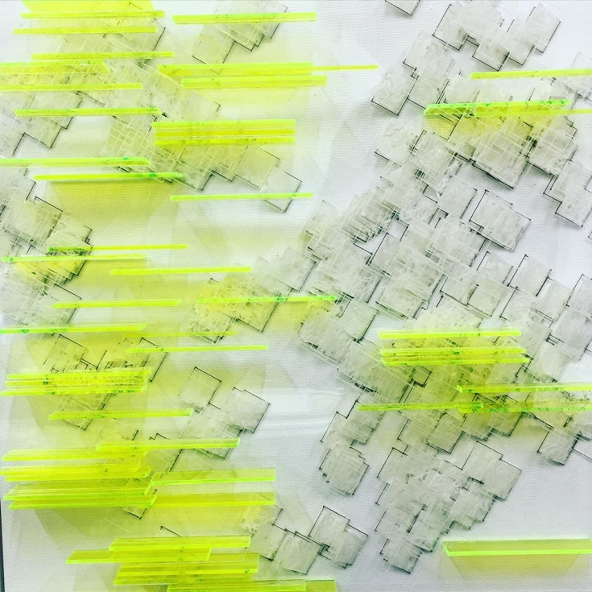

Figure 1. Image-based example of a thick drawing from a collection of lines. Image credit: Katherine Katz and Corinna Siu.

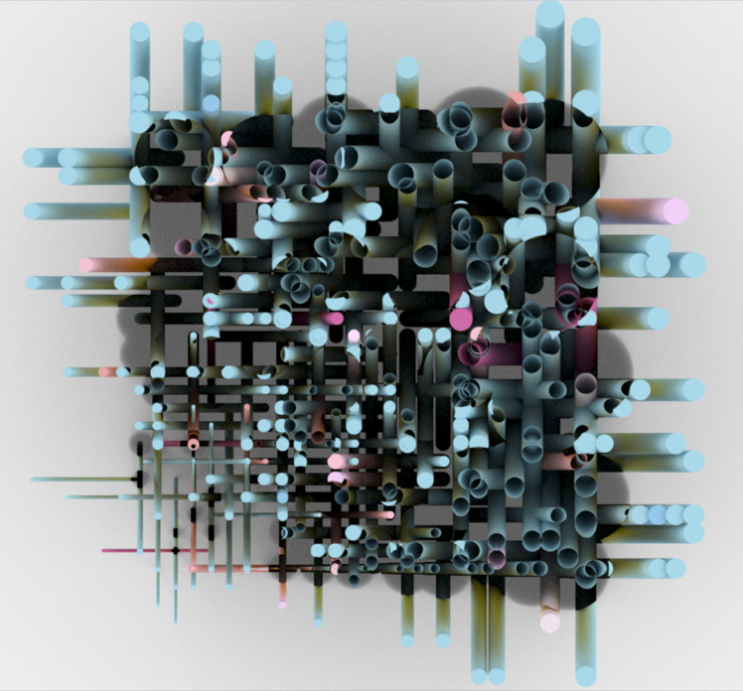

Figure 2. Image-based example of a thick drawing of cut volumes. Image credit: Donzhe Tao.

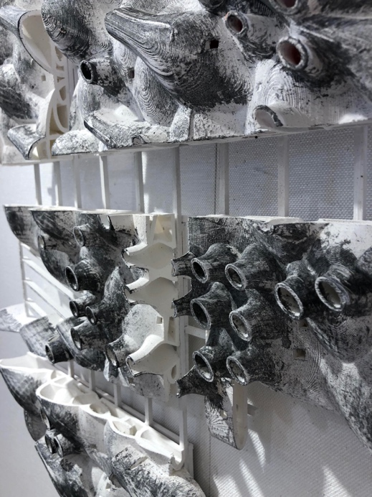

Figure 3. Image-based example of a thick drawing of cut volumes. Image credit: Chang Jiang and Derek Luth.

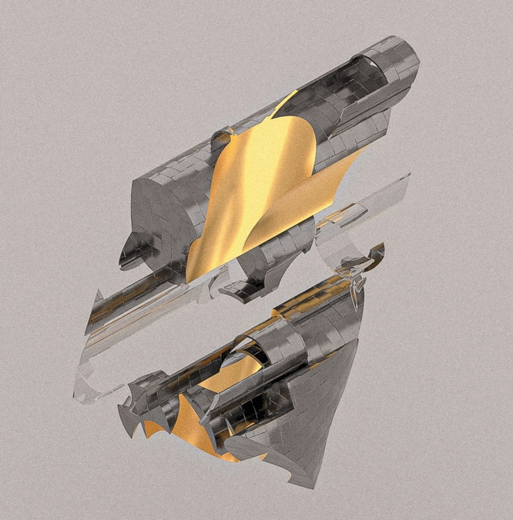

Figure 4. Object-based combination. Image credit: Liujie Lu.

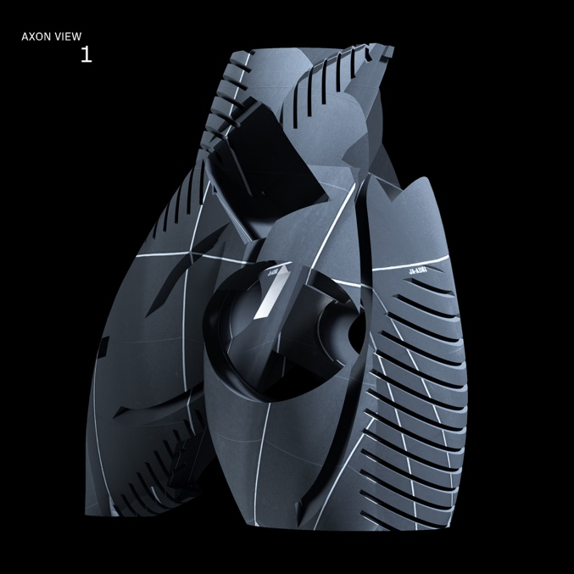

Figure 5. Object-based combination. Image credit: Noah Sturbois.

1. Maki, Fumihiko., *Investigations into Collective Form*, Washington University in St. Louis, 1964
2. Stan Allen, “Field Conditions” in *Points + Lines: Diagrams and Projects for the City*, New York, Princeton Architectural Press, 1999, p. 92.
3. Robert Venturi, *Complexity and Contradiction in Architecture*, New York, Museum of Modern Art, 1966, p. 16.
4. Ibid. p. 34.
5. Ibid. p. 41.
6. Stan Allen, “Thom Mayne’s Information Landscapes” in *Combinatory Urbanism, The Complex Behavior of Collective Form*, Stray Dog Café, 2011, pp. 53-64.
7. Thom Mayne, “Interview”, Chapter 9, in *Instabilities and Potentialities, Notes on the Nature of Knowledge in Digital Architecture*, Chandler Ahrens and Aaron Sprecher (eds.), New York, Routledge, 2019, p. 121.
8. Les Levine, “Systems Burn-off X Residual Software” in *From Software—Information Technology: Its New Meaning for Art*. Jack Burnham (ed.), Catalog of an exhibition held at the Jewish Museum, New York, September 16 through November 8, 1970, p. 61.
9. Christopher Alexander, ‘Systems Generating Systems’, Architectural Design, December issue No 7/6. John Wiley & sons Ltd (London), 1968, p. 90.
10. Ibid. p. 90.