**Thesis Submitted in Partial Fulfillment of the**

**Requirements for the M.Sc. Degree**

**Estimation of the instantaneous angular speed and diagnostic of bearings**

Gabriel Davidyan

July 2020



Ben-Gurion University of the Negev

Faculty of Engineering Sciences

Department of Energy Engineering

**BEN-GURION UNIVERSITY OF THE NEGEV**

**FACULTY OF ENGINEERING SCIENCES**

**DEPARTMENT OF MECHANICAL ENGINEERING**

**Estimation of the instantaneous angular speed and diagnostic of bearings**

THESIS SUBMITTED IN PARTIAL FULFILLMENT

OF THE REQUIREMENTS FOR THE M.Sc DEGREE

**By: Gabriel Davidyan**

**Supervised by: Prof. Jacob Bortman**

**Dr. Renata Klein**

March 2020

Author:………………………………….. Date:………………….

Supervisor:………………………………… Date:…………………..

Chairman of Graduate Studies Committee:………………….. Date:……………

**Abstract**

Rolling-element (RE) bearings are one of the most important components of rotating machinery and strongly impact the safety of such machines. Factors such as design, installation technology, conditions of use, and sudden load cause RE bearings to suffer from different degradation modes such as corrosion, overheating, and contamination. These degradation modes are serious problems and often result in fires and other phenomena that pose a clear risk to the health and safety of the operator.

Minimizing the occurrence of such failures requires that the remaining useful life of RE bearings be determined, which means not only detecting faults but also estimating their size and the time before they reach a critical size. One of the most common methods to diagnose rotating machinery is based on vibrations. Vibration analysis is an effective method for detecting various faults and malfunctions. The various methods of vibration signal processing require knowing the rotational speed of the machine in question, since, with rotating parts, events occur at specific angular positions rather than at specific times. For this reason, an accurate estimate of the instantaneous angular speed (IAS) is important for reliable diagnostics. Inaccurate angular speed due to dynamic phenomena such as unbalance, misalignment, or eccentricity can mask the effects of incipient localized faults. In practice, however, direct measurement of the rotational speed is often impossible, expensive, or inaccurate.

This work focuses on estimating the IAS directly from the vibration signal to diagnose bearings, gears, and other mechanisms. This study compares several methods of estimating IAS directly from the vibration signal and subsequently proposes and experimentally verifies a complete vibration-analysis scheme for bearings. In addition, a new algorithm is proposed to automatically determine the IAS from the vibrations when the angular speed varies in time. In the first stage, the rotating speed is approximated based on the time-frequency representation of the vibrations, and the IAS is determined in the second stage. A complete analysis scheme for the diagnosed IAS is then proposed and verified by comparison with experimental data and simulations.

**Acknowledgments**

I cannot offer enough gratitude for my supervisor Prof. Jacob Bortman for his guidance and support throughout my research. Without his active support this research could not be achieved. His knowledge, experience and belief in research independence were a significant factor for the success of this research.

I am particularly grateful like to Dr. Renata Klein for her advice at each stage of the research. Her nonstop attention and fruitful ideas. Her contribution is irreplaceable.

Furthermore, I would also like to thank Eng. Aharon Klipper for his broad help in the execution of experiments and technical support.

My thanks are also given to my friends who have been working with me at the HUMS lab in the Department of Mechanical Engineering.

**Publications**

Gabriel Davidyan, Renata Klein, Jacob Bortman (2019). "Estimation of the instantaneous angular speed and diagnostic of passengers coachs air-conditioner fan bearings". Annual Conference of the Machinery Failure Prevention Technology (MFPT) Society, Philadelphia, United States, May 2019.

**Contents**

1 INTRODUCTION 1

1.1 Research Objectives 3

2. LITERATURE REVIEW 3

2.1 Estimation of Stationary and Time Varying Rotational Speed 3

2.2 Bearing Diagnostics 7

3. THEORETICAL BACKGROUND 7

3.1 Bearing Feature Characterization 8

3.2 Power Spectral Density 10

3.3 Angular Resampling 10

3.4 Synchronous Average 11

3.5 Vold–Kalman Filter 11

3.6 Zero Crossing 12

3.7 Envelope 12

4. SIGNAL GENERATION 13

4.1. Bearings 14

4.2. Gears 15

4.2. Shaft 15

5. ALGORITHM FOR ESTIMATING ROTAIONAL SPEED 16

5.1. Preliminary IAS Curve Selection Process 18

5.3. IAS Extraction 23

5.3.1 Simulated Time-Varying Angular Speed 24

5.3.2 Experimental stationary Angular Speed 26

5.4. IAS Evaluation 29

5.4.1 Order Comparison 29

5.4.2 Order VS Synchronous Average Comparison 31

5.5 Conclusions 34

6. EXPERIMNTAL SETUP 35

6.1 Experimental Result 37

7.1 Energy-Level Analysis 40

8. SUMMARY 44

9. BIBLIOGRAPHY 46

**List of Figures**

Figure 1: The three steps of the CBM technique. 1

Figure 2: The research methodology. 2

Figure 3: Bearing tones parameters. 8

Figure 4 : Amplitude and Frequency Modulation on a sinusoidal signal. 9

Figure 5 : Illustration of the categories of peaks extracted in the order domain: BT, FM and AM. AM are the two closest (lowest order) side band (SB) pairs to the BT. The rest are FM-related SB. All SBs are spaced by shaft frequency 10

Figure 6 : Envelope detection process. (a) Unfiltered time domain signal, (b) band passed signal, (c) envelope of band passed signal, (d) spectrum of envelope. 12

Figure 7 : Transmission of the vibration signals generated in the system on their way to a sensor via a transmission path consisting of a number of transmission functions. The pictures of the gear, bearing and shaft are from [31] 13

Figure 8 : Schematic illustration of the simulation to create the vibration signal. The pictures in the illustration from [32] 14

Figure 9 : Algorithm for estimating rotational speed directly from a vibration signal. First the relevant IAS curve is isolated from the TFR, next the relevant phasors are extracted, and then the phasors are combined to determine the IAS. Additionally, the estimated IAS accuracy is evaluated. 17

Figure 10 : proposed preliminary IAS curve selection process to extract multiple time-frequency curves from the TFR of a vibration signal. 19

Figure 11 : Preliminary IAS curve selection process: (a) spectrogram, (b) third-harmonic T-F curves fall within the specified IAS range each peak is in the top 90 percentile in magnitude, (c) continuous third-harmonic T-F curves. 20

Figure 12 : Normalized continuous first and third harmonics of rotational speed T-F curves. 20

Figure 13 : Isolating of one value in the extracted curve which selected in the preliminary curve selection process, see 5.1) around which filtering is done using a cascade of band-pass filters and a VKF. The figure shows the filtration process around the first harmonic (≈24.6 Hz) of the rotational speed. 22

Figure 14 : Isolating of one value in the extracted curve which selected in the preliminary curve selection process, see 5.1) around which filtering is done using a cascade of band-pass filters and a VKF. The figure shows the filtration process around the twelfth (≈295.4 Hz) of the rotational speed. Lower and upper sidebands appears both in the recorded and filtered signals. 23

Figure 15 : Combined overlapping signals obtained after the filtering process. 6 of 38 overlapping segments are marked in red. Each of the 38 signals represents a Stationary IAS of different frequency. 23

Figure 16 : Estimated IAS (blue) compared with simulated RPS with slow rate of change varies according to (red). 24

Figure 17 : Estimated IAS (blue) compared with simulated RPS with rapid rate of change varies according to (25 Hz) + (red). 25

Figure 18 : MSD index. Shows the mean error between the simulated rotational speed and the estimated IAS. The result shows that as the acceleration increases, the error increases and that higher harmonics lead to smaller error. 26

Figure 19 : RPS measured from a balanced fan shaft (blue) and IAS estimated from first RPS harmonic (≈24.6 Hz) by a VKF (red) and a Butterworth filter (green). 27

Figure 20 : RPS measured from an unbalanced fan shaft (blue) and IAS estimated from first RPS harmonic (≈24.6 Hz) by a VKF (red) and a Butterworth filter (green). IAS estimated by the Butterworth filter appears smoother than that estimated by the VKF 27

Figure 21 : RPS measured from an unbalanced fan shaft (blue) and IAS estimated from the twelfth RPS harmonic (≈295.4 Hz) by a VKF (red) and a Butterworth filter (green). The IASs estimated by the different methods differ significantly between 35 and 36 s. 28

Figure 22 : RPS measured from an unbalanced fan shaft (blue) and IAS estimated from the first RPS harmonic (≈24.6 Hz) by a VKF (red) and a Butterworth filter (green). The estimated IAS is smooth and uniform and follows the general trend of the measured rotational speed, with no evidence of edge effects. 28

Figure 23 : IAS evaluation process. First the data are resampled using the estimated IAS, next the order spectrum, synchronous average, and order spectrum of the synchronous average are calculated. Finally, to evaluate the IAS, the order spectrum and the order spectrum and the order spectrum of the synchronous average are compared. 29

Figure 24 : Illustration of the order comparison process. The figure shows the order spectrum produced by using the estimated and recorded angular speed fixed around harmonic 56 of the RPS. In this case, the relatively smeared peak of order spectrum produced by the measured rotational speed (blue) has the lowest PEC and EL Indexes. Here, the order spectrum produced by the IAS estimated using the Butterworth filter (red) has the highest PEC and EL indexes. 30

Figure 25 : Illustration of the order VS Synchronous Average comparison process. The figure shows the reference order spectrum (blue) VS SA order spectrums fixed around harmonic 30 of the RPS. In this case, the synchronous average calculated by using the measured rotational speed (black) will have largest distance to the reference order (blue) among the three SA orders shown and therefore the largest EL. 32

Figure 26 : Average energy leakage of harmonics 1, 3, and 12 for (a) unbalanced shaft, (b) balanced shaft. The figure show the calculated total EL of the SA spectrum compared with the order spectrum according to the index. Each data set plotted consists of five points, where each point is an average EL of twelve harmonics. 33

Figure 27 : Average energy leakage for 125 experiments, each column represents the average EL of 25 experiments. 34

Figure 28 : Experiment rig; red rectangles show the position of the speed sensors. 36

Figure 29 : disassemble TVH 6205 bearing and outer race seeded fault.1 –bearing balls, 2 – inner race, 3 – outer race, 4 –polymeric cage 36

Figure 30 : The processing scheme for evaluating defects. First the IAS is estimated, next angular resampling is done and the PSD is calculated, finally the envelope PSD is calculated. 37

Figure 31 : Order spectra (heathy bearing shown in black, 1.5 mm defect bearing in red, 2.5 mm defect bearing in blue, and 3.5 mm defect bearing in green). 38

Figure 32 : Envelope order spectrum (heathy bearing shown in black, 1.5 mm defect bearing in red, 2.5 mm defect bearing in blue, and 3.5 mm defect bearing in green). 39

Figure 33 : expanded view of an envelope order spectrum for a 3.5-mm-defect bearing, in which upper and lower sidebands caused by modulation are easily identified. 39

Figure 34 : Mean summed energy of sidebands and of the BPFO fault in the order spectrum (Summed upper (lower) sidebands and cage sidebands energy (light blue), upper and lower sidebands energy (gray), cage sidebands energy (white) 41

Figure 35 : Mean summed energy of sidebands and of the BPFO fault in the order spectrum (Summed upper (lower) sidebands and cage sidebands energy (light blue), upper and lower sidebands energy (gray), cage sidebands energy (white) 41

Figure 36 : Box-plot diagram of order spectrum. Each point represents the total energy for orders associated with a fault in a particular experiment 42

Figure 37 : Box-plot diagram of envelope order spectrum. Each point represents the total energy for orders associated with a fault in a particular experiment 43

**List of Tables**

Table 1: Simulation specifications. 15

Table 2 : Cascade band-pass filter parameters. 21

Table 3 : VKF filter parameters. 21

Table 4 : Indexes resulting from spectrum shown in Figure 25. 30

Table 5 : Values of spectrum-evaluation indexes. 31

Table 6 : Experiments specifications. 37

Table 7: Values for mean summed energy evaluation. 40

**Nomenclature**

|  |  |  |
| --- | --- | --- |
| **Nomenclature** |  |  |
| | *signal in the time domain* | *[-]* |
| | *signal in the frequency domain* | *[-]* |
| *t* | *Time vector* | *[s]* |
| | *tracked order component* | *[Hz]* |
| | *nonhomogeneous term* | *[-]* |
| *y(n)* | *Data Equation* | *[-]* |
| | *nonhomogeneous term* | *[-]* |
| *r* | *weighted factor* | *[-]* |
| | *relative bandwidth* | *[Hz]* |
| | *Hilbert transform of function* | *[-]* |
| *EL* | *Energy Leakage* | *[dB]* |
| *PEC* | *Peak Energy Concentration* | *[dB]* |
| *RPS* | *Rotational speed* | *[Hz]* |
|*Attenuation*  *Ripple*  *Filter order*  *Filter cascades*  *Band pass* | *Angular velocity*  *frequencies reject coefficient*  *Variation of the filter's [insertion loss](https://en.wikipedia.org/wiki/Insertion_loss" \o "Insertion loss) in the passband*  *Maximum number of delay elements*  *Filtering in a succession of stages so that filtration stage acts upon the preceding signal*  *Certain range in which frequencies passes* | *[rad/s]*  *[dB]*  *[dB]*  *[-]*  *[-]*  *[Hz]* |
|  |  |  |

# 1 INTRODUCTION

Condition-based maintenance (CBM) is a maintenance technique whereby maintenance actions are based on the actual condition of a system. The goal of CBM is to avoid unnecessary maintenance tasks by executing them only when evidence exists that a component is behaving abnormally. When implemented correctly, CBM can significantly reduce maintenance cost and workload, increase availability, and improve safety.

CBM consists of three steps [1] (Figure 1):

1. Data acquisition, whereby data relevant to system health is obtained;

2. Data processing, in which the data from step 1 are analyzed;

3. Making maintenance decision, whereby efficient maintenance policies are recommended.

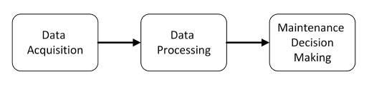

Figure 1: The three steps of the CBM technique.

The condition of components is monitored by processing data collected by sensors attached to the components. The data are summarized by condition indicators that reflect the component health, which is considered in the decision-making process. The analysis can be applied to various types of data, including vibration, acoustic, and oil debris. Vibration analysis is the prevalent method for monitoring rotating components. Vibration data are analyzed by using different signal-processing techniques to extract features that are then used to diagnose the current condition of the rotating mechanism. Faults are detected during the diagnosis stage. Following fault isolation, a specific failing component is identified, and the extent and nature of the fault are estimated. During the prognosis stage, the time-to-failure is estimated based on the fault identified during the diagnosis stage. The common method for diagnosis is vibration analysis, which is effective for detecting various faults and malfunctions and is already used to monitor jet engines, wind turbines, and other machines [2] [3].

The various methods of vibration signal processing require knowing the rotational speed of the machine in question, since, with rotating parts, events occur at specific angular positions rather than at specific times. For this reason, an accurate estimate of the instantaneous angular speed (IAS) is important for reliable diagnostics. Inaccurate angular speed due to dynamic phenomena such as unbalance, misalignment, or eccentricity can mask the effects of incipient localized faults. In practice, however, direct measurement of the rotational speed is often impossible, expensive, or inaccurate.

The present research uses the vibration signature of healthy and damaged ball bearings. The bearings signature includes local faults of different sizes as well as imbalance of the system. In this research, the vibration signature of a bearing is measured. Using the measured signal, the rotational speed of the system is estimated without direct measurement. Using the measured vibration signal and the estimated rotational speed, the diagnostics of the bearing can be calculated.

As shown in Figure 2, the research methodology is based on the combination of experiments and the analysis of simulated vibrational signals.

Validation

Simulation/ Experiments

comparison

The research methodology.

As a preliminary study for this work, the relevant literature is reviewed in Chapter 2, and Chapter 3 presents the theoretical background. Chapter 4 describes the research objectives, and Chapter 5 describes the simulation. Chapter 6 discusses an algorithm for estimating IAS directly from the vibration signal, and Chapter 7 presents the experimental setup for testing the algorithm. Chapter 8 analyzes the results, and Chapter 9 discusses how defects can be detected and diagnosed based on the vibration signal. Finally, Chapter 10 summarizes the work and discusses its implications.

# Research Objectives

The first objective of this study is to diagnose and detect faulted bearings by using the vibration signature of healthy and damaged ball bearings .The various methods of vibration signal processing require knowing the rotational speed. For operational limitations of the system under study (which do not allow the installation of a speed sensor) direct measurement of the rotational speed is impossible. For this reason, this study aims to directly estimating the IAS from a vibration signal.

rotational speed is stationary or varies in time. The hypotheses of this research are:

* Instantaneous angular speed can be automatically estimated based on vibrations without using tachometers for both stationary and time-varying angular speed.

# 2. LITERATURE REVIEW

This chapter reviews the literature on two themes, each of which will be presented separately: determination of the IAS under stationary and time-varying rotational speed and the detection and characterization of bearing defects.

## 2.1 Estimation of Stationary and Time Varying Rotational Speed

For bearings operating under stationary rotational speed, faults can be diagnosed in the frequency domain because each type of fault has a specific characteristic frequency that is proportional to the rotational speed of the shaft. If the rotational speed cannot be measured, the IAS can be estimated directly from the vibration signal in many different ways, each with its advantages and disadvantages. One of the earliest methods to estimate IAS is based on the Fourier transform, and this approach remains the simplest to implement. Some commercial IAS-estimation software packages offer Fourier-based IAS evaluation; Ref. [4] analyzes these methods in detail and compares the associated errors both qualitatively and graphically. Although Fourier-based methods are considered good tools to monitor IAS in steady-state conditions, such an approach is unsuited for non-steady-state data, in which the rotational speed fluctuations cause a spread in the frequency spectrum.

Signals are complex in nature, with different families of harmonics coexisting alongside the various harmonic orders and interacting with the structural resonances of the machine. This multicomponent nature means that the signal must be decomposed, which may be done by using the Empirical Mode Decomposition (EMD) algorithm, which is a popular technique to decompose multicomponent signals. With this technique, the decomposed signal is represented as a sum of a finite set of intrinsic mode functions, each of which is assumed to be single component. Although empirical mode decomposition has proven its usefulness for decomposing multicomponent signals, it is not characterized as a filter. In addition, despite being a well-known method, the full theoretical framework of empirical mode decomposition has yet to be clarified. Finally, the main disadvantage of the method is that, in the presence of noise, the technique provides poor estimates of the IAS [5].

Reference [6] introduced a new approach for robust IAS estimation called the “multi-order probabilistic approach” (MOPA). The main idea of this method is that it considers the most probable periodic mechanical events of the mechanism being studied to infer the most probable IAS at each time step. The first step is to obtain a list of all periodic phenomena of the system, such as shaft rotational speed and meshing frequencies and their harmonics, with frequencies related to the frequency of the shaft of interest. The MOPA then uses all the *a priori* kinematics knowledge to fusion all the component harmonics, which, after smoothing, finally gives the IAS. The MOPA was applied to a challenging signal recorded from the gearbox of a wind turbine and performed exceptionally in terms of relative error with respect to the IAS estimated by processing the tachometer signal [6]. Overall, the method accurately estimates the rotational speed even when the speed fluctuates significantly. However, despite the good results, the MOPA suffers from a number of disadvantages: First, it is a relatively new method, which increases the uncertainty regarding its limitations. In addition, the method has only been tested with steady-state signals produced by machines running at a relatively stationary rotational speed. Moreover, prior knowledge of the machine being studied is required to apply this method.

Adaptive filters such as the Vold-Kalman filter (VKF) can also be used to estimate the IAS. The VKF was first adapted to order tracking by Vold and Leuridan in 1993, but its underlying theory is not as straightforward. The VKF technique allows extraction of close and crossing orders in systems with multiple shafts and features a finer frequency and order resolution than conventional techniques. The filtering capabilities are independent of the rate of change of the rotational speed [7] [8] [9]. However, despite the many benefits, the VKF technique has some notable disadvantages. Reference [10] objectively compared the features of the VKF technique and found that other methods, such as Gabor order tracking, are clearly more efficient than the VKF technique in terms of rejecting out-of-band energies. Additionally, the VKF technique requires longer computation time than the other methods examined, making it unsuitable for real-time processing. Reference [11] proposed an adaptive VKF approach to overcome this drawback, which makes the VKF a more practical and powerful tool, suitable for real-time monitoring. Many researchers [12] [13] [14] [15] have discussed the issue of setting the filter passband, which is a fundamental characteristic of the VKF. However, the theoretical framework for selecting the VKF bandwidth is incomplete and requires further investigation.

Rotating machinery often operates at varying rotational speeds, in which case the stationary-speed methods are not applicable. Therefore, methods to diagnose machine faults for varying rotational speed are of critical importance for industrial applications. Various methods have been proposed to diagnose bearing faults under conditions of non-stationary rotational speed, including methods based on signal resampling [16] [17], machine learning [18] [19], and time-frequency analysis [20] [21]. However, some of the existing methods used to determine the IAS for non-stationary rotational speed are incomplete. Many factors limit the accuracy of angular resampling of signals. Machine learning methods can be used to automatically diagnose bearing faults without knowing the rotational speed and without signal resampling [22]. However, numerous data are required to train the method-related parameters. Time-frequency analysis techniques, such as the short-time Fourier transform, can reveal the instantaneous rotational frequency of the shaft as a curve in the time-frequency representation (TFR) [22]. Additionally, the TFR can be used to estimate the time-varying rotational speed or instantaneous rotational frequency of the shaft. However, the diagnosis of an automatic bearing fault requires that the instantaneous rotational frequency of the shaft be extracted from the TFR [22].

The algorithm to extract multiple time-frequency curves was recently developed to extract the time-frequency curves from the TFR of a signal [23]. This algorithm serves to extract multiple time-frequency curves from the TFR of the bearing-vibration signal. Bearing faults can be automatically diagnosed if the instantaneous characteristic frequency of the fault and the instantaneous rotational frequency of the shaft are recognized from the extracted time-frequency curves. This is done by calculating the average frequency ratio of two curves and comparing this average to the characteristic coefficient of each fault. The characteristic coefficient of the fault is the ratio of the characteristic frequency of the fault to the rotational frequency of the fault, which remains constant even for non-stationary rotational speed. However, if the bearing is healthy, the average ratio of two randomly extracted curves matches the characteristic frequency of the fault regardless of whether the extracted curve is the instantaneous characteristic frequency of the fault or the instantaneous rotational frequency of the shaft. This leads to a false result whereby a healthy bearing is diagnosed as faulty. Therefore, the average ratio of two curves is insufficient to identify the instantaneous characteristic frequency of the fault and the instantaneous rotational frequency of the shaft [23].

Reference [24] recently proposed a two-step method to estimate the IAS: In the first step, the IAS is roughly estimated based on a time-frequency distribution, such as a spectrogram. In the second step, a narrow-band-pass filter tuned to the desired frequency is applied based on the first IAS estimate, and a refined estimate is obtained by frequency demodulation. The first IAS estimate obtained from the spectrogram is used for angular resampling of the vibration signal, allowing the vibrational [24]. Second, the method requires *a priori* knowledge of the machinery and visual examination of the spectrogram (i.e., it is not automated).We thus conclude that further research and new methods are needed to estimate the IAS when the rotational speed is non-stationary.

## 2.2 Bearing Diagnostics

Methods for bearing diagnostics and prognostics can be divided into two main categories: physics-based methods and data-based methods [25]. Currently, most of the physics-based methods stem from frequency and time-domain analysis of the acceleration signal [26]. A widely accepted and well-known approach is to identify/ detect a fault in a bearing by examining the frequency domain.

Each bearing element affects the spectrum in a different way. A fault in one bearing element is signaled by an increase in the vibration energy related to the specific element. For example, in this study, a fault in the outer race produces a ball-pass frequency outer race (BPFO)

 frequency [27]. $=\frac{f_{r}}{2}n\left[1-\left(\frac{d}{D_{p}}\right)\cos\left(α\right)\right]$

 $n$

Examining the frequency domain is not the only method to detect defects. Various methods are available that use time-domain analysis or the combination of the frequency- and time-domain analysis to detect bearing defects and estimate their size. For example, for bearings, spike-energy analysis has been used to identify defects and estimate their severity [28]. The characteristic vibration signals of bearings with inner race defects, outer race defects, or roller defects allow these defects to be identified. To detect defects in bearings, Ref. [28] presents an acoustic-emission method that reportedly is more sensitive to variations in defects. A statistical comparison of the acoustic-emission results with vibration analysis using features such as root mean square and kurtosis reveals that the vibration signal is not correlated with fault size. However, although statistical parameters such as peak-to-peak value, root mean square, crest factor, and kurtosis may reveal the presence of defects, they give no information about defect location. With statistical methods, data gathered from pristine bearings are simply compared with those gathered from defective bearings. Compared with these conventional methods, experiments indicate that the proposed method of vibration monitoring is highly reliable, improves fault detection, and is very sensitive to fault severity, making it an extremely useful technique. In addition, the magnitude and frequency of the vibrations allow defects to be located precisely and their severity to be estimated.

## 3. THEORETICAL BACKGROUND

This chapter summarizes the theoretical background needed to understand the methods and techniques used in this research.

### 3.1 Bearing Feature Characterization

When observing the spectral signature of a signal, theoretically different peaks can be explained as being excited by the shaft or a bearings assembled on it. Classification of these peaks is essential to interpret the differences between “healthy” and “faulty” bearings. Moreover, they can provide information on the fault type and severity. With “faulty” bearings the most energetic peak in the frequency (order) domain would belong to the Bearing Tones (BT) and its harmonics. These frequencies are influenced by the geometric parameters (Figure 3) of the bearing and the rotational speed of the shaft, as indicated by

(1)

, (2)

, (3)

, (4)

where is the rotational speed of the shaft in revolutions per second (Hz),



Figure 3: Bearing tones parameters.

The BT frequencies are the frequencies corresponding to the rotational speed of the shaft on which the bearings are fixed. Other peaks in the spectra will indicate two phenomena: Amplitude Modulation (AM) and Frequency\Phase Modulation (FM) of the bearing tones.

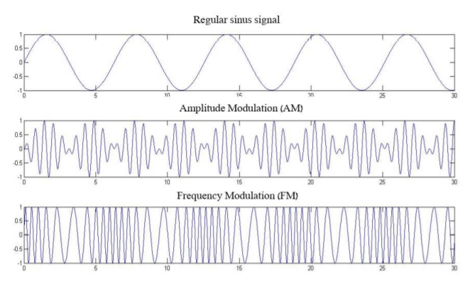

Figure 4 : Amplitude and Frequency Modulation on a sinusoidal signal.

These phenomena are expressed in the frequency (order) domain as a pair of side bands (upper and lower SBs). The spacing between the carrier frequency (BT) and the side band frequency is equal to the basic frequency of the modulating signal (in the case of bearings, shaft frequency—which is one in the order domain). Generally, the first adjacent SB around each bearing tone is associated to an AM component. The AM components are associated with imperfections such as unbalance, bearing eccentricity, and shaft misalignment [29]. Fourier analysis provides mathematic expressions for a periodic signal, AM and FM, presented by the following equations [30]:

 (5)

. (6)

. (7)

where is the carrier frequency.

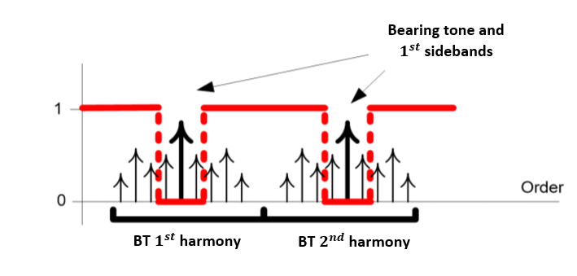

Figure 5 : Illustration of the categories of peaks extracted in the order domain: BT, FM and AM. AM are the two closest (lowest order) side band (SB) pairs to the BT. The rest are FM-related SB. All SBs are spaced by shaft frequency

### 3.2 Power Spectral Density

Measured signals contain random noise, which can be reduced by averaging several signals. Such averaging can be done by considering partial blocks (windows) of the signal, with each block containing a certain number of cycles. The power spectral density (PSD) provides the energy distribution of a signal in the frequency domain and is calculated by averaging the Fourier transform within several windows on the time-domain signal. The statistical error in the PSD is $1/\sqrt{M}$, where *M* is the number of windows. The PSD of the signal $\hat{F}\left(t\right)$ is

$PSD\left(f\right)=\frac{1}{M∙dt}\sum_{m=1}^{M}{{|{\hat{F}}_{m}(t)|}^{2}}$. (8)

where *M* is the number of windows is a measured signal and *t* is time.

### 3.3 Angular Resampling

The angular resampling algorithm was designed to overcome instability in the rotational speed. Angular-velocity tracking is one of the most important and sensitive stages in the vibration analysis of synchronous machines. The raw vibration signal is resampled by using the rotational-speed signal. With angular resampling, the signal is resampled in constant angular increments rather than in constant time increments as done originally. The sampled time-domain signal is remapped to a “cycle” domain, and a Fourier transform of cycle-domain data produces an “order-domain” signal, analogous to the Fourier transform of the time-domain signal to the frequency domain. In the order-domain, each impulse per cycle generates a peak in the first order.

### 3.4 Synchronous Average

The synchronous average (SA) is a signal-processing technique for the vibration analysis of mechanical systems. The SA removes all signal components asynchronous with a particular nominal frequency. In practice, the SA is done by averaging together a series of signal segments, each corresponding to one period *T* of a synchronizing signal:

$y(t)=\frac{1}{N}\sum_{n=0}^{N-1}{y(t+nT)}$. *n =*1, 2, 3 …. (9)

where is the number of cycles in the signal and 𝑦 is a vector in representing a single cycle.

Given sufficient averaging, non-synchronous peaks are averaged out of the spectrum, whereas spectral peaks that are harmonics of the rotational speed remain.

### 3.5 Vold–Kalman Filter

The VKF extracts vibration components from a time-varying vibrational signal. The VKF method has three main advantages: First, it works directly in the time domain. Second, it allows accurate tracking of harmonic orders. Third, its tracking performance is independent of rotational speed. The advantage of VKF compared with other order-tracking techniques is that it allows the amplitude and phase of the time-domain signal corresponding to a specific component to be extracted from the raw data. VKF relies on two basic equations, the first of which is the “data equation”

$y\left(n\right)=f\left(n\right)+μ(n)$, (10)

where $f\left(n\right)$ is the tracked order component, $μ(n)$ contains the other components, and *n =*1, 2,3 …. The second basic equation is the “structural equation”

$f\left(n\right)-2cos\left(ω∆T\right)f\left(n-1\right)+f\left(n-2\right)=ϵ(n)$, (11)

where $f\left(n\right)$ is the tracked-order component, $ω$ is the angular frequency, and $ϵ\left(n\right)$ is a nonhomogeneous term representing the other components. A more detailed explanation of the function of the data and structural equations can be found in Ref. [12].

Given these two fundamental equations, a VKF can extract and track the targeted components and acquire their corresponding temporal waveform without involving angular resampling. However, the filter performance depends strongly on the filter bandwidth $∆f$ and on the weighting factor *r*:

$r= \frac{1}{π∆f}\frac{\sqrt{\sqrt{2}-1}}{\sqrt{1-{\left[\cos\left(ω∆t\right)\right]}^{2}}}$. (12)

The weighting factor is inversely proportional to the frequency bandwidth $∆f$. The coefficients of the denominator of the VKF transfer function are functions of the weighting factor, and their values affect the filter selectivity. A large (small) weighting factor leads to high (low) values of these coefficients, making the filter more (less) selective. The VKF transfer function is



, (13)

### 3.6 Zero Crossing

The simplest way to estimate the instantaneous frequency of a signal is to count the number of times the signal crosses zero within a small segment of the signal. The instantaneous frequency can be estimated from the number of zero crossings [30] within a small window of length $\left(2N+1\right)$. This is done by using

$x\left[n\right]=\frac{π}{2(2N-1)}\sum_{m=-n}^{m=n}{|x\left(m\right)-x\left(m-1\right)|}$. (14)

where *x* is the recorded signal, *N* is the signal length and *n*=1, 2, 3…

### 3.7 Envelope

To solve the problem of non-detection of bearing characteristic defect frequencies in direct spectrum of vibration signal; envelope detection have been employed for bearing fault detection. There are three main steps involved in implementation of envelope. In first step vibration signal is band-passed which removes the high frequency random noise as well as the ‘large’ low-frequency components and only the burst of high [frequency vibrations](https://www.sciencedirect.com/topics/engineering/frequency-vibration" \o "Learn more about Frequency Vibration from ScienceDirect's AI-generated Topic Pages) remains as shown in [Fig. 6](https://www.sciencedirect.com/science/article/pii/S2288430017300192" \l "f0015)(a) and (b). Next, an “envelope” of band passed signal is traced around the bursts in the time [waveform](https://www.sciencedirect.com/topics/engineering/waveform" \o "Learn more about Waveform from ScienceDirect's AI-generated Topic Pages) ([Fig. 6](https://www.sciencedirect.com/science/article/pii/S2288430017300192" \l "f0015)(c)) by using the [Hilbert Transform](https://www.sciencedirect.com/topics/engineering/hilbert-transform" \o "Learn more about Hilbert Transform from ScienceDirect's AI-generated Topic Pages). In last step, the envelope signal is converted into frequency domain ([Fig. 3](https://www.sciencedirect.com/science/article/pii/S2288430017300192" \l "f0015)(d)) for analysis.

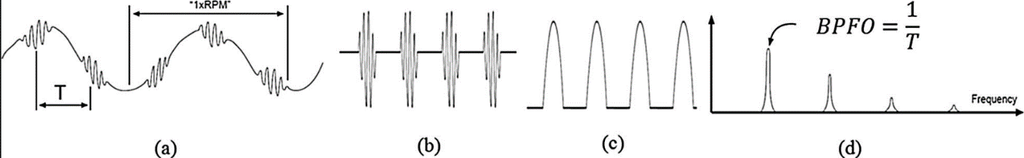

Figure 6 : Envelope detection process. (a) Unfiltered time domain signal, (b) band passed signal, (c) envelope of band passed signal, (d) spectrum of envelope.

The [Hilbert transform](https://www.sciencedirect.com/topics/engineering/hilbert-transform" \o "Learn more about Hilbert Transform from ScienceDirect's AI-generated Topic Pages) is defined as convolution of time domain signal with function *h*(*t*) = 1/*πt* . It is time-domain transform that maps a real-valued time domain signal to another time domain signal  as given below:



$h\left(u\right)\left(t\right)=\int_{-∞}^{∞}{u\left(t\right)h\left(t-τ\right)dτ}$. (15)

Hilbert transform is a frequency-independent 90° phase shifter in which, the non-stationary characteristics of the modulating signal are not influenced by taking Hilbert transform of the signal. Demodulation can be achieved by forming a complex valued time-domain signal that is called as analytic signal. The analytic signal is a complex time series. From this the envelope can be obtained by taking magnitude of analytic signal added with the original time domain signal

# 4. SIGNAL GENERATION

The goal of the simulation described in this chapter is to simulate a signal measured using a sensor. Signals recorded by a sensor are the system's response to excitation from the rotating parts in the system. The responses to the excitation depend on the transmission path between the parts and the sensor. Figure 7 schematically shows signals passed through transmission path on their way to the sensor. Mathematically this can be described as follows;

 (16)

where is the signal measured by the sensor, is the simulated gear signal, is the simulated bearing signal, is the simulated shaft signal,,,, are the shock response of the transfer functions,,, respectively and - * - is convolution.

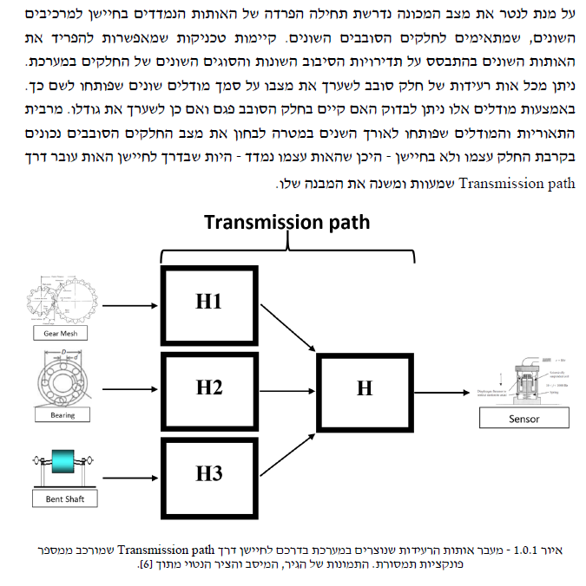

Figure 7 : Transmission of the vibration signals generated in the system on their way to a sensor via a transmission path consisting of a number of transmission functions. The pictures of the gear, bearing and shaft are from [31]

To test the algorithm, a large database of simulations was constructed. The simulations were constructed using transmission function, signals of gears and bearings, various signals of the rotational speed and white noise.

### The simulation of each vibration signal was done as follows (Figure 8): First, the global simulation parameters and the rotational speed are fixed, and the signal and noise are generated based on these parameters. Next, the transmission function is calculated to simulate signals from real machines in which excitations created by the rotating parts are transferred through the machinery’s structure transfer function, which amplifies each frequency range differently, to be detected at the sensor. The signals created in the second step are then convoluted with the transmission function. The simulation reproduces the dynamic behavior of shaft, gear, and bearing components.

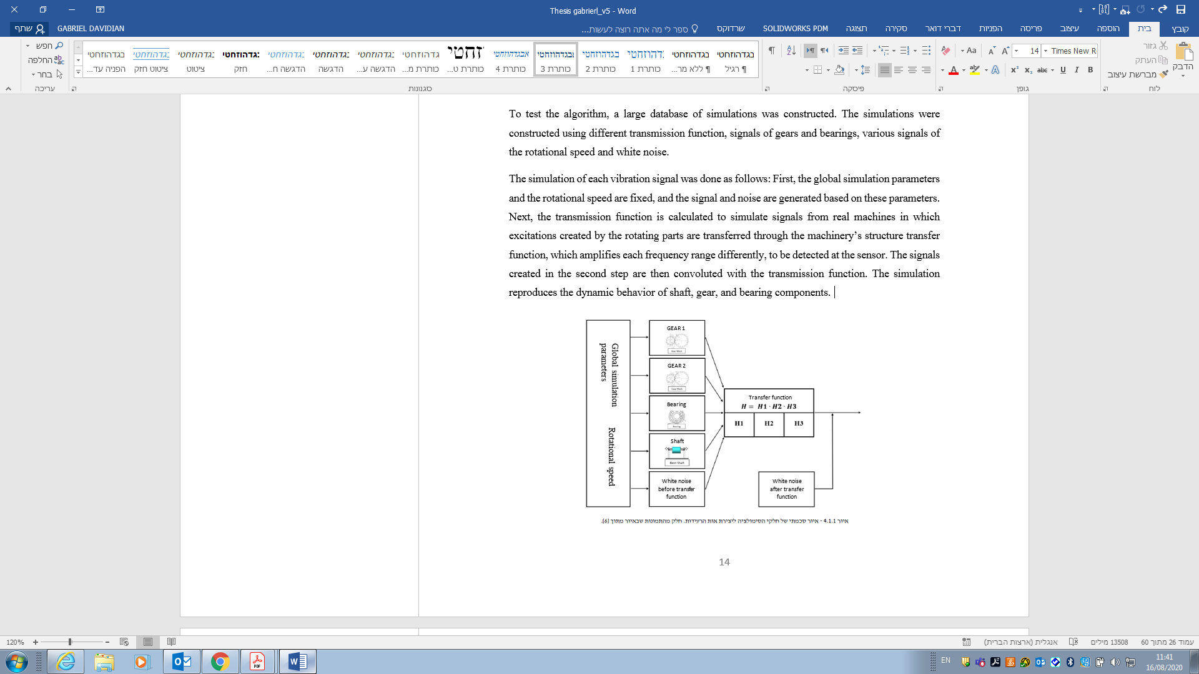

Figure 8 : Schematic illustration of the simulation to create the vibration signal. The pictures in the illustration from [32]

The simulated vibration signal simulate a single (virtual) motor shaft. In addition, by modulating the frequency of the rotation speed, virtual bearing- and gear-like components with gear meshes were added.

### 4.1. Bearings

The bearing simulation was done as follows: a series of delta functions was first produced at a rate corresponding to the defect (the BPFO in this case), and then the series was convolved with the bearing transmission function. The mathematical description of the bearing signal is

, (10)

where $B_{signal}$ is the simulated bearing signal, ${Delta}_{s}$ is the delta functions series, $A$ is the simulated bearing signal amplitude, $H$ is the number of harmonics and $RPS$ is the rotational speed.

### 4.2. Gears

The simulation allows for two gear wheels, for each of which the following parameters must be determined: amplitude, number of teeth, number of harmonics, and modulations. The simulation is produced by constructing periodic signals according to the modulations, which are modulated on the various harmonics using frequency modulation. The signal can be mathematically described as follows:

, (11)

here $G_{signal}$ is the simulated gear signal, $N$ is the number of gear teeth, $A$ is the amplitude of the simulated gear signal, $H$ is the number of harmonics, $RPS$ is the rotational speed, and ${FM}_{s}$ is the modulated signal (periodic signal).

### 4.2. Shaft

The shaft is simulated by creating harmonics corresponding to the rotational frequency of the shaft. Mathematically, this is described as follows:

, (11)

where $S_{signal}$ is the simulated shaft signal, $A$ is the amplitude of the simulated shaft signal, $H$ is the number of harmonics, $RPS$ is the rotational speed, $a_{n}$ is the amplitude of harmonic *n*, and $θ_{n}$ is the phase of harmonic *n*.

The amplitudes of all synchronous elements ( $A_{k,i}$ for 𝑘 = 1, 2 corresponding to $RPS)$ and gear meshes were constant, and 2 dB of white noise was added. The shaft $RPS$ was dictated by different functions (see Table 1). In total, twenty-two signals were simulated from constant-amplitude bearing faults with different $RPS$ profiles or shaft harmonics (see Table 1 for the specifications of the bearing tones, $RPS$ ranges and shaft harmonics).

Table 1: Simulation specifications.

|  |  |  |  |  |  |  |
| --- | --- | --- | --- | --- | --- | --- |
| Record | | Bearing tone | profile | Acceleration | RPS range | Shaft harmonics |
| 1 |  | BPFO – 3.5 | Stationary speed, 25 Hz | 1 | [23 26] | [1 12] |
| 2 |  | BPFO – 3.5 | Stationary speed, 25 Hz | 1 | [23 26] | [ 1 3] |
| 3 |  | BPFO – 3.5 | Stationary speed, 25 Hz | 1 | [23 26] | [1 3 12] |
| 4 |  | BPFO – 3.5 | Stationary speed + $5sin⁡(πt)$ | 11 | [15 35] | [1 12] |
| 5 |  | BPFO – 3.5 | Stationary speed + $5sin⁡(πt)$ | 11 | [15 35] | [1 3] |
|  |  |  |  |  |  |  |
| 6 |  | BPFO – 3.5 | Stationary speed + $5sin⁡(2πt)$ | 11 | [15 35] | [1 3] |
| 7 |  | BPFO – 3.5 | Stationary speed + $5sin⁡(2πt)$ | 11 | [15 35] | [1 12] |
| 8 |  | BPFO – 3.5 | Stationary speed + $5sin⁡(2πt)$ | 11 | [15 35] | [3 12] |
| 9 |  | BPFO – 3.5 | Stationary speed + $5sin⁡(2πt)$ | 11 | [15 35] | [1 3 12] |
| 10 |  | BPFO – 3.5 | $${100e}^{t/T}$$ | 10 | [95 285] | [1 3] |
| 11 |  | BPFO – 3.5 | $${100e}^{t/T}$$ | 10 | [95 285] | [12 24] |
| 12 |  | BPFO – 3.5 | $${100e}^{t/T}$$ | 10 | [95 285] | [1 12] |
| 13 |  | BPFO – 3.5 | $${100e}^{t/T}+5sin⁡(t)$$ | 12 | [95 285] | [1 3] |
| 14 |  | BPFO – 3.5 | $${100e}^{t/T}+5sin⁡(t)$$ | 12 | [95 285] | [1 3 12] |
| 15 |  | BPFO – 3.5 | $${100e}^{t/T}+5sin⁡(πt)$$ | 12 | [95 285] | [1 12] |
| 16 |  | BPFO – 3.5 | $${100e}^{t/T}+5sin⁡(πt)$$ | 12 | [95 285] | [3 12] |
| 17 |  | BPFO – 3.5 | $${100e}^{t/T}+5sin⁡(2πt)$$ | 12 | [95 285] | [1 3] |
| 18 |  | BPFO – 3.5 | $${100e}^{t/T}+5sin⁡(2πt)$$ | 12 | [95 285] | [1 12] |
| 19 |  | BPFO – 3.5 | $${100e}^{t/T}+5sin⁡(5πt)$$ | 19 | [95 285] | [1 3] |
| 20 |  | BPFO – 3.5 | $${100e}^{t/T}+5sin⁡(5πt)$$ | 19 | [95 285] | [1 12] |
| 21 |  | BPFO – 3.5 | $${100e}^{t/T}+5sin⁡(5πt)$$ | 19 | [95 285] | [1 3 12] |
| 22 |  | BPFO – 3.5 | $${100e}^{t/T}+5sin⁡(5πt)$$ | 19 | [95 285] | [1 50] |

# 5. ALGORITHM FOR ESTIMATING ROTAIONAL SPEED

|  |  |  |
| --- | --- | --- |
|  |  |  |



|  |  |  |
| --- | --- | --- |
|  |  |  |

Frequency characteristics of a signal can be revealed in the time-frequency domain. Time-frequency techniques, such as the Short Time Fourier Transform (STFT) or wavelet transform, can be used to obtain the TFR of a signal. The IAS frequencies appear as T-F curves in the TFR. However, to further analyze or utilize the frequencies, IAS T-F curves need to be extracted from the TFR. During curves extraction many curves are extracted from the TFR. Most of the extracted curves do not necessarily represent the integer multiples of the instantaneous rotational frequency of the shaft.

The originality of the proposed approach is as follows; the proposed algorism classified the extracted curves based on their continuity, that is, a curve whose length differs from the duration of the recorded vibration signal is erased because it is unlikely to represent the rotational speed. However, curves continuity alone is not enough and further analyze is done based on matching curve. The algorithm searches in the TFR for continuous and match curves in all of the integer multiples of the instantaneous rotational speed of the shaft until a matching curve is found. These lead to the following conclusions:

* The proposed algorithm needs at least two harmonic of the instantaneous rotational speed of the shaft.
* The more harmonics of rotational speed are given the higher the probability that the IAS curve will be extracted.

The proposed algorithm uses all the information that is available about the kinematics of the machine. A number of inputs are required for the proposed method: the range of the instantaneous rotational speed of the shaft, the IAS acceleration, the recorded vibration signal and the instantaneous-rotational-speed harmonics of the shaft. The simplicity and availability of the required inputs is a significant advantage of the proposed approach.

The method proposed herein to estimate angular speed was developed by combining several existing methods. Figure 9 describes three tasks: first a preliminary selection process in which the relevant IAS curve is isolated from the existing curves estimated from the TFR. Next, based on the estimated curve, the relevant phasors are extracted from the vibration signal. Each of the extracted phasors represent a stationary IAS curve. The extracted phasors (i.e., multiple stationary IAS curves) are then combined to determine the IAS. Finally, the estimated IAS accuracy is evaluated.

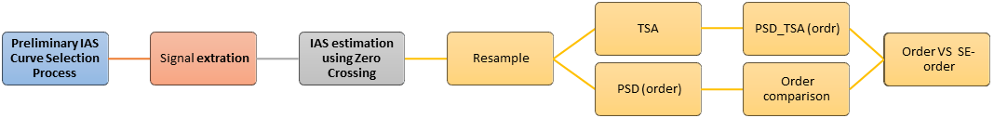

Preliminary IAS Curve Selection

Signal Extraction

IAS Extraction

IAS Evaluation

Multiple stationary IAS curves combined to comprise a vector

A low resolution IAS curve selected in the preliminary curve selection process

Estimated IAS obtained through overlapping of multiple stationary IAS curves and Zero Crossing

Figure 9 : Algorithm for estimating rotational speed directly from a vibration signal. First the relevant IAS curve is isolated from the TFR, next the relevant phasors are extracted, and then the phasors are combined to determine the IAS. Additionally, the estimated IAS accuracy is evaluated.

## 5.1. Preliminary IAS Curve Selection Process

The proposed preliminary IAS curve selection process enables ${EL}_{SA}=10\sum_{i}{\log_{10}{\frac{S_{O,i}}{S_{SA,i}}}}$



to extract multiple time-frequency curves from the TFR of a vibration signal. Figure 10 describes four tasks: first, the spectrogram is calculated and the frequency resolution of the spectrogram is calculated based on the IAS acceleration. For each spectrum in the TFR, this gives peaks that fall within the specified range. Next, in each curve, local maxima’s in the top 90 percentile in magnitude for each spectrum in the TFR are extracted. The use of percentile filters the noise that is not related to the instantaneous rotational speed.

Let the TFR of the signal $x(t)$ be $X(τ,f)$, where $τ$ is the time and $f$ is the frequency. The local maxima’s peaks within the specified range can then be extracted from $X(τ,f)$ as follows:



 (12)

where $p$ is the percentile, ***RPS1*** and ***RPS2*** are the lower and upper boundaries of the specified rotation-frequency range, respectively, $H$ is the harmonic of the rotational speed, is local maxima and $n=1,2,…,N$ is the time resolution of the TFR.

The remaining local maxima’s (top 90 percentile in magnitude) form a large number of time-frequency curves, do not necessarily represent the integer multiples of the instantaneous rotational frequency of the shaft. Therefore, further filtering is done based on the continuity of the remaining time-frequency curves. The remaining curves are normalized to the 1st harmonic of the rotational speed as follows:

$C(τ,f)=\left\{\begin{aligned}\frac{1}{H}C(τ_{n},f), & \{n∈z:n=1,2,…,N\}∩C(τ_{n},f)≠0 \\ ∅ , & else ,\end{aligned}\right.$ (13)

where $H$ is the harmonic of the rotational speed and is the time of the signal.

Finally, to associate the extracted curve with the instantaneous rotational speed of the shaft, the curves obtained from a certain harmonic are compared with those obtained from another harmonic until a match is found in all harmonics. This comparison process can be done only if in a certain harmonic only one curve left (i.e., if in one of the rotational speed harmonic only one continues top 90 percentile in magnitude within the lower and upper boundaries of the specified rotation-speed range curve left). This curve is than considered as a reference curve to which curves will be compared. If none of the rotational speed harmonic consists only one curve than another rotational speed should be chosen, this considered as a disadvantage of the proposed algorithm.

The comparison is done using an index to calculate the error between the curves. The index calculates the relative Squared Difference (SD) between the different curves at each time point:

*SD* =, (14)

where is a curve from a certain harmonic in which only one curve left, is a curve from a certain harmonic, is the rotational speed harmonic, is the curve number in a certain harmonic and is a time point.

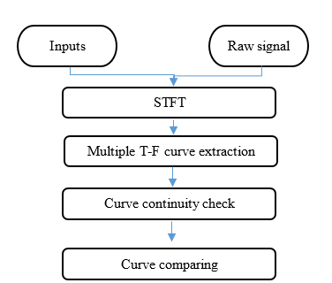

Figure 10 : proposed preliminary IAS curve selection process to extract multiple time-frequency curves from the TFR of a vibration signal.

The effectiveness of the method is validated by simulated signals with time-varying speed (see Table 1 for the specifications of the rotational speed).and data collected from an experimental system operating at constant speed. To illustrate the proposed process, the following example is provided. Figure 11a shows the spectrogram of the simulated signal. The rotational speed in this case is dictated by

$RPS={100e}^{t/T} Hz$, (15)

where *t* is the signal duration, and *T* is the signal period (20 s in this case), so the rotational speed ranges from 100 to 280 Hz.

The spectrogram shows all curves in the range for the third harmonic of the rotational speed, namely, 300 to 1000 Hz. Figure 11b shows the multiple time-frequency (T-F) curves extracted, which reveal that many curves are not continuous. These non-continuous curves are deleted so that only continuous curves remain (Figure 11c). This process is repeated for all harmonics of rotational speed. The remaining curves are normalized to the rotational speed of the first rotational-speed harmonic. Finally, the remaining curves from all rotational-speed harmonics are compared between themselves to find a matching curve. Figure 12 gives an example of two continuous matching curves, the first and third rotational -speed harmonics in this case.

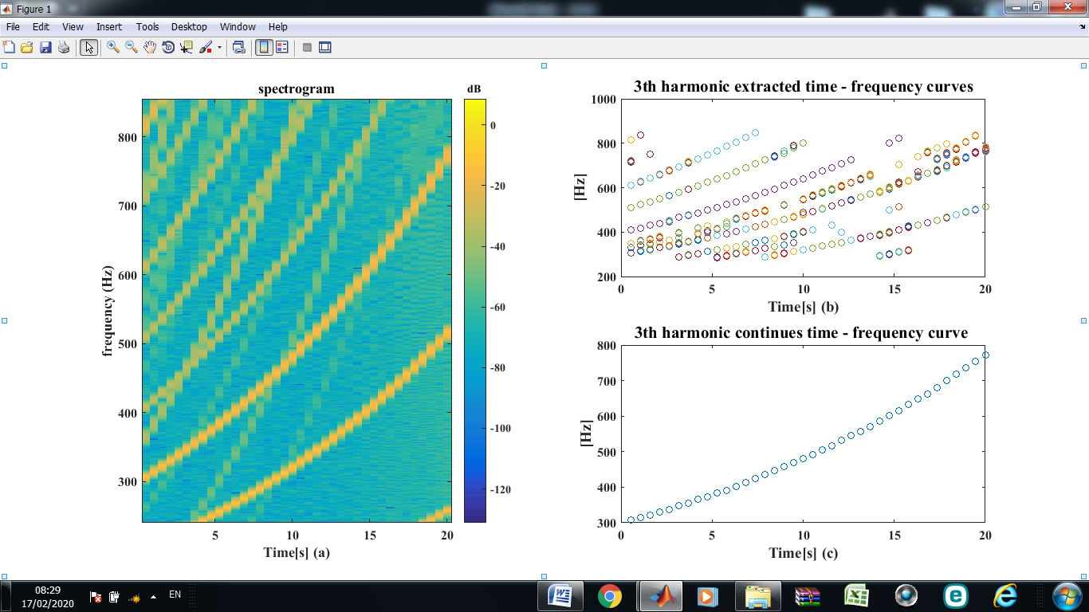

Figure 11 : Preliminary IAS curve selection process: (a) spectrogram, (b) third-harmonic T-F curves fall within the specified IAS range each peak is in the top 90 percentile in magnitude, (c) continuous third-harmonic T-F curves.

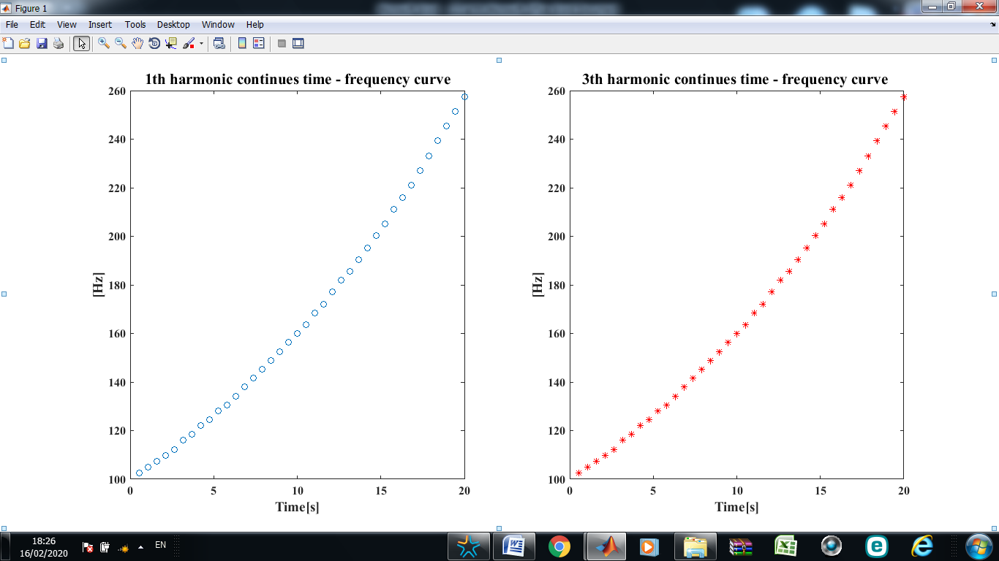

Figure 12 : Normalized continuous first and third harmonics of rotational speed T-F curves.

5.2. Signal Extraction

Each value in the estimated IAS curve (selected in the preliminary curve selection process) serves as a value around which filtering is done to estimate the specific phasor. For the signal extraction, two filter schemes where considered: A cascade of band-pass filters and a VKF.



Three rotational-speed harmonics (1, 3, and 12) were filtered from the recorded vibration signal obtained from the balanced and unbalanced experimental fan system. Table 2 lists the filter parameters, band pass, attenuation, and ripple. For stationary rotational speed, the VKF bandwidth was set at 10% of the nominal rotation frequency for all tracked harmonics (the literature indicates [7] that good results are observed when the filter bandwidth is 10% of the nominal rotation frequency), as shown in Table 2. However, when the rotational speed varied in time (so that the harmonics could shift from their nominal values), the VKF bandwidth had to be wider. Thus the bandwidth was calculated as four times the rotational speed acceleration so that the bandwidth increased with increasing acceleration, as shown in Table 3.

Table 2 : Cascade band-pass filter parameters.

|  |  |  |  |  |  |  |
| --- | --- | --- | --- | --- | --- | --- |
| Attenuation  (dB) | Ripple (dB) | Filter order | Filter cascades | Band pass  (Hz) | Harmonic | Nominal RPS  (Hz) |
| 10 | 3 | Auto | 20 | [20 30] | 1 | 24.6 |
|  |  |  |  | [70 80] | 3 |  |
|  |  |  |  | [290 300] | 12 |  |

Table 3 : VKF filter parameters.

|  |  |  |  |  |  |  |  |  |
| --- | --- | --- | --- | --- | --- | --- | --- | --- |
| Harmonic | | | Time-varying frequency band pass  (Hz) |  |  | stationary rotational speed Band pass  (Hz) | | |
| 1 | | | $$4×acceleration$$ | | | 10% of the nominal rotation frequency |  |  |
|  |  | 3 |  | | |  | | |
|  |  | 12 |  | | |  | | |

The filtering process is validated by data collected from experimental data and simulated vibration signals. Figure 13 shows the spectrum of the first harmonic of the rotational speed (≈24.6 Hz) using the proposed method. The spectrum shown in Figures 13 and 14 was generated by a bearing with a 3.5 mm spall on an unbalanced fan shaft. The figures show the spectrum (black), the spectrum of Butterworth filtered signal (light blue), and the spectrum of the VKF signal (red).

Figure 13 shows that both the Butterworth filter and the VKF provide high performance for isolating the first harmonic of the rotational speed (≈24.6 Hz). However, the VKF is slightly smoother than that produced by the Butterworth filter. This can be explained by the set of filter specifications (ripples, attenuation, etc.) and other filter properties. However, the general shape of each filter response curve is almost identical for the Butterworth filter and the VKF. Both the Butterworth filter and the VKF significantly attenuate the spectrum outside each filter’s passband. Clearly, both filtering methods can isolate the harmonics; however, within the passband, the VKF isolates better and attenuates less relative to the Butterworth filter.



Figure 13 : Isolating of one value in the extracted curve which selected in the preliminary curve selection process, see 5.1) around which filtering is done using a cascade of band-pass filters and a VKF. The figure shows the filtration process around the first harmonic (≈24.6 Hz) of the rotational speed.

As a result of shaft imbalance, two sidebands (Figure 14) appear near the twelfth harmonic (≈295.4 Hz); both filtering methods fail to completely overcome this issue (sidebands appeared in the filtered signal, Figure 14). The appearance of the sidebands in the filtered signal leads to an inaccurate estimate of the rotational speed (See 5.3, Figure 22). The region shown in Figure 13 is an example of a region where the use of the proposed method is not recommended.



Figure 14 : Isolating of one value in the extracted curve which selected in the preliminary curve selection process, see 5.1) around which filtering is done using a cascade of band-pass filters and a VKF. The figure shows the filtration process around the twelfth (≈295.4 Hz) of the rotational speed. Lower and upper sidebands appears both in the recorded and filtered signals.

|  |  |  |  |  |  |  |  |
| --- | --- | --- | --- | --- | --- | --- | --- |
|  |  |  |  |  |  |  | |

## 5.3. IAS Extraction

In the IAS extraction phase, the signals obtained after the filtering process are combined to comprise a vector with overlapping segments (Figure 15).Then, zero crossing is applied to the resulting vector to obtain the instantaneous rotational speed of the shaft.

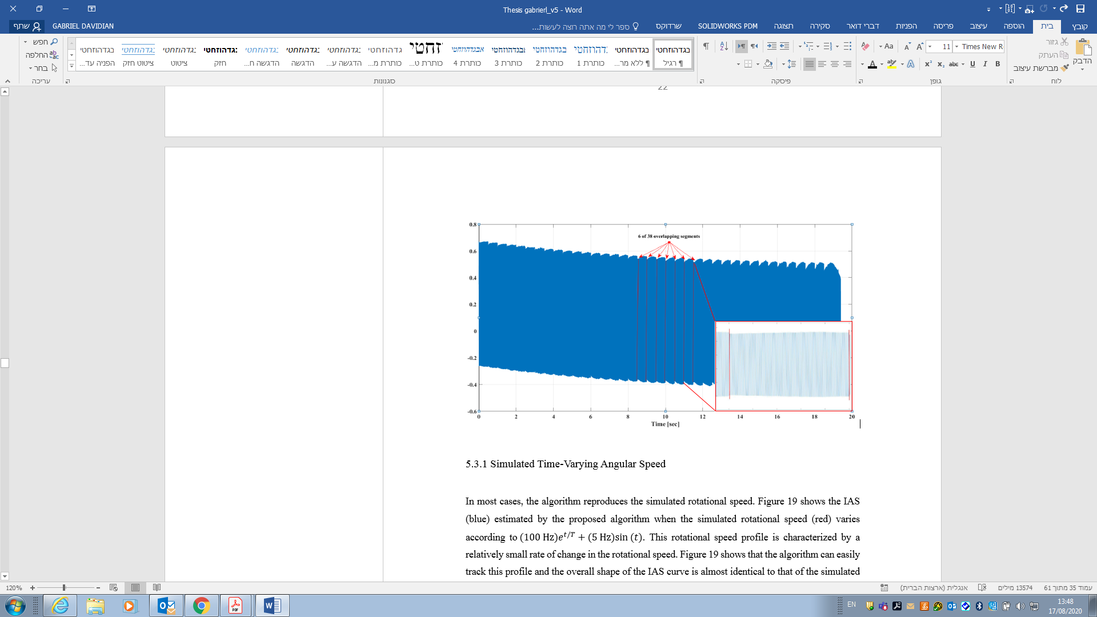

Figure 15 : Combined overlapping signals obtained after the filtering process. 6 of 38 overlapping segments are marked in red. Each of the 38 signals represents a Stationary IAS of different frequency.

Using simulated signals with time-varying speed (see Table 1 for the specifications of the rotational speed) and data collected from an experimental system operating at constant speed the effectiveness of the IAS extraction is validated.

5.3



### .1 Simulated Time-Varying Angular Speed

In most cases, the algorithm reproduces the simulated rotational speed. Figure 16 shows the IAS (blue) estimated by the proposed algorithm when the simulated rotational speed (red) varies according to. This rotational speed profile is characterized by a relatively small rate of change in the rotational speed. Figure 16 shows that the algorithm can easily track this profile and the overall shape of the IAS curve is almost identical to that of the simulated rotational speed. This means that the process functions well for extracting and selecting the T-F curves and estimating the IAS. The results in Figure 16 show that the IAS curve is smooth, with no evidence of edge effects. This explains the need for overlap between VKF segments and leads to the conclusion that the default 50% overlap is proper.

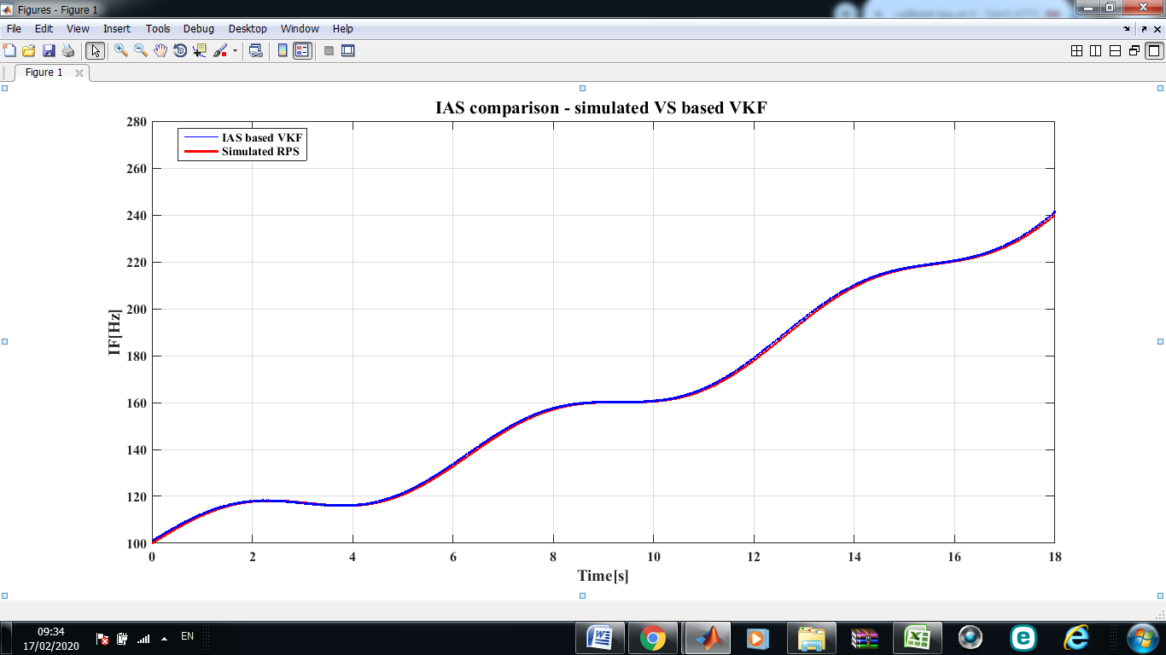

Figure 16 : Estimated IAS (blue) compared with simulated RPS with slow rate of change varies according to (red).

Figure 17 presents the results of the algorithm for estimating the IAS when the simulated rotational speed is the sum of a constant and a sine function: (25 Hz) +. In each segment, the rotational speed can accelerate by as much as ± $10 {Hz}/s$. A closer look reveals some differences between the estimated IAS and the simulated rotational speed. However, despite the rapid changes, the algorithm generated an IAS with the same shape as the simulated rotational speed. In this case, too, the curve is smooth without edge effects at the connecting points between VKF segments. Similar results occur for the other simulated rotational speeds.

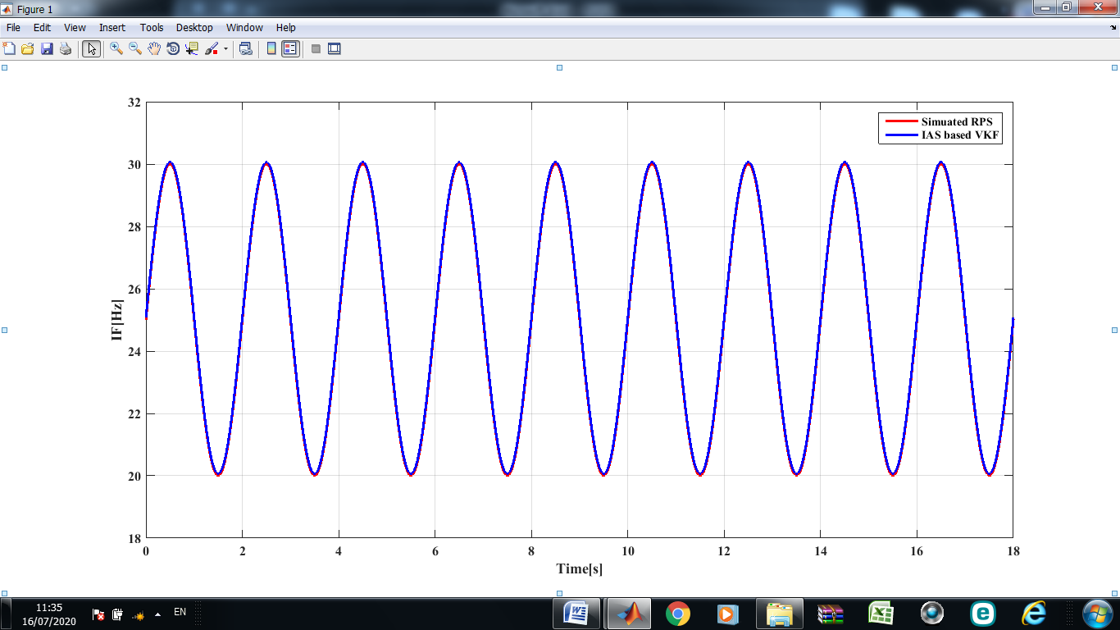

Figure 17 : Estimated IAS (blue) compared with simulated RPS with rapid rate of change varies according to (25 Hz) + (red).

The results presented to this point represent the IAS estimated by using the continuous T-F curve obtained from the first simulated harmonic of the rotational speed since it was chosen by default. However, one may decide to use another RPS harmonic. Moreover, when the IAS is estimated by using other rotational speed harmonics (the third and twelfth, in this case), the results remain just as good. However, we cannot rely solely on visual results, so an index is proposed to calculate the mean error between the simulated rotational speed and the estimated IAS. The index calculates the relative Mean Squared Difference (MSD) between the RPS and the estimated IAS at each time point:

*MSD* = $100\%×\sqrt{\frac{1}{N}\sum_{i=1}^{N}{\frac{{({RPS}_{i}-{IAS}_{i})}^{2}}{{{RPS}_{i}}^{2}}}}$, (16)

where *N* is the total number of time points and *i* iterates over all time points.

Figure 18 shows the results obtained by using *MSD* index for each simulated rotational speed and IAS estimated by each RPS harmonic. For example, the rightmost bar represents the result of the MSD index when using the twelfth RPS harmonic to estimate the IAS. The following conclusions can be drawn from these results:

* As the acceleration increases, the error increases;
* Higher harmonics lead to smaller error.

These results mean that working with higher harmonics of the RPS should be preferred to obtain better resolution.

Figure 18 : MSD index. Shows the mean error between the simulated rotational speed and the estimated IAS. The result shows that as the acceleration increases, the error increases and that higher harmonics lead to smaller error.

### 5.3.2 Experimental stationary Angular Speed

So far, the proposed algorithm has been tested on simulated signals. However, to verify the results and establish a reliable algorithm, the results must be compared with experimental results. Toward this end, a measured signal was used for this purpose.

Figures 19 and 20 show 5 s of rotational speed data (blue) measured from a balanced and unbalanced fan shaft, respectively. The figures also show the IAS estimated from the first harmonic filtered by a VKF (red) and a Butterworth filter (green). The estimated IAS estimated by using the Butterworth filter appears smoother than that estimated by the VKF.

The measured rotational speed for the balanced shaft differs significantly from that for the unbalanced shaft (noisier and fluctuates more relatively to balanced shaft). These differences also appear in the estimated IAS, which is noisier and fluctuates more than the IAS estimated from the balanced system.are cut from the overall estimated IAS time signal (40.2 s). For most operational limitations of the system, such a reduction has no effect. Conversely, the envelope (Hilbert transform) provide poor estimation of the IAS in the presence of noise. The IAS estimated by the envelope to abandon this method herein.

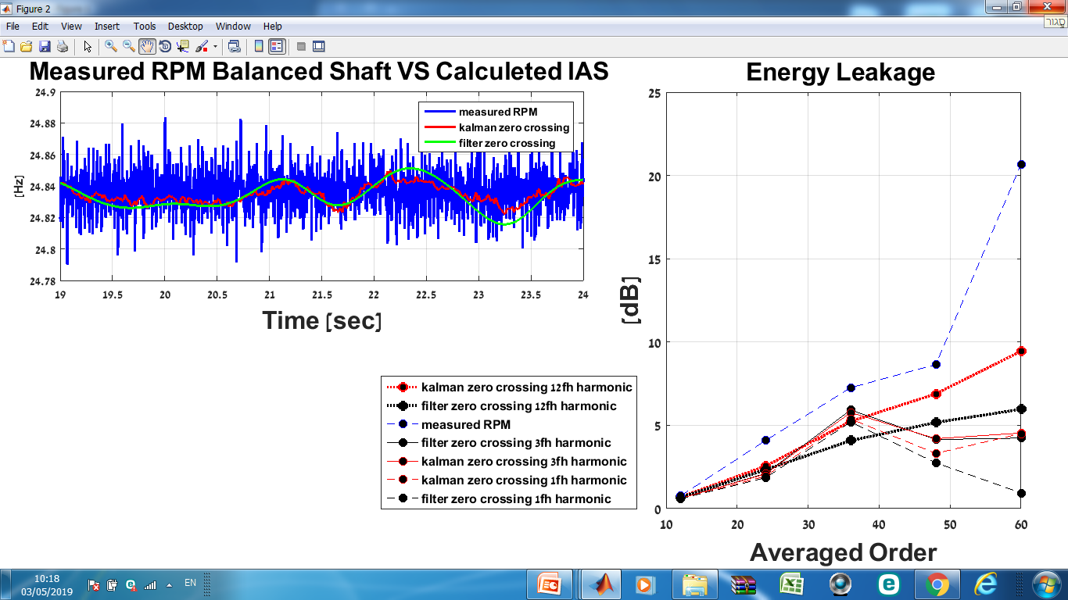

Figure 19 : RPS measured from a balanced fan shaft (blue) and IAS estimated from first RPS harmonic (≈24.6 Hz) by a VKF (red) and a Butterworth filter (green).

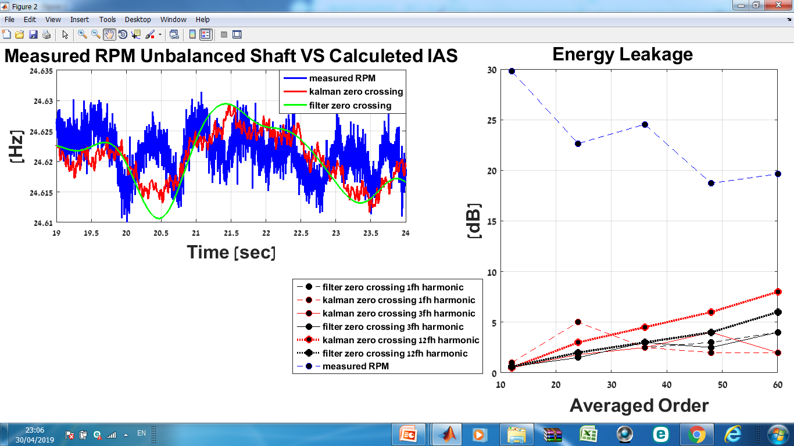

Figure 20 : RPS measured from an unbalanced fan shaft (blue) and IAS estimated from first RPS harmonic (≈24.6 Hz) by a VKF (red) and a Butterworth filter (green). IAS estimated by the Butterworth filter appears smoother than that estimated by the VKF

Figure 21 shows 5 s of the RPS (blue), which was measured for the unbalanced fan shaft. In the case shown, the IAS was estimated by using a signal filtered from the twelfth harmonic (≈295.4 Hz) of the RPS. As shown in Figure 21, the IASs estimated by the different methods differ significantly between 35 and 36 s. This difference is due to the incapacity of the VKF and the Butterworth filter to attenuate the sidebands present near the twelfth harmonic.

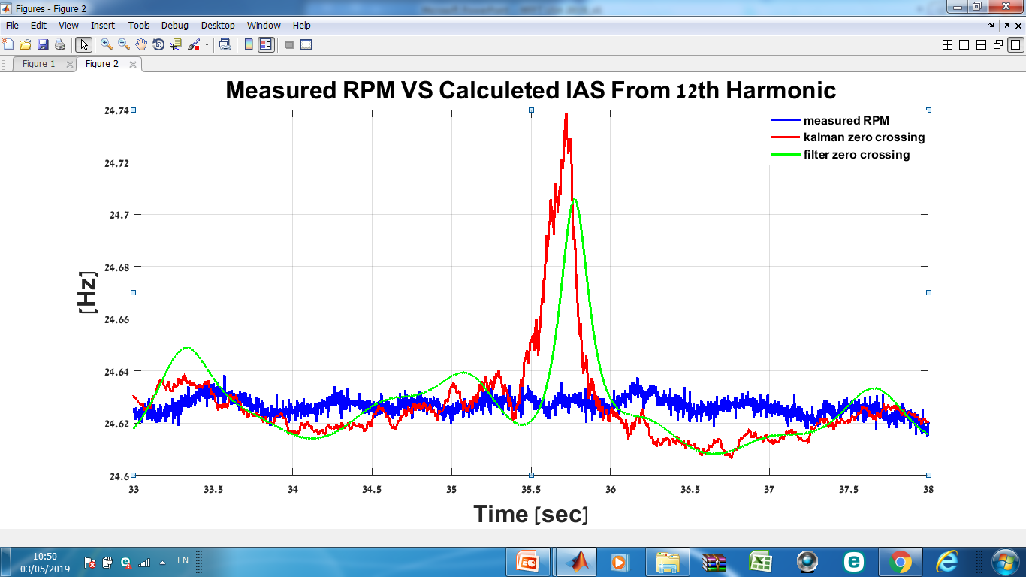

Figure 21 : RPS measured from an unbalanced fan shaft (blue) and IAS estimated from the twelfth RPS harmonic (≈295.4 Hz) by a VKF (red) and a Butterworth filter (green). The IASs estimated by the different methods differ significantly between 35 and 36 s.

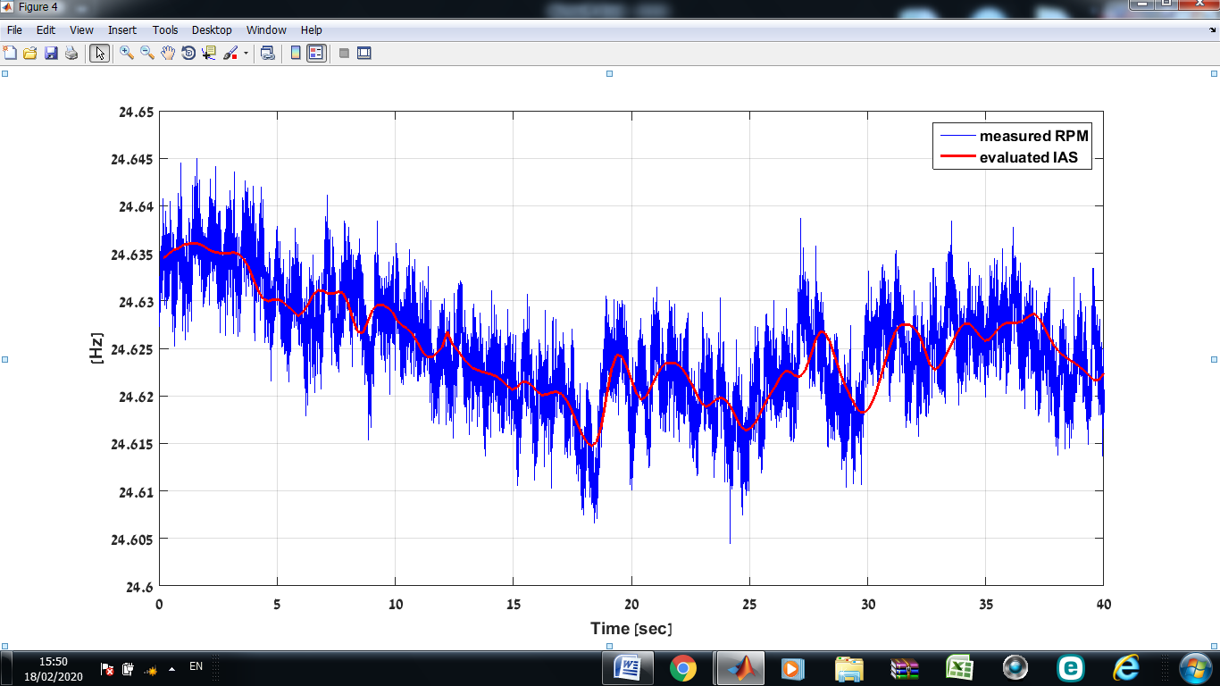Figure 22 show 40 s of rotational speed data (blue) measured from an unbalanced fan shaft. The figure also compares the IAS (red) estimated by the algorithm using the first harmonic filtered by a VKF (red) and a Butterworth filter (green) with the measured rotational speed. The measured RPS is noisy and fluctuate. Conversely, the estimated IAS is smooth and uniform. As shown in Figure 22, the estimated IAS follows the general trend of the measured rotational speed, with no evidence of edge effects. This result is important for most practical systems. Therefore, these methods can be considered practical for estimating the IAS based on either constant or time-varying rotational speed.

Figure 22 : RPS measured from an unbalanced fan shaft (blue) and IAS estimated from the first RPS harmonic (≈24.6 Hz) by a VKF (red) and a Butterworth filter (green). The estimated IAS is smooth and uniform and follows the general trend of the measured rotational speed, with no evidence of edge effects.

## 5.4. IAS Evaluation

In the evaluation phase, each estimated IAS is used to analyze the vibrations. Figure 23 shows the evaluation process in which, the data are resampled, and the order spectrum, synchronous average, and order spectrum of the synchronous average are calculated. To evaluate the IAS, the order spectrum of the vibrations and the order spectrum of the synchronous average are compared.

Figure 23 : IAS evaluation process. First the data are resampled using the estimated IAS, next the order spectrum, synchronous average, and order spectrum of the synchronous average are calculated. Finally, to evaluate the IAS, the order spectrum and the order spectrum and the order spectrum of the synchronous average are compared.

### 5.4.1 Order Comparison

To evaluate the nature of the estimated IAS, two indexes were developed based on an index proposed by Koren *et al.*: To evaluate the estimated IAS the order spectrum was calculated using estimated and recorded angular speed.

For each order spectrum the EL was measured as the ratio in dB between the order spectrum at integer multiples of the rotating speed to the background noise caused by other elements and the transfer function. This gives the ratio between the area under the order spectrum at integer multiples of the rotating speed to the background noise.

(17)

energy leakageSmeared peaks may mask the effects of faults in the bearings or in other rotating components.

(PEC) is the ratio of the order spectrum for integer multiples of the RPS to the root mean square (RMS) of the signal. This gives the ratio between the area concentrate under the order spectrum at integer multiples of the rotating speed to the area concentrate under the background noise:

(18)

where is the order spectrum at integer multiples of the RPS in bin *i*.

The PEC measures the fraction of the total energy that is concentrated in the peaks. A large PEC means that more energy is concentrated in the integer multiples of the spectrum rather than in the background noise.

Figure 24 illustrates the process for spectrum evaluation. The figure shows the order spectrum produced by using the estimated and recorded angular speed with a tachometer focused on harmonic 56 of the rotational speed.rotational speed (blue) has the lowest PEC and EL Indexes. In contrast, the order spectrum produced by the Butterworth filter (red) has the highest PEC and EL indexes, as can be seen in Table 4.

Table 4 : Indexes resulting from spectrum shown in Figure 25

|  |  |  |
| --- | --- | --- |
|  |  |  |
| 0.0176 | Sensor | **PEC** |
| 0.0184 | VKF |
| 0.0189 | Butterworth |
| 1.1631 | Sensor | **EL** |
| 1.7016 | VKF |
|  |  |

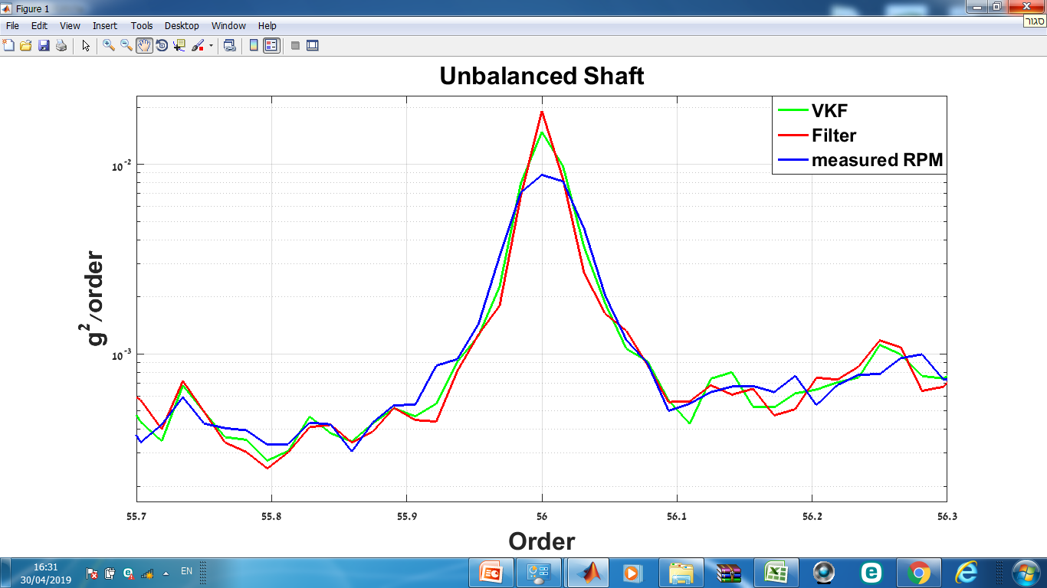

Figure 24 : Illustration of the order comparison process. The figure shows the order spectrum produced by using the estimated and recorded angular speed fixed around harmonic 56 of the RPS. In this case, the relatively smeared peak of order spectrum produced by the measured rotational speed (blue) has the lowest PEC and EL Indexes. Here, the order spectrum produced by the IAS estimated using the Butterworth filter (red) has the highest PEC and EL indexes.

Table 5 gives the calculated spectrum evaluation indexes (PEC and EL),

significant but remains consistent.

These results lead to the conclusion that the order spectrum produced using the IAS evaluated from the first IAS harmonic using the VKF has the highest and narrowest peaks.

|  |  |  |  |  |  |  |
| --- | --- | --- | --- | --- | --- | --- |
|  |  |  |  |  |  |  |
| 2.885 | 2.337 | 2.723 | 2.745 | 0.017 | **Sensor** | **PEC** |
| 2.920 | 2.362 | 2.739 | 2.772 | 0.018 | **VKF** |
| 2.895 | 2.341 | 2.727 | 2.749 | 0.017 | **Butterworth** |
| 2.813 | 2.702 | 2.962 | 2.910 | 1.163 | **Sensor** | **EL** |
| 2.995 | 2.916 | 2.994 | 2.997 | 1.700 | **VKF** |
| 2.901 | 2.811 | 2.978 | 2.959 | 1.648 | **Butterworth** |

### 

### 5.4.2 Order VS Synchronous Average Comparison

The synchronous average is extremely sensitive to noise and accuracy of the rotational speed. Inaccuracies in the rotational speed result in energy leaking from the high orders of the synchronous average spectrum. The evaluation process of the estimated IAS consists of calculating the total energy loss from the synchronous average spectrum compared to the order spectrum:

19)

is the level of the order spectrum, and is the level of the SA order spectrum of integer multiples of the resampled signal of the RPS in bin *i*. The comparison is only made at the integer multiples of the angular speed and is calculated in dB.

Figure 25 illustrates the differences between the spectrums, where different IAS estimates can produce different levels of EL. In the case shown in Figure 25, the order spectrum is determined by the rotational speed measured by a speed sensor (blue), and the EL index is calculated relative to this order. In this case, the synchronous average calculated by using the measured rotationalThis large EL is due to the inaccurate rotational speed caused by phase errors during signal resampling, which leads to significant energy leakage in the higher orders.



Figure 25 : Illustration of the order VS Synchronous Average comparison process. The figure shows the reference order spectrum (blue) VS SA order spectrums fixed around harmonic 30 of the RPS. In this case, the synchronous average calculated by using the measured rotational speed (black) will have largest distance to the reference order (blue) among the three SA orders shown and therefore the largest EL.

Figures 26a and 26b

The results show (Figure 26) that, for the balanced shaft, the smallest EL was calculated for the SA order spectrum calculated by using the Butterworth-estimated IAS. This result means that, in this case, the reference order spectrum fits the Butterworth SA order. In addition, for all cases, the EL increases with increasing harmonic order, which is the result of the inaccuracies in the estimated IAS that accumulate as phase errors during signal resampling, leading to significant EL in the high orders of the SA spectrum. Nevertheless, the largest EL occurs for the measured rotational speed—up to 21 dB at the highest SA order (Figure 26b).

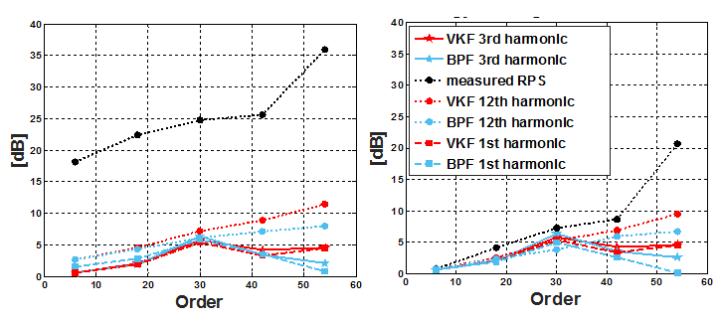Similar results appear in Figure 26a

(a) (b)

Figure 26 : Average energy leakage of harmonics 1, 3, and 12 for (a) unbalanced shaft, (b) balanced shaft. The figure show the calculated total EL of the SA spectrum compared with the order spectrum according to the index. Each data set plotted consists of five points, where each point is an average EL of twelve harmonics.

Figure 27 shows the average EL for all experiments.In most cases, the average EL is lowerIn this case, both

Figure 27 : Average energy leakage for 125 experiments, each column represents the average EL of 25 experiments.

## 5.5 Conclusions

This chapter presents the algorithm and it validation trough simulated time-varying rotational speed and recorded stationary rotational speed. The estimated IAS was compared with the simulated IAS and from the experiments, and an index quantifying the error is proposed. The index is calculated for several test cases, its significance is explained, and the results are discussed. It presents the IASs estimated by the proposed algorithm and explains the relationship between poor phasor isolating (i.e., the difficulties of tracking harmonics with low signal-to-noise ratios) and poor IAS estimates. In addition, it presents the calculated indexes for order evaluation and explains their significance and importance. Finally, it discusses how EL is related to “low-quality” IAS. These results lead to the following conclusions:

* The first IAS harmonic provides the best results at high orders.
* For the measured data, both methods for extracting rotational speed signals from the vibrations (i.e., a cascade of Butterworth filters and the VKF) provide good results.
* The Estimating rotational speed based on zero crossings is more accurate than phase estimation via envelope.
* The proposed algorithm can track, extract, and estimate the IAS even when the rotational speed changes rapidly.
* The root mean squared error is relatively low in all simulated scenarios, which reflects the quality of the algorithm.
* The error grows as the acceleration of the signal increases and as the rate of change of the rotational speed increases. However, a higher harmonic produces smaller errors.
* High rotational harmonic should be used by default to estimate the IAS.

# 6. EXPERIMNTAL SETUP

Experiments were conducted by using an experimental system consisting of a dedicated table to which was mounted a passenger-car condenser fan. Figure 28

In the experiments, rotational speed was measured by using a Honeywell 3030AN variable-reluctance speed sensor, and vibrations were monitored by using a three-axis piezo-electric Dytran 3053B2 S/N 1787 accelerometer.

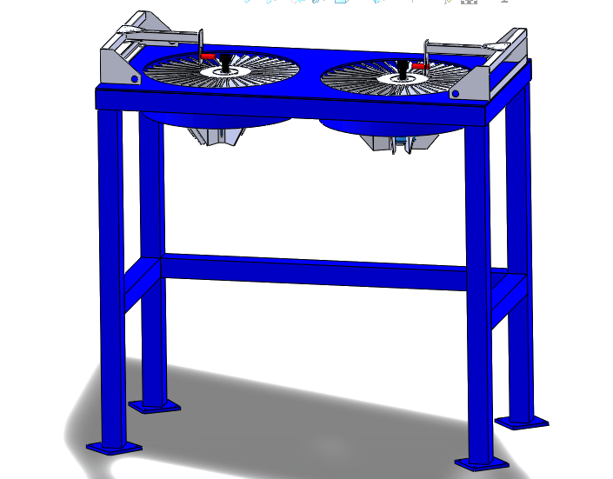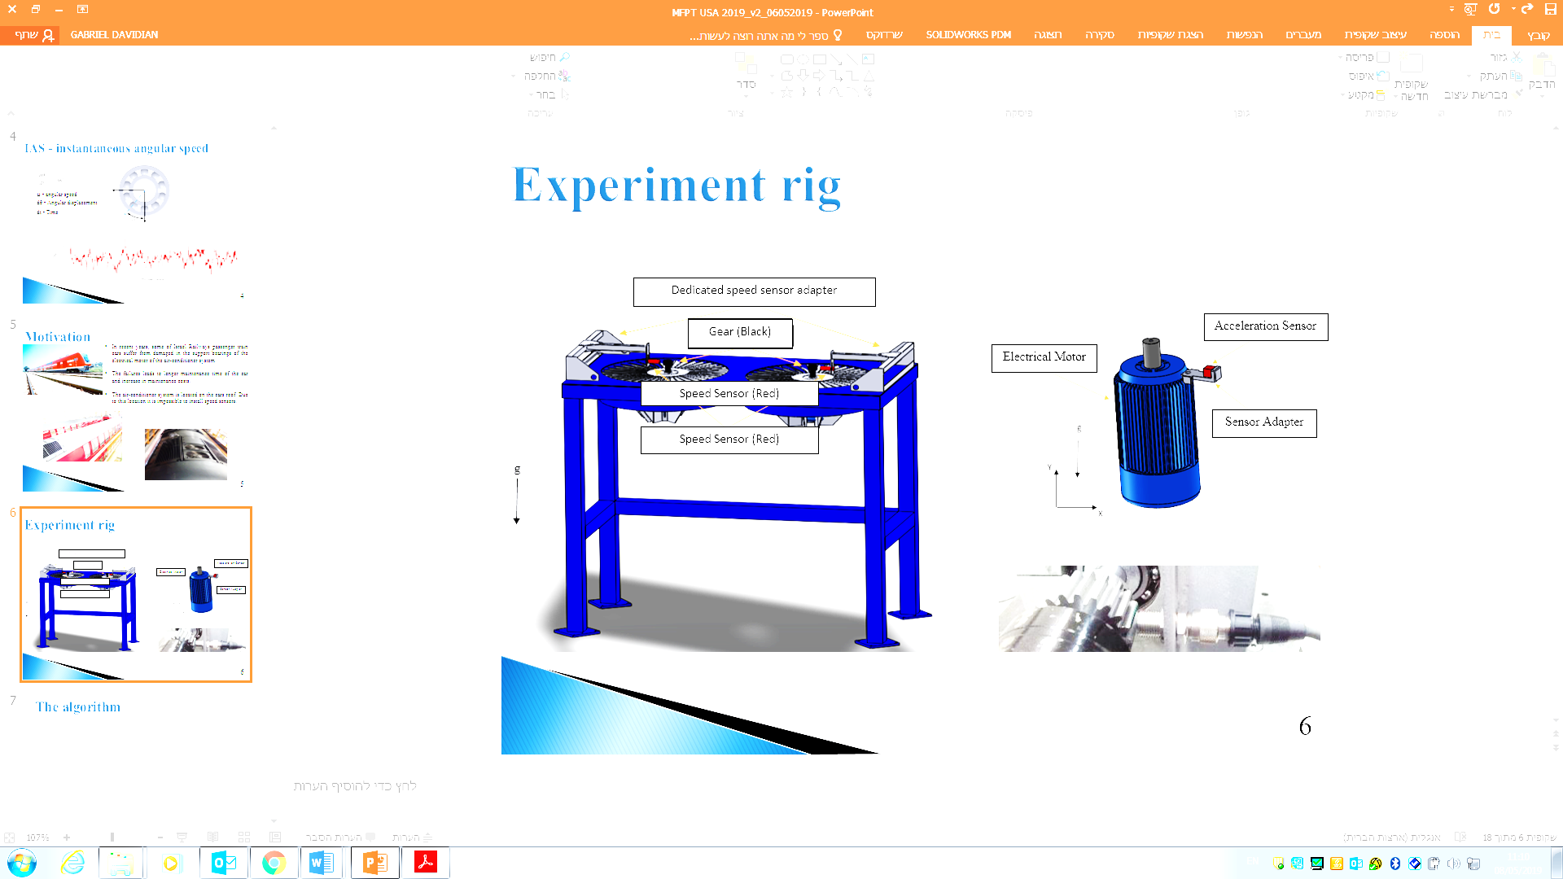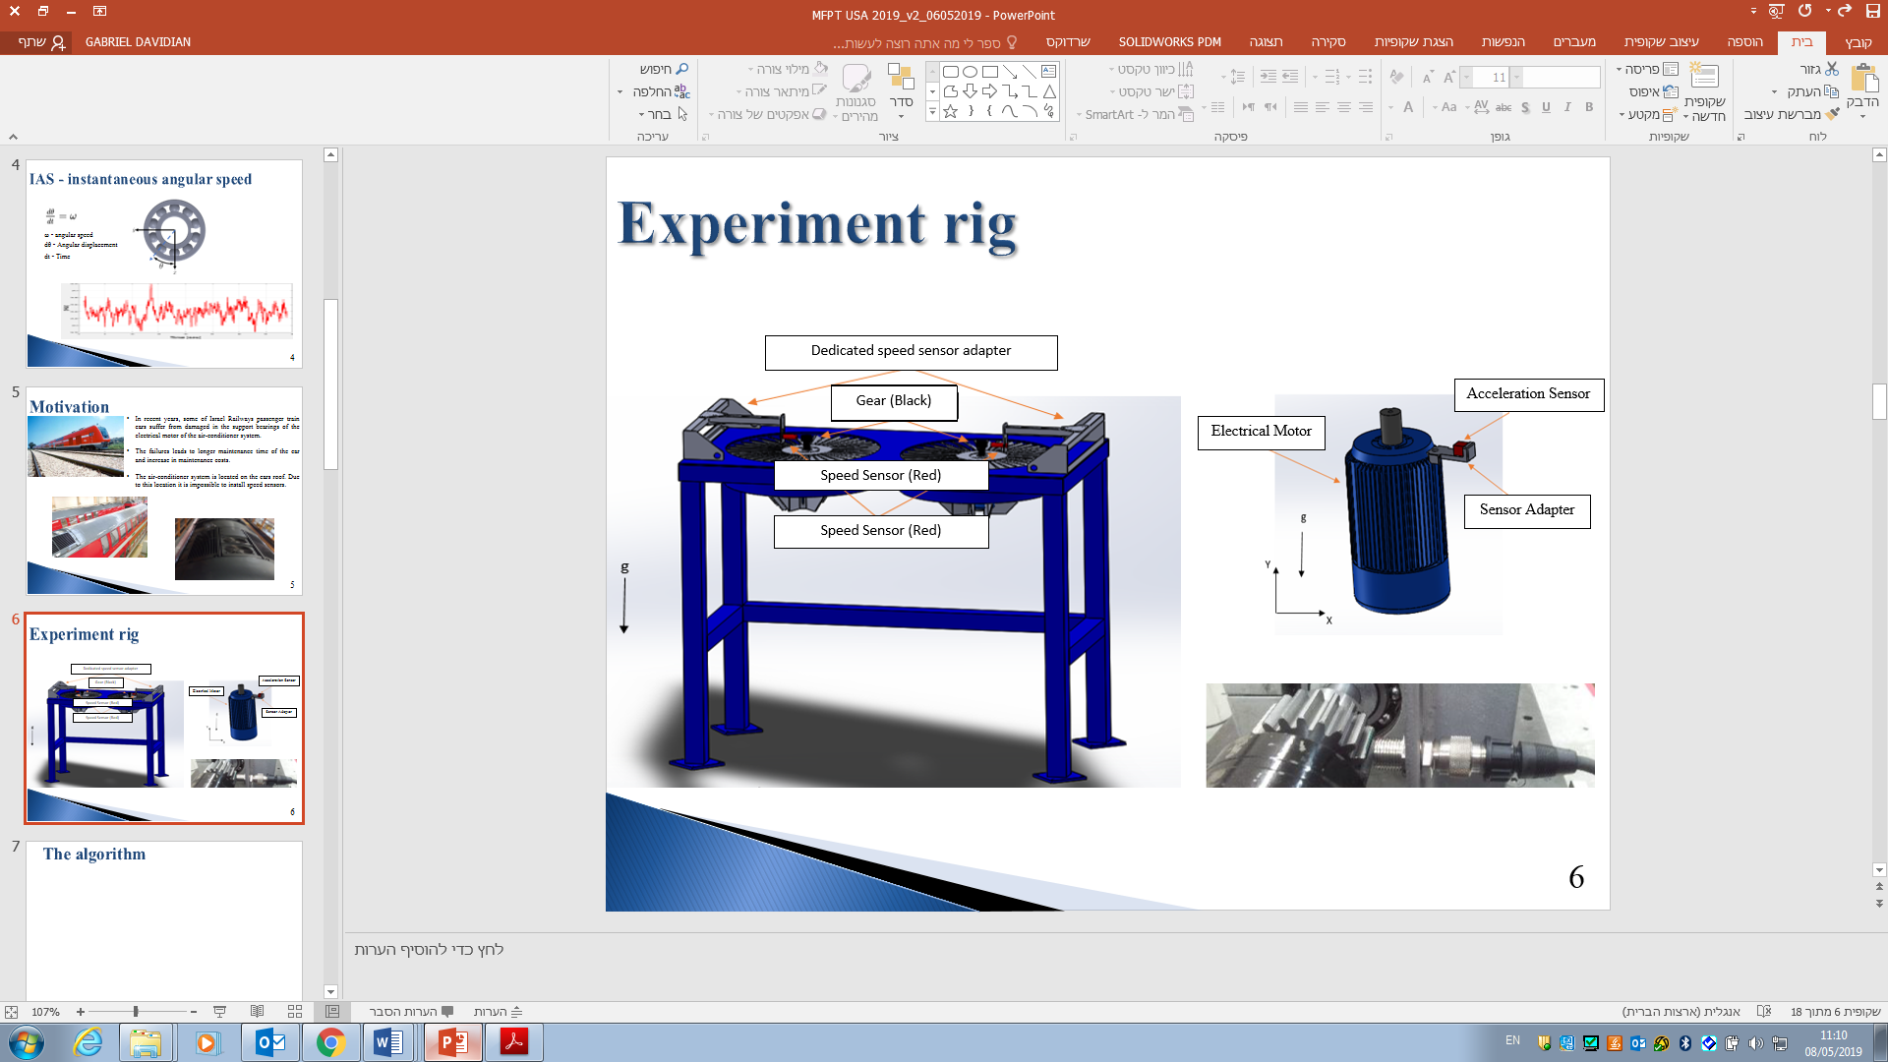

Figure 28 : Experiment rig; red rectangles show the position of the speed sensors.

A set of experiments was conducted on a healthy and seeded outer race bearings. In the experiments, a TVH 6205 bearings were used. The cage structure and material (polymer) of this bearing makes it possible to disassemble (reassemble) the bearing easily. This feature is important because it allows to seed the artificial defects in the bearing easily. Figure 29 shows a disassemble TVH 6205 bearing. The faults were created by removing material from the bearing outer race (Figure 29) using electric discharge machining. Table 6 lists the spall widths that were tested in these experiments.

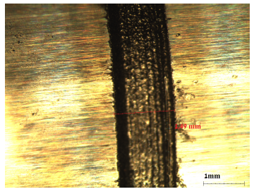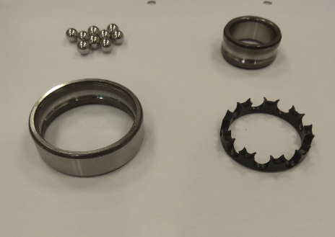

1

2

3

4

29 : disassemble TVH 6205 bearing and outer race seeded fault.1 –bearing balls, 2 – inner race, 3 – outer race, 4 –polymeric cage

The rotational speed of the fan shaft was about 1475 rpm, 24.6 Hz. Under these working conditions, the frequencies of interest [BPFO, ball pass frequency inner race (BPFI), FTF, BSF] were calculated and appear in Table 6. Five bearings were tested by running 25 experiments (each lasted 60 seconds) for each, making a total of 125 experiments. The sampling rate of the accelerations and of the rotational speed was set at 15 kHz.

Table 6 : Experiments specifications.

|  |  |  |  |  |  |  |  |
| --- | --- | --- | --- | --- | --- | --- | --- |
| Bearing mark  spall size [mm] | | Bearing tone | | Experiments | Nominal RPS (Hz) | Sampling frequency (kHz) | Experiment duration  (sec) |
| **Hz** | **Order** |
| E-00 | 0 | 133.42  87.98  114.84  9.78 | 5.418  3.577  0.4  4.707 | 25 | 24.6 | 15 | 60 |
| E-01 | 1.5 | 25 | 24.6 | 15 | 60 |
| E-02 | 2.5 | 25 | 24.6 | 15 | 60 |
| E-03 | 3 | 25 | 24.6 | 15 | 60 |
| E-04 | 3.5 | 25 | 24.6 | 15 | 60 |

## 6.1 Experimental Result

Effective diagnostics of bearings rely on extracting features from vibrations signals. These features contain information that can be used to identify the defect at early stages. This chapter thus investigates how bearing defects can be identified.

The processing scheme depicted in Figure 30 contains several steps. In the first step, the IAS is estimated by using the proposed method. Next, angular resampling is done and the PSD in the order domain is calculated. The envelope is then produced and the envelope PSD is calculated. The PSD and envelope PSD were calculated by using 34 frames and a 50% overlap Hanning window. Finally, the features are extracted.

Figure 30 : The processing scheme for evaluating defects. First the IAS is estimated, next angular resampling is done and the PSD is calculated, finally the envelope PSD is calculated.

Figure 31 shows the order spectrum obtained from a faultless bearing and from a faulty bearing. The signals are color-coded as noted in the figure caption. The electric motor subjected to an axial load of a 5.9 kg rotor mounted on its shaft, so it is not surprising that the highest-energy signature is in the axial direction. The analysis will therefore focus on measurements in this direction.

The order spectrum displays no bearing tones in the baseband measurement because other vibration sources produce dominant order components. Furthermore, distinguishing between faultless- and faulty-bearing order spectra is difficult, making it difficult to compare the spectra of the different orders with the spectrum of the nominal order.

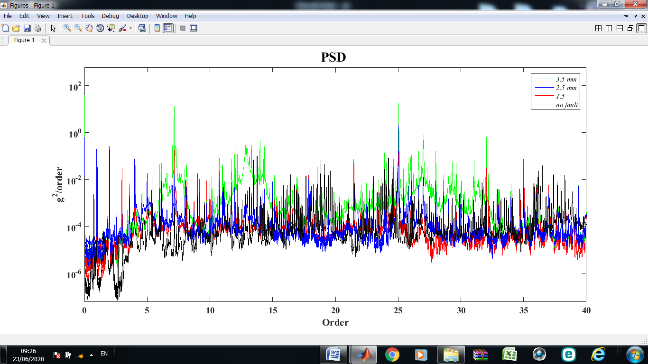

Figure 31 : Order spectra (heathy bearing shown in black, 1.5 mm defect bearing in red, 2.5 mm defect bearing in blue, and 3.5 mm defect bearing in green).

The envelope order spectrum presented in Figure

32. The BPFO orders (BPFO is 3.578 times the rotational speed of the bearing) and their harmonics appear clearly in Figure 32, which clearly indicates that the outer race contains a fault. Furthermore, note that the defect is more readily detected as it grows, which is expressed by a higher-amplitude BPFO. These features make the envelope spectrum an effective tool for signal analysis in this case.

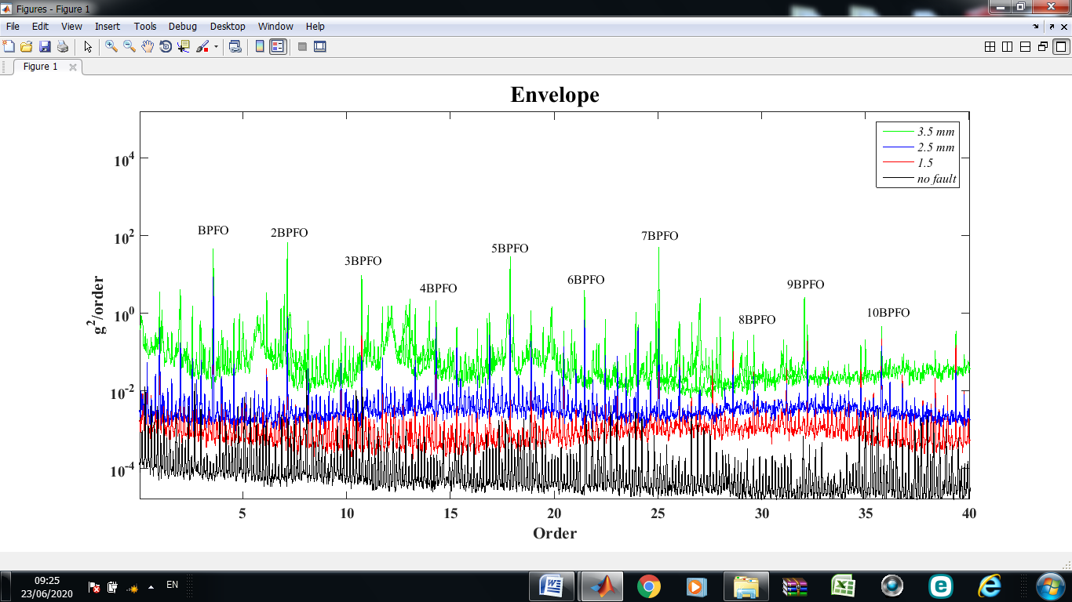

Figure 32 : Envelope order spectrum (heathy bearing shown in black, 1.5 mm defect bearing in red, 2.5 mm defect bearing in blue, and 3.5 mm defect bearing in green).

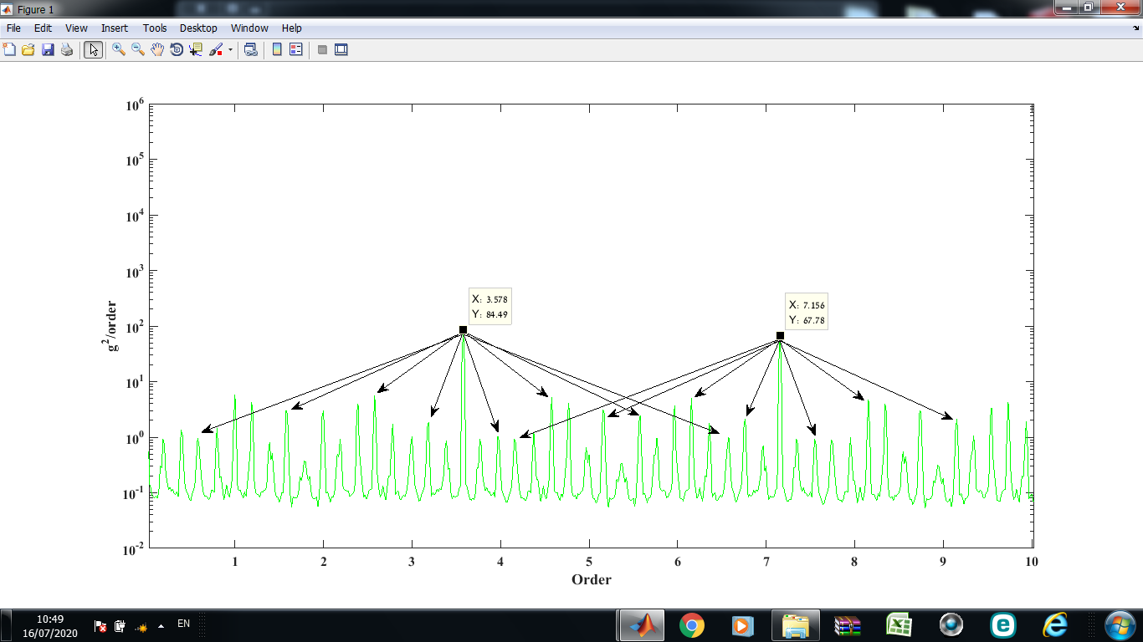Figure 33 shows an expanded view of an envelope order spectrum for a 3.5-mm-defect bearing, in which upper and lower sidebands caused by modulation are easily identified. The results (Figure 33) show that the BPFO value does not equate precisely with the theoretical value. This discrepancy stems from slippage and from the fact that the theoretical BPFO is based on the geometry of the bearing, whereas, in practice, the geometry and dimensions of the bearing may be inaccurate.

Figure 33 : expanded view of an envelope order spectrum for a 3.5-mm-defect bearing, in which upper and lower sidebands caused by modulation are easily identified.

For the case under study, the envelope analysis proves to be a powerful technique that helps to separate the effects of specific faults from background vibrations. Analyzing the envelope of the order spectrum facilitates the diagnosis and makes it easier to distinguish between signals due to defects because the periodicity of the impacts is easily recognized.

## 7.1 Energy-Level Analysis

The first part of this chapter distinguishes between the signal from a healthy bearing and that from a damaged bearing. The results indicate that the energy levels of the different bearing signals differ significantly. Because the experiments were done under identical conditions, we assume that this trend is related to the spall size.

To determine whether the increase in energy is due to the spall size, the energy of orders related to the fault are summed over the order spectrum and over the envelope order spectrum:

$E=\sum_{n=1}^{H}{\left[E_{H}+\sum_{i=0}^{N}{(E_{H-i}+E_{H+i})}\right]}$, (20)

where $E$ is the sum of the energies, $H$ is the harmonic number of the fault, and $N$ is the number of fault sidebands.

For each experiment, 50 BPFO harmonics were considered. However, a larger number of sidebands appeared in the envelope order spectrum compared with the order spectrum, as indicated by Table 7. In the envelope order spectrum, 15 sidebands and 10 cage sidebands are appeared around the BPFO and its harmonics, whereas, in the order spectrum, only 10 sidebands and 5 cage sidebands appear. Table 7 gives the mean summed energy, where each row represents the mean energy of 25 experiments; for example, the mean energy from 25 experiments with the healthy bearing is 10.79 $G_{rms}$ in the envelope order spectrum and 1.15 $G_{rms}$ in the order spectrum.

Table 7: Values for mean summed energy evaluation.

|  |  |  |  |  |  |  |  |  |  |  |
| --- | --- | --- | --- | --- | --- | --- | --- | --- | --- | --- |
| Bearing mark  spall size [mm] | | Bearing tone | Experiments | Summed fault harmonic | Summed fault sideband | | | | Mean summed energy  [] | |
| **Cage sideband** | | **Sideband** | | Envelope | Order |
| Envelope | Order | Envelope | Order |
| E-00 | 0 | 3.578 | 25 | 50 | 10 | 5 | 15 | 5 | 10.79 | 1.15 |
| E-01 | 1.5 | 3.5782 | 25 | 50 | 10 | 5 | 15 | 5 | 75.85 | 3.21 |
| E-02 | 2.5 | 3.5782 | 25 | 50 | 10 | 5 | 15 | 5 | 138.98 | 5.69 |
| E-03 | 3 | 3.5782 | 25 | 50 | 10 | 5 | 15 | 5 | 187.46 | 6.78 |
| E-04 | 3.5 | 3.5783 | 25 | 50 | 10 | 5 | 15 | 5 | 242.66 | 9.17 |

Figures 34 and 35 show the mean energy of sidebands and of the BPFO fault for all spall sizes in the envelope order spectrum and in the order spectrum, respectively. For all cases, the upper and lower sideband energy is greater than the energy of the cage sidebands. Furthermore, the energy increases with increasing spall size. Comparing the two figures reveals significant differences in the amplitudes of the BPFO and its sidebands. The amplitudes in the envelope order spectrum are significantly greater than those of the order spectrum. In addition, the relatively large energy differences among the various spall sizes in Figure 36 makes it easy to distinguish between different spall sizes, which contrasts with the result shown in Figure 35. This is important because it allows to follow and rank the severity of the faults.

Figure 34 : Mean summed energy of sidebands and of the BPFO fault in the order spectrum (Summed upper (lower) sidebands and cage sidebands energy (light blue), upper and lower sidebands energy (gray), cage sidebands energy (white)

Figure 35 : Mean summed energy of sidebands and of the BPFO fault in the order spectrum (Summed upper (lower) sidebands and cage sidebands energy (light blue), upper and lower sidebands energy (gray), cage sidebands energy (white)

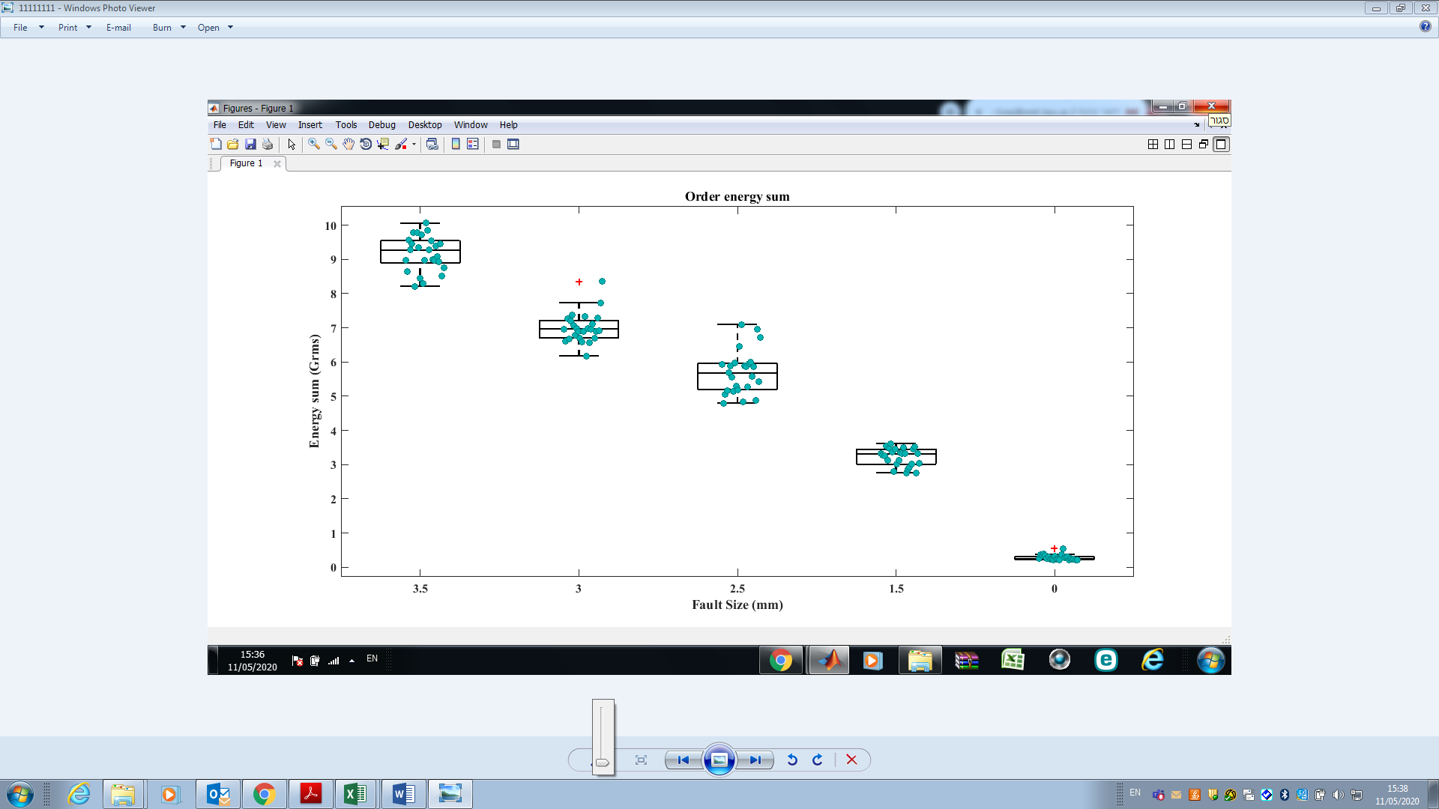Figures 36 and 37 show a box diagram of the total energy calculated for all 125 experiments. Each point represents the total energy for orders associated with a fault in a particular experiment. As can be seen in Figure 37, healthy and faulty bearings are easily distinguished based on their significant energy differences. For example, it is easy to distinguish between a healthy bearing with an average energy of 1.15 $G_{rms}$ and a variance of 0.28 $G_{rms}$ and a 1.5-mm-spalled bearing with an average energy 3.21 $G_{rms}$ and a variance of 0.85 $G_{rms}$. However, the situation becomes complicated as the spall size increases. Looking at the results for 2.5-, 3.0-, or 3.5-mm-spalled bearings (Figure 37) shows that the energy levels for each experiment are scattered and thus may be misleading. For example, in some of the experiments with the 2.5-mm-spalled bearing, the higher bounds of the energy are 6.5–7.0 $G_{rms}$, which is greater than the lower bounds of the energy (≈6 $G_{rms}$) for experiments with the 3.0-mm-spalled bearing. This may lead to a misdiagnosis of fault severity. Thus, a fault threshold cannot be accurately assigned from the results shown in Figure 37.

Figure 36 : Box-plot diagram of order spectrum. Each point represents the total energy for orders associated with a fault in a particular experiment

A fault threshold is thus required that will clearly separate, for all fault situations, the maximum energy of a non-faulty element (bearing, shaft, etc.) from the minimum energy of a faulty element.

Figure 37 shows that the use of the envelope order spectrum provides such a threshold, where the lower energy of an element with a smaller fault does not overlap with the upper energy of an element with a larger fault. Thus, the envelope order spectrum provides a reliable energy threshold. For the case under study, the threshold is determined to be 11 $G_{rms}$, which is the maximum energy level for non-faulty elements. For the experimental data acquired as part of this study this method provides 100% fault identification for all fault situations. In this way, the characteristic energy level 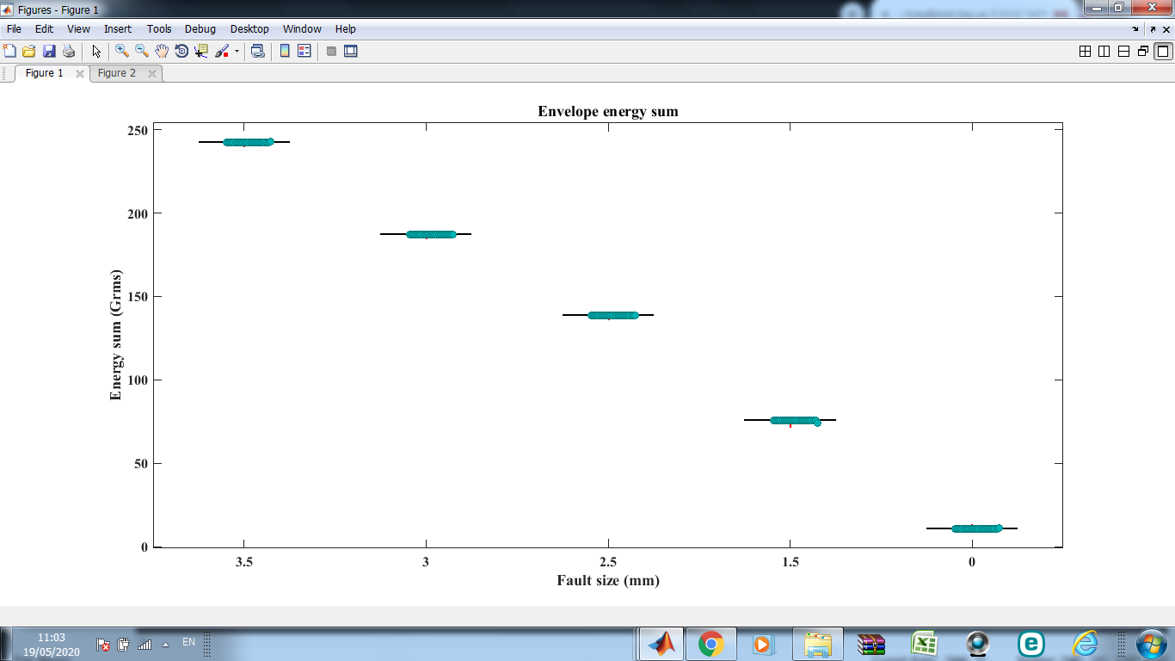can be used to diagnose bearing faults automatically and to locate faulty components.

Figure 37

: Box-plot diagram of envelope order spectrum. Each point represents the total energy for orders associated with a fault in a particular experiment

7.2 Conclusions

* The analysis of the bearing failures justifies the signal-processing scheme.
* For the experimental data acquired as part of this study, the envelope order spectrum should be used to search for bearing tones.
* The use of the IAS estimated by the proposed method allows a healthy bearing to be distinguished from a damaged bearing even when the defect is relatively small (1.5 mm).
* The analysis of experiments with seeded faults validates the concept of extracting the RPS from the vibration signal and demonstrates that bearing faults can be detected and their severity ranked. Based on these results, an algorithm to diagnose bearings that does not require a rotation speed sensor was developed and verified.

# 8. SUMMARY

This research offers a method for identifying defected bearings in machinery with rotating parts in which direct measurement of the rotational speed is impossible, expensive, or inaccurate. The study compares several methods to estimate the IAS directly from a vibration signal and shows that the rotational speed can be directly determined from the vibration signal. The relative advantages and disadvantages of each estimation method are discussed, and the experimental apparatus and units of measurement are also presented. A method to accurately determine the RPS is proposed and implemented, as is an algorithm to automatically extract the IAS from the vibration signal (even when the rotational speed varies in time). To diagnose rotating machine parts, a complete scheme for analyzing the IAS is proposed and then verified by comparing its results with experimental data and with the results of simulations.

Numerous experiments were carried out to verify the capabilities of the proposed algorithm. The experiments involved dismantling suitably sized bearings so as to insert defects of various sizes, following which the vibration signatures of the reassembled bearings were analyzed. The results show that defective bearings can be differentiated from healthy bearings and that even the spall size of defective bearings can be identified. Furthermore, the Hilbert method is determined to be unsuitable for the bearings studied herein because it is subject to edge effects. Additionally, the results indicate that the VKF and Butterworth methods provide accurate estimates of the IAS, even when applied to a relatively unbalanced shaft. Although the VKF and Butterworth methods are both superior to the measured rotational speed in terms of EL, the VKF is preferred because it is more efficient. The results indicate that the VKF method is a practical alternative for estimating the IAS in real systems.

The proposed algorithm to estimate the IAS under conditions of time-varying angular speed is described and verified by comparing its results with those of simulations and experiments. Overall, the algorithm provides accurate estimates of the IAS even under conditions of relatively large acceleration. The proposed algorithm performs well in terms of relative error with respect to the IAS estimated by processing a tachometer signal. One notable advantage of the proposed algorithm is that it requires almost no prior knowledge of kinematics, unlike other methods that are currently available.

The proposed algorithms can be used to support maintenance decisions and recommend effective maintenance policies. The algorithm clarifies several decision-making issues such as frequency of maintenance, safety definitions, and the decision-making method to select the most affordable maintenance operations (i.e., understanding which maintenance option is most economical in a given situation). The algorithm should lead to a much better understanding of which type of maintenance should be done and how to schedule maintenance to ensure maximum efficiency. By revealing the true condition of RE bearings, implementing this type of algorithm in the maintenance scheme will lead to the design of cost-effective action plans.

# 9. BIBLIOGRAPHY

|  |  |
| --- | --- |
| [1] | D. L. D. B. A. K. Jardine, "A review on machinery diagnostics and prognostics implementing condition-based maintenance," *Mechanical systems and signal processing,* p. 1483–1510, 2006. |
| [2] | D. G. N. A. L. a. R. S. W. Lewicki, "Evaluation of MEMS-Based Wireless Accelerometer Sensors in Detecting Gear Tooth Faults in Helicopter Transmissions.," 2015. |
| [3] | P. J. D. G. L. a. D. D. L. Dempsey, "Investigation of current methods to identify helicopter gear health," in *Aerospace Conference*, 2007. |
| [4] | J. R. Blough, " Development and analysis of time variant discrete Fourier transform order tracking," *Mechanical and Systems and Signal Processing ,* pp. 1185- 1199, 2003. |
| [5] | J. a. v. d. B. Han, " MEmpirical mode decomposition and robust seismic attribute analysis," in *CSPG CSEG CWLS Convention*, Alberta, CA, 2011. |
| [6] | H. A. J. A. Q. Leclère, "A multi-order probabilistic approach for Instantaneous Angular Speed tracking," *Mechanical Systems and Signal Processing,* pp. 375-386, 2016. |
| [7] | J. Tuma, "Setting the pass bandwidth in the Vold-Kalman order tracking filter," in *Twelfth International Congress on Sound and Vibration*, Lisbon, 2005. |
| [8] | M. C. a. L. Y. F. Pan, " Further exploration of Vold-Kalman-filtering order tracking with shaft –speed information," *Mechanical Systems and Signal processing,* pp. 1410-1428, 2006. |
| [9] | C. A. H. R. Feldbauer, " Realisation of a Vold-Kalman Tracking Filter – A Least Square Problem," in *COST G-6 Conference on Digital Audio Effects*, Verona Italy, 2000. |
| [10] | M. C. L. S. W. a. C. C. C. Pan, " Improvement on Gabor order tracking and objective comparison with Vold-Kalman filtering order tracking," *Mechanical Systems and Signal processing,* pp. 653-667, 2006. |
| [11] | M. C. a. W. C. X. Pan, " Adaptive Vold-Kalman filtering order tracking.," *Mechanical Systems and Signal processing.,* 2007. |
| [12] | H. M. M. a. B. J. Vold, " Theoretical foundations for high performance order tracking with the Vold-Kalman filter," in *Proc. SAE Noise & Vibration Conference*, Traverse City, 1997. |
| [13] | H. H. H. M. M. C.-R. D. Vold, " Multi axle order tracking with the Vold-Kalman tracking filter," *Sound and Vibration magazine,* pp. 30-34, 1997. |
| [14] | G. S. a. K.-H. H. Herlufsen Henerik, "Characteristics of the Vold/Kalman order tracking filter," in *17th International Modal Analysis Conference*, Kissimmee, 1999. |
| [15] | S. H. H. K.-H. H. a. V. H. Gade, "Characteristics of the Vold-Kalman order tracking filter," 1999. |
| [16] | M. L. J. L. W. C. T. Wang, "Rolling element bearing fault diagnosis via fault characteristic order (FCO) analysis," *Mech. Syst. Signal Process,* p. 139–153, 2014. |
| [17] | C. S. X. J. W. H. Z. Z. J. Shi, "An Auto Instantaneous Frequency Order Extraction Method for Bearing Fault Diagnosis under Time-Varying Speed Operation," pp. 2-6, 2017. |
| [18] | D. A. C.N. Networks, "Bearing Fault Diagnosis under Variable Speed Using Convolutional Neural Networks and the Stochastic Diagonal Levenberg-Marquardt Algorithm," 2017. |
| [19] | J. K. S.A. Khan, " Automated bearing fault diagnosis using 2D analysis of vibration acceleration signals under variable speed conditions," *Shock Vib,* 2016. |
| [20] | M. L. Y. G. J. Shi, "Bearing fault diagnosis under variable rotational speed via the joint application of windowed fractal dimension transform and generalized demodulation: a method free from prefiltering and resampling," *Mech. Syst. Signal Process,* pp. 15-33, 2016. |
| [21] | R. Z. R. R. W. B. M. Cocconcelli, "STFT based approach for ball bearing fault detection in a varying speed motor," *Cond. Monit. Mach. Non-Stationary Oper,* pp. 41-50, 2012. |
| [22] | N. B. M. L. H. Huang, "Bearing fault diagnosis under unknown time-varying rotational speed conditions via multiple time-frequency curve extraction," *Sound Vib,* pp. 414-423, 2018. |
| [23] | N. B. M. L. H. Huang, "Algorithm for multiple time-frequency curve extraction from time-frequency representation of vibration signals for bearing fault diagnosis under time-varying speed conditions," in *Proceedings of the ASME Design Engineering Technical conference 8*, 2017. |
| [24] | T. B. ,. J. A. Jacek Urbanek, "A two-step procedure for estimation of instantaneous rotational speed with large fluctuations," 2013. |
| [25] | A. Z. S. T. A. C. C. M. J. a. Heng, " Rotating machinery prognostics: State of the art, challenges and opportunities," 2009. |
| [26] | P. P. M. j. Gupta, "Fault detection analysis in rolling element bearing: A review.," *Materials Today: Proceedings 4 (2),* p. 2085–2094, 2017. |
| [27] | N. C. A. Tandon, "A review of vibration and acoustic measurement methods for the detection of defects in rolling element bearings," *Tribology international,* p. 469–480, 1999. |
| [28] | A. M. M. D. Al-Ghamd, " A comparative experimental study on the use of acoustic emission and vibration analysis for bearing defect identification and estimation of defect size," *Mechanical systems and signal processing,* p. 1537–157, 2006. |
| [29] | B. P. J. A. S. M. R.B Randall, "New cepstral methods of signal preprocessing," ISMA, Leuven, Belgium, 2012. |
| [30] | B. P. J. A. S. M. R.B Randall, "Cepstrum-based operational modal analysis revisited A discussion on pole-zero models and the regeneration of frequency response functions," *Mechanical Systems and Signal Processing (MSSP),* 2016. |
| [31] | R. Randall, "vibration based condition monotoring," 2011. |
| [32] | R. B. Randall, "Vibration-based condition monitoring: industrial, aerospace and automotive applications," John Wiley & Sons, 2011. |
| [33] | H. M. M. a. B. J. Vold, " Theoretical foundations for high performance order tracking with the Vold-Kalman filter," in *Proc. SAE Noise & Vibration Conference*, Traverse City, 1997. |

**תקציר**

מסב גלגול הוא אחד הרכיבים החשובים והנפוצים ביותר במכונות ומשפיעים מאוד על בטיחות המכונה. גורמים כמו תכנון, טכנולוגיית התקנה, תנאי שימוש ועומס פתאומי גורמים למסבים למצבי דגרדציה שונים כמו קורוזיה, התחממות יתר וזיהום. מצבי דגרדציה אלו מהווים בעיות חמורות וגורמים לרוב לשריפות ותופעות אחרות המהוות סיכון ברור לבריאותו ובטיחותו של מפעיל המכונה.

צמצום התרחשותם של כשלים מחייב להעריך את אורך החיים השימושי (Remaining Useful Life) של המסב. הערכת אורך החיים השימושי של המסב היא מרכיב מפתח לפרוגנוסטיקה במכונות סובבות. על מנת להעריך את אורך החיים שנותר למסב, נדרש לדעת אם קיימת תקלה, מהי חומרת התקלה והערכת פרק הזמן שנותר עד שהתקלה תתפתח והמכונה תגיע למצב קריטי.

אחת השיטות הנפוצות ביותר לאבחון מכונות מסתובבות מבוססת על רעידות. ניתוח רעידות הוא שיטה יעילה לגילוי תקלות שונות. השיטות השונות של עיבוד אות רעידות דורשות את ידיעת מהירות הסיבוב של המכונה, היות וכאשר עוסקים במכונה סובבת אירועים מתרחשים במיקומים זוויתיים ספציפיים ולא בזמנים ספציפיים. מסיבה זו, הערכה מדויקת של המהירות הזוויתית המידית (instantaneous rotational speed) חשובה לדיאגנוסטיקה אמינה. מהירות זוויתית לא מדויקת כתוצאה מתופעות דינמיות כגון חוסר איזון או אקסצנטריות עלולות להסוות את ההשפעות של תקלות מקומיות מתחילות. אולם בפועל, מדידה ישירה של המהירות הזוויתית המידית היא לעיתים בלתי אפשרית, יקרה או לא מדויקת.

עבודה זו מתמקדת באמידת המהירות הזוויתית המידית ישירות מאות הרעידות לאבחון מסבים, תמסורות ומכניזמים שונים. מחקר זה משווה בין מספר שיטות להערכת המהירות הזוויתית המידית ישירות מאות הרעידות ומציע גישה לניתוח אות הרעידות על בסיס תובנות פיזיקליות מתוצאות סימולציה וניסויים . בנוסף מוצע אלגוריתם חדש שיאמוד אוטומטית את המהירות הזוויתית המידית ישירות מאות הרעידות כאשר המהירות הזוויתית משתנה בזמן. בשלב הראשון נאמדת המהירות הזוויתית המידית על סמך הייצוג של אות הרעידות במישור תדירות - זמן, ובשלב השני נקבעת מהירות הסיבוב. לאחר מכן מוצעת גישה לניתוח מלא של המהירות הזוויתית המידית על בסיס תובנות מתוצאות סימולציות וניסויים.

אוניברסיטת בן גוריון בנגב

הפקולטה למדעי ההנדסה

המחלקה להנדסת אנרגיה

**הערכת המהירות הזוויתית המידית על סמך רעידות ודיאגנוסטיקה של מסבים**

חיבור זה מהווה חלק מהדרישות לקבלת תואר מגיסטר בהנדסה

**מאת: גבריאל דוידיאן**

תמוז תש"פ יולי 2020