EFI Head of School Survey

*Note: In some cases, the survey will be administed to the Senior Jewish Professional in the school, not necessarily the Head of School*

The language in the purple shading is dependent on the recipient’s region:

EFI for Europe, Lamorim for France, and Unit.Ed/מיזם התפוצות for Latin America.

*This survey has been commissioned by the Government of Israel’s Ministry of Diaspora Affairs and is being carried out by Rosov Consulting, a research firm that is evaluating the Ministry’s “Unit.Ed” initiative. In order to assess the impact that Unit.Ed and its partners – EFI and Lamorim – are having on participating schools, we would like to hear from you about your experience with EFI , to get a sense of your educational practices, and to learn about the students and educators in your school. We would appreciate if you can please complete the following survey – your open and honest perspective is crucial to understanding the value of EFI’s work. Please note that any information you share will be kept confidential and will only be reported in the aggregate.*

*If you have any questions or concerns, including any difficulty in accessing or completing the survey, please contact Avigail at* [*amwaknine@rosovconsulting.com*](mailto:amwaknine@rosovconsulting.com)*. Thank you for your participation.*

**We first have a few questions about you and your professional practices.**

1. [Display to EFI] Which of the following positions best characterizes your work?
   1. School Director
   2. Change Manager
2. For how long have you been serving in this position?
   1. Less than one year
   2. 1-2 years
   3. 3-5 years
   4. 6-10 years
   5. 11-20 years
   6. More than 20 years
3. What academic degree(s) do you currently hold? Please select all that apply.
4. B.A. in Education
5. B.A. in a field other than Education
6. M.A. in Education
7. M.A. in a field other than Education
8. Doctorate in Education
9. Doctorate in a field other than Education
10. S’micha (Rabbinic Ordination)
11. [If Jewish] Please rate how true each of the following statements is of you personally, on a scale from 1 to 5 where 1 means “not very true of me” and 5 means “very true of me”:

|  |  |  |  |  |  |
| --- | --- | --- | --- | --- | --- |
|  | Not very true of me (1) | (2) | (3) | (4) | Very true of me (5) |
| I feel a strong sense of belonging to the people of [Country/City] |  |  |  |  |  |
| I feel a sense of responsibility to Israel and Israelis |  |  |  |  |  |
| I can explain to others what being Jewish means to me |  |  |  |  |  |
| I feel a strong sense of belonging to the Jewish People |  |  |  |  |  |
| I feel proud of Israel |  |  |  |  |  |
| Taking part in Jewish rituals (Shabbat, holidays, etc.) is a very important part of who I am as a Jew |  |  |  |  |  |
| I feel a strong sense of responsibility to contribute to the development of the Jewish community in [Country/City] |  |  |  |  |  |

1. [If Jewish] Please rate how true each of the following statements is of you personally, on a scale from 1 to 5 where 1 means “not very true of me” and 5 means “very true of me”:

|  |  |  |  |  |  |
| --- | --- | --- | --- | --- | --- |
|  | Not very true of me (1) | (2) | (3) | (4) | Very true of me (5) |
| I believe in the future of European Jewry |  |  |  |  |  |
| I feel a strong connection to Israel and Israelis |  |  |  |  |  |
| I strongly believe that Jews should marry other Jews |  |  |  |  |  |
| I can articulate to others what Israel means to me |  |  |  |  |  |
| I feel a special responsibility to take care of Jews in need in my community |  |  |  |  |  |
| Caring about Israel is a very important part of who I am as a Jew |  |  |  |  |  |

1. [If Jewish] To what extent do you engage in each of the following behaviors?

|  |  |  |  |  |  |
| --- | --- | --- | --- | --- | --- |
|  | Not at all | A little | Somewhat | A lot | Very much |
| I try to understand what “being Jewish” means to my students |  |  |  |  |  |
| I articulate how my actions are guided by my Jewish knowledge and values |  |  |  |  |  |
| I exhibit a passion for contributing to the Jewish community above and beyond my job responsibilities |  |  |  |  |  |
| I speak with educators in my school about the importance of infusing Jewish values into classroom culture |  |  |  |  |  |
| I help the educators in my school understand how their teaching supports the school’s vision |  |  |  |  |  |
| I demonstrate a personal passion for Judaic knowledge |  |  |  |  |  |
| I invest time in my own Jewish learning |  |  |  |  |  |

6a. [For EFI – display to CM if SD is not Jewish] To what extent do you engage in each of the following behaviors?

|  |  |  |  |  |  |
| --- | --- | --- | --- | --- | --- |
|  | Not at all | A little | Somewhat | A lot | Very much |
| I try to understand what “being Jewish” means to my students |  |  |  |  |  |
| I articulate how my actions are guided by my Jewish knowledge and values |  |  |  |  |  |
| I exhibit a passion for contributing to the Jewish community above and beyond my job responsibilities |  |  |  |  |  |
| I speak with educators in my school about the importance of infusing Jewish values into classroom culture |  |  |  |  |  |
| I help the other educators in my school understand how their teaching supports the school’s vision |  |  |  |  |  |
| I demonstrate a personal passion for Judaic knowledge |  |  |  |  |  |
| I invest time in my own Jewish learning |  |  |  |  |  |

1. How confident do you feel in your ability to create positive change in your school’s Judaic and/or Hebrew studies departments?
   1. Not at all confident
   2. A little confident
   3. Somewhat confident
   4. Confident
   5. Very confident
2. Please explain your response: [Write-in]
3. In your opinion, is your school’s ability to provide Jewish education hindered by any of the following? Please select all that apply.
4. A lack of qualified teachers
5. Shortage or inadequacy of instructional materials or resources (e.g., textbooks, curriculum)
6. Shortage or inadequacy of technology capacity (e.g., computers, internet connection, etc.)
7. Shortage or inadequacy of facilities (e.g., classroom space, etc.)
8. Other (please specify: ___________________)

**The next few questions ask about the students and teachers in your school.**

1. [Do NOT display to France] We’d like to get a sense of the students in your school, in terms of their involvement in Jewish life. Using the slider, please indicate what proportion of students in your school identify as Jewish:

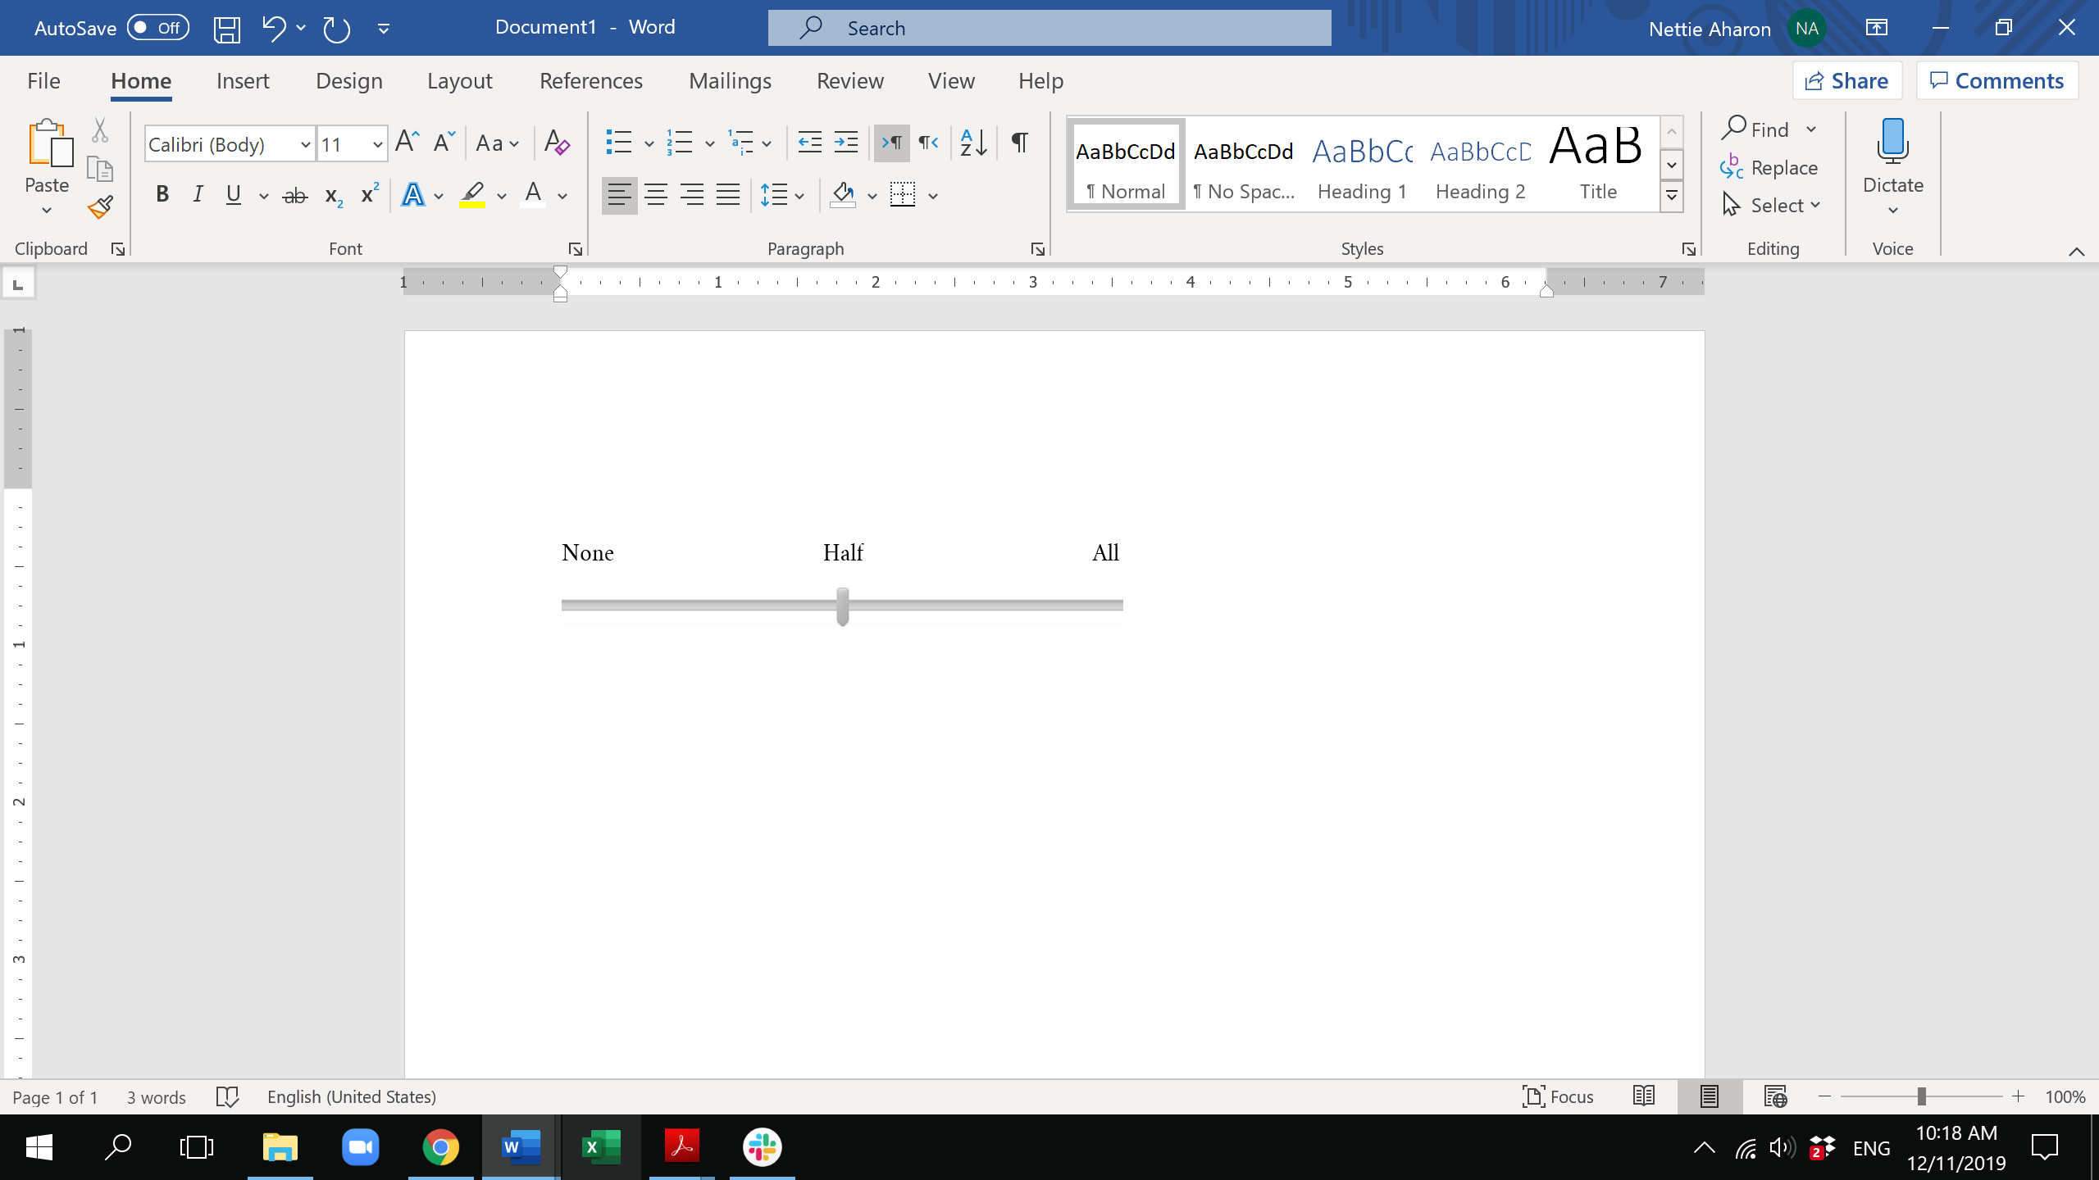

1. Of the students in your school who identify as Jewish, what proportion…



1. Have had, or plan to have, a Bar/Bat Mitzvah
2. Attend a *Seder* on Passover
3. Live in a home where Shabbat is marked differently than the rest of the week
4. Have visited Israel
5. [For Unit.Ed/Latin America] Have a parent who attends synagogue at least once a year
6. Have a parent who attends synagogue at least once a month
7. [Do NOT display to France] Of the students in your school who identity as Jewish, what percentage come from homes where…

|  |  |
| --- | --- |
|  | Percentage of students |
| All parents identify as Jewish |  |
| Only some parents identify as Jewish |  |
| No parents identify as Jewish |  |

1. When you think about your primary goals for your students, which of the following are your top five goals?
2. Students feel connected to the Jewish People
3. Students are knowledgeable about Jewish heritage, rituals, and traditions
4. Students act in ways that reflect Jewish values [For EFI, include: (e.g., giving Tzedaka, volunteering in communal activities)]
5. Students are involved in the local Jewish community
6. Students feel proud of being Jewish
7. Students are knowledgeable about Jewish texts (e.g., Torah, Oral Law)
8. Students feel connected to the local Jewish community
9. Students develop skills they can use throughout the rest of their lives
10. Students feel good about themselves
11. Students develop a relationship to the land, people, and state of Israel
12. Students are curious and interested to learn about Jewish life and Jewish heritage
13. Students take part in Shabbat and holiday rituals [For EFI, include: (e.g., lighting Shabbat candles, saying Kiddush, attending Passover seder)]
14. Students engage in volunteer work
15. Students develop Hebrew language skills
16. Students form strong Jewish friendships
17. Students feel a sense of responsibility to care for other Jews
18. Students understand the history of the local Jewish community
19. Please indicate how many Judaic and Hebrew studies educators teach in your school, and what their employment status is:

|  |  |  |
| --- | --- | --- |
| Employment status | Number of Judaic studies educators | Number of Hebrew studies educators |
| Full-time |  |  |
| Part-time – more than half-time |  |  |
| Half-time – half-time or less |  |  |

1. To what extent do the Judaic and Hebrew studies educators in your school have the following:

|  |  |  |  |  |  |
| --- | --- | --- | --- | --- | --- |
|  | Not at all | A little | Somewhat | A lot | Very much |
| A high level of knowledge of the subject matter they teach |  |  |  |  |  |
| Strong professional skills and capacities |  |  |  |  |  |
| Confidence to do their job well |  |  |  |  |  |
| A sense of commitment/dedication to their work |  |  |  |  |  |
| The ability to create positive change in your school’s Judaic/Hebrew studies departments |  |  |  |  |  |
| A strong sense of commitment to the school’s mission and vision |  |  |  |  |  |

1. In your opinion, which of the following professional development topics would the Judaic and Hebrew studies educators in your school benefit from most? Please select your top three choices.
2. Setting goals for students’ Jewish growth
3. Assessing students’ Jewish growth
4. Enhancing the *Tefilah* (prayer) experience
5. Teaching *Tanakh*
6. Teaching about Israel
7. Teaching Hebrew language
8. Integrating technology into Jewish/Hebrew studies
9. Integrating *midot* (character) education into the curriculum
10. Delivering experiential Jewish education
11. Other (please specify: ________________________)

**[Display this block only to EFI, and only to CM] The next set of questions ask about your experience and work thus far with EFI.**

*Note: The term “EFI’s workplan activities” refers to any consultation, mentorship, or professional development programs/activities made available as part of your school’s EFI workplan.*

1. Please indicate which stage your school is in with regards to its experience with EFI:
2. We will be starting soon (preparation stage/EFI Phase 1)
3. We just started (beginning stage/EFI Pre-Workplan)
4. We have participated (or are currently participating) in **a small number** of EFI’s workplan activities (intermediate stage/EFI Workplan implementation year 1)
5. We have participated (or are currently participating) in **several** of EFI’s workplan activities (advanced stage/EFI Workplan implementation year 2-3)
6. In your own words, what would you say are EFI’s goals? [Write-in]
7. EFI is partially funded by the Government of Israel, as well as local partners. Is this something that…

|  |  |  |
| --- | --- | --- |
|  | Yes | No |
| You personally are aware of |  |  |
| The educators in your school are aware of |  |  |
| The students in your school are aware of |  |  |
| The parents of students in your school are aware of |  |  |
| Your school board is aware of |  |  |

1. [Skip if Q17=a or b] Have you personally participated in any of EFI’s workplan activities?
2. Yes
3. No
4. [Skip if Q17=a or b] How many educators or administrators in your school – other than yourself – have participated in any of EFI’s workplan activities? [Write-in]
5. [Skip if Q17=a or b] Please list which EFI workplan activities the educators/administrators in your school have participated in, or are currently participating in? [Write-in form]
6. [Skip if Q17=a or b] Please rate your satisfaction with the following EFI workplan activities in your school:

|  |  |  |  |  |  |
| --- | --- | --- | --- | --- | --- |
|  | Very dissatisfied | Dissatisfied | Neutral | Satisfied | Very satisfied |
| [Carry forward entered text from Q22] |  |  |  |  |  |
|  |  |  |  |  |  |
|  |  |  |  |  |  |
|  |  |  |  |  |  |
|  |  |  |  |  |  |

1. How, if at all, has EFI furthered your school’s mission, or intend to further it, this academic year? [Write-in]

[Skip if Q17=a or b] We know it’s early in your work with EFI, but we’d like to get a sense of the extent to which the EFI workplan activities in your school may have had an impact thus far.

1. [Skip if Q17=a or b] To what extent have the EFI workplan activities in your school contributed to students’…

*(If the EFI workplan activities in your school do not address the following dimensions, or if they intend to but there haven’t yet been opportunities to affect these dimensions, please select “Not applicable.”)*

|  |  |  |  |  |  |  |
| --- | --- | --- | --- | --- | --- | --- |
|  | Not at all | A little | Somewhat | A lot | Very much | Not applicable |
| Knowledge of Jewish heritage, rituals, and traditions |  |  |  |  |  |  |
| Hebrew language skills |  |  |  |  |  |  |
| Connection to the land, people, and state of Israel |  |  |  |  |  |  |
| Involvement in the local Jewish community |  |  |  |  |  |  |
| Feeling proud of their Jewish identity |  |  |  |  |  |  |
| Sense of responsibility to care for Jews in need |  |  |  |  |  |  |
| Curiosity and interest in learning about Jewish life and Jewish heritage |  |  |  |  |  |  |
| Plans to incorporate Jewish practices into their homes |  |  |  |  |  |  |

1. [Skip if Q17=a or b] To what extent have the EFI workplan activities in your school contributed to students’…

*(If the EFI workplan activities in your school do not address the following dimensions, or if they intend to but there haven’t yet been opportunities to affect these dimensions, please select “Not applicable.”)*

|  |  |  |  |  |  |  |
| --- | --- | --- | --- | --- | --- | --- |
|  | Not at all | A little | Somewhat | A lot | Very much | Not applicable |
| Knowledge of Jewish texts (e.g., Torah, Oral Law) |  |  |  |  |  |  |
| Marking Shabbat in a way that is different from the rest of the week |  |  |  |  |  |  |
| Awareness of current events in Israel |  |  |  |  |  |  |
| Understanding the history of their local Jewish community |  |  |  |  |  |  |
| Development of leadership skills |  |  |  |  |  |  |
| Feeling a sense of belonging to their peers/community |  |  |  |  |  |  |

1. [Skip if Q30=a or b] What type of impact have the EFI workplan activities in your school had on educators in your school, in each of the following domains:

*(If the EFI workplan activities in your school do not address the following dimensions, or if they intend to but there haven’t yet been opportunities to affect these dimensions, please select “Not applicable.”)*

|  |  |  |  |  |  |  |
| --- | --- | --- | --- | --- | --- | --- |
|  | None | Little | Some | Significant | Highly significant | Not applicable |
| Increased knowledge of the subject matter they teach |  |  |  |  |  |  |
| Increased reflection about teaching and learning |  |  |  |  |  |  |
| Improved teaching practice |  |  |  |  |  |  |
| Increased sense of collegiality |  |  |  |  |  |  |
| Increased sense of professionalism |  |  |  |  |  |  |
| Learned specific techniques or theories |  |  |  |  |  |  |
| Increased sense that their current work can be a long-term career |  |  |  |  |  |  |