Gritando con el cuerpo: Poetry, Performance, and Necropolitics in Contemporary Mexico

**Introduction**

More than a decade has passed since former President Felipe Calderón launched a “war on drugs” or “narco war” in Mexico, yet the violence and systems of organized crime the government set out to dismantle are now even more deadly, elusive, and complex. The militarization of drug enforcement operations pitted the federal government against drug cartels, and included financial support and arms provided by the United States. Rather than curtail violence, the number of drug related deaths in Mexico continues to grow, and is estimated now at over 100,000, with last year marking the most deadly in the war’s history. Corruption and fear are widespread, deeming it impossible to name enemy sides or locate the origins of power and violence. In the Mexican states with the highest homicide rates, there is a less than a one percent chance that a crime will lead to a trial and sentencing.

Ravaged by narco war violence and neoliberal economics, Mexico operates under conditions of necropolitics, or the politics of death. As a counterpart to Foucault’s biopolitics, Mbembe’s “necropolitics” explores states of exception where “the ultimate expression of sovereignty resides, to a large degree, in the power and the capacity to dictate who may live and who must die” (Mbembe 11), “the capacity to define who matters and who does not, who is diposible and who is not” (Mbembe 27). Under the conditions of necropolitics, “death-worlds” develop transforming people deemed disposible into the “living dead” through the persistent threat of death (Mbembe 30).

The narco war and the conditions of necropolitics have produced new forms of communication and language through the violences enacted on the bodies of victims. The drug cartels famously dismember, assault, and torture bodies then leave them on display as a message. Through Rita Laura’s Segato’s work on the writings on the bodies of victims of femicide, and Rosanna Reguillo’s work on narco war violence, the critics have developed the term “expressive violence” to describe the communicative violence that is done to the body following the death and torture of a person, which reduces them to the categories produced by their deaths (ie: “*encajuelados,*” “*decapitados,*” *“consumidos”*) (Reguillo 7). Expressive violence operates as a tactic for power and territorial control that builds on the historical infrastructures of capitalism, colonialism, and misogyny already at work in Mexico. Through the work of narcopolitics, expressive violence erupts into social, cultural, and political aspects of life and displaces everyday language with a language of violence, which critic Rossana Reguillo calls “narcoñol” (8).

Through expressive violence and narcoñol, a new form of writing and expression has taken over the country with narcos as the authors. When the perpetrators speak the language of violence through the body of their victim, they use the body as a canvas or text to be interpreted. As a text, the body of the victim is read and understood in the terms of the perpetrator, striping the victim of all agency, identity, and humanity. The language is also propagated through consumerism which idealizes narcoculture and makes it a product to be bought and sold. The narco identity is a commodity and a lifestyle to be revered and performed by citizens, validating violence and celebrating the brutality enacted by the “authors.” Expressive violence and narcoñol are adopted by the state in instances of state-sanctioned violence and disappearances such as the case of Ayotzinapa.

The art and journalism produced in Mexico in response to the war have largely relied on testimonial or documental modes to represent violence, which ultimate reproduce it through realistic portrayals or detailed accounts of brutal acts. Through popular forms of cultural production such as narconovelas and narcocorridos, the work of expressive violence is repeated and solidifies its position as the dominant language of society and culture. The media frequently circulates and reproduces expressive violence and narcoñol through their publications which, in an attempt to document the war, adhere to the narratives of narcopolitics by sensationalizing death, glorifying perpetrators, and dehumanizing victims.

What is a body when it is missing? How can a body and language be reclaimed from the narco-system’s violence? This article examines protest art and poetry that challenge the dominant discourses produced by disappearance and expressive violence in Mexico. The following analysis considers anti-femicide performance interventions by the artist collective Taller Mujeres, Arte y Política and Sara Uribe’s poetic work *Antígona González* (2012). The works are calls for action against widespread silence and control, and are created under the threat of violence artists face today when challenging the narcostate. Because expressive violence speaks through, on, and about the body, the works reposition the body as a site of dissent and critique. The protest performances and poetry frame violence and disappearance as an embodied state occupied by the missing, the dead, and the living. In response to silence and inaction, the artists propose three modes of refusal. First, is the formation of a collective “I,” a unified voice or movement made from a collage of individual voices. Secondly, as a rejection of the narcosystem’s “death world,” these works feature limbo as an alternative time-space and as an embodied state where the living and dead meet in joined resistance. And lastly, the works develop a shared accountability and belonging formed through the relationship to the “I as Other” culminating in the act of claiming the body of the dead or disappeared as one’s own.

**The Taller Mujeres, Arte y Política**

It is afternoon following a day of classes at High School 128 Francisco Villa in San Andrés de la Cañada, Ecatepec, a school founded by progressive teachers from various leftist organizations across Mexico. A group of twenty-five students and their teacher, Manuel Amador, gather in a classroom for the ongoing art and performance workshop Taller Mujeres, Arte y Política (TMAP). In the words of the participants, TMAP is both a workshop and an artist collective that

Surge de la necesidad de fomentar estrategias alternativas de disentir y

cuestionar el poder y las formas opresivas hacia las mujeres; entre éstas el

machismo, la misoginia, la vida precaria, la cultura de la violencia, la

cultura de la discriminación, exclusión y negación socio-cultural de las

mujeres que viven en uno de los contextos más pobres, más violentos y más criminales como lo es Ecatepec, Estado de México. (Buenrostro)

Since 2011, the students have performed interventions throughout the region on issues of femicide and gender violence. The San Andrés region where the students are from has roughly two million inhabitants and is referred to as “San Hambres,” or Saint Hungers, as it is one of the most impoverished suburbs of Mexico City. According to recent government reports, Ecatepec is fifth in the nation for the highest rates of homicide, has the highest rates of femicide in the state, and is perceived to be one of the most dangerous cities by its residents according to a national census (Rea). However, the region is largely overlooked by the media and government which frequently locates the narco war outside of the Estado de Mexico in order to maintain an image of safety and control from the government’s center.

In the workshop, the students collectively design performance interventions. While Amador coordinates the workshop, the ideas and art interventions are the work of the students. The participants are transient as it is a voluntary workshop out of many offered at the school, but around twenty-five students are involved during each semester with most remaining in TMAP throughout their education. The majority of the participants are women, but men are increasingly joining the collective. Students throughout the school occasionally participate or attend art actions which at times involve members of the community.

The collective remains firm in their convictions, and hopes to gather more participants and support despite the discouragement that they receive from some peers, family members, and the general public. Blanca recalls, cada vez que salimos las personas nos dicen “esos revoltosos”, “pinches revoltosas”, pero no se dan cuenta que estamos poniendo un granito de arena para cambiar un pequeña parte” (Buenrostro).

Ana adds, “la sociedad nos critica mucho a la hora de expresarnos, se nos critica por el solo hecho de ser mujeres de salir vestidas de una manera y expresarnos en la calle” (Buenrostro). The young women march with rally cries and amplify their voices at the microphone, their bodies overtaking the streets and squares. The dominant discourse of violence and misogyny is disrupted, and some members of the public respond with threats and disapproval, attempting to restore the normal hierarchy of power. In this way, the work of the participants also places them at a higher risk of violence, attack, or kidnapping. However, the participants note that as members of the workshop, they are less fearful and optimistic about the future, “Nos vamos con un cambio, con ganas de seguir luchando por nuestros derechos, con ganas de seguir alzando la voz,…ahora nos expresamos más libres y caminamos más seguras de nosotras mismas” (Buenrostro). The changes begin with the participants as individuals, as their work is born from discussions and shared experiences on issues that are either so normalized they go undiscussed (domestic violence) or they provoke fear of retaliation (homicides and femicides).

The participants work as a collective and credit the ideas and performances to the group as a whole. While giving interviews on their work or creating their interventions, they ensure that various members are given space to speak. “Consideramos que es importante reconocer el coraje y la valentía de cada una y cada uno, además de que aporta a que se noten más voces. Las declaraciones que se hacen son en colectivo y  nombrando a cada uno y cada una por respeto” (Buenrostro). The collective names the individual participants, and credits their work, validating the individual experiences and contributions of each person. At the same time, they collectively create and unify their voices and choreographies in performance and writings. Speaking to the importance of working in a collective and through performance as a medium, the workshop responds,

Lo principal es que la gente voltea a mirar lo que está pasando, que la

gente deje de mirar la violencia a las mujeres y los feminicidios como

algo normal en esta sociedad, hacer conciencia, de que realmente hagan

algo, que no solo digan “estamos hartos de la violencia”, que es mejor

actuar, que esto va a cambiar desde uno mismo, desde donde estés hacer

algo para que esto cambie. Crea más impacto en colectivo que siendo una

sola persona, mediante los performance no se expresa de la voz de uno

sino la de un problema que es de todos y así es como invitamos a más

voces a integrarse a esta lucha. (Buenrostro)

The work of collective performance is to incite change and action from all people. Moving as a collective, TMAP show violence to be a problem that belongs to everyone and for which society must take collective responsibility.

*We Are Not Disposible*

In April of 2016, the members of TMAP march through Piedra Grande, de San Pedro Xalostoc, moving up the steep streets of the hillside chanting, “Ni objeto ni desecho, mujeres con derechos. Las mujeres pobres no somos desechables” (Red-Acción). At the front, three students carry a large banner with “Las mujeres no somos desechables” written in red paint. The participants adorn costumes made of recycled materials and trash, each outfit carefully constructed from newspapers, magazines, cardboard, bottle caps, CDs, toilet paper rolls, and wrappers.

The participants transform their bodies with waste, becoming the disposable materials and objects that their society continually relegates them to. In the trash costumes, the women recall the images of femicide victims that circulate in the media through the use of plastic bags, tape, and other materials typically used in the killings and public displays of bodies. The media capitalizes on the gruesome images and descriptions of killings, reducing the victims through expressive violence to waste and the materials used in their deaths (“envuelta en plástico”, “amarrada de pies con cinta canela”). The materials traditionally used by perpetrators to disappear women’s bodies are repurposed to make the women’s bodies visible. The use of dresses also accentuates the feminine, reducing the women to gender-conforming clothing. Some of the dresses have large skirts mimicking formal wear while others are short and form-fitting. The range of dresses created by the participants confront the media’s frequent citation of women’s clothing in reports of gender-based violence, as well as the sexualization of young women’s bodies. The dresses are an uncomfortable combination of beautiful and homely that evoke the disturbing abuse of perpetrators who sexualize and brutalize victims.

The creation of the dresses is a central part of the workshop leading to the performance. First, the questions, experiences, and messages of a work are processed internally and individually by each member of the collective, who creates and works from her own experience in relation to the project. “Así primero estas ideas las hemos empleado hacia nosotras mismas y después hacia afuera y ahí entran los performance” (Red-Acción). The project gives space for the participants to engage their personal history as a political action, using discarded materials as physical representations of memories and language used to harm them. The creation of the costumes is a symbolic gesture of removing the anger and hate associated with gender-based violence and relocating it into the materials outside of the body where they are made visible. Describing the process behind designing her costume from old CDs, Ruth says,

Debemos ver nuestro interior. Todos valemos lo mismo,

debemos mejorar la forma en que nos miramos. Yo utilicé

discos compactos, porque en ellos vemos solamente un reflejo,

no se ve nuestro interior y eso (el interior) es lo que nos hace

únicas como seres humanos y como mujeres valiosas para

mejorar esta sociedad” (Dorado)

The scratched and broken CDs on her dress make visible the violence she suffers as a woman in her community, and serve as a metaphor for the accumulative damage of mistreatment. Ruth’s dress demonstrates the process of self-reflection involved in the creation of the costumes, and the way that the public performance then invites the spectator to reflect on their role in contributing to violence as they confront their distorted face in the CD-dress.

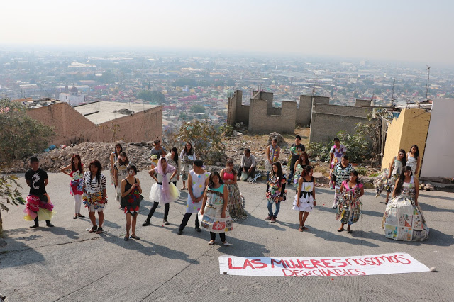photograph from Manuel Amador

From the top of the hill with a view overlooking the city below, the participants speak about the issues of violence against women in their community. “El modelo económico neoliberal tiene rostro de abandono, a las mujeres se nos trata como objetos, como algo desechable, se nos niego el derecho porque somos gente pobre,” says Melani (Dorado). Melani frames neoliberal economics as a body with a “face of abandon,” linking consumption with the disposability of poor women. The location of the performance in the hills at the edge of the city comments on the students’ circumstances living at the periphery of society where the poor are subjected to the highest rates of violence with little concern for the resolution of cases. The protest’s backdrop is mounds of trash and an abandoned, half-built structure, which at once absorbs the students’ covered in refuse into the surroundings while their firm stance in the street disrupts the scene. Their performance and remarks reveal how femicide and gender-based violence prohibit the development and treatment of women as subjects, and instead show them to be discardable objects.

The women refuse to become another body mistreated and disappeared at the margins. At the conclusion of their remarks, they remove their garbage costumes, stepping out of them and leaving them behind on the ground as they walk away. One participant explains, “En los vestidos nosotras plasmamos una idea y la dejamos ahí.

De todo lo que sentimos de como a veces los hombres nos hacen sentir como basura o como un objeto desechable. Al momento de quitarte el vestido, liberas todo tu enojo, tu rancor o los odios que a veces sentimos las mujeres” (Dorado).In this way, the performance is the final step in a process of reflection and critique practiced by each member of the collective. The women are symbolically liberated from the anger and hatred associated with the violence directed at them, while also rejecting society’s reduction of poor women to trash.

*Gritando con el cuerpo: No más feminicidios*

Another performance intervention created by TMAP responded to the government’s construction of a cable car transportation system through Ecatapec. On October 4, 2016, President Peña Nieto visited the region for the inauguration of the government-funded cable car system. At the inauguration, the cable car was celebrated as the first transportation system of its kind in Mexico, built to decrease ground traffic in the densely populated suburb of Mexico City. Connecting five destinations in the region, the President boasted that Mexicable would shorten commutes from forty to twenty minutes, reduce emissions, and cost only six pesos a ticket. As part of the Mexicable project, the Mexican government commissioned artists to paint murals on buildings below the cable car route, and funded the exterior painting of the buildings most visible from the cable car. “Dejará de ser esta zona gris, apartada, que poco invitaba a que se visitara,” President Peña Nieto commented. (Notimex)

The residents of the region had a much different reaction to Mexicable, and since its opening, the cable cars are used almost exclusively as a mode of tourism. While the cable car was estimated by the government to provide transportation for many people in the region, the cost remains inaccessible for people living in the area. Additionally, the funding of the cable car was prioritized over the more important needs of the community such as portable water, repairs to schools, and measures addressing the rising number of homicides and femicides in the region. The cable car is now a form of poverty-porn as tourists make their way from Mexico City for a round-trip tour over the impoverished and violence-stricken zone where there is no need for tourists to even touch the ground.

In response to the government funded Mexicable, the TMAP designed an intervention, “Gritando con el cuerpo: No más feminicidios” with the Mexicable riders as the unexpecting audience. The intervention protests the government profiting from the poverty and violence that is killing the community, and forces the spectators to confront their own consumption of the subaltern for entertainment. The performance addresses the interconnected forms of violence at work in the narco-system by revealing how economic violence, exclusion, and gender-based violence are linked and disproportionately harm poor communities.

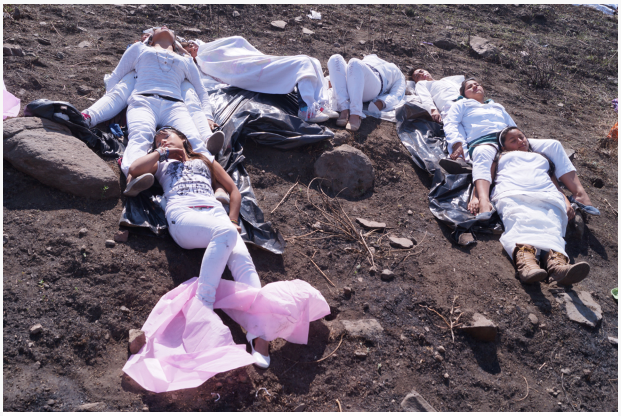

photograph from Manuel Amador

For the performance, the students dress in white and use their bodies to spell “No más feminicidios” in the hillside desert. The location on the hillside in the sand is a common dumping ground for victim’s bodies in the region. With their bodies unmoving in the sand, stretched out on sheets of plastic, the women become like the many victims of femicide left in the dirt, many of whom are still missing. Each person becomes part of a communal body shout, where each letter requires multiple bodies in order to be read and understood. This underscores the power of collective action, but also disturbingly asks, how many bodies are too many? How many bodies until you intervene?

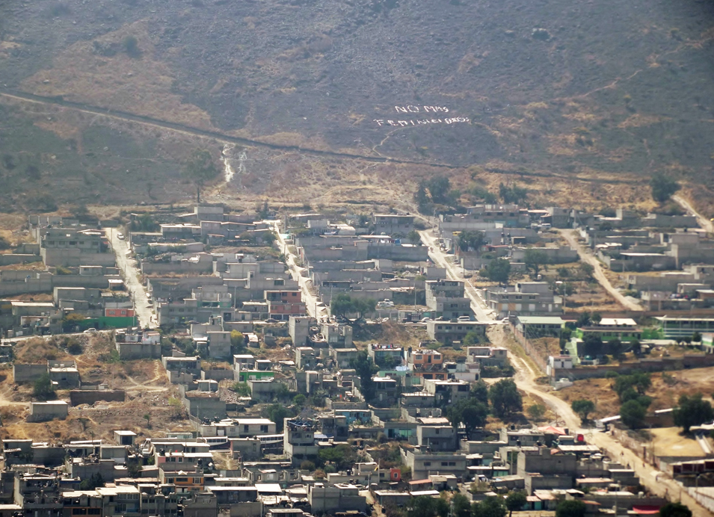

*photograph from Manuel Amador*

From the cable car, the collective’s message disrupts the gaze of the tourist and challenges their perception of the area, urging them to change their distant relationship to issues of violence, exclusion, and poverty. The spectator can no longer distract himself with the bright murals and painted houses immediately below as he is confronted with the message on the hillside. The intervention lifts the gaze of the spectator from the distraction of beautified buildings, forcing him to see the gray homes that populate the region, and the desert hills that serve as mass graves. The bodies of the women cry out, refusing to be disappeared or manicured for pleasure and consumption by the tourists. Yet, the spectators read their bodies as a singular message, unable to distinguish the individual bodies from afar. In this way, the performance critiques the distortion of language and bodies through expressive violence and the media, which erase the humanity and individuality of victims, and disappear bodies into unlocateable mass grass. Their location on the hillside also echoes the Hollywood sign bringing further attention to the problem of poverty tourism which attempts to make the area palatable to guests without addressing systemic issues. For the spectator, the comfortable distance from violence and poverty dissolves as they confront the cost of their inaction, forced to read the message as long as it is visible without an exit or means to act from the confined space of the cable car.

*Quinceañeras Muertas*

In a third performance, the members of the TMAP collective dress in quinceañera dresses or formal outfits and paint on bruises and wounds with makeup. They march to a public square in Ecatepec, while family members, classmates, neighbors, and supporters of their movement walk alongside them or await them in the center. The square is a scene of chaos and dissidence, as the protest coincides with a municipal health awareness event and the typical weekend traffic. Once in the square, the quinceañeras form a line at a microphone as popular party music begins to play in the background.

Swaying to the music, each woman approaches the microphone to document the life of a young victim of femicide in the region. They incarnate the victims as they speak, “Soy Mariana Yáñez. Tenía 17 años cuando desaparecí un 17 de febrero de 2014. Salí de noche a sacar unas copias por las calles de Los Héroes Tecámac; nunca regresé a casa. Les dijeron a mis padres que mi cuerpo había sido encontrado en el Río de los Remedios, pero mi muerte nunca ha sido aclarada” (Hernández). In the performance, the dead speak from the other side through the living. Here, the victims identify themselves and share fragments of their death or disappearance. In Ecatepec, many of the cases of femicide and disappearance never reach news sources, as only the most violent and grotesque cases are seen as profitable. The news of disappearances and homicides circulates locally, but is often hushed out of fear of retaliation or, in the case of femicides, is dismissed as personal domestic matters. The families that push for answers and justice through the judicial system enter the chaos of a system overwhelmed with cases and with less than a one percent chance of an indictment.

The TMAP participants disrupt the silence surrounding the deaths of their neighbors and classmates, and the subsequent erasure of their identities and stories through the media and threats to their families. Each woman begins with the name and age of the victim, counting them and reclaiming their identity from the grasp of necropower. The participants then describe the routine task that became the circumstances surrounding their death or disappearance. The stories then almost unanimously turn to the experiences of the family members left with unsettling fragments of information that hold neither closure nor justice for the death of their child. As they speak, the participant’s language turns to an ambiguous “they,” (“they told my parents”), an authority whom cannot be trusted to find the truth or carry out justice. In other instances, the “they” is a narco, a corrupt official, or a politician threatening the family to silence without the details of their child’s death or a body to mourn.

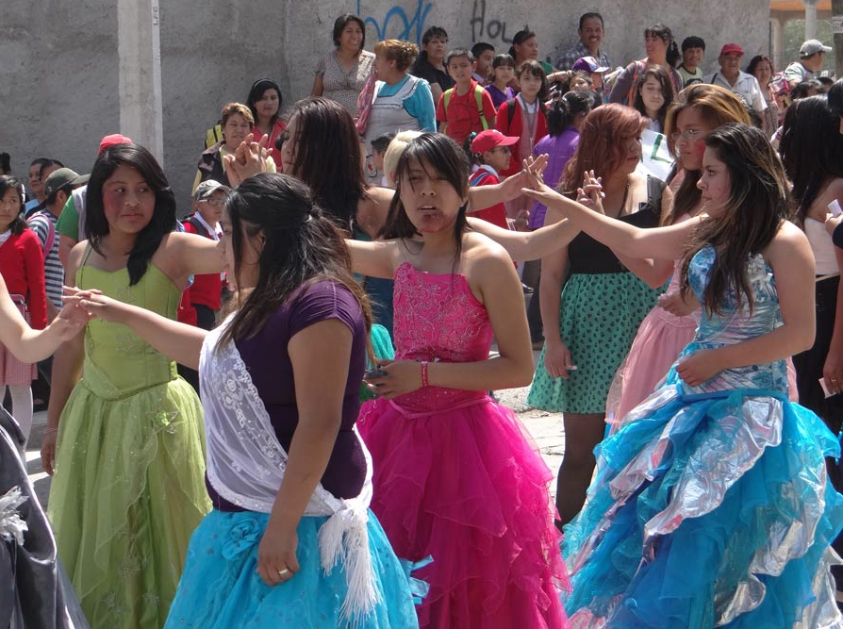

Competing for sound and space with the municipal event and honking cars, the high volume of the speakers distorts the music and the voices of the quinceañeras as they speak. Following their turn at the microphone, each quinceañera steps into the open space of the square littered with empty bottles, debris, rose petals, banners from the march, and personal belongings staged as items left behind by the dead and disappeared such as shoes. As they enter the space, the quinceañeras haunt among the personal items as though they were conjured from the belongings by memories. The women dance to the music of a traditional quinceañera celebration, at times coming together to partner dance or to perform well-known choreographies. The macabre bruises are an unsettling contrast with the bright dresses and youthful, celebratory dancing of the ghosts of young women lost to violence. The quinceañeras muertas reveal the loss of a generation of youth and the destruction of cultural traditions such as the quinceañera that many are deprived of due to fear and loss.

After several dances, the quinceañeras invite spectators from the crowd to dance with them. Although many hesitate to join in the dance, the women insist, showing the necessity of community involvement in the issue of femicide. The outstretched hand of the young woman meets the hand of the spectator, merging the worlds of the living and the dead. The spectator accepts the dance, and in doing so takes the quinceañera as a partner and acknowledges the presence of the embodied disappeared woman. As the townspeople dance with the ghosts of the quinceañeras, the city square transforms into a suspended limbo time-space opened through collective resistance and partnership.

**Sara Uribe’s *Antígona González***

Sara Uribe’s *Antígona González* was commissioned by actress and director Sandra Muñoz in 2011 following the discovery of a mass grave in San Fernando containing nearly 200 bodies. Muñoz imagined a retelling of Sophocles’ *Antigone* amidst the violent narco war in present-day Mexico. In the resulting poetic work, Antígona González searches for her missing brother, Tadeo, a victim of the narco war in Tamaulipas. Uribe weaves together the voices of historical Antigones from Latin America and beyond including Griselda Gambaro’s *Antígona Furiosa*, Leopoldo Marechal’s *Antígona Vélez*, María Zambrano’s *La tumba de Antígona*, and Judith Butler’s *Antigone’s Claim*. In this way, the work is both part of a history of bodies caught in limbo and their family members left behind, and the particular, localized violence of the ongoing war in Mexico.

*The Collective “I”*

Uribe employs a collage aesthetic, piecing together the voices of intertextual Antigones, citations from Mexican news sources, human rights statistics, and testimonies from family members searching for missing relatives. The range of voices are at once a chorus and a collective poetic “I” shaped by loss that is personal and communal. The “I” speaks from both a personal and shared pain, searching through language for a way to express despair.

It is not as if an 'I' exists independently over here and then simply loses

a 'you' over there, especially if the attachment to 'you' is part of what

composes who 'I' am. If I lose you, under these conditions, then I not

only mourn the loss, but I become inscrutable to myself. Who 'am' I,

without you? When we lose some of these ties by which we are

constituted, we do not know who we are or what to do. On one level, I

think I have lost 'you' only to discover that 'I' have gone missing as well.

At another level, perhaps what I have lost 'in' you, that for which I have

no vocabulary, is a relationality that is composed neither exclusively of

myself nor you, but is to be conceived as *the tie* by which those terms

are differentiated and related (Butler, *Precarious* 26).

Butler describes the reconfiguration of the self through grief, which in turn “furnishes a sense of political community of a complex order” (22). “No quería ser una Antígona / pero me tocó” (Uribe 15), Antígona exclaims, as she takes on an assigned role and all its unwelcomed responsibilities. In this adaptation of Antigone, “en su distorción y alteración Polínices es Tadeo” (Uribe 21), and the poetic voice becomes a distorted Antígona.

Antígona’s role is discussed throughout the text through conversations about how this particular version of Antigone will be written and staged. A metatextual discussion on the process of becoming Antigona and the process of adapatation, these notes on process offer central insights into Antígona’s role that reverberate throughout the text. For instance, the observation, “este monólogo debe posibilitar que una única actriz asuma todos los roles” (Uribe 60) demonstrates the gendered dimension of the labor of searching for the missing and the families left behind in the wake of narcowar violence. Uribe also gestures to the role of artists as activists who are called now more than ever to intervene. What is the role of Antígona?, is also, what is the role of the poet?, of the reader?

*Antígona González* is also distorted through genre, reaching toward a theatrical piece, but ultimately becoming a poetic work that stitches together voices across genres and mediums. The book resists adaption for the stage as the flood of voices defy singular ownership or characterization. The text reflects on Antígona’s role and words, articulating the difficulty of translating collective pain and experience. As though imagining the task of staging the work, the text seemingly addresses Muñoz and the reader, *“¿Quién es Antígona dentro de esta escena y qué vamos a hacer con sus palabras?”* (10). Antígona’s voice shifts throughout the work leaving the reader to question if this is a work with one poetic voice comprised of many, or many alongside the voice of Antígona. In this way, *Antígona González* exemplifies *desapropiación*, or the subversion of an established capitalist, hierarchical order by an author where the author-text relationship is replaced through the combining of many voices and texts into a communal, authorial one (Rivera Garcia). Used by critic Cristina Rivera Garcia to describe writings about the violence in Mexico, *desapropiación* locates resistance within the author’s relinquishing of writing as personal and owned in favor of writing as an act of belonging. For Uribe, *desapropiación* is also a way to write about violence that one has not personally experienced. In an interview with Uribe, she described writing the work out of an urgent need to respond to the violence happening in Mexico that was met with silence, while also confronting the challenge of telling a story that wasn’t her experience. The collective “I” therefore opens a space to speak against the violence from a space of belonging and shared response.

The “I” is a multitude of voices that overwhelms with the quantity of pain, unanswerable questions, and unresolved stories. Yet, the repetition and overlaps in the individual voices are also what stitch the personal into a unified and collective voice of solidarity and community. Despite the changes in register and style, the individual voices are not lost or overpowered, rather they step into the multidimensional “I.” Unlike the common lyrical “I”, the voices are made to speak not by presence, but by the absent people they seek. Speaking from a space of loss and confusion, the language of Antígona is one of questions, “¿Estaba muerto el cuerpo cuando fue abandonado?” (Uribe 84), “¿Fue Usted quien declaró muerto al cadáver?” (Uribe 89). The questions seek a response not only in the desperate search of each person for their disappeared, but for all the missing, “Dónde están los cientos de levantados?” (Uribe 77).

Uribe’s text centers on that which is disappeared, and throughout the work there is a search for the language, the genre, the questions that can answer, “¿Qué cosa es el cuerpo cuando está perdido?” (Uribe 68), and “*:¿Quién es Antígona González y qué vamos a hacer con todas las demás Antígonas?”* (Uribe 15). Like all family members searching for their disappeared loved ones, Antígona cannot find closure without the body of her brother. Her life is a constant state of searching, “necesito saber dónde / estás. / Ellos dicen que sin cuerpo no hay delito. Yo les digo / que sin cuerpo no hay remanso, no hay paz posible / para este corazón. / Para ninguno” (Uribe 24). Antígona’s life is reoriented around the task of searching for her brother, and coming to terms with recognizing herself as Antígona, the sister of a missing person.

*Contarlos a todos*

The poetic “I” opens the work with an introduction, “Me llamo Antígona González y busco entre los / muertos el cadaver de mi hermano” (Uribe 13). Yet, the poetic voice also reaches beyond the text to include the author and the commissioner of the text, “Soy Sandra Muñoz pero, también soy Sara Uribe / y queremos nombrar las voces de las historias que / occurren aquí” (Uribe 97). The collective naming of the disappeared and search for their bodies is pushed beyond the realm of the textual world. When the author inserts herself into the text, the reader is startled from the realm of fiction. Just as Uribe interweaves fiction with fact through a collage of source materials, Uribe reminds the reader that we are all Antígonas and we must respond to the narco war.

Antígona’s personal grief becomes collective through an ethical imperative to demand justice in a time of crisis. Antígona refuses to accept fear or silence as a response to Tadeo’s disappearance, showing that the only appropriate reaction to widespread violence is collective action, responsibility, and outcry. Just as there is no peace for anyone who mourns a dead or disappeared family member, there should be no peace in a community ravaged by violence. While many stay silent out of fear, Antígona calls for a collective response, “Contarlos a todos. / Nombrarlos a todos para decir: este cuerpo podría ser el mío. / El cuerpo de uno de los míos. / Para no olvidar que todos los cuerpos sin nombre / son nuestros cuerpos perdidos” (Uribe 13). Through the act of counting and naming, humanity can begin to be restored to the victims, and justice is demanded in the face of inaction and complicity. The process of grieving and seeking justice is not personal but communal as each unnamed body belongs to the community that has collectively lost them. The community should take ownership of each body as though it were their own because the next body could be one of yours.

*Against Documental Writing*

Voices from blogs and newspapers of those who have lost loved ones are woven throughout the text. “Monterry. Nuevo León. 26 de enero. / Tres hombres muertos y amordazados fueron / encontrados en una tumba” (Uribe 34), “Reynosa, Taumaulipas. 18 de abril. / El cuerpo de un hombre de entre 25 y 30 años fue / encontrado a orillas del libramiento que conduce al / Puente Reynosa-Mission” (Uribe 54). The news reports and splices of testimony from family members searching for their disappeared overwhelm the text with an accumulation of stories, unidentified bodies, and missing information. Despite the inclusion of these sources, Uribe’s work departs from the predominant turn to documental or testimonial writing about the narco war.

Rather than reproduce the languages of expressive violence, Uribe presents the testimonials as fragments or looped lines, generating a new rhythm and language that becomes the chorus of those searching for loved ones. While the specifics change from one account to another, the language of narrating disappearance is shown to be the same, “Se trata sólo de otro hombre que salió de su casa rumbo a la frontera y no se le volvió a ver. Otro hombre que compró un boleto y abordó un autobus. Otro hombre que desde la ventanilla dijo adiós a sus hijos y luego esa imagen se convirtió en…la última vez que vieron a su padre” (Uribe 20). The repetition of “otro hombre” is a counting of the uncounted, of the unresolved disappearances in the news or police reports. Here, Uribe counts each disappeared through the testimonies, gathering the last sightings of men alongside that of Tadeo. The reports and testimonial fragments tell the story of the missing person, conjuring their presence through identifying details such as a tattoo or the outfit the person was wearing when they were last seen.

The text further distinguishes itself from documental writing in that it does not fulfill the reader’s desires for a complete story nor provide the details of violent acts. While narconovelas and news stories relate the gruesome details of killings and glorify the lavish lifestyle of traffickers, *Antígona González* is nearly devoid of explicit violence, and instead narrates a life of suffering and endless searching. The are no drugs, cartels, or graves in the text. The testimonial voices that are included in the text alongside Antígona’s show how language is used to keep the missing present and continually demand justice.

*Disappearance and the Body*

Throughout the text, Antígona recounts memories of her brother and dreams about him, attempting to recall him any way she can because to forget him would be another way to make him disappear (Uribe 39). Disappearance also inhabits her body, “me voy con el estómago vacío al trabajo y mientras conduzco pienso en todos los huecos, en todas las ausencias que nadie nota y están allí” (Uribe 52). Grief settles in her, a void that is felt but not seen as it slowly disappears pieces of her that are imperceptible to those around her.

In the final section of the work, Antígona travels to San Fernando to a morgue where there are many unidentified bodies in hopes of finding Tadeo. She joins an immense line of people who have come in search of someone and notices, “Aquí todos somos invisibles. No tenemos rostro. / No tenemos nombre. Aquí nuestro presente parece / suspendido” (Uribe 63). In a crowd of other Antígonas, Antígona sees that they have become like the missing and dead they seek—invisible, faceless, nameless, and caught in an endless limbo. The search to name and identify has rendered the seekers nameless and unidentifiable. Approaching a moment of possible recognition of her brother, Antígona instead realizes, as Butler describes, “I think I have lost 'you' only to discover that 'I' have gone missing as well” (*Precarious* 26). Through the search for Tadeo, Antígona begins to disappear, “Yo también estoy desapareciendo, Tadeo. / Y todos aquí, si tu cuerpo, si los cuerpos de los nuestros / Todos aquí iremos desapareciendo si nadie nos busca, si nadie nos nombra. /Todo aquí iremos desapareciendo si nos quedamos inermes sólo viéndonos entre nosotros, vieno cómo desaparecemos uno a uno” (Uribe 95). It is not enough to look for the disappeared and to name them after they are gone, as this is too late. At this stage in the war, everyone will disappear if we continue to sit unmoving, merely watching as one after another vanishes. Disappearance does not apply only to the missing, but is also the embodied state of the living in the condition of war. In this way, inaction becomes another form of disappearance. The act of naming, searching, and accounting for people, not only the dead but living, is a radical act of refusal of the narcostate, and Uribe’s call to action, a call for appearance.

*In Limbo*

The reader of Antígona González enters a limbo temporality where “nuestro presente parece / suspendido” (Uribe 63). A line forms at the morgue where Antígona waits, with all the other Antígonas, in hopes of identifying the people they seek. “Somos un número que va en aumento. Una extensa / linea que no avanza, que no retrocede. Algo que / permenece agazapado, latente. Ese punzada que se/ instala con firmeza en el vientre, que se aloja en los / músculos, en cada bombeo de sangre, en el corazón / y las sienes” (Uribe 72). The seekers, like the disappeared, are caught in limbo, where every day there are more missing, more dead, and more bereft seekers, yet nothing advances or recedes.

While limbo is generally imagined as a space caught between the realms of the living and the dead, in Uribe’s work, the body itself is limbo. Whether living or disappeared, the bodies in Antígona González move, speak, and exist as living dead. Each becomes another body in a line of seekers, with a shared “punzada” of pain lodged and circulating in the body. In a section presenting a metatextual Tiresias, the blind soothsayer of *Antigone*, he questions Antígona’s ability to speak from limbo. Drawing certain questions from Judith Butler’s *Antigone’s Claim*, Tiresias wonders,

:¿Es posible entender ese extrano lugar entre la vida / y la muerte, ese

hablar precisamente desde el límite? / :una habitante de la frontera / :ese

extraño lugar / :ella está muerta pero habla / :ella no tiene lugar pero

reclama uno desde el discurso / : ¿Quieres decir que va a seguir aquí

sola, hablando / en voz alta, muerta, hablando a viva voz para que todos

lo oigamos? (Uribe 27).

Although alive, Antígona is seen as an inhabitant of the strange borderland, limbo. Yet, limbo is not described as a place separate from Antigona but rather the embodied space from she speaks. She speaks with a “living voice” although she is “muerta” with “ese hable precisamente desde el límite.” The liminal caught between space means Antígona does not have a place, yet she claims one “desde el discurso.” Antígona’s subjectivity and agency is dependent on her claiming of territory through discourse, a clear communication on the side of the living.

For Antigona, and all the Antigonas, challenging the narcowar is made possible through discourse “en voz alta…a viva voz para que todos la oigamos.” While Antigona is stuck in limbo, searching for the dead among the living, and slowly disappearing herself, the disappeared are also reaching continuously from the realm of the dead into the living, their status never confirmed.

Somos lo que deshabita desde la memoria. Tropel.

Estampida. Inmersión. Diáspora. Un agujero en el

bosillo. Un fantasma que se niega a abandonarte.

Nosotros somos esa invasión. Un cuerpo hecho de

murmullos. Un cuerpo que no aparece, que nadie

quiere nombrar. Aquí todos somos limbo.

(Uribe 73)

The disappeared haunt the living, slowly abandoning their memories, but reappearing as everyday voids like holes in a purse. The dead and disappeared are forceful in their numbers and power, a “stampede” or “invasion” disrupting the realm of the living. Yet, in contrast to Antígona’s “voz alta”, they are “un cuerpo hecho de murmullos.” The disappeared are voiceless, dependent on the living to name them, to make them reappear. From either side, the disappeared or the seeker, Uribe writes “todos somos limbo.” Limbo is no longer a place, but an identity, a condition of living death that Mexico’s citizens are resigned to.

*Silencio*

Antígona is shocked when her younger brother and Tadeo’s wife tell her that they did not go to the authorities when Tadeo went missing, and that it is best “que Nadie acudiera” (Uribe 22). Terrified of retribution from narcos and without faith that the judicial system will bring justice and locate Tadeo, they urge Antígona not to investigate his disappearance, “Son de los mismos. Nos van a matar a todos, Antígona. Son de los mismos. Aquí no hay ley. Son de los mismos. Aquí no hay país. Son de los mismos. Piensa en tus sobrinos. Son de los mismos. Quédate quieta. No grites. No pienses. No busques. Son de los mismos” (Uribe 23). As the disappearances and deaths continue to rise under the narco war, the fear of speaking out contributes to a culture of silence and acceptance. Not only does this strip victims and their families of agency and the ability to resist, their language and behavior become those of the narcoculture they wish to stop. The phrase “son de los mismos” becomes an incantation of the diffuse and elusive perpetrators that cannot be named, collapsing them into a collective force that cannot be challenged. For those who do speak out, they are frequently met with threats as shown by the woman who goes to the police to report her brother’s death and is later confronted on the street, “Vale más que dejen de chingar. Ustedes síganle y se los va a llevar la chingada” (Uribe 14). Antígona’s family tells her to stay quiet, don’t think, don’t look (Uribe 23), reproducing the violence of the perpetrators. Silence also operates as a form of disappearance as the hushed family members refuse to speak of Tadeo. “Donde antes tú ahora el vacío… Nadie dijo una sola palabra: como si quisieren deshacerte aún más en el silencio” (18). The absence where Tadeo once was becomes a negative body space which can be further undone and erased through silence.

*Somos Muchos*

At the morgue, Antígona faces the absurdity of attempting to recognize Tadeo in a corpse. “¿Cómo se reconoce un cuerpo? ¿Cómo reclamarte, Tadeo si aquí los cuerpos son sólo escombro?” (Uribe 75). Antígona faces the difficult process of recognizing the body when many are in a condition past recognition, without any identifying features or marks. She feels the colletive pain and desire of all those in line, a twisted but shared desire to claim a corpse, “Este dolor tambien es mio. Este ayuno. La absurda, la extenuante, la impostergable labor de desenterrar un cuerpo para volver a enterrarlo. Para confirmer en voz alta lo tan temido, lo tan deseado: sí señor agente, sí, señor forense, sí, señor policía, este cuerpo es mío” (Uribe 75). The process of naming, reclaiming, finding, and recovering a disappeared person is to take ownership of the body of the other by calling it your own. The only way for the disappeared to be recognized and for their identity to be returned to them is through the living, and yet that very process involves the living claiming the body as their own, “este cuerpo es mío.”

In the closing pages of the book, Antígona fires questions at the authorities in the morgue, but receives no answers. The questions accumulate, shouting off the page in capital letters, “¿COMO LO ENCONTRARON? *Lo queremos encontrar auenque sea muertito”* (Uribe 84). Each question is followed by a response in lower-case italics, as Antígona must answer her own question in the face of the silence of the officials. The questions come, one after the other, each holding space on a page, the reader holding their breath alongside Antígona that this question will receive an answer. The pages are overwhelmed with blank space, with the presence of absence. Each question floats in a page of silence, demanding presence and a response.

The questions are not met with direct replies or a body, but instead the answers become a chorus of “*Somos muchos*” (Uribe 92-93), both a wail and an outcry as the seekers come together in shared pain and fury. The seekers overwhelm the earlier repetitions of “son de los mismos” that were spoken from the realm of fear and silence as Antígona’s relatives attempted to silence her and inhibit the search for her brother. The return to a chorus acknowledges the vast number of suffering people at the same time as it unites them through shared grief and as a force for demanding justice. The book closes with the question Antigone asks her sister in Sophocles’ work, “¿Me ayudarás a leventar el cadaver?” (Uribe 101). The sole line on the final page of the work reaches across to the reader like an outstretched hand in blank space, and awaits their response.

**Conclusion: An outstretched hand**

The performances of the Taller Mujeres, Arte y Política and the poetry of Sara Uribe reimagine the body and language as a site of resistance against narco war violence. The narco-machine’s discourse of expressive violence works to break apart the body, the name, and language, until it can only speak and generate violence. While many necrowritings reproduce war violence by utilizing the language and tactics of the oppressor, the works explored here create new choreographies and verses that form a communal space of shared pain, loss, and rage. It is an imperative to write, to perform, to protest, because otherwise, as Uribe notes, “Todos aquí iremos desapareciendo si nos quedamos inermes sólo viéndonos entre nosotros” (95). In this way, inaction and silence are forms of disappearance that render the living missing alongside the dead. Through their performances and poetry, the artists develop a politics and aesthetics of collective response and action. Each poetic “I” becomes a collage of voices, registers, artistic mediums, and experiences where the multitude converges into a single chorus of dissent. The works emphasize communal accountability and responsibility, where each person is named, identified, and counted. Countering necropolitics’ separation of who is disposable and who is not, the artists unanimously claim, “son de los míos,” they are also mine.

Through performance and poetry, the works create a suspended limbo time-space which opens a realm inhabited by the living and the missing. Here, limbo functions as a space of possibility awaiting the inhabitants of Mexico’s “death-world” where silence and fear condemn the living to inaction. Limbo becomes an embodied state synonymous with disruption and outcry and a realm where the living and the dead seek one another and justice. Uribe’s book concludes with the same question Antigone proposes to her sister in Sophocles’ work, “¿Me ayudarás a leventar el cadaver?” (Uribe 101). The sole line on the final page of the text reaches across to the reader like an outstretched hand in blank space, and awaits their response. This closing is a call to action in the same gesture as the quinceañera extending her hand to the spectator and asking, “May I have this dance?”