**Embedding educational computer-games in lessons –** **illuminating that integration.**

Keywords: mathematics learning, computer-games, lesson plan, methodology

# Literature review

Integrating computer-games into learning, have already been described in the literature. When students use them, the advantages can be for learning outcomes and motivation. Concerning motivation for learning mathematics, research had found that interacting with those games can be beneficial more than pencil-and-paper practice (Ke, 2008); Additionally, exposure to computer-games can rise students’ self-efficacy, and their attitude toward learning, even after the actual time of playing (Riconscente, 2013). Influences on learning, also described. Playing a game in the domain of fractions in a number-line, (Riconscente, 2013); Playing an arithmetic computer-game that contain reflective features (Pareto et al., 2011); Or practice in a proportional reasoning game, had all contributed to student’s knowledge in the game, and even to the explicit knowledge they gain consequently (Vrugte et al., 2015).

As for researches that took into account wider learning considerations, research that compared computer-games usage in three different conditions: cooperative within the game, competitive along with a game, or non-game condition. It was found that the first two conditions using the game, were useful for learning compared to the third condition (Ke & Grabowski, 2007). In other research, learning of preliminary algebraic thinking in a computer-game held with a short class discussion, led to users learning improvement (Van den Heuvel-Panhuizen, Kolovou & Robitzsch, 2013). In light of this, it seems that examining the learning in a wider context is needed.

The notion orchestration describes teacher use an artifact in the lesson, during a specific task. Drijvers et al. (2013) had define the different orchestrations teachers can perform when working with computer/s in a lab during a lesson. Eight orchestrations describe the teacher’s work with a whole class and five describe his work with one student or with a pair.

From lesson goals perspective, teacher's actions in the lesson cannot be separated from his students learning prosses. therefore, description of teacher's orchestrations performed in the lesson, should be represented alongside his students' level of thinking.

Identifying the levels of thinking, in the Israeli educational system, is done by dividing them into four levels. Two describes the lower levels of thinking (Knowing and Recognizing/ Algorithmic thinking) and two describes the higher level of thinking (Procedure thinking/ Open search and Reasoning). Though there is no specific definition for High Level of Thinking (HLoT), there are some characteristics to describe it (Resnick, 1987):

* HLoT is non algorithmic.
* HLoT is characterized by complexity and uncertainty about the way to reach the solution.
* HLoT requires the learner for judgment, interpretation, and self-regulation.

# The study – Research aims and questions

The aim of the research: to suggest a methodological tool that allows tracing teaching deed in a lesson integrating mathematical computer games.

Research question: How math's teachers in primary schools, whit no previous experience, integrating math compute- games during the lesson?

# Methodology

The participants in the research were 18 math teachers in primary-school, that participated in a professional development course during 2018. As part of the course requirements, the teachers were asked to plan a lesson that embeds computer-game usage and to implement it in their classes. During the professional development course meetings, they shared their experiences. All teacher's reports were documented by a camera and transcribed, to provide a supplemental description to the written report each teacher submitted that includes a plan of the lesson and a reflective description.

Analyzing the lessons were done by a *lesson fluency picture*. This tool developed to give an elaborated description of teacher's actions along with all lesson parts, considering different aspects in the lesson, such as Orchestrations, Sequence, Participants, Level of thought and the Artifacts in use. The Instrumental Orchestration describes the specific teaching actions the teacher does during the lesson, sequence - give a chronological description to the activities in a lesson. The participant circle- describes a distinction between different interactions in the lesson, such as teacher-student interaction, teacher-student interaction, or students working without teachers' help or guidance. A complementary description will give a portray of the level of thought that characterizes the activity and the specific artifact in use, and especially detailed description of the use that enacted with the computer-game(s) in the lesson.

# Preliminary results and Discussion

*figure 1* displays three *lesson fluency pictures*, of three different teachers. All three lessons took place in a computer lab. The teaching action sequence reflects in the horizontal order of actions as it introduces in the picture, from the beginning of the lesson- the left picture side till the end of the lesson, on the right side. The vertical place of each oval shape in the picture represents the level of thinking that characterizes the activity. The different outline of the oval shapes gives information about the participants in the activity. The double outline signifies the actions of a teacher with a whole class, the single outline signifies teacher interaction with a single student or with a pair, and the oval dotted shape represents student/s working by themselves, without teacher guidance.

The arrows mark describes the connection between the game-use with the nearby lesson sections, among them, the high-order thinking tasks.

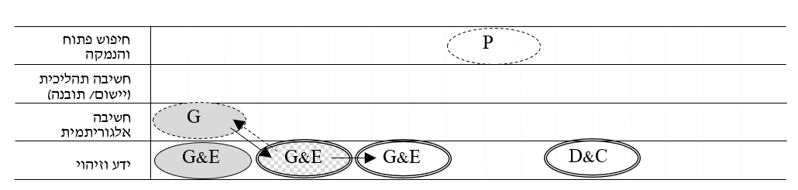

figure 1a: Bracha's lesson

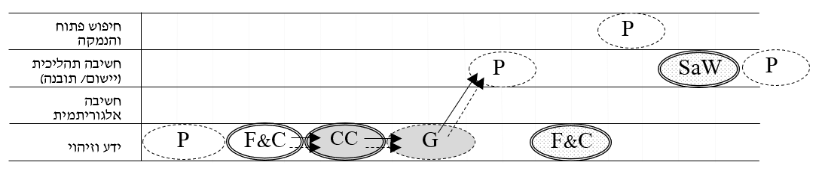

נועה figure 1b: Noaa's lesson

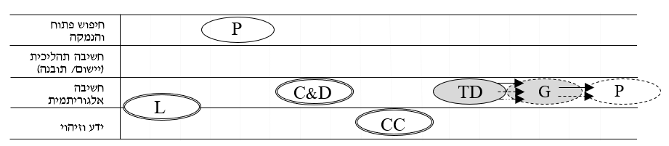

figure 1c: Sigal's lesson

Comparing the lessons show that the time in the lesson that teachers use the computer- games (shaded shape), are differed. The orchestration the teacher implements while using the game also changes between- Guide & Explain of the game content, Technical Demonstration of using the game, Gaming–students playing in the game by themselves, or Concept Clarifying- of mathematical concepts, with the game.

This research has several contributions. The methodological contribution- putting lesson description succinctly allows to compare them. The conceptual contribution- by expanding Drijvers et al. (2013) conceptualization, since the features of the game (feedback), age of students (primary school) and the learning environment (a class with head projector), allow new orchestrations. The research as a practical contribution too. It enables the instructional community to follow different lesson’s layers, when planning and implementing it.

References