Karst and cave formation at the Earth's upper crust by cooling of CO2-rich geothermal flow

Roi Roded1, Einat Aharonov2, Amos Frumkin2, Nurit Weber3, Boaz Lazar2 and Piotr Szymczak4

1Hydrology and Water Resources, The Hebrew University, Jerusalem, Israel

2Institute of Earth Sciences, The Hebrew University, Jerusalem, Israel

3Department of Earth and Planetary Sciences, The Weizmann Institute of Science, Rehovot, Israel

4Institute of Theoretical Physics, Faculty of Physics, University of Warsaw, Warsaw, Poland

**Abstract**

Porous and fractured rocks in the Earth’s upper crust continuously undergo reactive flow, altering their porosity and permeability. In carbonate aquifers, this process may produce extensive karst, with sizeable (often kilometers-long) cave systems. Of special interest are “hypogenic” karst and caves formed by upwelling deep-seated flow with no genetic connection to the surface. Despite its vast economic and environmental importance, hypogenic karst formation remains elusive.

This work combines geochemical and numerical analysis with field observations to demonstrate that cooling of CO2-rich geothermal flows, upwelling into a confined permeable layer, may induce aggressive karstification and cave forming processes (“speleogenesis”). As the water cools, carbonate solubility increases (“retrograde solubility”), inducing undersaturation, forming caves at relatively short time-scales (dozens of kyr). This process explains the location of observed caves in a presented test field case study, as well as captures the characteristics of cave morphology, and particularly the formation of the maze-like caves, typical for hypogenic karst. From a broad perspective, the findings demonstrate that the Earth’s geothermal heat loss by upwelling of thermal fluids, in conjunction with deep-seated CO2 fluxes, may extensively shape the upper crust, forming sizeable cave systems.

1. **Introduction**

Large portions of the Earth’s upper crust are dominated by carbonate aquifers, in which fluid flow transports solute and heat, driving the system out of geochemical equilibrium and inducing fluid-rock interactions1,2. The characteristic high reaction rates of carbonates result in significant void-space alterations, ranging from wide diagenetic changes to the development of karstic aquifers with the formation of extensive cave systems (“speleogenesis”)3,4. Positive and negative feedbacks arise between flow and reaction, fundamentally altering the flow processes themselves5–9. These feedbacks are important for a range of different phenomena and applications, such as sustainable management of water resources10,11, geothermal energy usage12, CO2 geological storage13,14, and mitigation of induced-seismicity hazards15.

Historically, the formation of karst and speleological systems in carbonates was attributed entirely to the percolation of CO2-enriched meteoric water (“epigenic karst”). In recent decades it is progressively understood that karst-induced by upwelling of deep-seated flows (“hypogene karst”) is common, and a considerable portion of the known caves are attributed to hypogenic origin. Since these caves form by recharge from below, they are commonly isolated, with no direct genetic link to the surface11,16,17.

Despite the abundance of hypogene processes and their wide hydrogeological implications, the formation process of hypogenic karst remains enigmatic16,18. A variety of dissolution reactions may be involved, mostly encompassing low-pH fluids as carbonic, sulfuric, or organic acids. Furthermore, various scenarios were suggested for producing fluid reactivity, including undersaturation induced by mixing of saturated solutions of different compositions (“mixing corrosion”) arising due to cross-formational flow, or processes involving water condensation on the rock walls above the water table (“condensation corrosion”). The later can be highly aggressive if induced by sulfuric vapors19–24.

Additionally, because hypogenic caves form in regions of upwelling of thermal fluids, it was suggested that dissolution may be driven by the cooling of thermal groundwater (e.g., ref. 25). Dissolution by cooling of thermal groundwater is attributed to the retrograde solubility of carbonate minerals, whereby their solubility increases as the water cools. However, this mechanism was often argued to play a minor role in speleogenesis and to only contribute to diffuse and dispersed enhancement of porosity26–28. The present work focuses on this mechanism, demonstrating that previous calculations have underestimated the speleognetic potential of cooling geothermal fluids in carbonates.

A still open question is whether the hypogene speleogenesis process may also be linked to the variety of observed natural cave morphologies and intricate patterns, whose details of formation are still enigmatic17,28–31. Unraveling the underlying physics and resulting cave morphologies is a scientific challenge that may provide a key to the understanding of hypogenic karstification.

This study examines carbonate dissolution driven by cooling geothermal flow, using diverse perspectives: first, geochemical analysis demonstrates that retrograde solubility can produce a highly aggressive karstification process. Next, a case study of a group of hypogene caves32 in a confined carbonate aquifer is used as the basis for the development of a conceptual and numerical model. Model results highlight optimal conditions for rapid development of localized dissolution and speleogenesis under cooling geothermal flow in carbonates. Lastly, we demonstrate, using a network model for dissolution along a bedding horizon, that the resulting cave morphologies are of a maze-like character, typical for hypogenic caves. In a wider context, the findings demonstrate that geothermal fluid upwelling, in conjunction with deep CO2 fluxes, may shape and extensively karstify carbonate aquifers in the upper crust, with the formation of sizable speleological structures.

1. **The conceptual model**

Our conceptual model involves groundwater flow that circulates in deep aquifers (>1 km), where it is heated and the fluid becomes considerably enriched with CO222,27,33. Under favorable hydrological conditions, this hot groundwater may upwell through permeable sub-vertical faults and fractures, driven by artesian or tectonic pressures and buoyancy forces18,27. Such upwelling often occurs in a pipe-like manner, either at fault or fracture plane intersections34–37 or at flow conduits that naturally occur on rough surfaces of fractures38,39. Rapidly ascending fluids will maintain their heat and temperature until they reach a flow barrier, e.g., a shallower aquicludic layer stratum. At this point, beneath the aquiclude, the flow will be diverted sideways radially into a permeable bedding horizon of aperture *h* in a soluble layer3,40,41. The radial flow in the horizon cools rapidly by transferring heat to the bedrock below and caprock above. Due to the retrograde solubility of carbonates, the rapid cooling leads to a large increase in calcite solubility product, and hence, the solution becomes undersaturated. This in turn, induces localized dissolution, which over time produces a large cave surrounding the inlet (cave feeder; Fig. 1).

The conceptual model described above is consistent with the configuration and morphological features of our case-study group of caves. The group comprises dozens of extended caves located along the monocline system of the Syrian arc adjacent to the Dead Sea transform in Israel. Rooted large faults at the base of the monoclines are assumed to facilitate upwelling of thermal flow, as further supported by hydrological and geochemical evidence32,42. The caves are commonly developed along prominent bedding horizons in limestone formations and overlay thick (>400 m) carbonate succession of mainly massive limestone and dolostone. The cave-forming rock layer is overlaid by low permeability layers comprising mainly soft chalk and limestone-rich in marl horizons. Speleogenesis patterns involve commonly maze-like forms and also chamber caves43. The maze caves were developed by a relatively uniform dissolution of the network of conduits formed at the intersection of the horizon and subvertical fracture network.

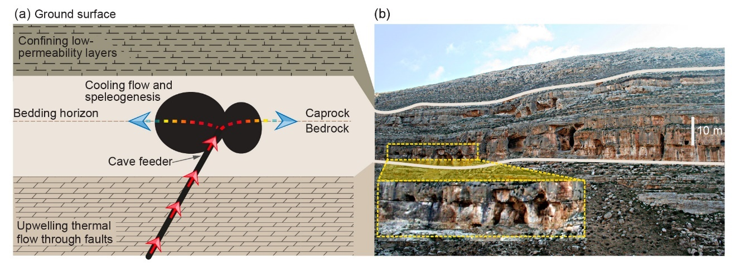

Fig. 1. The conceptual model of thermal speleogenesis (a) and case study example (b). (a) Thermal and CO2-enriched groundwater upwells through faults and fractures (red arrows and black line), upon approaching a confining low-permeability layers, flow is diverted sideways to the permeable bedding horizons in a soluble layer (dashed lines). While the flow through the fault is channelized through a conduit pathway it does not lose much of its heat. However, when it is diverted to flow radially in the horizon, it cools rapidly by transferring heat to the rock (gradient color arrows). The rapid cooling leads to a large increase in calcite solubility and solution undersaturation and inducing localized dissolution and speleogenesis (black circles). (b) A series of hypogene caves, located near Jerusalem, Israel. Beige lines highlight the borders of the main karstified limestone layer, with caves along bedding horizons and fractures (see magnification); the confining low permeability layer is located above.

The deep-seated groundwater upwelling is assumed to originate from a vast sandstone aquifer as it also contemporarily locally occurs (1-2 km), though shallower origin from carbonate aquifer cannot be excluded (<1 km). The speleogenesis duration is constrained by dated tectonical and hydrological events to a rather large time span, of the order of millions of years (Oligocene–early Miocene). Its termination is associated with Neogene uplifting and deepening of the Dead Sea transform, which led to the disconnection of the far-field groundwater flow, water level drop, and cave dewatering. Further details and a complete description of the caves and the geological setup can be found in ref. 32 and the references therein.

1. **Geochemical and mathematical analysis**

Here, analysis using the geochemical PHREEQC code is applied to estimate the dissolution capacity of cooling thermal water (section 4.1). The results of the geochemical analysis are then incorporated in numerical modelling of (I) heat transport and dissolution in a confined bedding horizon (“Axisymmetric horizon dissolution model”, AHD model), and (II) investigation of channelized dissolution and cave pattern formation using a network model. The AHD model is described in section 3.1, while the network model is described in section S5 in the Supporting Information (SI).

* 1. **Axisymmetric horizon dissolution model**

The conceptual model (section 2) is next portrayed by a simple physical system (Fig. 2). We consider fluid discharge through a central inlet of radius *r0*, accounting for the channelized upwelling. The fluid enters radially into a permeable bedding horizon at a constant temperature, *Tin*, and flow rate, *Q*. In the horizon, uniform flow and dissolution and axisymmetry are assumed (channelized flow and dissolution are considered in section 4.4.2). Furthermore, flow in the upper caprock and lower bedrock are neglected, assuming orders of magnitude contrasts in permeability11,44.

Conductive geothermal heat flux and the initial geothermal gradient are assumed negligible compared to the fluid heat input. We further assume that the vertical extent of the domain is relatively large so that the heat transfer to the surface is limited. Otherwise, the cooling rate will be larger and dissolution and speleogenesis even more localized near the inlet.

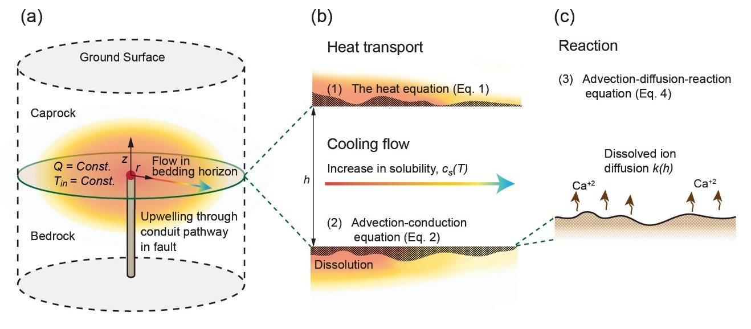

Fig. 2. The numerical AHD model geometry (a), and close-ups showing heat transport in the horizon (b) and the surface reaction (c). (a) Fluid discharges from a pipe through an inlet of radius *r0* (redpoint) with total flow rate, *Q*, and temperature, *Tin*. The flow is distributed radially, where it cools by transferring heat to the bedrock and caprock (color gradient arrow). (b) As the fluid cools, saturation concentration, *cs(T)*, increases, inducing carbonate dissolution. Heat transport is governed by conduction in the rock and by the advection-conduction equation in the fluid, with heat exchange term accounting for conduction between the rock and fluid, *Θ*. (c) Similarly, solute transport is calculated using an advection-diffusion-reaction equation. For reaction, we assume a fully transport-limited reaction that depends on the mass transfer coefficient, *k(h)*.

Closed-system conditions are assumed and that the fluid pressure, *p*, in the confined aquifer is higher than the thermal water CO2 partial pressure (PCO2), such that no degassing takes place. Under unconfined conditions degassing of CO2 close to the water table can diminish undersaturation and can lead to supersaturation and precipitation21,45,46. Because the cavities are formed as isolated voids the overall permeability of the system is not altered considerably, allowing us to assume constant flow rate discharge27. Such an assumption breaks down only when dissolution approaches the surface outlet, i.e., a breakthrough is achieved47.

Section S3 (SI) presents a theoretical analysis for dissolution in a uniform horizon as a result of heat exchange with the rock and fluid cooling. This analysis is then used to validate the numerical model presented here and implemented in a finite-difference code (see sections S4 and S2.3); the physical parameter notations and values are given in Tables S1 and S4, respectively.

* + 1. **Heat transport**

Heat transport in the rock, confining the horizon above and below (Fig. 2), is governed by the heat equation, which in polar coordinates takes the form,

$$\frac{∂T}{∂t}=\frac{α_{r}}{r}\frac{∂}{∂r}\left(r\frac{∂T}{∂r}\right)+α_{r}\frac{∂^{2}T}{∂z^{2}}, (1)$$

where *T* is temperature, *t* is time, and *r* and *z* are the radial and vertical coordinates, with their origins defined at the inlet. *αr=Kr/ρrCpr* is the thermal diffusivity where subscript *r* denotes rock and *K* is thermal conductivity, *ρ* density and *Cp* the heat capacity48.

Assuming heat transport in the horizon is governed by advection and conduction, and complete mixing along the horizon aperture, “depth-averaged” heat transport equation can be written as,

$$\frac{∂\left(hT\right)}{∂t}=-\frac{1}{r}\frac{∂\left(rqT\right)}{∂r}+\frac{α_{f}}{r}\frac{∂}{∂r}\left(hr\frac{∂T}{∂r}\right)+Θ\left(r,t\right), (2)$$

where *h* is the aperture, *q* is the fluid velocity integrated over *h* [L2/T] and calculated from the total volumetric flow rate, *Q*, using *q=Q/(2πr)*, *αf* is the fluid thermal diffusivity26,49. *Θ* accounts for the heat exchange with the bedrock and caprock and calculated using Fourier's law,

$$Θ=\frac{2Κ_{r}}{ρ_{f}C_{p_{f}}}\frac{∂T}{∂|z|}. (3)$$

The complete mixing approximation can be posterior validated and is justified since transverse temperature gradients in the horizon remain relatively small throughout speleogenesis.

* 1. **Reactive transport**

The depth-averaged solute transport advection-diffusion-reaction equation is,

$$0=-q\frac{∂c}{∂r}+\frac{D}{r}\frac{∂}{∂r}\left(hr\frac{∂c}{∂r}\right)+Ω\left(r,t\right), (4)$$

where *c* is the (depth) averaged dissolved calcite ions concentration, *D* is the molecular diffusion coefficient and *Ω* is the reaction term50,51. In Eq. 4 transient terms are neglected and the quasi-static approach is justified by the separation of time-scales between mineral dissolution and flow and solute concentration relaxation (ref. 52 and the references therein).

Here, the initial PCO2 is relatively high and kinetics is rapid and the rate-limiting step for the reaction is the diffusion of reaction products away from the mineral surface so that undersaturation is sustained26,53,54. *Ω* is proportional to the difference between *cs* (*c* at calcite saturation or equilibrium at the given conditions) and *c* and defined as,

$$Ω=2k(h)ε(c_{s}(T)-c), (5)$$

where *k(h)* is the mass transfer coefficient that is inversely proportional to the aperture, *h*, *ε* is a geometrical correction term, which accounts for the aperture inclination that develops following dissolution and the factor of 2 accounts for the upper and lower surfaces. The complete derivation of Eq. 5 and its justification are provided in section S2 (SI).

The saturation concentration, *cs,* depends on the temperature, *cs(T)*, and is represented as a Taylor expansion, accounting for retrograde solubility,

$$c_{s}\left(T\right)=c_{s}\left(T_{0}\right)-β(T-T_{0}), (6)$$

using the constant *β* evaluated from the data presented in section 4.1 and *T0* is the reference (ambient) temperature. Last, the change in the horizon aperture can then be calculated using,

$$\frac{∂h}{∂t}=\frac{Ω}{υc_{sol}}\left(c_{s}\left(T\right)-c\right), (7)$$

where *ν* is stoichiometric constant and *csol* is the soluble solid concentration within the solid rock.

* 1. **Initial and boundary conditions**

The initial conditions are constant temperature, *T0*=20 oC. The boundary conditions at the horizon inlet (*r=r0*) are constant volumetric flow rate, *Q*, of fluid that has a temperature of *Tin*=60 oC and initially no undersaturation, *θ*=0, where *θ=(cs(T)-c)/∆cs0* and *∆cs0=cs(T0)-cs(Tin)*. Here, we model conditions of a large domain, such that no substantial heat transport takes place near the boundaries and affects the results (*r*→*∞* and|*z*|→*∞*). In practice, the extent in *z* and *r* is set to 1 km. At the upper surface, constant temperature *T0* is set and at the horizon outlet (*r*=1 km) the temperature and concentration are calculated from thermal and solute conservation equations (Eq. 2 and 4; free-flow boundary); the rest of the boundaries were assumed as thermally insulating with zero conductive flux.

1. **Results and discussion**
   1. **Geochemical analysis**

Groundwater compositions encountered in deep-seated aquifers commonly demonstrate that PCO2 is approximately in equilibrium with the given rock composition, temperature and pressure conditions. This equilibrium is promoted by the large CO2 fluxes originating, for example, from magmatic fluxes and organic matter decomposition33,55–57. PCO2 is typically much higher for pore-water in sandstone and carbonate aquifers compared to crystalline aquifers33.

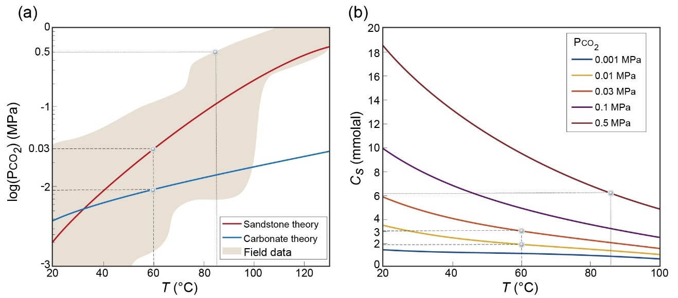 Fig. 3. (a) Theoretical predictions of the dependence of PCO2 on temperature, for clastic sandstone (red line) and carbonate (blue line) confined aquifers and range of field data for sedimentary aquifers (carbonate and clastic rocks, brown region; modified after ref. 33,57). For *T*≳30 oC pore-water PCO2 becomes progressively higher in sandstone aquifers compared to carbonate aquifers and PCO2 can be higher than 0.5 MPa for *T*≳85 oC (marked by dotted lines). (b) Thermodynamic calculations of calcite concentration at saturation vs. temperature, *cs(T)*, for different initial PCO2 values. Calcite retrograde solubility is sensitive to initial PCO2; the higher the initial PCO2 the larger the *cs* and the potential of the fluid to induce aggressive dissolution. Here, inlet fluid temperature of *Tin*=60 oC is considered in the numerical calculations and marked by dashed lines. The chemical composition of aquifer water and the rock are presented in Tables S2 and S3 (SI).

In Fig. 3a are provided theoretical predictions of PCO2 for sandstone (red line) and carbonate (blue line) aquifers obtained using PHREEKQC (v.3.7.0)58 and range of field data for sedimentary aquifers (i.e., carbonate and clastic rocks, brown region)33,57. In the calculations, a confined aquifer and closed system conditions are assumed, and representative values of fluid pressure and compositions are used and given in Tables S2 and S3 (SI). For slightly elevated temperatures (*T*≳30 oC) PCO2 becomes progressively higher for sandstone aquifers compared to the carbonate ones.

The curves for calcite concentration at saturation vs. temperature, *cs(T)*, for different values of PCO2, demonstrate a large sensitivity of calcite retrograde solubility to PCO2 (Fig. 3b). Thus, cooling water with high initial PCO2 leads to considerable calcite undersaturation as indicated by the substantial increase in *cs*. Accordingly, for water from sandstone aquifer of a temperature of 60 oC (1.5-2 km depth) and PCO2≈0.03 MPa that upwells and discharges to a shallow aquifer and cools to 20oC, the saturation concentration can change by *cs(T=*20 oC*)-cs(T=*60 oC*)≈*3 mmolal. In carbonate aquifer, PCO2 at these conditions is PCO2≈0.01 MPa and *cs(T=*20 oC*)‑cs(T=*60 oC*)≈*1.5 mmolal (see dashed lines in Fig. 3b). For comparison, in epigenic karst conditions under atmospheric pressure typical value is *cs*=2 mmolal59, demonstrating that these conditions favor karst formation.

Furthermore, the available field data show that in sandstone pore-water PCO2 can be as high as 0.5 MPa for temperatures ≳85 oC and *cs* can change by more than 12 mmolal when cooled to 20 oC (see dotted lines in Fig. 3). At these conditions, a relatively small seepage of *Q*=1 m3/day of cooling water, will dissolve 1 cubic meter of limestone rock of density *ρr*=2400 kg/m3 within ~5 yr and potentially can form a cave during a period of several hundreds of years. The upwelling of thermal groundwater from sandstone formations following long-range migration to shallower strata and carbonate aquifers is a common scenario60, which likely occurs for our case study in Israel (see section 4.3). However, the large time-scales of millions of years associated with hypogene karstification16,32 also permits speleogenesis with relatively low PCO2 (e.g., 0.001 MPa) and small temperature decrease of only a several degrees.

In summary, this analysis indicates that carbonate dissolution due to cooling and retrograde solubility can be a major and sometimes a highly aggressive karstification process that can possibly form cave systems over relatively short time-scales.

* 1. **Cave formation by localized dissolution**

The results obtained by solving the coupled equations 1-7, in the setting of Fig 2, show that upon flowing in the horizon, groundwater cools quickly (from 60 oC at the inlet to 25 oC at *r*=10 m; Fig. 4a). The quick cooling is promoted by the conditions of a localized source of low discharge48, hence the fluid reaches quasi-steady state after ~50 yr. The fluid is hot and fully saturated at the inlet, *c=cs(Tin)*, and undersaturation, *θ*,then grows downstream and forms a characteristic convex shape (Fig. 4b). Undersaturation along the flow path is controlled by the interplay between (I) reaction that acts to reduce undersaturation, (II) progressive cooling that renews reactivity by elevating *cs*, and (III) advection that transports reaction products away and sustains undersaturation, its effect decaying as 1/*r*.

Close to the inlet, the high advection and cooling rates lead to a buildup of undersaturation. Further downstream, cooling and advection rates are much lower, and undersaturation decreases due to the dissolution reaction. Accordingly, the cave profile develops a pronounced maximum few meters away from the inlet point (Fig. 4c). Over time, following aperture, *h*, grow, a slowing rate of diffusion across the aperture also dampens the reaction. In turn, the slower reaction leads to the further buildup of undersaturation, with its maximum migrating progressively downstream (arrow in Fig. 4b).

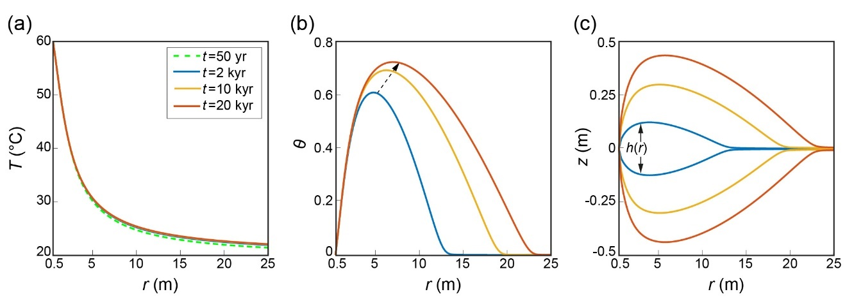

Fig. 4. Evolution of temperature, *T*, solute undersaturation, *θ*, and aperture profile, *h*, at the horizon along the radialdirection, *r*. (a) Upon flowing into the horizon, the water quickly cools; the temperature curves overlap showing a relatively brief (~50 yr) approach to a quasi-steady thermal state. (b) Fluid cooling leads to a large increase in undersaturation, which first peaks and then decreases downstream due to the dissolution reaction. (c) Accordingly, the cave profile develops a pronounced maximum a few meters away from the inlet. In addition, as the cave widens (i.e., the growth of *h* with time) dissolution reaction becomes hindered by diffusion resulting in a gradual increase in undersaturation with its maximum moving progressively downstream (arrow in (b)).

The flow rate magnitude, *Q*, has an important effect on karstification, affecting the aspect ratio of the void created as a result of dissolution. We define the degree of dissolution focusing, *η=hp/lv*, as the ratio between the maximum (peak) aperture, *hp*, and the inner length of the void, *lv*, calculated from the interval in which *h*>1.01*h0* (Fig. 5). Lower flow rates elevate *η*, producing increasingly localized dissolution with time (measured here by the total fluid volume discharge, *Vf=Qt*). Higher flow rates result in a lower *η* (more elongated void) due to a twofold advective effect: (I) heat is transported further downstream, leading to more gradual cooling and renewed reactivity, and (II) undersaturated fluid has lower residence time and is flushed further away down the flow path, sustaining dissolution to a greater distance from the inlet.

The evolution of *η* shows a power-law dependence on the total volume of fluid discharged, *Vf*, and inverse proportionality to the flow rate, *η(Q)=(a/Q)Vfτ*, with the constants *a* and *τ* (inset in Fig. 5). Our results emphasize that speleogenesis (high *η*) favors low flow rates, otherwise only diffuse aperture change, or diagenetic alterations develop in the aquifer61–63. Low flow rates are also often associated with the upwelling of thermal flows from depth (>1 km) and thermal seepages and springs discharge17,60,64,65.

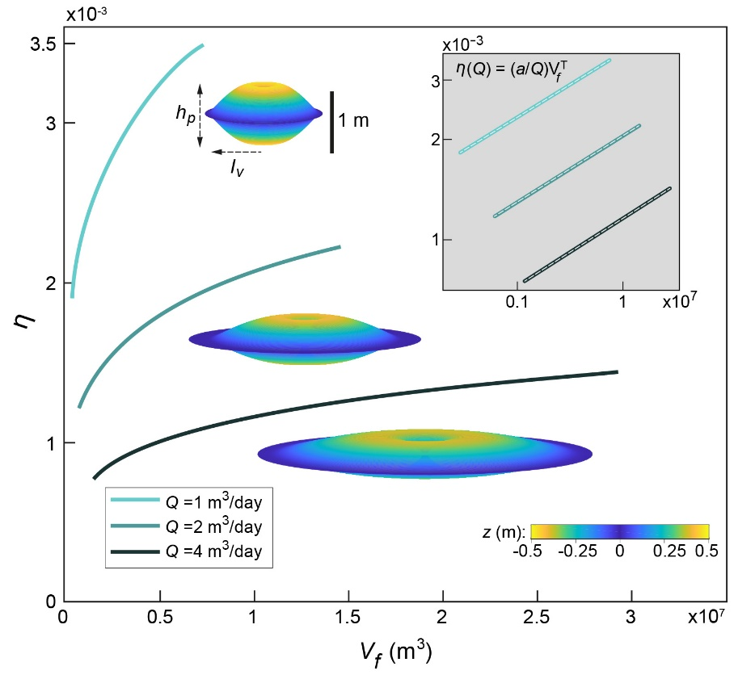

Fig. 5. Degree of dissolution focusing, *η*, vs. fluid volume discharge, *Vf*=*Qt*, for different flow rates, *Q*, between *t*=1 to 20 kyr. *η=hp/lv*, where *hp* is the maximum aperture and *lv* is the inner length of the void, calculated from the interval in which *h*>1.01*h0*. Lower flow rates lead to a progressively larger *η* and localized dissolution, as demonstrated by the 3-D visualizations of the cavities after 20 kyr; axis origin is located at the center and vertical dimension, *h*, is rescaled by a factor of 30 relative to length. The log-log plots in the inset show the power-law fits (gray dashed line), *η(Q)=(a/Q)Vfτ* with *a* ranges between 1.45x10-4 to 1.8x10-4 and *τ*=0.2.

The results demonstrate that the time-scale of speleogenesis and formation of human size passages due to cooling of CO2-rich geothermal flow is several dozen of thousands of years. This time-scale will change with the assumed value of PCO2. However, this indicates that the time-scale of speleogenesis at these conditions is comparable to the typical epigenic speleogenesis time-scales3,28 and can often be even shorter. This is in contradiction to the earlier estimates suggesting that hypogene speleogenesis requires exceedingly long time-scales (e.g., ~1 Ma)17,28. Specifically, early calculations of dissolution by rising thermal waters (ref. 28, pp-18), assumed rather low values of cooling rates and thermal gradients (5 oC/100 m). These led the author to conclude that “only under the most favorable conditions can dissolution by cooling of thermal water produce caves of traversable size. Even then, times on the order of 105 to 106 yr required.”.

* 1. **Confined speleogenesis and the case study**

The geometrical configuration of the caverns in mathematical model is compatible with the field observations in our case-study, demonstrating the formation of caves under confined conditions. For localized dissolution and speleogenesis to take place, both a substantial geochemical driving force and an appropriate hydrogeological setup need to exist. The hydrogeological conditions that facilitate speleogenesis are (I) channelized upwelling flow through a fault thanks to which the groundwater remains hot; (II) aquifer confinement that promotes rapid cooling by a transition from channelized upwelling flow to lateral radial flow in the horizon and substantial heat exchange with the rock, as seen in Fig. 1; (III) relatively low groundwater discharge that promotes localized dissolution and cave formation. Continues low discharge is ensured by isolated caves, with no connection to the surface, so that the overall system permeability and fluid flux do not appreciably change during speleogenesis27.

Conversely, it was shown that when thermal flow upwells through a fault and discharges to the surface (i.e., unconfined conditions) advection rate increases with dissolution. This occurs either due to overall system permeability and flow rate increase26 or by the development of localized dissolution channels where advection rate is high49. In turn, the high advection rate leads to the formation of low thermal gradients and promotes more gradual dissolution along most of the fault or channels, and only towards the surface the cooling rate increases and dissolution rate becomes high. However, it is not clear if in most instances under typical PCO2 a cave can form at shallow depth, because of the CO2 degassing, and consequently solution supersaturation and precipitation that often take place in proximity to the surface16,21. In fact, the upwelling of the flow, underlying the hypogenic processes, inherently implies a certain degree of hydrogeological confinement because of the ubiquitous layered heterogeneity in sedimentary basins. Consequently, confined conditions are frequent and are rather the rule for most hypogenic karstifications27.

In terms of the origin of upwelling flow and geochemical driving force, we note that the case study caves are assumed to form by upwelling from clastic sandstone aquifer32,66. This aquifer is deeper (and hotter) than the carbonate aquifer and was shown here to be associated with substantially higher PCO2 (section 4.1 and Fig. 3a). Nevertheless, the possible long time span of speleogenesis and the commonly large time-scale associated with tectonical and hydrogeological processes (on the order of 105 years and longer) does not permit to exclude the shallower carbonate aquifer origin of the upwelling groundwater. Particularly, the large time-scale permits the formation of the caves even by geothermal waters that are only a few degrees warmer than the temperature of the surrounding rock masses. Additionally, especially large and spacious cave systems in the case study group are presumably associated with large time spans or alternatively high reactivity flow. These large voids can also become mechanically unstable and associated with documented large collapses and sinkholes67,68.

* 1. **Cave’s morphologies and pattern formation**

The analysis in previous sections demonstrates the feasibility of a mechanism of cave formation by confined thermal flows. This section investigates more detailed characteristics of the cave’s morphologies. First, we present and discuss observations regarding the characteristic shape of the caverns predicted by the AHD model, with the maximum aperture located away from the feeder (Fig. 4c). This is followed by a brief analysis of the cave passage patterns formation. There are smaller-scale morphologic features (meso-morphology) that are characteristic of hypogene processes, e.g., smooth walls, cupolas, and solution pockets27,32,43. However, here we do not focus on such features, as these, in many instances, do not comprise accurate and conclusive indicators for specific processes17,27,69.

* + 1. **Characteristic cave profile**

In the group of caves under investigation, cave feeders in most locations cannot be identified since they are covered by debris and sediments. Below, we present two unique observations of hypogene karst caves in Israel, in a similar setting to our case study (Fig. 6). In these caves feeders are identified, allowing a direct comparison of the cave morphology to the results of section 4.2.

Cave (a) includes feeders and dissolution features along a prominent oblique fracture or fault (red dashed line), comprising the backbone of the three-dimensional maze cave66. While feeders and dissolution along the fracture are clearly seen in many parts of the cave, the largest chambers and their ceiling peaks (A.1-5) are prominently located several to 20 meters away from the fracture and feeders (Fig. 6a). Similarly, observation in the cave (b) demonstrates a characteristic convex profile with the most spacious region appearing ∼10 meters from the inlet and diminishing passage sizes further downstream, see plan-view and respective vertical profile a-a’ in Fig. 6b70.

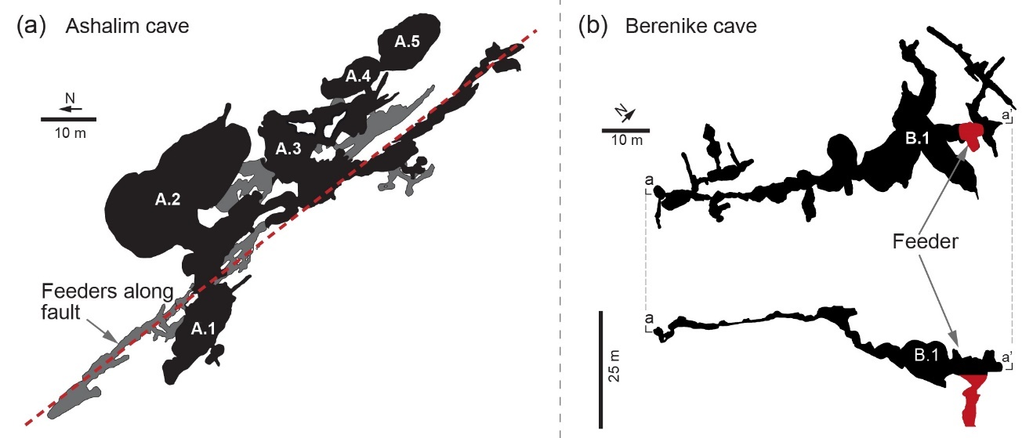

Fig. 6. Morphology of two hypogenic caves with identified feeders. (a) In Ashalim cave, feeders are visible at the lower level along a fracture (dashed red line). The largest chambers (A.1-5) and their ceiling maximal height are prominently located several to 20 meters away from the fracture and feeders; gray zones mark overlapped lower levels66. (b) Berenike Cave upper level in plan-view (above) and its vertical profile a-a’ (below). The largest hall (B.1) is located ∼10 meters away from the feeder (red region) and cave morphology has a convex shape profile with passages size gradually decaying downstream70.

In other caves from our case study group feeders are rarely identified, and morphological characteristics associated with dissolution by thermal flows possibly can be observed. However, these features are less clear, e.g., due to morphological reshaping by mechanical collapses and sedimentation71.

* + 1. **Maze pattern formation**

Hypogene caves are often characterized by intricate maze or sponge-like patterns with many closed loops, which are formed by relatively uniform dissolution of the pre-existing void-space, commonly angular fracture networks11,17,27. This is in marked contrast to the common epigenic branchwork caves formed by competitive dynamics9,72. Several mechanisms for maze caves genesis were previously suggested and studied for different hydrogeological setups, including epigenic and hypogenic origins (see summary in ref. 17,28). These, among others, include uniform floodwater flow into fracture networks, e.g., by a sinking stream73,74, or by distributed ascending groundwaters through the cave-forming layer, which enlarges uniformly the fractures and forms a maze pattern (“the transverse hypogenic cave origin model”, THCOM16,75–77).

THCOM assumes a soluble rock layer sandwiched between permeable but insoluble strata and recharge from below. The insoluble strata sustain distributed flow and precludes channelized flow that may develop in soluble rock due to preferential dissolution. The flow is then predominantly vertical and distributed, discharging via multiple feeders and leads to enlargement of all major fractures in the soluble rock at comparable rates. A prominent case-study example for the THCOM are the giant gypsum caves in Ukraine17,78. The THCOM setup requires a confined soluble layer between permeable and insoluble layers, and it cannot explain the formation of caves in aquifers confined by impermeable caprock layer, as in our case study. Nor can it explain the formation of the caves in soluble carbonate rock successions, which remains largely obscure17,32. The inapplicability of THCOM to our case study is also evident from the lack of multiple ceiling and floor feeders, which are invoked in the THCOM.

Fig. 7. Caves with the characteristic maze-like pattern ((a) Chariton and (b) Qina)32 and (c) simulation results using a network model for dissolution by cooling and retrograde solubility in fractured bedding horizon. Simulations produce a typical maze-like pattern characterized by many closed loops over 43 kyr; only passages of one-meter width or larger are shown. Fig. S3 and Fig. S4 (SI) show the initial fracture distribution and the progression of speleogenesis up to the final state shown in (c).

Here, we present an additional model, extending the AHD model presented in section 3.1, to demonstrate maze cave formation by the radially cooling geothermal flow. This model simulates point injection of geothermal flow to a dissolving network of conduits in a fractured bedding horizon, due to cooling and retrograde solubility (see section S5 (SI) for details). In running the model, we exploit the fact that the temperature distribution is to a good approximation time-invariant, as demonstrated in section 4.1.

The most prominent attribute of the maze pattern, compared with other speleological patterns such as the common epigenic branchwork caves, is the appearance of many closed-loops17. This is seen in the plan-views of the caves (Fig. 7a and b) and in the corresponding simulation results (Fig. 7c). The maze pattern captured by the simulations was obtained with a relatively low flow rate, *Q*=2 m3/day, characteristic of thermal flows and seepages17,60,64,65. This result demonstrates the formation of maze-caves without diffuse infiltration through an insoluble layer as commonly suggested17,27,28,77,79, and the inherent tendency of confined artesian flows to develop maze caves in carbonate rock successions.

An additional prominent phenomenon observed in the simulation results is the merging of adjacent passages in some areas to form merged halls (bulky black regions, Fig 7c), which can explain the formation of some of the prevalent halls encountered in maze caves (see e.g., Fig. 7a and b)32.

1. **Summary and Conclusions**

The geochemical analysis suggests that due to a high initial PCO2 and the retrograde solubility of carbonates, cooling of deep-seated geothermal flow can produce highly aggressive solutions and hypogene karstification. The numerical analysis further reveals that when such a channelized upwelling flow discharges to a confined aquifer it promotes localized dissolution and speleogenesis. The localized dissolution is promoted by continuous low flow rate discharge, typical to upwelling thermal flows. In contrast to previous estimations, it is shown that such a process can commonly form a cave at relatively short time-scales of several dozens of kyr.

Dissolution by this process can further explain the location of the caves and major characteristics of hypogene cave morphologies observed in nature. The model predicts that maximal dissolution rate is attained a few meters downstream from the inlet, for which corresponding field observations are presented. Moreover, the maze-pattern caves, typical to hypogene speleogenesis, are shown to be formed under confined conditions and in carbonate rocks successions, which have not been explained by previous models. Under these conditions, thermal water can flow from a vertical inlet into the network of conduits in a bedding horizon and create a maze cave by lateral flow which does not escape upwards.

From a broad perspective, the study emphasizes the link between global geothermal heat and the global carbon balances: the Earth’s geothermal heat loss in conjunction with the large deep-seated CO2 fluxes induce transformations of the upper crust carbonate strata and form extensive speleological systems, which in turn affect back CO2 fluxes.

**Acknowledgements**

We thank P. Lu for sharing the field data used in Fig. 3a.

**Author contributions**

R. Roded contributed by planning and conducting the research and writing the manuscript. E. Aharonov and P. Szymczak contributed by planning the research and writing the manuscript. A. Frumkin contributed by planning the research and guiding field trips. N. Weber and B. Lazar conducted the geochemical analysis and contributed to the writing of the manuscript.

**Competing interests**

The authors declare no competing interests

**Correspondence** and requests for materials should be addressed to E.A or to R.R (emails: [einatah@mail.huji.ac.il](mailto:einatah@mail.huji.ac.il); [roi.roded@mail.huji.ac.il](mailto:roi.roded@mail.huji.ac.il)).

**References**

1. Agar, S. M. & Geiger, S. Fundamental controls on fluid flow in carbonates: current workflows to emerging technologies. *Geol. Soc. Lond. Spec. Publ.* **406**, 1–59 (2015).
2. Jamtveit, B. & Hammer, Ø. Sculpting of rocks by reactive fluids. *Geochem. Perspect.* **1**, 341–342 (2012).
3. Dreybrodt, W. *Processes in karst systems, physics, chemistry, and geology*. (Springer, 1988).
4. Phillips, O. M. *Geological fluid dynamics: sub-surface flow and reactions*. (Cambridge University Press, 2009).
5. Aharonov, E., Whitehead, J. A., Kelemen, P. B. & Spiegelman, M. Channeling instability of upwelling melt in the mantle*. J. Geophys. Res. Solid Earth* **100**, 20433 (1995).
6. Aharonov, E., Spiegelman, M. & Kelemen, P. Three-dimensional flow and reaction in porous media: Implications for the Earth’s mantle and sedimentary basins. *J. Geophys. Res. Solid Earth* **102**, 14821–14833 (1997).
7. Aharonov, E., Tenthorey, E. & Scholz, C. H. Precipitation sealing and diagenesis: 2. Theoretical analysis. *J. Geophys. Res. Solid Earth* **103**, 23969 (1998).
8. Ortoleva, P., Chadam, J., Merino, E. & Sen, A. Geochemical self-organization II; the reactive-infiltration instability. *Am. J. Sci.* **287**, 1008–1040 (1987).
9. Szymczak, P. & Ladd, A. J. C. The initial stages of cave formation: Beyond the one-dimensional paradigm. *Earth Planet. Sci. Lett.* **301**, 424–432 (2011).
10. Bakalowicz, M. Karst and karst groundwater resources in the Mediterranean. *Environ. Earth Sci.* **74**, 5–14 (2015).
11. Ford, D. & Williams, P. *Karst hydrogeology and geomorphology* (John Wiley & Sons, 2007).
12. Huenges, E. & Ledru, P. *Geothermal energy systems: exploration, development, and utilization*. (John Wiley & Sons, 2011).
13. Fu, X., Cueto-Felgueroso, L. & Juanes, R. Pattern formation and coarsening dynamics in three-dimensional convective mixing in porous media. *Philos. Trans. R. Soc. Math. Phys. Eng. Sci.* **371**, 20120355 (2013).
14. Snæbjörnsdóttir, S. Ó. et al. Carbon dioxide storage through mineral carbonation. *Nat. Rev. Earth Environ.* **1**, 90–102 (2020).
15. Rattez, H., Disidoro, F., Sulem, J. & Veveakis, M. Influence of dissolution on long-term frictional properties of carbonate fault gouge. *Geomech. Energy Environ.* **26**, 100234 (2021).
16. Klimchouk, A. Types and settings of hypogene karst. In *Hypogene Karst Regions and Caves of the World* 1–39 (Springer, 2017).
17. Palmer, A. N. Distinction between epigenic and hypogenic maze caves. *Geomorphology* **134**, 9–22 (2011).
18. Audra, P. & Palmer, A. N. Research frontiers in speleogenesis. Dominant processes, hydrogeological conditions and resulting cave patterns*. Acta Carsologica* **44**, (2015).
19. De Vriendt, K., Pool, M. & Dentz, M. Heterogeneity‐Induced Mixing and Reaction Hot Spots Facilitate Karst Propagation in Coastal Aquifers. *Geophys. Res. Lett.* **47**, e2020GL087529 (2020).
20. De Waele, J. et al. Sulfuric acid speleogenesis (SAS) close to the water table: examples from southern France, Austria, and Sicily. *Geomorphology* **253**, 452–467 (2016).
21. Dublyansky, Y. Hydrothermal caves. In *Encyclopedia of caves* 546–552 (Elsevier, 2019).
22. Gabrovšek, F. & Dreybrodt, W. Early hypogenic carbonic acid speleogenesis in unconfined limestone aquifers by upwelling deep-seated waters with high CO2 concentration: a modelling approach*. Hydrol. Earth Syst. Sci.* **25**, 2895–2913 (2021).
23. Mylroie, J. E. Coastal caves. In *Encyclopedia of Caves* 301–307 (Elsevier, 2019).
24. Polyak, V. J., Hill, C. A., Asmerom, Y. & Decker, D. D. A Conceptual Model for Hypogene Speleogenesis in Grand Canyon, Arizona. In *Hypogene Karst Regions and Caves of the World* 555–564 (Springer, 2017).
25. Bakalowicz, M. J., Ford, D., Miller, T., Palmer, A. & Palmer, M. Thermal genesis of dissolution caves in the Black Hills, South Dakota. *Geol. Soc. Am. Bull.* **99**, 729–738 (1987).
26. Andre, B. J. & Rajaram, H. Dissolution of limestone fractures by cooling waters: Early development of hypogene karst systems. *Water Resour. Res.* **41**, (2005).
27. Klimchouk, A. Speleogenesis—Hypogenе. In *Encyclopedia of Caves* 974–988 (Elsevier, 2019).
28. Palmer, A. N. Origin and morphology of limestone caves. *Geol. Soc. Am. Bull.* **103**, 1–21 (1991).
29. Audra, P., Mocochain, L., Bigot, J.-Y. & Nobécourt, J.-C. Morphological indicators of speleogenesis: hypogenic speleogens. *Hypogene Speleogenesis Karst hydrogeology of artesian basins. pp 17À22. Simferopol Ukr. Inst. Speleol. Karstology Spec. Pap. 1* (2009).
30. Covington, M. D. & Perne, M. Consider a cylindrical cave: A physicist’s view of cave and karst science. *Acta Carsologica* **44**, (2016).
31. Kaufmann, G., Gabrovšek, F. & Romanov, D. Deep conduit flow in karst aquifers revisited. *Water Resour. Res.* **50**, 4821–4836 (2014).
32. Frumkin, A., Langford, B., Lisker, S. & Amrani, A. Hypogenic karst at the Arabian platform margins: Implications for far-field groundwater systems. *GSA Bull.* **129**, 1636–1659 (2017).
33. Coudrain-Ribstein, A., Gouze, P. & de Marsily, G. Temperature-carbon dioxide partial pressure trends in confined aquifers. *Chem. Geol.* **145**, 73–89 (1998).
34. Craw, D. Fluid flow at fault intersections in an active oblique collision zone, Southern Alps, New Zealand. *J. Geochem. Explor.* **69**, 523–526 (2000).
35. Hyman, J. D. & Dentz, M. Transport Upscaling under Flow Heterogeneity and Matrix-Diffusion in Three-Dimensional Discrete Fracture Networks. *Adv. Water Resour.* **155**, 103994 (2021).
36. Micklethwaite, S. & Cox, S. F. Progressive fault triggering and fluid flow in aftershock domains: Examples from mineralized Archaean fault systems. *Earth Planet. Sci. Lett.* **250**, 318–330 (2006).
37. Tripp, G. I. & Vearncombe, J. R. Fault/fracture density and mineralization: a contouring method for targeting in gold exploration. *J. Struct. Geol.* **26**, 1087–1108 (2004).
38. Ishibashi, T., McGuire, T. P., Watanabe, N., Tsuchiya, N. & Elsworth, D. Permeability evolution in carbonate fractures: Competing roles of confining stress and fluid pH. *Water Resour. Res.* **49**, 2828–2842 (2013).
39. López, D. L. & Smith, L. Fluid flow in fault zones: Influence of hydraulic anisotropy and heterogeneity on the fluid flow and heat transfer regime. *Water Resour. Res.* **32**, 3227–3235 (1996).
40. Auler, A. S. Caves and Speleogenesis in the Lagoa Santa Karst. In *Lagoa Santa Karst: Brazil’s Iconic Karst Region* 167–186 (Springer, 2020).
41. Filipponi, M., Jeannin, P.-Y. & Tacher, L. Evidence of inception horizons in karst conduit networks. *Geomorphology* **106**, 86–99 (2009).
42. Frumkin, A. & Gvirtzman, H. Cross-formational rising groundwater at an artesian karstic basin: the Ayalon Saline Anomaly, Israel. *J. Hydrol.* **318**, 316–333 (2006).
43. Frumkin, A. & Fischhendler, I. Morphometry and distribution of isolated caves as a guide for phreatic and confined paleohydrological conditions. *Geomorphology* **67**, 457–471 (2005).
44. Klimchouk, A. et al. Hypogenic origin, geologic controls and functional organization of a giant cave system in Precambrian carbonates, Brazil. *Geomorphology* **253**, 385–405 (2016).
45. Meakin, P. & Jamtveit, B. Geological pattern formation by growth and dissolution in aqueous systems. *Proc. R. Soc. Math. Phys. Eng. Sci.* **466**, 659–694 (2010).
46. Polyak, V., Hill, C. & Asmerom, Y. Age and evolution of the Grand Canyon revealed by U-Pb dating of water table-type speleothems. *Science* **319**, 1377–1380 (2008).
47. Szymczak, P. & Ladd, A. J. C. Wormhole formation in dissolving fractures. *J. Geophys. Res. Solid Earth* **114**, 1–22 (2009).
48. Stauffer, F., Bayer, P., Blum, P., Giraldo, N. M. & Kinzelbach, W. *Thermal use of shallow groundwater*. (CRC Press, 2019).
49. Chaudhuri, A., Rajaram, H. & Viswanathan, H. Early‐stage hypogene karstification in a mountain hydrologic system: A coupled thermohydrochemical model incorporating buoyant convection. *Water Resour. Res.* **49**, 5880–5899 (2013).
50. Hanna, R. B. & Rajaram, H. Influence of aperture variability on dissolutional growth of fissures in karst formations. *Water Resour. Res.* **34**, 2843–2853 (1998).
51. Szymczak, P. & Ladd, A. J. C. Reactive-infiltration instabilities in rocks. Fracture dissolution. *J. Fluid Mech.* **702**, 239–264 (2012).
52. Roded, R., Aharonov, E., Holtzman, R. & Szymczak, P. Reactive flow and homogenization in anisotropic media. *Water Resour. Res.* p.e2020WR027518. (2020).
53. Fu, X., Cueto-Felgueroso, L., Bolster, D. & Juanes, R. Rock dissolution patterns and geochemical shutdown of–brine–carbonate reactions during convective mixing in porous media. *J. Fluid Mech.* **764**, 296–315 (2015).
54. Golfier, F. et al. On the ability of a Darcy-scale model to capture wormhole formation during the dissolution of a porous medium. *J. Fluid Mech.* **457**, 213–254 (2002).
55. Ceriotti, G., Geloni, C., Dalla Rosa, M., Guadagnini, A. & Porta, G. Probabilistic modeling of field-scale CO2 generation by carbonate–clay reactions in sedimentary basins. *Hydrol. Earth Syst. Sci.* **25**, 3539–3553 (2021).
56. Cerón, J. C., Pulido-Bosch, A. & Bakalowicz, M. Application of principal components analysis to the study of CO2-rich thermomineral waters in the aquifer system of Alto Guadalentín (Spain). *Hydrol. Sci. J.* **44**, 929–942 (1999).
57. Lu, P., Luo, P., Zhang, G., Zhang, S. & Zhu, C. A mineral-water-gas interaction model of pCO2 as a function of temperature in sedimentary basins. *Chem. Geol.* **558**, 119868 (2020).
58. Parkhurst, D. L. & Appelo, C. *Description of input and examples for PHREEQC version 3: a computer program for speciation, batch-reaction, one-dimensional transport, and inverse geochemical calculations*. US Geological Survey (2013).
59. Dreybrodt, W., Gabrovšek, F. & Romanov, D. *Processes of a Speleogenesis: A Modeling Approach*. vol. 4 (Založba ZRC, 2005).
60. Garven, G. Continental-scale groundwater flow and geologic processes. *Annu. Rev. Earth Planet. Sci.* **23**, 89–117 (1995).
61. Jones, G. D. & Xiao, Y. Geothermal convection in the Tengiz carbonate platform, Kazakhstan: Reactive transport models of diagenesis and reservoir quality. *AAPG Bull.* **90**, 1251–1272 (2006).
62. Jones, G. D. & Xiao, Y. Geothermal convection in South Atlantic subsalt lacustrine carbonates: Developing diagenesis and reservoir quality predictive concepts with reactive transport models. *AAPG Bull.* **97**, 1249–1271 (2013).
63. Mazzullo, S. & Harris, P. Mesogenetic dissolution: its role in porosity development in carbonate reservoirs. *AAPG Bull.* **76**, 607–620 (1992).
64. Roded, R., Shalev, E. & Katoshevski, D. Basal heat-flow and hydrothermal regime at the Golan-Ajloun hydrological basins. *J. Hydrol.* **476**, 200–211 (2013).
65. Weber, N. et al. The circulation of the Dead Sea brine in the regional aquifer. *Earth Planet. Sci. Lett.* **493**, 242–261 (2018).
66. Frumkin, A. & Langford, B. Arid hypogene karst in a multi-aquifer system: hydrogeology and speleogenesis of Ashalim Cave, Negev Desert, Israel. *Geol. Soc. Lond. Spec. Publ.* **466**, 187–200 (2018).
67. Frumkin, A. et al. Gravitational deformations and fillings of aging caves: the example of Qesem karst system, Israel. *Geomorphology* **106**, 154–164 (2009).
68. Frumkin, A. et al. Sagging and collapse sinkholes over hypogenic hydrothermal karst in a carbonate terrain. *Geomorphology* **229**, 45–57 (2015).
69. Mylroie, J. E. & Mylroie, J. R. Diagnostic features of hypogenic karst: is confined flow necessary? In *NCKRI Symposium* vol. 1 12–26 (2009).
70. Ullman, M. Human selection and exploitation patterns of complex karstic caves during the later prehistory of the southern Levant. PhD in progress. (The Hebrew University, 2020).
71. Frumkin, A. *Holy Land Atlas: Judean Desert Caves*. (Magnes Press, 2015).
72. Worthington, S. R. H. & Ford, D. C. Self-organized permeability in carbonate aquifers. *Groundwater* **47**, 326–336 (2009).
73. Howard, A. D. & Groves, C. G. Early development of karst systems: 2. Turbulent flow. *Water Resour. Res.* **31**, 19–26 (1995).
74. Kaufmann, G. & Braun, J. Karst aquifer evolution in fractured rocks. *Water Resour. Res.* **35**, 3223–3238 (1999).
75. Klimchouk, A. Speleogenesis in gysum. *Int. J. Speleol.* **25**, 5 (1996).
76. Klimchouk, A. Conceptualisation of speleogenesis in multi-storey artesian systems: a model of transverse speleogenesis. *Int. J. Speleol.* **34**, 4 (2005).
77. Rehrl, C., Birk, S. & Klimchouk, A. Conduit evolution in deep-seated settings: Conceptual and numerical models based on field observations. *Water Resour. Res.* **44**, (2008).
78. Klimchouk, A. Large maze caves in gypsum in the Western Ukraine: speleogenesis under artesian conditions. *Natl. Speleol. Soc. Bull* **53**, 71–82 (1991).
79. Clemens, T., Hückinghaus, D., Sauter, M., Liedl, R. & Teutsch, G. Simulation of the evolution of maze caves. In *Proceedings, 12th International Congress of Speleology* vol. 2 65–68 (1997).