Identification of 4Q11 (4QpaleoGenExl) Fragments

4Q11, also known as 4QpaleoGenExl, is a fragmentary manuscript that preserves text from the last verse of Genesis and portions of Ex 1:1 to 36:36. This study offers some identifications of small fragments of 4Q11. Some of the fragments were transcribed in the official edition of the scroll, published in 1992 by Patrick Skehan, Eugene Ulrich, and Judith Sanderson.[1] Although the fragments were transcribed, the editors could not offer an association with a specific text of Genesis or Exodus. Fortunately, we are now privileged to have access to new images that were not accessible to the editors. These images, available at Leon Levi Dead Sea Scrolls Digital Library of Israel Antiquities Authority, enable us to improve readings and to offer new identifications. Other fragments discussed in this study have not yet been published. Some of these were cataloged by the editors but not transcribed, while others were not assigned to 4Q11 by the editors at all.

1. Material Evidence and the Official Edition of 4Q11

According to Skehan, Ulrich, and Sanderson, 4Q11 comprises sixty-four fragments. It was written in paleo-Hebrew script, paleographically to the last century BCE.[2] 4Q11 was categorized by Emanuel Tov as a *De Luxe* edition, due to the large writing block, the large bottom margins, the skilled script, and the limited amount of scribal interventions.[3]

In fact, the number of fragments that belong to 4Q11 and were not included in the official edition is even greater. IAA plate 395, associated with 4Q11, comprise twenty-eight fragments.[4] Of these fragments, only six fragments were assigned to 4Q11 in the official edition.[5] However, the other twenty-two fragments certainly also belong to 4Q11, as their share the same material features. The leather surface of these fragments and the ink deterioration, when letter traces were preserved, correspond to the materiality of 4Q11’s fragments. Some fragments are also paleographically compatible with 4Q11. Although most of plate 395's fragments are hardly legible, letter samples have been sporadically preserved in some of the fragments. These letters correspond to the script of 4Q11 and indicate that these fragments derive from the same manuscript. Consequently, we suggest that 4Q11 comprises eighty-six fragments.

This study proposes new identifications of fragments of the three categories: (1) Fragments that were transcribed at the official edition but were not identified (2.1);[6] (2) Fragment that is included in the official edition but was not transcribed and identified (2.2); (3) Unpublished fragments from IAA plate 395 (2.3). Unfortunately, among the unpublished fragments, only three are identifiable. We numbered them as fragments 65–67, determining their order by the association with the text of Exodus.

2. New Identifications

2.1Fragments transcribed at the official edition but not identified

2.1.1 *Frag. 44 (IAA 398.23; PAM 42.011, 42.803)[7]*

Fragment 44 preserves traces of seam on its left-hand side, indicating that it belongs to the last column in the sheet. Although each line preserves only numerous letters, the identification is based on the successful combination of all legible letters in the five lines attested in the fragment.[8]

Based on the new identification, fragment 44 should be joined with fragment 7ii, which preserves Ex 11:4–12:12.[9] The join yields the following transcription of 4Q11 7ii+44 lines 19–23:[10]

2.1.2 *Frag. 46 (IAA 398.13; PAM 42.011, 42.803)[11]*

The editors did not read the letters *aleph* at the end of lines 2 and 3 and therefore did not offer identification for this fragment.[12] Nonetheless, the reading of these letters is probable, even though they are broken. The only possible identification for such a combination is Ex 19:22–23. The traces of the letter precede *lamed* in line 3, well seen in the IR image, match the letter *bet*, and reinforce the new identification:

Fragment 21 attests to Ex 19:24–20:2. According to the new identification of fragment 46, we may conclude that fragments 21 and 46 were originally close to each other in the original scroll, before its deterioration.

2.1.3 *Frag. 47* *(IAA 398.3; PAM 42.011, 42.802)[13]*

Fragment 47 is poorly preserved. It attests to the remains of four lines of text, only two of them are legible. Reading of the hitherto indecipherable letters *tsade* and *samech* in lines 2 and 3 respectively enables one to identify the text preserved in fragment 47 with Ex 23:9–11.[14] The new identification yields the following transcription:

The textual identification of fragment 47 is supported by material considerations. According to the proposed identification, fragment 47 should directly join with fragment 23 which preserves the text of Ex 23:5–16.[15] Indeed, when aligning the fragments according to the preserved text, their physical protrusions fit well together (fig. 1). Consequently, the new identification of fragment 47 with Ex 23: 9–11 is certain.

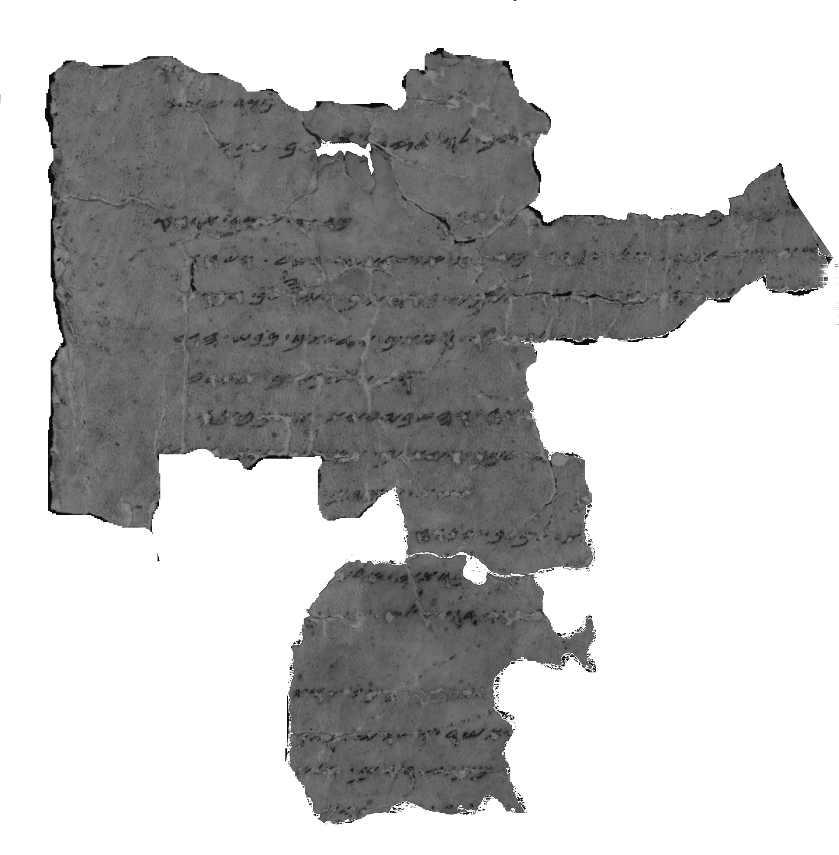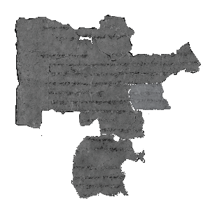

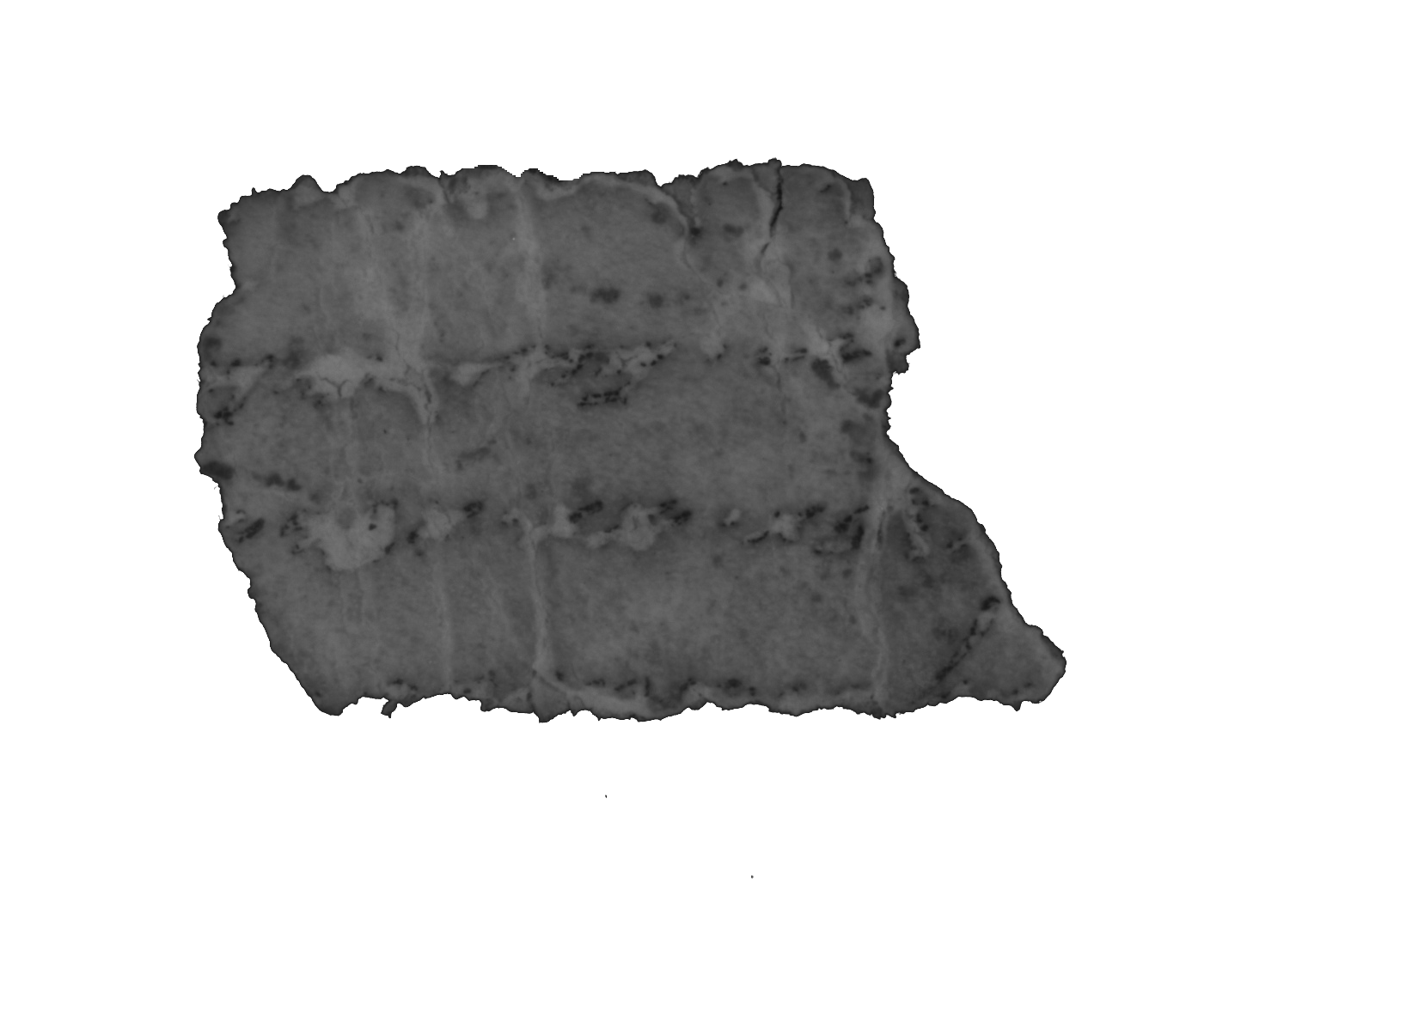

Figure 1: 4Q11 23; 4Q11 47; 4Q11 23+47

According to the new join, one may propose readings for the indecipherable letters of lines 1 and 4 of fragment 47. This then could result in the following transcription of 4Q11 47+23 lines 8–11:

2.1.4 *Frag. 48 (IAA 398.14; PAM 41.387, 42.803)[16]*

Fragment 48 preserves wide partial intercolumnar margins, whose width equals to 2 cm.[17] Only three partial words have survived in this fragment. However, despite the paucity of evidence, one may identify the fragmentary text. The particular string of letters and words fits with Ex 15:2–4, yielding the following partial reconstruction:[18]

The ink traces in line 1 seem to match the word יה. In addition, this reading is in line with the expected distance between lines 1 and 2, determined by the textual reconstruction of lines 2 and 3 (fig. 2).

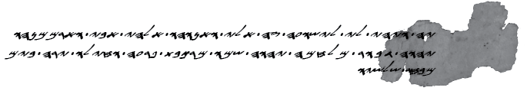

Figure 2: Textual reconstruction of 4Q11-Ex 15:2–4 (4Q11 48)[19]

The traces of the last legible letter in line 2 may fit the right leg of *gimel*. If this is true, the new identification of fragment 48 reveals a possible agreement of 4Q11 with SP-Ex 15:3, against MT:[20]

|  |  |  |  |
| --- | --- | --- | --- |
| 4Q11 | SP | MT | NRSV |
| יהוה ג֯[בור | יהוה גיבור במלחמה  יהוה שמו | ‏יְהוָה אִישׁ מִלְחָמָה  ‎  יְהוָה שְׁמוֹ | The Lord is a warrior; the Lord is his name |

2.2 Fragment included in the official edition but not transcribed and identified

2.3 Unpublished fragments from IAA plate 395

2.3.1 *Frag. 65 (IAA 395.13; PAM 42.803)[21]*

Only two partial words survived at fragment 65, while the distance between them is approximately one line. There are three possibilities for the identification of the fragment in MT-Ex and SP-Ex: (1) Ex 9:23–24 (מצרים; היה כמוהו); (2) Ex 10:14 (מצרים; ארבה כמוהו); (3) Ex 15:10–11 (אדירים; מי כמוכה).[22]

The traces of the two uncertain letters in line 2 indicate that the identification of Ex 10:14 is preferable:

1. The second letter is represented by traces of left vertical stroke and remains of a letter’s head. These traces do not match *yod*, which is expected according to the possible identification with Ex 15:10–11. Instead, it seems that the traces represent the letter *he*, according to the proposed identifications with Ex 9:23–24 or Ex 10:14.
2. The traces of the first letter in line 2 fit with *bet*, rather than *yod*. Therefore, they are suitable to the reconstruction אר]ב֯ה֯ (Ex 10:14), rather than ה]י֯ה֯ (Ex 9:24).

Thus, the identification of fragment 65 with Ex 10:14 results in the following transcription:[23]

The new identification may be reinforced by the materiality of fragment 65 and closed preserved fragments. According to the new identification, fragment 65 apparently belongs to the column of fragments 7i+8, the later preserve Ex 9:33–10:5.[24] Based on the textual reconstruction of the fragmentary lines preserved in frg. 7i, the width of this column is approximately 50–55 characters. This estimation is in line with the column width of fragment 65, estimated by the reconstruction of the missing text between the lines.

2.3.2 *Frag. 66 (IAA 395.25; PAM 41.388, 42.803)[25]*

Fragment 66 preserves three lines. Lines 1 and 3 are poorly preserved and hardly legible. Yet, the identification of the fragment is possible due to the reading of line 2. Traces of the oblique stroke of the *aleph* are best seen in the PAM image. Moreover, the ink of the letters *resh* and *vav* have peeled away. However, these letters are recognized by their outlines, well seen in the IR image. Based on these readings, fragment 66 can only be identified with Ex 25:21–22, yielding the following transcription of lines 2–3:

According to this identification, fragment 66 should be joined with fragment 29, which preserves Ex 25:19–21 (fig. 3).[26]

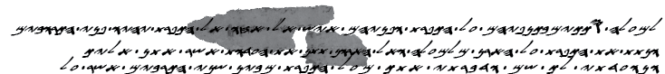

Figure 3: Join of 4Q11 66 with 4Q11 29

2.3.3 *Frag. 67 (IAA 395.9; PAM 42.803)[27]*

Identification: Ex 28:28 (possible)

Fragment 67 is tiny, attesting to three fragmentary lines. Of the three lines, only line 2 is legible. The ink marks in line 1 are probably remnants of a base of a letter, possibly representing *bet*, *kaf*, *mem*, *nun*, or *pe*. Based on the certain reading of line 2, there are two possible identifications: (1) Ex 28:28; (2) Ex 39:21. Both identifications may fit with the additional traces in the fragment.

4Q11 does not preserve text from Ex 36:36 onwards, while two additional fragments preserve the text of Ex 28.[28] Therefore, the identification of fragment 67 with Ex 28:28 seems plausible. The possible new identification yields the following transcription:

3. Conclusions

In this study, we have proposed new identifications of eight hitherto unidentified fragments of 4Q11: frags. 44; 46–48; 52; 65; 66; 67. The new identifications, first and foremost, shed light on the state of the scroll before its deterioration and allow us a better understanding of its evidence.

Moreover, the proposed identifications provide insightful clues for the examination of textual and material aspects of 4Q11. Textually, fragment 48 reveals a possible agreement of 4Q11 with SP in Ex 15:3. Given the fragmentary preservation of the scroll and the inconclusive situation regarding its textual classification, this agreement is valuable to the analysis of the text of the scroll and its relations with other copies of Exodus from Qumran.[29]

The new identifications also contribute to the conception of the materiality of 4Q11. In some cases, they reveal direct or distant joins of the discussed fragments with additional preserved fragments. The new joins provide fruitful information for the identification of repeated damage patterns and processes that occurred when the scroll was rolled up. These, as well as material signs in particular fragments, such as seam remains (frg. 44) and bottom margin (frg. 52), may contribute to the material reconstruction of 4Q11.

1. Patrick Skehan, Eugene Ulrich, Judith Sanderson, “11. 4QpaleoGenesis-Exodusl,” in *Qumran Cave 4 IV: Paleo-Hebrew and Greek Biblical Manuscripts* (DJD 9; Oxford: Clarendon Press, 1992).
2. Mark David McLean, *The Use and Development of Paleo-Hebrew in the Hellenistic and Roman Periods* (Harvard University, 1982), 66. Despite the time elapsed, McLean’s study is the most comprehensive typological development of paleo-Hebrew script attested in the Dead Sea scrolls. Cf. Michael Langlois, “Dead Sea Scrolls Paleography and the Samaritan Pentateuch,” in *The Samaritan Pentateuch and the Dead Sea Scrolls*, ed. Michael Langlois (Leuven: Peeters 2019), 272. Langlois dated 4Q11 to the third century BCE, “though earlier and later dates are possible.”
3. Emanuel Tov, *Scribal Practices and Approaches Reflected in the texts Found in the Judean Desert* (STDJ 54; Leiden: Brill, 2004), 119.
4. Image on <https://www.deadseascrolls.org.il/explore-the-archive/image/B-371331>. For the association of plate 395 with 4Q11, see Stephen A. Reed, *The Dead Sea Scrolls Catalogue: Documents, Photographs, and Museum Inventory Numbers* (Atlanta: Scholars Press, 1994), 44; Tov, *Revised Lists of the Text from the Judean Desert* (Leiden: Brill, 2010), 22.
5. Frgs. 51 (IAA 395.17); 52 (IAA 395.26); 53 (IAA 395.11); 56 (IAA 395.15); 59 (IAA 395.12); 62 (IAA 395.22).
6. The identification of fragments 44, 47, and 48 was firstly proposed at Drew Longacre, *A Contextualized Approach to the Dead Sea Scrolls Containing Exodus* (PhD Thesis: University of Birmingham, 2015), 108.
7. Image on <https://www.deadseascrolls.org.il/explore-the-archive/image/B-475414>.
8. Cf. Skehan, Ulrich, and Sanderson, “4QpaleoGenesis-Exodusl,” 49. The editors read the first legible letter in line 2 as *ayin*. In addition, they did not offer readings for the letters *het*, *resh*, and *vav* in lines 3, 4, and 5, respectively.
9. Image on <https://www.deadseascrolls.org.il/explore-the-archive/image/B-499664>; For the transcription, see Skehan, Ulrich, and Sanderson, “4QpaleoGenesis-Exodusl,” 31–32.
10. Note that 4Q11 reads מן [העזים] in Ex 12:5 (frgs. 7ii+44, 19–20), while MT and SP reads ומן העזים. LXX reflects an agreement with MT/SP (καὶ τῶν ἐρίφων).
11. Image on <https://www.deadseascrolls.org.il/explore-the-archive/image/B-475374>.
12. Skehan, Ulrich, and Sanderson, “4QpaleoGenesis-Exodusl,” 49.
13. This fragment is not available on the website of the Leon Levy Dead Sea Scrolls Digital Library. For the PAM image, see <https://www.deadseascrolls.org.il/explore-the-archive/image/B-284767>.
14. Cf. Skehan, Ulrich, and Sanderson, “11. 4QpaleoGenesis-Exodusl,” 49. The editors incorrectly read the second word in line 2 as two words: מ◦ וֹיֹכֹ[. In addition, they read the first word in line 3 as ◦בת. Therefore, they were not able to suggest identification of this fragment.
15. Skehan, Ulrich, and Sanderson, “11. 4QpaleoGenesis-Exodusl,” 42.
16. Image on <https://www.deadseascrolls.org.il/explore-the-archive/image/B-475378>.
17. Skehan, Ulrich, and Sanderson, “11. 4QpaleoGenesis-Exodusl,” 50, suggest that ink from letters of the preceding column were survived on the right edge of the fragment, but such traces are not seen in PAM and IAA images.
18. Cf. Skehan, Ulrich, and Sanderson, “11. 4QpaleoGenesis-Exodusl,” 50. The editors did not propose an identification of fragment 48 as they incorrectly read line 3: בב[ ] כֹל֯י[.
19. Font design: Einat Tamir.
20. Cf. LXX-Ex 15:3: κύριος συντρίβων πολέμους, that possibly reflects the Hebrew ה' גובר במלחמה.
21. Image on <https://www.deadseascrolls.org.il/explore-the-archive/image/B-362147>.
22. The word מצרים occurs twice in Ex 11:5–6, alongside the word כמהו. However, the distance between the words is too short or too long to encompass a complete line. The line length is estimated by the text of frg. 7ii, which preserves Ex 11:4–12:12 (see n. 10).
23. Note the spelling of the word כמוהו with *vav*, as opposed to כמהו in MT-Ex and SP-Ex.
24. Image on <https://www.deadseascrolls.org.il/explore-the-archive/image/B-499664>; For the transcription, see Skehan, Ulrich, and Sanderson, “4QpaleoGenesis-Exodusl,” 30–31.
25. Image on <https://www.deadseascrolls.org.il/explore-the-archive/image/B-362171>.
26. Image on <https://www.deadseascrolls.org.il/explore-the-archive/image/B-475422>. For the transcription, see Skehan, Ulrich, and Sanderson, “11. 4QpaleoGenesis-Exodusl,” 43.
27. Image on <https://www.deadseascrolls.org.il/explore-the-archive/image/B-362139>.
28. Fragments 36, 37. See images on <https://www.deadseascrolls.org.il/explore-the-archive/image/B-475382>; <https://www.deadseascrolls.org.il/explore-the-archive/image/B-475350>, respectively. For the transcription, see Skehan, Ulrich, and Sanderson, “11. 4QpaleoGenesis-Exodusl,” 46–47.
29. For a discussion of the textual classification of 4Q11, see e.g. Tov, “The Biblical Texts from the Judaean Desert: An Overview and Analysis of Published Texts,” in *The Bible as Book: The Hebrew Bible and the Judaean Desert Discoveries*, ed. Edward D. Herbert, Emanuel Tov (London: British Library, 2002), 154; Armin Lange, “2.2.1 Ancient, Late Ancient, and Early Medieval Manuscript Evidence”, in *Textual History of the Bible*, General Editor Armin Lange. Consulted online on 11 March 2021 <http://dx.doi.org.rproxy.tau.ac.il/10.1163/2452-4107_thb_COM_0002020100>.