[1]

Design and Evaluation of a Passive Knee Exoskeleton for Vertical Jumping

Coral Ben-David, Barak Ostraich, and Raziel Riemer, Member, IEEE

*Abstract*— Exoskeletons were proven to augment human mobility through different daily tasks such as walking, running, and hopping. These exoskeletons' goal is to reduce the effort expended during aerobic tasks (i.e., the metabolic rate). However, exoskeletons that assist during fast explosive movements, specifically vertical jumping, have not yet been thoroughly researched. Further, for all exoskeleton there is still lack of understanding about the human exoskeleton interaction. In this paper, we designed and tested a passive knee exoskeleton to improve vertical jumping activity by jumping higher. The exoskeleton consists of springs that act in parallel to the quadriceps femoris muscle. The springs store energy in the negative work phase, during knee flexion, and inject the energy in the following positive work phase, during knee extension. This energy could be translated into increasing the jump height. The exoskeleton was tested on ten healthy subjects during two experimental sessions in each the subjects were aiming to jump as high as possible. In the first session, the subjects jumped without instructions on how to use the exoskeleton. In the second session, the subjects were trained to better utilize the exoskeleton, by exploring different jumping techniques to improve the adaption to the exoskeleton. The second experiment results revealed a 6.2 $±$ 0.9% (mean $±$ SE) increase of jump height when using the exoskeleton compared to jumping without the exoskeleton. To the best of our knowledge, this is the first passive exoskeleton who succeeded in augmenting vertical jumping.

*Index Terms*— Adaptation, Augmentation, Exoskeleton, Vertical Jumping.

# INTRODUCTION

T

He field of wearable exoskeletons has developed tremendously over the past decades. Exoskeletons are primarily designed for rehabilitation or augmentation of normal humans’ performance. Enhancing the performance of humans during different activities could improve the user’s efficiency and is highly applicable for workers in a physically demanding environment such as industry workers, police officers, soldiers, and firefighters.

Multiple wearable exoskeletons designed and studied in the scientific literature aim to augment walking or running by reducing the metabolic cost. In the past decade, there were several studies which showed a reduction in the metabolic power during walking [1]–[5], running [6]–[8], and one research even assisted both walking and running [9].

Sawicki *et al*. [10] compiled peer-reviewed publications that reported an exoskeleton improved user walking or running economy versus without using a device. They categorized the exoskeletons as tethered and autonomous. Further, they classified autonomous systems as active or passive. Active exoskeletons contain actuators that add energy to the motion [9], [11], and passive exoskeletons use passive elements like springs and dampers [7], [8], [12]. Nuckols *et al*. [13] describe the notion of energy transfer from one phase of the motion to a subsequent phase, either within or across joints. This notion can be used by passive exoskeletons, when extracting energy during the negative phase and injecting the energy in a later positive phase. Passive exoskeletons are typically cheaper and lighter than active devices, whereas active exoskeletons are more adaptable due to the ability of applying any torque-time profile.

The augmentation of an exoskeleton for walking, running, and leaping was proposed back in 1890 by Yagn [14], who presented a theoretical design consisting of long bow springs operating in parallel to the legs. Grabowski and Herr [15] designed a full leg exoskeleton that reduced the metabolic cost during hopping up to 30% over a range of frequencies from 2.0 to 2.6 Hz. Farris and Sawicki [16] also designed exoskeleton that reduced the metabolic cost during hopping. They designed a passive spring-loaded ankle exoskeleton that reduced the metabolic cost by 12% at 2.5 Hz. However, hopping is an aerobic activity and differs from fast-explosive movement such as vertical jumping. To the best of our knowledge, only one study attempted to build and test exoskeleton for fast-explosive motion. Kim *et al*. [17] designed a passive-elastic ankle exoskeleton with a one-way clutch mechanism to enhance vertical jumping activity. In the pilot-tests, the subjects could nearly reach their maximum vertical jump heights while wearing the exoskeleton, but could not surpass it.

Vertical jumping starts with a negative work phase, during hip and knee flexion, and ankle dorsiflexion. In this phase, the jumper lowers the body into a squat position. The next phase is a positive work phase, during hip and knee extension, and ankle planter-flexion. This phase is from the start of upward movement until the toes left the ground [18]. It was also found that the hip and knee joint moments are more significant than the ankle during the vertical jump [18]–[20].

Therefore, in this study we built and tested experimentally a passive knee exoskeleton with springs acting in parallel to the muscle. Where the springs could store energy during the negative work phase and return the energy during the following positive work phase. The knee joint was chosen due to the high moments that this joint provides, and the simpler design relative to the hip joint.

This study aims are to test whether a passive exoskeleton could improve vertical jumping height, to gain better understanding on development of exoskeleton for fast explosive motions, and to learn on the interaction between exoskeletons and their human users.

# Methods

## Subjects

Ten healthy males (age 24.9 ± 2.7 years; mass 73.0 ± 3.7 kg; and height 1.74 ± 0.03 m) participated in this study. Note that we only had one exoskeleton thus the subjects were chosen in the goal that the exoskeleton would fit their dimensions. Two additional subjects dropped out during the experiments. One of them showed a great fear using the exoskeleton, hence he did not bent his knees during the jump. For the second subject, the exoskeleton was not sufficiently wide at the knee, causing pain during the jump. All subjects provided written informed consent before participation in the study. The study was approved by Ben-Gurion University’s Human Research Institutional Review Board.

## Exoskeleton Design

In this study, we designed and constructed a passive knee exoskeleton, as presented in Fig 1. The exoskeleton consists of aluminum 6061 frames, attached to the leg with wide Velcro stripes. Rubber springs provide the assistance moment and are located near the knee, and in parallel to the quadriceps femoris muscle. These springs are typically used for a speargun. The overall exoskeleton mass is about 1.5 kg for each leg. Specifications of the exoskeleton’s components can be found in appendix A.

## Protocol

Two experimental sessions were performed. In the first session, the subjects jumped without instructions on how to utilize the exoskeleton, aiming to jump as high as possible. In the second session, the subjects were trained to utilize the exoskeleton better. Two sessions were performed as in previous studies [1], [21] results showed that the subjects adapted to the exoskeleton during walking, and their performance improved from one session to the other.

Fig. 1. The designed Knee Exoskeleton.

In the first session, the subjects performed vertical jumping under five conditions: without the exoskeleton (NoExo); with the exoskeleton but with no spring connected (Exo0) in this condition the exoskeleton is a deadweight; with the exoskeleton and 4 springs that provide 70Nm at a 90° knee bend (Exo1); with the exoskeleton and 6 springs that provide 105Nm at a 90° knee bend (Exo2); and without the exoskeleton again (NoExo2). These values of the moment that the exoskeleton provide are based on results from tensile test preformed on the rubber springs using a universal testing machine (Hounsfield, H10KT) that enables relating the springs force to strain ratio. The 70Nm and 105Nm moments are equivalent to spring stiffness of 38 Nm/rad and 57 Nm/rad, respectively. These values were a compromise between keeping the device compact and light using relative cheap components, and providing larger moments. Further, based on previous studies [18]–[20] with professional athletes, these values provide about 20% and 33% of knee peak moment during the jump. The order of performing the conditions with the exoskeleton was randomized for each subject. The first and last conditions in the experiment order were the control conditions, without the exoskeleton. Before each condition with the exoskeleton, the subjects performed 5 minutes of free jumping to adapt to the exoskeleton. After that, the subjects performed eight vertical jumps with the exoskeleton, while data were collected from the last five jumps.

The second session was executed about three months after the first session, due to COVID-19 limitations. Since the results from the first session showed a positive correlation between spring stiffness and the height of the jump, this session included two conditions only: without the exoskeleton (NoExoS2); and with the exoskeleton and springs that provide 105Nm at a 90° knee bend, after training (Exo2S2). In this session to improve the adaption we included an exploration of different jumping techniques. This experimental protocol is adapted from Gast [22], which found that walking on rough terrain while exploring various walking speeds reduce the time for converges of the cost of transport to minimum during walking at preferred speed. And from, Selinger [23], who studied humans walking with exoskeletons and found that in order to find the optimal step frequency, subjects had to carry out an exploratory session in which they walked at fast and slow step frequencies. Thus, after the condition of jumping without the exoskeleton, the subjects were trained to utilize the exoskeleton better. In training, the subjects were instructed to try four squat jumps with different starting postures (e.g. maximum bend at the knee, flat foot and strait back). We then chose the jump that resulted in the maximum vertical height, and we tweak the technique to try achieving better results. The subjects were instructed to keep their foot at pelvic width, as possible. Each subject performed up to ten training jumps until they got used to the new jumping technique with the exoskeleton.

In both sessions, the subjects followed a warm-up routine. Then, during each jump they were instructed to jump as high as possible and keep their hands crossed on their chest. The subjects rested for 2 minutes between jumps, to prevent the effect of fatigue. The phases of the jump, followig this protocol are presnted in Fig.2.

## Data Collection

Subjects’ motion was recorded using fourteen cameras that tracked reflective markers on the subject and the exoskeleton operating at 179Hz (Qualisys, Gothenburg, Sweden). Ground reaction forces were recorded at 2040Hz using an instrumented treadmill (Bertec, Columbus, OH, USA). During one of the jumps, there was a malfunction in the force plate's initialization, so this jump was omitted. Rectus Femoris and Gastrocnemius muscles activity were measured in the right leg, using surface electromyography (sEMG) sensors (Trigno Wireless System – Delsys, Boston, MA) at 2000Hz. We chose to examine these muscles because of their contribution to the vertical jumping activity ,as previously studied [24]–[27]. The skin around the attachment of the EMG sensors was shaved and cleaned by scrubbing it with 70% alcohol. The EMG sensors were attached to the body using adhesive tape provided by the manufacture. However, due to sweating and shock during landings, the EMG sensor on the Rectus Femoris moved for three subjects during the trials' latest conditions. Additionally, the EMG sensor on the Gastrocnemius moved for two subjects during the trials' latest conditions. Thus, the data from these jumps were excluded.

Fig. 2. The jumping experiments. a) The subject wearing the exoskeleton and preparing for vertical jumping under the experimental protocol. The subject is standing on an instrumented treadmill while markers and EMG sensors are attached to him. b) The different phases of the vertical jump: Standing, the starting position for the Upward Movement (UPM), Take-Off (TO), and reaching Max Height. During knee flexion the springs are stretched, and from UPM to TO, the stored energy in the springs is added to the biological energy. The COM height parameters are also presented according to the phase of the jump. The muscles in red represents the knee extensor muscles and ankle plantar flexors. We measured EMG from Rectus Femoris and Gastrocnemius.

## Data Analysis

The data from all three systems were recorded and synchronized using Qualisys Track Manager software (Qualisys, Gothenburg, Sweden). Next, it was exported into Visual 3D (C-Motion Inc, Rockville, MD, USA), that used bottom up inverse dynamics [28] using 6DOF to calculate joints angles, angular velocities, body Center of Mass (COM), moments and powers. The ankle, knee, and hip joints’ angles are defined as follows. The ankle angle is between the foot and the shank, and at standing it is about 90 $°$, while during plantar flexion, the angle increases. The knee angle is between the shank and the thigh, and at standing is about 180 $°$, while during flexion, the angle decreases. Lastly, the hip angle is between the thigh and the pelvic, and at standing is about 180 $°$, while during flexion, the angle decreases.

The recorded subjects’ motion and ground reaction forces were filtered using a fourth-order Butterworth lowpass filter with a 10 Hz and 35 Hz cut-off frequency, respectively. EMG recordings were digitized with a bandpass filter (20-450 Hz) and processed using code written in Matlab (Math Works Inc., Cambridge, MA, USA) to obtain a linear envelope (LE). The EMG data were rectified and filtered using second-order lowpass Butterworth filter with 3 Hz cut-off frequency. This signal processing is based on [29]–[31].

Matlab code was also implemented for the calculation of height, kinetic, and kinematic parameters. The height parameters are the difference of the COM from standing to maximum jump height ($ΔH_{max}$), and the difference of the COM from standing to minimum COM height ($ΔH_{min})$, both presented in Fig.2, and given as follows:

$ΔH_{max}=H_{max}-H_{Standing}$ (1)

$ΔH_{min}=H_{Standing}-H_{min}$ ($SEQ Equation \backslash * ARABIC$ $2$)

Where $H_{standing}$ is the COM height during standing, $H_{max}$ is the maximum COM height during flight phase of the jump, and $H_{min}$ is the minimum COM height.

Next, we calculated the net mechanical work performed at the ankle, knee, and hip joints from the start of upward movement (UPM) to take-off (TO):

$W_{j}=\int_{UPM}^{TO}{P_{j} dt= \int_{UPM}^{TO}{M_{j}∙\dot{ω_{j}} dt }}$ ($SEQ Equation \backslash * ARABIC$ $3$)

Where $P_{j}$ is the power at each joint, $M_{j}$ is the moment at each joint, and ${\dot{ω}}_{j}$ is the angular velocity at each joint. The UPM point is defined in the minimum COM ($H_{min})$, and the TO point defined when the ground reaction forces equals zero. The total knee power and work are composed from exoskeleton and biological components. The exoskeleton power was calculated using a model that predicts the moment provided by the exoskeleton (based on experiment and theory) multiplied by the measured angular velocity. For more information see appendix B.

$W_{Exo}=\int_{UPM}^{TO}{P_{EXO} dt=\int_{UPM}^{TO}{M_{Exo}∙{\dot{ω}}_{knee} dt }}$ ($SEQ Equation \backslash * ARABIC$ $4$)

The biological knee power obtained by subtracting the exoskeleton power from the total knee power, calculated as follows:

$W_{BioKnee}= W_{totaltKnee}-W_{Exo}$ ($SEQ Equation \backslash * ARABIC$ $5$)

Finally, maximum EMG of the Rectus Femoris and Gastrocnemius was determined for each of the jumps. Then maximum muscle activity of each jump was normalized by the average maximum muscle activity of the control conditions (i.e., NoExo for the first session and NoExoS2 for the second session).

## Statistics

The subjects had different physical traits and jumping techniques. Therefore, we used a Linear Mixed Model (LMM), with subject as random effect, across all conditions (i.e., NoExo, Exo0, Exo1, Exo2, NoExo2, NoExoS2, and Exo2S2) to examine the effect of the exoskeleton on the jumping height. The LMM was also conducted on the following parameters: work performed by the joints and the exoskeleton, muscles activity, joints’ angles, and minimum COM height. In addition, Q-Q plots were conducted to ensure that the residuals of the models are normally distributed. Pairwise comparisons were conducted using Tukey’s honestly significant difference test, with a significance level of 0.05. Statistical analysis was performed using R-studio, Ver 1.1.463 (R Ver 3.5.1; RStudio, Inc. Boston, MA).

# Results

To examine the effect of the different experiment conditions on vertical jumping height, we defined the difference of COM height from standing to maximum COM during the jump as the jump height, $ΔH_{max}$ (Fig. 3). By examining the height gained by each of the conditions, of the first session, with the exoskeleton (i.e., Exo0, Exo1, and Exo2) it is noticeable that as spring stiffness increased, so did the height of the jump (P<0.05). However, there was no significance difference between NoExo and Exo2. In the second session it can be seen that training with the exoskeleton (Exo2S2) contributed to significantly higher jump than all other conditions (P<0.0001). The average $ΔH_{max}$ in Exo2S2 is 45.9±7.3 cm (mean $±$ SD), which is higher by 2.7 $±0.4$ cm and 8.2 $±0.4$ cm (mean $±$ SE) than in NoExoS2 and Exo0, respectively (i.e., 6.2% and 21.6% higher, respectively). Furthermore, we tested if there was a change in the subjects vertical jumping ability between the two experimental sessions and found no significant difference between the conditions without the exoskeleton (NoExo, NoExo2, and NoExoS2, P>0.05). Where eight out of the ten subjects jumped higher with the exoskeleton (Exo2S2) compare to no exoskeleton (NoExoS2), Appendix C.

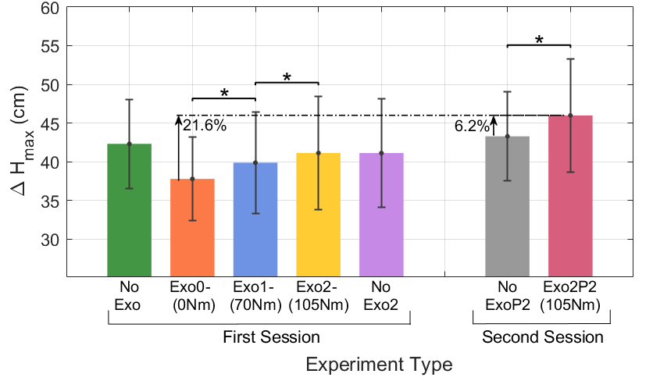

Fig. 3. Max jump height relative to standing, for each of the 7 conditions. Averaged across subjects. Error bars are SD and $\text{*}\text{P}≤0.05.$

To gain better understanding on these results we used the data from the inverse dynamics analysis for four conditions: Exo0, Exo2, NoExoS2, and Exo2S2. First, we calculated the joint work performed by the ankle, knee, and hip as shown in equation (3), for both legs together. We also calculated the net biological knee work and net exoskeleton work )Fig.4(. The total joints and exoskeleton work at the Exo2S2 condition, 694.75 $±$ 90.9J, was the largest compare to all other conditions (P<0.0001). It was larger by 155.7 $±$ 9J and 142.5 $±$ 9J (mean $±$ SE) than in NoExoS2 and Exo0, respectively. Also, the total knee work (i.e., exo+bio) at Exo2S2 was larger than in all other conditions. (P<0.0001). Additionally, all the conditions with the exoskeleton caused an increment in hip work relative to NoExoS2 condition (P<0.01). Further, the hip work was the largest in Exo2S2 condition compare to all other conditions (P<0.0001). 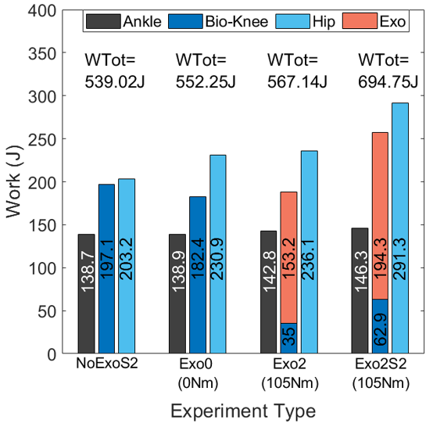

Fig. 4. The work of the exoskeleton and biological knee, the ankle, and the hip joints from upward movement (UPM) to take-off (TO), for NoExoS2, Exo0, Exo2, and Exo2S2 conditions, both legs. Averaged across subjects.

Next, we compared between NoExoS2, and Exo2S2 conditions using the profiles of the angle, moment, and power at the ankle, total knee (i.e., bio+exo), and hip. We examined these parameters from upward movement (UPM) to take-off (TO), and normalized this phase in the motion to 100% so that the results from the two conditions will be on the same scale (Fig.5). Full data of example subject’s jump from standing to TO, not normalized, is presented in Appendix D. Due to symmetry, we presented data are from the right leg only. The comparison shows that the trajectories of the joints angle, moment, and power are similar in shape. The peak average of total knee moment without exoskeleton (NoExoS2) for right leg was 1.39 $±0.48$ N/kg, which is about 101 $±35.0$ Nm. Further, quantitative information on the average joints’ angle during UPM point, and the difference of the COM from standing to minimum COM height ($ΔH_{min}$), during NoExoS2, Exo0, Exo2, and Exo2S2 conditions is presented in Table I. It can be seen that at the UPM point, the angles at the knee and hip during Exo2S2 are smaller than NoExoS2, indicating greater joints flexion (P<0.0001). The lowest COM height obtained (i.e., larger $ΔH_{min})$, relative to the other conditions, was at Exo2S2 (P<0.0001). Also, the $ΔH_{min}$ during NoExoS2 was larger than in Exo0 and Exo2, meaning lower COM height (P<0.03).

TABLE I

Average Joints’ Angles and Minimum COM at UPM

|  |  |  |  |  |
| --- | --- | --- | --- | --- |
|  | NoExoS2 | Exo0 | Exo2 | Exo2S2 |
| **Squat Angle (deg)**  Ankle  Knee  Hip | 78.0 $± 5.8$ 71.1 $± 15.4$ 48.9 $± 18.0$ | 79.0 $± 8.2$ 74.5 $± 15.9$ 47.5 $± 23.1$ | 78.8 $± 58.2$ 77.4 $± 16.5$ 44.9 $± 21.0$ | 80.2 $± 8.1$ 59.2 $± 9.2$ 35.2 $± 10.0$ |
|  |  |  |  |  |
| $ΔH_{min}$**(cm)** | 37.9 $± 8.2$ | 35.2 $±8.0$ | 35.2 $±7.4$ | 44.6 $±4.4$ |

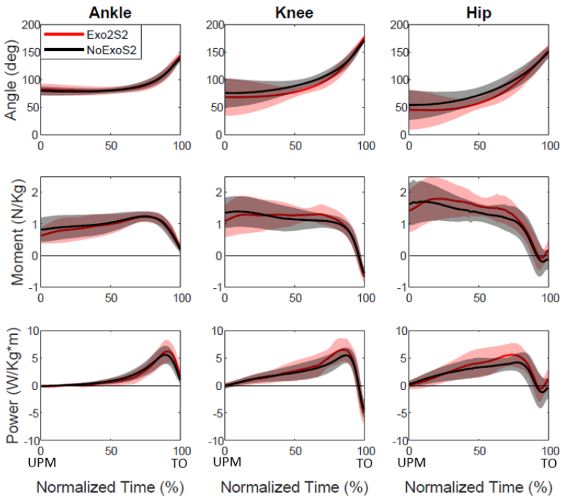Fig. 5. The angle, moment, and power at the ankle, hip, and total knee (i.e., bio+exo), during NoExoS2 and Exo2S2 conditions, from upward movement (UPM) to take-off (TO), for right leg. The average (for all subjects last 5 jumps at each condition) is the solid line and the shaded areas are the SD.

Last, a comparison between normalized EMG peak signals was conducted in Exo0, Exo2, NoExoS2, and Exo2S2 conditions and presented in Fig.6.

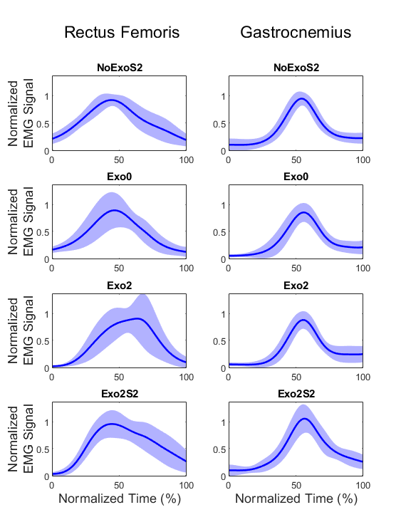Fig.6. The normalized EMG signals of Rectus Femoris and Gastrocnemius during NoExoS2, Exo0, Exo2, and Exo2S2 conditions. The solid line is the average (for all subjects last 5 jumps at each condition), and the shaded areas are the one standard deviation.

The Rectus Femoris EMG peak signal was not statistically different (P>0.4). However, the Gastrocnemius EMG peak in all expect one conditions where the same. Were the signal during Exo2S2 was the largest compare to all other conditions (P<0.01), and specifically greater by 12.7 $± 0.2$% than during NoExoS2. The EMG signal is examined from standing (0.25 seconds before UPM) to maximum jump height, and normalized this phase in the motion to 100% so that the results from the four conditions will be on the same scale.

# Discussion

The results show that after training on jumping technique with the exoskeleton, users increased their jump height by 6.2% compare to jumping without the exoskeleton. To the best of our knowledge, this is the first exoskeleton that was proven to augment a fast explosive movement, by improving vertical jumping height.

One of the main findings of the jumps that resulted in improved jump height was a dipper squat position. Although there are studies showing that the squatting position does not affect the height of the jump, [32], [33], these studies were performed without the use of an exoskeleton. In this study to achieve the dipper squat position, the subjects increased knee flexion which mean storing more energy in the springs. Also, the hip angle was smaller (larger hip flexion) at the starting position of the upward movement, which also corresponds to the lower COM height. The changes in the hip joint might be explained by the need for the subjects to create balance to avoid falling backward. The changes in $ΔH_{min}$ and joints angles are also reflected in the net work at the joints. The total knee work and hip work increased with the use of the exoskeleton, where part of this additional energy is required just to bring the body from a lower COM back to standing COM.

By comparing the total joints work and the maximum height difference between condition of exoskeleton with no springs (Exo0) and condition with highest spring stiffness (Exo2S2), we aim to gain better understanding on the interaction between the human and the exoskeleton. Using energy balance analysis, where each jump has two energy components to move the COM from the lowest point (UPM) to standing, and from standing to maximum height. If we assume no energy lost, then the difference in the joint work between the two conditions Exo2S2 to Exo0 energy could be formulated as follows:

($SEQ Equation \backslash * ARABIC$ $6$)

$$ΔW=mg∙(ΔH_{min,2}^{ }+ΔH_{max,2}^{p})-mg∙(ΔH_{min,0}^{ }+ΔH_{max,0}^{ })$$

$$ΔH_{max,2}^{p}=\frac{142.5}{76g}-0.45+\left(0.35+0.37\right)=0.461m=46.1cm$$

Where $ΔH_{max,2}^{p}$ is the predicted gained height using the exoskeleton. $ΔW$ is the difference in total joint work between the two conditions, and m is the average subjects’ mass (73 kg) plus the exoskeleton mass (3 kg). Recall that $ΔH_{min}$ is the difference of the COM from standing to minimum COM height, and $ΔH_{max}$ is the difference of the COM from standing to maximum COM height (2 and 0 stands for Exo2S2 and Exo0, respectively). In this analysis, the jump height $ΔH_{max,2}^{p}$ is predicted using the other work parameters and the other heights obtained from the experiments. The expected gained height for Exo2S2 condition based on experimental results of Exo0 condition, is 46.1 cm, while the actual height gained in the experiments was 45.9 $±7.3$ cm (mean $±$ SD). This is a good fit to the measurements.

Next, the energy balance analysis was applied to compare between predicted and actual height gained in the conditions with and without the exoskeleton (i.e., NoExoS2 and Exo2S2). In this case there is a difference in the total mass between the two conditions due to added mass of the exoskeleton. The calculation is as follows:

(7)

$$ΔW=(m_{h}+m_{e})∙g∙(ΔH_{min,2}^{ }+ΔH_{max,2}^{p})-m_{h}g∙(ΔH_{min,no}^{ }+ΔH_{max,no}^{ })$$

$$ΔH_{max,2}^{p}=\frac{155.7}{76g}-0.45+\frac{73\left(0.38+0.43\right)}{76}=0.537m=53.7cm$$

Where $m_{h}$ is the average subjects’ mass, and $m_{e}$ is the exoskeleton mass. Here $ΔH_{min/max, 2/no}$ is for Exo2S2 and NoExoS2 respectively.

Accordingly, based on experimental results of NoExoS2 condition, the expected jump height for Exo2S2 condition, is 53.7 cm, while the actual height in the experiments was 45.9 $±7.3$ cm (mean $±$ SD). This result indicates that not all difference in joint work is translated into the jump height, comparing to the result predicted and actual height based on Exo0 and Exo2S2 conditions that was neglectable. We believe that the difference between the two jumps height predication (Exo2S2 based on Exo0 vs. Exo2S2 based NoExoS2) might be explained by several limitations of the exoskeleton such as the fit of the exoskeleton to the user (note we use one Exoskeleton for all subject). That might result in work that is lost into compressing the shank and thigh. We believe that a fabricated custom attachment for each subject (e.g. Collins *et al*. [1]) will potentially lead to better utilization of the exoskeleton work and to higher jumps. Further, it is possible that the exoskeleton reduces some of the DOF in the joint, causing the jump mechanics to be less efficient.

When the exoskeleton was designed, the springs moments were determined to be 70Nm and 105Nm to provide additional moment equivalent to about 20% and 33% ,respectively, of the knee peek moment (approximately 300 Nm). These ratios were based on studies [18]–[20] whose subjects were professional athletes that weighed about 80 kg. However, the subjects in this study were not professional athletes, their average weight was 73 kg, and there peak moment was approximately 200 Nm (both knees together). Thus, in the second experiment spring stiffness was approximately 50% of the biological knee capability. In our study, in the second experiment (Exo2S2) it was found that the total work provided by the biological knee was 26% of the total knee work which was improvement over the first experiment where the biological knee preformed was only 17%. In addition, we compared our findings to simulated human jumping with a passive exoskeleton [34] that used a model with peak total biological knee moment of 320Nm. The results from the simulation predicted that of springs that provide approximately 50% of the maximum knee torque the biological knee would lead to about 35% biological work from the total knee work. Which is higher by 9% than our results.

When analyzing the maximum normalized EMG signal indicates that there was no statistical difference in the Rectus Femoris muscle activation between with and without exoskeleton conditions. EMG signal for all the conditions in Gastrocnemius, except one that had a small change, where the same. This means that the subjects reached their maximum capability in terms of force production. This is also is in line with findings from [34] that found that the muscles reaching their maximum force production regardless of the spring stiffness. The improvement between the two experiment and the fact that the EMG reached a peak in all the condition might suggest that users might be able to improve their performance, if they train on jumps using the exoskeleton which might lead to force speed curve of the muscle [35], [36].

Further, when analyzing the difference between jumping with exoskeleton and without, it is important to examine the techniques in the two conditions. During a vertical jump with the exoskeleton, the subjects were required to explore for a better squat position that enables starching of the springs. The consequence was that they remained in the low position for a long time relative to the vertical jump without the exoskeleton. Thus, the jumps without the exoskeleton were more like countermovement jump, while the jumps with the exoskeleton were more like squat jumps, see Appendix C.

According to multiple studies, countermovement almost always results in a higher jump when compared to squat jumps [18], [37]–[39]. Komi *et al*. [38] suggested that the height gained differences are due to elastic energy storage and utilization. They claimed that the tendinous tissues could store elastic energy during downward movement and use the energy during upward movement. However, recently several researchers claimed that elastic storage and utilization are not the main difference between countermovement and squat jumps [37], [40]–[42] since a significant portion of the energy is lost as heat during the execution of a countermovement when compared with the squat jumps. Bobbert *et al*. [37] argued that the countermovement's primary contribution is that it allows the muscles to build up a high level of active state and force before the start of shortening. By that, the muscles were able to produce more work.

Therefore, future study should examine if jumping with exoskeleton using countermovement strategy will contribute to a better understanding of the human-exoskeleton interaction and potentially increase the jump height.

# Conclusion

This study presents a novel passive exoskeleton for improving height of vertical jumping. The exoskeleton contained springs that provided the assistance moment of approximately 50% of biological knee and were located parallel to the quadriceps femoris muscle.

In the study there were two experimental sessions. In the first session, the subjects jumped without instructions on how to use the exoskeleton. In the second session, the subjects were trained to better utilize the exoskeleton by exploring different jumping techniques to improve the adaption to the exoskeleton.

The second experiment results revealed an increase of 6.2 $±$ 0.9% (mean $±$ SE) of jump height when using the exoskeleton compared to jumping without the exoskeleton, and 21.6% compared to jumping with exoskeleton with no springs

Since there was no improvement in jump height during the first session, it indicates that exploration is necessary for increasing jump height. It is important to note that this is the first time that using an exoskeleton improved jump height during vertical jump activity.

From energy balance analysis and additional potential jumping strategies, we believe that the jump height can be further improved. Hence, a future study should focus on exploration of additional jumping techniques including countermovement.

## Appendix

Appendix A:

Passive Exoskeleton Mass by Component for One Leg

|  |  |
| --- | --- |
| Segment | Mass |
| **Aluminum Frame** | **1272 g** |
| Net Spring  Spring with attachments | 14.8 g  24.4 g |
| **3 Springs for highest stiffens** | **73.2 g** |
| **Velcro stripes with attachments** | **160 g** |
| **Total Mass** | **1505.2 g** |

This is the total mass of exoskeleton with the highest spring stiffness, for one leg.

Appendix B: Calculation of the exoskeleton work

The design of the knee exoskeleton required using a light spring. A rubber tubing generally used for speargun was found to supply enough force per additional length. However, rubber materials are known to have a viscous behavior. Which mean that force-length curve is changing with the stretching velocity. Our initial intent was to measure the forces using s-type sensor. However due to the dimensions of the exoskeleton the s-type sensor could only be used when only one spring was attached to the exoskeleton. Thus, we develop a model for the spring force based on experimental data.

There are several models for behavior of viscoelastic materials. All those models are combinations of springs and dumpers (Fig.B1).

To find the most suitable model for out spring we performed experiment. In the experiment two subjects performed total of 20 jumps (6 squat jumps, 6 countermovement jumps, and 8 continues jumps). The force was measured at 125 Hz using S-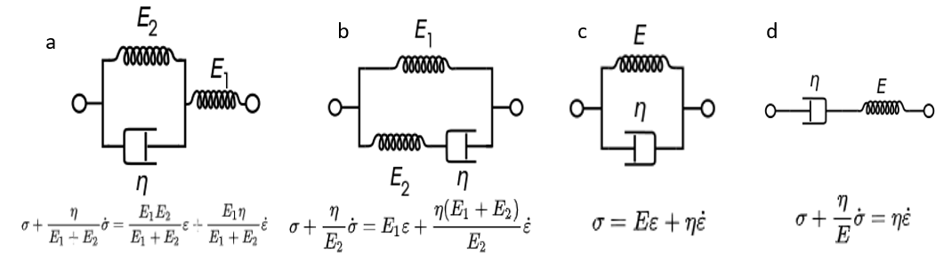type (model 363, Vishay, Malvern, PA, USA) with a A/D board (PhidgetBridge 4 Model 1046_0B, PHIDGETS Inc, Calgary, Canada). Next, we wrote an optimization code to find the model parameters for each of the 4 models that minimized the least square error between the model and the experimental data. It was found that that Kelvin–Voigt model had the best fit with minimum number of parameters. Thus, our model is:

Fig.B1. The four viscoelastic models: a) Kelvin representation b) Standard linear solid model Maxwell representation c) Kelvin–Voigt model d) Maxwell model. where E- is young module, η – is damping coefficient

$σ=E∙ϵ+ η∙\dot{ϵ}$ (1)

Where $σ$ is stress, $E$ is young module, η is damping coefficient $ϵ$ is strain, and $\dot{ϵ}$ is strain rate.

To convert the stress into force we used the following:

$F=σA+F_{0}$ (2)

Where A- is the true cross-section area of the rubber spring and $F_{0}$-initial force caused due to initial tension of the spring.

Thus, we combined (1) and (2):

$F=\left(Eϵ+ η\dot{ϵ}\right)⋅\frac{V_{0}}{L}+F_{0}$ (3)

Where $V_{0}$ is the initial volume of the spring, and L is the length which depends on the angle. $ϵ,\dot{ϵ}$ are computed from the knee angle and angular velocity.

$ε=\frac{R∙θ}{L_{0}}$, where R is the radius of the exoskeleton pulley (Fig.B1), $L_{0}$-is the spring initial length and $θ$-is the change in the knee angle. Thus:

$F=\left(Eϵ+ η\dot{ϵ}\right)∙\left(\frac{L_{0}∙A_{0}}{L_{0}+R∙θ}\right)+F_{0}$ (4)

Next, we inserted the radius (55mm), the initial length of the spring (50mm), and the initial radius of the spring (9mm):

$$F=\left(E\left(\frac{55∙θ}{50}\right)+η\dot{\left(\frac{55∙\dot{θ}}{50}\right)}\right)∙\left(\frac{\left(50\right)∙\left(π{∙9}^{2}\right)}{50+55∙θ}\right)+F_{0}$$

The $F_{0}$ measured in our trial experiments was about zero.

To find the $E,η$ we run a least square fit on matlab. The values we get are $E=1.588,η=0.016$ and correlation factor of $R^{2}=0.91$. Another measure for the accuracy is the difference in the work calculated on each jump. The mean error of the work in each simulated torque relative to the experiment is 4.6% with standard deviation of 13%.

When examining the data, we noticed that there is interaction between the effect of the strain and the strain rate. Thus, using curve fit, we add to Kelvin model a component Cϵ $⋅\dot{ϵ}$:

(5)

$$F=\left(E\left(\frac{55∙θ}{50}\right)+η\dot{\left(\frac{55∙\dot{θ}}{50}\right)+C∙\left(\frac{55∙θ}{50}\right)∙\left(\frac{55∙\dot{θ}}{50}\right)}\right)∙\left(\frac{\left(50\right)∙\left(π{∙9}^{2}\right)}{50+55∙θ}\right)+F_{0}$$

Which resulted in: $E=1.663, η=-0.0066, C=0.029$. This equation gives correlation factor of R2=0.93 with the mean work error of 2.4% and standard deviation of 13.3%. In Fig.B2 are a sample of 9 jumps showing the model vs the experimental results.

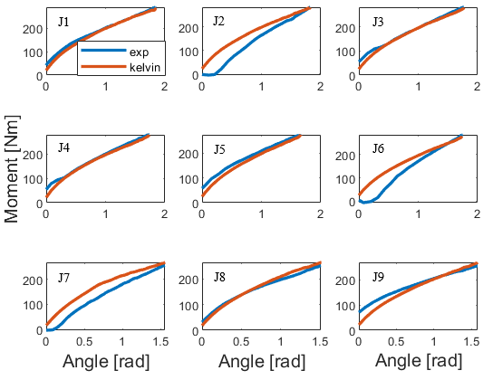

Fig. B2. Nine examples to present the fit of the force predication vs. the experimental result.

To calculate the total work performed we used:

$W=\int_{t_{i}}^{t_{f}}{M∙ω dt}=\int_{t_{i}}^{t_{f}}{F∙R∙ω dt}$ (4)



Appendix C: The $ΔH_{max}$ of each subject for the NoExoS2 and Exo2S2 conditions.

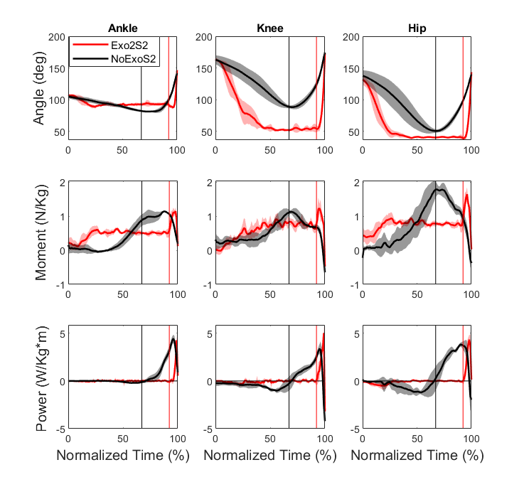

Appendix D: The angle, moment, and power of the ankle, total knee (exo+bio), and hip from standing to take-off (TO), of one subject (Average $±$ SD of5 jumps), right leg. The vertical lines represents the start of upward movement (UPM) at each of the conditions. From Exo2S2 condition, it can be seen that the subject reached a squat position and searched for the right position for several moments until the start of upward movement. Hence his jumping strategy with the exoskeleton is more like squat jump, compare to countermovement without the exoskeleton. Notice that the normalized time is calculated differently than in Fig.5.

Acknowledgment

The authors would like to thank Prof. Yisrael Parmet for his advice regarding the proper statistical methods, Benyamin Shargorodski for the assistant in conducting the experiments, and Shimon Richter and Aviel Maman for their contribution to the development of the force measurement system and the prediction model of the spring forces.

References

[1] S. H. Collins, M. Bruce Wiggin, and G. S. Sawicki, “Reducing the energy cost of human walking using an unpowered exoskeleton,” *Nature*, vol. 522, no. 7555, pp. 212–215, 2015.

[2] P. Malcolm, W. Derave, S. Galle, and D. De Clercq, “A Simple Exoskeleton That Assists Plantarflexion Can Reduce the Metabolic Cost of Human Walking,” *PLoS One*, vol. 8, no. 2, pp. 1–7, 2013.

[3] L. M. Mooney and H. M. Herr, “Biomechanical walking mechanisms underlying the metabolic reduction caused by an autonomous exoskeleton,” *J. Neuroeng. Rehabil.*, vol. 13, no. 1, pp. 1–12, 2016.

[4] H. J. Lee *et al.*, “A Wearable Hip Assist Robot Can Improve Gait Function and Cardiopulmonary Metabolic Efficiency in Elderly Adults,” *IEEE Trans. Neural Syst. Rehabil. Eng.*, vol. 25, no. 9, pp. 1549–1557, 2017.

[5] B. Lim, J. Jang, J. Lee, B. Choi, Y. Lee, and Y. Shim, “Delayed Output Feedback Control for Gait Assistance and Resistance Using a Robotic Exoskeleton,” *IEEE Robot. Autom. Lett.*, vol. 4, no. 4, pp. 3521–3528, 2019.

[6] G. Lee *et al.*, “Reducing the metabolic cost of running with a tethered soft exosuit,” *Sci. Robot.*, vol. 2, no. 6, pp. 1–3, 2017.

[7] R. Nasiri, A. Ahmadi, and M. N. Ahmadabadi, “Reducing the energy cost of human running using an unpowered exoskeleton,” *IEEE Trans. Neural Syst. Rehabil. Eng.*, vol. 26, no. 10, pp. 2026–2032, 2018.

[8] C. S. Simpson *et al.*, “Connecting the legs with a spring improves human running economy,” *J. Exp. Biol.*, vol. 222, no. 17, 2019.

[9] J. Kim *et al.*, “Reducing the metabolic rate of walking and running with a versatile, portable exosuit,” *Science (80-. ).*, vol. 365, no. 6454, pp. 668–672, 2019.

[10] G. S. Sawicki, O. N. Beck, I. Kang, and A. J. Young, “The exoskeleton expansion: improving walking and running economy.” J*ournal of NeuroEngineering and Rehabilitation*, *17*(1), 1-9, 2020.

[11] S. Lee *et al.*, “Autonomous multi-joint soft exsosuit with online optimization reduces energy cost of loaded walking,” *J. Neuroeng. Rehabil.*, p. Under review, 2018.

[12] C. J. Walsh, K. Edo, and H. Herr, “a Quasi-Passive Leg Exoskeleton for Load-Carrying Augmentation,” *Int. J. Humanoid Robot.*, vol. 04, no. 03, pp. 487–506, 2007.

[13] R. W. Nuckols, K. Z. Takahashi, D. J. Farris, S. Mizrachi, R. Riemer, and G. S. Sawicki, “Mechanics of walking and running up and downhill: A joint-level perspective to guide design of lower-limb exoskeletons,” *PLoS One*, vol. 15, no. 8, p. e0231996, Aug. 2020.

[14] N. Yagn, “Apparatus for facilitating walking, running, and jumping,”. U.S. Patents 420 179 and 438 830, 1890.

[15] A. M. Grabowski and H. M. Herr, “Leg exoskeleton reduces the metabolic cost of human hopping,” *J. Appl. Physiol.*, vol. 107, no. 3, pp. 670–678, 2009.

[16] D. J. Farris and G. S. Sawicki, “Linking the mechanics and energetics of hopping with elastic ankle exoskeletons,” *J. Appl. Physiol.*, vol. 113, no. 12, pp. 1862–1872, 2012.

[17] S. Kim, Y. Son, S. Choi, S. Ham, and C. Park, “Design of a simple, lightweight, passive-elastic ankle exoskeleton supporting ankle joint stiffness,” *Rev. Sci. Instrum.*, vol. 86, no. 9, 2015.

[18] S. Fukashiro and P. V. Komi, “Joint moment and mechanical power flow of the lower limb during vertical jump,” *Int. J. Sports Med.*, vol. 8, no. SUPPL. 1, pp. 15–21, 1987.

[19] A. Vanezis and A. Lees, “A biomechanical analysis of good and poor performers of the vertical jump,” *Ergonomics*, vol. 48, no. 11–14, pp. 1594–1603, 2005.

[20] M. F. Bobbert and G. J. van Ingen Schenau, “Coordination in vertical jumping,” *J. Biomech.*, vol. 21, no. 3, pp. 249–262, 1988.

[21] S. Galle, P. Malcolm, W. Derave, and D. De Clercq, “Adaptation to walking with an exoskeleton that assists ankle extension,” *Gait Posture*, vol. 38, no. 3, pp. 495–499, 2013.

[22] K. Gast, R. Kram, and R. Riemer, “Preferred walking speed on rough terrain: Is it all about energetics?,” *J. Exp. Biol.*, vol. 222, no. 9, 2019.

[23] J. C. Selinger, S. M. O’Connor, J. D. Wong, and J. M. Donelan, “Humans Can Continuously Optimize Energetic Cost during Walking,” *Curr. Biol.*, vol. 25, no. 18, pp. 2452–2456, 2015.

[24] P. C. Goodwin, K. Koorts, R. Mack, S. Mai, M. C. Morrissey, and D. M. Hooper, “Reliability of leg muscle electromyography in vertical jumping,” *Eur. J. Appl. Physiol. Occup. Physiol.*, vol. 79, no. 4, pp. 374–378, 1999.

[25] R. Pereira, M. Machado, M. Miragaya, L. N. Pereira, and F. Sampaio-jorge, “Muscle Activation Sequence Compromises Vertical Jump Performance,” *Serbian J. Sport. Sci.*, vol. 2, no. 1–4, pp. 85–90, 2008.

[26] K. Sotiropoulos *et al.*, “Effects of warm-up on vertical jump performance and muscle electrical activity using half-squats at low and moderate intensity,” *J. Sport. Sci. Med.*, vol. 9, no. 2, pp. 326–331, 2010.

[27] F.-J. Tsai, Y. Liu, S.-H. Chen, and Y.-C. Huang, “Biomechanical Characteristics and EMG Activities of Weighted Countermovement Jump,” in *ISBS-Conference Proceedings Archive*, 2004.

[28] D. A. Winter, *Biomechanics and Motor Control of Human Movement: Fourth Edition*. 2009.

[29] T. Lenzi *et al.*, “Intention-Based EMG Control for Powered Exoskeletons,” vol. 59, no. 8, pp. 2180–2190, 2012.

[30] W. Rose, “Raw signal amplification,”. Mathematics and Signal Processing for Biomechanics ,2014.

[31] T. K. K. Koo and A. F. T. Mak, “Feasibility of using EMG driven neuromusculoskeletal model for prediction of dynamic movement of the elbow,” vol. 15, pp. 12–26, 2005.

[32] W. S. Selbie and G. E. Caldwell, “A simulation study of vertical jumping from different starting postures,” *J. Biomech.*, vol. 29, no. 9, pp. 1137–1146, 1996.

[33] Z. J. Domire and J. H. Challis, “The influence of squat depth on maximal vertical jump performance,” *J. Sports Sci.*, vol. 25, no. 2, pp. 193–200, 2007.

[34] B. Ostraich and R. Riemer “Simulation of a Passive Knee Exoskeleton for Vertical Jumping,”. *ASB 44Annual Meeting.* Georgia Institute of Technology, 2020.

[35] P. Jiménez-Reyes, P. Samozino, M. Brughelli, and J. B. Morin, “Effectiveness of an individualized training based on force-velocity profiling during jumping,” *Front. Physiol.*, vol. 7, no. JAN, pp. 1–13, 2017.

[36] C. U. A. Nalysis, O. F. The, and C. O. J. Ump, “Power-Time,Force-Time, and Velocity-Time Curve Analysis of the Countermovement Jump: Impact of Training,” *J. Strength Cond. Res.*, vol. 23, no. 1, pp. 177–186, 2009.

[37] M. F. Bobbert, K. G. M. Gerritsen, M. C. A. Litjens, and A. J. Van Soest, “Why is countermovement jump height greater than squat jump height?,” *Medicine and Science in Sports and Exercise*, vol. 28, no. 11. pp. 1402–1412, 1996.

[38] Komi P. V and Bosco C, “Utilization of stored elastic energy in leg extensor muscles by men and women,” *Medicine and Science in Sports*, vol. 10, no. 4. pp. 261–5, 1978.

[39] B. Van Hooren and J. Zolotarjova, “The Difference between Countermovement and Squat Jump Performances: A Review of Underlying Mechanisms with Practical Applications,” *J. Strength Cond. Res.*, vol. 31, no. 7, pp. 2011–2020, 2017.

[40] B. Kopper, Z. Csende, L. Trzaskoma, and J. Tihanyi, “Stretch-shortening cycle characteristics during vertical jumps carried out with small and large range of motion,” *J. Electromyogr. Kinesiol.*, vol. 24, no. 2, pp. 233–239, 2014.

[41] G. J. van Ingen Schenau, “An alternative view of the concept of utilisation of elastic energy in human movement,” *Hum. Mov. Sci.*, vol. 3, no. 4, pp. 301–336, 1984.

[42] F. C. Anderson and M. G. Pandy, “Storage and utilization of elastic strain energy during jumping,” *J. Biomech.*, vol. 26, no. 12, pp. 1413–1427, 1993.

1. This paper was submitted for review at XXX. This work was supported in part by Helmsley Charitable Trust through the Agricultural, Biological and Cognitive Robotics Initiative of Ben-Gurion University of the Negev and the Israel Science Foundation under Grant 899/18.

   Coral Ben David is with the Faculty of Industrial Engineering, Ben-Gurion University of the Negev, Israel (e-mail: coralben@post.bgu.ac.il).

   Barak Ostraich is with the Faculty of Industrial Engineering, Ben-Gurion University of the Negev, Israel (e-mail: ostr@post.bgu.ac.il)

   Dr. Raziel Riemer is with the Faculty of Industrial Engineering, Ben-Gurion University of the Negev, Israel (correspondence email: rriemer@bgu.ac.il)