**Independence Day Posters - Lesson Plan**

Since the establishment of the State of Israel, the Israeli government has commissioned graphic artists to design posters for Independence Day.  
In this lesson we will go back in history and take a look at some of the posters that were created in the early years of the State of Israel.

**Getting Ready**

|  |  |
| --- | --- |
| Short description of lesson | The lesson opens with a discussion about Israeli Independence Day to make clear to students that Israel is a relatively new country that did not exist when their grandparents were children.  The teacher explains that each year the Israeli government published a poster to celebrate Independence Day and then presents five Independence Day posters from 1959 from the NLI collections. The students use a worksheet to analyse and compare the posters while researching life in Israel in its first decade. This activity can be done as individual or group work. The students can research one or all of the posters and should then discuss their findings with the rest of the class. Finally, the students design an Independence Day poster for the coming year. |
| Age group | Upper primary school, lower secondary school |
| Curriculum | * **Israel Studies** – Independence Day, the history of the establishment of the State of Israel * **History** – history of the twentieth century * **Art** – graphic design |
| Goals | * To learn about the early years of the State of Israel. * To examine posters and understand the use of graphic design to convey messages. * To apply this understanding and create posters for the coming Independence Day. |
| Primary sources from the NLI collections | * [Independence Day poster, Menorah, 1959](http://web.nli.org.il/sites/NLI/Hebrew/digitallibrary/pages/viewer.aspx?presentorid=NLI_EDU&DocID=NNL03_EDU700276201&SearchUrl=http%3A%2F%2Fmerhav.nli.org.il%3A80%2Fprimo_library%2Flibweb%2Faction%2Fsearch.do%3Fct%3Dfacet%26dscnt%3D2%26ct%3Dsearch%26mode%253) * [Independence Day poster, Window, 1959](http://web.nli.org.il/sites/NLI/Hebrew/digitallibrary/pages/viewer.aspx?presentorid=NLI_EDU&DocID=NNL03_EDU700276200&SearchUrl=http%3A%2F%2Fmerhav.nli.org.il%3A80%2Fprimo_library%2Flibweb%2Faction%2Fsearch.do%3Fct%3Dfacet%26dscnt%3D2%26ct%3Dsearch%26mode%253) * [Independence Day poster, Buildings, 1959](http://www.nli-education-uk.org/independence-day-poster) * [Independence Day poster, Aliya, 1959](http://web.nli.org.il/sites/NLI/Hebrew/digitallibrary/pages/viewer.aspx?presentorid=NLI_EDU&DocID=NNL03_EDU700276198&SearchUrl=http%3A%2F%2Fmerhav.nli.org.il%3A80%2Fprimo_library%2Flibweb%2Faction%2Fsearch.do%3Fct%3Dfacet%26dscnt%3D2%26ct%3Dsearch%26mode%253) * [Independence Day poster, Wheat, 1959](http://web.nli.org.il/sites/NLI/Hebrew/digitallibrary/pages/viewer.aspx?presentorid=NLI_EDU&docid=NNL03_EDU700276199) |
| Background information | * [Independence Day Posters](http://www.nostal.co.il/Site.asp?table=Terms&option=single&serial=4564&subject=%E9%E5%ED%20%E4%F2%F6%EE%E0%E5%FA&portal=%E7%E2%20%E5%EE%E5%F2%E3), *Nostalgia Online* (text in Hebrew) * [State of Israel (1948-present),](https://en.wikipedia.org/wiki/History_of_Israel#State_of_Israel_.281948.E2.80.93present.29) *Wikipedia* * [History: The State of Israel](http://www.mfa.gov.il/mfa/aboutisrael/history/pages/history-%20the%20state%20of%20israel.aspx), *Israel Ministry of Foreign Affairs* * [Israel Wing](http://www.jewishvirtuallibrary.org/israel), *Jewish Virtual Library* |
| Material, equipment, and preparations | * Printed worksheets * Computers or art materials for designing the posters * Projector to show the posters or printed copies of the images |
| Files | * Worksheet |

**Lesson Plan**

|  |  |
| --- | --- |
| Opening  (5 minutes) | * Class discussion about the establishment of the State of Israel.  Ask the following questions:   + How old is the State of Israel?   + Did the State of Israel exist when your great-grandparents were alive?   + How do people in Israel and Jews around the world celebrate the day that Israel was established? * Explain that the government publishes posters to celebrate Independence Day. |
| Historical background  (10 minutes) | * Teach the class about the achievements and the challenges of the first decade of the State of Israel. You can compare this to a new family starting off in life.  You should refer to the following points:   + Mass immigration   + Security problems – War of Independence, Suez Crisis, Arab-Israel conflict   + Establishing new economy   + Building infrastructures – cities and towns, transport, education, health, welfare, etc. |
| Class activity | * Choose one of the posters to present to the class and relate to the following features:   + Images   + Colours   + Texts   + Symbols   + Year * Important and interesting details to highlight in the different posters:   + **Poster 1 –** variety of people, Israeli flag, the Menorah as emblem of the State of Israel   + **Poster 2 –** window shutters in the shape of the number 11 (the year of independence in 1959), traditional Israeli hat, dove of peace   + **Poster 3 –** New and old buildings, new buildings in the shape of the number 11, Israeli flag   + **Poster 4 –** fireworks, new immigrants carrying luggage in front of a ship   + **Poster 5 –** wheat symbolizing agriculture and the seven species of Israel, icons representing modern Israel – immigration (*aliya*), science, industry, livestock, trees, water, fruit, building, education, defense and the navy, emblem of the State of Israel * Summarise and explain that the design of the posters indicates the achievements and challenges of Israel after eleven years of independence, the special features of the country, and the celebrations on Independence Day. |
| Student activity | * Students now analyse the four other posters in the same way as in the previous class activity. This can be an individual activity with each student choosing one poster to analyse. Alternatively, divide the class into groups, and give each group a different poster to analyse. * Distribute printouts and worksheets to the students. |
| Class discussion | * Representatives of the different groups or individual volunteers present their work. * The class discuss their thoughts about the posters.  Ask the following questions:   + Which poster do you like the best?   + What feelings do the posters convey?   + What design methods were used to convey these feelings?   + How do the posters reflect the fact that they were printed in 1959?   + What features make these posters specifically for Independence Day?   + Would these posters be relevant for Independence Day today? What would be the same? What would be different? * Summarise. The Independence Day posters reflect the joy and appreciation of the establishment of the State of Israel in 1948. Israel is the national homeland of the Jewish people who returned to their land after two thousand years of being dispersed around the world. The posters include symbols and colours that reflect these ideas such as the Menorah, the dove of peace, the colour blue of the Israeli flag and the tallit, fireworks symbolizing the festivities and joy on Independence Day. |
| Creative activity | * The students create a poster for the coming Independence Day. * Discuss the different features that should appear in the design:   + Colours   + Texts   + Symbols   + Images   + The number of years since independence * Students can create their posters with online tools such as [Canva.com](https://www.canva.com/)or other graphic software or using regular art materials. [Click for presentation](https://www.emaze.com/@AOOLWICCC/making-a-poster) explaining how to use Canva.com. |
| Wrapping up | * Create a class or school exhibition featuring the posters created by the students. |

**Name ___________________**

**Independence Day Posters**

Every year, the government of Israel publishes posters in honour of Independence Day.

Learn about the poster and about Israel by answering the following questions.

* What colours appear in the poster?   
  ____________________________________________________________________________________________________________________________________  
  Why do you think the designer used these colours?  
  ____________________________________________________________________________________________________________________________________
* What images appear in the poster?  
  ____________________________________________________________________________________________________________________________________  
  What do these images represent?  
  ____________________________________________________________________________________________________________________________________  
  What is written on the poster?  
  ____________________________________________________________________________________________________________________________________
* This poster was published on Israel’s 11th Independence Day in 1959. What feelings does the poster convey?

__________________________________________________________________  
__________________________________________________________________  
__________________________________________________________________

* How does the design reflect the achievements and challenges in Israel at that time?

__________________________________________________________________  
__________________________________________________________________

__________________________________________________________________

__________________________________________________________________

**1 - Independence Day Poster, 1959**

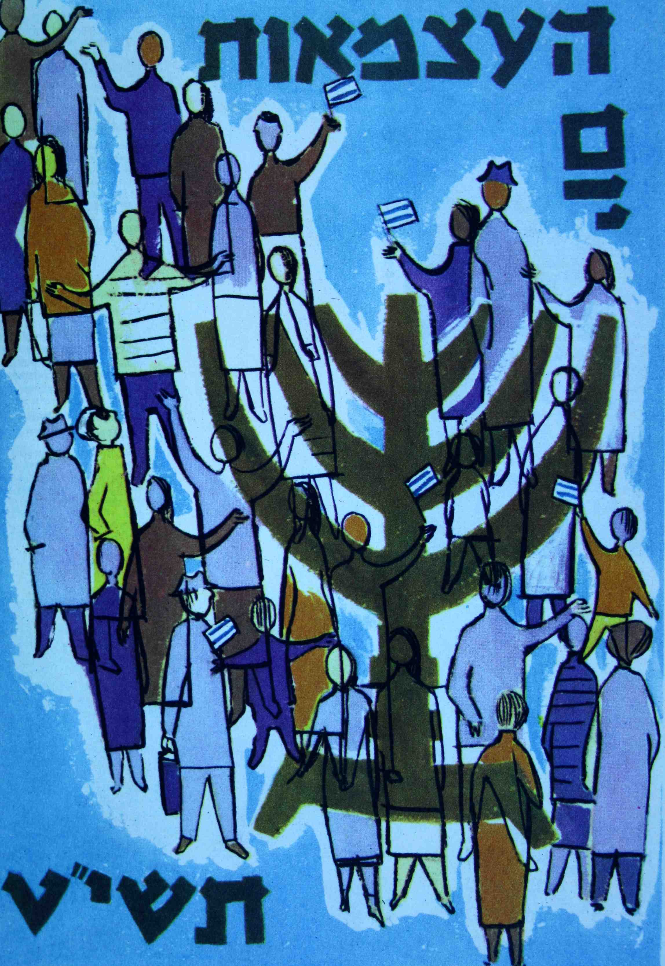

**2 - Independence Day Poster, 1959**

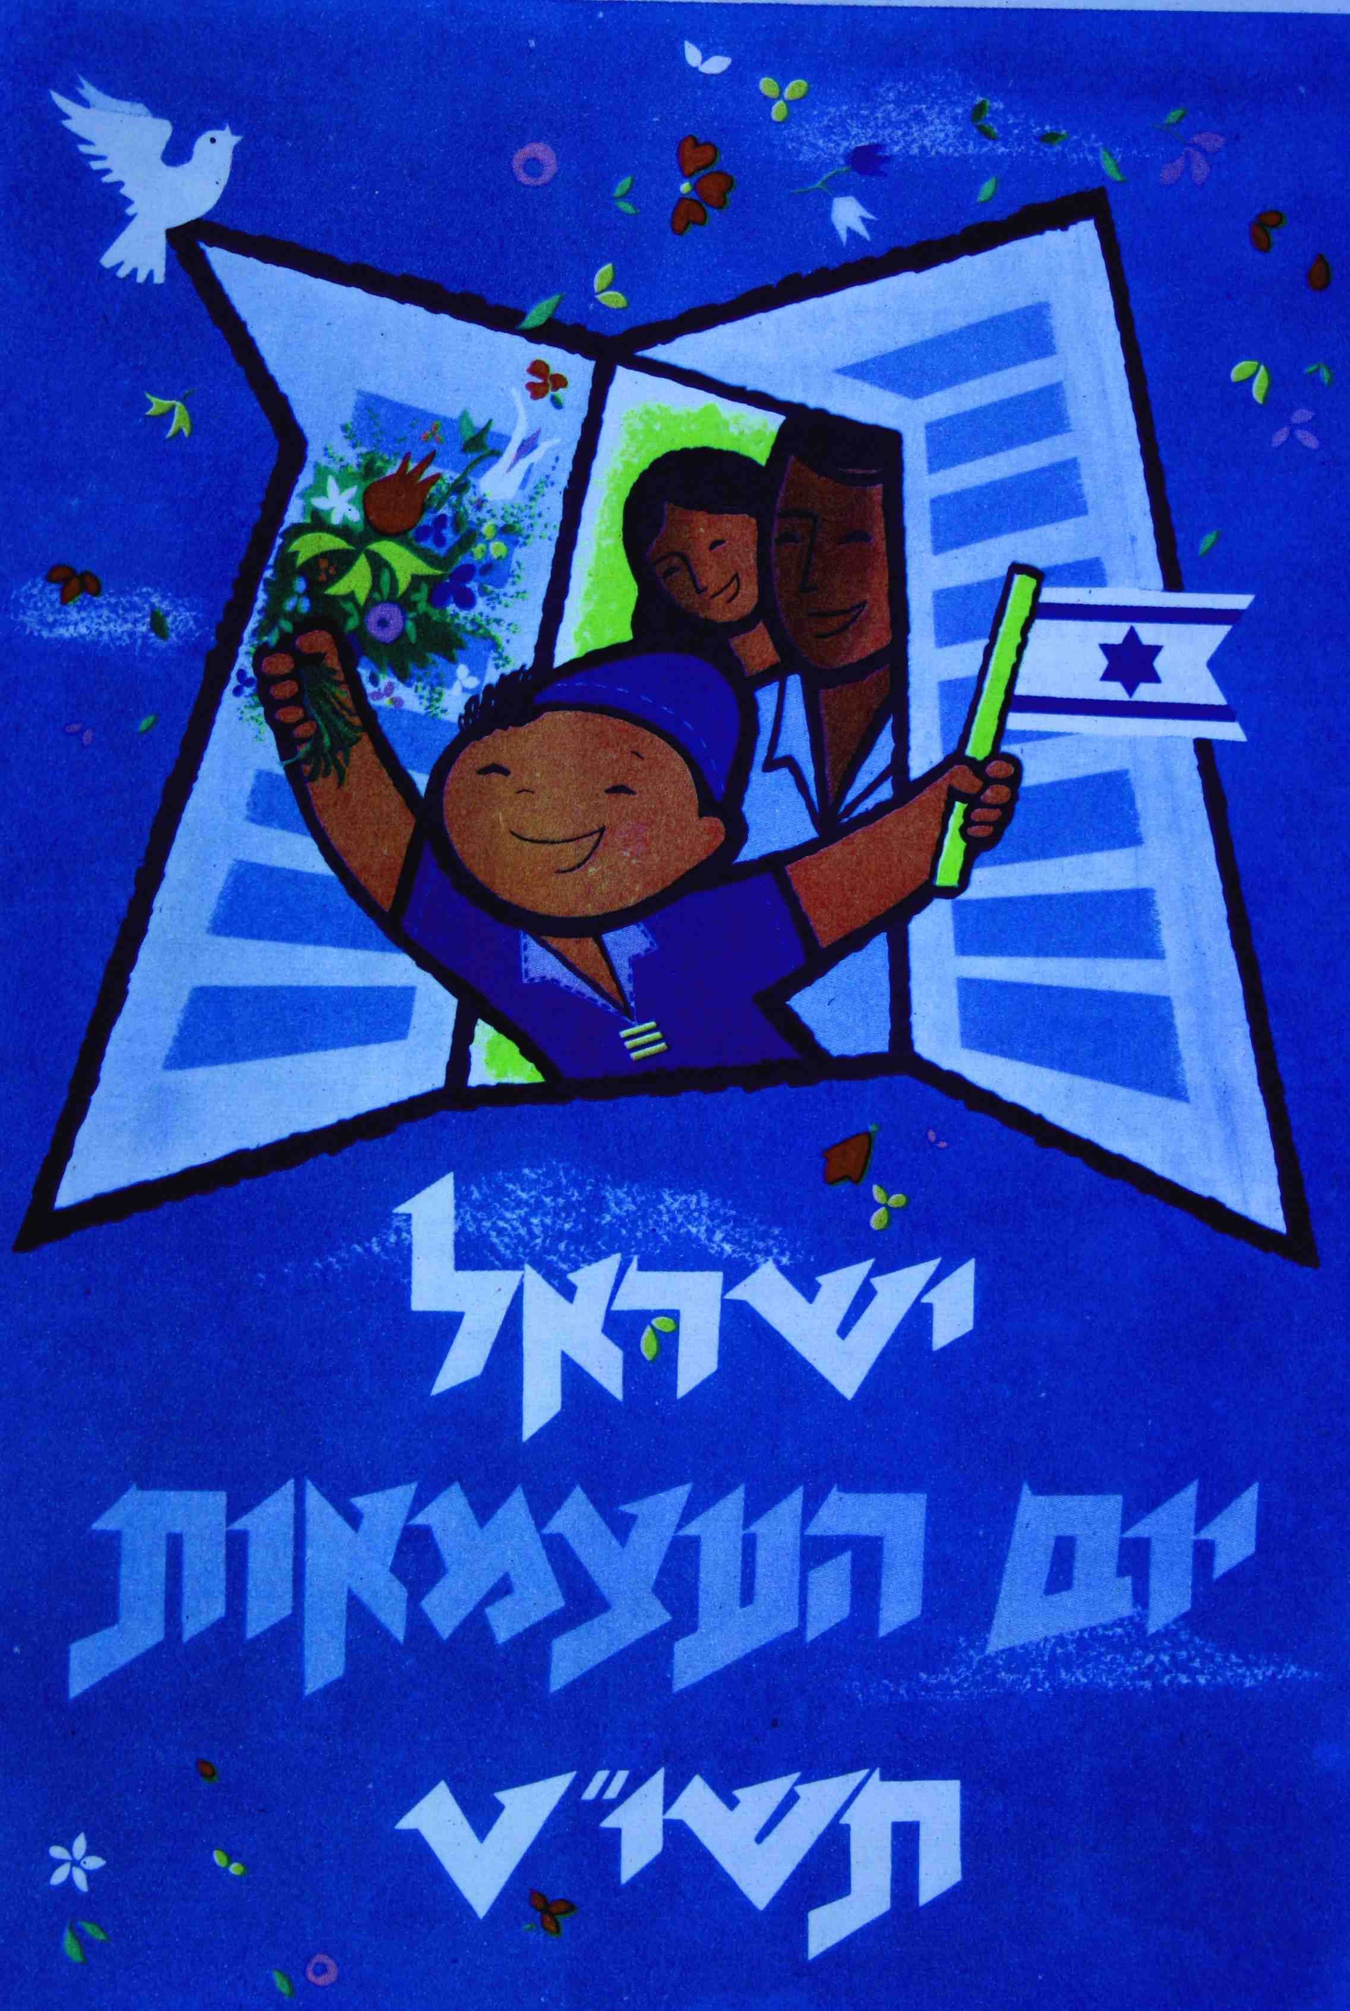

**3 - Independence Day Poster, 1959**

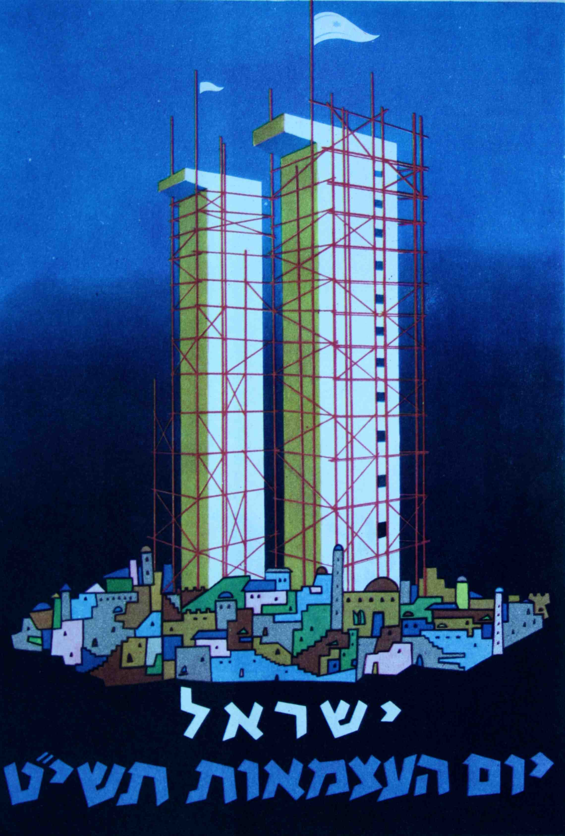

**4 - Independence Day Poster, 1959**

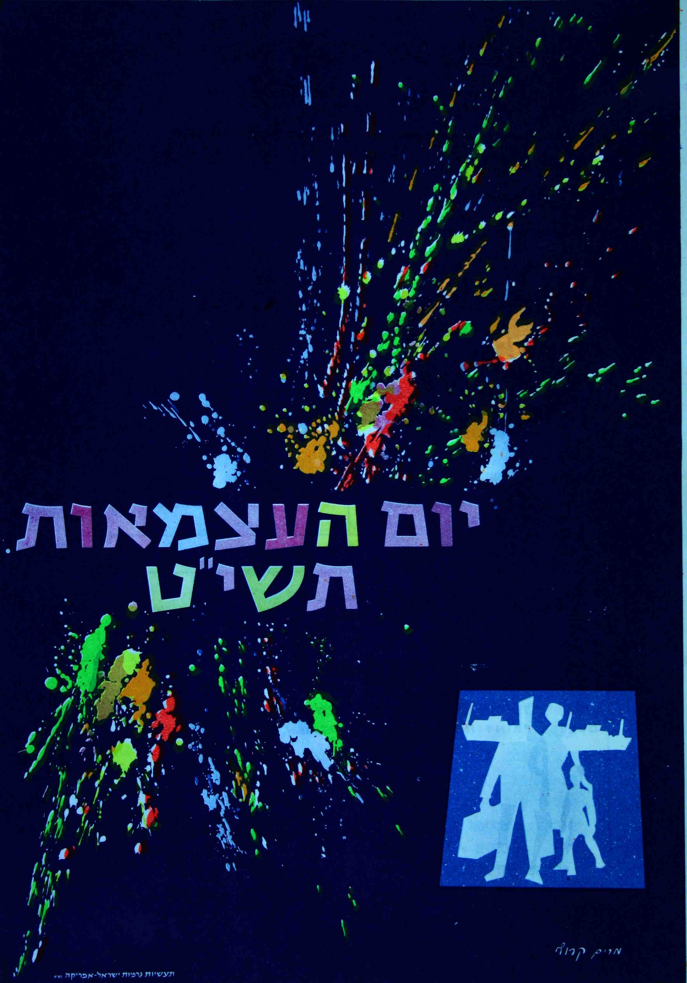

**5 - Independence Day Poster, 1959**