**Novel Infrasound-Based AI Stethoscope Fights COVID19**

Doron Adler, Noa Bachner-Hinenzon, Guy Dori, Haitem Zaidani, Sivan Perl, Michael Kotchok, Nor, Maayan, Shitrit, Darawshe

Affiliations:

1. Sanolla, Nesher, Israel, 2. HaEmek medical center, Afula, Israel, 3. Rambam medical center, Haifa, Israel, 4. Hilel-Yafe medical center, Hadera 5. Assaf-Harofeh, Tzrifin, Israel. 6. Barzilai medical center, Ashkelon, Israel

Summary (200 words)

COVID19 outbreak, first reported in Wuhan, China, has rapidly spread around the world, causing global public health and economic crisis. One of the critical manifestations of COVID19 is “silent pneumonia”, while the patient having only mild flu-like symptoms or even no symptoms at all 1. Since the respiratory part of the disease carries the most significant part of the morbidity, it is crucial to detect the “silent pneumonia” as early as possible2. Lung CT is considered the gold standard for the detection of COVID19 pneumonia3; however, the high radiation and cost does not make it practical for large scale examinations and patients’ follow-up. In this study we report that COVID19 pneumonia is "silent" **only** to human hearing and can easily be "heard" by Sanolla’s computerized stethoscope that enables to detect acoustic waves outside the audible range (VoqX™). After acquiring acoustic data of COVID19 patients (N=2,268), non-COVID19 pneumonia patients (N=840) and healthy subjects (N=1974), a classifier was developed to distinguish between the groups. The accuracy of the classifier reached 92% using lungs’ full acoustic data (including infrasound), while reaching only 85% without infrasound. Lungs Infrasound was shown to have an important role in detecting COVID19.

Article

The Severe Acute Respiratory Syndrome Coronavirus appeared in December 2019 and caused the Coronavirus Disease 2019 (COVID19)4. COVID19 results in a syndrome leading in some cases to a critical care respiratory condition, that requires specialized management at intensive care units5-6. This respiratory condition is termed “silent pneumonia” due to the inability to hear any pathological disfunction when examining these patients via stethoscope1. Some available clinical data shows that both mild and severe COVID19 patients showed bilateral distribution of patchy shadows or ground glass opacity7-8. It is more surprising that similar CT abnormalities have also been observed in asymptomatic patients, and there was no significant difference between asymptomatic and symptomatic patients9. In addition to that, it was found that although severe patients suffered from severe hypoxemia, the mechanical characteristics of the lungs were relatively well preserved and the patients did not show breathing difficulties until late in the disease course10-11. Thus, the ability to objectively detect this silent form of pneumonia in COVID19 patients is critical for preventing the pneumonia from progressing to a dangerous level. In this study we recruited a novel smart stethoscope for recording of lungs’ acoustic waves in the range on 3-2000Hz. This stethoscope picks up and analyzes both: the audible sound and infrasound generated in the lungs. This research showed that it is crucial to analyze the infrasound, although the doctor inherently cannot heart it since it contains additional information12.

First, we recorded 1,974 breathing sounds of healthy subjects, 2,268 sounds of COVID19 pneumonia and 854 sounds of non-COVIN19 pneumonia by using VoqX™ smart stethoscope of Sanolla (Fig. 1A). This stethoscope can analyze the lung sounds, show the sound signature (Figs. 1.B-D) and automatically classify the sounds. For every patient, 14 breathing sounds were collected at 14 different locations, so we had 141 exams of normal subjects, 164 exams of COVID19 subjects and 61 exams of non-COVID19 pneumonia subjects. In Fig.1 it is easy to visually recognize the difference in the sound signatures of normal subject (Fig1.B), patient with wheezes (Fig1.C) and patient with crackles (Fig1.D).

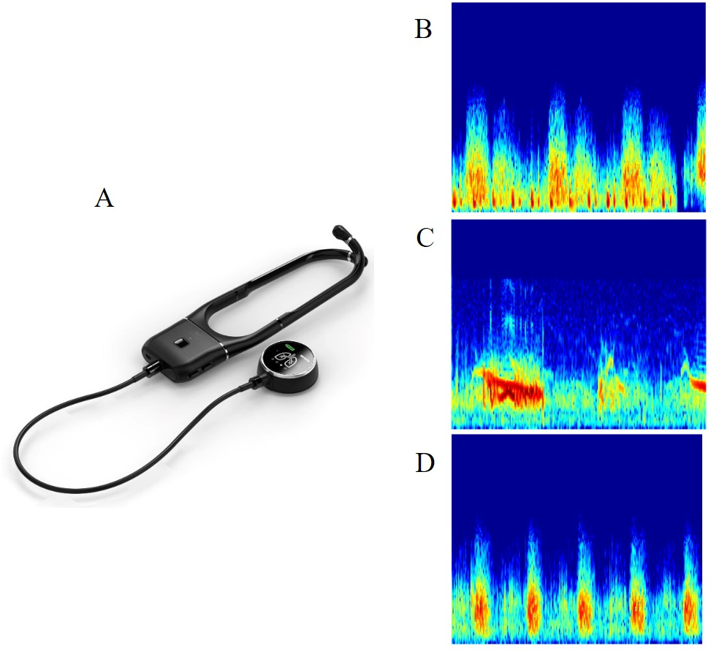

*Figure 1 – VoqXTM computerized stethoscope that can receive sound and infrasound waves for classification of lung/heart diseases (A) and the sound signature on its screen when receiving: normal lung sounds (B), wheezes (C) and crackles (D).*

The patients’ characteristics and the diagnosis according to lung auscultation is summarized in Table 2.

Table 2 – Patients’ characteristics and diagnosis by lung auscultation

|  |  |  |  |  |  |  |  |  |  |  |  |
| --- | --- | --- | --- | --- | --- | --- | --- | --- | --- | --- | --- |
|  | | | | | | | Lung auscultation | | | | |
|  | **N** | **Age [Years]** | **Height [cm]** | **Weight [Kg]** | **Smokes [N]** | **Gender [N]** | **Crackle [N]** | **Wheeze [N]** | **Crackle & Wheeze [N]** | **Low sound [N]** | **Normal [N]** |
| **Normal** | 141 | 42±19 | 168±11 | 73±21 | 52 | F-58  M-83 | 0 | 0 | 0 | 0 | 141 |
| **Non**  **COVID19** | 61 | 62±17 | 166±9 | 81±20 | 38 | F-33  M-28 | 36 | 4 | 2 | 2 | 17 |
| **COVID19** | 164 | 58±12 | 170±11 | 78±28 | 32 | F-77  M-87 | 31 | 6 | 0 | 4 | 123 |

As can be seen at Table 1, in 44 out of 61 (72%) of non-COVID19 patients the physician could hear a pathology by lung auscultation: 59% had only crackles, 7% had only wheezes, 3% had both crackles and wheezes and 3% had low breathing sounds and 28% had normal breathing sounds. However, COVID19 patients show a different picture. Only in 41 (25%) out of 164 test it was possible to recognize a pathology by lung auscultation: 19% had only crackles, 4% had only wheezes, 1% had both crackles and wheezes and 1% had low breathing sounds and 75% had normal breathing sounds.

These breathing sounds were analyzed, and 164 features were calculated for every exam. Out of 164 features only 50 were selected according to their significance in distinguishing between the groups: normal, COVID19 patients, and non-COVID19 pneumonia. Out of 164 features 144 showed p value < 0.05. 60% of the exams were dedicated for machine learning and 40% served as a test group. This separation was randomly performed 12 times. The results of the sensitivity, specificity, positive predictive value, negative predictive value, and accuracy with and without infrasound are described at Table 2.

**Table 2 – Results of 12 runs of random sets [% Average ± Standard deviation]**

|  |  |  |  |  |  |  |  |  |
| --- | --- | --- | --- | --- | --- | --- | --- | --- |
|  | | **Specificity** | **Sensitivity – nonCOVID19 pneumonia** | **Sensitivity - COVID19 pneumonia** | **NPV** | **PPV –**  **nonCOVID19 pneumonia** | **PPV - COVID19 pneumonia** | **Accuracy** |
| **Test group** | **With IFS** | 93±4** | 70±7 | 97±2** | 90±4** | 90±4* | 94±3** | 92±1** |
| **No IFS** | 80±7 | 69±11 | 93±4 | 85±5 | 84±6 | 85±3 | 85±2 |
| **Cross-validation** | **With IFS** | 87±2** | 71±7* | 93±2** | 88±3* | 78±6** | 89±1** | 87±2** |
| **No IFS** | 75±4 | 65±8 | 85±3 | 79±2 | 68±5 | 80±2 | 78±2 |

*IFS-Infrasound, NPV-Negative predictive value, PPV–Positive predictive value, *P<0.05 vs no infrasound, **P<0.01 vs no infrasound*

It can be seen in Table 1 that the infrasound plays an important role in the detection of COVID19 pneumonia, and that the “silent pneumonia” is not silent. This phenomenon is emphasized in the example in Figure 2 (MFCC1 vs Magnitude of breathing frequency), where it is easy to separate the 3 groups when adding the infrasound (Fig2.A.), while in Fig2.B. the normal and COVID19 are inseparable.

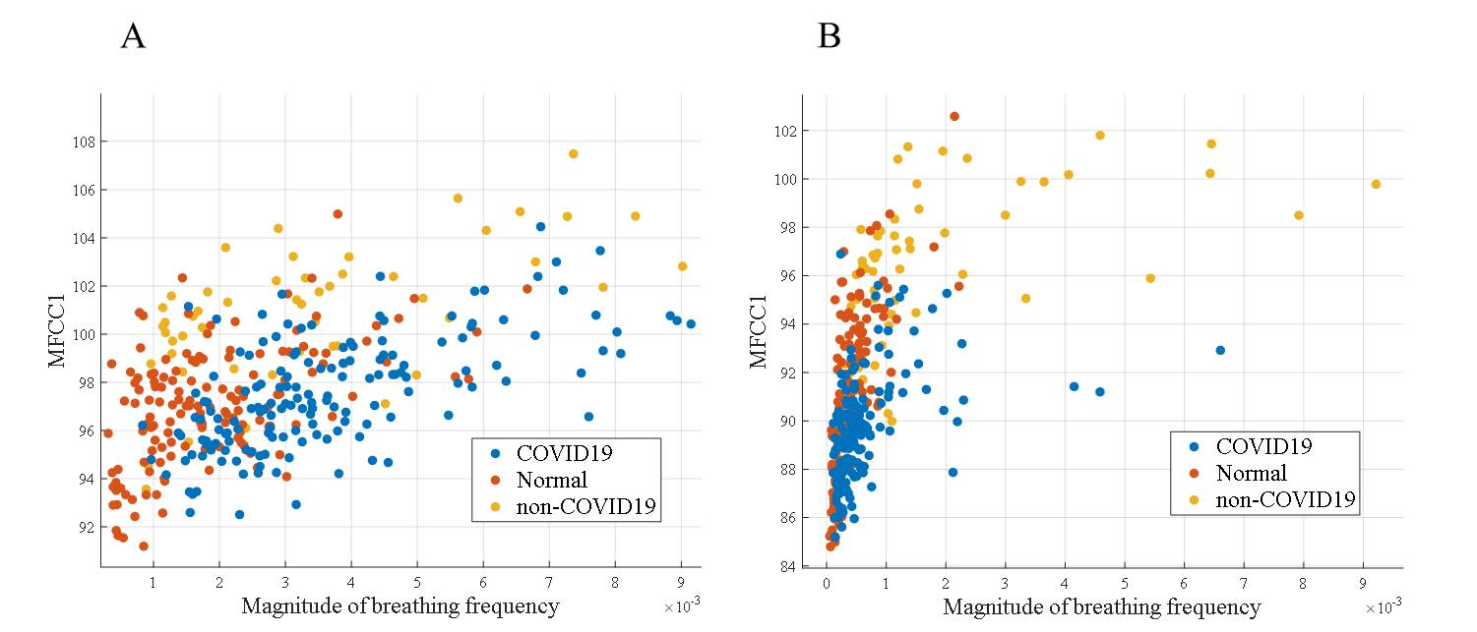

*Figure 2 – Two features that strongly depend on the infrasound: MFCC1 as function of Magnitude of breathing for COVID19 (blue), Normal (red) and non-COVID19 (yellow). A. With infrasound B. No infrasound.*

Finally, the ROC curves with and without infrasound were statistically compared, and were found to be significantly different for the COVID19 group (Fig. 3.A. P<0.01), while for the non-COVID19 patients it was insignificant (Fig.3.B.). The reason for that might be the fact that COVID19 pneumonia damages a vast area of the lungs, while the non-COVID19 pneumonia is more local.

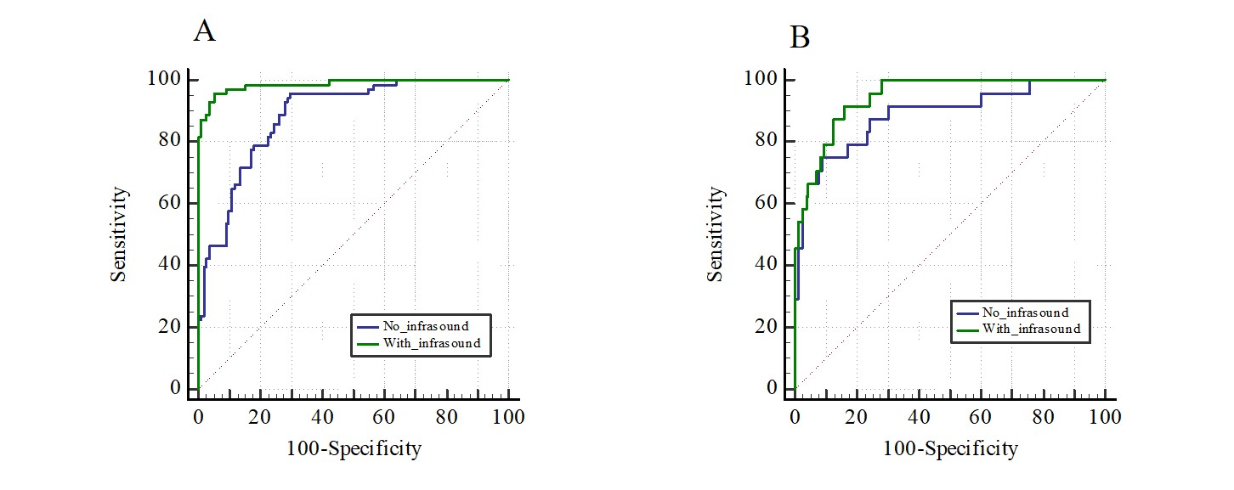

*Figure 3 – Receiver operator characteristics (ROC) curves after classification with and without infrasound. A. Detection of COVID19 “silent” pneumonia. B. Detection of non-COVID19 pneumonia.*

Discussion

In 1816 Dr. Rene Laënnec consulted by a young woman laboring, suffering from heart disease. Dr , Rene used his hands in order to listen to the young woman heart sounds – process known as [direct auscultation](https://en.wikipedia.org/w/index.php?title=Direct_auscultation&action=edit&redlink=1), leading him to invented two years later the stethoscope that enabled physicians to listen to heart and lung sounds. Since then diagnosis of lung diseases is performed by it as a conventional method. However, auscultation using a stethoscope is subjective and needs a well-trained physician to recognize the abnormalities13-14. AI methods have enormous amount of possibilities for analyzing lung sounds, and open new area of research that one could not imagine back in 1816. This study shows the potency of AI in the detection of lung disease. This study demonstrates the necessity of adding body infrasound data during auscultation and during AI analysis. The smart computerized stethoscope (VoqX™) that was used improved dramatically the diagnostic ability of auscultation by adding:

1. Full range acoustic waves data (including body infrasound)
2. Immediate, automatic, and objective AI decision support for the doctor
3. “Sound Signature” image making it easy to diagnose by visualizing the breathing sounds (Fig.1).
4. Lastly this 200-year-old diagnostic tool was revived by using the smart computerized stethoscope that requires no special training.

A smart detection of lung sounds, that includes the infrasound, is critical for COVID19 pneumonia patients due to the slow process of deterioration10-11 that can be manifested in the infrasound. While non-COVID19 pneumonia patients suffer from shortness of breath and their lung sound can mostly be heard, COVID19 patients do not suffer from shortness of breath until they are suddenly in a severe condition. The tool that is presented here has the potential to assist during the follow-up of COVID19 patients without any previous experience or training.

References

1. Tan, B., Zhang, Y., Gui, Y., Wu, S. & Li, Y. The possible impairment of respiratory‐related neural loops may be associated with the silent pneumonia induced by SARS‐CoV‐2. *J. Med. Virol.* (2020) doi:10.1002/jmv.26158.

2. Rodriguez-Morales, A. J. *et al.* Clinical, laboratory and imaging features of COVID-19: A systematic review and meta-analysis. *Travel Medicine and Infectious Disease* (2020) doi:10.1016/j.tmaid.2020.101623.

3. Ye, Z., Zhang, Y., Wang, Y., Huang, Z. & Song, B. Chest CT manifestations of new coronavirus disease 2019 (COVID-19): a pictorial review. *Eur. Radiol.* (2020) doi:10.1007/s00330-020-06801-0.

4. Bonilla-Aldana, D. K., Dhama, K. & Rodriguez-Morales, A. J. Revisiting the one health approach in the context of COVID-19: A look into the ecology of this emerging disease. *Adv. Anim. Vet. Sci.* (2020) doi:10.17582/journal.aavs/2020/8.3.234.237.

5. Zhu, N. *et al.* A novel coronavirus from patients with pneumonia in China, 2019. *N. Engl. J. Med.* (2020) doi:10.1056/NEJMoa2001017.

6. The Lancet. Emerging understandings of 2019-nCoV. *The Lancet* (2020) doi:10.1016/S0140-6736(20)30186-0.

7. Wang, D. *et al.* Clinical Characteristics of 138 Hospitalized Patients with 2019 Novel Coronavirus-Infected Pneumonia in Wuhan, China. *JAMA - J. Am. Med. Assoc.* (2020) doi:10.1001/jama.2020.1585.

8. Huang, C. *et al.* Clinical features of patients infected with 2019 novel coronavirus in Wuhan, China. *Lancet* (2020) doi:10.1016/S0140-6736(20)30183-5.

9. Zhang, R. *et al.* CT features of SARS-CoV-2 pneumonia according to clinical presentation: a retrospective analysis of 120 consecutive patients from Wuhan city. *Eur. Radiol.* (2020) doi:10.1007/s00330-020-06854-1.

10. Gattinoni, L. *et al.* COVID-19 Does Not Lead to a ‘Typical’ Acute Respiratory Distress Syndrome. *American journal of respiratory and critical care medicine* (2020) doi:10.1164/rccm.202003-0817LE.

11. Xie, J. *et al.* Critical care crisis and some recommendations during the COVID-19 epidemic in China. *Intensive Care Med.* (2020) doi:10.1007/s00134-020-05979-7.

12. Gavriely, N. & Cugell, D. W. *Breath Sounds Methodology*. *Breath Sounds Methodology* (2019). doi:10.1201/9780429260544.

13. Loudon, R. & Murphy, R. L. H. Lung sounds. *American Review of Respiratory Disease* (1984) doi:10.1136/thx.47.9.671.

14. Pasterkamp, H., Kraman, S. S. & Wodicka, G. R. Respiratory sounds: Advances beyond the stethoscope. *American Journal of Respiratory and Critical Care Medicine* (1997) doi:10.1164/ajrccm.156.3.9701115.

**Acknowledgements**

**Author Contributions:**