**The Rich Get Richer and the Poor Get Poorer:**

**Investors’ Behavior post Biotechnology Firms IPO**

Tiran Rothman and Smadar Siev[1]

**Abstract**

We analyze stock prices behavior patterns post Initial Public Offering (hereafter: IPO) events within the Biotechnology industry as well as exploring the role of social media in determining these patterns. Our main results indicate positive and significant Cumulative Average Abnormal Return (hereafter: CAAR) of 3.70% after the first 20 days post IPO (until the end of quiet period) and a decline of tens percent in the subsequent 3 years. However, when dividing the sample into two sub samples using $500M market value as separator, the overall picture change dramatically - firms with market value lower than $500M yielded a positive yet not significant CAAR 20 days post IPO and an immense negative significant CAAR from day 50 and on. Firms with market value higher than 500M$ presented a positive significant CAAR from day 20 after the IPO and during the consequent year. We relate these findings to investors’ limited attention. Attention for the new IPOs arises until the end of quiet period and then diminishing to small size firms in the post IPO years. Observing social media and share returns, we see a robust correlation between the two, which may indicate that investors’ attention is also reflected in social media.

**Keywords:** IPO; Pharmaceutical Companies; Social media; Attention; Behavioral Finance;; ; Financial Markets;. Inefficient market

**JEL Classification:** D8 (information, Knowledge, and Uncertainty) G11 (Portfolio Choice; Investment Decisions), G14 (Information and Market Efficiency; Event Studies), G17 (financial forecasting and simulation).

**1. Introduction**

Biotechnology sector relies on entrepreneurship, technology, science and finance. While technology and science are freely moving among entrepreneurs, finding funding is more challenging. The ‘new world’ companies that are seeking to develop one or few drugs have started to emerge a decade ago when technology became less expansive. Most of these companies do not have tangible assets and their operational risk is relatively high. Hence, funding issue has become a difficult task. As a result, we witness a growing number of biotech companies that seek to raise public capital throughout IPOs.

* 1. **IPO relevant Legislation**

The public offering process is divided into few main regulation periods: Pre-IPO (1) the pre-filing period that begins when the company choses an underwriter and ends when a company fills a registration statement with the SEC. During this period, a potential registrant is in the “quiet period” and is subject to restrictions on public disclosure relating to the offering. During this pre-filing period, no offers can be made, prospective purchasers cannot be contacted and the identity of underwriters cannot be publicly disclosed. (2) The pre-effective/waiting period that ends when the registration statement is declared effective. During this period, the company may generally make oral offers; sales of the securities and entering into binding agreements to sell the offered security are prohibited; and Post IPO: (3) the post-effective period begins when the registration declared effective, during this period the company can sell its shares if they are accompanies by a prospectus. The period ends after 25 days when underwriters or broker-dealers are no longer required to deliver a prospectus and they can publish share coverage. This is also the end of the quiet period (4) the lock-up period when major shareholders are prohibited from selling their shares. Lock-up periods usually last between 90 to 180 days after the IPO. Once the lock-up period ends, most trading restrictions are removed.

Another relevant legislation to our study is the JOBS Act that was enacted In April 2012. The act has altered the ‘new world’ environment, and established, inter alia, a new process of disclosures for public offerings by a new class of companies referred to as “Emerging Growth Companies” or “EGCs.”  According to the SEC regulation, An EGC is defined as a company with total annual gross revenues of less than $1 billion during its most recently completed fiscal year, which first sells equity in a registered offering after December 8, 2011. The Act was designed to boost job creation by giving smaller companies access to the capital needed to grow their business. Companies, who qualify, can file draft IPO registration statements confidentially with the SEC, file two years of audited financial statements instead of three, delay compliance with the Sarbanes-Oxley Act requirement for auditor opinions on internal controls and are allowed to delay implementation of new or revised accounting standards. More important is the new use of ‘test-the-waters’ communications with qualified institutional buyers and institutional accredited investors. Thus, EGCs are allowed to reach qualified institutional buyers before the lock-up period ends

Below is a general description of IPO regulation periods:

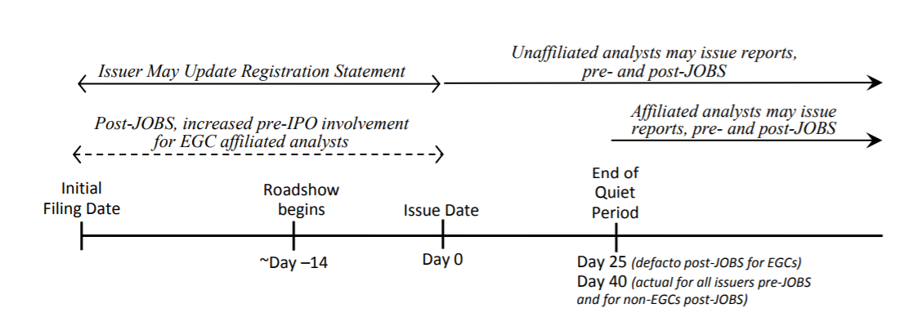

**1.2 IPO and stock performance**

IPOs have been widely studied in several aspects. Most relevant studies to our study dealt with shares performance up to three years post IPO. Jain and Kini (1994) showed low performance of IPOs for up to three years after the offering. Loughran and Ritter (1995) reported that IPO stocks yielded an average of 5% over the one-year post IPO period, compared to 12% for the size-matched non-IPO benchmark. Ritter and Welch (2002) investigated, in their seminal paper, long-run performance of IPOs and found that three-year average market-adjusted return )CAAR) on IPOs is a negative 23.4%. Unlike, Goergen et al., (2009) conducted a study on IPOs in France and Germany during 1996-2000 but did not observe any significant abnormal returns. In one of Ritter’s latest studies, Chang et al (2017) found that if one purchased a share of every company which went public between 1980 and 2015, a simple buy-and-hold strategy for three years post-IPO would yield decreased value of 18.7%. He also found that shares of technological firms exhibited even greater decreases in value. The returns around the expiration of IPO lock-up periods have puzzled researchers and a few previous studies conclude that market reacts negatively to the expiration of lock-up periods. Ofek (2000) who conducted their research in the U.S during 1996-1998 found an abnormal negative return during this period. In addition, they documented 1% to a 3% drop in the stock price, and a 40% increase in volume 180 days post IPO. Field and Hanka (2001), Bradley et al. (2001) and Brav and Gompers (2003) all observed negative abnormal returns of approx. 2% around expiration of the lock-up period when examining IPOs in the U.S. during 1988-1997.

**1.3 Media and Stock performance**

Most common way to boost investors' awareness according to Merton (1987) is to promote the visibility of the firm through the media. Shiller (2000) wrote, "The role of the news media in the stock market is not, as commonly believed, simply as a convenient tool for investors who are reacting directly to the economically significant news itself. The media actively shape public attention and categories of thought, and they create the environment within which the stock market events we see are played out." Shiller (2000) found that extra media coverage draws investors' attention to these stocks. This leads to a positive feedback effect, in which big returns follow big returns because of increased media coverage. Opposite results were found by Fang and Peress (2009) who analyzed the effect of the media coverage magnitude, on stock returns in the U.S stock market. They found that a portfolio of stocks not covered by the media outperformed a portfolio of stocks with high media coverage by 3% per year following portfolio formation. In their view the "no media premium" may stems from limitation to trade or compensation for little or lack of information.

Bhattacharya at, et al. (2009) explored the role of media in the internet IPO bubble between 1996 and 2000. They found that media coverage was much more intense for internet IPOs: there were more total news, more good news and more bad news for internet IPOs than for a matching sample of non-internet IPOs. They found that the media hyped good news for internet IPOs in the bubble period and hyped the bad news for internet IPOs in the post bubble period. Regarding the effect on daily abnormal returns, the market discounted the media hype. The effect was lower for internet IPOs, especially in the bubble period.

Siev (2014) also documented a gap in stock returns between firms that publish low and high number of Press Releases (PR) per annum in favor of the former. This gap (PR Premium) was found for both: the year of the PR publication and the following one, and its magnitude was 7–8% and 5–6%, respectively. The analysis also indicated that average daily trading volume of firms with high PR volume firms was three times higher than with firms with Low PR volume. The difference in trading supports the notion that perceived company image can bias financial trading activity. Applying the same logic, firms that have a high public attention due to a much higher volume of annual PR get more noticed, which leads to overpricing, which can ultimately yield lower returns.

In addition to the information originated by the firms and the press, discussed in the previous section, firm related information is disseminated also by the investment community using online social media.

One of the earliest studies conducted about internet stock messages boards was that of Wysocki (1998) who examined what characterizes firms whose stocks receive the highest volume of posted messages. He found that the most grabbing attention firms were characterized by: Extreme returns whether high or low; high market value; high price to earnings ratio; high book to market ratio; high volatility; high trading volume and high analyst coverage. Wysocki (1998) also found that increase in overnight messages postings leads to positive abnormal return and increase in trading volume on the next day. Studies on the online Social networks effect like Antweiler and Frank (2004), determined a direct correlation between activity in Internet message boards, stock volatility and trading volume. The authors found that, when many messages are posted on a given day, there is a negative return on the next day. Das and Chen (2007) found a negative correlation between changes in the amount of messages and changes in the contemporaneous stock prices. Chen et al (2014) found that the views expressed in both articles and commentaries posted on a popular social media outlet predict future stock returns in a period of three months after the publication.

Other researches employed blog posts to predict stock market behavior. Gilbert and Karahalios (2010) used over 20 million posts from the LiveJournal website to create an index of the US national mood, which they call the Anxiety Index. They found that when this index rose sharply, the S&P 500 ended the same day marginally lower than was expected.

In their initial work, Zhang et al (2011) measured collective fear and hope arising from analyzing a sample of Twitter posts for six months on a daily basis. They examined whether these collective emotions are correlated with major stock indices in the US market. The authors found that “emotional tweet percentage significantly negatively correlated with Dow Jones, NASDAQ and S&P 500, but displayed significant positive correlation to VIX. Forbergskog and Blom (2014) demonstrate that the positive and negative sentiment extracted from tweets can predict , the following day S&P 500 returns both positive and negative, respectively. Furthermore, Sul, Dennis, and Yuan (2014) prove that sentiment polarities extracted from tweets are positively correlated with intraday returns of the S&P 500, and Twitter users with more followers have stronger influence on the returns. Liew and Wang (2016) documented contemporaneous relationship between IPOs’ tweet sentiment and returns in the first trading day. In addition they found that prior days IPOs sentiment can predict IPO’s first-day returns from opening price to closing price**.**

**1.4 Focus of the study**

Our paper focuses on the ‘new world’ of biotech firms that were traded in U.S market. In the first part we examine how the new regulation (JOBS ACT), has influenced investors’ activity during the three years post IPO as reflected in the cumulative average abnormal return.

The second part is behaviouristic in its orientation as we connect between investments patterns and investors’ activity in social media. Decision-making process of financial markets participants is not always rational, and is often influenced by additional motives other than risk and return, such as the perceived quality of a firm. One of the channels to shape such perception is posts published about it through social media channels, from online message boards to Facebook and Tweeter. We chose to focus on Twitter, as it has increasing popularity and because twits are characteristics with a non-scrutinize unstructured, informal and very short text.

In a world where the amount of available information is almost endless, firms competition for investors' attention has become difficult than ever, therefore, we were interested to explore the mutual influence between the discourse level in Tweeter (without getting into the controversial evaluation of its content) and main capital market variables in the short and long term after the IPO.

**2. Stock behavior post IPO**

2.1. **Research Goals and Hypotheses**

As we described above, after an IPO is priced and opens for trading it does so as an "uncovered" stock since investment banks are in the IPO ‘quiet period’ during which their affiliated analysts or underwriters are not allowed to publish any research about the company. The ending of the quiet period is important as coverage of a firm is launched and that may have an outsized impact on the stock. The duration of the quiet period has changed over the years and recently the SEC has shortened it to 10 days. However, the vast majority of investment banks still observe the 25th day rule, i.e. coverage starts 25 days after the day of pricing. Our goal was to investigate CAAR behavior from the IPO date to the end of the quiet period and afterwards.

Thus, we expect to see an upward trend in CAAR during the quiet period and a downward trend after the quiet period ends. CAAR upward is expected due to the natural hype immediately post the IPOs. The consecutive downward is expected, in part, due to the publishing of numerous studies in that area and future forecasts by affiliated analysts. Dividing the sample into two sub-samples by firm size, we expect to observe better performance amongst large size firms for the following reasons: Large size firms are likely to have more experience, higher available resources and bigger products portfolio. These factors are probable to increase large firms' potential future success as well as to grab higher investors’ attention. Formally, we derived the following hypotheses:

***H1- Quiet period:* stocks return until the end of the quiet period**

The natural hype from the new IPO will yield positive CAAR from the IPO date and until the end of the quiet period.

***H2 - Quiet period:* stocks return post-quiet period:**

As new information arrives to the market, due to the end of the quiet period, the diminishing of the hype is reflected in a negative CAAR.

***H3 -* stock returns and market capitalization:**.

Large size firms are likely to exhibit better performance in compare to small size firms, due to higher potential for future success and higher investors' attention.

**2.2 Data and method**

Our initial database consists of all biotech companies that conducted IPOs in the period from January 2013 to November 2017. Data was extracted from EvaluatePharma database and consists of 283 companies.[2] We focused on US traded companies, and hence excluded firms that were traded in non-US stock exchanges. We also excluded firms that became private or were merged into or acquired by others from the IPO date up to 3 years post IPO. Our final database consists of 182 firms. Table 1 displays the number of IPOs per year in our final database[3]

[Insert Table 1 here]

A prominent feature of the firms in our sample is their relatively low market capitalization[4], as can be seen from table 2. Average market value is 454.2M$ and the Median is 287.1M$.

[Insert table 2 here]

We examine market reaction to IPO events using the event study approach. To that end, we mark the IPO day as t=0 and use daily stock prices, extracted from NASDAQ website and Yahoo Finance, for the period t= 0,.. ,755 (3 years post IPO), to calculate daily (logarithmic) returns. We employ two return benchmarks: the (i) IXJ Healthcare index, and (ii) S&P 500 market index; and calculate Cumulated Average Abnormal Return (CAARs) by subtracting the benchmark returns from the stock return. As no stock prices exists pre IPO, we did not calculate conditional return using the market model. Due to the low average market value of 454.2M$ (Table 2), we were motivated to explored the difference in CAARs with respect to firms’ size. Hence, we divided our database into two sub-samples of small and large firms and calculated CAAR for each of them; we choose our average rounded market value of $500M as a threshold to differentiate between small and large size firms

In addition, as a proxy for market attention, we computed normalized trading volumes. For each firm in our sample, we record the natural logarithm of the daily trading volume throughout the period t=0,.., 755, and normalize each observation by subtracting the mean and dividing by the standard deviation calculated over the period. Next, we average across all firms for each day relative to the IPO date.

2**.3 Results**

CAARs results for selected time periods during the 3 years post IPO are presented in Table 3. Panel A presents the results for the entire sample. Panel B presents the results for firms with market capitalization ≤ 500M$ (70% of the sample) hereafter: small firms. Panel C presents the results for the firms with market capitalization higher than 500M$ (30% of the sample) hereafter: large firms. Results are shown for two benchmarks - market and sector indices. As the CAAR results relative to the two benchmarks are similar, we will refer only to sector index benchmark. Figure 1 panels A to C describes the daily CAAR and normalized trading volumes for the entire sample, small and large firms respectively.

As shown in Panel A of table 3, CAAR that had been collected for the first 20 trading days post IPO is positive, significant, and equals 3.7% (t=2.18). These results support our H1 hypothesis. After 20 trading days, performance began to decrease and diminishing around the 50th trading day. CAAR = 0.26% (t=0.09), Post 100 trading days CAAR = - 7.11% (t=-1.68); 200 trading days post IPO, CAAR is -20.57% (t=-3.42) ; 250 trading days CAAR is -21% (t=-3.18); after two years (550 trading days) CAAR is -50.33% (t=-4.92); and after 3 years (755 trading days) CAAR is -70.66% (t=-5.54). Panel A in Figure 1, proves that the decline was consistent from day 20 onwards. These results are in line with previous literature and support our H2.

Regarding small companies (table 3, Panel B): CAAR for the first 20 trading days post IPO, was positive yet not significant (CAAR = 1.44%, t =0.92); 50 trading days Post IPO CAAR was negative and significant of -5.12%,( t = -1.64), 100 trading days post IPO ,CAAR was -15.63%, (t=-3.35 ) a year after the IPO CAAR was negative -33.72% (t=-4.45). Panel B in Figure 1 presents that the decline started on day 25 and was consistent onward. The results for large firms (table 3, panel C) presents completely different picture. After 20 trading days CAAR was positive and significant (CAAR = 9.1%, t = 2.19); after 50 trading days CAAR = 13.0%, (t = 2.26); after 100 trading days CAAR = 13.1% (t = 1.73). A year after the IPO, CAAR = 9.1% (t=0.83). The refined picture of daily CAAR is presented on panel C of Figure 1. CAAR reaches its pick of 15.76% at the 165-day post IP and from that point on, it started to decline until it diminishes completely 596 days post IPO. Another prominent finding is that large firms' CAAR was much more volatile than small firms' CAAR.

To wit, investors’ activity post IPO differs between firms according to their size. Small (large) size firms exhibit negative (positive) CARR in the first year post IPO. This supports our H3 hypothesis.

**[Insert table 3 here]**

**[Insert figure 1 here]**

Observing trading volumes: The IPO day was characterized by the higher trading volumes upon the three years period post IPO, in the second trading day, trading volumes decreased substantially and from that point and on, trading volumes show an increase growing trend over time. It is true for both small and large firms. See figure 1 panels A to C. Comparing trading volumes between large and small firms reveal that in the first 20 trading days, trading volume of small size firms was twice than of large size firms.. During the three years following the IPO, there is no advantage for small (large) firms in this respect. Half the time, trading volume of small firms exceeds the trading volume of large firms and vice versa.

We now turn to explore investors’ activity in the twitter social media platform before and after the IPO. We explore the relation between Twitter volume and stocks returns. In addition, based on the results above, we look at the relation between firms’ size and tweets volume and analyze, inter alia, do firms use social media as a tool to promote a successful IPO?

**3. Social media and IPO**

When viewing tweets volume as an attention getter, one should keep in mind that tweets volume has been weighted relative to other firms' volume, i.e. even a low tweets volume can stand out in an environment when adjacent firms have lower volume or no tweets at all, creating an impact, perhaps similar to one of a firm with very high tweets volume in an environment of high tweets volumes. That is why the sheer number itself is often meaningless; it becomes more meaningful only when compared with others in the segment. For that reason, we characterized the number of tweets above and below the median for each year relative to the IPO as High Twitter Volume and Low Twitter Volume (HTV and LTV) respectively.

**3.1 Research Goals and Hypotheses**

Our goal was to analyze the relation and causality between annual volume of tweets and main capital market variables. We expect to find positive relation between the two: Large firms, high trading volumes and high returns will increase investors’ interest as will be reflected in higher volume of tweets, and the other way around, higher volumes of tweets will draw investors’ attention as will be reflected in higher market activity[5]. In addition, we expect to find positive causality between the annual volume of tweets and returns. namely, a high volume of tweets in a given period will have positive effect on return in the subsequent period.

Formally we derived the following hypotheses:

**H4**  ***correlation -*** there will be a positive correlation between Twitter volume and capital market variables: risk, returns, trading volume and market capitalization.

**H5** – ***causality*** – a: There will be a positive causality between the annual volume of tweets and returns.

b: There will be positive causality between volume of tweets in periods of less than one year (a week/ two weeks and one month) in the period prior to the IPO and return in parallel periods post IPO.

ראש הטופס

**3.2 Data and Method**

For each firm in our sample we downloaded, using Python programing, its related twits, starting from the calendar year proceeding the IPO day and up to 3 calendar years post IPO. We extracted all tweets containing: full company name, $ + firms’ ticker and also the company's twitter user name if there was one, e.g. "@chimerix" for Chimerix. Next, we have excluded all the unrelated twits in which the company name appeared in a non-company context, such as “Adam Kadmon” for Kadmon. Our twitter database consists of daily twits for each company and amount to more than 1.5 million twits. Table 4 displays descriptive statistics regarding the annual tweets volume.

**[Insert table 4 here]**

Two main findings arose from Table 4. First, the average annual numbers of twits is growing over the years, from 359 at the year before the IPO, 2,237 twits at IPO year and up to 3,558 at the IPO + 2 year. The second is the huge variance in the annual volume of tweets within the firms. For example in the IPO year “Adverum Biotechnologies” had zero tweets while “Juno Therapeutics “had more than 26,000 related tweets. The growing annual number of tweets reflects both the growth in Twitter's popularity and the increase interest in firms over time.

To explore the relations between tweets volume and capital market variables, we employ both: univariate and multivariate analysis. In the univariate analysis we calculate several capital market variables for each firm in our database and compare the average of these variables between the LTV and HTV groups. The compared variables were: Return (t) is the rate of return on a firm's stock at period t; Trading volume (t) is a firm's daily average trading volume at period t; Std.Dev(t), is the standard deviation of daily returns - calculated over the period, and used as a proxy for total risk. Beta is a proxy for systematic risk coefficients. It was estimated from the market model regression on the S&P500 index returns using the first 50 trading days after the IPO and hence is displayed only for the IPO year. Market value(t) – was calculated as the number of shares for December of that year multiplied by the stock price of that day.

The multivariate analysis employs two sets of OLS regressions to analyze the contemporaneous relation between annual tweets volume and annual (abnormal) return. The regressions equations were:



(2)





Explained variables were return and abnormal return. The abnormal return was calculated relative to two benchmarks: the S&P 500 index and the IXJ index. Explanatory variables were: Beta; HTV is a dummy variable that receives 1 for companies with high tweets volume and 0 otherwise. Y2013 to Y2016 are dummy variables for the IPO years 2013-2017, aimed at capturing potential influence at a given year. NMV stands for Normalized Market Value; it was calculated by subtracting firms’ average market value from the firm value and divided by standard deviations of firms’ size for that year[6].

More multivariate analysis employs causality tests as will be details later.

**3.3 Results**

**3.3.1 Univariate analysis**

Table 5 presents capital market variables’ descriptive statistic for the years IPO, IPO+1 and IPO+2 in Panels A, B and C, respectively. Panel D presents absolute tweets volume for small and large firms. Results suggest that firms that were characterized by HTV are also characterized by higher risk (total and systematic), higher return, higher trading volume and higher market value compare to LTV firms. For example: differences in return reached 7% (P-value = 0.08) in the IPO year, 51% ( p-value = 0.001) in the following year and 29% (p-value = 0.04) in the IPO+2 year; Trading Volumes for the HTV firms were 2.7-2.8 times higher than for LTV firms and Market value was 1.7-2 times higher for the HTV firms. These results, supports our H4 hypothesis.

[Insert table 5 here]

**3.3.2 Multivariate analysis**

In light of the positive contemporaneous relation found between annual tweets volume and return, we conducted the regression equations described in equations 1 and 2. Regressions’ results are displayed in Table 6. Panels A, B and C display the results for the IPO, IPO+1 and IPO+2 years respectively.

The extended and the limited models are presented for each year. In cases that the tweets’ annual volume was not part of the limited model, we analyzed its contribution as an addition to the limited model and as a stand-alone variable. We presented only the AR regressions result relative to the sector index due to similarity between the two selected benchmarks.

[Insert table 6 here]

At IPO year (Table 6 Panel A), tweets’ volume is not part of the limited models (models 2 and 6). It gets explanatory power in the absence of the NMV (normalized market value) variable: 0.3 in model 3 (P = 0.03) and in 0.33 in model 7 (P = 0.02). As a standalone variable (model 8), the tweets’ volume coefficient was 0.25 (P = 0.07) and explains 1% of the AR variance. The significant coefficients of the years and the intercept capture the change in firm’s (abnormal) return during the first year after the IPO for each year. Beta coefficient was negative. The NMV coefficient found to be significant and, ranged between 22% and 24%,

Regressions conducted for the IPO+1 year )Table 6 panel B(, show that HTV firms yield to their holders 37%-39% higher (abnormal) returns than LTV firms (Models 1,2 ,4 and 5). Another interesting result is that the volume of tweets as a stand alone variable explains 8% of the variance of the return and abnormal return (models 3 and 6). NMV coefficient is positive and significant (all the models), indicating that (abnormal) return is growing along with firms’ value.

Regarding IPO+2 year, (Table 6, Panel C), the volume of tweets was the only significant coefficient. It explains about 2% of the variance of (abnormal) returns (models 2 and 4). Companies characterized by a high volume of tweets demonstrate 29% (32%) higher returns (abnormal) relative to firms with low volume of tweets.

We turn now to examine the causality between tweets volume and return. We conducted 3 sets of regressions: first, we examine whether tweets volume in a certain year affected stocks return in the following consecutive year. Specifically, we conducted the following $regressions$:



$Return\left(IPO_{year}+t\right)=β_{0}+β_{1}*Beta+β_{2}*HTV\left(I{PO}_{year}+t-1\right)+β_{3}*Y2013+…+β_{6}Y2016+β_{7}*NMV\left(IPO_{year}+t\right)$

$AR\left(IPO_{year}+t\right)=β_{0}+β_{1}*Beta+β_{2}*HTV\left(I{PO}_{year}+t-1\right)+β_{3}*Y2013+…+β_{6}Y2016+β_{7}*NMV(IPO_{year}+t)$

$$∀0≤t≤2$$

We did not find any causality.

In light of these results, we analyzed smaller time periods and were interested mainly in time period around the IPO. Therefore, we explore all the combinations of: one week, two weeks, one month, , for both periods before and after the IPO, i.e. we analyze whether high/low tweets volume a week/two weeks/ a month before IPO affected a week/two weeks/a month post IPO returns. Here, too we did not find any causality.

Thirdly, we employ Granger's (1969) causality approach. We analyze whether return can be explained by lagged values of returns, and whether adding lagged value of HTV improves this explanation. Likewise, we examine the opposite direction, whether tweets volume can be explained by its lagged values and whether a lagged value of return adds explanatory power.

The regression equations were:

(3)

(4)



Regressions’ Results are displayed in Table 7.

Though very small, IPO+1 year return has some explanatory power for next year return (Adjusted R2=2%). However, High tweets volume at the IPO+1 year do not explain next period return (Panel A). Regarding the opposite direction (Panel B), high tweets volume during IPO+1 year is a good predictor for high tweets volume during IPO+2 year (R2=17%). return at IPO+1 year does not explain the realization of high or low tweets volume in the consecutive year. Both regressions present contemporaneous relation between tweets volume and returns during IPO+2 year.

[Insert table 7 here]

To conclude, we did not find any causality between tweets volume, high or low, and returns nor for the opposite direction.

**4. Discussion and Conclusions**

In the last few decades, psychological aspects of decision making have been successfully implemented in economic modeling, adding to the descriptive power of the traditional normative approach based on rational expectations. Numerous studies results pointing at individuals’ cognitive limitations have been documented as part of these efforts.

Contributing to this line of work, we focus on post IPO period of biotechnology firms representing the ‘new world’ of firms. Most of these are small size firms developing one or only few drugs and hence investors’ attention has vast influence on companies’ shares price. Shares CAAR collapse after IPO is well known for years (see Loughran and Ritter, 1995 and Ritter and Welch, 2002), however only small portion of the studies has focus on the biotechnology sector, although it ranked as one of the top sectors by revenues. Furthermore, regulations regime change in 2012 (JOBS ACT) has dramatically alter investors approach to these kind of small size firms, putting them closer to capital market attention.

Our study document the investment patterns in the innovative biotechnology industry. The overall picture of stocks’ performance after IPO’s demonstrates short-term hype immediately after the IPO with positive and significant CAARs that reaches its top in proximity to the end of the quiet period 20 days after the IPO. This upward in CAAR is followed by a consistent and long decline in the consequent three years. IPO’s stocks underperform the market with negative CAARs of 20% during the first year, negative 54% during the second and negative 79% during the third. These results manifested a weak inefficiency of the market. Yet another example to the individuals’ cognitive limitations. These findings also indicate that 2012 (JOBS ACT) regime change has actually did not change the return down road found in similar studies (see Loughran and Ritter, 1995 and Ritter and Welch, 2002) conducted before 2012 (JOBS ACT).

Unexpected results, emerged when analyzing investors’ activity according to firms’ size. In our sample, small size firms demonstrated negative CAAR, while large size firms presents positive CAAR in the consecutive years post IPO. We suggest that these basic difference between the two size samples is due to the firms' ability to meet investors' expectations of desirable growth rate of revenues and profits. Large companies, who are likely to rely on a broad product line, meet or exceed market expectations in that regard, as evidenced by the positive yet volatile CAAR, in the years following the IPO (Figure 1 panel C.). It appears that the volatility reflects the market's close monitoring and response of the results of trials and adherence to drug development timeline. Small size firms' existence rely on one or few drugs. Delayed in development or experiment failure, make it difficult to meet investors' expectations regarding desirable growth rate of revenue and profit. Failing to meet these expectations lead to negative CAAR. This make-or-break situation for small size firms may lead to the optimal timing for IPO.

Our study shows that observing IPO in terms of firms’ maturity is critical to the success of the issuance, thus the $500M may be viewed as a threshold for biotech firms seeking for IPO. We can point that small size firms are overpriced while large size firms are underpriced at the IPO stage. This finding is of great importance to firm aiming at raising money via the capital markets.

Failure to meet market expectation, as explained above, results in limited investors’ attention as can be viewed in small size firm findings. Our findings are in line with Barber and Odean (2007) that measured indirect investors’ attention using three observable measures that are likely to be associated with attention grabbing events: media, unusual trading volume, and extreme returns. We did find that small size firms are characterized by lower tweets volume a year before and a year after IPO (Table 5 panel D) as well as returns which lead to negative CAARs (table 3, panel B). We did not find volume difference.

We contribute to the behavioral aspect in documenting the relations between the yearly discourses level on Twitter and stock returns. The univariate analysis indicates that firms characterized by high volume of tweets are larger, their trading volume is higher, and their volatility and stock return are higher as well. The contemporaneous relation between tweets volume and returns was also recorded in the multivariate analysis, indicating that the difference in returns between HTV and LTV firms is about 30% per year in favor of the HTV firms, in each of the three years after the IPO. These findings are consistent with our view that larger and high yield companies will grab more investors' attention as reflected in the discourse volume in Twitter and vice versa.

We emphasize once again that the correlation was found for the mere volume of tweets, regardless of the content and/or the resulting sentiment. We suggest that the high volume of discourse in itself contributes to investors' awareness of the company. The ongoing exposure on Twitter leads to the branding effect of the firm, which increases investors' confidence in its reliability and prosperity. The resulting perceived quality of the firm leads to an increased purchase of their shares at a high price. This purchase proves to be justified due to the continued difference in returns in favor of the HTV firms. Finding a gap of 30% in returns should be of great interest to the firms themselves, as they can be active on this platform and tweet for themselves. As noted above, the percentage of tweets originating by the companies themselves was very low and they were responsible for an average of less than 1% of the whole tweets.

Despite our expectations for finding causality between tweets’ volume and returns, we did not find one in the various regressions we conducted. This (lack of) finding may stem from the relatively long periods of time we examined a week, two weeks, a month and a year. It may be the case that the effect of tweets is myopic in its nature and affect for time periods of hours or days as was shown by Zhang et al (2011); Forbergskog and Blom (2013) and Sul, Dennis, and Yuan (2014). These relatively long periods of time constitute a limitation in this study and further research is needed in that respect to examine causation in short time periods as daily or two-day in the years post-IPO as well as exploring tweets volume effect for small size and large size firms separately.

To conclude, our findings are related to investors’ limited attention as to the fact that small size firms are ‘off-radar’ stocks. We assume IPO ignites a period of investors’ attention which arises until the end of quiet period and then investors’ attention to small size firms diminish at the post IPO years as they seek their next lottery like opportunity. Observing social media and share returns, we see a robust correlation between the two, which may indicate that investors’ attention is also reflected in social media.

**References**

Antweiler, W. & Frank, M.Z. (2004). Is All That Talk Just Noise? The Information Content of Internet Stock Message Boards. Journal of Finance Vol. 59, No. 3 (Jan., 2004), pp.1259-1294.

Barber, B. M., & Odean, T. (2007). All that glitters: The effect of attention and news on the buying behavior of individual and institutional investors. The Review of Financial Studies, 21(2), 785-818.‏

Bhattacharya, U., Galpin, N., Ray, R., & Yu, X. (2009). The role of the media in the internet IPO bubble. Journal of Financial and Quantitative Analysis, 44(3), 657-682.‏

Bradley, D. J., Jordan, B. D., Yi, H. C., & Roten, I. C. (2001). Venture capital and IPO lockup expiration: An empirical analysis. Journal of Financial Research, 24(4), 465-493.

Brav, A., & Gompers, P. A. (2003). The role of lockups in initial public offerings. The Review of Financial Studies, 16(1), 1-29.‏

Chang, C., Chiang, Y. M., Qian, Y., & Ritter, J. R. (2017). Pre-market trading and IPO pricing. The Review of Financial Studies, 30(3), 835-865.

Chen, H., De, P., Hu, Y. J., & Hwang, B. H. (2014). Wisdom of crowds: The value of stock opinions transmitted through social media. The Review of Financial Studies, 27(5), 1367-1403.‏

Das, S. R., & Chen, M. Y. (2007). Yahoo! for Amazon: Sentiment extraction from small talk on the web. Management science, 53(9), 1375-1388.‏

Fang, L., & Peress, J. (2009). Media coverage and the cross‐section of stock returns. The Journal of Finance, 64(5), 2023-2052.‏

Field, L. C., & Hanka, G. (2001). The expiration of IPO share lockups. The Journal of Finance, 56(2), 471-500.‏

Forbergskog, J. O., & Blom, C. R. (2014). Twitter and stock returns (Master's thesis).

Gilbert, E., & Karahalios, K. (2010, May). Widespread Worry and the Stock Market. In ICWSM (pp. 59-65).‏

Goergen, M., Khurshed, A., & Renneboog, L. (2009). Why are the French so different from the Germans? Underpricing of IPOs on the Euro New Markets. International Review of Law and Economics, 29(3), 260-271.

Granger, C. W. (1969). Investigating causal relations by econometric models and cross-spectral methods. Econometrica: Journal of the Econometric Society, 424-438.‏

Jain, B. A., & Kini, O. (1994). The post‐issue operating performance of IPO firms. The journal of finance, 49(5), 1699-1726.‏

Liew, J. K. S., & Wang, G. Z. (2016). Twitter sentiment and IPO performance: a cross-sectional examination. Journal of Portfolio Management, 42(4), 129.‏

Loughran, T., & Ritter, J. R. (1995). The new issues puzzle. The Journal of finance, 50(1), 23-51.‏

Merton, R. C. (1987). A simple model of capital market equilibrium with incomplete information. The journal of finance, 42(3), 483-510.‏

Ofek, E. (2000). The IPO lock-up period: Implications for market efficiency and downward sloping demand curves.

Ritter, J. R., & Welch, I. (2002). A review of IPO activity, pricing, and allocations. The journal of Finance, 57(4), 1795-1828.‏

SEC ECG regulations link (2017) https://www.sec.gov/smallbusiness/goingpublic/EGC

Shiller, R. J. (2000). Measuring bubble expectations and investor confidence. The Journal of Psychology and Financial Markets, 1(1), 49-60.‏

Siev, S. (2014). The PR Premium. Journal of Behavioral Finance, 15(1), 43-55.‏

Sul, H. K., Dennis, A. R., & Yuan, L. I. (2014, January). Trading on Twitter: The financial information content of emotion in social media. In System Sciences (HICSS), 2014 47th Hawaii International Conference on (pp. 806-815). IEEE.

Wysocki, P. (1998). Cheap talk on the web: The determinants of postings on stock message boards

Zhang, X., Fuehres, H., & Gloor, P. A. (2011). Predicting stock market indicators through twitter “I hope it is not as bad as I fear”. Procedia-Social and Behavioral Sciences, 26, 55-62.

**Table 1: IPOs per year**

|  |  |
| --- | --- |
| **Year** | **No. of IPOs** |
| 2013 | 30 |
| 2014 | 70 |
| 2015 | 49 |
| 2016 | 29 |
| 2017 | 4 |
| Total | 182 |

Note: This table presents the number of IPOs per year in the final database.

**Table 2: Market Value statistic at December of the IPO Year (M$)**

|  |  |  |
| --- | --- | --- |
| Average | 454.2 | |
| Median | | 287.1 |
| Min | 1 | |
| Max | 2,346.7 | |
| Std. Dev. | 494.4 | |
| Observations | 182 | |

Note: This table presents descriptive statistics of the firms' market capitalization.

**Table 3: Post IPO CAARs, +1 to +755 days**

Panel A: The entire sample

|  |  |  |  |  |
| --- | --- | --- | --- | --- |
| Days relative to event | Diff from Market Index | | Diff from Sector index | |
| CAAR, % | t-stat. | CAAR, % | t-stat. |
| 1 to 10 | 0.58% | 0.47 | 0.50% | 0.38 |
| 1 to 20 | 3.88% | 2.35 | 3.70% | 2.18 |
| 1 to 50 | 0.60% | 0.19 | 0.26% | 0.09 |
| 1 to 100 | -6.83% | -1.54 | -7.11% | -1.68 |
| 1 to 150 | -12.17% | -1.96 | -12.84% | -2.42 |
| 1 to 200 | -19.75% | -2.76 | -20.57% | -3.42 |
| 1 to 250 | -19.80% | -2.58 | -21.00% | -3.18 |
| 1 to 550 | -54.05% | -4.92 | -50.33% | -4.92 |
| 1 to 755 | -77.45% | -5.77 | -70.66% | -5.54 |
| Observations | 182 |  | 182 |  |

Panel B: Small size firms (market cap. < $500M)

|  |  |  |  |  |
| --- | --- | --- | --- | --- |
| Days relative to event | Diff from Market Index | | Diff from Sector index | |
| CAAR | t-stat. | CAAR | t-stat. |
| 1 to 10 | 0.12% | 0.10 | 0.09% | 0.07 |
| 1 to 20 | 1.57% | 1.04 | 1.44% | 0.92 |
| 1 to 50 | -4.89% | -1.22 | -5.12% | -1.26 |
| 1 to 100 | -15.61% | -2.93 | -15.63% | -2.92 |
| 1 to 150 | -23.41% | -2.93 | -23.79% | -2.99 |
| 1 to 200 | -33.56% | -3.67 | -34.12% | -3.74 |
| 1 to 250 | -32.60% | -3.35 | -33.72% | -3.49 |
| 1 to 550 | -77.32% | -5.56 | -73.48% | -5.30 |
| 1 to 755 | -101.50% | -5.97 | -92.61% | -5.47 |
| Observations | 128 |  | 128 |  |

Panel C: Large size firms (market cap.> $500M)

|  |  |  |  |  |
| --- | --- | --- | --- | --- |
| Days relative to event | Difference from Market Index | | Difference from Sector index | |
| CAAR | t-stat. | CAAR | t-stat. |
| 1 to 10 | 1.69% | 0.52 | 1.45% | 0.44 |
| 1 to 20 | 9.35% | 2.30 | 9.06% | 2.19 |
| 1 to 50 | 13.63% | 2.38 | 13.01% | 2.26 |
| 1 to 100 | 13.97% | 1.85 | 13.08% | 1.73 |
| 1 to 150 | 14.48% | 1.60 | 13.12% | 1.44 |
| 1 to 200 | 13.00% | 1.27 | 11.55% | 1.14 |
| 1 to 250 | 10.51% | 0.95 | 9.14% | 0.83 |
| 1 to 550 | 1.51% | 0.10 | 4.92% | 0.31 |
| 1 to 755 | -19.54% | -1.03 | -12.10% | -0.64 |
| No. of firms | 54 |  | 54 |  |

Note: This table displays Cumulative Average Abnormal Return for the entire sample and two sub samples below (Panel B) and above (Panel C) market value of 500M$ as of December of the IPO year.

**Figure 1 – Post IPO CAARs, +1 to +755 days**

Panel A: The entire sample

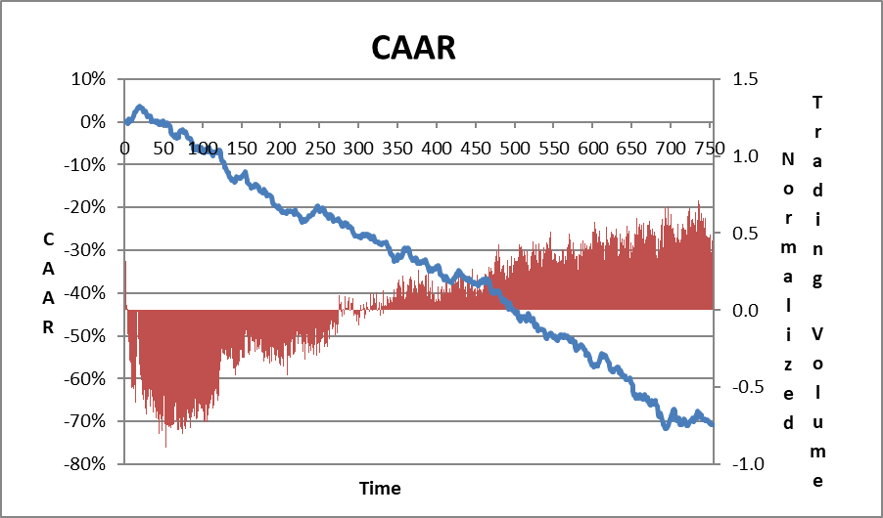

Panel B: Small Firms(market value <500M$)

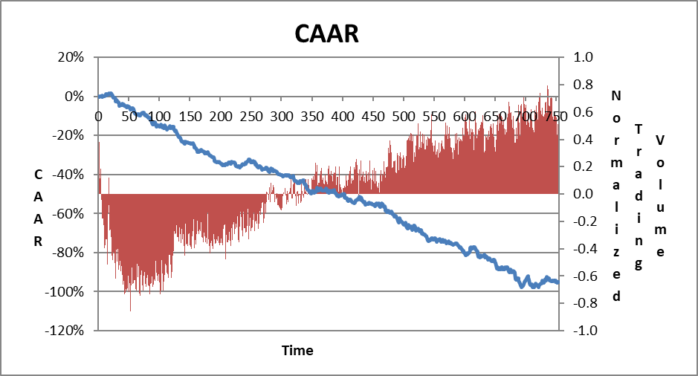

Panel C: Large Firms (market value >500M$)

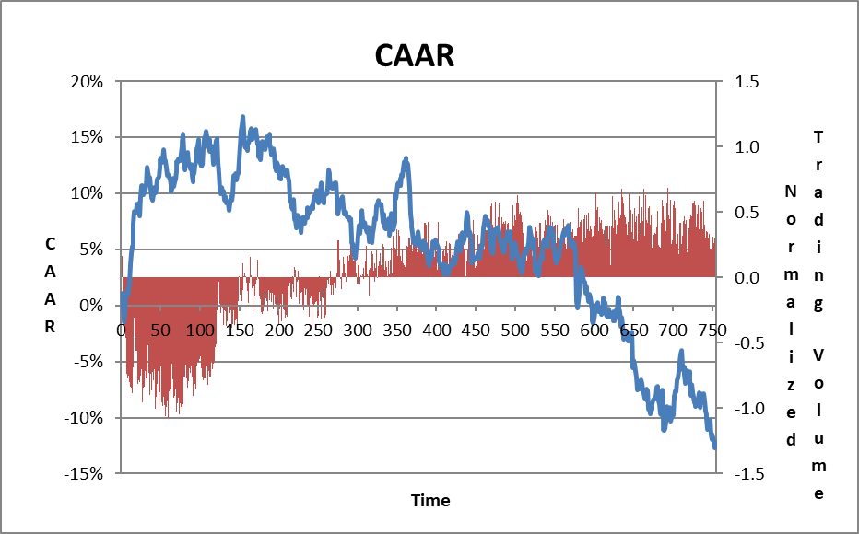

Note: These figures present daily CAAR after the IPO from day 0 to day 755; panel A present CAAR for the entire sample; panel B for small firms and panel C for large firms . AR was calculated versus the sector index.

**Table 4: Tweets volume descriptive statistics**

|  |  |  |  |  |
| --- | --- | --- | --- | --- |
|  | **IPO Year-1** | **IPO Year** | **IPO+1 Year** | **IPO+2 Year** |
| **Average** | 359 | 2,237 | 3,083 | 3,558 |
| **Median** | 246 | 1,524 | 2,377 | 2,326 |
| **Std. Dev.** | 377 | 2,690 | 2,978 | 3,976 |
| **Min** | 0 | 0 | 197 | 15 |
| **Max** | 2,035 | 26,126 | 20,022 | 27,579 |
| **No of Tweets** | 65,349 | 407,067 | 548,815 | 542,232 |
| **No of firms** | 182 | 182 | 178 | 147 |

Note: This table presents Tweeter volume descriptive statistics for one tear before the IPO up to three years post IPO.

**Table 5: Capital market variables’ descriptive statistics for HTV and LTV firms**

**Panel A: IPO Year**

|  |  |  |  |  |
| --- | --- | --- | --- | --- |
|  | **LTV** | **HTV** | **Diff** | **P-Value of Diff** |
| Beta (50 Days) | 0.68 | 1.00 | 0.31 | 0.03 |
| Return's Volatility | 0.05 | 0.12 | 0.07 | 0.14 |
| Return | 0.05 | 0.12 | 0.07 | 0.08 |
| Trading Volume | 94,321 | 267,332 | 173,011 | 0.00 |
| Market Value (M$) | 322.74 | 585.66 | 262.91 | 0.00 |
| Observations | 91 | 91 |  |  |

**Panel B: IPO Year+1**

|  |  |  |  |  |
| --- | --- | --- | --- | --- |
|  | **LTV** | **HTV** | **Diff** | **P Value of Diff** |
| Return's Volatility | 0.044 | 0.057 | 0.013 | 0.001 |
| Return | -0.15 | 0.36 | 0.51 | 0.001 |
| Trading Volume | 162,046 | 441,602 | 279,556 | 0.000 |
| Market Value (M$) | 418.17 | 844.56 | 426.38 | 0.001 |
| Observations | 89 | 89 |  |  |

**Panel C: IPO Year+2**

|  |  |  |  |  |
| --- | --- | --- | --- | --- |
|  | **LTV** | **HTV** | **Diff** | **P Value of Diff** |
| Return's Volatility | 0.04 | 0.06 | 0.01 | 0.000 |
| Return | 0.00 | 0.29 | 0.29 | 0.043 |
| Trading Volume | 244,890 | 660,862 | 415,973 | 0.000 |
| Market Value (M$) | 493.44 | 841.79 | 348.35 | 0.017 |
| Observations. | 75 | 72 |  |  |

**Panel D: Absolute tweets volume per firm size**

|  |  |  |  |
| --- | --- | --- | --- |
| **Absolute Tweets volume** | **Small** | **Large** | **P value of the difference** |
| IPO Year -1 | 310 | 474 | 0.01 |
| IPO year | 2,068 | 2,636 | 0.07 |
| IPO year +1 | 3,063 | 3,135 | 0.43 |
| IPO year +2 | 3,404 | 4,001 | 0.20 |

Note: Panels A to C presents market variables descriptive statistics for the sample firms divided to LTV and HTV firms. Panel D presents absolute annual tweets volume from a year before the IPO up to three years after the IPO.

**Table 6: The relation between (abnormal) return and tweets volume- regressions results**

**Panel A: IPO year**

|  |  |  |  |  |  |  |  |  |
| --- | --- | --- | --- | --- | --- | --- | --- | --- |
|  | **Return** | | | | **AR to Sector** | | | |
|  | **Model 1** | **Model 2** | **Model 3** | **Model 4** | **Model 5** | **Model 6** | **Model 7** | **Model 8** |
| Intercept | 1.63 (0.00) | 1.71 (0.00) | 1.76 (0.00) | 0.07 (0.48) | 1.38 (0.01) | 1.48 (0.00) | 1.51 (0.00) | -0.05 (0.59) |
| Year 2013 | -1.12 (0.04) | -1.13 (0.04) | -1.29 (0.02) |  | -1.12 (0.04) | -1.13 (0.03) | -1.29 (0.02) |  |
| Year 2014 | -1.20 (0.02) | -1.21 (0.02) | -1.4 (0.01) |  | -1.11 (0.03) | -1.13 (0.03) | -1.31 (0.01) |  |
| Year 2015 | -1.94 (0.00) | -1.94 (0.00) | -2.12 (0.00) |  | -1.66 (0.00) | -1.66 (0.00) | -1.83 (0.00) |  |
| Year 2016 | -1.59 (0.00) | -1.56 (0.00) | -1.8 (0.00) |  | -1.46 (0.01) | -1.43 (0.01) | -1.67 (0.00) |  |
| Beta | -0.13 (0.03) | -0.12 (0.05) | -0.14 (0.03) |  | -0.14 (0.02) | -0.13 (0.04) | -0.15 (0.02) |  |
| NMV | 0.22 (0.00) | 0.24 (0.00) |  |  | 0.22 (0.00) | 0.24 (0.00) |  |  |
| HTV | 0.18 (0.20) |  | 0.30 (0.03) | 0.21 (0.15) | 0.21 (0.12) |  | 0.33 (0.02) | 0.25 (0.07) |
|  |  |  |  |  |  |  |  |  |
| Adjusted R Square | 0.20 | 0.20 | 0.16 | 0.01 | 0.16 | 0.15 | 0.11 | 0.01 |
| Observations | 182 | 182 | 182 | 182 | 182 | 182 | 182 | 182 |

**Panel B: IPO Year +1**

|  |  |  |  |  |  |  |
| --- | --- | --- | --- | --- | --- | --- |
|  | **Return** | | | **AR to Sector** | | |
|  | **Model 1** | **Model 2** | **Model 3** | **Model 4** | **Model 5** | **Model 6** |
| Intercept | 0.06 (0.69) | -0.08 (0.34) | -0.15 (0.10) | -0.04 (0.80) | -0.13 (0.13) | -0.19 (0.03) |
| Year 2013 | 0.08 (0.69) |  |  | 0.05 (0.83) |  |  |
| Year 2014 | -0.44 (0.02) |  |  | -0.30 (0.10) |  |  |
| Year 2015 | 0.02 (0.92) |  |  | 0.02 (0.91) |  |  |
| Beta | 0.00 (0.94) |  |  | 0.01 (0.82) |  |  |
| NMV | 0.27 (0.00) | 0.27 (0.00) |  | 0.26 (0.00) | 0.26 (0.00) |  |
| HTV | 0.39 (0.00) | 0.38 (0.00) | 0.51 (0.00) | 0.38 (0.00) | 0.37 (0.00) | 0.50 (0.00) |
| Adjusted R Square | 0.18 | 0.17 | 0.08 | 0.18 | 0.16 | 0.08 |
| Observations | 178 | 178 | 178 | 178 | 178 | 178 |

**Panel C: IPO Year +2**

|  |  |  |  |  |
| --- | --- | --- | --- | --- |
|  | **Return** | | **AR to Sector** | |
|  | **Model 1** | **Model 2** | **Model 3** | **Model 4** |
| Intercept | 0.08 (0.62) | 0.00 (0.98) | -0.02 (0.89) | -0.09 (0.44)  09 (0.44) |
| Year 2013 | -0.74 (0.00) |  | -0.6 (0.02) |  |
| Year 2014 | -0.05 (0.8) |  | -0.05 (0.79) |  |
| Beta | 0.00 (0.97) |  | 0.00 (0.98) |  |
| NMV | 0.02 (0.77) |  | 0.02 (0.79) |  |
| HTV | 0.49 (0.01) | 0.29 (0.08) | 0.48 (0.01) | 0.32 (0.05) |
|  |  |  |  |  |
| Adj. R Square | 9.4% | 2.08% | 4.3% | 2.04% |
| Observations | 147 | 147 | 147 | 147 |

Note: This table displays the results of OLS regressions in which the dependent variables were Return and Abnormal Return. P-values are in parentheses. Our data ends in 12/1/18, therefore for IPO Year+1, firms for which the IPO took place after 12.1. 2017 were excluded. For the IPO+2 year, firms for which the IPO took place after 12.1.2016 were excluded.

Table 7: Granger's Causality tests

|  |  |  |  |  |
| --- | --- | --- | --- | --- |
| **Panel A: Dependet Variable Return(IPO_Year+2)** | | | | |
|  | **Model 1** | **Model 2** | **Model 3** | **Model 4** |
| Intercept | 0.16 (0.05) | 0.167 (0.05) | 0.14 (0.25) | 0.15 (0.23) |
| Return IPO_Year+1 | -0.17 (0.05) | -0.18 (0.04) | -0.18 (0.05) | -0.24 (0.02) |
| Return IPO_Year |  | -0.05 (0.6) | -0.05 (0.58) | -0.09 (0.33) |
| HTV IPO_year+1 |  |  | 0.05 (0.79) | 0.06 (0.73) |
| NMV Dec IPO_Year+2 |  |  |  | 0.13 (0.15) |
| Adjusted R Square | 2.00% | 1.51% | 0.87% | 1.61% |
| Observations | 147 | 147 | 147 | 147 |

|  |  |  |  |
| --- | --- | --- | --- |
| **Panel B: Dependent Variable HTV(IPO_Year+2)** | | | |
|  | **Model 1** | **Model 2** | **Model 3** |
| Intercept | 0.26 (0.00) | 0.25 (0.00) | 0.25 (0.00) |
| HTV IPO_year+1 | 0.42 (0.00) | 0.41 (0.00) | 0.4 (0.00) |
| HTV IPO_year |  | 0.04 (0.66) | 0.04 (0.64) |
| Return IPO_Year+1 |  |  | 0.02 (0.68) |
| Adjusted R Square | 17.0% | 16.6% | 16.1% |
| Observations | 147 | 147 | 147 |

Note: This table displays Granger's causality tests. P-values are in parenthesis.

1. Rothman: School of Management, Wizo Academic College, Haifa, 31090, Israel, tiran@wizodzn.ac.il; Smadar Siev: Ono Academic College, Faculty of Business Administration. The authors' names appear in alphabetical order.
2. EvaluatePharma database is one of the top global pharma database - <http://www.evaluate.com/>
3. A list of the companies will be provided upon request.
4. Market capitalization for December of the IPO year calculated by the number of shares as appear in the firms’ profit and loss statement multiplied by the stock price at that day. The result was confirmed with the value appears in stockraw.com web site.
5. One of our goals was to explore whether firms who conduct active twitting policy had an advantage over these who don’t, with respect to returns. Surprisingly, firms’ activity on Twitter was zero or very low. For example, in the IPO year, only 15 out of 182 companies’ twits, and were responsible for less than 0.6% of the total number of tweets, s. This low participation rate from the total tweets made this analysis pointless.
6. Market capitalization is calculated for December of that year due to firms IPO all over the year