**Is conscious awareness needed for fear extinction?**

**INTRODUCTION**

**Fear conditioning and anxiety disorders**

Classical fear conditioning concerns the learning of an association between a neutral and an aversive stimulus. Through their pairing, the neutral stimulus becomes an indicator for the negative effect (Lovibond & Shanks, 2002). Acquisition refers to the process that associates between the neutral conditioned stimulus (CS) and the aversive unconditioned stimulus (UCS). In contrast, extinction constitutes an opposite process, in which the conditioned stimulus is presented repeatedly without the aversive stimulus, thereby weakening their association.

Fear conditioning may be regarded as an adaptive form of learning, which contributes to survival (Ohman & Mineka, 2001). Nonetheless, it might, occasionally, be a source for psychopathology in cases where anxious reactivity to a conditioned stimulus continues to exist, in the absence of an association between the conditioned stimulus and the aversive unconditioned stimulus (Lissek, 2005). Several theories postulated that fear conditioning underlies various anxiety disorders, post-traumatic stress disorder and other psychopathologies (Mineka, 2008). Anxiety disorders constitute the most prevalent psychiatric disorders (Kessler, Chiu, Demler, & Walters, 2005), and the most effective treatment for anxiety disorders is exposure (Deacon& Abramowitz, 2004). The goal of exposure is to facilitate extinction – the reduction in the conditioned fear response associated with feared stimuli (Abramowitz, 2013). Although effective psychological and pharmacological treatments exist for anxiety disorders (Alonso, 2004), most people with anxiety disorders never seek treatment (Wittchen et al, 2010). A possible explanation for these low rates is that patients consider confronting feared objects or situations as overly demanding. This highlights the need for novel interventions which may overcome this difficulty.

Inhibitory Learning is defined as a main model of extinction, yet other mechanisms were also suggested, such as habituation (i.e., a decrease of the strength of reaction to a certain stimulus following a repeated exposure to it). In the process of extinction, the evoking association between the conditioned stimulus and the aversive stimulus is not erased, but rather accompanied by a new association to which according to which the conditioned stimulus does not predict an aversive stimulus. .

**Fear Conditioning without conscious awareness**

In recent years, there is increasing evidence suggesting that fearful responses can occur even without explicit stimulus presentation (Ohman, 1986, 1993; Dimberg & Ohman, 1996; Ohman et al., 2000a, Raio et al, 2012). One study examined whether fearful expressions emerge from suppression into awareness more quickly relative to images of neutral or happy expressions. Fearful faces were found to emerge faster, implying that emotional expressions are unconsciously processed (Yang, Zald& Blake, 2007). These results are supported by findings of increased amygdala activation in response to fearful faces compared with happy, masked faces (Whallen, 1998). They are further in line with LeDoux’s (1996) suggestion that there is a direct path which passes between the thalamus and the amygdala, so that information may evoke fear, even without activation of the visual cortex.

If learning can occur without explicit stimulus presentation and fear can be acquired and experimentally evoked outside of awareness, it seems plausible that fear could diminish under similar conditions. Although learning without explicit stimulus presentation had been previously demonstrated, whether fear can be reduced without explicit exposure remains largely unknown. However, several studies have tested whether subliminal exposure to spider images affects the willingness to approach a spider, among people who are afraid of spiders (Siegel & Weinberger, 2009; 2011). In these studies, participants completed a behavioral avoidance test (BAT) one week subsequent to receiving masked exposure, to examine long-term effects of this form of exposure. They were then presented with spider images, either masked or unmasked. Participants in the masked condition were willing to approach a spider to a greater extent than those who were consciously exposed to spider pictures. These experiments were replicated with two-week and one-year follow-up measurements (Siegel & Warren, 2013; Siegel & Weinberger, 2012). Concerning physiological responses, one recent study used skin conductance and concluded that masked extinction is not associated with increased physiological responses in the extinction process (Siegel, 2017). However, except for a recent study in which skin conductance was measured, these findings were mainly based on behavioral measurements. In this recent study, participants in the masked condition succeed more in the BAT. However, no evidence for reduced physiological responses was obtained (Siegel, 2017). Furthermore, another methodological limitation in the aforementioned study concerns the way awareness was measured and assessed. In that study, subjects were asked in a preliminary masking experiment, to identify the masked images. These participants did not participate in the main experiment. Therefore, it is impossible to ascertain whether participants were aware of the spider images. In order to verify whether participants are aware of stimuli presented during exposure, trial-by trial awareness should be assessed, and objective as well as subjective measures need to be employed.

**Methodologies for the presentation of unconscious stimuli**

Various techniques were developed to suppress stimuli from awareness and assess unconscious processing by measuring the impact of those stimuli on subjects’ thoughts, feelings, actions and learning processes (Kouider & Dehaene, 2007; Stein & Sterzer, 2014). Here, we focus on two prominent techniques: visual masking (VM; Breitmeyer & Ogmen, 2000, 2006; Kahneman, 1968) and continuous flash suppression (CFS; Tsuchyia & Koch, 2005). In VM, a stimulus is presented (“target”) for a short duration of several dozens of milliseconds or less, and is immediately preceded/followed by masks, leading to its suppression from awareness (Breitmeyer & Ogmen, 2000, 2006; Kahneman, 1968). CFS relies on dichoptic vision to render stimuli invisible: a target stimulus is presented to one eye, while the other eye is constantly being projected with a changing pattern of different shapes. This technique prevents subjects from seeing the constant target image for a relatively long period of time which could last up to several seconds (Tsuchyia & Koch, 2005). Importantly, the two techniques may evoke different mechanisms, and different types of unconscious processing (Breitmeyer, 2004; Kim & Blake, 2006; Fogelson et al., 2014). Therefore, employing both unconscious methodologies is imperative when studying unconscious processes.

Typically, a combination of subjective and objective measures is used to ascertain that stimuli were indeed invisible. In the former, subjects report the content of their perception, either dichotomously (i.e., “I saw/didn’t see the stimulus”), or – more commonly today – on a gradual scale (i.e., perceptual awareness scale; Ramsey & Overgaard, 2004). Objective measures focus on participants’ performance regarding the suppressed stimuli under the assumption that if the stimuli were indeed invisible, subjects should be at chance level in explicitly judging them (Reingold & Merikle, 1998; for discussions about the limitations of both subjective and objective measures, see Snodgrass et. al., 2004).

Two commonly used autonomic measures of fear conditioning prevalent in the literature are skin conductance (Esteves, Critchley, Mathias, Parra, Dimberg, & Öhman, 1994), and heart rate (Öhman & Mineka, 2001(. Studies have demonstrated that these measures contribute to the understanding of anxiety disorders when used in experiments of fear conditioning (Bunce, Bernat, Wong & Shevrin, 1999). The present research will first aim at evaluating the feasibility and robustness of extinction evoked by unconsciously perceived stimuli, using the two common methodologies, CSF and VM. The advantage of CFS is the long duration of stimuli presentation, while VM has been claimed by some to allow for higher-level processing than CFS (Stein & Strezer, 2014).

**EXPERIMENT 1**

**Method**

*Participants*. Forty-eight (48) undergraduate participants received course credit for partaking in a 2-hr laboratory session. All participants provided written informed consent prior to completion of the experiment.

*Stimuli and Apparatus*

The study included measurements of changes in skin conductance, while viewing a pre-installed computer presentation on a monitor. Participants were presented with Conditioned Stimuli (CS+ and CS-): a scared face of a man or a woman. While the conditioned stimulus was presented, participants received mild electric shocks at a level of which they determine to be “aversive” (undesired and unpleasant) and “uncomfortable, but not painful” (Öhman, Erixon, & Löfberg, 1975). In addition, subjects filled in self-report measures. Further details are provided in the Supplemental Experimental Procedures.

*Procedure*

All participants underwent three phases in the experiment: acquisition, extinction, and testing phases (see Fig 1). The experiment started with an acquisition phase, where participants were presented with a face of a woman or a man, while receiving an electric shock for some of the trials (4 practice trials, 12 CS+ trials, 12 CS- trials, 6 CS-US trials). The order of stimuli appearance was pseudorandomized. Subsequently, participants underwent an extinction phase, where participants were presented with the same stimuli again, **without receiving the electric shock** (12 CS+ trials, 12 CS- trials). Participants were divided into 3 groups: (1) “Unaware group”, for which a subliminal stimulus (face of a man or a woman) was presented for 4 seconds in the extinction phase by using CSF, (2) the “Aware group”, for which a face of a man or a woman was presented for 4 seconds as well, and (3) the “Control group”, for which a scrambled face stimulus was presented using CSF (4 sec), serving as a comparison non-extinction group (while undergoing the same technical procedure as the group receiving unconscious CSF extinction).

In the unaware group and the control group where CFS was used, subjects were asked two questions at the end of each trial. These questions were used as an objective and subjective measures in order to assure the level of the subjects’ awareness. The objective question was: Was the picture presented a man’s or a woman’s? The subjective question was: How sure are you that you saw the picture? (1= I did not see anything to 4= I a saw the picture clearly).

Finally, all participants underwent a testing phase to assess the effects of conscious and unconscious extinction forms relative to the control group receiving no extinction. In the testing phase, all three groups were presented with the same stimuli that were used in the acquisition of fear while receiving an electric shock for one trial, in order to measure the recovery process in all three groups. Following the testing phase, the experimenter asked participants to fill out debriefing questionnaires, and to report the likely purpose of the study.

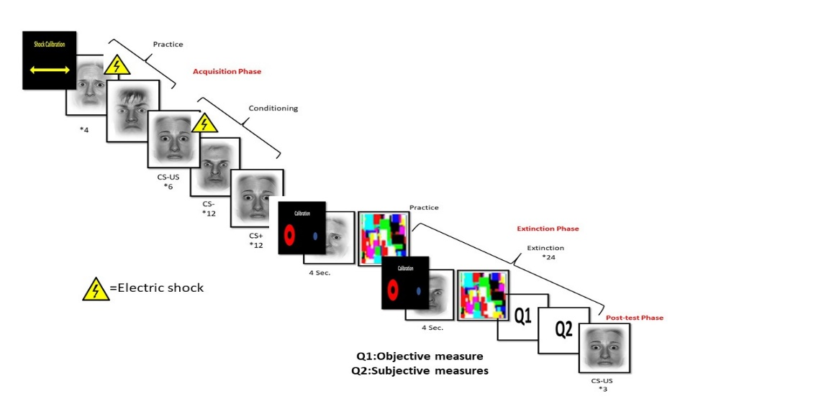

**Figure 1.** Experimental procedure and stimuli.

**Results and discussion**

Objective and subjective measures. First, participats’ responses from the extinction phase in the unaware group were analyzed to test for awareness. The subjective ratings showed that 80.2% of the trials were rated as 1 (“I did not see anything”), 14.6% as 2, (“I had a vague perception of something”), and only 0.4% were rated as either 3, (“I saw a clear part of the image” ) or 4, ("I saw the picture clearly "). On the objective measure, subjects’ accuracy whether the picture was of male or female was 48%, which was not different than chance level (t(40) = 3.42, p=0.56).

Skin conductance. Normalized skin conductance response (SCR) differences were entered in a two-way mixed model ANOVA with a between-subject factor of group (aware, unaware, no extinction) and within-subject factor of extinction time (early extinction, late extinction and post-test). There was a main effect of extinction time (F (2, 76) = 13.20, p < 0.001), an effect of group (F (2,38) = 9.170, p = 0.01), and an interaction of group and extinction time (F(2,38) = 10.582, p < 0.001; see Fig. 2). Simple effects analyses showed that there was a difference between the 3 groups (aware, unaware, control) in the post-test stage (p < 0.001), and in the late extinction stage (p=0.044) but there were no differences between the groups in the early extinction stage (p=.77). In addition, in order to delineate the temporal sequence of change, normalized SCR differences were entered into a two-way mixed model ANOVA with a between-subject factor of group (aware, unaware, control) and within-subject factor of the latter half of acquisition phase trials, compare to the post-test phase (late acquisition vs. post-test). There was a main effect of time (F (1, 38) = 25.47, p < 0.001), a main effect of group (F(1,38) = 6.79, p = 0.03), and an interaction of group and time (F(2,38) = 10.968, p < 0.001). The pairwise comparison for the main effect of group showed a difference between SCR of the control group and the aware group (p=0.002) and the control group and the unaware group (p=0.04), but not between the unaware group and aware groups (p=0.09; see again Fig. 2).

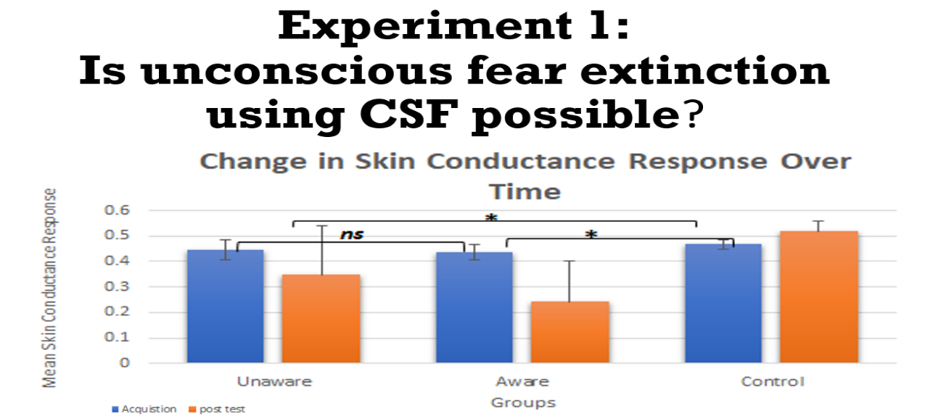

Figure 2. Normalized SCR differences for the unaware, aware, and the Control groups.

Taken together, the results suggest a decrease in skin conductance both in the conscious and unconscious groups, to a comparable degree. At the phase of acquisition as well as at the initial phase of extinction there was no distinctive difference between the groups, while in the final extinction phase and in the post-test phase it seems that the level of skin conductance decrease in the conscious and unconscious group, as opposed to the control group (see Figure 1). These findings confirm the results of Weinberger & Siegel (2009, 2011, 2012) and demonstrate that these effects persist even when awareness is properly controlled and measured.

**EXPERIMENT 2**

The findings of experiment 1 suggest that it is possible to unconsciously extinct a fearfully conditioned stimulus with CFS. Experiment 2 examined extinction with VM, to determine if the techniques differ in efficacy of inducing unconscious extinction. Indeed, there is some indirect evidence suggesting differential processes in CFS and VM. For example, several studies employing VM demonstrated that awareness is not necessary for the processing of facial expressions (Whalen et al., 1998, 2004, Murphy & Zajonc, 1993). However, studies using CFS indicated difficulty to processes facial expressions unconsciously (Amihai, 2010; Moradi, 2005, Shin et al., 2009).

In the current experiment, subjects first underwent fear acquisition in which a neutral stimulus – an image of a man or a woman – was associated with an electrical shock. In the second phase, they were presented with the same stimulus again, but this time the stimulus was presented without the electrical shock. Finally, all participants underwent a testing phase to assess the effects of conscious and unconscious extinction relative to the control group receiving no extinction.

**Method**

Methods were be identical to those depicted in experiment 1, except for the following differences:

*Subjects*

GPower software version 3.0.5 (Faul et al. 2007) was used to determine the needed sample size using an effect size (ES) estimate of 0.25 based on the results of the first experiment.  For an ES of 0.25, α = 0.05, power (1–β) = 0.95, three groups, and three repetitions, a minimum of 60 subjects is needed in the current study. We decided to recruit 72 Subjects.

*Stimuli and Procedure*

Subjects were randomly assigned to one of three extinction groups: (1) the “unaware group”, a subliminal stimulus (face of a man or a woman as detailed in experiment 1) was presented by VM., (2) the “aware group”, a face of a man or a woman was presented for a 4 second duration, and (3) the control group, a scrambled face stimuli was presented by using VM, so this group did not undergo extinction.

The masking stimulus was

The extinction phase included 24 trials: 12 trials with CS+ stimulus and 12 trials with CS- stimulus. All stimuli of the man/woman pictures from the acquisition phase were masked by scrambled face stimuli. The duration of the presentation was 33 milliseconds for the target stimulus and additional 6 seconds for the masked stimuli. The stimuli were presented in a counterbalanced order.

As in Experiment 1, after the presentation of each target–mask pair, participants had to indicate “man” or “woman” via a button press. They then had to rate the confidence in their response on a scale of 1 to 4 (1= I did not see anything, to 4= I a saw the picture clearly).

In the unaware group and the control group where VM was used, subjects were asked two questions at the end of each trial. These questions were used as an objective and subjective measures in order to assure the level of the subjects’ awareness. The objective question was: Was the picture presented a man’s or a woman’s? The subjective question was: How well did you see saw the picture? (1= I did not see anything to 4= I a saw the picture clearly).

**RESULTS**

Out of the 83 participants, 11 participants had to be excluded: 3 participants

were excluded due to technical problems with data recording. As mentioned above, the minimal SCR criterion was 0.02ms. Responses lower than this pre-determined criterion of were recorded as zero. 8 Participants were classified as non-responders because of their lack measurable SCR on >75% of the trials.

**Objective and Subjective Measures**

As in experiment 1, awareness has been assessed according to subjective and objective criteria. The subjective ratings showed that 83.9% of the trials were rated as 1 (“I did not see anything”), 13.1% as 2, (“I had a vague perception of something”), and only 2.89 % were rated as either 3, (“I saw a clear part of the image” ) or 4, ("I saw the picture clearly "). On the objective measure, subjects across all trials were not able to detect whether the picture was of a male or female better than chance (M = 47%, SD = 1.38%, t(23) = -1.04, p =0 .152). This null result was confirmed by a Bayesian paired-sample t-test which revealed that given our data, the null hypothesis was 2.86 times more likely than the alternate hypothesis.

**Skin Conductance Responses**

**Acquisition Phase**

Skin conductance responses to the CS+ were larger than those to the CS- (F (1,69) =139.92, p < 0.001). This sensitization was equally pronounced across all groups (F < 1, ns).

Table 1

*Mean Skin Conductance Response to the conditioned stimulus (CS+) and unconditioned stimulus (CS−)*

|  |  |  |  |
| --- | --- | --- | --- |
|  | CS- |  | CS+ |
| Conditions | M (SD) |  | M (SD) |
| Unaware | 0.45 (0.09) |  | 0.61 (0.10) |
| Aware | 0.45 (0.09) |  | 0.64 (0.15) |
| Control | 0.45 (0.11) |  | 0.70 (0.11) |
| Total | 0.45 (0.10) |  | 0.65 (0.12) |

**Extinction Phase**

To test the effects of within-subject and between-subjects variables on electrodermal responses, a mixed-model analysis of variance was conducted with a between-subject factor of Condition: aware, unaware, and control and within-subject factor of Extinction time (early extinction, late extinction and post-test). Analyses were performed separately for early (first half of trials) and late (second half of trials) extinction.

A main effect of Time (F (1, 69) =83.954, p < 0.001, partial *η*2 = 0.35), Condition (F (2, 69) = 7.998, p < 0.001, partial *η*2 = 0.33), as well as the interaction of Condition and Time, were found (F (2, 69) = 43.541, p < 0.00, partial *η*2 = 0.3). The pairwise comparison for the main effect of time showed a difference in the Post Hoc test between Skin conductance response of the control group and the aware group (p < 0.001) and the control group and the unaware group (p < 0.001), but not between the unaware group and aware groups in the post-test phase (p=0.06; further analyses appear in table 2).

Table 2

*Significance levels of post-hoc comparisons*

|  |  |  |  |  |
| --- | --- | --- | --- | --- |
|  |  | Unaware | Aware | Control |
| Time | Conditions |  |  |  |
| Early Extinction | Unaware |  | p=0.254 | p=0.344 |
| Aware | p=0.254 |  | p<0.001 |
| Control | p=0.344 | p<0.001 |  |
| Late Extinction | Unaware |  | p=0.014 | p=0.119 |
| Aware | p=0.014 |  | p<0.001 |
| Control | p=0.119 | p<0.001 |  |
| Post Test | Unaware |  | p=0.06 | p<0.001 |
| Aware | p=0.06 |  | p<0.001 |
| Control | p<0.001 | p<0.001 |  |

**Skin conductance over time**

Figure 2 presents the changing pattern of skin conductance over time. While on the acquisition phase the skin conductance of the 3 groups remain alike, on the extinction phase the difference in groups are more noticeable and attributed by the level of awareness. The GLMM analysis revealed a highly significant time effect (p < 0.0001), and interaction effect (p < 0.0001).

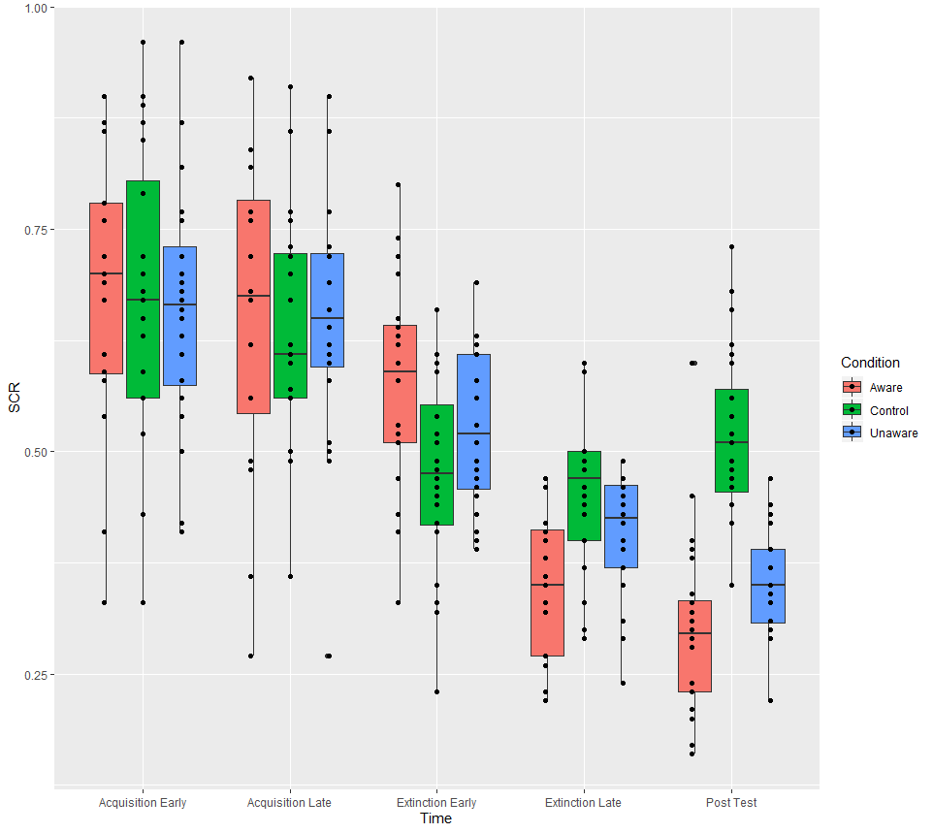

Figure 1. Skin conductance over time

The pairwise comparison analysis demonstrated that for the unaware group, responses declined between early and late extinction (p<0.0001) and post-test (p<0.0001), while responses did not differ throughout the acquisition phase (p=1.00).

Similarly, in the aware group, responses declined between early and late extinction (p<0.0001) and post-test (p<0.0001), while responses did not differ throughout the acquisition phase (p=1.00). For the control group the responses in acquisition phase did not differ (p=0.176). Appose to the unaware and aware groups the responses did not differ between early and late extinction (p=1.00) and post-test (p=0.635).

דיון

מתוצאות ניסוי 1 ו-2 ניכר כי ישנה ירידה במדד המוליכות העורית גם בטכניקה של CFS וגם בטכניקה של VM. בבואנו לבחון את תהליך הרכישה וההכחדה, נראה כי בשלב הרכישה ובשלב הראשוני של ההכחדה, אין הבדל בין שלושת הקבוצות במדד המוליכות העורית. לעומת זאת בסוף שלב ההכחדה ובשלב ה-POST TEST המוליכות העורית יורדת בקבוצות החשיפה המודעת ובקבוצת החשיפה הלא-מודעת, אך לא בקבוצת הביקורת. כלומר, למרות זמן ההצגה הקצר בקבוצת החשיפה הלא מודעת, המוליכות העורית של הנבדקים היתה דומה לקבוצת החשיפה, בה הוצגו לנבדקים הגירויים למשך זמן ארוך. בקבוצת הביקורת שלא עברה כלל חשיפה לגירויים, לא נרשמה ירידה משמעותית במדד המוליכות העורית.

תוצאות שני הניסויים הללו מדגימות הכחדה לא מודעת בתנאי מעבדה. מחקרים הדגימו כיצד תמונות ממוסכות (masked) מסייעות בהפחתת פחד (Siegel & Weinberger, 2009; 2011; Siegel,2017), אך לא בטכניקה של CFS (Koizumi et al., 2016). מחקר זה ככל הנראה הינו המחקר הראשון בו מתבצעת רכישה והכחדה באופן מבוקר בתנאי מעבדה, ,תוך השוואה בין שתי טכניקות: VM ו- .CFS

במרוצת השנים טכניקות שונות פותחו על מנת לדכא גירויים מהמודעות, ולאמוד את השפעתם של גירויים לא מודעים אלה בין היתר, על תהליכי למידה. ממחקרים עולה כי טכניקות שונות עשויות להניב לעיתים תוצאות שונות (Fogelson et al., 2014; Dubois & Faivre, 2014). מכאן עולה החשיבות לבחון באמצעות יותר מטכניקה אחת את תפקידה של המודעות. במחקר הנוכחי השתמשנו בכל ניסוי בטכניקה שונה. בניסוי מספר 1 השתמשנו ב-CSF שהיתרון הבולט שבה הוא משך הצגת הגירוי. בניסוי מספר 2 השתמשנו בטכניקה של VM שהיתרון הבולט הוא רגישותו. על-אף ההבדל בין השיטות (Stein & Strezer,2014) ובתהליכים הלא מודעים שטכניקות אלה חושפות (Fogelson et al., 2014), קיבלנו שבשתיהן ניתן להכחיד גירוי באופן לא מודע. האם הממצא הזה אמור להפתיע? מחקרים מראים ש-

CFS allows for awareness that can assist high-level processing

(Gelbard-Sagiv, Faivre, Mudrik, & Koch, 2016)

מחקרים מראים שהשימוש בטכניקה של VM משפיעה על תהליכים התנהגותיים גם כשהגירוי נמצא מחוץ למודעות הנבדקים (Whalen et al. 1998, Ohman & Soares 1994, Dimberg et al. 2000). קיימות גם עדויות לתהליכים תרפויטים המתקיימים באמצעות (Siegel, 2018) VM. מכאן, שתוצאות המחקר הנוכחי הן עדות נוספת ליכולת לבצע הכחדה בלתי מודעת. פשטותה של מתודולוגיה זו שאינה מצריכה מכשור פרט למסך מחשב או טלפון נייד, יכולה לשמש ככלי עתידי עבור מטפלים בביצוע חשיפה.

תוצאות המחקר עשויות לשפוך אור על מידת הקשב הנחוצה בביצוע חשיפה בטיפול. אחת מהאסטרטגיות הטיפוליות התומכות את מודל הלמידה האינהיביטורי היא Expectancy Violation. האסטרטגיה הזו נובעת מהנחת היסוד שחוסר הלימה בין הציפיה לבין מה שקורה בפועל, נחוצה עבור למידה חדשה. כלומר ככה נוצרת ציפייה מעכבת ש"מתחרה" עם הציפיה המעוררת. ככל שהציפייה **מופרת** על ידי הניסיון, ככה גדלה הלמידה המעכבת ( Craske, 2014;Blakey & Abramowitz,2016) (במילים שלי, הרעיון כאן הוא לא להיות בתוך חווית הפחד, ולחכות שהפחד אט-אט יתפוגג ויופחת כמו בהביטואציה, אלא לכוון לכך שהציפייה לדוגמא ש"הכלב ינשוך אותי" פשוט תופר. באופן הזה נוצרת למידה חדשה מהציפייה שהופרה, שכלב אינו נושך).

אספקט מרכזי במודל הפרת הציפיות (Expectancy Violation) היא הקצאת **קשב** לגירוי המותנה ולאי-התרחשותו של הגירוי הבלתי מותנה. לאור העובדה שלמידת הכחדה, מייצגת את היווצרות הקשר שאינו מקרי בין גירוי מותנה לגירוי בלתי מותנה, **מודעות** גם לגירוי וגם לאי התרחשותו של הגירוי הבלתי-מותנה, הינה נחוצה (Craske, 2014.‏) (במילים שלי: אני חייבת לשים לב ולהיות מאוד מודעות לקיומם של הגירויים, כדי להבחין בקשר ובסמיכות בהם שני אלה מתקיימים). מממצאי המחקר הנוכחי עולה כי ניתן לבצע הכחדה גם מחוץ למודעות, מכאן ויתכן ותהליך החשיפה יכול להתרחש עם מידה פחותה של קשב, ממה שהתיאוריה מצפה.

שיטות שונות ננקטו על מנת להבחין בין תהליכים מודעים לתהליכים לא מודעים בהקשר של פחד. במחקרים אלה ניסו לבחון באיזה אופן גירוי לא מודע משפיע פיזיולוגית והתנהגותית (Ohman, 1986, 1993; Dimberg & Ohman, 1996; Ohman et al., 2000a, Raio et al, 2012) לפי תיאוריות מסדר גבוה למודעות, אנו מצפים שתפיסת הפחד תיהיה שונה ונפרדת מהבסיס הפיזיולוגי, אך כן שהראשון ישקף את האחרון. כלומר שהפחד שלי ישקף את הביטוי הפיזיולוגי. תוצאות המחקר הנוכחי יחד עם מחקרים נוספים ((Siegel, 2017; Killgore, Britton, Schwab, Price, Weiner, Gold & Rauch, 2014; Nuske, Vivanti, Hudry & Dissanayake, 2014). ‏) מדגימות כי התערבות פסיכולוגית המשפיעה על תגובות הגנתיות שאינן מודעות, עשויה להשפיע בתורה על סימפטומים מודעים. למסקנה זו מספר השלכות יישומיות בהן ניתן להתמקד במחקרי המשך.

SCR (skin conductance response) הינו מדד רגיש ונוח (convenient) המסוגל לאמוד עוררות במערכת הסימפטית כתוצאה משינוי רגשי וקוגניטיבי. על-פי -רוב SCR נמדד יחד עם משתנים נוספים כגון: heart rate, respiratory rate, blood pressure. משתנים אלה שייכים למערכת העצבים האוטונומית ועשויים לבוא לידי ביטוי במנגנון Fight or Flight (Critchley , 2002). כמו-כן Startle Reflex הינו רכיב נוסף השייך לתגובות הגנתיות של פחד (Öhman, & Mineka, 2001‏). במחקר המשך ניתן לבחון את היכולת לבצע הכחדה לא מודעת ולהשתמש במדדים נוספים אלה על מנת לתקף והכליל את ממצאי המחקר הנוכחי.

פחד וחרדה הינם רגשות הנקשרים על פי רוב להפרעות חרדה. עם זאת, מחקרים מראים כי הפרעות חרדה כגון: פוביה מעכבישים, הפרעה אובססיבית קומפולסיבית הקשורה לזיהום, ופוביה ממחטים ודם, נקשרות גם עם רגש נוסף, גועל (Woody & Teachman, 2000) . לפחד וגועל מכנה משותף: שניהם מוגדרים "כרגש שלילי" (negative affect) ושניהם מלויים בהימנעות ובריחה מהגירוי, מחשש לפגיעה (Stark et al, 2003). בנוסף, פחד וגועל שניהם מתאימים למודל ההתניה הקלאסית (Woody & Teachman, 2000), ולנוכח שני הרגשות הללו מתעוררת עליה במוליכות העורית (Beadley, Codispoti, Cuthbert & Lang, 2010). לדמיון בין פחד וגועל קיימת השלכה יישומית-הכחדה לא מודעת לגירויים המעוררים גועל, כמו בטיפול בחשיפה בהפרעה אובססיבית קומפולסיבית (Abramowitz & Foa, 2000).

בניסוי הנוכחי קיבלנו שלא היה הבדל מובהק בין הקבוצה שעברה חשיפה מודעת לקבוצה שעברה חשיפה לא מודעת, בשונה מהקבוצה שלא עברה חשיפה כלל. מה משמעות ממצאים אלה בהיבט הקליני? בטיפול הקליני חשיפה עשויה להשתנות במשך שלה. מחקרים מראים כי in-session habituation עשויה להצליח ככל שמשך החשיפה גדול יותר (Bouchard et al., 2004).. בנוסף לכך, נמצא ש- Prolonged exposure יעילה יותר בהפחתת פחד יותר מאשר shorter exposure sessions (e.g., Antony & Swinsom, 2000; Meadow & Philpps, 2007) האם ניתן להקיש ממצאים אלה על חשיפה מודעת גם על חשיפה שאינה מודעת? במחקר המשך ניתן לבחון whether increasing the dosage of unconscious extinction affects physiological reaction.

Page et al (1999; 2003) מצאו עדויות שלפחות צורות מסוימות של הסחת דעת עשויות להפחית את עוצמות הפחד בחשיפה, והתנהגויות בטחון (Milosevic & Radomsky,2008 ) לא פוגמות בתהליך הטיפולי ואף עשויות לסייע לטיפול תחת נסיבות מסוימות. מחקרים מראים שאסטרטגיות הסחה גורמות לתחושה שאירועים ורגשות מתנהלים תחת שליטה. בדרך זו אנשים חשים עצמם בטוחים ותחת שליטה לגבי היכולת להתמודד עם סיטואציה ולבצע משימה ספציפית. הסחה לפיכך עשויה לשפר את יעילות החשיפה כתוצאה מתחושת השליטה ומסוגלות עצמית (self-efficacy) Craske, Street, & Barlow, 1989;Page et al, 2008))

אם אכן תהליך ההכחדה הלא מודע דומה לתהליך ההכחדה המודע, האם כאשר אדם מבצע חשיפה לא מודעת, בדומה להסחה, הוא עשוי לתפקד טוב יותר, לחוש עצמו בעל מסוגלות עצמית ולפיכך תעלה יעילות הטיפול? במחקרי המשך ניתן לבחון היבטים אלה ואולי בעתיד לייצר טיפול מקדים בחשיפה לא מודעת אשר ישלים את הטיפול הקיים היום בחשיפה.

**References**

Abramowitz, J. S. (1997). Effectiveness of psychological and pharmacological treatments for obsessive-compulsive disorder: a quantitative review. *Journal of Consulting and Clinical Psychology*, 65(1), 44.‏

Abramowitz, J. S. (2013). The practice of exposure therapy: relevance of cognitive-behavioral theory and extinction theory. *Behavior Therapy*, 44(4), 548-558.‏

Abramowitz, J. S., & Foa, E. B. (2000). Does comorbid major depressive disorder influence outcome of exposure and response prevention for OCD?. *Behavior Therapy*, 31(4), 795-800.

Arffa, S. (2007). The relationship of intelligence to executive function and non-executive function measures in a sample of average, above average, and gifted youth. *Archives of Clinical Neuropsychology*, 22(8), 969-978.‏

Alonso, J., Angermeyer, M. C., Bernert, S., Bruffaerts, R., Brugha, T. S., Bryson, H &Haro, J. M. (2004). Prevalence of mental disorders in Europe: results from the European Study of the Epidemiology of Mental Disorders (ESEMeD) project. *Acta Psychiatrica Scandinavica*, *109*(s420), 21-27.‏

Antony, M. M., & Swinson, R. P. (2000). Phobic disorders and panic in adults: a guide to assessment and treatment. Washington, DC, *US: American Psychological Association*.‏

Amihai, I., Deouell, L., &Bentin, S. (2011). Conscious awareness is necessary for processing race and gender information from faces. *Consciousness and Cognition*, *20*(2), 269-279.‏

Bouchard, S., Mendlowitz, S. L., Coles, M. E., & Franklin, M. (2004). Considerations in the use of exposure with children*. Cognitive and Behavioral Practice*, 11(1), 56-65.‏

Blakey, S. M., & Abramowitz, J. S. (2016). The effects of safety behaviors during exposure therapy for anxiety: Critical analysis from an inhibitory learning perspective. Clinical Psychology Review, 49, 1-15.‏

Breitmeyer, B. G., &Ogmen, H. (2000). Recent models and findings in visual backward masking: A comparison, review, and update. *Perception & Psychophysics*, *62*(8), 1572-1595.‏

Breitmeyer, B. G., Ro, T., & Ogmen, H. (2004). A comparison of masking by visual and transcranial magnetic stimulation: implications for the study of conscious and unconscious visual processing*. Consciousness and Cognition,* 13(4), 829-843

Bunce, S. C., Bernat, E., Wong, P. S., &Shevrin, H. (1999). Further evidence for unconscious learning: Preliminary support for the conditioning of facial EMG to subliminal stimuli. *Journal of Psychiatric Research*, *33*(4), 341-347.

Cisler, J. M., Olatunji, B. O., & Lohr, J. M. (2009). Disgust, fear, and the anxiety disorders: A critical review. *Clinical Psychology Review*, 29(1), 34-46.‏

Cougle, J. R., Wolitzky-Taylor, K. B., Lee, H. J., & Telch, M. J. (2007). Mechanisms of change in ERP treatment of compulsive hand washing: Does primary threat make a difference? *Behaviour Research and Therapy,* 45(7), 1449-1459.

Critchley, H. D. (2002). Electrodermal responses: what happens in the brain. *The Neuroscientist*, *8*(2), 132-142

Craske, M. G., Street, L., & Barlow, D. H. (1989). Instructions to focus upon or distract from internal cues during exposure treatment of agoraphobic avoidance. Behaviour research and therapy, 27(6), 663-672.‏

Craske, M. G., Treanor, M., Conway, C. C., Zbozinek, T., & Vervliet, B. (2014). Maximizing exposure therapy: An inhibitory learning approach. *Behaviour research and therapy*, *58*, 10-23.‏

Davis III, T. E., Ollendick, T. H., & Öst, L. G. (2009). Intensive treatment of specific phobias in children and adolescents*. Cognitive and Behavioral Practice*, 16(3), 294-303.

Deacon, B. J., & Abramowitz, J. S. (2004). Cognitive and behavioral treatments for anxiety disorders: A review of meta‐analytic findings. *Journal of Clinical Psychology*, 60(4), 429-441.‏

De Jong, P. J., Andrea, H., & Muris, P. (1997). Spider phobia in children: Disgust and fear before and after treatment*. Behaviour Research and Therapy,* 35(6), 559-562.‏

De Jong, P. J., Vorage, I., & van den Hout, M. A. (2000). Counterconditioning in the treatment of spider phobia: Effects on disgust, fear and valence. *Behaviour Research and Therapy*, 38(11), 1055-1069.‏

Dimberg, U., Thunberg, M. & Elmehed, K. (2000). Unconscious Facial Reactions to Emotional Facial Expressions. Psychological Science, 11, 1, pp. 86-89.

Izatt, G., Dubois, J., Faivre, N., and Koch, C. (2014). A direct comparison of unconscious face processing under masking and interocular suppression. Front. Psychol. 5:659.

Esteves, F., Parra, C., Dimberg, U., &Öhman, A. (1994). Nonconscious associative learning: Pavlovian conditioning of skin conductance responses to masked fear‐relevant facial stimuli. *Psychophysiology*, *31*(4), 375-385.

Faul, F., Erdfelder, E., Lang, A. G., & Buchner, A. (2007). G* Power 3: A flexible statistical power analysis program for the social, behavioral, and biomedical sciences. *Behavior Rsearch Methods*, *39*(2), 175-191.

Foa, E. B., & Kozak, M. J. (1986). Emotional processing of fear: exposure to corrective information. *Psychological Bulletin*, 99(1), 20.

Foa, E. B., Grayson, J. B., Steketee, G. S., Doppelt, H. G., Turner, R. M., & Latimer, P. R. (1983). Success and failure in the behavioral treatment of obsessive-compulsives. Journal of consulting and clinical psychology, 51(2), 287.

Hepburn, T., & Page, A. C. (1999). Effects of images about fear and disgust upon responses to blood-injury phobic stimuli. Behavior Therapy, 30(1), 63-77.‏

Fox, E. (2002). Processing emotional facial expressions: The role of anxiety and awareness. *Cognitive, Affective, & Behavioral Neuroscience*, *2*(1), 52-63.‏

Fogelson, S. V., Kohler, P. J., Miller, K. J., Granger, R., & Tse, P. U. (2014). Unconscious neural processing differs with method used to render stimuli invisible. *Frontiers in Psychology*, 5, 601

Gelbard-Sagiv, H., Faivre, N., Mudrik, L., & Koch, C. (2016). Low-level awareness accompanies “unconscious” high-level processing during continuous flash suppression. *Journal of vision*, *16*(1), 3-3.‏

Haidt, J., McCauley, C., & Rozin, P. (1994). Individual differences in sensitivity to disgust: A scale sampling seven domains of disgust elicitors. *Personality and Individual diff*erences, 16(5), 701-713.‏

Hembree, E. A., Foa, E. B., Dorfan, N. M., Street, G. P., Kowalski, J., & Tu, X. (2003). Do patients drop out prematurely from exposure therapy for PTSD?. *Journal of Traumatic Stress*, 16(6), 555-562

Kahneman, D. (1968). Method, findings, and theory in studies of visual masking. *Psychological Bulletin*, *70*(6p1), 404.

Kendall, P. C., & Hedtke, K. A. (2006). Cognitive-behavioral therapy for anxious children: *Therapist manual.* Workbook Publishing.‏

Kessler, R. C., Chiu, W. T., Demler, O., & Walters, E. E. (2005). Prevalence, severity, and comorbidity of 12-month DSM-IV disorders in the National Comorbidity Survey Replication. *Archives of General Psychiatry*, *62*(6), 617-627.

Killgore, W. D., Britton, J. C., Schwab, Z. J., Price, L. M., Weiner, M. R., Gold, A. L& Rauch, S. L. (2014). Cortico‐limbic responses to masked affective faces across ptsd, panic disorder, and specific phobia. Depression and Anxiety, 31(2), 150-159.‏

‏Kim, C. Y., & Blake, R. (2005). Psychophysical magic: rendering the visible ‘invisible’. *Trends in Cognitive Sciences*, *9*(8), 381-388.

Koizumi, A., Amano, K., Cortese, A., Shibata, K., Yoshida, W., Seymour, B. & Lau, H. (2016). Fear reduction without fear through reinforcement of neural activity that bypasses conscious exposure. *Nature human behaviour*, *1*(1), 1-7.‏

Koster, E. H., Crombez, G., Verschuere, B., & De Houwer, J. (2004). Selective attention to threat in the dot probe paradigm: Differentiating vigilance and difficulty to disengage. *Behaviour Research and Therapy*, *42*(10), 1183-1192

Koster, E. H., Crombez, G., Verschuere, B., Van Damme, S., & Wiersema, J. R. (2006). Components of attentional bias to threat in high trait anxiety: Facilitated engagement, impaired disengagement, and attentional avoidance. *Behaviour Research and Therapy*, *44*(12), 1757-1771.‏.‏

Kouider, S., &Dehaene, S. (2007). Levels of processing during non-conscious perception: a critical review of visual masking. *Philosophical Transactions of the Royal Society B: Biological Sciences*, *362*(1481), 857-875.

Lang, P. J., & Bradley, M. M. (2010). Emotion and the motivational brain. *Biological Psychology*, 84(3), 437-450.‏

Lang, P. J., Melamed, B. G., & Hart, J. (1970). A psychophysiological analysis of fear modification using an automated desensitization procedure. *Journal of Abnormal Psychology,* 76(2), 220.

LeDoux, J. E. (1995). Emotion: Clues from the brain. *Annual Review of Psychology*, *46*(1), 209-235.‏

Le Doux, J. (1996). The Emotional Brain Simon and Schuster New York.‏

Lissek, S., Powers, A. S., McClure, E. B., Phelps, E. A., Woldehawariat, G., Grillon, C., & Pine, D. S. (2005). Classical fear conditioning in the anxiety disorders: a meta-analysis. *Behaviour Research and Therapy*, *43*(11), 1391-1424.

Lissek, S. (2012). Toward an account of clinical anxiety predicated on basic, neurally mapped mechanisms of Pavlovian fear‐learning: the case for conditioned overgeneralization. *Depression and Anxiety*, 29(4), 257-263.

Lovibond, P. F., & Shanks, D. R. (2002). The role of awareness in Pavlovian conditioning: empirical evidence and theoretical implications. *Journal of Experimental Psychology: Animal Behavior Processes*, *28*(1), 3.

MacLeod, C., Mathews, A., & Tata, P. (1986). Attentional bias in emotional disorders. *Journal of Abnormal Psychology*, *95*(1), 15.

Magee, W. J., Eaton, W. W., Wittchen, H. U., McGonagle, K. A., & Kessler, R. C. (1996). Agoraphobia, simple phobia, and social phobia in the National Comorbidity Survey. *Archives of General Psychiatry*, 53, 159-168‏

Mathews, A., Fox, E., Yiend, J., & Calder, A. (2003). The face of fear: Effects of eye gaze and emotion on visual attention. *Visual Cognition*, *10*(7), 823-835.

McNally, R. J. (1995). Automaticity and the anxiety disorders. *Behaviour Research and Therapy*, *33*(7), 747-754.

Meadows, E. A., & Phipps, K. A. (2007). Cognitive-Behavioral. Anxiety Disorders: *A Practitioner's Guide to Comparative Treatments*, 43.‏

Nuske, H. J., Vivanti, G., Hudry, K., & Dissanayake, C. (2014). Pupillometry reveals reduced unconscious emotional reactivity in autism. *Biological psychology*, *101*, 24-35.‏

‏Mineka, S., &Oehlberg, K. (2008). The relevance of recent developments in classical conditioning to understanding the etiology and maintenance of anxiety disorders. *Acta Psychologica*, *127*(3), 567-580.

Moradi, F., Koch, C., &Shimojo, S. (2005). Face adaptation depends on seeing the face. *Neuron*, *45*(1), 169-175.‏

Murphy, S. T., & Zajonc, R. B. (1993). Affect, cognition, and awareness: affective priming with optimal and suboptimal stimulus exposures. *Journal of Personality and Social Psychology*, *64*(5), 723.‏

Öhman, A., Erixon, G., & Löfberg, I. (1975). Phobias and preparedness: Phobic versus neutral pictures as conditioned stimuli for human autonomic responses. *Journal of Abnormal Psychology,* 84(1), 41.‏

Öhman, A. (1993). Fear and anxiety as emotional phenomena: Clinical phenomenology, evolutionary perspectives, and information-processing mechanisms.‏

Öhman, A., & Soares, J. J. (1994). " Unconscious anxiety": phobic responses to masked stimuli. *Journal of abnormal psychology*, *103*(2), 231.

Öhman, A., & Mineka, S. (2001). Fears, phobias, and preparedness: toward an evolved module of fear and fear learning. *Psychological Review*, *108*(3), 483.

Öst, L. G. (1989). One-session treatment for specific phobias*. Behaviour Research and Therapy,* 27(1), 1-7.

Olatunji, B. O., Forsyth, J. P., & Cherian, A. (2007). Evaluative differential conditioning of disgust: A sticky form of relational learning that is resistant to extinction. *Journal of Anxiety Disorders*, 21(6), 820-834.‏

.‏ Olatunji, B. O., Wolitzky-Taylor, K. B., Willems, J., Lohr, J. M., & Armstrong, T. (2009). Differential habituation of fear and disgust during repeated exposure to threat-relevant stimuli in contamination-based OCD: An analogue study. *Journal of Anxiety Disorders,* 23(1), 118-123.

Oliver, N. S., & Page, A. C. (2003). Fear reduction during in vivo exposure to blood‐injection stimuli: Distraction vs. attentional focus. British Journal of Clinical Psychology, 42(1), 13-25.‏

Pearson, J. (2012). Associative learning: Pavlovian conditioning without awareness. *Current Biology*, 22(12), R495-R496

‏Penfold, K., & Page, A. C. (1999). The effect of distraction on within-session anxiety reduction during brief in vivo exposure for mild blood-injection fears. Behavior Therapy, 30(4), 607-621.‏

Pessoa, L. (2005). To what extent are emotional visual stimuli processed without attention and awareness?. *Current Opinion in Neurobiology*, *15*(2), 188-196.

Pitman, R. K., Orr, S. P., Altman, B., Longpre, R. E., Poiré, R. E., Macklin, M. L & Steketee, G. S. (1996). Emotional processing and outcome of imaginal flooding therapy in Vietnam veterans with chronic posttraumatic stress disorder. *Comprehensive Psychiatry*, 37(6), 409-418

Raio, C. M., Carmel, D., Carrasco, M., & Phelps, E. A. (2012). Nonconscious fear is quickly acquired but swiftly forgotten. *Current Biology*,*22*(12), R477-R479.

Ramsøy, T. Z., & Overgaard, M. (2004). Introspection and subliminal perception. *Phenomenology and the Cognitive Sciences*, 3(1), 1-23.

‏ Reingold, E. M., & Merikle, P. M. (1988). Using direct and indirect measures to study perception without awareness. *Perception & Psychophysics,* 44(6), 563-575

Rodebaugh, T. L., Scullin, R. B., Langer, J. K., Dixon, D. J., Huppert, J. D., Bernstein, A., ... &Lenze, E. J. (2016). Unreliability as a threat to understanding psychopathology: The cautionary tale of attentional bias. *Journal of Abnormal Psychology*, *125*(6), 840.

Shin, K., Stolte, M., & Chong, S. C. (2009). The effect of spatial attention on invisible stimuli. *Attention, Perception, & Psychophysics*, *71*(7), 1507-1513.‏

Snodgrass, M., Bernat, E., &Shevrin, H. (2004). Unconscious perception: A model-based approach to method and evidence. *Perception & Psychophysics*, *66*(5), 846-867.

‏Siegel, P., & Weinberger, J. (2009). Very brief exposure: The effects of unreportable stimuli on fearful behavior. *Consciousness and Cognition*, *18*(4), 939-951.

Siegel, P., Anderson, J. F., & Han, E. (2011). Very brief exposure II: The effects of unreportable stimuli on reducing phobic behavior. *Consciousness and Cognition*, *20*(2), 181-190.

Siegel, P., & Weinberger, J. (2012). Less is more: The effects of very brief versus clearly visible exposure. *Emotion*, *12*(2), 394.

Siegel, P., Warren, R., Jacobson, G., & Merritt, E. (2017). Masking exposure to phobic stimuli reduces fear without inducing electrodermal activity. *Psychophysiology*

Stark, R., Schienle, A., Walter, B., Kirsch, P., Sammer, G., Ott, U., ... & Vaitl, D. (2003). Hemodynamic responses to fear and disgust-inducing pictures: an fMRI study*. International Journal of Psychophysiology,* 50(3), 225-234.‏

Stein, T., &Sterzer, P. (2014). Unconscious processing under interocular suppression: getting the right measure. *Frontiers in Psychology*, *5*, 387.

Szymanski, J., & O'Donohue, W. (1995). Fear of spiders questionnaire. *Journal of behavior therapy and experimental psychiatry*, 26(1), 31-34.‏

Taschereau-Dumouchel, V., Liu, K. Y., & Lau, H. (2018). Unconscious psychological treatments for physiological survival circuits. *Current opinion in behavioral sciences*, *24*, 62-68.‏

Tooley, M. D., Carmel, D., Chapman, A., & Grimshaw, G. M. (2017). Dissociating the physiological components of unconscious emotional responses. *Neuroscience of Consciousness*, 3.(1)

Tsuchiya, N., & Koch, C. (2005). Continuous flash suppression reduces negative afterimages. *Nature Neuroscience*, *8*(8), 1096-1101.

Whalen, P. J., Rauch, S. L., Etcoff, N. L., McInerney, S. C., Lee, M. B., &Jenike, M. A. (1998). Masked presentations of emotional facial expressions modulate amygdala activity without explicit knowledge. *The Journal of Neuroscience*, *18*(1), 411-418.

Whalen, P. J., Kagan, J., Cook, R. G., Davis, F. C., Kim, H., Polis, S., ... & Johnstone, T. (2004). Human amygdala responsivity to masked fearful eye whites. *Science*, *306*(5704), 2061-2061.

Wittchen, H. U., Jacobi, F., Rehm, J., Gustavsson, A., Svensson, M., Jönsson, B.

&Fratiglioni, L. (2011). The size and burden of mental disorders and other disorders of the brain in Europe 2010. *European Neuropsychopharmacology*, *21*(9), 655-679

Woody, S. R., & Teachman, B. A. (2000). Intersection of disgust and fear: Normative and pathological views. *Clinical Psychology: Science and Practice*, 7(3), 291-311

.‏‏Yang, E., Zald, D. H., & Blake, R. (2007). Fearful expressions gain preferential access to awareness during continuous flash suppression. *Emotion*, *7*(4), 882.

Yang, E., & Blake, R. (2012). Deconstructing continuous flash suppression. *Journal of vision*, *12*(3), 8-8.

# Supplemental Experimental Procedures

**Subjects**

48 healthy subjects with normal or corrected normal visual acuity from the department of Psychology participated in the current experiment for course credit (37 women, 38 right-handed, age=25, SD=1.33). Seven subjects who were not observed with measurable responses to the shocks, were not included in the data analysis (SCR Score>0.2). The subjects were randomly assigned to one of 3 groups: a group undergoing aware exposure (n=13), a group undergoing unaware exposure (n=14), and a group that does not undergo any exposure.

The experiment was validated by the Ethics Committee of Ben-Gurion University. The subjects signed an informed consent form before conducting the experiment and completed a filtering question in order to ensure that the subjects in the current experiment have no psychiatric or neurologic background.

**Stimuli and Apparatus**

The subjects performed the experiment in a slightly darkened room. The stimuli were presented via E-Prime Software on a 19-inch Samsung screen with 60 HZ refresh rate and 1024*768 resolution. The heads of the subjects were supported by a chinrest, which is located at a distance of 61 cm from the screen. On the screen were presented to the subjects Conditioned Stimuli (CS+ and CS-):

A scared face of a man and a scared face of a woman taken from the NIMSTIM Database (Tottenham et al, 2009). The selection of facial expressions of fear supported by studies. Simulation studies found that the amygdala plays a vital role in identification and evaluation of scared facial expressions (Adolphs et al 1994; Whalen, 1998). Researches also show that these identification and evaluation processes can be performed even without any relation to attention (Öhman, 2001) and awareness (Esteves et al. 199).

The experiment included two stages, the acquisition stage and extinction stage, which will be specified in the procedure section. The three groups were exposed to the same couple of stimuli in the acquisition stage (Figure A). In the extinction stage, the subject group that undergoes aware extinction and the subject group undergoes unaware extinction, expose to the same picture it was exposed to in the acquisition stage (Figure A). To the subject group that does not undergo extinction, an scrambled face picture is presented (Figure B).

The scrambles face stimulus is actually a picture identical to the picture presented in the other 2 experiment groups, only that in this condition it was cut into a matrix of 7 * 6 parts mixed together using Matlab software.

The stimuli in all three groups are black and white color scale, and of identical contrast and luminance degree. Additionally, the stimuli were presented on top of a black background.. the pictures are blurry at the tips by PhotoShop software and surrounded by black-and-white rectangle frames as shown in Figure 2.

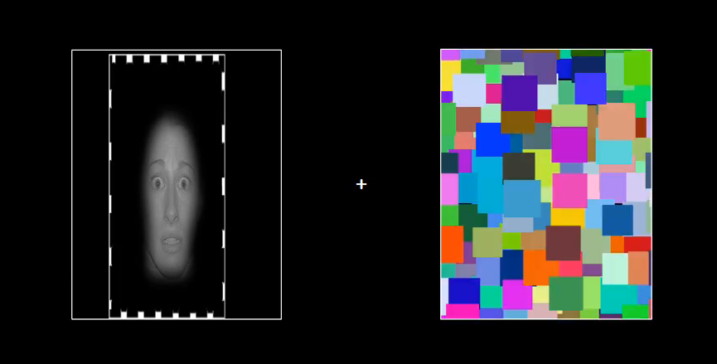

Figure A.

The man's and woman's face were partially attached to the Unconditioned Stimuli: a mild electric shock and Skin Conductance Response was measured. The electric shock was transferred to the subject via STMEPN system of Biopac Company. The system includes a STMISOLA slider and a USB component enabling mediation between the shocker appliance and the EPrime software. The power of the electric shock was defined in the range between 0-50 and the shock’s duration 200 milliseconds. Snap electrode with isotonic gel was attached to the subject’s arm.

Skin conductivity was measured using the 150 MP system of the Biopac GSR100C Company. For GSR recording electrodes were attached to the forefinger and the forearm in the left hand of the subject. The samples of the subjects were collected with Acknowledge system of Biopac Company.

In stimuli via stereoscope produced by Stereo Aids (Western Australia) that presents each eye with a separate image. This will be described in detail in the procedure.

**GSR Analysis**

SCR waveforms were analyzed offline, using Acknowledge 3.9 software (BIOPAC Systems Inc.). SCR amplitudes to the conditioned and unconditioned stimuli were the dependent measures of conditioned and unconditioned responses, respectively. The level of SCR response was determined by taking the base-to-peak difference for the first waveform (in microsegments, ms) in the 0.5–4.5s window after stimulus onset. The minimal response criterion was 0.02ms. The raw SCR scores were square-root transformed to normalize distributions. These normalized scores were scaled according to each subject’s unconditioned response by dividing each response by the mean square-root transformed unconditioned stimulus response.

**Experimental Procedure**

The experiment included two consequential stages: Acquisition and Extinction.

Acquisition. This stage is identical to all subjects. The subjects were attached to a shocker and a skin conductivity system. The power of the shock was defined according to the subject under the guidance “to establish a level of shock that is highly annoying but not painful”.

After the calibration stage, the subjects were presented with a picture of a man or a woman attached to an electric shock. The guidance given to the subjects was to be concentrated on the screen and try to understand the connection between the appearance of the picture and the electric shock. The electric shock appeared randomly about 0.5-4.5 seconds from the moment the stimulus was presented. Between one stimulus and another there was a time gap of 8-12 seconds. The electric shock was attached to a stimulus of CS+ type and never to a stimulus of CS- type. The order of stimuli appearance was pseudorandomized. In total, electrical shocks appeared in 33% of the steps in which CS + stimulation appeared (CS + with shock 6, CS + 12, CS-12). At the end of this stage, the subjects were presented with two diversion questions: 1. In this section, do you think more pictures of women or men were presented? 2. What did you think while the shock was given?

It is known that in the partial reinforcement array (That is, not every time CS + appeared, an electric shock was given) the acquisition process is slower. Nevertheless, this partial reinforcement contributes to a slow decay process relatively to the full reinforcement array.

Extinction. In the stage of extinction the subjects were assigned to one of the three groups: aware, unaware, no-extinction. This stage included 24 steps in which pictures were presented randomly (CS+ and CS-), and a post-test stage.

In the aware group, the subjects were presented with the stimuli of the acquisition stage (the man/woman picture), overtly. In the unaware group and the no-extinction group there was a use of CFS technique. The unaware group was presented with the stimulus from the acquisition stage to one eye and at the same time a flickering stimulus of colored squares (Mondrian) was presented to the other eye. The no-extinction group was presented with a stimulation from the acquisition stage but in a scrambled configuration (detail in the previous section). In both groups, in each step after the presentation of the screened stimuli, the subjects were asked two questions in order to assure the level of the subjects’ awareness to the stimulation:

1. Does the picture presented was a man’s or a woman’s? 2. How sure are you that you saw the picture? (1= I did not see anything to 4= I a saw the picture clearly).

By the end of the 24 steps all three groups had the post-test stage: 3 steps of the stimulation from the acquisition stage in order to examine how the stage of extinction affected the response of the subjects.

After the post-test stage there was a debriefing including 5 questions:

1. What did you feel in the first stage in which you received electric shocks?
2. Did you think you will receive electric shocks in the second part of the experiment as well? When did you realize that you will not receive a shock?
3. Have you felt the same emotion from section A in the second part of the experiment as well? If the subject answers no, ask why.
4. Asking – was there a stage in which he thought about the shocks? Maybe in the last part?
5. What was in your opinion the purpose of the experiment?

At the end of this stage, the subjects completed computerized questionnaires: BDI, OCI, STAI, DES