**A. Scientific Background**

An understanding of the origin of different body plans requires knowledge of how the genes and genetic pathways that control embryonic development have evolved. The AP axis in chordates is patterned by the spatio-temporal expression regulation of a common set of genes early in development, although extreme variation in adult morphology is observed. The initial events determining AP patterning occur during gastrulation stages in specific embryonic structures such as the primitive streak (PS) in amniotes and the blastopore in fish and amphibians. Several gene families and morphogens are involved in this orchestrated process, among which are *Hox* genes and Retinoic Acid (RA) which provide an excellent starting point for understanding the control of regionalization because they play a well-understood causal role in AP patterning and the organization of the body plan of all bilaterians.

The amniote kidney is an example of an organ that develops in a specific position along the AP axis. All vertebrate kidney tissue is derived from a strip of tissue called the intermediate mesoderm (IM), which is located between the somites and the lateral plate mesoderm of the embryo4. As development proceeds, the IM differentiates sequentially from anterior to posterior into several types of kidney tissues, which, are called the pronephros, the mesonephros, and the metanephros. In birds and mammals, the definitive adult kidney is the metanephros, while the pronephros and mesonephros largely degenerate or are incorporated into the reproductive system. Despite its subsequent degeneration, the pronephros is an essential structure since it is the source of the nephric duct, which induces formation of the mesonephros and metanephros5.

A morphogenetic field is defined as a group of cells competent to respond to biochemical influences of surrounding tissues, subsequently differentiating into specific morphological structures. The morphogenetic field has definitive boundaries that determine the eventual position of molecular events leading to its derivatives. In vertebrate embryos, the kidney morphogenetic field within the IM is characterized by a specific gene expression profile, including *Pax2, Pax8, Lim1,* *Wilms’ Tumor 1* (*WT1*), *c-ret*, *Wnt4*5-10 and *Osr1*11. The major patterning events specifying the kidney lineage take place during and shortly after gastrulation1;2;12-15. In chick embryos, while still in the PS, the prospective IM is committed to its kidney fate but requires extrinsic signals in order to become specified1. The initial specification toward IM fate occurs at stages HH5-716 shortly after prospective IM cells leave the PS and migrate anteriorly. By stage 8, IM cells are located in their final position and start to express both *Lim1* and *Pax2*. This expression is restricted to IM located posterior to the 6th somite level17-19;6, consistent with specific tissue structure that gives rise to the pronephric duct primordium20. However, examination of early chordate groups such as amphioxus reveals expression of these gene homologs in Hatschek’s nephridium, an excretory, kidney-like structure positioned in anterior segments in the head region and thus significantly more anterior to the location of the pronephros in amniotes21;22. Adding to the complexity, this organ is an ectoendodermal derivative evoking a long lasting debate regarding the homology of this kidney structure to the vertebrate pronephros23;24.

Knowledge regarding the signals governing IM specification is still incomplete. Several studies have demonstrated the role of neighboring tissues in IM specification, mainly with respect to the mediolateral axis25-27;19;15;1. Considerable evidence from studies in zebrafish, Xenopus, mice and avian embryos have shown a role for BMP, Activin and RA signaling in early events of mesoderm and pronephros induction28-36;26;27;14;2.

We previously showed that the specification of the chick IM along the AP axis depends on the competence of cells to respond to kidney inductive signals emanating from midline tissues along the entire axis1. In Preger-Ben-Noon et al. (2009)2, we developed a model according to which TGF-β signaling molecules secreted from the dorsal neural tube and BMP4 secreted from lateral plate mesoderm30 are the inductive source of kidney genes, and the competence of IM cells to respond to these signals is driven by RA and mediated by *Hoxb4*. Moreover, both studies and other ones point to decision-making processes occurring at early stages in the PS and to the potential role played by RA and *Hoxb4* in these processes.

Recent study in our lab compared the formation of the pronephros among early vertebrate model organisms *(Amphioxus, Lamprey and catshark)* with the known one of chick embryos representing amniotes. The cephalochordate, Amphioxus, represent an invertebrate chordate that holds basal chordate traits that can reflect basal vertebrate traits (Holland, 2018). Lamprey represents the most ancient vertebrate group, cyclostomes, and the catshark represents a group of organisms that are positioned at the early Gnathostomata. Our results reveal a conserved, unknown yet, control mechanism for defining the position of the pronephros along the AP axis, in particular with respect to its anterior boundary, in association with the 6th somite axial level. This control mechanism is conserved between lampreys, chondrichthyans and birds and has thus evolved very early in the vertebrate lineage. Our data indicate that RA signaling and *Hox4* genes do not contribute to this ancient pronephros positioning mechanism. However, during early Gnathostome diversification, the RA-dependent regulation of *Hox4* genes and the *Hox4*-dependent control of pronephros development (Preger Ben-Noon, 2009) were then incorporated concomitantly into the nephric gene regulatory network. Thus, the association between both components, RA and Hox4, with pronephros development, seems to evolve simultaneously in the vertebrate lineage with the coordinated actions of both components. A vertebrate pronephros can only form, if either both RA and *Hox4* involved in its regulatory control (like in Gnathostomes) or neither one of them (like in cyclostomes) are involved (Schmidt et al., submitted for publication). Understanding the differences between the gene regulatory networks controlling the patterning and formation of a functional kidney in Gnathostomes and cyclostomes, therefore, holds the key to understanding the evolution of vertebrate nephric development.

Finally, analyses in other vertebrate models, including the zebrafish and frogs have focused on pronephros development58-60. These analyses have allowed insights into the molecular mechanisms controlling its specification along the AP and DV body axes and its subsequent subdivision into specialized segments. While many genes characterized in these species are also involved in mammals nephric development, cross-species comparisons have highlighted differences in segmental organization59;61. However, detailed descriptions of the developmental trajectories and molecular signatures of specific cell populations from mesoderm to pronephric territories are still lacking in these species, which hampers comprehensive comparisons. In summary, while data accumulated in established model organisms point to the existence of a conserved core of nephrogenic regulatory programs, the degree of conservation, the identity of nodes prone to variations and the constraints shaping their evolution remain largely unknown.

**B. Research Objectives and Expected Significance**

This proposal aims at understanding the evolution of IM and pronephros formation. This study supposedly will provide us with a deep understanding on the sequence by which the nephric field developed during the course of evolution and hence on tissue origin and the basics of the nephric system molecular control. In order to achieve this goal, we take a developmental evolutionary approach and use three animal models that taxonomically are positioned at key branch points in the early chordate/vertebrate evolutionary tree. The rational is to elucidate basal traits, gene expression and gene regulatory networks that are involved in the formation of the IM and the pronephros and wish to establish an evo-devo reference for pronephros formation.

Two main complementary aims will guide this research. The first focuses on the positional information determining the origin of the IM and the molecular regulation establishing the pronephros morphogenetic field (PMF) and the nephric duct. This will carried out by using existing knowledge and candidate gene approach. The second aim will complement the first aim and plans to discover the progenitors of the nephric system and their molecular regulation by using RNA-seq and TomoSeq techniques. These expression screens will provide new genes and molecular pathways involved in the IM, PMF and the nephric duct formation.

**Specific research aims:**

**B1. The origin of the intermediate mesoderm**

**B1a.** **Positioning and developmental relationships between nephric genes and somitic markers**

Detailed analysis of the expression of several somitic markers (mainly *Pax1*, *Pax3 and MyoD*) in parallel to the expression of nephric genes will be performed on early and late developmental stages in the Catshark (partially done, see section C1) and Lamprey models. These will be followed by gain and loss-of-function experiments using *Hox4* paralogues and signaling molecules known for their effect on somite compartmentalization and nephric gene regulation.

**B1b. The formation of the pronephros in Catshark and Lamprey**

**B1b1**. Whole mount 3D analysis of nephric markers in various relevant developmental stages using confocal microscopy will be performed in order to reconstruct the formation of the pronephros.

**B1b2**. Fluorescent dye labeling experiments will be performed in catshark embryos to elucidate the cell source of the nephric duct formation. The motivation is to reveal whether the duct source is only from the pronephric somites (6-10) or along the entire axis including the mesonephric somitic level.

**B1b3**. Based on early study in our lab (Schmidt et al., 2021), we will interfere with the RA signaling, controlling pronephros formation in catshark, in order to elucidate its effect on mesonephros formation.

**B1b4.** Budding off the somite; EMT and MET or evagination by proliferation?Following preliminary results (C1), detailed expression patterns of various markers for the three cell processes using the candidate gene approach will be performed in the two model organisms.

**B2. Discovering and characterizing nephric progenitor cells and their differentiation**

In this section we aim to discover genes, gene combinations and/or molecular pathways that are unknown to early IM cell specification and PMF formation by using the Catshark model. According to our preliminary results this model organism reveals an unexpected origin for the IM from a specific ventrolateral domain within the epithelial somite. We hypothesize that this particular domain includes the progenitors of the IM and the PMF. Therefore, discovering the molecular profile of this domain is of prime importance in order to understand the molecular control and the origin of the IM and the pronephros. Two complementary methodologies are in use to reveal the RNA expression in these early developmental stages domain.

**B2a**. The first is RNA-seq of anterior versus posterior regions along the AP axis at four developmental stages. This section is partially done (see the Preliminary section for the compared domains and stages).

**B2b**. Based on the results obtained from the first RNA-seq methodology (**B2a**), the second RNA-seq method will use one developmental stage in this proposal (St. 19-20). This method, named TomoSeq aims to present the *in situ* expression of RNA along the AP axis including anterior and posterior domains as will be specified later.

**B2c**. Following the results that will be obtained in the two above sections, validation and analyses of selected candidate pronephros patterning genes will be done by *in situ* hybridization followed by immunostaining. Furthermore, these selected genes will be cloned and analyzed in the other model organisms serving in this project, Amphioxus, Lamprey and chick embryos.

**B2d**. Gain and loss-of-function experiments will be performed to assess the role of the selected genes in the initiation, regulation and morphogenesis of the IM and the pronephric duct.

**Expected Significance and Rational**

The evolutionary approach taken in this proposal should reveal new insights into the molecular basis of current developmental processes involved in AP patterning in general and the establishment of the nephric field in particular. Discovering the molecular mechanisms that control nephric genes in early chordate groups will point to the basic requirements for this process that are not yet fully understood in late vertebrate groups. However, the use of the advanced, well established amniote model system in this proposal including the large background of molecular studies in the field of mesoderm patterning will able us to provide new data on molecular cascades and mechanisms to be investigated in the early chordate/vertebrate models. Taken together, this cross species approach, although conceptually not new, in particular studies is not often followed, if at all. The collaboration of three labs expert in their model systems should provide significant advantages in understanding evolutionary transitions and in particular the early events in the formation of the nephric field.

**C. Preliminary results**

**C1. The origin of the IM and evolutionary development of the nephric duct**

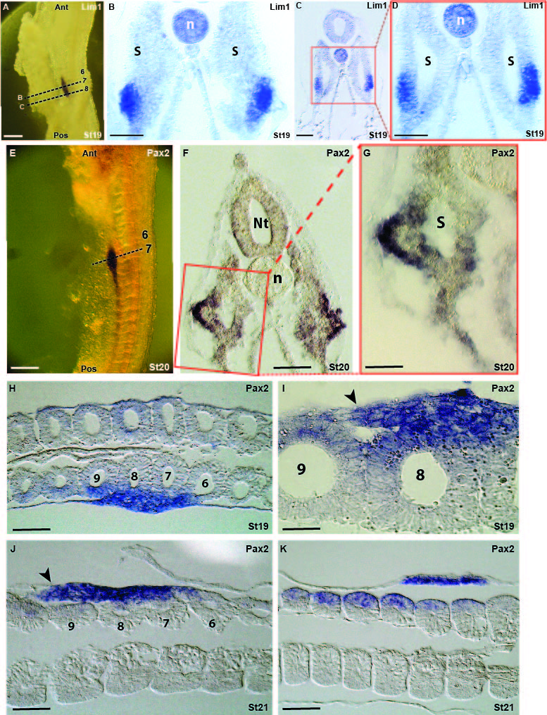**C1a. Expression pattern of pronephros genes in somitic domain in catshark**From the WMISH of *Lim1* and *Pax2* it is clear that at early stages or relatively young somites at later stages the expression has a segmented mode (Fig, 1E, posterior somites and Schmidt et al., 2021). Cross section of these embryos reveal an unexpected specific expression domain of these two genes in the ventrolateral part of the epithelial somite (Fig. 1). At early somitic developmental stages there is no discernible domain of intermediate mesoderm as it is exhibited in Aves and Mammals. The expression of *Lim1* and *Pax2* is within the epithelial somite (Fig. 1C,D, the level of somites 8 or 9, level of cross section is indicated in panel A) and as the somite matures this specific domain start to evaginate in a process which remains to be elucidated (Fig. 1B, somite 7). A stage later this somitic level of somite 7 reveals an advanced stage of this evagination which starts to create a duct-like structure lateral to the somite (Fig. 1E-G). Furthermore, frontal sections at stages 19 and 21 (Fig. 1H-K) clearly exhibit somitic origin and posterior extension of the nephric duct (Fig. 1I-J, arrowheads).Note, at stage 21 the expression of Pax2 in posterior somites, 10-12, is clearly observed on the lateral somitic domains (Fig. 1K), leaving the question of their contribution to the nephric duct open.

**Fig.1. Expression pattern of pronephros genes in somitic domains in catshark. (A-D)** Expression of *Lim1* in two axial (A, dashed lines) levels at the pronephros region of stage 19 embryo. (B) Cross sections at somite 7 level and the level of somite 8 (C and enlargement in D). **(E-G)** Expression of *Pax2* at the 7th somite level (E, dashed line) of stage 20 embryo. Cross section in F and enlargement in G. **(H-K)** Frontal sections at the level of somites 6-12. Scale bars in A and E represent 200µ and 100µ in B,C,D,F,H,J,K. Scale bar in G and I represents 50µ.

**C1b. Expression pattern of pronephros genes in relation to somitic markers in catshark**

The expression of the nephric genes within the somite raise the question of their relationship with known somitic markers such as *Pax3* (dermomyotome) and *Pax1* (sclerotome). In order to understand these relationships we first cloned and analyzed the expression pattern of the catshark *Pax3* and *Pax1*. WMISH of *Pax3* reveal a strong expression in the nervous system including head regions (not shown) and the neural tube. Within the somites the expression is in the dorsal part and strengthens in more posterior somites (Fig. 2B).The

*in situ* of *Pax1* shows a strong and clear expression in the pharyngeal arches and in the somites along the entire trunk (Fig. 2C, red arrow marks the first anterior somite). From a comparison of these two TFs with the nephric gene *Pax2* (Fig. 2A) it is clear that these genes are sharing different expression patterns in both the AP and DV axes.

Double immunostaining of Pax2 and Pax3 on cross sections reveal clear separate expression domains for these two TFs. While Pax3 is expressed in the dorsal neural tube and the dermomyotome, Pax2 is expressed ventrolateral to Pax3 and shares a clear border (Fig. 2D-F, arrows). In the more mature somite 7 (Fig. 2D), Pax2 is expressed in the evaginating tissue which starts to be organized in a duct-like shape. In the less mature somite 9 (Fig. 2F) Pax2 is still within the epithelial somitic domain. Interestingly, somite 8 (Fig 2E) of a later stage (St. 20) reveals an advanced phase in which a small duct-like tissue expressing Pax2 (black arrowheads) appears lateral to the epithelial somitic domain of the gene (yellow arrowheads). Does the duct-like Pax2 expression of somite 8 represent a posterior extension of a Pax2 expression in the more anterior somite 7? The dynamics (space and timing) of *Pax2* and *Lim1* expression during the nephric duct formation will have to be elucidated in future experiments. Cross sections of *Pax1* WMISH embryos show a relatively small expression domain in the medial part of the somite close to the notochord and most probably not overlapping with the 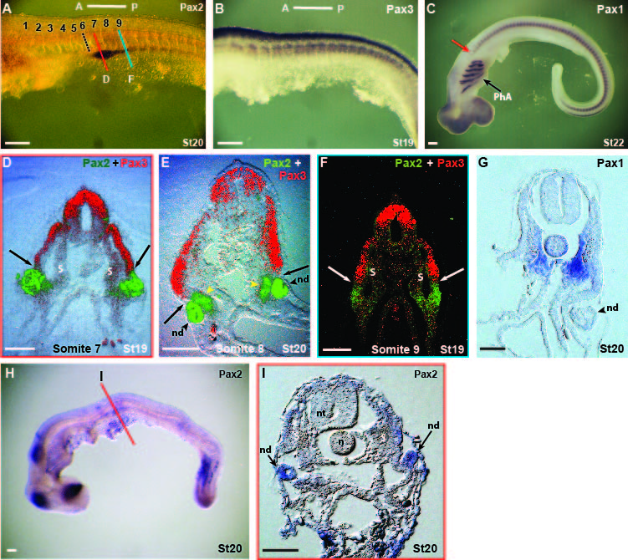expressions of Pax3 and Pax2. What is the regulation of these three separate domains and especially in our context what regulates the expression of the nephric genes within the paraxial mesoderm? Moreover, what regulates the budding of the nephric duct and by what cell arrangement processes does this structure form?

**Fig.2. Expression pattern of pronephros genes in relation to somitic markers in catshark. (A-C)** WMISH of *Pax2* (A), *Pax3* (B) and *Pax1* (C). **(D-F)** Cross sections with double immunostaining of Pax2 and Pax3 at different axial levels (color lines in A) of the pronephros domain. **(G)** Cross section of the *Pax1* WHISH embryo. **(H-I)** Inhibition of canonical Wnt signaling by the chemical anatagonist IWR 1. N, notochord, nd, nephric duct, nt, neural tube, PhA, pharyngeal arches, S, somite. Scale bar in A-C, H represents 200µ and 100µ in D-G,I.

Several Wnt family members were shown to be involved in somitic compartmentalization and regulation of somitic genes including *Pax3* and *Pax1* (Reshef et al., 1998; Munstenberg et al., 1995; Capdevila et al., 1998; Piran et al., 2009; Sela-Donenfeld and Kalcheim 2002; Geetha-Loganathan et al., 2007). Preliminary experiments using the canonical Wnt signaling antagonist IWR 1 in a concentration of 1mM (the higher limit before embryos die) administrated to catshark embryos at stage 15 (before the onset of pronephros markers at stage 17-18) result in morphological defects such as curved axis (Fig. 2H) and deformed dorsal neural tube and somites (Fig. 2I). However, despite the expression of pronephros genes in somitic domain (Fig. 2D-F), analysis of stage 20 embryos reveal expression of Pax2 in almost normal formed pronephros (Fig. 2I, arrows). These results suggest that Wnt signaling does not affect the somitic expression of Pax2 and the formation of the pronephros and the nephric duct.

**C1c. Expression pattern of pronephros genes in Lamprey; cross sections**

Cross sections of Lamprey embryos analyzing for *Pax2* reveal strong expression (Fig. 3D-F, arrows) ventral to the myotome (St. 25, red arrowheads). This expression, which appears already at the early embryo of stage 24, appears to be ventral to the somitic region although this will have to be confirmed by double or triple staining with other somitic markers such as *MyoD, Pax3* and *Pax1*. Interestingly, this strong ventral expression is connected to a short tubule (Fig. 3D,E, black arrowheads) which seems to be connected to the nephric duct (Fig. 3A, yellow arrows). The expression pattern of the nephric genes and the development of the pronephros is different from what was observed in the catshark. Part of these differences was recently suggested in an article based on this project (Schmidt et al., 2021, submitted for publication) in which catshark pronephros is RA dependent while Lamprey pronephros is RA independent and is differentially regulated by other molecular mechanisms that still has to be elucidated in this project. Moreover, adding to this evolutionary developmental complexity, the initial expression of lamprey *Pax2* at stage 22 is within a clear large domain (Fig. 3C, black line) which medially contains the future somitic domain. This structure resembles the clear separation between paraxial and IM domains in chick embryos. However, while in chick, *Pax2* expression in the IM is continuous along the entire axis, here in the Lamprey it is segmented like in the Catshark (Fig.3B, arrows). These observed differences in the appearance of the nephric system from this evolutionary perspective will be subjected to a deeper analysis during this project.

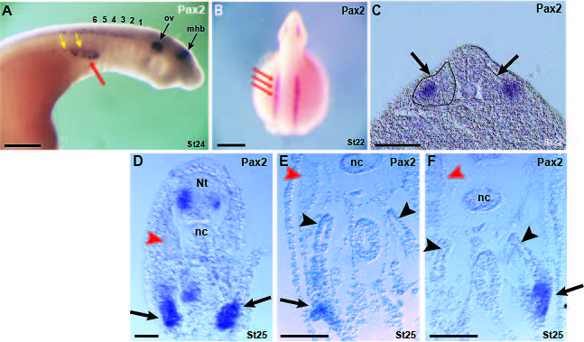

**Fig. 3. Expression pattern of the Lamprey nephric genes.** (**A-B**) Expression of *Pax2* at stage 24 and 22. Numbers in A represent the somite from anterior to posterior. Red arrows mark the segmented pattern of *Pax2* expression. Yellow arrows mark the pronephric duct. (**C**) Expression of *Pax2* in cross section of a 22 stage embryo. Black line marks a clear paraxial domain. **(D-F**) Cross sections of stage 25 embryo expressing *Pax2* in three AP levels from posterior (D) to anterior (F). Arrows mark developing glomeruli and black arrowheads mark the tubules connecting these glomeruli to the nephric duct. Red arrowheads mark myofibers within the myotome. mbh, mid-hindbrain boundary, nc, notochord, Nt, neural tube, ov, otic vesicle. Scale bar in panels A-B represent 200µ and 100µ in panels C-F.

**C1d. Cell tracing using Dye methodologies**

As was shown in the previous sections (C1a and C1b.), the catshark IM is originated from the ventrolateral part of the somites starting in mid-somite 6 posteriorly. Despite the great contribution of cross and frontal sections of *Pax2* or *Lim1* WMISH (Fig. 1) to our understanding of the nephric duct formation it is still difficult to reconstruct the precise somitic source of the nephric duct and the way somitic cells are assembled into the tube form. Moreover, is the nephric duct a result of pronephric somitic level and further posterior elongation (as in chick embryos) or somites along the entire AP axis including mesonephros level contribute to its formation? For understanding these nephric duct formation issues we sought of a cell lineage methodology which will allow us to detect cell movements and structure formation. In order to achieve this goal we started to develop the dye staining methodology for this model organism, a method that has been rarely used in this model organism.

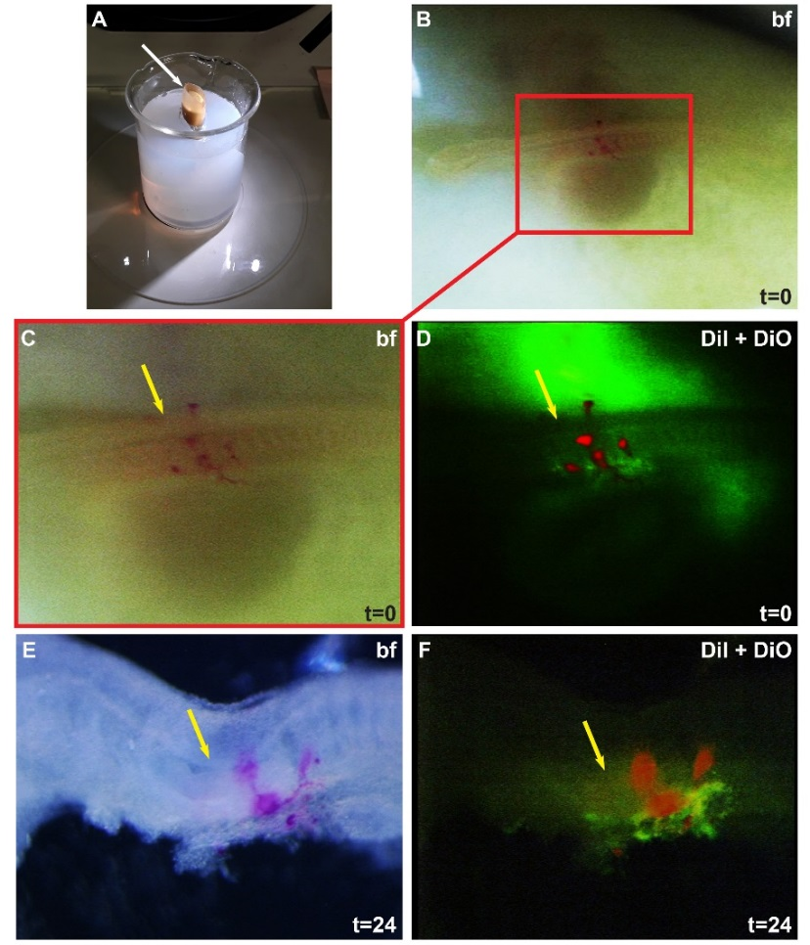Cm-DiI (red) and DiO (green) (Invitrogen) were injected into stages 18 – 20 catshark embryos *in ovo*. The egg was placed in a vertical position under the binocular (Fig. 4A) and the top of the egg shell was removed (Fig. 4A, arrow). The two dyes were injected into somites 6 and posteriorly in an alternating manner as shown in Fig. 4B-D in order to elucidate the somitic cell origin of the pronephric duct. Alternate dyes along the entire axis will indicate different somitic origin of the nephric duct and one color will provide evidence of one somitic source and a posterior elongation as it is known from Aves. Arrow marks the 6th somite level. Following 24h it was clearly seen that the two dyes start to rearrange along the pronephric duct as separate entities suggesting different somitic origin (Fig. 4E-F). Elaboration of this kind of experiments will extend the dye injection into more posterior somites and time lapse up to 96h plus analyses of all orientation sections in order to reveal the formation of the fully developed duct.

**Fig.4. Cell tracing by DiI methodology.** (A) The method of opening and placing the egg shell. **(B-D)** Injection of two different dyes (D) into the somitic ventrolateral domain. **(E-F)** 24h following the injection the Dyes seem to arrange in a segmented mode along the forming nephric duct. Yellow arrows mark the 6th somite level.

**C2. Discovering and characterizing nephric cells and their differentiation pathways**

**C2a. RNA-seq analysis**

As was previously shown (Fig. 2A) the anterior border of pronephros genes expression is mid-somite 6. The pronephros extends posteriorly and from somite 11-12 turns into the mesonephros. In order to discover new genes and molecular pathways involved in the regulation, coordination and formation of the PMF and the nephric duct, we designed a RNA screen comparing between the first anterior five somites, non-generating PMF, IM or nephric duct, and the next 5-6 somites level that includes the PMF and the duct (Fig. 5A, yellow rectangle vs. red rectangle respectively). Collection of tissues was done at four developmental stages; 15-16, prior to the first appearance of nephric markers in somite 6 and posteriorly, 17-18, the onset of nephric gene expression in somite 6 and posteriorly, 19-20, the budding stage in which ventrolateral somitic cells leave the somite to create the nephric duct and stage 21 in which the duct differentiate into epithelial structure and elongate posteriorly. These four developmental stages supposedly cover all developmental events of our interest in the limits of this project.

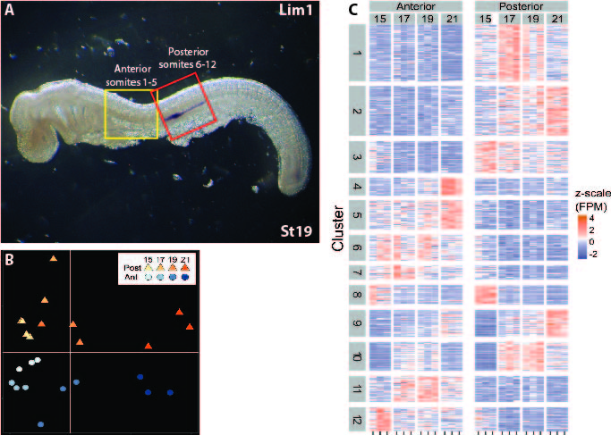Following tissue collection, RNA extraction, libraries construction and Ilumina sequencing, differential expression analysis was carried out, based mapping to a draft genome of the catshark (*Scyliorhinus caninula*) available at Prof. Sylvie Mazan laboratory (Laboratoire Arago - Observatoire Océanologique de Banyuls sur Mer CNRS, Sorbonne University, See letter of collaboration) and gene expression quantification. This analysis was done by the University of Haifa Bioinformatic Service Unit. Overall transcription patterns varied among developmental stages and between somite level positions, as illustrated in non-metric multidimensional scaling (NMDS) ordination (Fig. 5B). These trends were tested by permutational analysis of variance (PERMANOVA). Significant differences in overall gene transcription patterns were found for both, developmental stages (R2=0.65, *P*<0.001) and anterior vs. posterior somites (R2=0.07, *P*<0.01). Differential transcribed analysis, searching for interactions between developmental stage and somite position identified 172 genes significant at adjusted *P* value <0.05. Additional 350 genes were differentially transcribed between anterior and posterior somite positions. In order to understand expression dynamics of this set of 522 genes, we have applied clustering using Kmeans method and have extracted twelve cluster, each representing unique dynamic contrast (Fig. 5C). Gene set enrichment analysis identified, among others, highly significant enrichment in gene ontology term ‘regulation of transcription, DNA-templated’ (GO:0006355). This set included 73 differentially transcribed genes, 43 associate with the posterior domain characterizing different developmental stages.

**Fig. 5. Differential expression of genes following RNA-seq. (A)** Anterior (yellow) versus posterior (red) regions of embryo trunk were collected for RNA-seq at four developmental stages. **(B)** Heatmap presenting 12 clusters demonstrating differential expression according to stage and position along the AP axis (anterior vs. posterior). **(C)**

**C2b. Analysis and validation of selected genes**

Following gene transcription analyses and literature searches, several genes were selected for further analysis and validation (Fig. 6). Among the selected genes, Wt1, a known kidney developmental gene that is expressed in the nephric mesenchyme and regulate glomeruli differentiation (Hwei-Jan et al, 2003; Kreidberg, 2010; Hastie, 2017) in vertebrates, is serving as validation control for expression in nephric tissues, assuming conserved role in catshark (Fig. 6.A-C). Other genes in this preliminary survey may appear in the literature to be connected with kidney development (mostly metanephros) in one or two model organisms with or with no clear role in the process or relation to the pronephros or mesonephros and some reveal no known connection to the subjected process.

***Wt1*** at catshark stage 19 is expressed from the 6th somite level posteriorly similar to the expression of Pax2 and Lim1 (Fig. 6A,B). However, cross sections through the expression domain reveal that this gene, in contrast to Lim1 that is expressed only within the evaginating tissue and later on in the nephric duct, is expressed only in the nephric mesenchyme that will give rise to the glomeruli and tubules (Fig. 6C, compare the expression in the nephric duct, nd, to the nephric mesenchyme, nm). In that sense this Wt1 expression pattern is conserved among vertebrates (Ishii et al., 2007).

***Emx2*** is a TF that is expressed at catshark stage 19 from the 7th somite posteriorly (Fig. 6D,E). Cross section through the expression domain clearly demonstrate the expression of the gene in the budding nephric duct (Fig. 6F, arrows). Emx2 was shown to be important for metanephros development (Miamoto et al., 1997; Pellegrini et al., 1997) and its expression in the catshark pronephros was already observed previously (Derobert et al., 2002). However, beside these observations and reports its role in the pronephros and nephric duct development is completely unknown.

***MECOM*** or *Mds1/Evi1* COMplex was previously associated with kidney diseases and metanephros malformation (Bartholomew and Clark, 1994). Evi1 was also reported previously to be expressed in the pro-and mesonephros of chick and Xenopus but its role in forming the nephric duct or other pronephros tissues in these species remain unknown (Mead et al., 2005; Cela et al., 2013). Mecom was identified in Zebrafish in association with the pronephros and found to be involved in a dynamic role in regulating Notch signaling and antagonizing RA in the formation of renal tubules (Li et al., 2014). This gene appeared in the transcriptome in clear association with the pronephros markers and its levels are increased at stage 21 (the later stage examined). WMISH of stage 20 catshark embryos demonstrate expression in the neural tube, somites and the pronephros (Fig. 6G,H). Indeed, cross sections of these embryos confirmed the WMISH (Fig. 6I). Clear expression can be seen in the dorsal neural tube, dermomyotome (especially in the ventrolateral region), sclerotome and the nephric duct (Fig. 6I, nd). The nephric mesenchyme reveal no expression of this gene at this particular stage (Fig. 6I, nm). Cloning and expression analysis of the gene in chick embryos of approximately the same developmental stage exhibit specific expression in the IM similar to the known expression of chick Lim1. Cross section of these embryos demonstrate in anterior regions (advanced differentiation) specific expression in the nephric duct (Fig. 6I', nd) and in posterior regions specific expression in the nephric cord (Fig. 6I'', nc) which later develops into the nephric duct.

***Nynrin*** have been reported as one of several Wilms Tumor (WT) predisposition genes (Mahamdallie et al., 2019). Little is known about the Nynrin gene, but it is believed to be play a role in microRNA processing and endoribonuclease activity (Turner et al., 2021; Peng and Yi Luo., 2018). This gene was differentially transcribed in our transcriptome dataset associated with cluster 1 (Fig. 5C). WMISH analysis reveal high expression levels in ventral domains in the anterior region of the trunk which extend to more dorsal regions (from somite 11) in posterior domains of the trunk (Fig. 6J, K) Cross sections demonstrate high levels of expression (confirmed in the transcriptome dataset) in the lateral plate mesoderm in both, the somatopleura and the splanchnopleura, along the entire axis (Fig. 6L,M). While no expression was observed in the budding nephric duct (nd) or the nephric mesenchyme at the level of the pronephros (Fig. 6L), from somite 11 and posteriorly, the mesonephros region, Nynrin is expressed in the ventral part of the somite and in a robust manner in the venrto-lateral domain. This expression pattern raise the question of its role in the regulation and formation of the mesonephros and the distinction between the two embryonic kidneys and the somitic contribution to the nephric duct.

**CDH6** is a member of the cell surface proteins of the cadherin family playing a role in cell-cell interactions. CDH6 was previously shown in zebrafish to be expressed and to have a role in pronephros development in both, glomeruli/tubules and nephric duct formation (Kubota et al., 2007). In our transcriptome dataset this gene was differentially transcribed in high levels in both anterior and posterior regions and was associated to cluster 2 (Fig. 5C). WMISH reveal strong expression in the dorsal neural tube and ventral domains (Fig. 6N,O). Cross sections through the pronephros territory demonstrate expression in the dorsal neural tube and both, the nephric duct and the nephric mesenchyme (Fig. 6P). This is in particular interesting since this gene is the only so far examined in this validation analysis which exhibit expression in both domains, the nephric duct and the nephric mesenchyme which will give rise to the glomeruli and tubules.

***Uncx*** is a paied-type homeodomain TF that was shown to be expressed in many type of embryonic tissues including the somites, first branchial arch, forelimb digits, central nervous system and meso-and metanephros (Neidhardt et al., 1997). This gene in our transcriptome dataset reveals transcription in the posterior domain which increase in levels from stage 17-18, resembles the pattern of Pax2 and Lim1, and is in association with cluster 2 (Fig. 5C). WMISH shows expression at stage 19 embryos which is exactly like the one observed for Lim1 in the pronephros (Fig. 6Q,R). Indeed, cross sections of these embryos clearly demonstrate exclusive expression in the budding nephric duct (Fig. 6S, nd). The reported relationships between Uncx and various somitic TFs in mouse, Xenopus and zebrafish (Neidhardt et al., 1997; Sanchez and Sanchez 2013; Nittoli et al., 2019) suggest a role for this gene in the gene regulatory network (GRN) that controls the compartmentalization and differentiation of somitic properties. Furthermore, these TFs activities are under the influence and effect of surrounding signaling factors, raising questions regarding the origin of the pronephros and the role of Uncx in this developmental process. Interestingly, in none of the publications regarding expression and activity of Uncx the pronephros was not detected and mentioned. Cloning and expression analysis of chick *Uncx* in embryos of approximately the same developmental stage reveal similar expression to Pax2 and Lim1 (Fig. 6Q'). However, as appears in cross sections, while Pax2 in expressed in both domains of the IM, Lim1 and as shown here Uncx are expressed only in the nephric cord (Fig. 6S'), similar to the expression of chick Mecom (Fig. 6I',I'').

Taken together, these preliminary analyses of several genes out of 43 selected ones demonstrate dynamic expression patterns varied between stages, position along the AP axis and mainly between the apparently two distinct pronephros domains, the nephric duct and the nephric mesenchyme which will give rise to the glomeruli and the tubules. Further investigation into the relationships and activity of these genes in an evolutionary oriented context will enhance our understanding of the PMF and nephric duct formation.

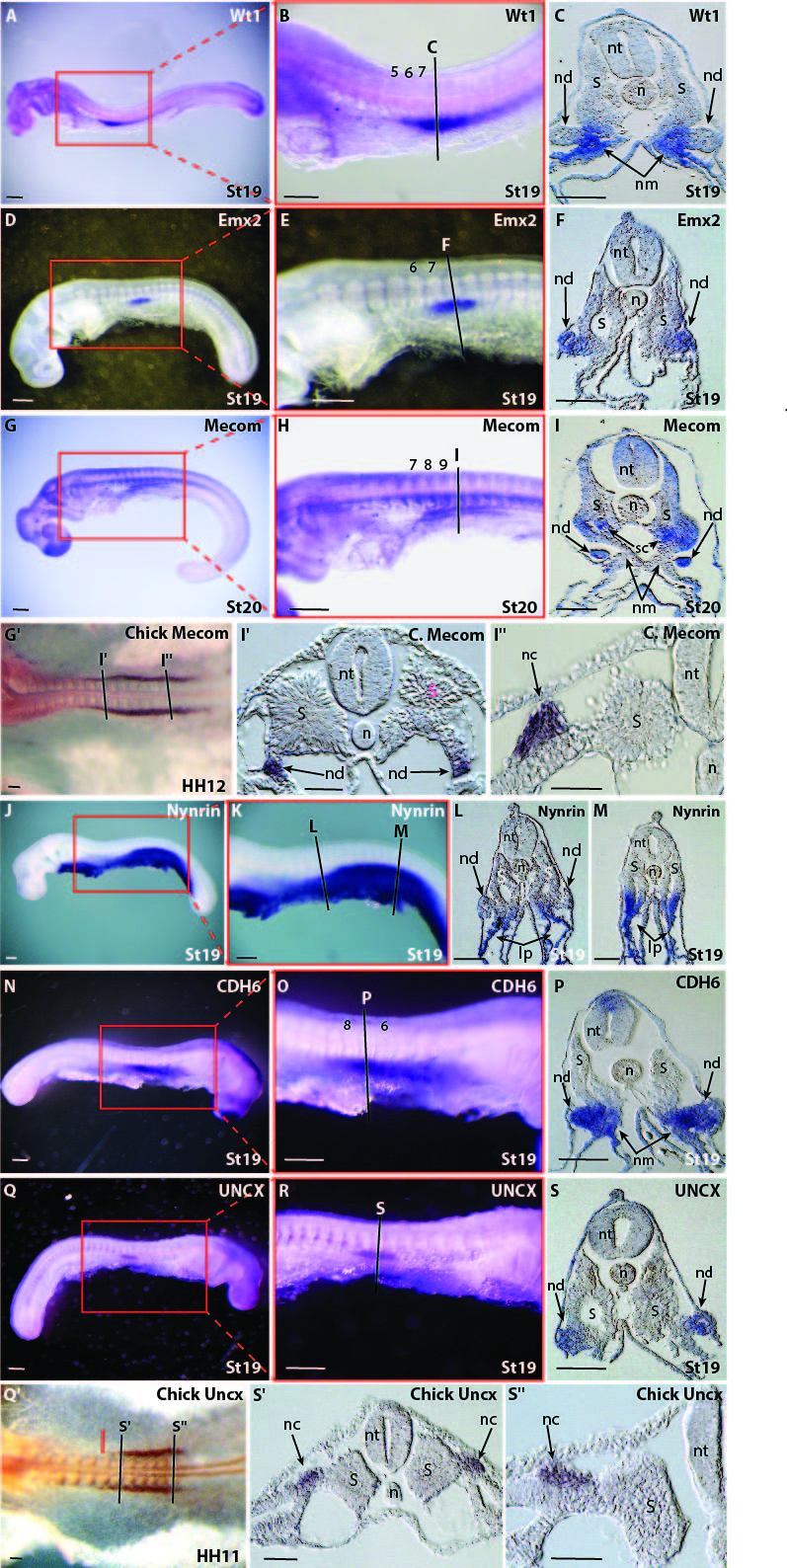**Fig. 6.** WMISH of selected genes that emerged from the RNA-seq screen. **(A-C)** *Wt1* expression at stage 19 embryos. **(D-F)** *Emx2* expression at stage 19 embryos. Note, staging is determined by several criteria such as the development of the pharyngeal arches. Differences in size and shape of same stage embryos may occur. **(G-I)** *Mecom* expression at stage 20 embryos. **(G'-I'')** Chick *Mecom* expression at HH12. I' and I'' are cross sections through the corresponding regions indicated in G'. **(J-M)** *Nynrin* expression at stage 19 embryos. **(N-P)** *CDH6* expression at stage 19 embryos. **(Q-S)** *UNCX* expression at stage 19 embryos. **(Q'-S")** Chick *Uncx* expression at HH11. S' and S'' are cross sections through the corresponding regions indicated in Q'. lp, lateral plate mesoderm, n, notochord, nc, nephric cord, nd nephric duct, nm, nephric mesenchyme, nt, neural tube, S, somite, sc, sclerotome. Scale bars represent 100µ.