**We invite you to participate in the International Tobacco Survey – a unique study of adults in Israel and the United States. You can complete the survey online, at your convenience. The survey will ask you about your beliefs, attitudes, and behaviors related to tobacco and nicotine use. Your answers will help us understand views among adults in these countries.**

**There are no known risks associated with the survey. The benefits are that your responses will help policymakers and health professionals develop future policies and programs on tobacco and nicotine products.**

**We would like to start by getting some basic demographic and social information about you.**

Please indicate what country you currently reside in:

Do you have an Israeli ID?

1. Yes
2. No

Where were you born?

1. Israel
2. United States
3. Somewhere else

Please indicate your country of birth:

How old are you (in years)?

Under 18

__

Older than 45

What is your gender?

1. Male
2. Female
3. Other; please specify:

Please indicate your father’s country of birth:

Please indicate your mother’s country of birth:

Are you:

1. Jewish
2. Arab
3. Other; please specify

Are you:

1. Jewish
2. Muslim
3. Christian
4. Druze
5. Other; please specify:
6. Don’t know
7. Prefer not to answer

Do you see yourself as:

1. Ultra-Orthodox (Haredi)
2. Orthodox
3. Traditional religious/conservative
4. Traditional non-religious
5. Non-religious, secular
6. Other; please specify:
7. Don’t know
8. Prefer not to answer

Do you see yourself as:

1. Very religious
2. Religious
3. Not so religious
4. Not religious
5. Other; please specify:
6. Don’t know
7. Prefer not to answer

How do you define yourself in terms of your origin?

1. Ashkenazi
2. Sephardic
3. Mixed
4. Mizrachi
5. Russian
6. Ethiopian
7. Israeli
8. Arab
9. Christian
10. Palestinian
11. Muslim
12. Bedouin
13. Druze
14. Other; please specify:
15. Don’t know
16. Prefer not to answer

What is the highest level of formal education that you have completed?

1. Grade school/ some high school
2. Completed high school
3. Technical/ trade school or community college
4. Some university, no degree
5. Completed university degree
6. Post-graduate degree
7. Other; please specify:
8. Don't know
9. Prefer not to answer

Which of the following categories best describes your ANNUAL household income, that is the total income before taxes, or gross income, of all persons in your household combined, for one year?

1. Up to 30,000 NIS
2. 30,001 – 48,000 NIS
3. 48,001 – 60,000 NIS
4. 60,001 – 72,000 NIS
5. 72,001 – 96,000 NIS
6. 96,001 – 120,000 NIS
7. 120,001 – 156,000 NIS
8. 156,001 – 192,000 NIS
9. 192,001 – 288,000 NIS
10. 288,001 or more
11. Don't know
12. Prefer not to answer

Which of the following categories best describes your primary employment during the last 12 months? *(Consider individual farming as self-employed.)*

1. Government employee
2. Employed in the non-government sector
3. Self-employed (own business/freelancer)
4. Student
5. Homemaker/Stay-at-home parent
6. Retired
7. Unemployed, able to work
8. Unemployed, unable to work
9. Other; please specify:
10. Don’t know
11. Prefer not to answer

What is your marital status?

1. Married
2. Living with partner/cohabitating
3. Widowed
4. Separated
5. Divorced
6. Single, never married
7. Other; please specify:
8. Don't know
9. Prefer not to answer

Do you consider yourself

1. Heterosexual or straight
2. Gay, lesbian, or homosexual
3. Bisexual
4. Other; please specify:
5. Prefer not to answer

How many people older than 18 years old, including yourself, live in your household?

How many children under the age of 18 live in your home?

On how many days of the past 30 days have you used cigarettes, e-cigarettes, or any other tobacco product?

__ days

Don’t know

Prefer not to answer

**In this section, we hope to learn more about you, your interests, and some of your experiences in daily life.**

Please rank in order the 3 topics below that are most important to you or of interest to you.

* Business
* Current events
* Politics
* Art & culture
* Fashion
* Entertainment (for example, television, movies, theater)
* Music
* Innovation & technology
* Health & fitness
* Sports
* Nature & outdoor activities (for example, hiking)
* Cooking
* Other; please specify:

Most important:

Second most important:

Third most important:

*All three responses should be different*

You selected *Other* as a topic that is important to you or of interest to you. What topic were you thinking of?

Please indicate the extent to which you agree with each of the following statements:

1=Not at all

2=A little

3=Neutral/don’t know

4=Somewhat

5= Very much/completely

In general, I usually try new products before other people do.

When I shop, I look for what is new.

I like to be the first among my friends and family to try something new.

I usually prefer to wait and see if a new product is successful before trying it out myself.

I like to weigh the pros and cons of a product before trying it.

I usually try a new product only when I have to (or there is no other option).

I like to stick with brands I know.

I tend to buy on impulse or if something simply intrigues me.

I tend to buy items that I think will get noticed by others.

To me, quality is the most important consideration when making a purchase.

What matters most to me when I shop is value – how far my money will go.

It is important to me how responsibly products are made, for example, if they are recyclable, made from recycled materials, or organic.

In general, people consider many things when making purchasing decisions. Using the following list, please rank in order the top 3 considerations that most guide your purchasing decisions, from most important to third most important.

* Value, utility
* Familiarity, stability
* Quality, investment in quality
* Image, appearance, fashion
* Discovery, being different, new ideas/products
* Authenticity, social awareness
* Whatever I can afford or whatever I feel like in the moment

Most important:

Second most important:

Third most important:

*All three responses should be different*

Do you consider yourself Left wing, Central, or Right wing?

1. Left wing
2. Central (centrist)
3. Right wing
4. None of the above
5. Don't know/undecided
6. Other; please specify:
7. Prefer not to answer

Using the options below, please mark how you would identify with regard to most issues.

1. Very liberal
2. Liberal
3. Somewhat liberal
4. Moderate
5. Somewhat conservative
6. Conservative
7. Very conservative
8. Don’t know/undecided
9. Other; please specify:
10. Prefer not to answer

Do you have access to the following: (Select all that apply.)

* Smartphone
* Computer/laptop with internet at home
* Computer/laptop with internet at work/school
* None of the above

How often do you use the internet, either on a computer or on your cell phone?

1. Almost constantly
2. Several times a day
3. About once per day
4. A few times per week
5. Less often
6. Never

How often, if at all, do you use the following media sources:

1=Almost constantly

2=Several times a day

3=About once per day

4=A few times per week

5=Less often

6=Never

Newspapers, magazines

Television

Radio, news podcasts

News websites

Social media sites (such as Facebook, Twitter, or Snapchat)

Which of the following sources of social media have you used in the past week? (Select all that apply.)

* Facebook
* Instagram
* LinkedIn
* Reddit
* Snapchat
* TikTok
* Tumblr
* Twitch
* Twitter
* WhatsApp
* YouTube
* Other; please specify:
* None of the above

**Over the last 2 weeks, how often have you been bothered by any of the following problems?**

|  |  |  |  |  |
| --- | --- | --- | --- | --- |
|  | **Not at all** | **Several days** | **More than half the days** | **Nearly every day** |
| Little interest or pleasure in doing things. |  |  |  |  |
| Feeling down, depressed, or hopeless. |  |  |  |  |
| Feeling nervous, anxious, or on edge |  |  |  |  |
| Not being able to stop or control worrying |  |  |  |  |

Have you ever been diagnosed with any of the following conditions? (Select all that apply.)

* COVID-19
* Diabetes
* Hypertension
* High cholesterol
* Chronic lung disease (for example, asthma, chronic obstructive pulmonary disease (COPD), etc.)
* Heart disease
* Cancer
* Depression
* Anxiety
* ADD/ADHD (attention deficiency disorder/attention deficiency hyperactivity disorder)
* Substance use problems (dependence, abuse)
* Other; please specify:
* None of the above
* Prefer not to answer

In the past 30 days, on how many days have you consumed alcohol?

__

Don’t know

Prefer not to answer

Have you seen or heard of claims that smoking or using nicotine can protect against COVID-19 infection?

1. Yes
2. No
3. Don't know/don’t remember

Where have you seen or heard about these claims? (Select all that apply.)

* WhatsApp
* Facebook
* Instagram
* Twitter
* Telegram
* Traditional newspaper
* Online news website
* From a friend, family member, or someone in my community
* Other; please specify:

Note that current evidence is unclear regarding the association between smoking and COVID-19 infection. There is evidence to suggest that smoking might put you at greater risk for severe COVID-19 infection.

**The following questions are aimed at learning more about your perceptions of heated tobacco products. These products heat tobacco but do not actually burn it.**

**One common brand is IQOS (pictured below). IQOS is an electronic device and has three main parts: 1) the device charger; 2) the IQOS device (or heatstick “holder”) into which heatsticks are inserted and heated; and 3) the heatsticks that contain tobacco and are inserted into the IQOS device to be heated.**

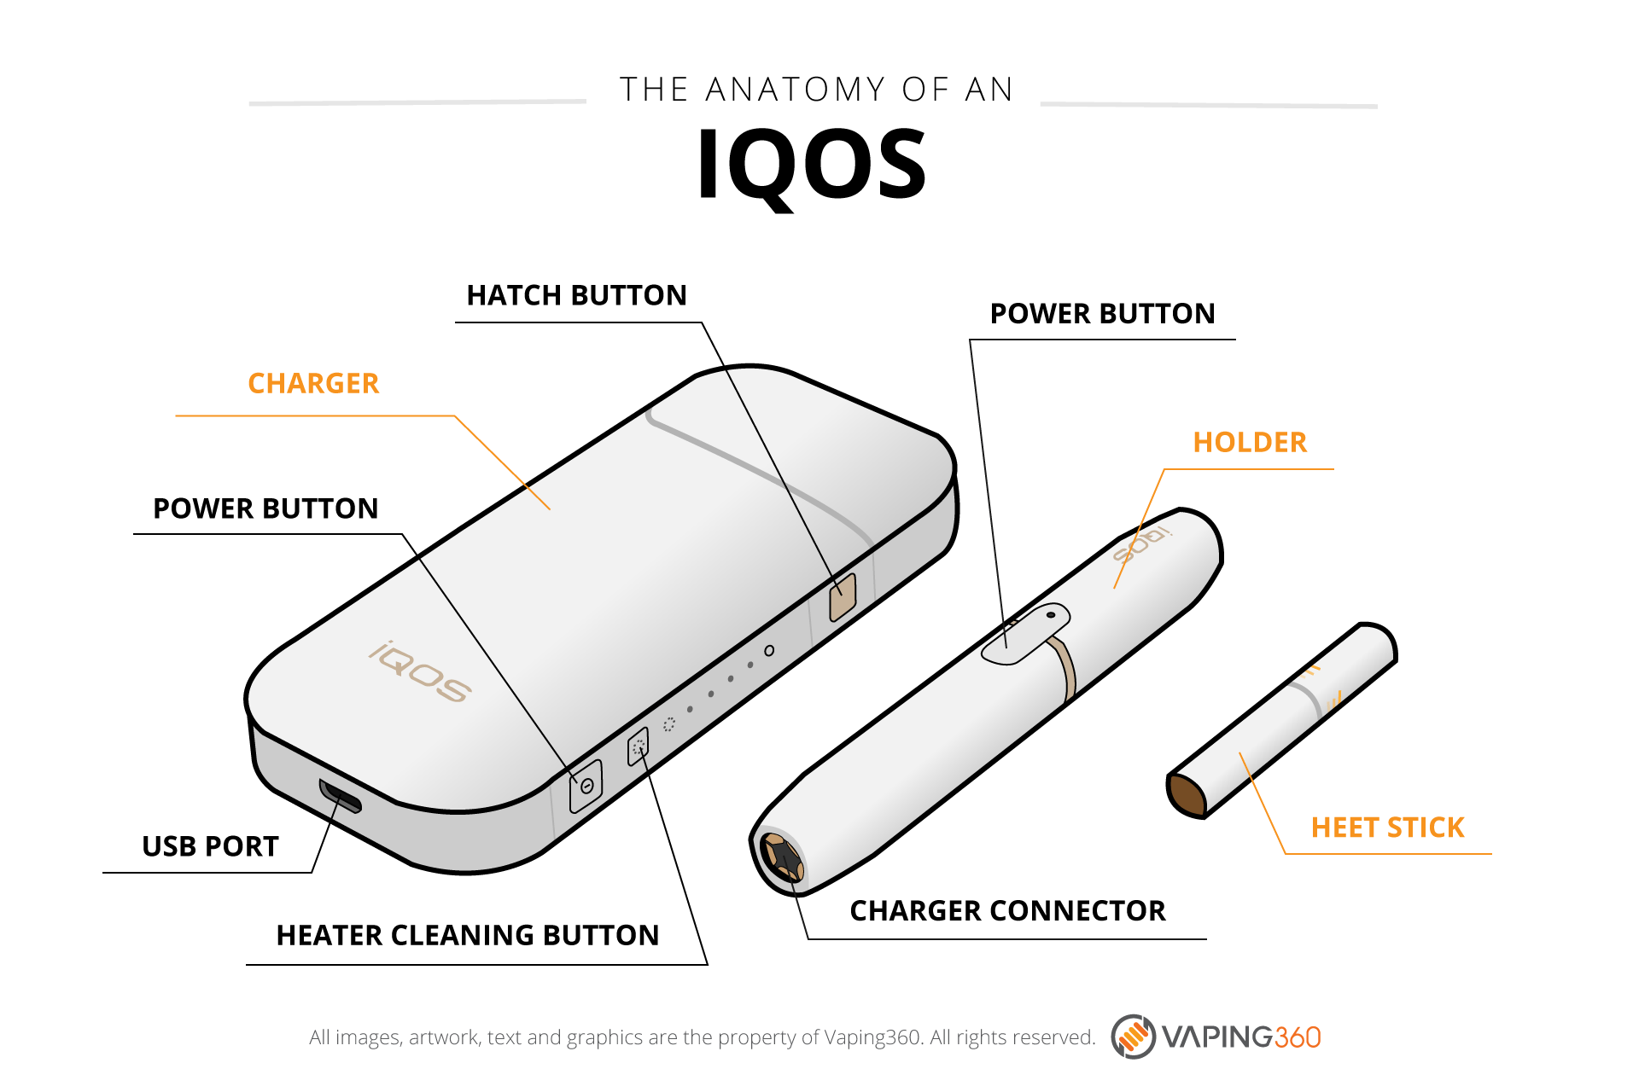

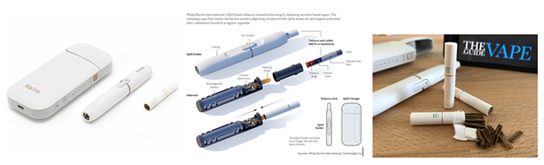

Before beginning this survey, had you heard of heated tobacco products, like IQOS, which heat sticks of tobacco instead of burning it?

1. No
2. Yes
3. Don’t know
4. Prefer not to answer

For each of the items below, please indicate your response using the response options below.

1=Not at all

2=A little

3=Neutral/don’t know

4=Somewhat

5= Very

Thinking about all you know about IQOS, how different do you think IQOS is from traditional cigarettes?

Thinking about all you know about IQOS, how different do you think IQOS is from e-cigarettes?

Overall, how curious are you about IQOS?

How likely would you be to try IQOS?

How likely would you be to suggest IQOS to a friend who smokes cigarettes?

How did you first learn about heated tobacco products, such as IQOS?

1. Saw advertisements
2. Saw product at store
3. Friends or family or colleagues
4. Saw their use on TV, movies, etc.
5. Saw posts on social media (not ads)
6. Other; please specify:
7. Don’t know/remember
8. Prefer not to answer

Where did you first see the advertisements?

1. On websites (for example, pop-up ads)
2. On social media sites, like Facebook, Instagram or Twitter
3. Inside or outside stores that sell cigarettes and other tobacco products
4. Seeing specialty stores that sell heated tobacco products
5. On television
6. On the radio
7. On posters, billboards, etc.
8. In newspapers or magazines
9. Direct mail
10. Email
11. IQOS events (for example, parties or festivals)
12. Other; please specify:
13. None of the above
14. Don't know/remember
15. Prefer not to answer

At what kind of a store did you first see IQOS/heatsticks?

1. IQOS specialty shop
2. IQOS temporary or mobile sales location (for example, pop-up store or booth)
3. Vape shop
4. Tobacco specialty store
5. Convenience store
6. Gas station
7. Liquor store
8. Somewhere else; please specify:
9. Don't know/remember
10. Prefer not to answer

This item asks about **advertisements**, meaning ads made and paid for by companies who make the products. In the last 30 days, have you noticed heated tobacco product (like IQOS) **advertisements** in any of the following places? (Select all that apply.)

* On websites (for example, pop-up ads)
* On social media sites, like Facebook, Instagram or Twitter
* Inside or outside stores that sell cigarettes and other tobacco products
* Seeing specialty stores that sell heated tobacco products
* On television
* On the radio
* On posters, billboards, etc.
* In newspapers or magazines
* Direct mail
* Email
* Other; please specify:
* None of the above.
* Don’t know
* Prefer not to answer.

**Outside of advertisements**, in the last 30 days, have you noticed heated tobacco products (like IQOS) being **referenced, used, or portrayed** in any of the following places? (Select all that apply.)

* In movies, television, or theater
* On the radio
* On websites
* In social media
* Other; please specify:
* None of the above.
* Don’t know
* Prefer not to answer.

Thinking about all you have seen and read about heated tobacco products (like IQOS) from all sources, would you say the information has been:

1. Mostly positive
2. Slightly positive
3. Equally balanced
4. Slightly negative
5. Mostly negative
6. Don’t know
7. Prefer not to answer

What effect have health warnings had on your thoughts about using heated tobacco products (like IQOS)?

1. Have not seen or noticed them
2. Made me concerned about using them
3. Reassured me about using them
4. Had no effect
5. Don’t know
6. Prefer not to answer

**As mentioned previously, IQOS is an electronic device and has three main parts: 1) the device charger; 2) the IQOS device (or heatstick “holder”) into which heatsticks are inserted and heated; and 3) the heatsticks that contain tobacco and are inserted into the IQOS device to be heated. The figures below provide additional detail regarding IQOS’s technology and design.**

How appealing is the overall design?

1. Not at all
2. A little
3. Neutral/don’t know
4. Somewhat
5. Very

How appealing is the technology involved in IQOS?

1. Not at all
2. A little
3. Neutral/don’t know
4. Somewhat
5. Very

**IQOS requires charging the device and cleaning it. It takes about 90 minutes to charge the device, which will support the use of about 20 heatsticks. To clean it, you must let it cool after use, use the IQOS cleaning tool to clean the blade and other components, and wipe it. It is recommended that you clean it after using 20 heatsticks.**

How much does IQOS’ maintenance reduce its appeal?

1. Not at all
2. A little
3. Neutral/don’t know
4. Somewhat
5. A lot

**IQOS has a wide range of colors (top) and accessories such as carrying cases (bottom).**



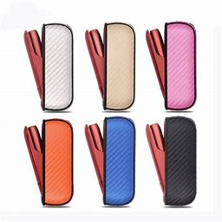 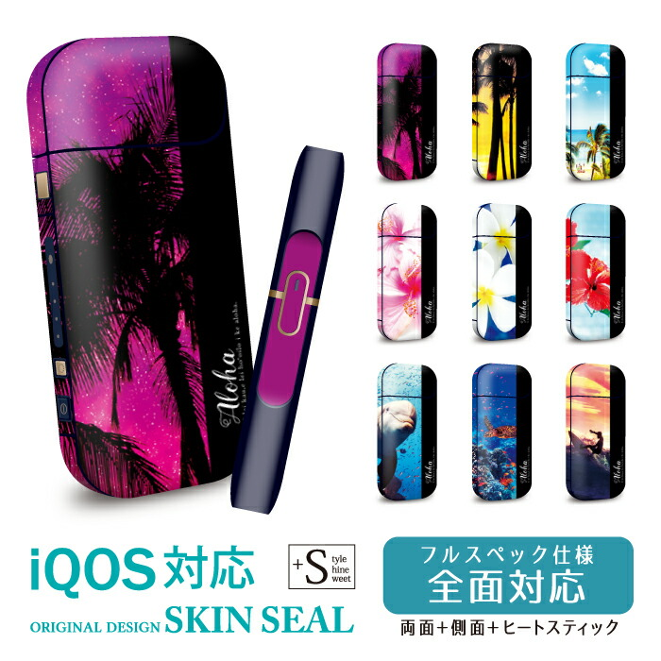 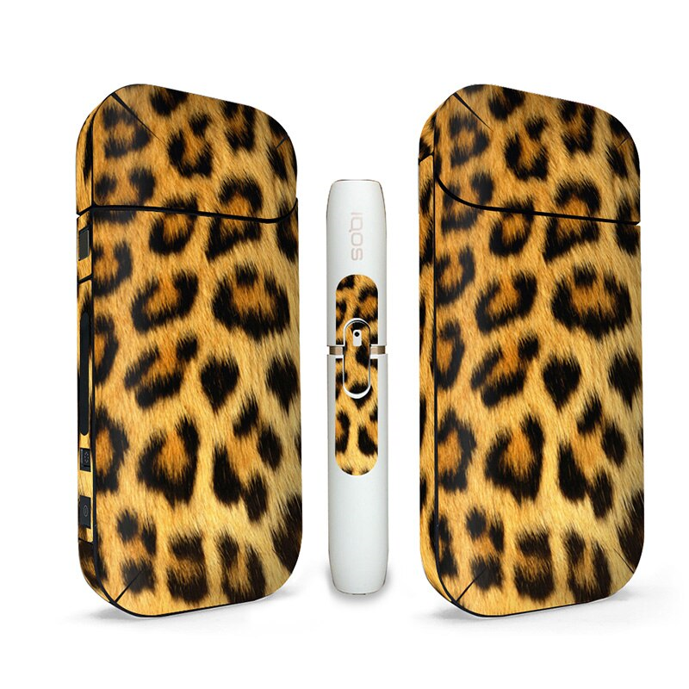 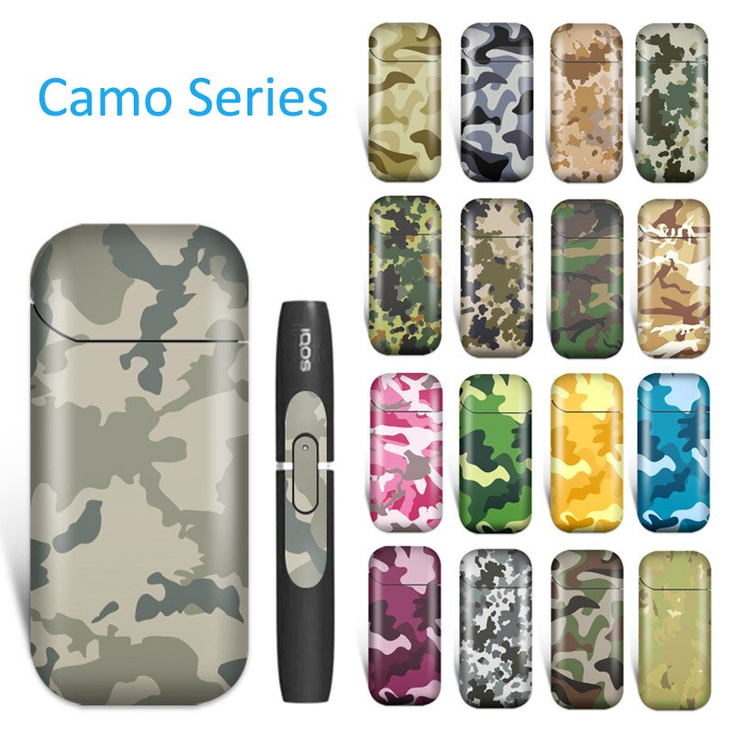

How appealing are the variety of colors provided?

1. Not at all
2. A little
3. Neutral/don’t know
4. Somewhat
5. Very

How appealing is the ability to customize the device with additional accessories, such as carrying cases?

1. Not at all
2. A little
3. Neutral/don’t know
4. Somewhat
5. Very

The devices cost roughly [199 to 320 NIS]; a carton of heatsticks includes 10 packs (each containing 20 heatsticks) and costs about [250 – 280 NIS]. How do you feel about the cost?

1. Much too cheap
2. Somewhat cheap
3. Neutral/about the right price
4. Somewhat expensive
5. Much too expensive
6. Don’t know

The heatsticks come in a couple of different flavors, depending on which country you live in. Below are the flavors available in several countries.

|  |  |  |
| --- | --- | --- |
| Amber | מאוזן וקלויתערובת טבק קלויה לטעם טבק מאוזן ומלא | BALANCED AND ROASTEDRoasted tobacco blend with balanced and complete tobacco taste |
| Bronze | עשיר וארומטי תערובת טבק קלויה וארומטית לטעם טבק עשיר ועגול | RICH AND AROMATIC Roasted and aromatic tobacco blend with rich and round tobacco taste |
| Purple | מנתול ארומטיתערובת טבק המספקת תחושת מנתול קרירה בשילוב ארומה עשירה ועמוקה | AROMATIC MENTHOLA tobacco blend that provides a cool menthol feel combined with a rich and deep aroma |
| Sienna | מלא ומאוזן תערובת טבק קלויה לטעם טבק מאוזן עם ניחוח עץ | FULL AND BALANCED Roasted tobacco blend with balanced tobacco flavor with a woody scent |
| Turquoise | מנתול קריר תערובת טבק המכילה מנתול לחווית טעם קרירה | COOL MENTHOL A tobacco blend containing menthol for a cool taste experience |
| Yellow | עגול ומאוזן תערובת טבק קלויה לטעם טבק מאוזן | ROUND AND BALANCED Roasted tobacco blend with balanced tobacco flavor |

How appealing are the variety of flavors provided?

1. Not at all
2. A little
3. Neutral/don’t know
4. Somewhat
5. Very

Based on how each flavor is described and presented, please rank in order the 3 flavors you would be **most likely to try.** (We understand that you may not be interested in trying these flavors at all, but ask that you answer regardless.)

Most likely to try

Second most likely to try

Third most likely to try

*All three responses should be different*

Based on how each flavor is described and presented, please rank in order the 3 flavors you think are the **least harmful** to use. We understand that you may not be interested in trying these flavors at all, but ask that you answer regardless.)

Least harmful:

Second least harmful

Third least harmful

*All three responses should be different*



** **

These are examples of IQOS specialty stores. How likely would you be to go into such a store to learn more about its products?

1. Not at all
2. A little
3. Neutral/don’t know
4. Somewhat
5. Very

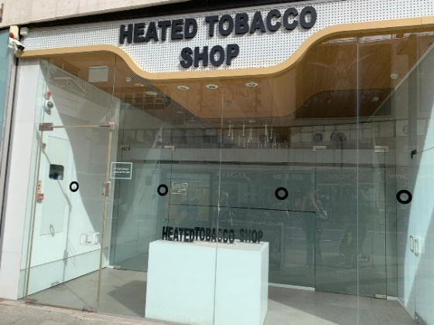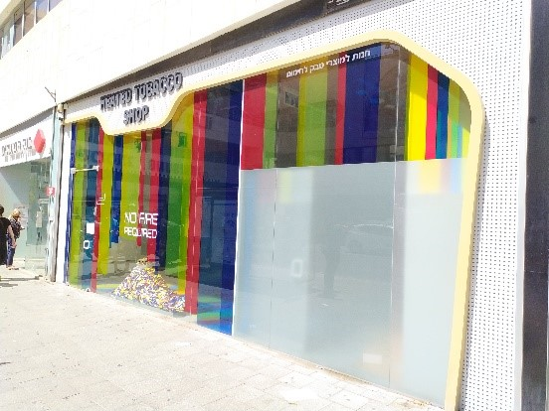

Policies that restrict tobacco advertising and branding at retailers have been implemented in some countries, which have resulted in IQOS stores appearing like the one in the photo above (without advertising or brand name). How likely would you be to go into such a store to learn more about its products?

1. Not at all
2. A little
3. Neutral/don’t know
4. Somewhat
5. Very

Philip Morris International has used various slogans to promote IQOS. For each of the following statements, indicate the extent to which each might persuade you to try IQOS:

1=Not at all

2=A little

3=Neutral/don’t know

4=Somewhat

5= Very

Real tobacco meets innovative technology

Go Smoke-free, Go IQOS

True tobacco taste

Meet IQOS: real tobacco, no ash, less odor

Moving beyond smoking

Change to tobacco without smoke and ashes

The future of tobacco has arrived

A cleaner way to use tobacco

This changes everything

Your IQOS, Your way

**IQOS has used various messages in their advertising. Below, we will ask you some questions about a few examples of their advertising.**

|  |
| --- |
| The future of tobacco is here |
| Cigarette-like satisfaction without the odor. IQOS heats tobacco but does not burn it. |
| Looking for an alternative to cigarettes? IQOS significantly reduces the production of harmful and potentially harmful chemicals. |

|  |
| --- |
| * + IQOS is the first and only tobacco heating system completing the US FDA examination of tobacco products. FDA concluded that IQOS is a better choice for adult smokers. |
| * + The US FDA decision shows that IQOS is a fundamentally different product compared to cigarettes such that it does not burn tobacco, but heats it. |

|  |
| --- |
| * Scientific studies have shown that switching completely from cigarettes to IQOS significantly reduces your body’s exposure to harmful or potentially harmful chemicals. |
| * Scientific studies have shown that switching completely from conventional cigarettes to the IQOS system can reduce the risks of tobacco-related diseases. |

|  |
| --- |
| 1. WARNING: This product contains nicotine. Nicotine is an addictive chemical. |
| 1. SURGEON GENERAL'S WARNING: Smoking Causes Lung Cancer, Heart Disease, Emphysema, And May Complicate Pregnancy. w/ WARNING: This product contains nicotine. Nicotine is an addictive chemical. |
| 1. SURGEON GENERAL'S WARNING: Quitting Smoking Now Greatly Reduces Serious Risks to Your Health. w/ WARNING: This product contains nicotine. Nicotine is an addictive chemical. |
| 1. SURGEON GENERAL'S WARNING: Heated Tobacco Products Cause Damage to the Lungs and Heart. |

Considering the ad above, compared to ***cigarettes,*** how harmful to your health do you think IQOS is?

1=Much less

2=Somewhat less

3=Equally/same

4=Somewhat more

5=Much more

Considering the ad above, do you think that using IQOS would expose you to:

1=Almost no harmful chemicals

2=A few harmful chemicals

3=Some harmful chemicals

4=A lot of harmful chemicals

Considering the ad above, if you used IQOS regularly for the next 10 years, how likely do you think it is that you would eventually develop serious health problems? (If you currently smoke cigarettes, imagine that you switched completely to IQOS for the next 10 years and used it as frequently as you smoke cigarettes.)

Considering the ad above, if one of your best friends was to offer you IQOS, would you try it?

Considering the ad above, how likely are you to recommend IQOS to a friend or family member who smokes cigarettes?

1=Not at all to 7=Extremely likely

The following are marketing strategies to promote IQOS. How likely would you be to do the following:

1=Not at all

2=A little

3=Neutral/don’t know

4=Somewhat

5=Very

Follow IQOS on social media

Use an IQOS hashtag on social media

Attend an IQOS party

Set up a meeting with an IQOS representative

Sign up for an IQOS “risk-free” trial period

Compared to ***cigarettes***, heated tobacco products are more, less, or about the same:

1=Much less

2=Somewhat less

3=Equally/same

4=Somewhat more

5=Much more

6=Don’t know

7=Prefer not to answer

Clean

Harmful to health

Addictive

Complicated

Accessible (easy to get)

Expensive

Satisfying

Conducive to socializing with smokers

Conducive to socializing with nonsmokers

Innovative or technologically advanced

Trendy or elegant

Youthful or appealing to young people

Appealing overall

Compared to ***e-cigarettes***, heated tobacco products are more, less, or about the same:

1=Much less

2=Somewhat less

3=Equally/same

4=Somewhat more

5=Much more

6=Don’t know

7=Prefer not to answer

Effective in helping cigarette smokers quit

Clean

Harmful to health

Addictive

Complicated

Accessible, easy to get

Expensive

Satisfying

Conducive for socializing with smokers

Conducive for socializing with nonsmokers

Innovative, technologically advanced

Trendy, elegant

Youthful, appealing to young people

Appealing overall

For each of the items below, please indicate your response using the response options below.

1=Not at all

2=A little

3=Neutral/don’t know

4=Somewhat

5= Very

Thinking about all you know about IQOS, how different do you think IQOS is from traditional cigarettes?

Thinking about all you know about IQOS, how different do you think IQOS is from e-cigarettes?

Overall, how curious are you about IQOS?

How likely would you be to try IQOS?

How likely would you be to suggest IQOS to a friend who smokes cigarettes?

**E-cigarettes, vaping products or other electronic nicotine delivery devices,** are devices that vaporize liquids that may contain nicotine, such as the devices below. (In this survey, IQOS and other heated tobacco products are NOT considered e-cigarettes.)

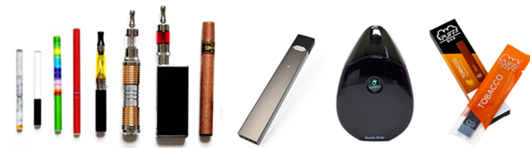

This item asks about **advertisements**, meaning ads made and paid for by companies who make the products. In the last 30 days, have you noticed vaping product (or e-cigarette) **advertisements** in any of the following places? (Select all that apply.)

* On websites (for example, pop-up ads)
* On social media sites, like Facebook, Instagram or Twitter
* Inside stores that sell cigarettes and other tobacco products
* Outside stores that sell cigarettes and other tobacco products (including on signs in windows, visible from the outside)
* Seeing specialty stores that sell vaping products
* On television
* On the radio
* On posters, billboards, etc.
* In newspapers or magazines
* Direct mail
* Email
* Other; please specify:
* None of the above.
* Don’t know
* Prefer not to answer.

**Outside of advertisements**, in the last 30 days, have you noticed vaping products (or e-cigarettes) being **referenced, used, or portrayed** in any of the following places? (Select all that apply.)

* In movies, television, or theater
* On the radio
* On websites
* In social media
* Other; please specify:
* None of the above.
* Don’t know
* Prefer not to answer.

Thinking about all you know about vaping devices, how different from traditional cigarettes do you think vaping devices are?

1. Not at all
2. A little
3. Neutral/don’t know
4. Somewhat
5. Very

Thinking about all you have seen and read about vaping devices, from all sources, would you say the information has been:

1. Mostly positive
2. Slightly positive
3. Equally balanced
4. Slightly negative
5. Mostly negative
6. Don’t know
7. Prefer not to answer

What effect have health warnings had on your thoughts about using vaping products (or e-cigarettes)?

1. Have not seen or noticed them
2. Made me concerned about using them
3. Reassured me about using them
4. Had no effect
5. Don’t know
6. Prefer not to answer

**\*\*IMPORTANT: This survey asks about various types of products. In particular, we want to ensure that three product categories are clear, so please read the following definitions (and also refer to the images below).**

**1. Ordinary cigarettes are filled with tobacco, lit with a match or lighter, and burned to produce ashes. They can be factory made or roll-your own.**

**2. Vaping products (sometimes called e-cigarettes) heat a LIQUID ONLY. Vaping products do NOT contain actual tobacco. The liquid often contains nicotine and is often flavored.**

**3. Heated tobacco products heat ACTUAL TOBACCO to create an emission that is inhaled. Heated tobacco products ALWAYS contain actual tobacco in the form of sticks or capsules, or loose tobacco. Some heated tobacco products may also have liquid, but also contain actual tobacco.**

The following questions are about your use of various tobacco products **in your lifetime**; please respond based on your actual situation.

The following questions are about your use of various tobacco products **in the past 30 days.** In the past 30 days, how many days have you used the following products?

|  |  |  |
| --- | --- | --- |
| **In your lifetime, have you ever used:** | **Yes**  **No** | **In the past 30 days, on how many days did you use the following products** |
| **Traditional, ordinary cigarettes** (filled with tobacco, lit with a match or lighter, and burned to produce ashes) – including roll-your-own cigarettes/tobacco? |  | __  don’t know  prefer not to answer |
| **E-cigarettes, vaping products or other electronic nicotine delivery devices,** which are devices that vaporize liquids that may contain nicotine, such as the devices below? (Do not include IQOS or other similar products.) |  |  |
| **Heated tobacco products**, which are devices that heat actual tobacco but do not burn tobacco, such as IQOS? |  |  |
| **Hookah, waterpipe, or nargila**, which are devices that vaporize tobacco through a water basin, such as the devices shown below?  C:\Users\cjberg\AppData\Local\Microsoft\Windows\Temporary Internet Files\Content.Outlook\YM9XN5NR\CollageHookah.jpg |  |  |
| **Large or little cigars**, which are rolled bundles of dried and fermented tobacco leaves to be smoked, such as the products pictured below?  http://thehavanaclubcigars.com/wp-content/uploads/2014/04/Cigar.pnghttp://s3.amazonaws.com/rapgenius/1347727462_bigblack.jpghttp://1.bp.blogspot.com/-9izVwRy87a8/UxRSfpFH7FI/AAAAAAAAANg/YDU2gavIZiE/s1600/swishersweets.jpg |  |  |
| **Pipe with tobacco**, such as the device and tobacco below?  Image result for pipe tobacco |  |  |
| **Smokeless tobacco**, including chewing tobacco, snuff, dip, or snus, such as Dryft, ZYN, Velo, On!, Redman, Levi Garrett, Beechnut, Skoal, Skoal Bandits, Copenhagen, or Camel or Marlboro snus? |  |  |

For each of the following tobacco products, indicate **the order in which you first tried them in your lifetime**. For example, you first tried cigarettes when you were 14 and chewing tobacco when you were 15 but used no others, you would place a “1” by cigarettes and a “2” by chewing tobacco and leave the others blank. **If you have never tried any of these tobacco products,** you would place a "1" by "**I have never tried any of these"** and leave other options blank.

Traditional, ordinary cigarettes

E-cigarettes, vaping products or other electronic nicotine delivery devices

Heated tobacco products such as IQOS

Cigar products

Smoking tobacco from a pipe

Smoking tobacco from a hookah or waterpipe

Smokeless tobacco, including chewing tobacco, snuff, snus, or dip (such as Redman, Skoal, or Copenhagen)

Marijuana

I have never tried any of these.

*No values should match. Please go back and indicate the order in which you first tried each of these in your lifetime.*

***You’ve mentioned that you smoked cigarettes at some point in your life. We’d like to ask you a bit more about that.***

About how many cigarettes have you smoked in your **entire life**?

1. Just a few puffs
2. 1 to 19
3. 20 to 100
4. More than 100

How old were you when you smoked a whole cigarette for the first time?

I have never smoked a whole cigarette

5 or younger

__

40 or older

How old were you when you started smoking cigarettes regularly?

I have never smoked regularly

5 or younger

__

40 or older

Have you ever smoked cigarettes daily, that is, at least one cigarette every day for at least 30 days?

* 1. No
  2. Yes

Do you ***presently*** smoke cigarettes every day, less frequently than every day, or not at all?

1. Every day
2. Less than every day
3. Not at all
4. Don’t know
5. Prefer not to answer

In the ***past***, did you smoke tobacco every day, less frequently than every day, or didn’t smoke at all?

1. Every day
2. Less than every day
3. Not at all
4. Don’t know
5. Prefer not to answer

On the days that you do smoke, how many **cigarettes** do you smoke per day?

__

40 or more

What brand of cigarettes do you usually smoke? (Please select one.)

American Spirit

Basic

Benson & Hedges

Capri

Camel

Dunhill

Golf

Kent

Kool

LD

L&M

Lucky Strike

Marlboro

Maverick

Merit

Newport

Next

Noblesse

Pall Mall

Parliament

Salem

Santa Fe

Time

Virginia Slims

Vogue

Winston

Storebrand/generic

I typically roll-my-own tobacco

Other; please specify:

Currently, when you smoke cigarettes, how often do you smoke menthol cigarettes…?

1. Never
2. Rarely
3. Some of the time
4. Most of the time
5. All of the time

Compared to a year ago, do you smoke less, more, or about the same?

1. Less
2. About the same
3. More
4. Didn’t smoke a year ago

How soon after you first wake up do you smoke your first cigarette?

1. Within 5 minutes
2. 6-30 minutes
3. 31-60 minutes
4. After 60 minutes
5. I don’t smoke every day

On a scale of 0 to 10, how important is it that you quit using cigarettes, with 0 being NOT AT ALL IMPORTANT and 10 being ABSOLUTELY IMPORTANT?

0 1 2 3 4 5 6 7 8 9 10

On a scale of 0 to 10, how confident are you that you could quit using cigarettes if you wanted to, with 0 being NOT AT ALL CONFIDENT and 10 being ABSOLUTELY CONFIDENT?

0 1 2 3 4 5 6 7 8 9 10

Are you planning to quit smoking…

1. Within the next month
2. Between 1-6 months from now
3. Sometime in the future, beyond 6 months
4. Not planning to quit
5. Don't know
6. Prefer not to answer

During the **past 12 months**, how many times did you stop smoking cigarettes for **one day or longer** because you were trying to quit smoking cigarettes for good?

__

31 or more

Which of the following have you ever used or tried to help you quit or cut down on your smoking cigarettes? (Select all that apply.)

* Any type of nicotine replacement product, such as patches, gum, lozenges, etc.
* Oral medication, such as Varenicline, Chantix, Champix, Bupropion, Zyban or Cytisine.
* Telephone or quitline service.
* Clinic, individual or group counselling, stop-smoking course, or behavior therapy.
* A smoking cessation session offered by your doctor's office.
* Apps or automated services on a mobile phone or tablet.
* The internet (for example, a website about quitting smoking).
* Pamphlets or brochures on how to quit.
* E-cigarettes
* Heated tobacco products
* Other tobacco products (for example, cigars, hookah, smokeless tobacco, lower nicotine cigarettes)
* Other; please specify:
* None of the above.

If you were to try to quit smoking cigarettes in the future, rank the 3 options you would be most likely to try. (We understand that you may not be interested in trying one of these. If so, please check “none of the above”.)

* Any type of nicotine replacement product, such as patches, gum, lozenges, etc.
* Oral medication, such as Varenicline, Chantix, Champix, Bupropion, Zyban or Cytisine.
* Telephone or quitline service.
* Clinic, individual or group counselling, stop-smoking course, or behavior therapy.
* A smoking cessation session offered by your doctor's office.
* Apps or automated services on a mobile phone or tablet.
* The internet (for example, a website about quitting smoking).
* Pamphlets or brochures on how to quit.
* E-cigarettes
* Heated tobacco products
* Other; please specify:
* None of the above.

Most likely to try

Second most likely to try

Third most likely to try

Which of the following would you MOST prefer to do over the next 1-2 years?

1. Continue to smoke cigarettes like I currently do
2. Continue to smoke cigarettes but cut down on how much I smoke
3. Quit smoking cigarettes but switch to other tobacco or nicotine products
4. Quit the use of all tobacco products
5. Don't know
6. Prefer not to answer

In your attempts to quit or cut down on smoking cigarettes, which of the following would you be likely to use to help? (Select all that apply.)

* E-cigarettes
* Heated tobacco products
* Other alternative tobacco products, such as cigars, hookah, smokeless tobacco
* Nicotine replacement therapy, such as the nicotine patch or nicotine gum
* Using oral medication, such as Zyban or Champix/Chantix
* None of the above
* Don't know
* Prefer not to answer

Have you changed your consumption of cigarettes because of COVID-19?

1. No, my consumption stayed the same
2. Yes, my consumption increased
3. Yes, my consumption decreased
4. Don’t know
5. Prefer not to answer

**You mentioned that you smoked a number of cigarettes in your lifetime but none in the past 30 days. We’d like to ask you about quitting.**

How long ago did you quit smoking?

30 days-6 months ago

6-12 months ago

1-5 years ago

1. More than 5 years ago

To what extent were the following reasons that you stopped smoking?

1=Not at all

2=A little

3=Somewhat

5=Very much

I was concerned about its harm to my health.

Cigarettes cost too much.

I was worried about my health and COVID-19.

I was worried about the health of family members or significant others.

I felt it was not socially acceptable/stigmatized.

Is there any other reason that you stopped smoking?

Which of the following did you use to help you quit smoking cigarettes? (Select all that apply.)

* Any type of nicotine replacement product, such as patches, gum, lozenges, etc.
* Oral medication, such as Varenicline, Chantix, Champix, Bupropion, Zyban or Cytisine.
* Telephone or quitline service.
* Clinic, individual or group counselling, stop-smoking course, or behavior therapy.
* A smoking cessation session offered by your doctor's office.
* Apps or automated services on a mobile phone or tablet.
* The internet (for example, a website about quitting smoking).
* Pamphlets or brochures on how to quit.
* E-cigarettes
* Heated tobacco products
* Other; please specify:
* None of the above.

***You’ve mentioned that you used e-cigarettes at some point in your life. We’d like to ask you a bit more about that.***

How old were you when you used an e-cigarette for the first time?

5 or younger

__

40 or older

How old were you when you started using e-cigarettes regularly?

I have never used e-cigarettes regularly

5 or younger

__

40 or older

Have you ever used e-cigarettes daily, that is, at least once every day for at least 30 days?

1. No
2. Yes

How satisfying is vaping compared to smoking ordinary cigarettes?

1. Much less satisfying than smoking ordinary cigarettes
2. Somewhat less satisfying
3. Equally satisfying to smoking ordinary cigarettes
4. Somewhat more satisfying
5. Much more satisfying than smoking ordinary cigarettes
6. I’ve never tried smoking ordinary cigarettes
7. Don’t know
8. Prefer not to answer

In general, is vaping harsher or smoother on the throat compared to smoking cigarettes?

1. Much smoother than smoking cigarettes
2. Somewhat smoother than smoking cigarettes
3. The same as smoking cigarettes
4. Somewhat harsher than smoking cigarettes
5. Much harsher than smoking cigarettes
6. I’ve never tried smoking
7. Don’t know
8. Prefer not to answer

On the days that you use e-cigarettes, how many **puffs** do you have per day?

__

40 or more

What brand of e-cigarette do you use most often?

1. JUUL
2. Vuse
3. Blu
4. Logic
5. MarkTen
6. NJOY
7. eGo
8. iTaste
9. Suorin
10. Other; please specify:
11. Don’t know
12. Prefer not to answer

What kind of e-cigarette do you use most often?

1. A disposable device
2. A device that uses replaceable prefilled cartridges
3. A device with a tank that you refill with liquids
4. A mod system
5. Something else; please specify:
6. Don’t know
7. Prefer not to answer

Do you typically use:

0=Never

1=Rarely

2=Some of the time

3=Most of the time

4=All of the time

5=I don’t know

E-liquids with nicotine salt

E-liquids with CBD

E-liquids with marijuana (containing THC)

What concentration of nicotine do you usually use?

1. 0 mg or 0% (non-nicotine e-liquid)
2. 1-3mg/mL or 0.1-0.3%
3. 4-6mg/mL or 0.4-0.6%
4. 7-12mg/mL or 0.7-1.2%
5. 13-17mg/mL or 1.3-1.7%
6. 18-24mg/mL or 1.8-2.4%
7. 25-39mg/mL or 2.5-3.9%
8. 40-49mg/mL or 4.0-4.9%
9. 50-59mg/mL or 5.0-5.9%
10. 60+mg/mL or 6.0+%
11. Other; please specify:
12. Don’t know
13. Prefer not to answer

Where do you **most commonly purchase** vape products, e-cigarettes, and/or e-liquids?

1. Vape shop
2. Online via a site connected to a local vape shop
3. Online via a vendor not connected to a local vape shop
4. Gas station
5. Convenience store
6. Grocery store
7. Pharmacy
8. Tobacco specialty store (for example, smoke shop)
9. Liquor store
10. A mall kiosk
11. A bar, pub, restaurant, or casino
12. Outside the country
13. A duty free shop or military commissary
14. Somewhere else; please specify:
15. I don’t know where
16. I don’t buy the vape products I use
17. Prefer not to answer

What flavors of e-liquid do you use most of the time? (**Check up to the 3 you most frequently use**.)

* + Tobacco-flavored
  + Menthol or mint
  + Fruit flavors
  + Coffee or tea
  + Alcoholic drink flavors (for example, mojitos or daiquiris)
  + Caramel, vanilla, chocolate, cream
  + Candy flavors (for example, licorice, gummy bears, or bubble gum)
  + Other food flavors (for example, cupcakes or muffins)
  + Other; please specify:
  + None of these

Compared to a year ago, do you use e-cigarettes less, more, or about the same?

1. Less
2. About the same
3. More
4. I didn’t use e-cigarettes a year ago

On the days that you use e-cigarettes, how soon after you first wake up do you use e-cigarettes?

1. Within 5 minutes
2. 6-30 minutes
3. 31-60 minutes
4. After 60 minutes
5. I don’t use e-cigarettes every day

On a scale of 0 to 10, how important is it that you quit using e-cigarettes, with 0 being NOT AT ALL IMPORTANT and 10 being ABSOLUTELY IMPORTANT?

0 1 2 3 4 5 6 7 8 9 10

On a scale of 0 to 10, how confident are you that you could quit using e-cigarettes if you wanted to, with 0 being NOT AT ALL CONFIDENT and 10 being ABSOLUTELY CONFIDENT?

0 1 2 3 4 5 6 7 8 9 10

Are you planning to quit using e-cigarettes…

1. Within the next month
2. Between 1-6 months from now
3. Sometime in the future, beyond 6 months
4. Not planning to quit
5. Don't know
6. Prefer not to answer

During the **past 12 months**, how many times did you stop using e-cigarettes for **one day or longer** because you were trying to quit for good?

__

31 or more

Have you changed your consumption of e-cigarettes because of COVID-19?

1. No, my consumption stayed the same
2. Yes, my consumption increased
3. Yes, my consumption decreased
4. Don’t know
5. Prefer not to answer

**You mentioned that you used e-cigarettes in your lifetime but none in the past 30 days. We’d like to ask you about quitting.**

How long ago did you quit using e-cigarettes?

30 days-6 months ago

6-12 months ago

1-5 years ago

1. More than 5 years ago

To what extent were the following reasons that you stopped using vaping products?

1=Not at all

2=A little

3=Somewhat

4=Very much

I was concerned they might be harmful.

They cost too much.

I didn't find them satisfying enough.

They did not help me quit smoking ordinary cigarettes.

I no longer needed them to keep from smoking.

I was worried about my health and COVID-19.

I was worried about the health of family members or significant others.

I felt it was not socially acceptable/stigmatized.

Is there any other reason that you stopped using vaping products?

***You’ve mentioned that you used heated tobacco products at some point in your life. We’d like to ask you a bit more about that.***

How old were you when you used a heated tobacco product for the first time?

5 or younger

__

40 or older

How old were you when you started using heated tobacco products regularly?

I have never used heated tobacco products regularly

5 or younger

__

40 or older

Have you ever used heated tobacco products daily, that is, at least once every day for at least 30 days?

1. No
2. Yes

What variety of heatsticks do you use most often?

1. Amber
2. Bronze
3. Purple
4. Sienna
5. Turquoise
6. Yellow
7. Other; please specify:
8. Don't know
9. Prefer not to answer

How satisfying is using heated tobacco products compared to smoking ordinary cigarettes?

1. Much less satisfying than smoking ordinary cigarettes
2. Somewhat less satisfying
3. Equally satisfying to smoking ordinary cigarettes
4. Somewhat more satisfying
5. Much more satisfying than smoking ordinary cigarettes
6. I’ve never tried smoking ordinary cigarettes
7. Don’t know
8. Prefer not to answer

In general, is using heated tobacco products harsher or smoother on the throat compared to smoking cigarettes?

1. Much smoother than smoking cigarettes
2. Somewhat smoother than smoking cigarettes
3. The same as smoking cigarettes
4. Somewhat harsher than smoking cigarettes
5. Much harsher than smoking cigarettes
6. I’ve never tried smoking
7. Don’t know
8. Prefer not to answer

In the past 12 months, have you purchased a heated tobacco product such as IQOS?

1. No
2. Yes

The last time you purchased tobacco sticks, where did you make this last purchase?

1. Online via a Philip Morris, IQOS, Altria, RJ Reynolds, or Eclipse website
2. Online via a vendor not connected to Philip Morris, IQOS, Altria, RJ Reynolds, or Eclipse
3. IQOS store
4. Vape shop
5. Tobacco specialty store
6. Pharmacy
7. Convenience store
8. Gas station
9. Temporary or mobile sales location (for example, pop-up store or booth)
10. Liquor store
11. A mall kiosk
12. A bar, pub, restaurant, or casino
13. A duty free shop or military commissary
14. Outside the country
15. Somewhere else; please specify:
16. I don't know where
17. I don’t buy the tobacco sticks I use
18. Prefer not to answer

On the days that you use heated tobacco products, how many **heatsticks** do you use per day?

__

40 or more

Compared to a year ago, do you use heated tobacco products less, more, or about the same?

1. Less
2. About the same
3. More
4. I didn’t use heated tobacco products a year ago

How soon after you first wake up do you use heated tobacco products?

1. Within 5 minutes
2. 6-30 minutes
3. 31-60 minutes
4. After 60 minutes
5. I don’t use heated tobacco products every day

On a scale of 0 to 10, how important is it that you quit using heated tobacco products, with 0 being NOT AT ALL IMPORTANT and 10 being ABSOLUTELY IMPORTANT?

0 1 2 3 4 5 6 7 8 9 10

On a scale of 0 to 10, how confident are you that you could quit using heated tobacco products if you wanted to, with 0 being NOT AT ALL CONFIDENT and 10 being ABSOLUTELY CONFIDENT?

0 1 2 3 4 5 6 7 8 9 10

Are you planning to quit using heated tobacco products…

1. Within the next month
2. Between 1-6 months from now
3. Sometime in the future, beyond 6 months
4. Not planning to quit
5. Don't know
6. Prefer not to answer

During the **past 12 months**, how many times did you stop using heated tobacco products for **one day or longer** because you were trying to quit for good?

__

31 or more

Have you changed your consumption of heated tobacco products because of COVID-19?

1. No, my consumption stayed the same
2. Yes, my consumption increased
3. Yes, my consumption decreased
4. Don’t know
5. Prefer not to answer

**You mentioned that you used heated tobacco products in your lifetime but none in the past 30 days. We’d like to ask you about quitting.**

How long ago did you quit using heated tobacco products?

30 days-6 months ago

6-12 months ago

1-5 years ago

1. More than 5 years ago

To what extent were the following reasons that you stopped using heated tobacco products?

1=Not at all

2=A little

3=Somewhat

4=Very much

I was concerned they might be harmful.

They cost too much.

I didn't find them satisfying enough.

They did not help me quit smoking ordinary cigarettes.

I no longer needed them to keep from smoking.

I was worried about my health and COVID-19.

I was worried about the health of family members or significant others.

I felt it was not socially acceptable/stigmatized.

Is there any other reason that you stopped using heated tobacco products?

***You’ve mentioned that you used hookah at some point in your life. We’d like to ask you a bit more about that.***

How old were you when you used hookah for the first time?

5 or younger

__

40 or older

How old were you when you started using hookah regularly?

I have never used hookah regularly

5 or younger

__

40 or older

Have you ever used hookah daily, that is, at least once every day for at least 30 days?

1. No
2. Yes

On the days that you use hookah, how many **times per day** do you use hookah?

__

40 or more

Compared to a year ago, do you use hookah less, more, or about the same?

1. Less
2. About the same
3. More
4. I didn’t use hookah a year ago

How soon after you first wake up do you use hookah?

1. Within 5 minutes
2. 6-30 minutes
3. 31-60 minutes
4. After 60 minutes
5. I don’t use hookah every day

On a scale of 0 to 10, how important is it that you quit using hookah, with 0 being NOT AT ALL IMPORTANT and 10 being ABSOLUTELY IMPORTANT?

0 1 2 3 4 5 6 7 8 9 10

On a scale of 0 to 10, how confident are you that you could quit using hookah if you wanted to, with 0 being NOT AT ALL CONFIDENT and 10 being ABSOLUTELY CONFIDENT?

0 1 2 3 4 5 6 7 8 9 10

Are you planning to quit using hookah…

1. Within the next month
2. Between 1-6 months from now
3. Sometime in the future, beyond 6 months
4. Not planning to quit
5. Don't know
6. Prefer not to answer

During the **past 12 months**, how many times did you stop using hookah for **one day or longer** because you were trying to quit for good?

___

31 or more

Have you changed your consumption of hookah because of COVID-19?

1. No, my consumption stayed the same
2. Yes, my consumption increased
3. Yes, my consumption decreased
4. Don’t know
5. Prefer not to answer

**You mentioned that you used hookah in your lifetime but none in the past 30 days. We’d like to ask you about quitting.**

How long ago did you quit using hookah?

30 days-6 months ago

6-12 months ago

1-5 years ago

1. More than 5 years ago

To what extent were the following reasons that you stopped using hookah?

1=Not at all

2=A little

3=Somewhat

4=Very much

I was concerned it might be harmful.

It cost too much.

I didn't find it satisfying enough.

It did not help me quit smoking ordinary cigarettes.

I no longer needed it to keep from smoking.

I was worried about my health and COVID-19.

I was worried about the health of family members or significant others.

I felt it was not socially acceptable/stigmatized.

Is there any other reason that you stopped using hookah?

In the next few questions, we would like to ask about your personal use of any form of MARIJUANA (containing THC). This includes dried herb, edibles, oils, hash or kief, concentrates (wax, shatter, budder, etc.), marijuana drinks (tea, cola), tinctures, lotions, and other marijuana products. This does NOT include synthetic marijuana or cannabis without THC.

How old were you when you first used marijuana?

I have never used marijuana

5 or younger

___

45 or older

Prefer not to answer

For which of the following reasons do you primarily use marijuana?

1. For recreational purposes
2. For medical purposes
3. For both recreational and medical purposes
4. Don’t know
5. Prefer not to answer

How have you used marijuana/ cannabis in the last 12 months? Select all that apply.

* Smoked it without tobacco
* Smoked it with tobacco
* Vaped it in liquid form
* Vaped (used a vaporizer for) the dried leaves or herb
* Vaped it some other way; please specify:
* Dabbed concentrates such as shatter, budder, or wax
* Used it orally (for example, oil, capsules, dissolvable strips, or spray)
* Used it topically (for example, lotions, bath salts)
* Consumed it in food or drinks (edibles such as 'pot brownies', cannabis-infused beverage)
* Some other way; please specify:
* None of the above, I have not used marijuana/cannabis in the last 12 months

In the last 12 months, where have you most often obtained your marijuana/ cannabis?

1. Made or grew your own
2. A family member or friend
3. A dealer (or other non-legal source), in person
4. A licensed online store
5. An unlicensed online store
6. In person at a vape shop, co-operative, dispensary or other store
7. A temporary or mobile sales location (for example, pop-up store or booth)
8. Other; please specify:
9. Don't know
10. None of the above, I have not used marijuana/cannabis in the last 12 months
11. Prefer not to answer

During the past 30 days, on how many days did you use marijuana?

___

Prefer not to answer

How many times do you use marijuana on the days that you use it?

___

15 or more

Prefer not to answer

Which is the one method you used most in the last 12 months?

1. Smoked it without tobacco
2. Smoked it with tobacco
3. Vaped it in liquid form
4. Vaped (used a vaporizer for) the dried leaves or herb
5. Vaped it some other way
6. Dabbed concentrates such as shatter, budder, or wax
7. Used it orally (for example, oil, capsules, dissolvable strips, or spray)
8. Used it topically (for example, lotions, bath salts)
9. Consumed it in food or drinks (edibles such as 'pot brownies', cannabis-infused beverage)
10. Some other way; please specify
11. Don't know
12. Prefer not to answer

**Now, we would like to ask you about your attitudes and perceptions about various tobacco products and marijuana.**

How **likely are you to try or continue to use** each of the following in the **next year**?

1=Not at all likely to 7=Extremely likely

How **addictive** do you think the following products are?

1=Not at all addictive to 7=Extremely addictive

How **harmful to your health do you think the use** of the following products are?

1=Not at all harmful to 7=Extremely harmful

How **likely** are you to **allow people to use** the following products **in your home**?

1=Not at all likely to 7=Extremely likely

Please indicate the extent to which **people important to you** would (or do) **approve** of you using:

1=All disapprove, 2=Nearly all disapprove, 3=Most disapprove, 4=About half disapprove and half approve/don’t know, 5=Most approve, 6=Nearly all approve, 7=All approve

|  |
| --- |
| Regular cigarettes  E-cigarettes, vaping products, or other electronic nicotine delivery systems (such as Juul)  Heated tobacco products (such as IQOS)  Hookah (devices that vaporize tobacco through a water basin)  Cigar products (such as large cigars or flavored little cigars)  Smokeless tobacco (such as chewing tobacco, snuff, dip, or snus)   1. Marijuana |

How **likely are you to try** (or continue to use) these **marijuana products** in the **next year**? (Keep in mind we are referring to marijuana that contains THC or a combination of THC and CBD.)

1=Not at all likely to 7=Extremely likely

Smoke it without tobacco

Smoke it with tobacco

Vape it in liquid form

Vape (used a vaporizer for) the dried leaves or herb

Vape it some other way

Dab concentrates such as shatter, budder, or wax

Use it orally (for example, oil, capsules, dissolvable strips, or spray)

Use it topically (for example, lotions, bath salts)

Consume it in food or drinks (edibles such as 'pot brownies', cannabis-infused beverage)

**The next set of questions are focused on who in your social environment uses tobacco, marijuana, and alcohol.**

Do either or both of your **parental figures**… (Select all that apply.)

* Smoke cigarettes
* Use e-cigarettes
* Use a heated tobacco product like IQOS or Eclipse
* Smoke tobacco using a hookah or waterpipe
* Smoke cigars, cigarillos, or little cigars
* Use smokeless tobacco
* Use marijuana (containing THC)
* None of the above
* Prefer not to answer

Does your **significant other, spouse, or dating partner**: (Select all that apply.)

* Smoke cigarettes
* Use e-cigarettes
* Use a heated tobacco product like IQOS or Eclipse
* Smoke tobacco using a hookah or waterpipe
* Smoke cigars, cigarillos, or little cigars
* Use smokeless tobacco
* Use marijuana (containing THC)
* None of the above
* I don’t have a significant other, spouse, or dating partner
* Prefer not to answer

How many of your closest friends (who might include relatives and co-workers) use the following:

1=None

2=Almost none

3=Less than half

4=About half

5=More than half

6=Almost all

7=All

8=Don’t know

9=Prefer not to answer

1. Smoke cigarettes
2. Use e-cigarettes
3. Use a heated tobacco product like IQOS or Eclipse
4. Smoke tobacco using a hookah or waterpipe
5. Smoke cigars, cigarillos, or little cigars
6. Use smokeless tobacco
7. Use marijuana (containing THC)

**The next questions ask about marijuana (or cannabis that includes THC) and related recreational policy. Some items ask about “if recreational marijuana use were legalized” – if you already live in an area that has legal marijuana use, please just respond given your current situation.**

If marijuana (or cannabis including THC) were legalized for recreational use, how likely would you be to allow marijuana use..

In your home

In the presence of children

[1=Not at all, 2=A little, 3=Somewhat, 4=Very, 5=Prefer not to answer]

Compared to alcohol, how much do you think being under the influence of marijuana impairs one’s driving?

1. Much less
2. Somewhat less
3. No difference
4. Somewhat more
5. Much more
6. Prefer not to answer

In the past month, how many times have you been a passenger in a vehicle driven by someone using alcohol?

___

10 or more

In the past month, how many times have you been a passenger in a vehicle driven by someone using marijuana?

___

10 or more

In Jan 2020, all tobacco and nicotine products in Israel, including e-cigarettes and heated tobacco products, were required to be sold in plain packaging with text warnings.

To what extent, if at all, has cigarette plain packaging changed your awareness of health risks associated with..

Smoking

E-cigarette use

Using IQOS

1. Not at all
2. A little
3. Somewhat
4. Very
5. Prefer not to answer

In the last 6 months, how many consumer surveys have you completed online?

1. None
2. 1 to 5, or up to 1 per month
3. 6 to 10, or about 2 per month
4. 11 to 15, or about 3 per month
5. 16 to 20, or about 4 or 5 per month
6. 21 to 30, or about 6 or 7 per month
7. 31 to 40, or about 8 or 9 per month
8. More than 40, or more than 10 per month
9. Don't know
10. Prefer not to answer

Of the consumer surveys you have completed in the last 6 months, how many, besides this current survey, were about smoking?

___

More than 40

Don’t know

Prefer not to answer

We would like to have your answer to this question.

We would like to have your answer to both of these questions.

List of countries:

Afghanistan

Albania

Algeria

Andorra

Angola

Antigua & Deps

Argentina

Armenia

Australia

Austria

Azerbaijan

Bahamas

Bahrain

Bangladesh

Barbados

Belarus

Belgium

Belize

Benin

Bhutan

Bolivia

Bosnia Herzegovina

Botswana

Brazil

Brunei

Bulgaria

Burkina

Burundi

Cambodia

Cameroon

Canada

Cape Verde

Central African Rep

Chad

Chile

China

Colombia

Comoros

Congo

Congo {Democratic Rep}

Costa Rica

Croatia

Cuba

Cyprus

Czech Republic

Denmark

Djibouti

Dominica

Dominican Republic

East Timor

Ecuador

Egypt

El Salvador

Equatorial Guinea

Eritrea

Estonia

Ethiopia

Fiji

Finland

France

Gabon

Gambia

Georgia

Germany

Ghana

Greece

Grenada

Guatemala

Guinea

Guinea-Bissau

Guyana

Haiti

Honduras

Hungary

Iceland

India

Indonesia

Iran

Iraq

Ireland {Republic}

Israel

Italy

Ivory Coast

Jamaica

Japan

Jordan

Kazakhstan

Kenya

Kiribati

Korea North

Korea South

Kosovo

Kuwait

Kyrgyzstan

Laos

Latvia

Lebanon

Lesotho

Liberia

Libya

Liechtenstein

Lithuania

Luxembourg

Macedonia

Madagascar

Malawi

Malaysia

Maldives

Mali

Malta

Marshall Islands

Mauritania

Mauritius

Mexico

Micronesia

Moldova

Monaco

Mongolia

Montenegro

Morocco

Mozambique

Myanmar, {Burma}

Namibia

Nauru

Nepal

Netherlands

New Zealand

Nicaragua

Niger

Nigeria

Norway

Oman

Pakistan

Palau

Palestine

Panama

Papua New Guinea

Paraguay

Peru

Philippines

Poland

Portugal

Qatar

Romania

Russian Federation

Rwanda

St Kitts & Nevis

St Lucia

Saint Vincent & the Grenadines

Samoa

San Marino

Sao Tome & Principe

Saudi Arabia

Senegal

Serbia

Seychelles

Sierra Leone

Singapore

Slovakia

Slovenia

Solomon Islands

Somalia

South Africa

South Sudan

Spain

Sri Lanka

Sudan

Suriname

Swaziland

Sweden

Switzerland

Syria

Taiwan

Tajikistan

Tanzania

Thailand

Togo

Tonga

Trinidad & Tobago

Tunisia

Turkey

Turkmenistan

Tuvalu

Uganda

Ukraine

United Arab Emirates

United Kingdom

United States

Uruguay

Uzbekistan

Vanuatu

Vatican City

Venezuela

Vietnam

Yemen

Zambia

Zimbabwe