**ITALY CATALOGUING HEBREW BOOKS PROJECT**

**INTRODUCTION**

This project is a unique collaboration between UCEI, BNCR and NLI to help make the rich legacy of printed books in Italy appreciated by and accessible to researchers and historians across the world.

Manuscripts, incunabula and old books are an important testimony of the rich history of Jewish life in Italy and to the development of Jewish books and printing across Europe.

There are many uncatalogued collections of relatively old books starting from the early print era through the 19 Century. Large parts of these are found in libraries of the Jewish Communities, but there are also important and rare collections in the public owned State libraries, as well as important numbers of Hebrew books in Churches libraries owned by Italian Church Institutions (CEI) and in the Vatican State.

These books are highly regarded by scholars and historians but it is not easy to find where these books are located and in many places, they are not accessible to researchers.

Some of these collections have been partially catalogued; however, there is no single integrated, standardised listing /catalogue of these collections in one place.

**AIMS AND OBJECTIVES**

This project aims to protect, preserve and make accessible Italian Hebrew book holdings in Jewish communities and selected state collections through the creation of a Union Catalogue of Hebrew books in Italy.

It will also help communities and state institutions to understand and appreciate the extent and importance of their holdings of Hebrew books.

The entire project will include an estimated 35,000 volumes from 14 Jewish communities and 25 state institutions.

**THE PILOT**

In 2019, a pilot project was carried out to test the idea and to help us design the larger project. Two thousand books were processed and uploaded on to an especially dedicated area on the TECA website of the BNCR. We have learned a lot from the process and are now embarking on an ambitious programme to include many more collections.

**THE PROJECT TEAM**

**PARTNERS**

Union della Comunita Ebraiche Italiane (UCEI) – the project managers who will be overseeing the entire process in Italy

Biblioteca Nazionale Centrale di Roma (BNCR) – the host institution for the final product – a unified catalogue of Hebrew books in Italy will be made accessible on the BNCT digital TECA system

National Library of Israel– advisory body providing expertise on Hebrew books, training and support

**IMPLEMENTATION TEAM**

ScanData Experts - providing the on-line platform for the implementation process

Community representatives and librarians – will prepare the books in their collections to be included in the project

Photographers – will photograph key pages in each book

Cataloguers – will review the photographs and data on each book and complete the catalogue record.

**PREPARING THE COLLECTIONS**

**Overview**

The whole process starts with organizing the collections of Hebrew books in the community or institution library.

Librarians and community workers need to prepare their collections and create inventory lists, which will be used as the basis for the rest of the project.

Each book on the inventory list has a unique identifier number, this will be used to trace that book throughout the process.

The inventory is recorded on an Excel sheet, specifically prepared in advance for each collection, including the lists of unique identifier numbers for each book in that collection.

Barcode sheets (Dockets) will be prepared for each book, each barcode sheet contains a unique identifier number, relating to its specific row in the Excel sheet.

The Excel sheet will be sent out with pre-prepared numbering for each collection together with the batch of barcode sheets.

**Key Steps**

1. **GETTING STARTED**

**What you will need:**  *An appropriate working environment with e nough space for processing books. Access to computer with Excel.*

**What the project will supply:** Barcode sheets, Excel sheets, photographic equipment, bookmark slips

1. IDENTIFY THE HEBREW BOOKS IN THE COLLECTION / INSTITUTION
2. PRINT OUT THE BARCODE SHEETS – ONE FOR EACH BOOK
3. OPEN THE EXCEL SPREADSHEET
4. **RECORDING EACH BOOK**
5. OPEN THE BOOK
6. INSERT THE BARCODE SHEET INSIDE THE BOOK
7. MARK THE PAGES FOR THE PHOTOGRAPHER ( ACCORDING TO INSTRUCTIONS THAT FOLLOW)
8. COMPLETE THE EXCEL ENTRY FOR THE BOOK
   1. FIND THE UNIQUE IDENTIFIER NUMBER FROM THE BARCODE SHEET ON THE EXCEL SHEET.
   2. ADD THE SHELF MARK IF THIS EXISTS
   3. CHECK THE BOOK FOR ANY SPECIFIC MARKINGS (PROVENANCE, MARGINALIA, CENSORSHIP) AND MARK THESE ON THE EXCEL
   4. CHECK IF MULTIPLE COPIES AND MARK ON THE EXCEL
9. SAVE THE EXCEL FILE
10. CLOSE THE BOOK AND RETURN TO ITS PLACE
11. **COMPLETING THE INVENTORY**
12. CHECK THAT YOU HAVE RECORDED EVERY BOOK IN THE COLLECTION ON THE EXCEL AND HAVE MARKED WHERE THERE ARE MULTIPLE COPIES
13. WHEN ALL THE BOOKS IN THE COLLECTION ARE RECORDED SEND THE EXCEL TO PROJECT MANAGER
14. **GETTING STARTED**
15. IDENTIFY THE HEBREW BOOKS IN YOUR COLLECTION / INSTITUTION:

Which books are to be included?

The project is focusing on books which are mostly (over 50%) in Hebrew script. This can include Hebrew, Ladino, Yiddish and other forms of Hebrew languages eg Judeo-Italian.

Some Hebrew books have title pages in Latin characters, so it is worth checking through each book to check if the rest of the book is in Hebrew.

Please note: books that are bound with another book or books, should each be treated as a separate entity and photographed separately.

NB: Make sure that you have checked all the possible places where the books are stored and that you have space for them while you complete the inventory.

1. PRINT OUT THE BARCODE SHEETS – ONE FOR EACH BOOK
2. OPEN THE EXCEL SPREADSHEET

Need some text to explain the naming convention for naming the files

**B: RECORDING EACH BOOK**

1. OPEN THE BOOK - Remember Hebrew Books open from the right hand side!
2. INSERT THE BARCODE SHEET INSIDE THE BOOK – make sure that some of the sheet is showing above the book – that way it is easier to see which ones you have processed. The Barcode must be kept inside the book throughout the process.
3. MARK THE PAGES FOR THE PHOTOGRAPHER (using slips of paper or whole pages?)

The photographer needs to photograph the following pages for each book

* The Barcode
* The front cover

The title page/s - including information about the book's production (place, printer, date). This publishing information is very important for identifying the book.

* The spine (if it includes information)
* A double page from the middle of the book
* The final numbered page in the book
* Colophons, if there is – usually on the last page.

We will also need a photograph of one example of specific markings:

* Marginalia (handwritten notes in the margins)
* Provenance stamps
* Censorship stamps

We are not expecting each incidence of these markings to be photographed, just one example. This will highlight the presence of the special markings for users of the Catalogue.

(See below more guidelines on the pages to be marked)

1. COMPLETE THE EXCEL ENTRY FOR THE BOOK

4.1 FIND THE UNIQUE IDENTIFIER NUMBER FROM THE BARCODE SHEET ON THE EXCEL SHEET –

Column B in the Excel contains the unique identifier that you should also see on the Barcode sheet.

4.2 ADD THE SHELF MARK IF THIS EXISTS – if the books processed are already part of a library, then record the shelf mark that appears on the spine of the book. Otherwise leave blank.

4.3 RECORD ANY SPECIFIC MARKINGS (PROVENANCE, MARGINALIA, CENSORSHIP) AND MARK THESE ON THE RELEVANT EXCEL COLUMN.

* 1. CHECK IF MULTIPLE COPIES AND MARK ON THE EXCEL

This refers to sets of books, such as prayer books, which would often be located together, we don't expect at this stage to identify occasional duplicate copies. (these will be found at the cataloguing stage)

SAVE THE EXCEL FILE – any specific place / name to save?

CLOSE THE BOOK AND RETURN TO ITS PLACE

1. **COMPLETING THE INVENTORY**

* CHECK THAT YOU HAVE RECORDED EVERY BOOK IN THE COLLECTION ON THE EXCEL AND HAVE MARKED WHERE THERE ARE MULTIPLE COPIES
* WHEN ALL THE BOOKS IN THE COLLECTION ARE RECORDED AND SAVED, SEND THE COMPLETED EXCEL TO DILETTA/PM <Email address>

**WHICH PAGES SHOULD BE PHOTOGRAPHED?**

The following images show examples of the pages in each book, which should be marked to be photographed.

* Front cover

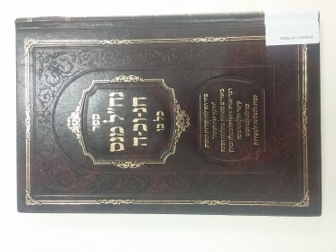 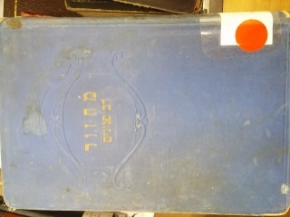

* Title page/s

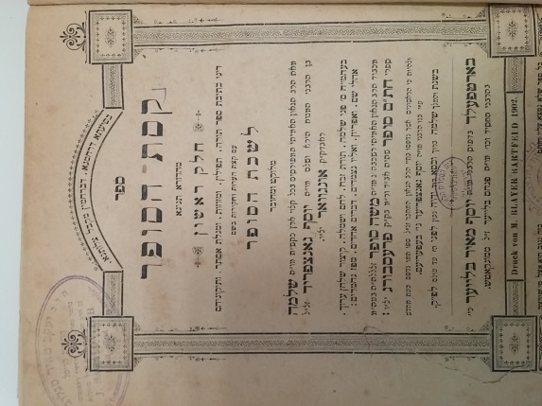

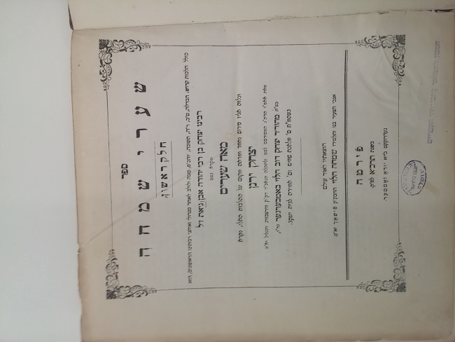

* Spine – only If there is no title page and no title on the cover.
* 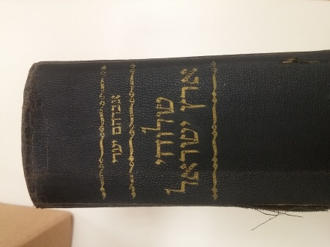
* Page from the middle of the book
* Last page or last numbered page

**SPECIAL MARKINGS - Marginalia, Censorship, and Provenance**

**1. Marginalia**

Marginalia, handwritten notes in the margins of books, turn each copy of a printed book into a unique artifact. These notes, which may include corrections, illuminations, or commentary, provide insights into the original authors and owners of the books. In some cases, comments that originally appear as marginalia may, in later editions, be printed as commentaries alongside the original text.

**What to look for and where:**

-handwritten notes may appear on the sides, top, or bottom margins of the printed text, or within the text

-marginal notes in different handwritings may indicate more than one owner who wrote in the book

**2. Censorship**

Book banning and censorship have existed throughout history, but organized censorship of Hebrew books originated in Italy in the Sixteenth Century, when the church sought to ban all heretical books. As part of this decree, all Hebrew books had to be submitted to Christian authorities, who usually employed Jewish converts to Christianity (who knew Hebrew) to examine the books. After examination, a book would either be banned outright and destroyed, or would be deemed acceptable after the “reviser” expunged all words or passages deemed offensive to the church, and returned to its owners.

Any book that was checked by the censor will have the censor’s certificate, attesting that it was “approved”, and censorship within the text itself. Books were often reviewed more than once over time, so a book may include multiple layers of censorship and signatures of more than one “reviser.”

**What to look for and where:**

**a. censor’s certificate:**

-on either the title page or the last page of the book

-typically in Latin or Italian, but occasionally in Hebrew

-consists or a signature and brief comments, often including the word “revisor” or “inquisitor”

**b. marks of censorship**

-in the main body of the text

-may be only individual words or phrases crossed out

-sometimes an entire section will be blacked out or cut out

**3. Provenance**

Provenance refers to the history of the ownership and location of a book from its publication to the present. Rare books may have changed hands many times over the years, under a variety of circumstances. A book’s provenance may shed light on the book itself, and how it was used by individuals or communities, or it may shed light on the shifting fortunes of the communities it traveled through.

**What to look for and where:**

-usually on the title page, or on the inside cover (front or back)

-sometimes provenance indicators will appear in the middle of a book in the margins

-stamps or bookplates may indicate the name and place of the owners

-written inscriptions may include the owner’s name, a dedication, or a record of the transaction by which the book was acquired

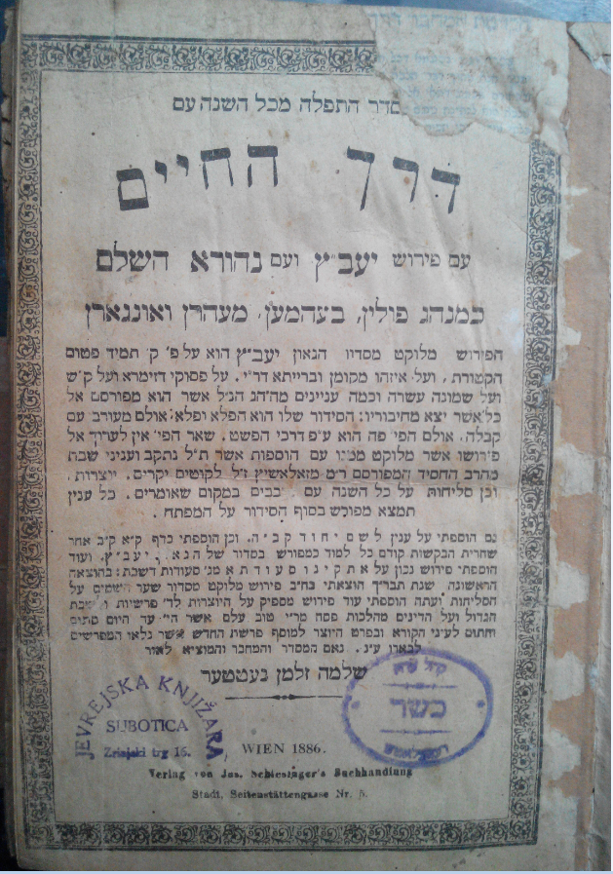

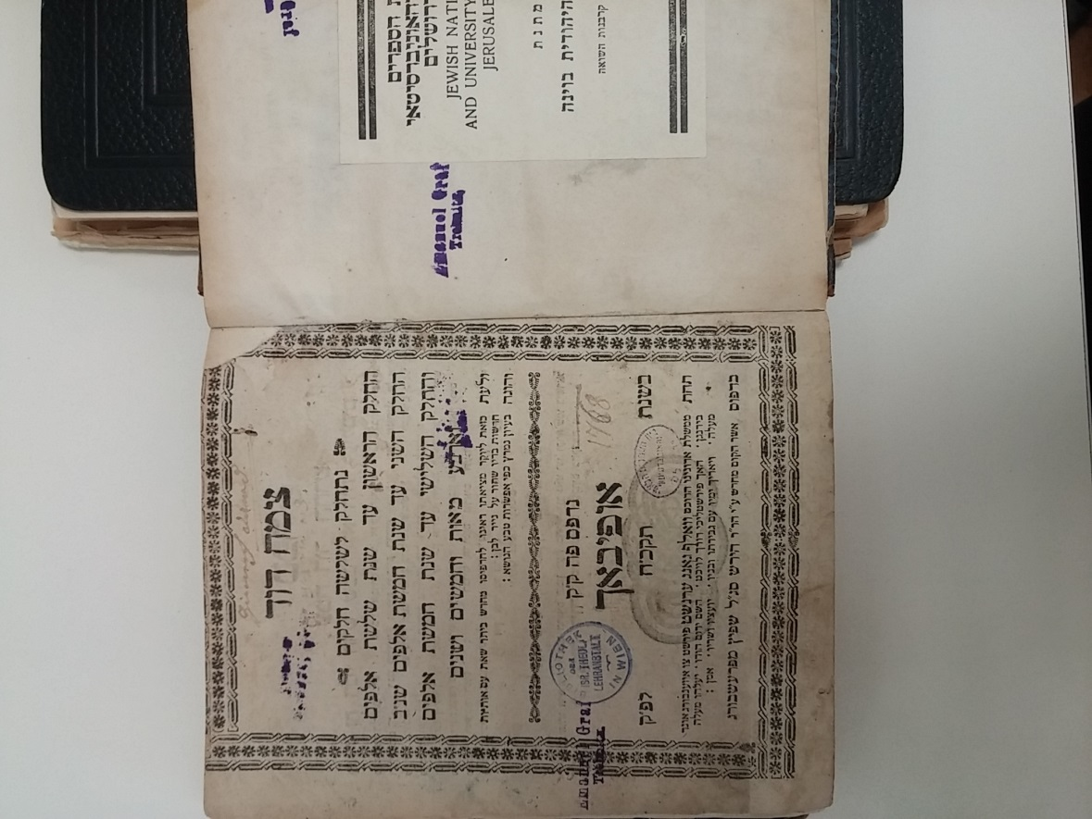

This book has numerous handwritten notations

