

The Worms Mahzor
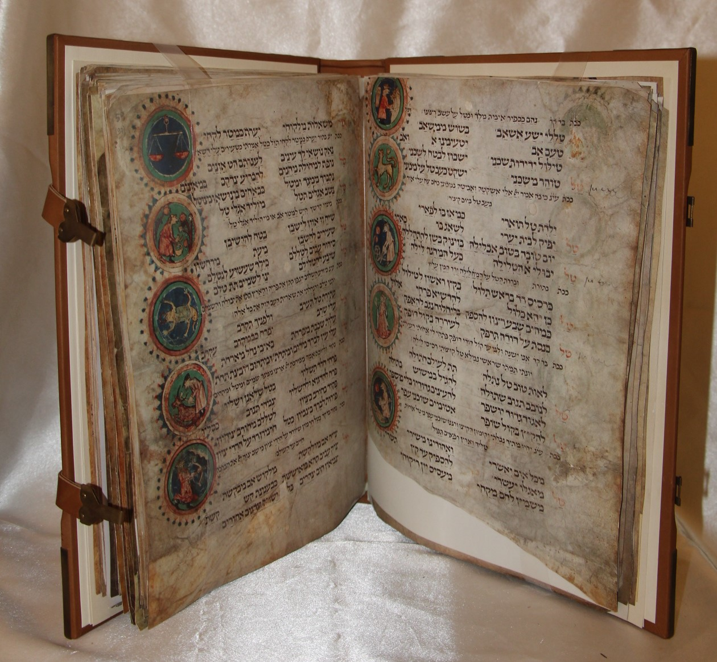

The Worms Mahzor, among the oldest known Ashkenazi High Holiday Prayer Books in existence, is considered one of the Ashkenazi Jewry that was written in its entirely during the Middle Ages. It was completed in 1272 in the Rhine area of Germany, and was held in the loving hands of the cantors of the famous Worms Synagogue (Rashi Sahul) during the Festivals for over 650 years. It is written on large sheets of parchment in square, calligraphic Ashkenazi script with vowels. The pages are illustrated with the spectacular characteristic of the South German style of the period.

The Flery Darts of Satan, or the Secret and Terrible Books of the Jews Against Christ
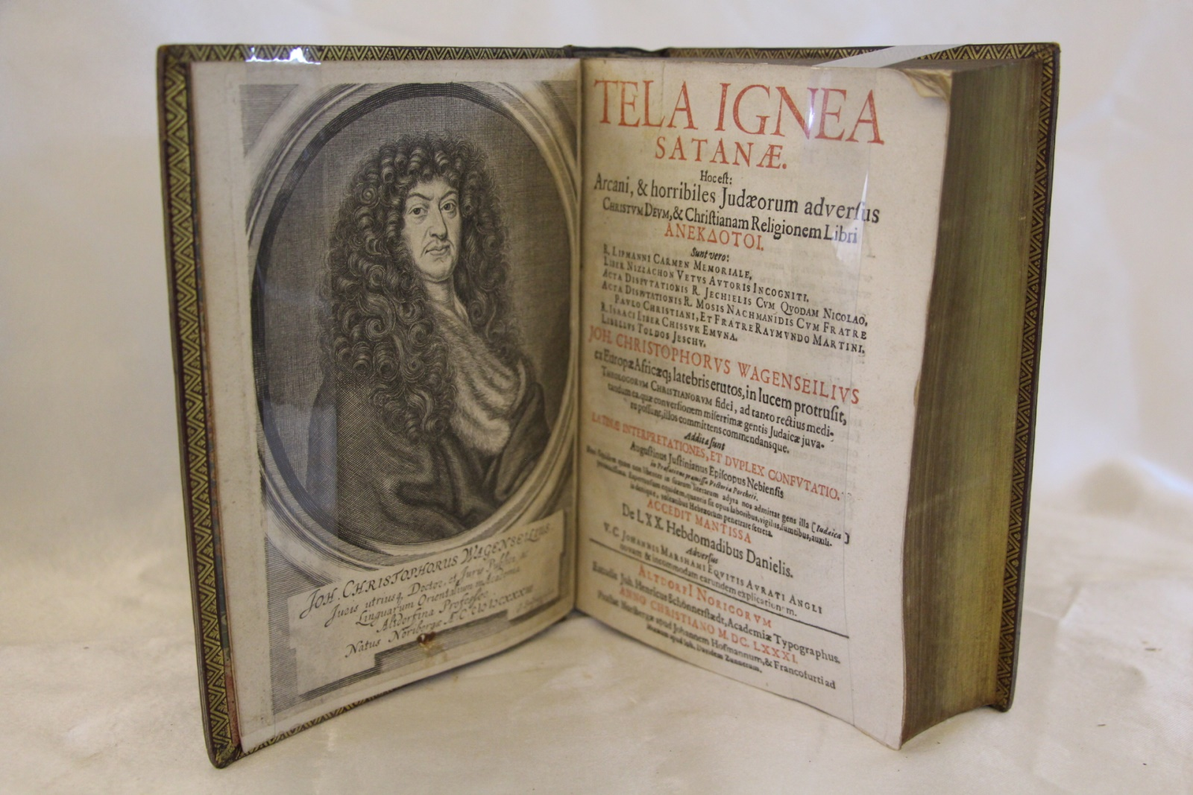

It is more polemical title than the contents of Wagenseil's book warrant. To redress the balance we may note a comment of H.J. Schoeps in Philosemitismus in Barock (Mohr, Tubingen, 1952), "the Altdorf Professor J.C. Wagenseil who did a lot for the Jews by his courageous opposition to allegations of blood guilt and/or ritual murder.

Torah Exodus 16
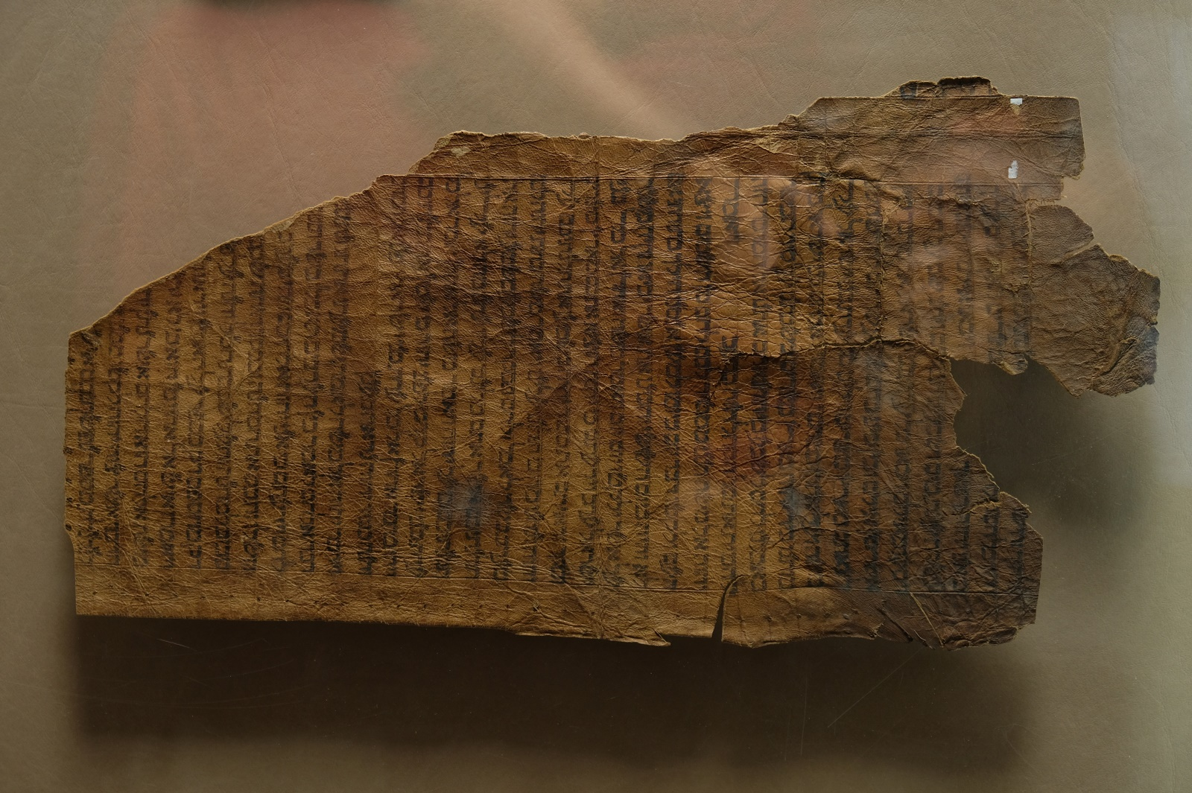

This chapter (Hebrew) describes the wander of the Israelites through the wilderness of Sini desert after the exodus from Egypt. Without any food in their possessions, they turned to God, which promised bread from heaven. In an answer for their prayers, God sent quails and manna, a special bread from the sky, for each day.

Magic Bowl from Oman Peninsula Late 19th Century
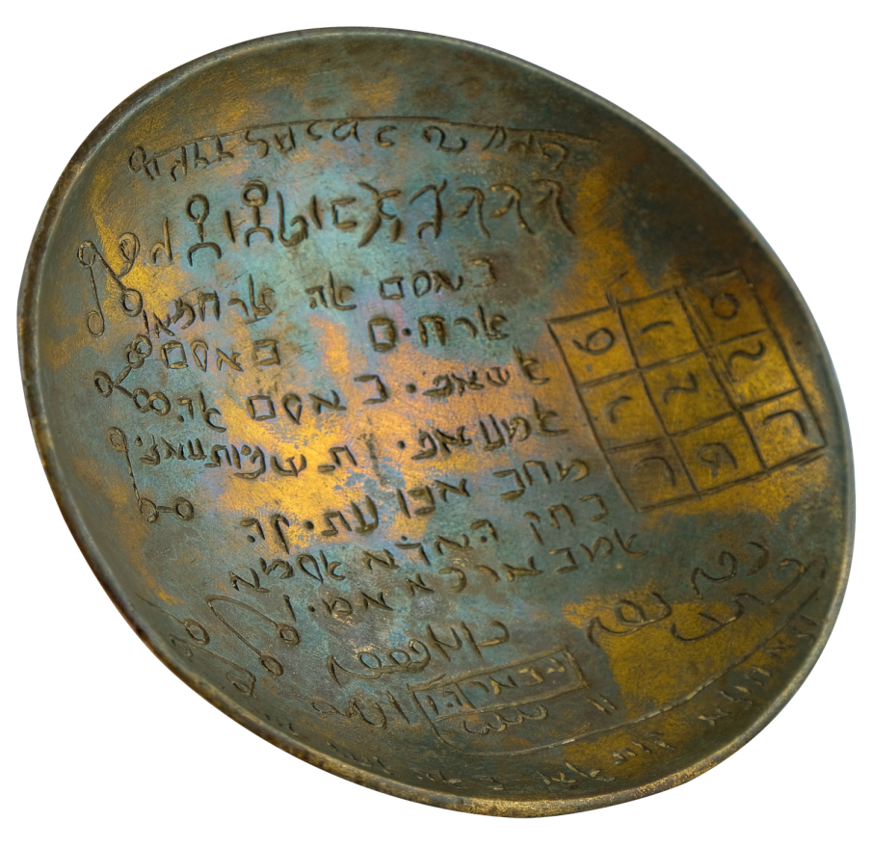
Unlike well-known Jewish Magic Bowl that is either has calligraphy in Hebrew or in Aramaic. Our Magic Bowl is written in both Aramaic and in Hebrew calligraphers. More interesting is that the writings and the prayers are in Arabic. So it has all three Semitic languages in one copper bowl.
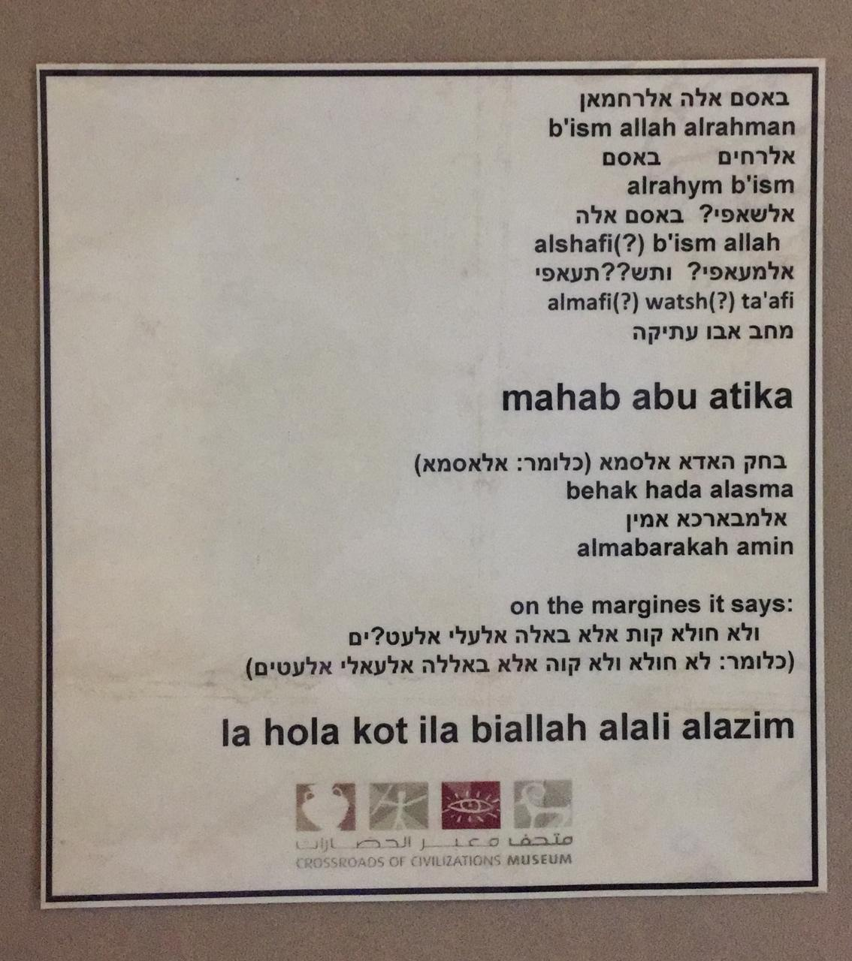

The Birds of Israel

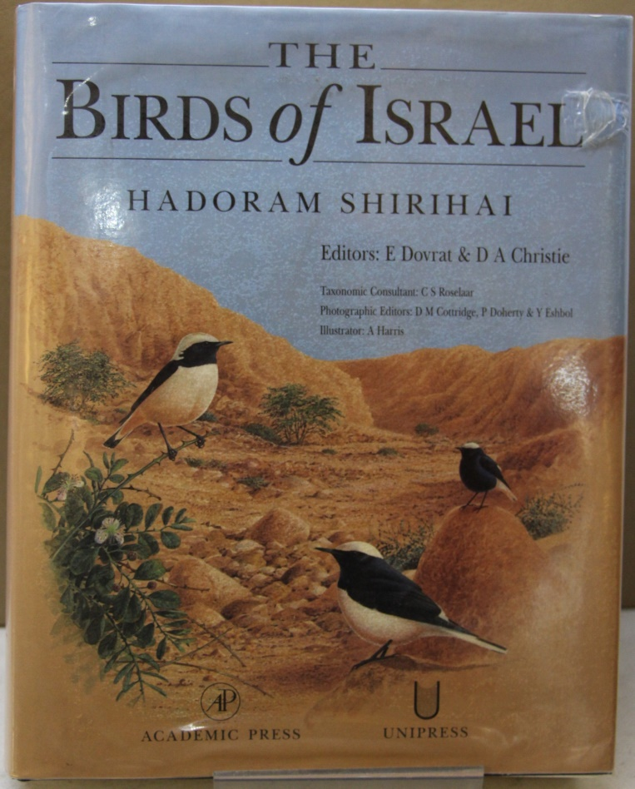

Lying at the crossroads of one of the main migration routes from Africa to the Palearctic, Israel attracts many species of migrant birds, often in large numbers.
This monumental new work will be invaluable, both to the visiting birdwatcher and to the more studious ornithologists. It contains more information packed into its pages than any previous country avifauna. The information in it is of relevance well beyond the borders of the country it describes and will be of use to anybody with an interests in birds throughout the Middle East and North Africa – and, indeed, throughout most of the Palearctic as well.

Survey of the Proposed Railway Between Haifa, Palestine and Baghdad, Iraq
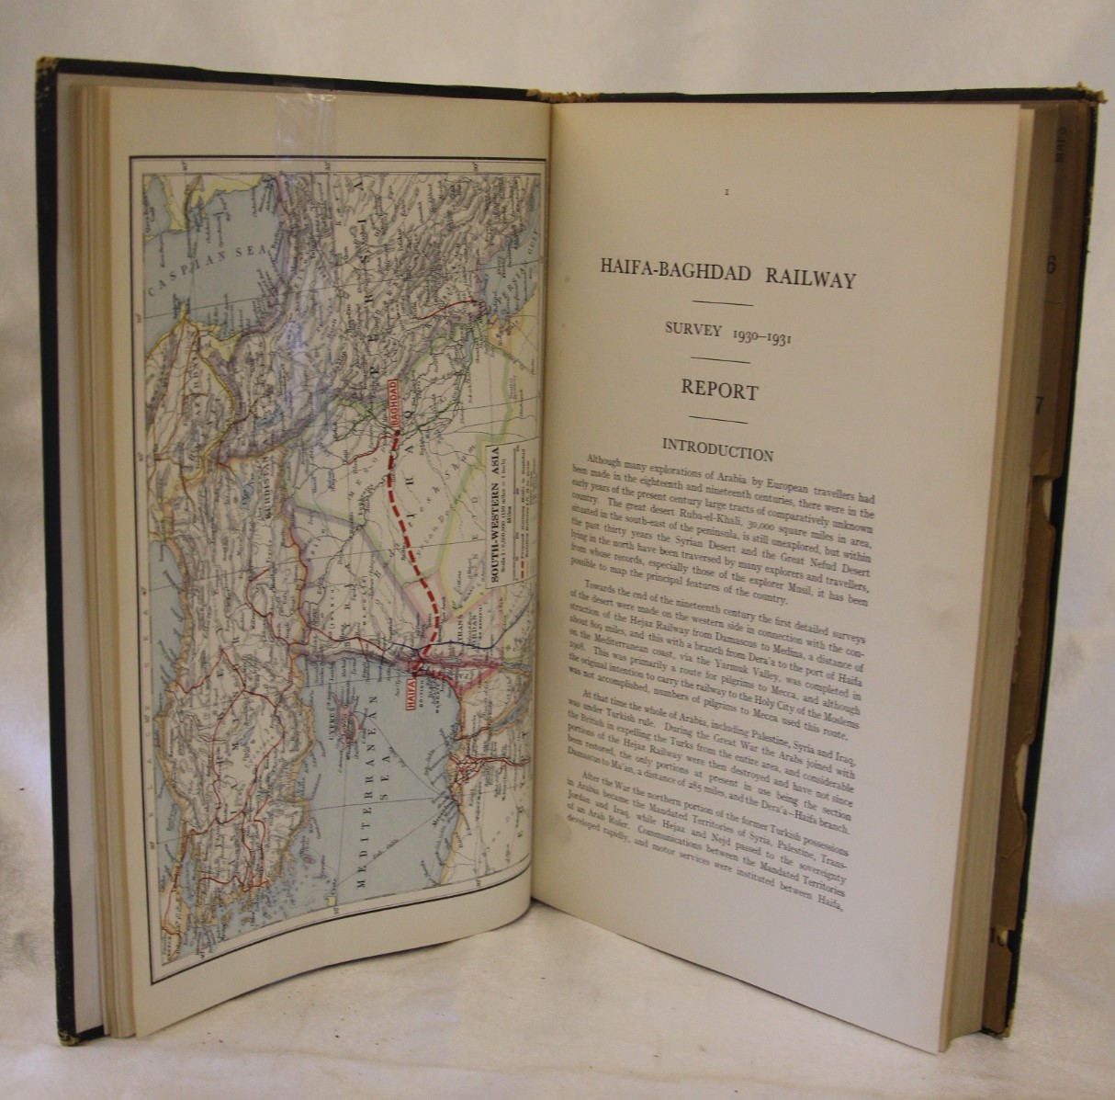

Rare first and only edition, privately published of the first volume of a report and survey of the proposed railway from Haifa, Palestine, to Baghdad, Iraq published by "Rendell, Palmer, and Tritton, consulting engineers". It recounts the results of the investigation whether a railway would be beneficial, what the building would cost, etc,. The photograph shows the terrain, towns, and villages, rivers, and the native population. The maps also show the different counties, their geology, and the proposed route of the railway.

Sketch Map of "Jerusalem"
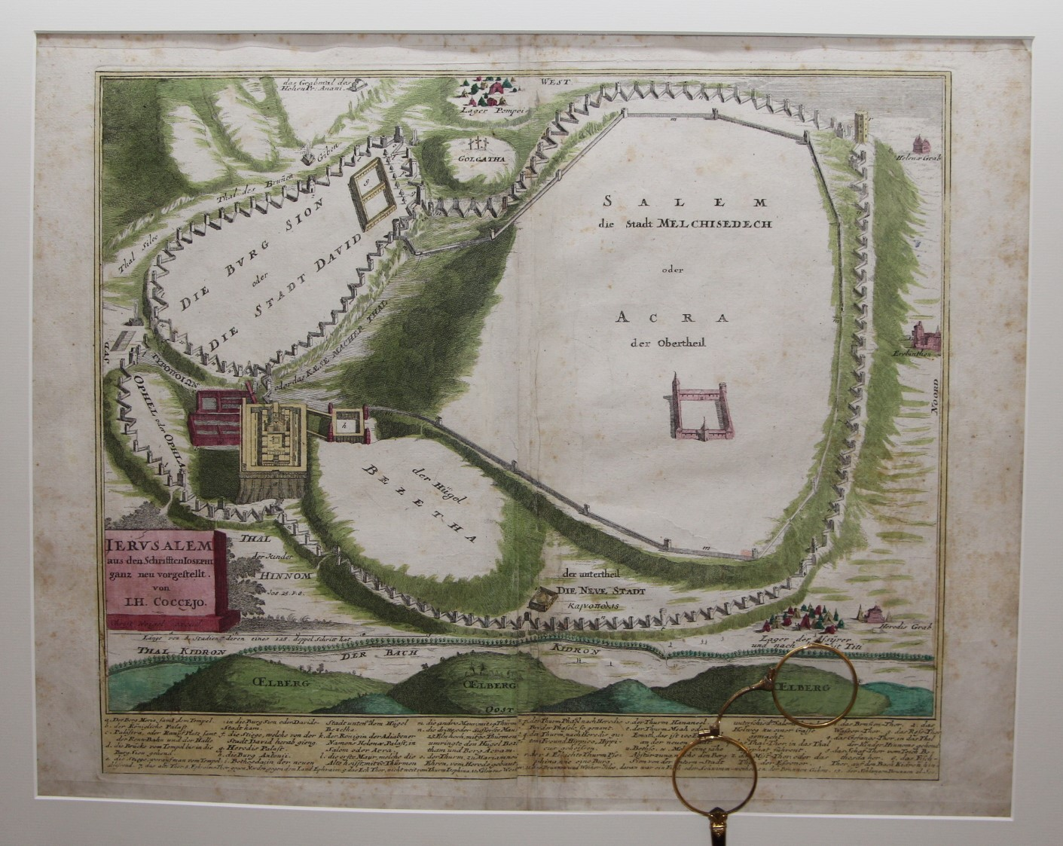

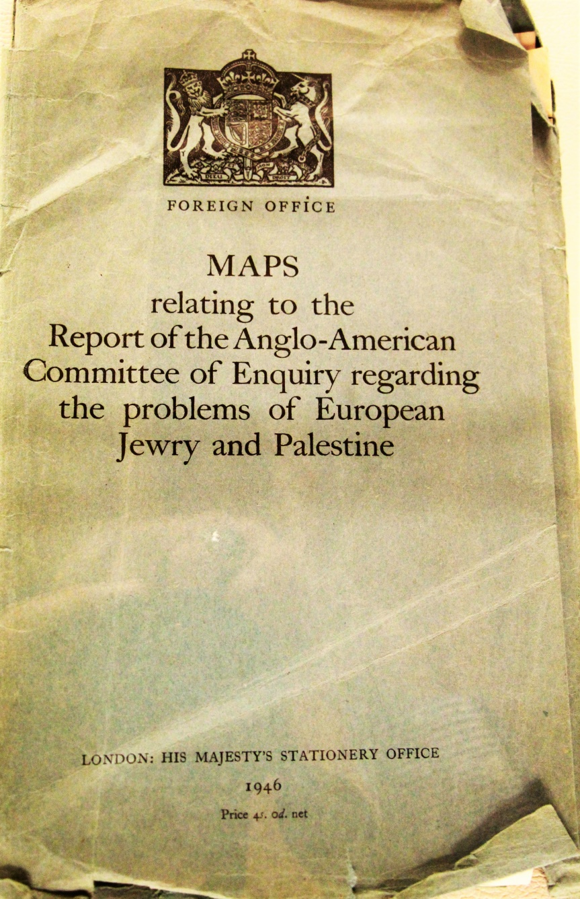

The Balfour Declaration (dated 2 November 1917) was a letter from the United Kingdom's Foreign Secretary Arthur James Balfour to Walter Rothschild, a leader of the British Jewish community. Says; "His Majesty's government view with favour the establishment in Palestine of a national home for the Jewish people, and will use their best endeavors to facilitate the achievement of this object, it being clearly understood that nothing shall be done which may prejudice the civil and religious rights of existing non-Jewish communities in Palestine, or the rights and political status enjoyed by Jews in any other country".

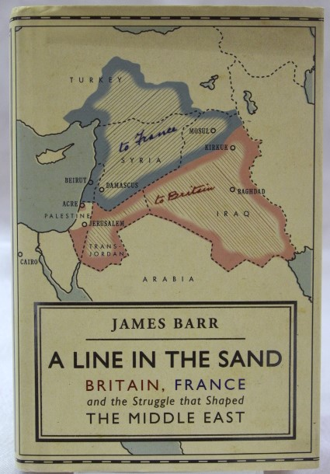

A line in the sand vividly tells the story of the short but crucial era when Britain and France ruled the Middle East. It explains exactly how the old antagonism between these two powers inflamed the more familiar modern rivalry between the Arabs and the Jews, and ultimately led to war between the British and the French in 1941 and between the Arabs and the Israelis in 1948.
In 1946, after many years of intrigue and espionage, Britain finally succeeded in ousting France from Lebanon and Syria, and hoped that, having done so, it would be able to cling on to Palestine. Using newly declassified papers from the British and France archives, James Barr brings this overlooked clandestine struggle back to life, and reveals, for the first time, the stunning way in which the French finally got their revenge.

Jewish Sword

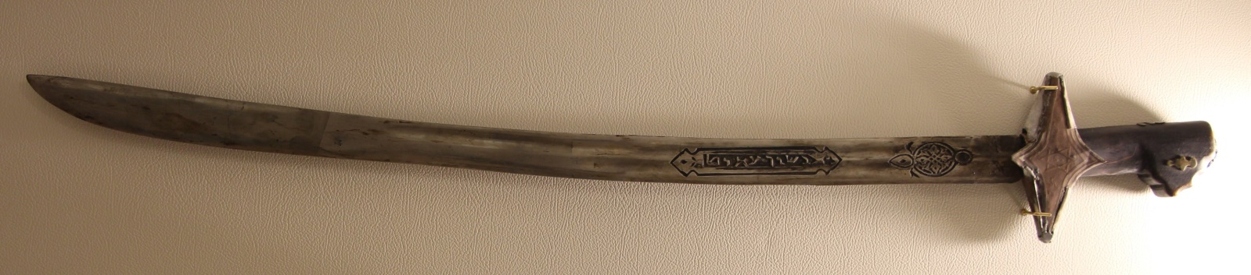

A Yemeni sword with wooden hilt, shows some engraved decorations and Hebrew inscriptions, made by the Arab Jews in Yemen, traded between Yemen and Oman.

Theodor Herzl (1860-1904)

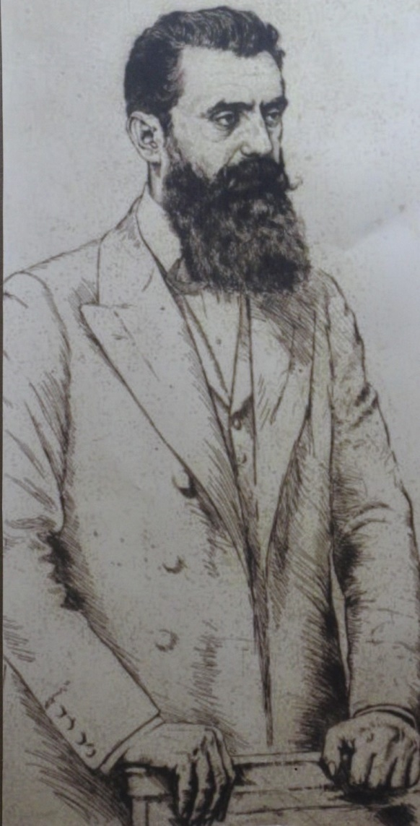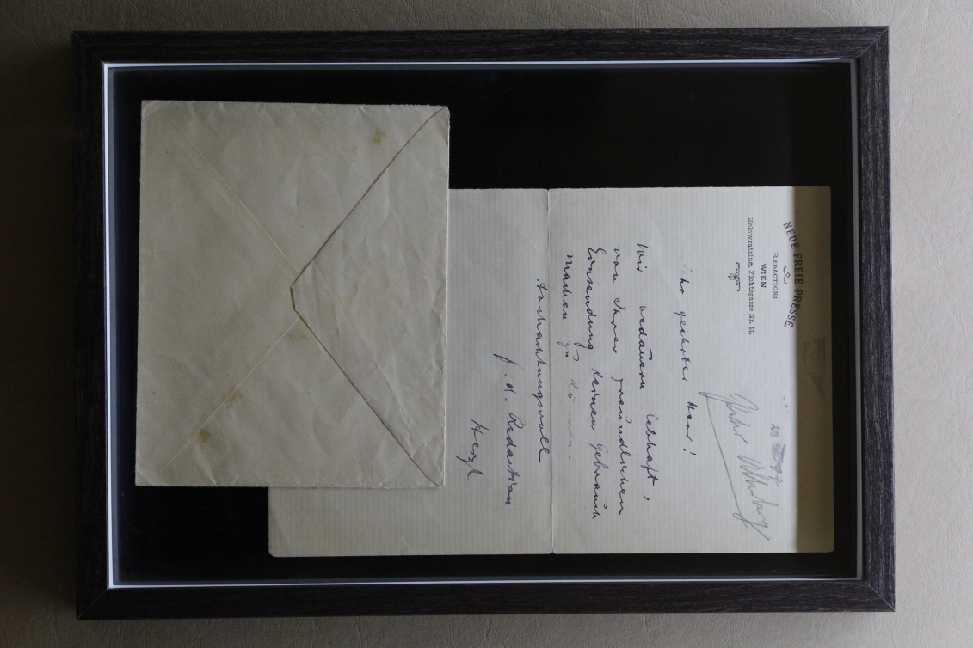

Herzl had returned to Vienna from his post as Paris correspondent for the Neue Freie Presse in the autumn of 1895 and was now working as a feature section editor. After he had published his book “Der Judenstaat” in 1896, he organized the first World Zionist Congress in Basel in 1897 and was elected President of the World Zionist Organization. Three years later he left the Israelite religious community, then remained without a denomination for ten years and finally settled in 1910.

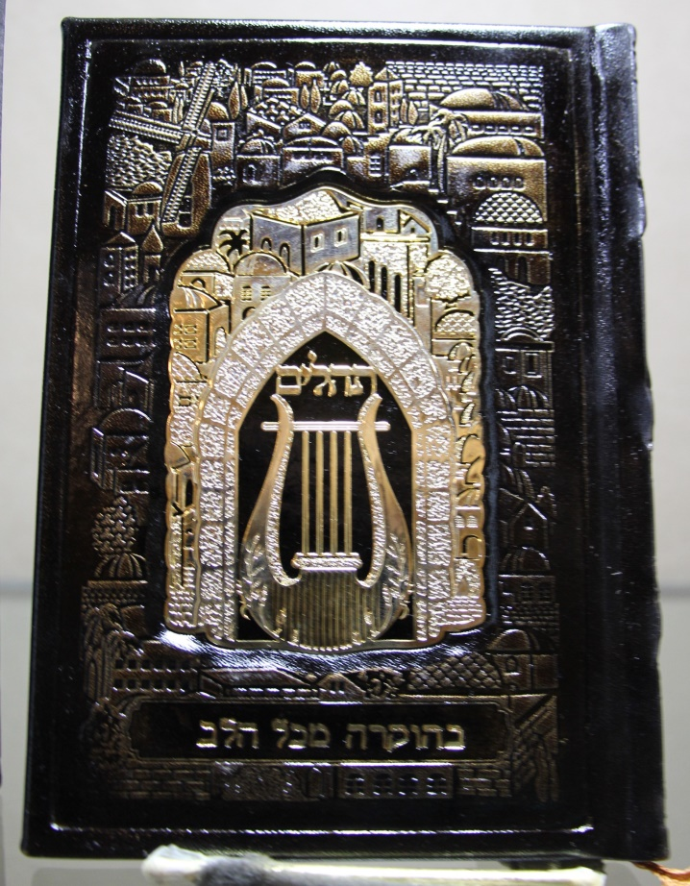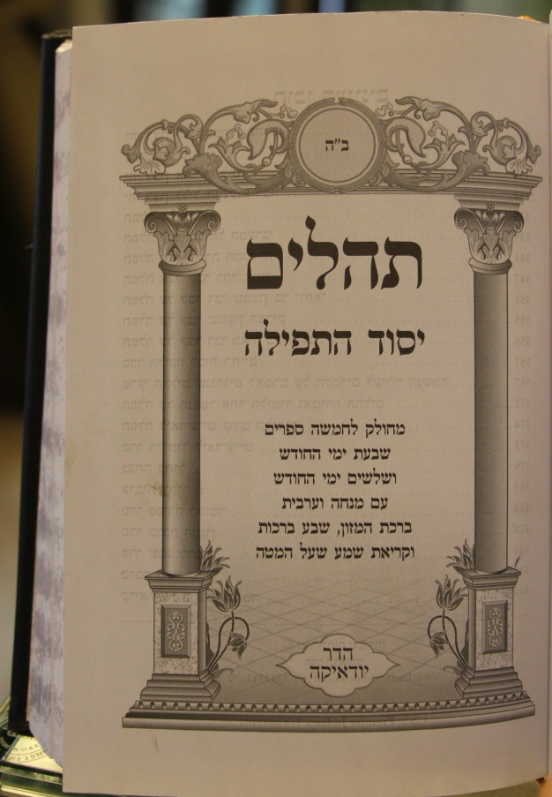

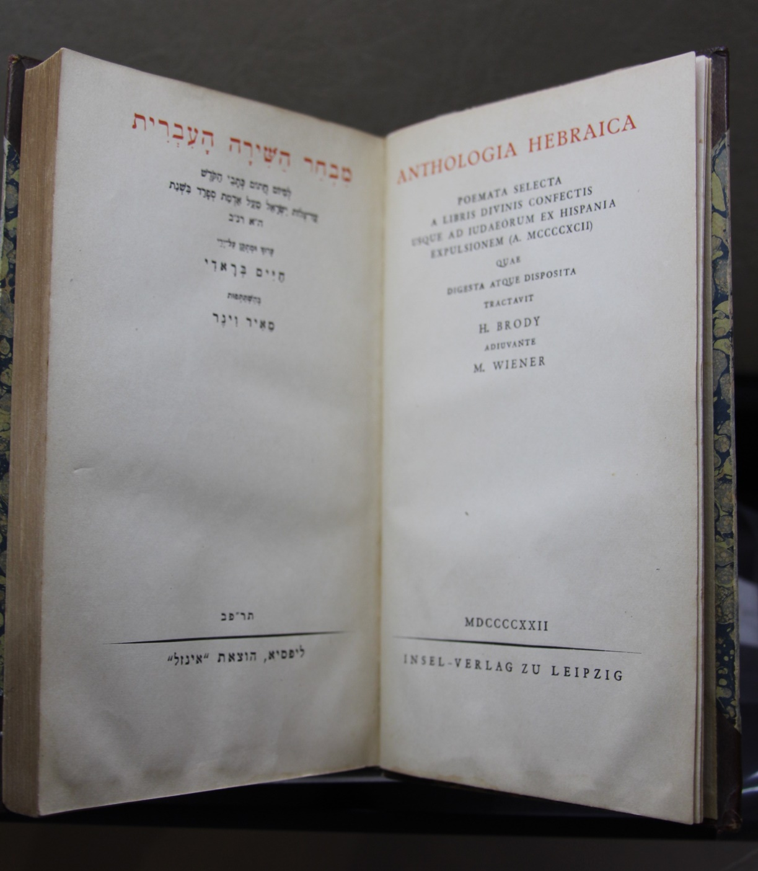

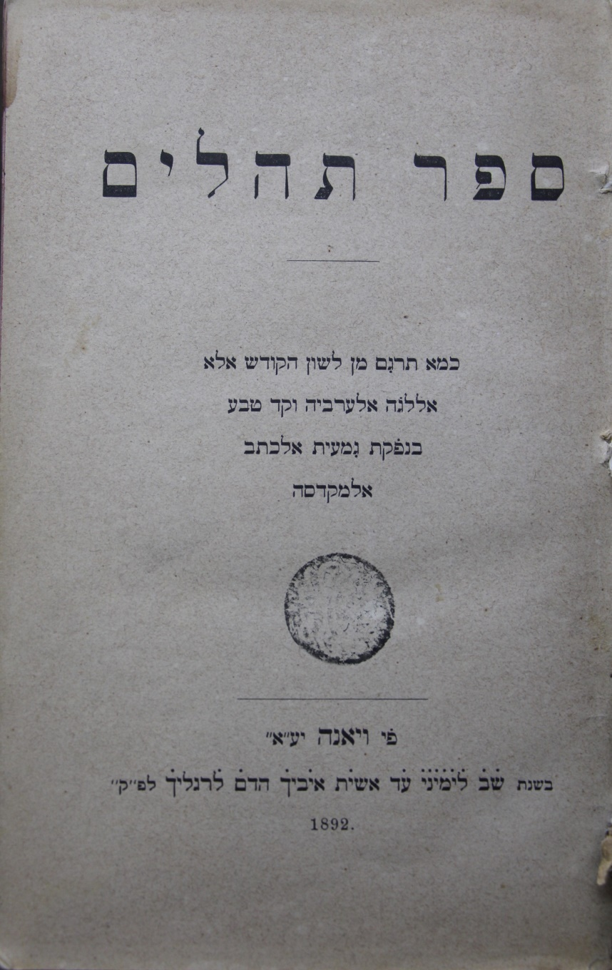

Mezuzah
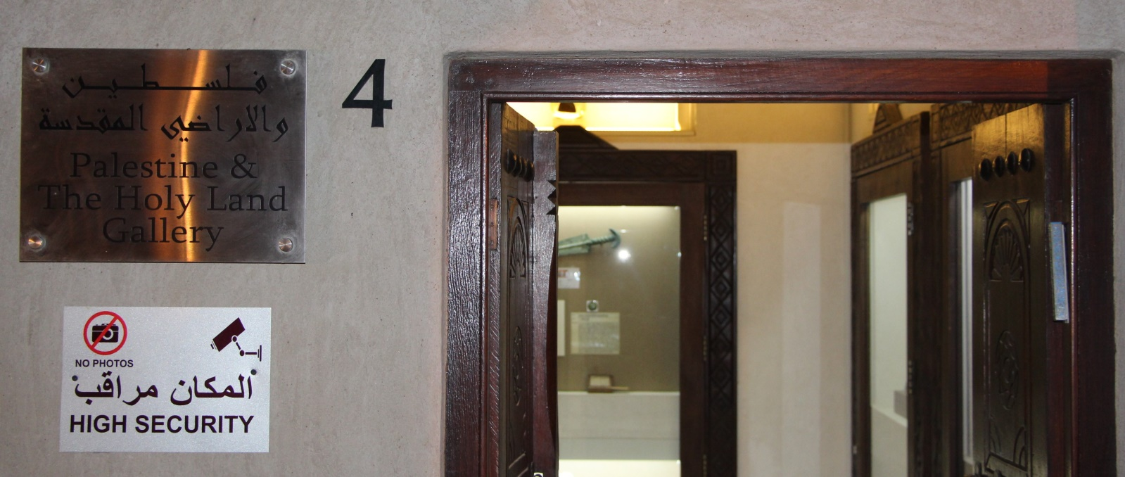
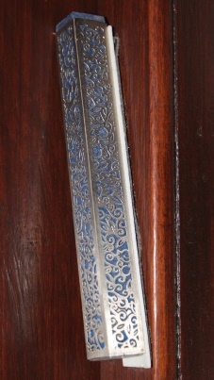
A mezuzah (Hebrew: doorpost plural: mezuzot) is a piece of parchment called a klaf contained in a decorative case and inscribed with specific Hebrew verses from the Torah. These verses consist of the Jewish prayer Shema Yisrael, beginning with the phrase: "Hear, O Israel, the Lord (is) our God, the Lord is One". In mainstream Rabbinic Judaism, a mezuzah is affixed to the doorpost of Jewish homes to fulfill the mitzvah (Biblical commandment) to "write the words of God on the gates and doorposts of your house"Some interpret Jewish law to require a mezuzah in every doorway in the home except bathrooms (which are not a living space), laundry rooms and closets, if they are too small to qualify as rooms. The klaf parchment is prepared by a qualified scribe ("sofer stam") who has undergone training, both in studying the relevant religious laws, and in the more practical parts i.e. carving the quill and practising writing. The verses are written in black indelible ink with a special quill pen made either from a feather or, in what are now rare cases, a reed. The parchment is then rolled up and placed inside the case.

A copper tray with inscriptions and motifs tells the story of Prophet Joseph
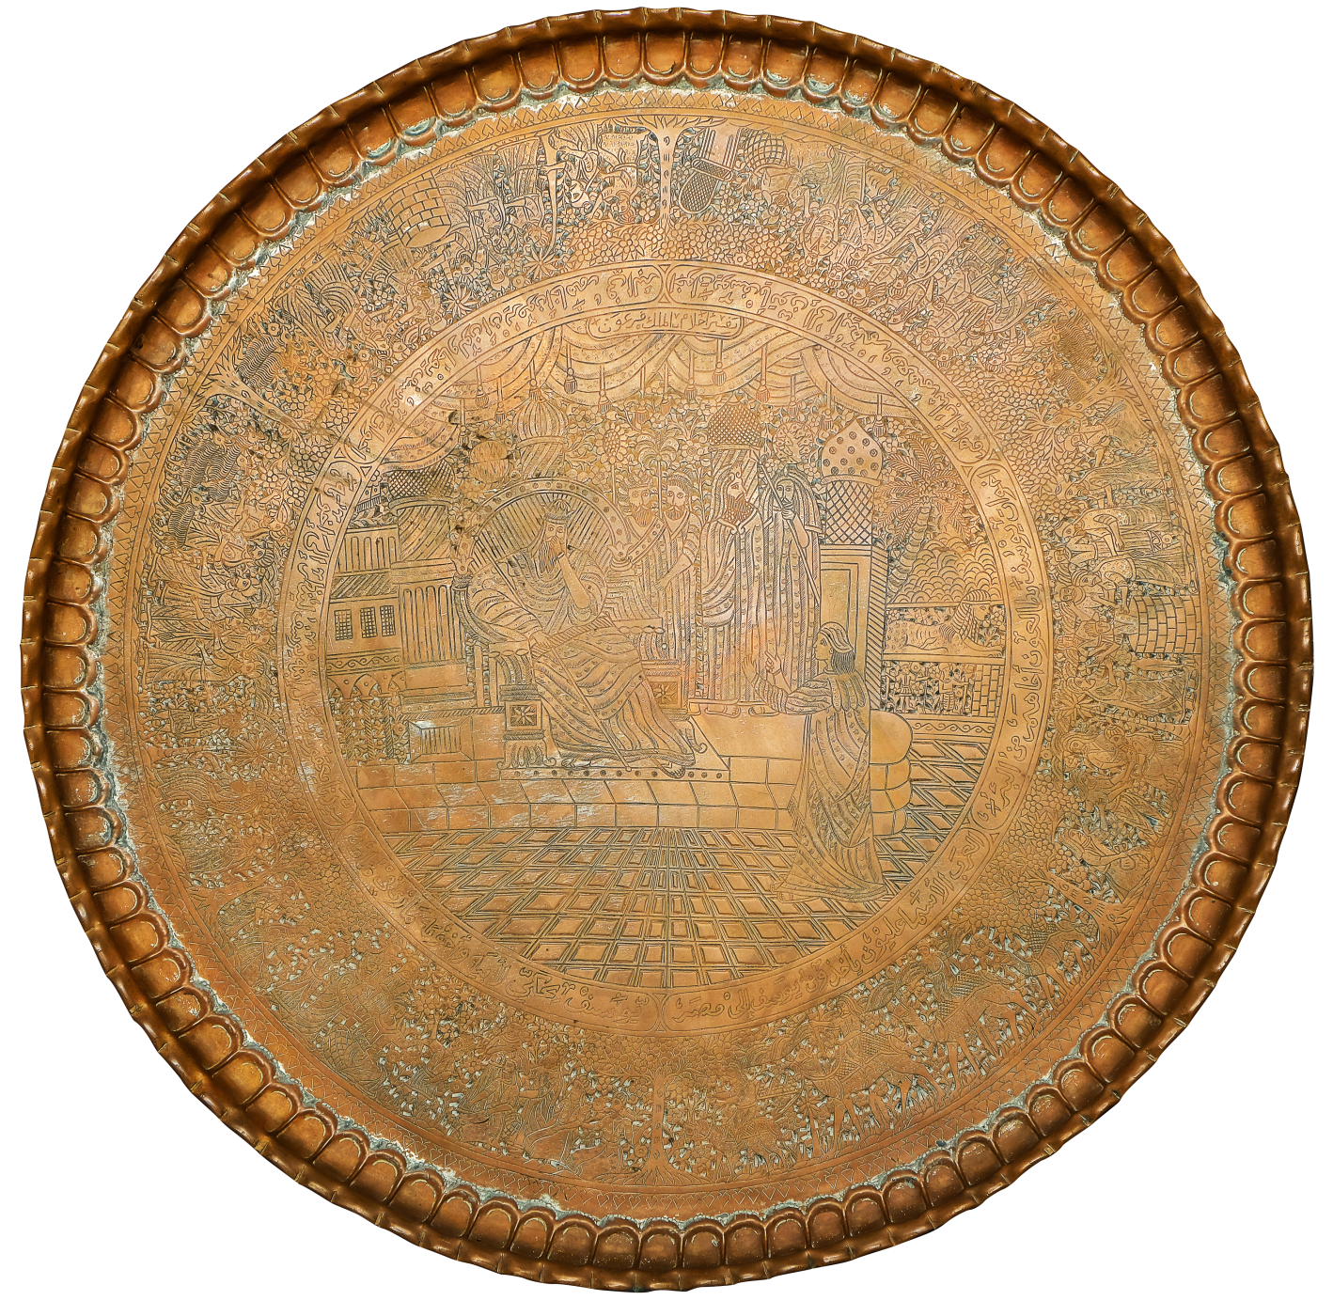
A copper tray with inscriptions and motifs tells the story of Prophet Joseph as it mentioned in the heavenly books before Islam with a quite similarities with the story mentioned in the Holy Quran. This piece of art made by the Arab Jews in Yemen during the Imamate time. Each part of the story is written in Arabic with a scene explains it.

