

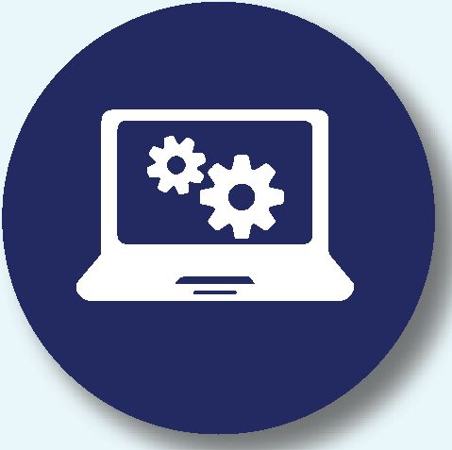

**Tool Kit**

Contribute and access  
technological solutions,  
applications, management  
tools and more.

**Expert Consultation**

Share your expertise and  
gain access to leading  
professionals from a  
variety of fields.

**Webinars**

Lead, share or participate in webinars  
focusing on the most prominent issues  
of the time - enrich your knowledge  
and present your expertise.

**Innovation Arena**

A space for entrepreneurs and  
investors. Share your cutting-edge  
technologies and gain exposure to  
potential partners and investors.

**Online Forum**

Connect with community leaders  
and professionals, learn from  
the experience of others, and  
implement joint solutions.

JReady: The Jewish Agency's Online Resource  
Center for Community Resilience

The COVID-19 pandemic has inflicted unprecedented hardship on every one of our global communities.  
For the first time in decades, Jewish communities everywhere are confronted with a shared challenge.  
In response to the current crisis, and in readiness for future emergencies that may arise, key organizations  
in Israel and across the world have mobilized to establish JReady - a platform for emergency preparedness,  
support, and relief for Jewish professionals.

**r 1**

[JOIN OUR EMERGENCY NETWORK TODAY >](https://www.jready.org/)

**[www.jready.org](http://www.jready.org)**

Key Services



**Best Practices**

Propose new content or access  
protocols and procedures  
implemented in other  
communities.

Our Global Reach

• Dozens of communities • Building resilience infrastructure  
• Training local partners and professionals

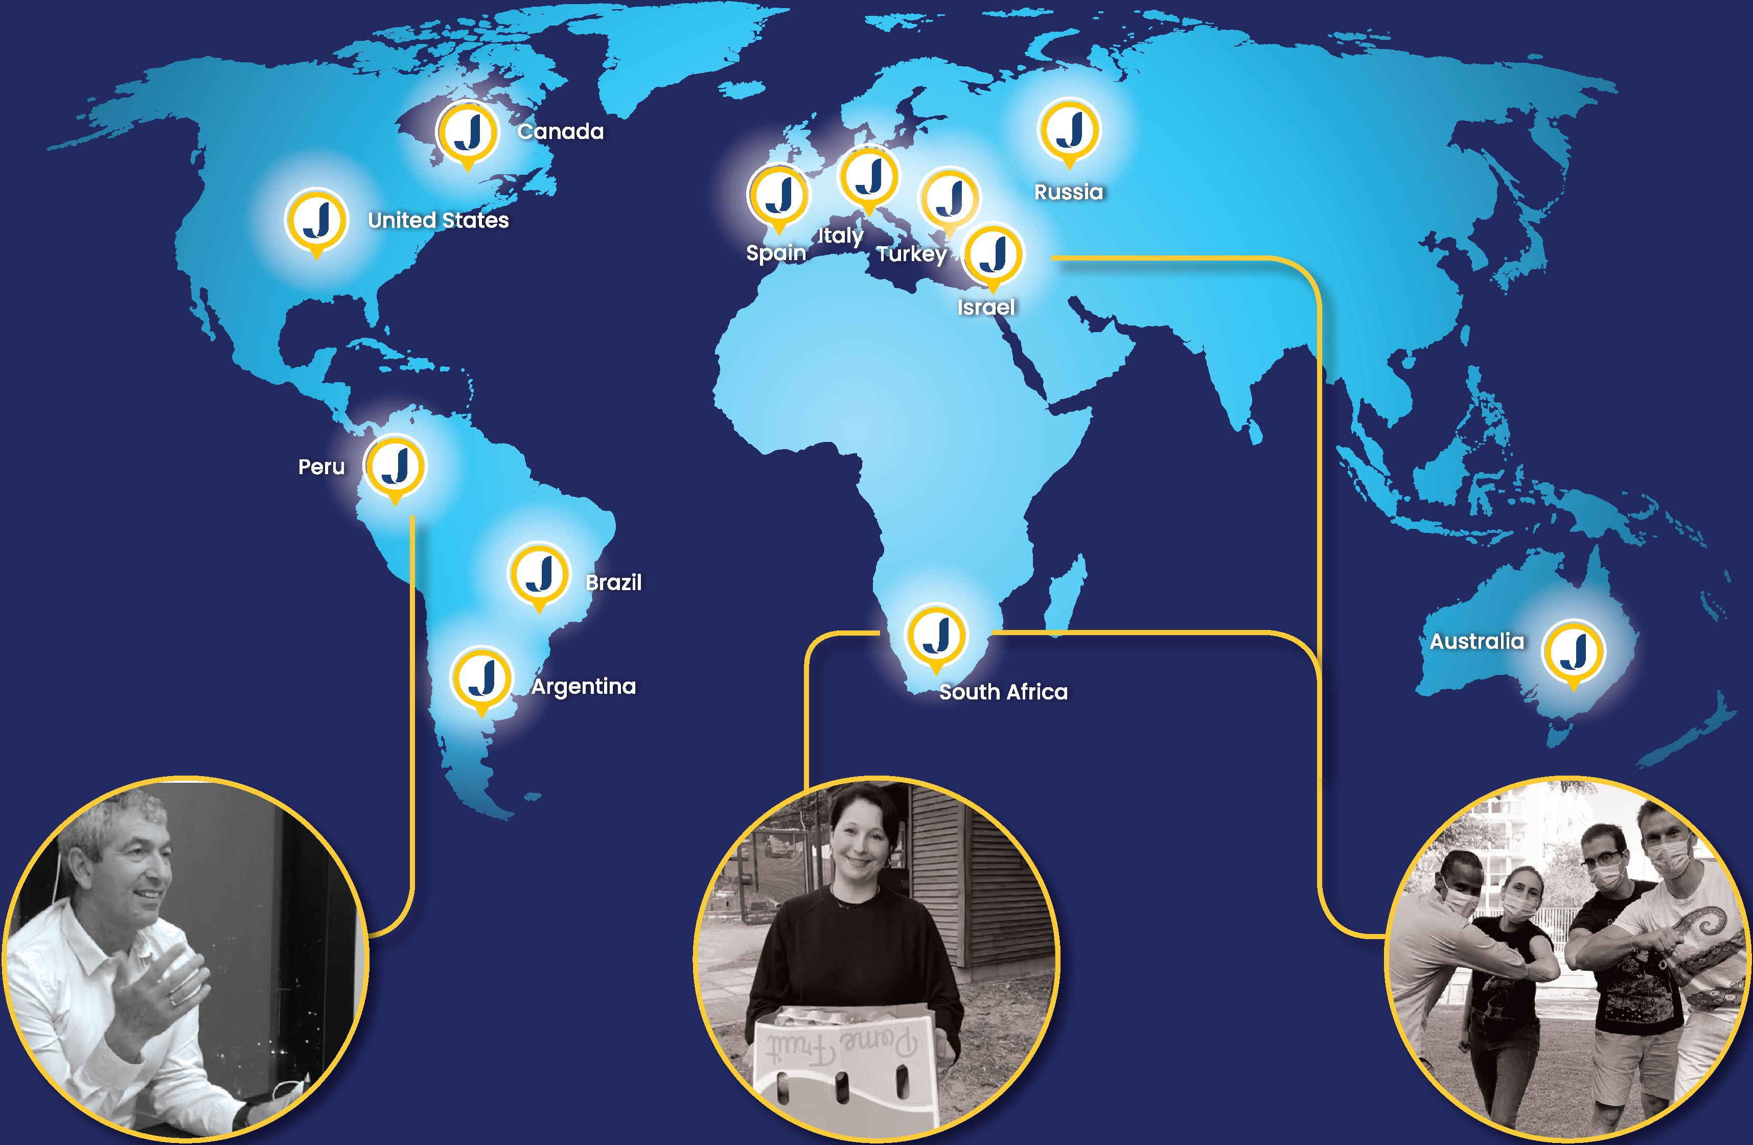

***JReady****,* together with Tel Aviv University, ran  
a course for professionals in South Africa and  
Israel, providing tools for crisis management,  
trauma response, volunteering, and more.

***JReady*** guided the Jewish Community  
in Cape Town in implementing a  
mobile application to facilitate local  
food distribution to struggling families.

***JReady*** facilitated online training  
for professionals from Mexico and  
Peru, focusing on trauma response  
and community resilience.

JReady’s advisory committee is headed by former Member of Knesset, Ayelet Nahmias Verbin, and  
was developed by The Jewish Agency in collaboration with local and global experts in the fields of  
crisis management and emergency response.

We invite you to become a part of this important initiative,  
ensuring the future resilience of our global Jewish communities.

***״All Jews are responsible for one anotherכל ישראל ערביס זה לזה" ״"***

xA7 the הסוכנות היהודית  
Jewish agency לארץ  
Y FOR ISRAEL ישראל

The Jewish Federations®

**OF NORTH AMERICA**

Keren hayesod **7**ןרן היסוד

**FOR THE PEOPLE OF ISRAEL**

Ministry of Diaspora Affairs

Creating a common Jewish future

IDF Home Front  
Command

MOD - National Emergency  
Managment Authority

