Scientific Abstract: INS/DVL Fusion with Complete, Partial or Lack of DVL Beam Measurements

The continuous operation of the navigation system of an autonomous underwater vehicle (AUV) is critical to successfully complete the AUV task. Those include scientific, industrial, military and search and rescue missions. To that end, fusion between the inertial navigation systems (INS) and Doppler velocity log (DVL) is carried out. In many different AUV scansions, DVL fails to provide measurements and as a consequence the navigation solution drift in time resulting with immediate mission termination. Here we aim to develop a comprehensive framework for INS/DVL fusion to cope with all three possibilities of DVL measurements availability: 1) complete measurements (normal conditions) 2) partial measurements 3) no measurements (DVL outages).

We divide the research into three tracks to address each type of DVL measurement availability. Although, situations of complete and partial DVL outages commonly occur during AUV missions, they are rarely addressed in the literature as most research is focused on normal operating conditions, i.e. complete DVL measurements. In a recent, pioneering, theoretical analysis we showed that accurate navigation levels can be preserved even during partial DVL measurements. Later, we proposed a solution for short time periods for situations of complete DVL outages. Yet, the lack of comprehensive solutions for partial and complete DVL outages still remains.

Our goal is to offer research results of substantial effect, laying foundations and major directions supported by theory and sea experiments. Currently there is room for core solutions, which are major leaps relative to the state-of-the-art and may act as basis for any future work and implementations of INS/DVL fusion with all three types of DVL measurements availability.

With the help of those approaches the navigation solution drift will be mitigated or completely stopped. This issue is critical, particularly, in situations of partial or complete DVL outages. Then, longer time duration will be allowed for the AUV to complete its mission instead of immediately issuing a command to surface when the DVL is not available. Also, for a practical cost-effective point of view, improving the INS/DVL fusion performance may result in using lower grades of INS or DVL. As a consequence, new possibilities for INS/DVL in micro AUVs, bio-inspired marine platforms or other low-cost small-sized platforms, which currently cannot use such fusion due to sensor costs and size, will be available.

Detailed Description of the Research Program

1 Scientific Background

The ocean covers about two-thirds of the earth and has a great effect on the future existence of all human beings [1]. Extensive use of manned submarines and tethered and remotely operated underwater robots are currently limited to a few applications because of very high operational costs and safety issues. The demand for advanced multi-purpose underwater vehicle technologies lead to the development of autonomous underwater vehicles (AUVs) at the 1970s [2]. Since then, advancements in the efficiency, size, sonar, computers and navigation sensors have enhanced that potential up to a point where today, in parallel to ongoing research in the field, AUVs are commonly used in many applications [3]. For scientific missions, AUVs are used for seafloor mapping [4], environmental monitoring [5] and marine biology studies [6] to name a few. For industry applications, AUVs assist in monitoring underwater construction work and health monitoring of underwater infrastructures [7]. AUVs are also employed for military applications [8], payload delivery to ocean floor [9] and search and rescue missions [10].

To successfully accomplish its tasks, the accuracy of the navigation solution is critical. To achieve reliable and accurate navigation solution, commonly, inertial navigation system (INS) and a Doppler velocity log (DVL) are employed [11]-[15]. The INS popularity steams from that fact it provides a full navigation solution (position, velocity and attitude), it is a standalone system which is capable of working in any environment and it is available in many different grades (starting with low-cost low performance to high-cost high performance systems). The INS contains inertial sensors capable of measuring the specific force and angular velocity vectors. Utilizing those measurements, the INS navigation solution can be calculated at each epoch. The inertial sensor measurements contains noises and biases which penetrate to the navigation solution during the integration process. Therefore, regardless of the INS quality, the navigation solution will drift with time.

A DVL calculates the vehicle’s velocity with respect to the sea bottom or water column by observing the frequency shift as a result of the Doppler effect. The calculated velocity, is bounded and usually provided with high accuracy, yet the sampling rate is low compared to the inertial sensors.

DVl/INS fusion aims at utilizing the advantages of the two individual systems and overcome their weakness. When combined, both systems can provide a complete bounded navigation solution including position, velocity and attitude for long time-periods. The fusion between the two systems, in normal operating conditions, is extensively addressed in the literature in terms of the fusion type (loosely or tightly) [16]-[19], nonlinear filter type [20]-[24], observability analysis [25-27] and alignment [28-32].

In normal conditions, the provided INS/DVL navigation solution is satisfactory to achieve mission goals. However, the AUV can operate also in complex environments, in which some or all of the DVL beams may outage. Those include operating in extreme roll/pitch angles, passing over fish and other sea creatures, sound scattering and passing over trenches in the seafloor. In tightly coupled approach, even partial beam measurements may be used to aid the INS, yet with a cost of reduced accuracy. On the other hand, in loosely coupled approach all four beams are required to obtain the AUV velocity. Thus, when less are available the AUV velocity cannot be estimated.

To address the case of partial DVL measurements, we started a theoretical analysis that so far led to an important conclusion - external information combined with partial DVL measurements can be used to estimate the DVL based AUV solution [33]. This approach, enables the usage of a loosely coupled INS/DVL integration approach was never exploited until now. Later, our pioneering approach was extended in [34] for “+” and “x” DVL configurations, however only for the tightly coupled approach in simulation and without sea experiments. Since many AUVs operate in a loosely coupled approach more effort is required to strengthen the framework in [33].

We aim to continue this analysis, extend it to include interstation of additional information, take into account the analytical process measurement noise covariance, use deep-learning to estimate missing beam velocities and validate it in thorough experiments.

To cope with situations of short-time periods complete DVL outages, usually the last AUV velocity estimation (or an average of some past estimates) is used to update the navigation filter. Yet, if the AUV changes its velocity or turns or experience some perturbations (winds, currents and etc.) this approach will fail. Motivated by our recent work on land vehicle heading estimation [35], we derived an analytical closed form solution to enable the estimation of the AUV velocity and acceleration and thereby cope better also in varying trajectories [36]. Our goal is to elaborate this analysis to examine the possibility of using those accelerations to estimate the accelerometer biases. Particularly, the x and y axis which or not observable. To that end, linear and nonlinear observability analysis will be made. Moreover, using the approach estimated velocity we aim to calculate the AUV heading angle and also its sideslip angle in order to bound the heading drift in straight-line trajectories. In addition, we aim to use deep-learning and the inertial sensors measurements to estimate the velocity and acceleration of the DVL model as derived in [36].

With the help of such methods, in situations of partial or complete DVL outages, longer time will be allowed for the AUV to complete its mission instead of immediately issuing a command to surface when the DVL is not available.

2 Research Objectives and Expected Significance

Our **research objectives** are:

1. Develop an enhanced DVL/INS nonlinear adaptive filter using deep-learning approaches.

2. Derive algorithms to enable the usage of partial DVL measurements in a loosely coupled integration, including the analytical process-measurement covariance matrix.

3. Drive a framework to cope with situations of complete DVL outages for short time periods.

The **expected significance** lies in the novel theoretical understanding of partial and complete DVL outages scenarios and deriving means to mitigate the immediate INS navigation solution drift. Also, in normal conditions of INS/DVL fusion, we aim to drive theoretical knowledge of the implementation of deep-learning based algorithms in the nonlinear navigation filter. While most INS/DVL literature assumes normal operating conditions, it is our intention to tackle the fusion process in practical real-life scenarios where such assumption does not hold and thereby to fill this gap in the literature.

That is, our goal is to address all three possible DVL measurement availability situations during INS/DLV fusion: 1) complete DVL outages for short-time periods 2) partial DVL measurements for short-time periods and 3) deep-learning nonlinear filtering in normal INS/DVL operating scenarios.

Our aim is to offer research results of substantial effect, laying foundations and major directions and defining new and important problems in the field supported by theory and sea experiments. Currently there is room for core solutions, which are major leaps relative to the state-of-the-art and may act as basis for any future work and implementations of INS/DVL fusion.

The outcome of our algorithms will enable continuous operations of AUVs on their planned missions. Today, in situations of partial or complete DVL outages, the AUV navigation solution is allowed to rely on the INS solution only for a very limited time duration due to the INS solution drift. Therefore, in such scenarios, the autonomous functioning of the AUV will order it to surface leading to the cancellation on the current mission. Besides the failure to complete the task (resulting in waste of effort, money and delay in operation), in search and rescue missions it could also cost of life of people.

With the proposed approaches, a much larger buffer will be allowed to the AUV to operate with partial or complete DVL measurements ensuring the continuation of the AUV mission. Also, for a practical cost-effective point of view, improving the INS/DVL fusion performance may result in using lower grades of INS or DVL. Besides the savings of such outcome, it could open new possibilities for using INS/DVL in micro AUVs, bio-inspired marine platforms or other low-cost small-sized platforms which currently cannot exploit such fusion due to sensor costs and size.

3 Detailed Description of the Proposed Research

3.1 Formulation of INS/DVL Fusion

The INS equations of motion are nonlinear, thus when fused with DVL a nonlinear filter is required. In most cases, an error state Extended Kalman Filter (EKF) implementation is used with $δx∈R^{12}$ [37-38]. The error state vector consists of the velocity error vector $δv^{n}$ expressed in the navigation frame, misalignment errors $ε^{n}$, accelerometer bias residuals $b_{a}$ and gyro bias residuals, $b_{g}$, expressed in the body frame, such that

$δx={\left[\begin{matrix}\begin{matrix}δv^{n} & ε^{n}\end{matrix} & \begin{matrix}b_{a} & b_{g}\end{matrix}\end{matrix}\right]}^{T}$ (1)

The linearized error-state model is

$δ\dot{x}=δxF+Gw$ (2)

where $F$ is the system matrix, $G$ is the shaping matrix and $w$ is a zero mean white Gaussian noise. The accelerometers and gyros residuals are modeled as random walk processes. The system matrix is given by

$F=\left[\begin{matrix}\begin{matrix}F_{vv} & F_{vε} \\ F_{εv} & F_{εε}\end{matrix} & \begin{matrix}T_{b}^{n} & 0_{3×3} \\ 0_{3×3} & T_{b}^{n}\end{matrix} \\ \begin{matrix}0_{3×3} & 0_{3×3} \\ 0_{3×3} & 0_{3×3}\end{matrix} & \begin{matrix}0_{3×3} & 0_{3×3} \\ 0_{3×3} & 0_{3×3}\end{matrix}\end{matrix}\right]$ (3)

where $T_{b}^{n}$ is the transformation matrix from body to navigation frame and $F_{ij}$ are submatrices corresponding to the linearizion of the nonlinear equation of motion (more details on the internalization process can be found in navigation textbooks such as [39-40]). The shaping matrix is given by

$G=\left[\begin{matrix}\begin{matrix}T_{b}^{n} & 0_{3×3} \\ 0_{3×3} & T_{b}^{n}\end{matrix} & \begin{matrix}0_{3×3} & 0_{3×3} \\ 0_{3×3} & 0_{3×3}\end{matrix} \\ \begin{matrix}0_{3×3} & 0_{3×3} \\ 0_{3×3} & 0_{3×3}\end{matrix} & \begin{matrix}I_{3} & 0_{3×3} \\ 0_{3×3} & I_{3}\end{matrix}\end{matrix}\right]$ (4)

and the noise vector is

$w={\left[\begin{matrix}\begin{matrix}w_{a} & w_{g}\end{matrix} & \begin{matrix}w_{ab} & w_{gb}\end{matrix}\end{matrix}\right]}^{T}$ (5)

where $w_{a}$ and $w_{g}$ are zero mean white Gaussian noise assumed to be constant for all samples of the accelerometers and gyros, respectively and $w_{ab}$ and $w_{gb}$ are zero-mean white Gaussian noise assumed to be constant for all samples of the accelerometers and gyros biases, respectively. The EKF error-state closed loop implementation algorithm following [37,41] is

$δ{\hat{x}}_{k}^{-}=0$ (6)

$P_{k}^{-}=Φ_{k-1}P_{k-1}^{+}Φ_{k-1}^{T}+Q_{k-1}$ (7)

$δ{\hat{x}}_{k}^{+}=K_{k}δz_{k}^{}$ (8)

$P_{k}^{+}=\left[I-K_{k}H_{k}\right]P_{k}^{-}$ (9)

$K_{k}^{}=P_{k}^{-}H_{k}^{T}{\left[H_{k}P_{k}^{-}H_{k}^{T}+R_{k}\right]}^{-1}$ (10)

where k is the time step index, $δ{\hat{x}}_{k}^{-}$ is the a priori estimate of the error-state, $δ{\hat{x}}_{k}^{+}$ is the a posteriori estimate of the error-state, $z_{k}^{}$ is the measurement residual vector, $P_{k}^{-}$ is the covariance of the a priori estimation error, $P_{k}^{+}$ is the covariance of the posteriori estimation error, $K_{k}^{}$ is the Kalman gain, $Q_{k}^{}$ is the process noise covariance assumed to be constant for all samples, $R_{k}^{}$ is the measurement noise covariance assumed to be constant for all samples, $Φ_{k}$ is the state transition matrix and $H_{k}^{}$ is the measurement matrix.

The process noise covariance is determined based on the inertial sensors quality while the measurement noise covariance, measurement and measurement matrix are determined based on the DVL’s fusion type - loosely coupled (LC) or tightly coupled (TC). To explain the difference between the two, we first describe the DVL measurement model.

Commonly, a four-beam DVL contains four transducers, each emits an acoustic beam to the seafloor and receive the reflected signal. Figure 1(a) shows a four-beam DVL in the Janus “x” configuration. Each of the DVL beam velocity, ${\tilde{y}}_{j}$, can be modeled by [33]:

${\tilde{y}}_{j}=d_{k}^{T}\left[v^{b}\left(1+s_{j}\right)+ω^{b}×l_{j}^{b}\right]+b_{j}+v_{j}$ (11)

where $v^{b}$ is the platform velocity vector expressed in the body frame, $ω^{b}$ is the angular velocity vector expressed in the body frame, $l_{j}^{b}$ is the lever-arm vector of transducer *j* expressed in the body frame and $d_{j}$ is the unit vector along beam *j* direction. The DVL error terms of each transducer *j* are scale-factor, $s_{j}$, bias $b_{j}$, and zero mean white Gaussian noise, $v_{j}$.

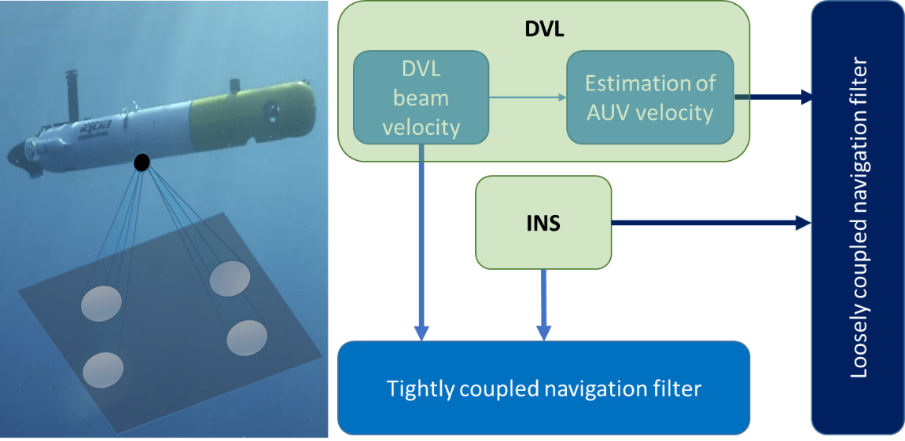

(a) (b)

Figure 1: (a) AUV with a Janus “x” DVL configuration (b) INS/DVL fusion types – loosely coupled (body velocity) and tightly coupled (beam velocities).

The relation between the four DVL measurements

$y={\left[\begin{matrix}\begin{matrix}{\tilde{y}}_{1} & {\tilde{y}}_{2}\end{matrix} & \begin{matrix}{\tilde{y}}_{3} & {\tilde{y}}_{4}\end{matrix}\end{matrix}\right]}^{T}$ (12)

and the platform velocity is defined by:

$y=Mv^{b}$ (13)

where

$M={\left[\begin{matrix}\begin{matrix}d_{1}^{} & d_{2}^{}\end{matrix} & \begin{matrix}d_{3}^{} & d_{4}^{}\end{matrix}\end{matrix}\right]}^{T}$ (14)

Finally, the platform velocity can be estimated

${\hat{v}}_{DVL}^{b}={\left(M^{T}M\right)}^{-1}M^{T}\tilde{y}$ (15)

When using the DVL’s beam velocity measurements (12) in the navigation filter the fusion is called a TC integration. There, the DVL raw data is directly used in the navigation filter with its calculated INS counterpart. Therefore, there is no need for a bottom lock stage, and aiding may be applied even with a single beam measurement. On the other hand, LC integration approach uses the DVL estimation of the platform’s velocity (15). The advantage of this method is the simplicity of integration and the ability to combine any off-the-shelf INS with any DVL. However, in order for the DVL to calculate vehicle velocity, it must operate in bottom lock, which refers to the condition when a sufficient number of beam measurements (at least three) are available. Both LC and TC integration approaches are illustrated in Figure 1(b).

3.1 Fusion with Partial DVL Measurements

In the loosely coupled INS/DVL approach, the DVL estimated velocity (15) is employed in the navigation filter. To that end, three (the forth is for redundancy) DVL beam measurements (12) are needed. In some situations during AUV operation, such as passing over trenches or operating in extreme roll/pitch angles, only one or two DVL beams are available and as a consequence the DVL estimated velocity (15) cannot be calculated.

3.1.1 Preliminary Work

Our pioneering preliminary work [33] proposed the extended loosely coupled (ELC) INS/DVL fusion approach, enabling the application of the loosely-coupled approach with partial DVL beam measurements. There, four different approaches were suggested to cope with partial measurements:

* ‘Virtual Beam’ – the last velocity estimate from the navigating filter is used as the current velocity of the AUV and utilizing the known beam geometry (14), the missing beam velocity can be found using (11)

${\tilde{y}}_{j}=d_{k}^{T}v^{b}$ (16)

* ‘Nullifying Sway Velocity’ – an assumption of zero sway velocity is made. The motivation lies in the fact that, in practice, most AUV trajectories are made in straight lines (although the AUV may be influenced by some disturbances that alter the straight line). Thus, the unknown velocity vector now has only two components and using two (instead of three) measured DVL beams velocity they can be determined utilizing (13).
* ‘Partial Loosely Coupled Fusion’ - this method utilizes the DVL setup configuration in order to calculate one component of the AUV velocity components (in the surge or heave directions), depending on the active transducer order. For example, in the “x” configuration the surge velocity component is estimated and only it is used in the navigation filter.
* ‘Virtual Heave Velocity’ – to further elaborate the previous approach, the last estimated velocity from the navigation filter is used to calculate then heave velocity component.

3.1.2 Proposed Research

The proposed research goals as well as the current ELC approach are presented in Figure 2. The ELC approach, is based on providing more DVL measurements to enable the LC method as seen in the blue rounded rectangles. In orange, is the current state-of-the art in the field as described in Section 3.1.1 while in green the proposed research directions.

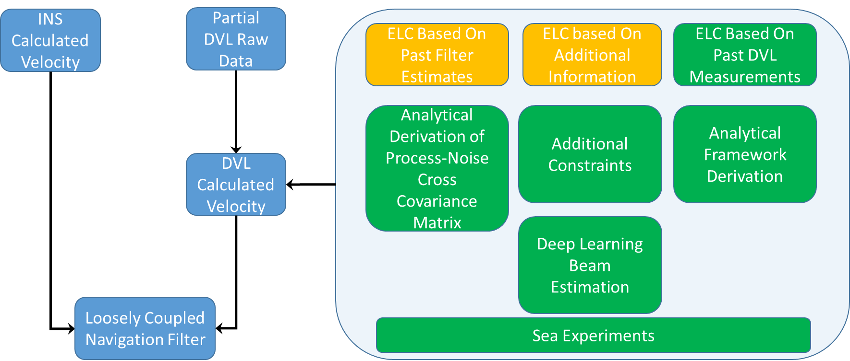

Figure 2: INS/DVL fusion with partial DVL measurements. The blue rounded rectangles present the ELC approach the orange ones the current state-of-the art and the greens show the proposed research directions topics.

The proposed research topics include:

1) Analytical derivation of the process-noise cross covariance matrix in the navigation filter.

Usually, in the derivation of the navigation filter (6)-(10) one of the underlying assumptions is that the process and measurement are not corralled. In fact, this is the case in INS/DVL fusion since the process noise depends on the INS inertial sensors while the measurement noise on the DVL. Yet, in the ELC approach when using past filter estimates the process-noise cross covariance matrix is not zero anymore since the filter solution depends both on the INS and DVL. This covariance matrix, **N**, is defined by [42]

$E\left[w,v_{}^{T}\right]=N$ (17)

where ***w*** is the process noise and ***v*** is the measurement noise. As a consequence of the nonzero process-noise cross covariance matrix the navigation filter error covariance and gain calculations (9)-(10) are modified to

$P_{k}^{+}=P_{k}^{-}-K_{k}\left[H_{k}P_{k}^{-}+N_{k}^{T}\right]$ (18)

$K_{k}^{}=\left[P_{k}^{-}H_{k}^{T}+N_{k}\right]{\left[H_{k}P_{k}^{-}H_{k}^{T}+{H_{k}N}_{k}{+H_{k}^{T}N_{k}^{T}+R}_{k}\right]}^{-1}$ (19)

In [21], using a numerical value for N, the influence of process-noise cross covariance matrix on the navigation accuracy was shown. Herein, we aim to calculate a closed form analytical solution for the cross covariance matrix using (17). When using this analytical derived matrix in (18)-(19) the accuracy of the navigation filter is expected to improve.

2) Additional constraints to enable the calculation of the velocity vector.

In [33] it was assumed that only one beam velocity is unavailable while in [34] even two for the tightly coupled approach. Herein, we aim to elaborate the ELC approach in several aspects including

* Address the case of only one available DVL beam measurement and using motion constraints assumptions and/or past DVL measurements construct the velocity vector need for the INS/DVL fusion.
* Add more approaches using motion constraints to the ELC framework when two beam DVL velocities are available.
* Make a clear distinction between ELC for both “+” and “x” DVL configurations and derive the proposed framework for both of the configurations.

3) Deep-Learning based beam velocity estimation.

Recently, machine and deep learning approaches are employed in navigation related applications. For example, in pedestrian dead reckoning, a commonly used approach for smartphone based indoor navigation, deep-learning approaches are used to classify the user dynamics (walking/escalator and etc.) [43-44] or smartphone location (texting/talking and etc.) [45-47], estimate the user step-length and heading angle [48-52]. Following the great success of deep-learning indoor navigation approaches, we aim to bring the same achievements to INS/DVL fusion. In this part, the objective is to use the partial beam measurements and additional information as input to a neural network in order to estimate the missing beam velocities. Next, with the measured and estimated beam velocities to calculate the AUV velocity (15) and apply the loosely coupled approach.

4) Analytical derivation of the ELC framework using past DVL measurements.

Both [33] and [34] use the last velocity estimation from the navigation filter. Both of them also don’t use the noise-process cross covariance matrix as required from the Kalman filter theory. To overcome this need, instead of using the filter estimated velocity we propose to use past DVL based velocity in order to calculate the missing DVL beams velocity. In other words, we aim to derive the ELC framework based only on DVL measurements to avoid the cross-covariance coupling.

3.2 Fusion with Complete DVL Outages

As in partial DVL measurement availability, in some situations during AUV operation none of the DVL beams are available. As a result, the DVL velocity update (15) is not available. Thus, the navigation solution will rely only on the INS one and hence will drift in time.

3.2.1 Preliminary Work

In [36] we derived an algorithm to enable the estimation of the velocity vector in situations of complete DVL outages, based on past DVL measurements. To that end, it was assumed that past DVL measured velocities from a segment of the AUV trajectory, $v\left(t\right)$, can be modeled as

$v\left(t\right)=v_{0}+a_{0}{\left(t-t_{0}\right)}^{}$ (20)

with constant but unknown vectors of the velocity $v_{0}$ and acceleration $a_{0}$. To solve for the unknown vectors, a minimization problem was analytically solved to yield close-form expressions, as a function of past DVL measurements. Using those estimated values for the velocity ${\hat{v}}_{0}$ and acceleration ${\hat{a}}_{0}$, the current velocity vector at time *j* of the AUV is found by

${\hat{v}}_{j}={\hat{v}}_{0}+{\hat{a}}_{0}{\left(t_{j}-t_{0}\right)}^{}$ (21)

Notice, that since $v_{0}$ and $a_{0}$, in (20), have six unknown parameters, the number of past velocity measurements to be used should be equal or greater than two.

3.2.2 Proposed Research

The proposed research goals as well as our preliminary work in the field are presented in Figure 3. In the blue rounded rectangles the flow chat of INS/DVL fusion with complete DVL measurements is presented. In orange, is the current state-of-the art in the field as described in Section 3.2.1 while in green the proposed research directions.

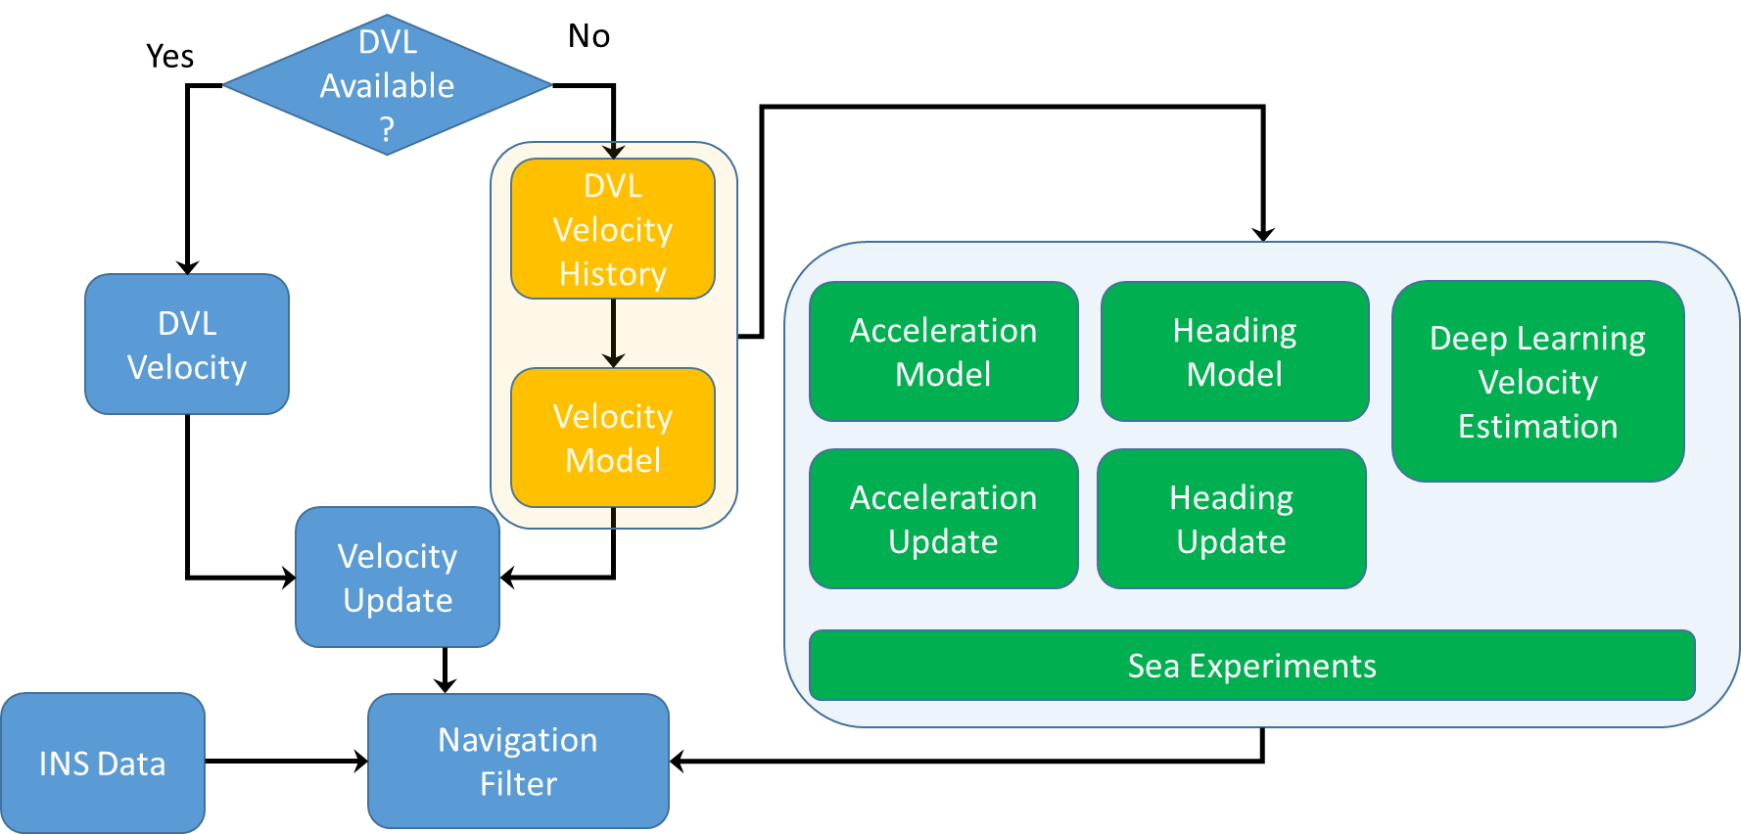

Figure 3: INS/DVL fusion when with or without DVL measurements. The blue rounded rectangles present the fusion process, the orange ones the current state-of-the art and the greens show the proposed research directions topics.

The proposed research directions are:

1) Acceleration model to enable accelerometers bias estimation.

When using DVL velocity measurements to update the navigation filter, the system is only partially observable, meaning that not all states in the state vector (1) could be estimated. Two of those states are the accelerometer *x* and *y* axis biases [25].

Now, with the analytical close form solution of the acceleration ${\hat{a}}_{0}$ (obtained from solving (20) using past DVL velocity measurements), at hand it could be used as an additional update to the navigation filter. With such update, we believe, that not only the accelerometer *x* and *y* axis biases will be observable, but also an improvement in the roll and pitch angles estimation accuracy. As a consequence, the overall estimation performance is expected to be improved in situations with no DVL updates.

2) Heading model to enable heading estimation.

In global navigation satellite system (GNSS) position and velocity updates (as well as in DVL velocity updates) the heading angle is not observable [35, 53]. To facilitate heading estimation its geometric constraint using the measured GNSS velocity vector is employed [54-56]

$ψ_{GNSS}=arctan\left({v_{E}^{GNSS}}/{v_{N}^{GNSS}}\right)$ (22)

where $v_{E}^{GNSS}$ and $v_{N}^{GNSS}$ are the GNSS measured velocity components in the east and north directions. Yet, the measured DVL velocity vector is given in the body frame and therefore, (22) cannot be utilized even when those measurements are available.

Since most AUVs operates in low velocities and mainly in straight line trajectories, we propose to leverage from this behavior and use past estimated AUV velocity vectors from the navigation filter to estimate the heading angle as in (22). Assuming the underlying assumptions are valid, the calculated heading angle will also help to estimate the gyro *z* axis bias. When using this proposed approach, the process measurement cross covariance matrix (17) should be taken into account and we aim to analytically calculate it and employ in the navigation filter.

3) Deep Learning based velocity estimation.

In this part, our goal is employ deep-learning based algorithms to estimate the AUV velocity vector, which in turn will be used in the navigation filter. To that end, we propose to different directions:

* In [36] we showed that our theoretical model (20), used to estimate the current velocity vector expressed in the body frame, is valid using sea experiments. There, we presented means to calculate the initial velocity and acceleration vectors based on past DVL measurements. Herein, we aim to use deep learning approaches and leverage their noise reduction ability to estimate the initial velocity and acceleration vectors and by plugging them into (21) to obtain the current velocity vector in the body frame.
* Instead of using past DVL measurements, we propose to use the AUV’s inertial sensors readings to estimate directly the AUV velocity vector in the navigation frame.

3.3 Enhanced DVL/INS Fusion Using Machine and Deep Learning Approaches

Our goal is to employ machine and deep learning approaches to improve the performance of INS/DVL fusion in situations when all DVL measurements are available. To that end, we consider the regression of four different quantities, as presented in Figure 4, to be estimated.

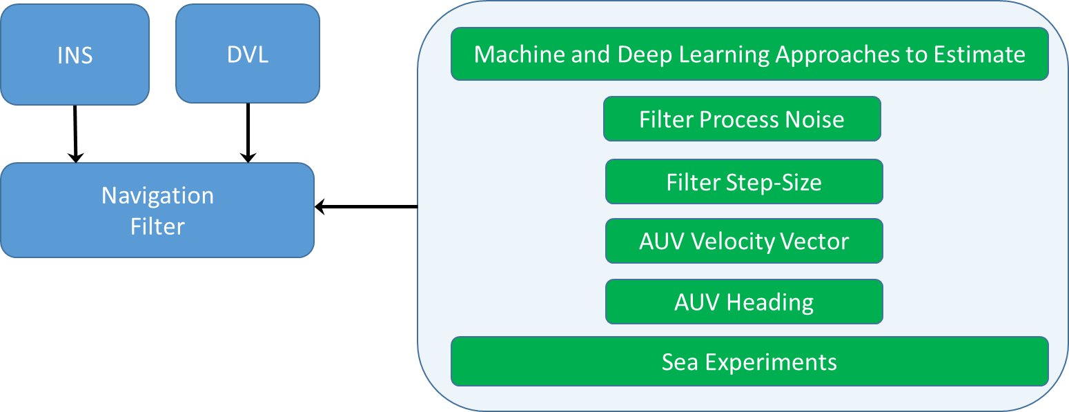

Figure 4: INS/DVL fusion. The blue rounded rectangles present a top-view of the fusion process while the green ones show the proposed research directions topics.

Those include:

* Filter Process Noise – the navigation filter requires knowledge of the inertial sensors noise statistics in order to accurately determine the process noise covariance [37-38]. Together with the measurement noise covariance they determine the filter accuracy and bandwidth [41-42]. Although commonly assumed to be known, in practice, the noise covariances are generally unknown and vary during operation. Using deep learning, we aim to estimate the time varying process noise covariance taking into account real-time conditions and thereby improving the filter ability to change its bandwidth and improve the overall navigation accuracy.
* Filter Step-Size – the step size, defined as the difference between two successive time steps, is selected according to the scenario type and computational constraints. Generally, reducing the step size improves the estimation error accuracy with the cost of a high computational load. This trade-off raises the issue of choosing an appropriate step size. To avoid this conflict, our objective is to propose a criterion to act as a guideline for a reasonable choice of the step size and then used machine and deep learning approaches to estimate it.
* AUV Velocity Vector – two different input types are considered as inputs to a neural network architecture to regress the AUV velocity. First, is the measured four beams velocities to yield the AUV velocity vector in the body frame and also in the navigation frame. In the former, instead of using (15) deep learning will be used while in the latter, instead of using a body to navigation transformation the velocity will be regressed directly in the navigation frame. Second, the inertial sensors readings with or without DVL beam velocities to output the velocity vector in the navigation frame. Regardless of the input type, we aim to achieve improved accuracy in the velocity estimate before it is introduced to the navigation filter.
* AUV heading – following the methodology proposed in Section 3.2.2, we further extend it and propose using also current and past DVL beams velocity as input to a neural network to regress the AUV heading angle.

3.4 Sea Experiments and Datasets

Currently we are negotiating with several AUV manufactures to purchase a one-man portable micro-AUV equipped with an INS and DVL to conduct the sea experiments. We estimate that each year at least five sea days will be required making a total of 20 days during four years. Our goal in conducting the sea experiments is twofold:

1. Algorithm validation. Record inertial sensors and DVL data in order to validate the proposed methods and algorithms.
2. Dataset generation. In addition to the theoretical contributions, a major goal of this research is to create extensive datasets of underwater navigation with ground-truth and to publish it online.

3.5 Personal and Facilities

The PI has a strong background in inertial sensors, navigation, estimation theory, Doppler velocity log, machine learning and deep-learning. Both in theory and in practice. In addition, the PI brings not only an academic viewpoint but also an industry one from his 15 years exceptional experience in the industry at leading companies in Israel. In addition, he has extensive experience in the core methodologies of inertial navigation systems including building some experimental systems to conduct experiments in the field.

Relevant examples includes more than 30 papers about inertial navigation, estimation and tracking, attitude deamination and alignment, multiple navigation systems, INS/DVL and INS/GPS fusion and machine and deep learning approaches for navigation applications.

His group consists of a fulltime research assistant, two Ph.D. candidates and ten M.Sc. students (one Ph.D. and one M.Sc. students are already working on related topics).

The PI’s Autonomous Navigation and Sensor Fusion Lab (<http://marsci.haifa.ac.il/labs/ansf/>) includes a high-end INS/GNSS system with real time kinematic (RTK) capabilities, two massive multi-inertial measurement unit array module each has 192 inertial sensors. In addition, currently we are negotiating with several AUV manufactures to purchase a one-man portable micro-AUV equipped with an INS and DVL and also one underwater drone.

The lab is located in the Helmsley Mediterranean Sea Research Center at the University of Haifa, that comprises an advanced underwater vehicle maintenance workshop, a salt water test pool, and fully equipped electronics and mechanical workshops. Underwater experiments will take place in the Mediterranean Sea.

Time Schedule and Work-Plan

|  |  |  |
| --- | --- | --- |
| Objective | Beginning | End |
| Develop the ELC approach based on past filter measurements | Oct 2021 | Oct 2021 |
| Develop the ELC approach based on additional information |  |  |
| Derive the ELC framework based on past DVL measurements |  |  |
| Develop acceleration model aiding in situations of complete DVL outages |  |  |
| Develop heading model aiding in situations of complete DVL outages |  |  |
| Drive deep-learning framework for velocity estimation in situations of complete DVL outages |  |  |
| Generate datasets of INS and DVL measurements including ground truth obtained from sea experiments |  |  |
| Filter process noise covariance analytical and regression based approaches |  |  |
| Derive filter step-size approaches |  |  |
| Develop a velocity vector regression framework using both INS and DVL outputs |  |  |
| Derive approaches to estimate the AUV heading angle |  |  |

Explanatory Notes:

All objectives require both theoretical and experimental work, where some of the experiments can be joint for several objectives.

Two full time Ph.D. students will work on the project, with a half-time engineer assisting in all technical and experimental aspects.

We will embark on experiments as soon as possible, to strengthen the theoretical development with real data, and provide data to develop and test the methods. The experimental activity will run in parallel to the theoretical activity and will last through the four-year duration of the grant, with the first half of year devoted to equipment purchase and to establish a web server to post the datasets online. The engineer will be responsible for this activity and will conduct it jointly with the Ph.D. students.

The theoretical and algorithm development will be done by two Ph.D. students with the following rough division of topics:

Ph.D. #1 will work on: INS/DVL fusion with partial DVL measurements (roughly in years 1-2), and fusion with complete DVL outages (roughly in years 3-4).

Ph.D. #2 will work on analytical and deep learning methods for estimating an adaptive process noise covariance and appropriate filter step size (roughly in years 1-2) and various approaches to estimate the AUV velocity and heading angles using deep-learning methods (roughly in years 3-4).