[](https://www.google.co.il/url?sa=i&rct=j&q=&esrc=s&source=images&cd=&cad=rja&uact=8&ved=0ahUKEwjyue7wocbQAhXJnBoKHXcJCwIQjRwIBw&url=https://he.wikipedia.org/wiki/%D7%A7%D7%A8%D7%99%D7%94_%D7%9C%D7%9E%D7%97%D7%A7%D7%A8_%D7%92%D7%A8%D7%A2%D7%99%D7%A0%D7%99_%E2%80%93_%D7%A0%D7%92%D7%91&psig=AFQjCNF2RSZWN96pBqoajKPvBm3Zkn4b2g&ust=1480244216452532)Israel Atomic Energy Commission

Shimon Peres Nuclear Research Center

POB 9001, Beer Sheva, 84190 Israel

December 06, 2016

Professor Craig Buckley,

Curtin University

Perth, Western Australia

Dear Prof. Buckley

I am planning to take a Sabbatical leave of absence for a year starting at the end of July 2017, from my position as Research Associated, at the Material Department, Shimon Peres Nuclear Research Center.

I would like to inquire whether you would be able to offer me a suitable research position for this period. I am enclosing my curriculum vitae for your perusal.

Thank you for your kind assistance and I look forward to hearing from you soon.

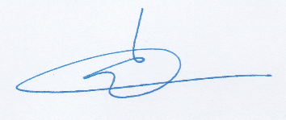Yours sincerely,

Dr. Gabriel Zamir (Solovioff)