**P. 241**

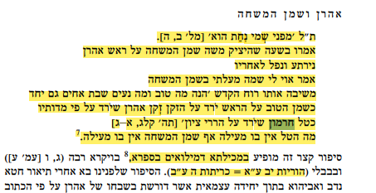

The verse states: *For he stood in awe of My name* (Mal. 2:5). They said: At the moment when Moses spilled the anointment oil on Aaron's head, he recoiled and fell backwards, saying: Woe unto me for defiling the anointment oil! Whereupon the Holy Spirit responded: *How good and how pleasant it is that brothers dwell together. It is like fine oil on the head running down onto the beard, the beard of Aaron, that comes down over the collar of his robe; like the dew of Hermon that falls upon the mountains of Zion* (Ps. 133:1-3). Just as the dew is not defiled, the oil of anointment is not defiled.

In the Mekilta de-Millu'im of the Sifra

b. Hor. 12a = b. Ker. 5b

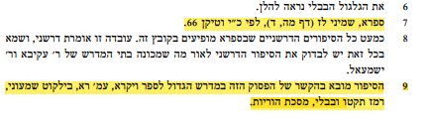

Sifra, Shemini 37 (p. 45d), Vatican MS 66.

This story is brought in connection with this verse in the Midrash HaGadol to the Book of Leviticus, p. 201, in Yalqut Shimoni no. 515 and in the Babylonian Talmud, in Tractate Horayot.

**P. 242**

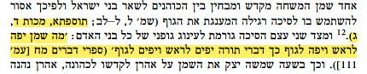

t. Mak. 4:3

Just as oil is good for the head and good for the body, so, words of Torah are good for the head and good for the body (Sifre Deut. 48 [p. 111]).

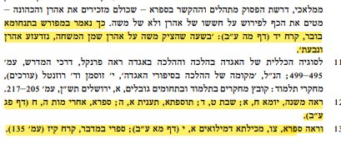

This is clearly stated in Tanḥuma Buber, Koraḥ 14 (p. 45b): “At the moment when Moses spilled the anointment oil on Aaron's head, Aaron recoiled and fell backwards.”

12 See m. Yoma 8:1; m. Sabb. 9:4; t. Ta’an. 1:5; Sifra Aḥarei Mot 5:8 (p. 83b)

13 See also Sifra, Tzav, Mekilta de-Millu'im 1:10 (p. 41b); Sifre Num. Koraḥ 117 (p. 135).

**P. 243**

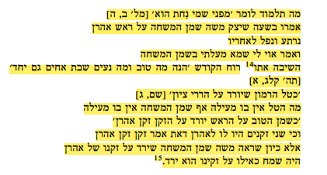

What is the meaning of the verse that states: *For he stood in awe of My name* (Mal. 2:5). They said: At the moment when Moses spilled the anointment oil on Aaron's head, he recoiled and fell backwards, saying: Woe unto me for defiling the anointment oil! Whereupon the Holy Spirit responded: *How good and how pleasant it is that brothers dwell together* (Ps. 133:1). *Like the dew of Hermon that falls upon the mountains of Zion* (Ps. 133:3). Just as the dew is not defiled, the oil of anointment is not defiled. *It is like fine oil on the head running down onto the beard, the beard of Aaron, that comes down over the collar of his robe* (Ps. 133:2). But did Aaron possess two beards, that you say: *the beard, the beard of Aaron*? Rather, when Moses saw the anointment oil running down Aaron’s beard, he rejoiced as if it had been running down his own beard.



That the “teachings of R. Ḥiyya” that appears Leviticus Rabba are, in fact, our Sifra.

**P. 244**



In Song of Songs Rabbah in the name of R. Aḥa.

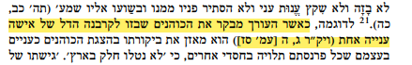

For example, when the editor criticizes the priests who scorn the meager offering brought by a poor woman (Lev. Rab. 3:5 [p. 67])

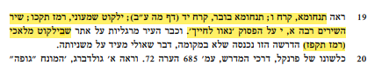

See Tanḥuma, Koraḥ 6; Tanḥuma Buber, Koraḥ 14 (p. 45b); Yalqut Shimoni no. 526; Song Rab. 1:10 on the verse *Your cheeks are comely.* And Margaliot has already noted there that in the Yalqut Malachi (no. 587)

**P. 246-247**

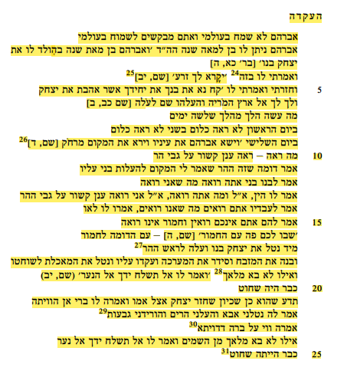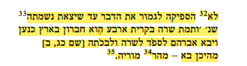

The Binding of Isaac

Abraham was not happy in my world, so would you seek to be happy in my world? Abraham had a son born to him at the end of a hundred years, as Scripture writes: *Now Abraham was a hundred years old when his son Isaac was born to him* (Gen. 21:5). And I said to him, it is with this one24 *that offspring shall be continued for you* (Gen. 21:12).25 And then I said to him: *Take your son, your favored one, Isaac, whom you love, and go to the land of Moriah, and offer him there as a burnt offering on one of the heights that I will point out to you* (Gen. 22:2). What did he do? He went on a three day journey. On the first day he saw nothing. On the second day he saw nothing. On the third day: *Abraham looked up and saw the place from afar* (Gen. 22:4).26 What did he see? He saw a cloud joined to the mountain. He said: It appears to me that this is the place to which I was commanded to bring my son up. He said to his son: My son, do you see what I see? He responded: Yes. He said to him: And what do you see? He responded: I see a mountain with a cloud joined to it. He said to his servants: Do you see what we see? They responded: We do not. He said to them: You do not see, and the ass does not see. *You stay here with the ass* (Gen. 22:5) – a people that is similar to an ass. He immediately took his son Isaac and went up to the top of the mountain.27 Then he built the altar, arranged the wood, bound him upon the altar, and took the knife. If the angel28 had not come and said to him: *Do not raise your hand against the boy* (Gen. 22:12), he would have already been slaughtered. Proof to this idea is that when he came to his mother, and she said to him: My son, where have you been? He told her: Father took me, brought me up mountains, brought me down valleys.29 She said to him: Woe to you, my poor son!30 If the angel had not come from heaven and said to him *Do not raise your hand against the boy,* you would have already been slaughtered.31 She did not32 succeed in finishing the sentence before her breath departed33 from her as it says: *Sarah died in Kiriath-arba—now Hebron—in the land of Canaan; and Abraham came to mourn for Sarah and to bewail her*. From where did he come? From Mount34 Moriah.35

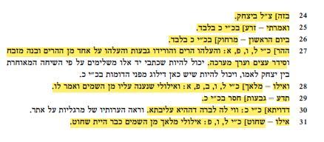

24 with this one] this should read *through Isaac.*

25 And I said to him - *offspring shall be continued for you*] appears only in MS K.

26 On the first day - *from afar*] appears only in MS K.

27 the mountain] In MS L, V, P, A: And he brought him up mountains and brought him down valleys, and brought him up to one of the mountains and built an altar and set up the wood and made the arrangement.

28 If the angel] In MS L, V, B, P, A: And had he not received a response from heaven saying to him.

29 Proof – valleys] This is missing in MS K.

30 Poor son] In MS K: Woe to the son of that poor woman.

31 If – slaughtered] In MS L, V, P: Were it not for the angel from heaven you would have already been slaughtered.

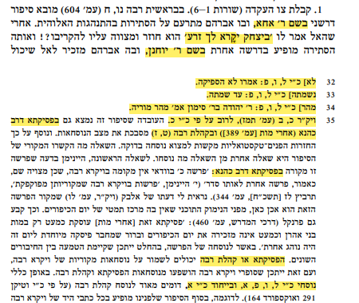

in the name of R. Aḥa

it is through Isaac that offspring shall be continued for you

in the name of R. Yoḥanan

32 She did not] MS L, V, P: They said, she did not

33 her breath] MS L, V, P: before she died

34 From Mount] MS L, V, P: R. Yehudah son of R. Simon said: From Mount Moriah.

35 Lev. Rab. 20:2 (p. 447), mainly based on MS K.

in Pesiqta de Rab Kahana (Aḥarei Mot [p. 389]) and in Ecclesiastes Rabbah (9:7)

in Pesiqta de Rab Kahana

The Pesiqta or Ecclesiastes Rabbah

The textual variants in MS L, V, P, A, and in particular, MS A,

**P. 248- 249**

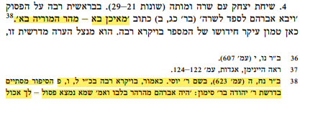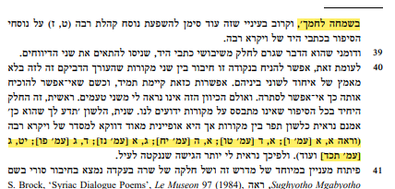

From where did he come? He came from Mount Moriah.

38 Gen. Rab. 58:5 (p. 623), in the name of R. Yosi. As noted, on Lev. Rab. MS L, V, P the story concludes with the teaching of R. Yehudah son of R. Simon: Abraham contemplated in his heart and said: perhaps he was found unfit - *Go, eat your bread in gladness.*

40…to the compiler of Lev. Rab. (see 1:1 [p. 6], 1:4 [p. 15], 1:5 [p. 18], 3:1 [p. 57], 4:3 [p. 81], 19:3 [p. 424]

**p. 250**

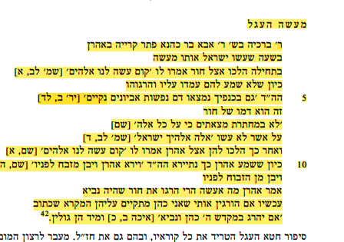

The Golden Calf

R. Berakhyah said in the name of R. Aba Bar Kahana expounding on the verse about Aaron. At the time when the Israelites were about to commit the act, they first came to Ḥur, and they said to him: *Come, make us a god* (Exod. 32:1). Since he did not listen to them, they rose up and slew him. This is why it is written: *Moreover, on your garments is found the lifeblood of the innocent poor* (Jer. 2:34). This refers to the blood of Ḥur. *You did not catch them breaking in. Yet, despite all these things* (Jer. 2:34) it was because they did not fulfill *This is your god, O Israel* (Exod. 32:4). Afterwards, they went to Aaron and said to him: *Come, make us a god* (Exod. 32:1). When Aaron heard this, he became frightened, as is written: *When Aaron saw this, he built an altar before it* (Exod. 32:5), meaning: he understood because of the one who had been slaughtered before him. Aaron said, what should I do? They have already killed Ḥur, who was a prophet. Now if they kill me, the priest, they will fulfill what is written in Scripture: *Alas, priest and prophet are slain In the Sanctuary of the Lord!* (Lam. 2:20), and will immediately be exiled.

**p. 251**

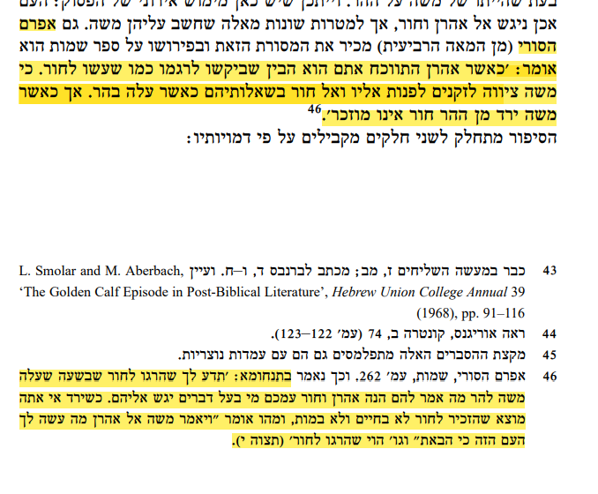

The 4th Century saint, Ephrem the Syrian was also familiar with this tradition, and in his commentary to the Book of Exodus he writes: When Aaron argued with them he understood that they wanted to stone him as they had done to Ḥur, since Moses had instructed them to direct their questions to him and to Ḥur while he was on the mountain. Yet when Moses came down from the mountain, Ḥur is no longer mentioned.

46 Ephrem the Syrian, Exodus, p. 262. The Tanḥuma (Tetzaveh 10) presents it as follows: Proof of the fact that they killed Ḥur is that when Moses went to climb the mountain he said to the elders: *You have Aaron and Hur with you; let anyone who has a legal matter approach them* (Exod. 24:14). Yet when he came down from the mountain you find no mention of Ḥur, neither with the living nor with the dead. So when it says: *Moses said to Aaron, “What did this people do to you that you have brought such great sin upon them?”* (Exod. 32:21) it was that they had killed Ḥur.

**p. 252**

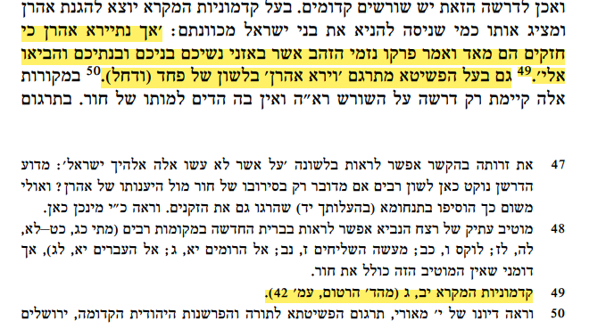

But Aaron was fearful because they were very powerful, and he said to them: *Take off the gold rings that are on the ears of your wives, your sons, and your daughters, and bring them to me* (Exod. 32:2). The author of the Peshitta also translates v. 5 as *Aaron became fearful* rather than *When Aaron saw this.*

49 *Biblical Antiquities* 12:3 (Hartum ed. P. 42).

**p. 253**

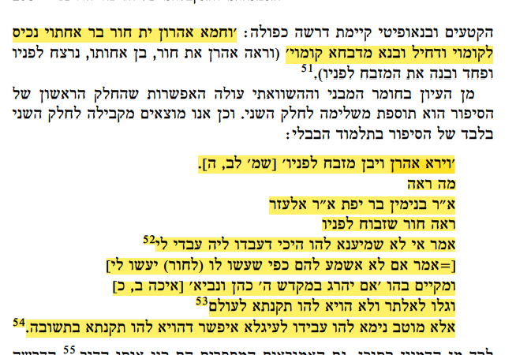

An Aaron saw his sister’s son Ḥur murdered before his eyes, and he became frightened and built an altar before him.

When Aaron saw this, he built an altar before it (Exod. 32:5). What did he see? R. Binyamin bar Yefet says that R. Elazar says: He saw Ḥur slaughtered before him. Aaron said: If I do not listen to them now, they will do to me as they did to him, and they will fulfill the verse: *Alas, priest and prophet are slain In the Sanctuary of the Lord!* (Lam. 2:20). They will be exiled immediately and they will never have a remedy forever. It is better for me to tell them to worship the calf; perhaps they will have a remedy through repentance.

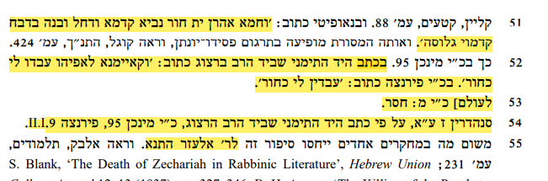

51 “And Aaron saw Ḥur the prophet before him and he became frightened and built an altar before the calf.”

52 In the Yemenite manuscript held by Rabbi Herzog the text reads: If I stand up to them, they will do to me as they did to Ḥur. In MS Florence it reads: They will do to me like Ḥur.

53 forever] is missing in MS M.

54. b. Sanh. 7a, according to the Yemenite manuscript held by Rabbi Herzog, MS Munich 95, Florence II.I.9.

**p. 255**

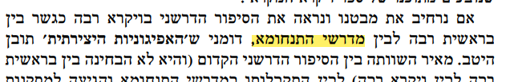

as a bridge between Genesis Rabbah and the Tanḥuma midrashim,

**p. 257**

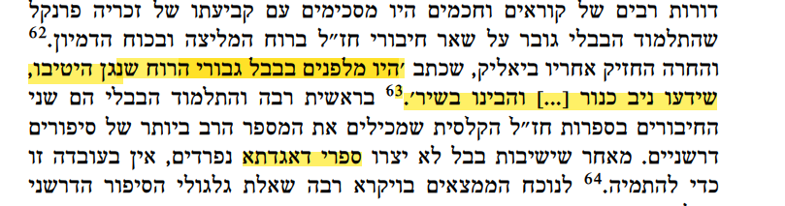

In days of old in Babylonia there were men of great spirit who excelled at music and who knew the language of the harp…and understood poetry.

Aggadic works

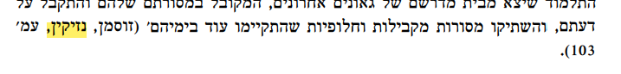

(Y. Sussman, “Nezikin,” p. 103)

**p. 258-259**

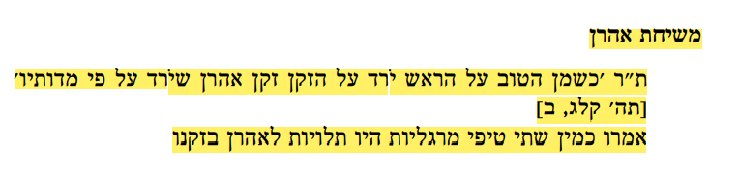 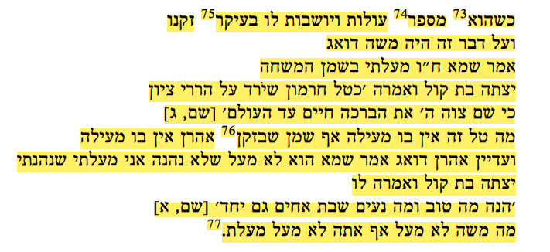

The Annointing of Aaron

The Sages taught: *It is like fine oil on the head running down onto the beard, the beard of Aaron, that comes down over the collar of his robe* (Ps. 133:2). Two drops of anointing oil, shaped like pearls, were suspended for Aaron from his beard. When he73 would speak74 those drops would rise and settle on the roots75 of his beard. Moses was concerned about this matter. He said: Perhaps, Heaven forfend, I misused the consecrated anointing oil. A Divine Voice emerged and said: *like the dew of Hermon that falls upon the mountains of Zion. There the LORD ordained blessing, everlasting life* (Ps. 133:3). Just as there is no misuse of the dew of Hermon, so too, regarding the anointing oil that is on Aaron’s beard,76 there is no misuse of consecrated property.And still Aaron was concerned. He said: Perhaps he did not misuse consecrated property; but perhaps I misused consecrated property, as I enjoy it. A Divine Voice emerged and said to him: *How good and how pleasant it is that brothers dwell together* (Ps 133:1). Just as Moses did not misuse consecrated property, so too, you did not misuse consecrated property.77



of a baraita

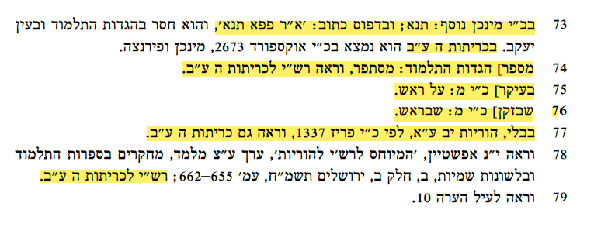

73 In MS Munich: It was taught. The printed version reads: R. Pappa said that it is taught,

In b. Ker. 5b

74 would speak] In Haggadot HaTalmud: When he trimmed his beard, see Rashi to b. Ker. 5b.

75 roots] MS M: on the head.

76 beard] MS M: that are on the head.

77 b. Hor. 12a, according to MS Paris 337. See also b. Ker. 5b.

Rashi on b. Ker. 5b.

**p. 260-261**

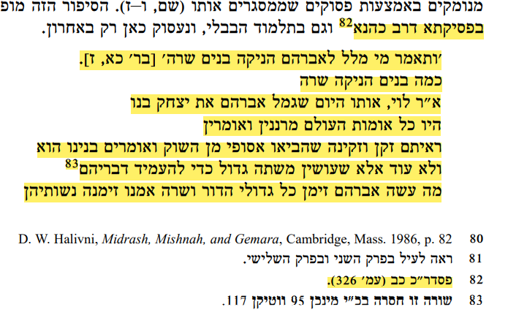

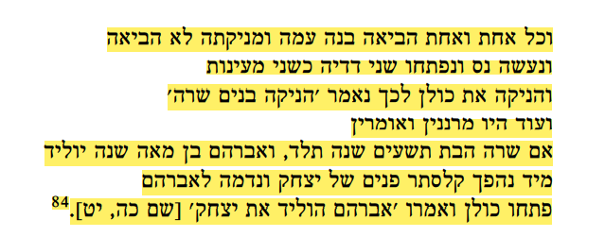

In Pesiqta of Rab Kahana82

*Who would have said to Abraham That Sarah would suckle children!* (Gen. 21:7). How many children did Sarah nurse? Rabbi Levi says: That day when Abraham weaned his son, Isaac, all of the nations of the world were gossiping and saying to each other: See this old man and old woman who brought a foundling from the market and are saying: He is our son. Moreover, they are making a great feast to bolster their claim.83 What did Abraham, our forefather, do? He went and invited all of the great men of that generation, and Sarah, our foremother, invited their wives. Each and every one brought her child with her but did not bring her wet nurse. And a miracle occurred to Sarah, our foremother, and her breasts were opened like two springs, and she nursed all of these children. And still those people were gossiping and saying to each other: Even if Sarah, at ninety years of age, can give birth, can Abraham, at one hundred years of age, father a child? Immediately, the countenance of Isaac’s face transformed and appeared like that of Abraham. Everyone exclaimed and said: *Abraham begot Isaac* (Gen. 25:19).84



82 Pesiq. Rab Kah. 22 (p. 326).

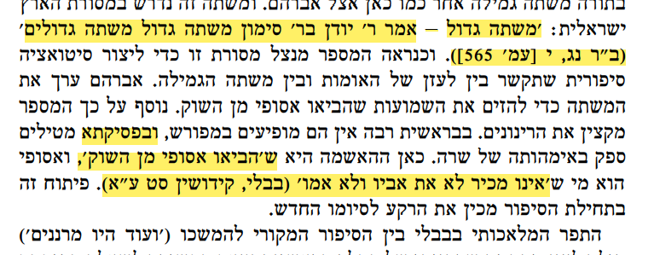

*A great feast* – R. Yuden son of R. Simon said: *A great feast* – a feast of great men (Gen. Rab. 53:10 [p. 565]).

…and in the Pesiqta

That they brought a foundling from the market

A foundling is anyone who was collected from the marketplace and does not know the identity of both his father and his mother (b. Qidd. 69a).

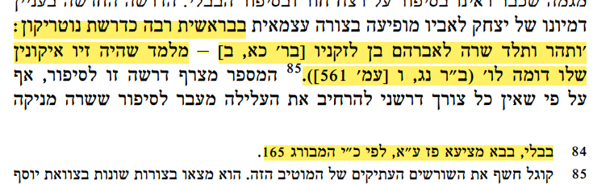

In Genesis Rabbah it appears as a homily based on word-play: Sarah conceived and bore a son to Abraham in his old age [*lezekunav*] (Gen. 21:2) – this teaches us that his *ziv ikonin* – his features – were similar to his [father’s] (Gen. Rab. 53:6 [p. 561]).

84. b. B. Meṣ. 87a, according to MS Hamburg 165.

**p. 261-262**

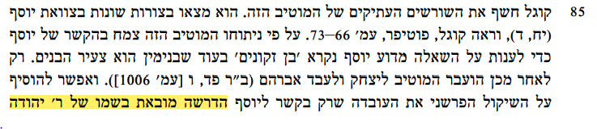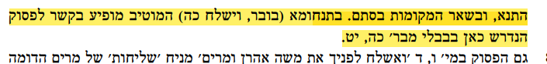

Only with regard to Joseph do we find that the homily appears in the name of R. Judah the tanna; in all other places is appears anonymously. In the Tanhuma (Buber Vayishlah 25) this motif appears in connection with the verse that is found here in the Bavli, from Gen. 25:19.

**p. 263**

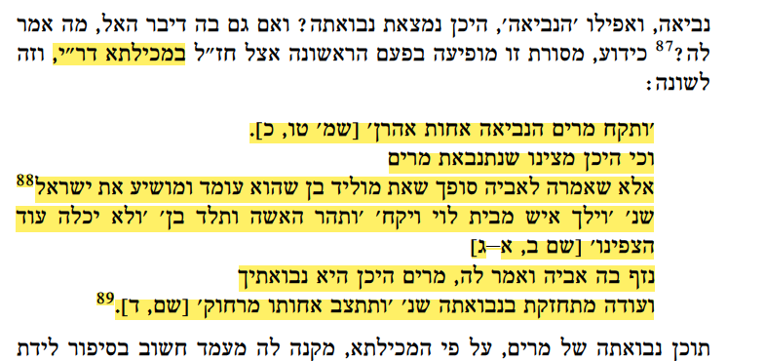

In the Mekilta of R. Ishmael

*Then Miriam the prophetess, Aaron’s sister* (Exod. 15:20). Yet where do we find that Miriam offers prophecy? Rather, she said to her father: In the end, you will beget a son who will rise up and be the savior of Israel,88 as it says: *A certain man of the house of Levi went and married … The woman conceived and bore a son … When she could hide him no longer* (Exod. 2: 1-3). Whereupon her father rebuked her, saying: My daughter, where is your prophecy? But she stood fast to her prophecy, as it says: *And his sister stationed herself at a distance* (Exod. 2:4).89

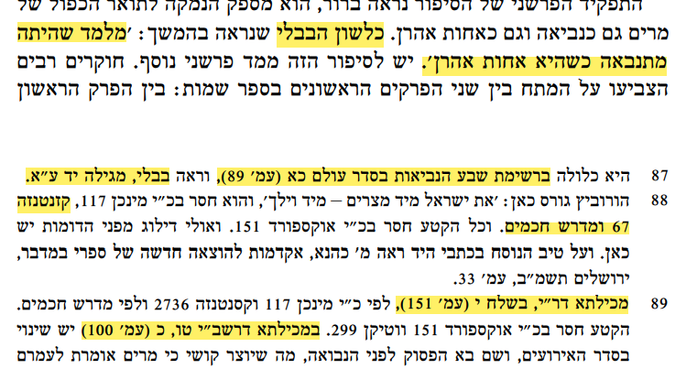

As the Bavli expresses it: Teaching you that she prophesied when she was the sister of Aaron.

87 She is included in the list of the seven prophetesses that appears in Seder Olam 21 (p. 89). See also b. Meg 14a.

88 Casanatense 67 and Midrash Ḥakhamim.

89 Mek. of R. Ishmael, Beshalaḥ 10 (p. 151),

Mek. of R. Simeon ben Yoḥai 15:20 (p. 100)

**p. 264**

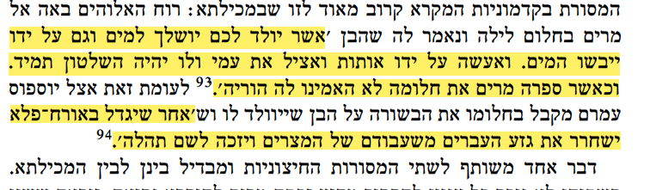

The child that will be born to you will be thrown into the water, but also, by his hand, the waters will dry up. And I will perform miracles by his hand and I will save my nation, and he will rule forever. But when Miriam told her dream to her parents, they did not believe her.

And after he is brought up in a miraculous manner, he shall deliver the Hebrew nation from the distress they are under from the Egyptians, and he will merit fame among all.

**p. 266**

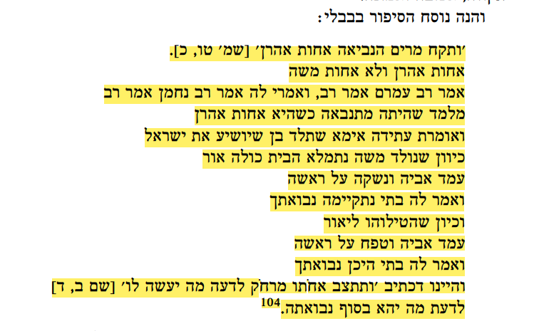

*Then Miriam the prophetess, Aaron’s sister* *took* (Exod. 15:20). Is she Aaron’s sister and not the sister of Moses? Rav Amram says that Rav says, and some say that Rav Naḥman says that Rav says: This teaches that Miriam already prophesied when she was still the sister of only Aaron, and she would say: In the future, my mother will give birth to a son who will save the nation of Israel. And once Moses was born, the entire house was filled with light. Her father arose and kissed her on her head. He said to her: My daughter, your prophecy has been fulfilled. And once they put him into the river, her father arose and hit her on her head. He said to her: My daughter, where is your prophecy? And this is as it is written: *And his sister stationed herself at a distance, to learn what would befall him* (Exod. 2:4), to know what will be the ultimate resolution of her prophecy.

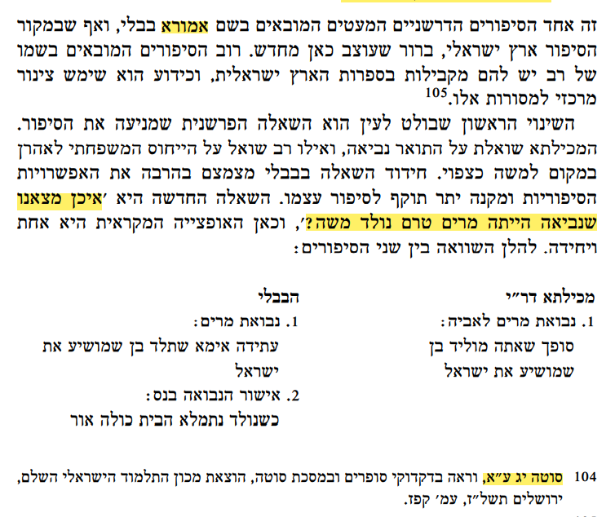

A Babylonian amora

The new question is: Where do we find that Miriam was a prophetess prior to the birth of Moses?

104 b. Sota 13a

**p. 267**

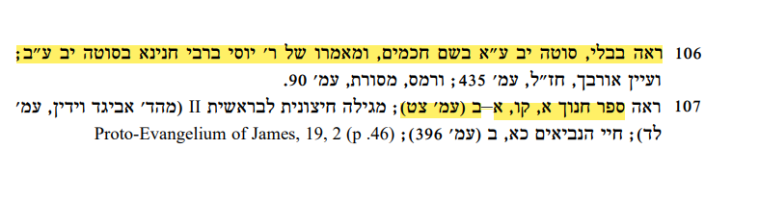

106 See. B. Sota 12a in the name of the sages and the statement of R. Yosei, son of Rabbi Ḥanina on b. Sota 12b;

107 See the Book of Enoch I:106:1-2 (p. 99)

**p. 268-269**

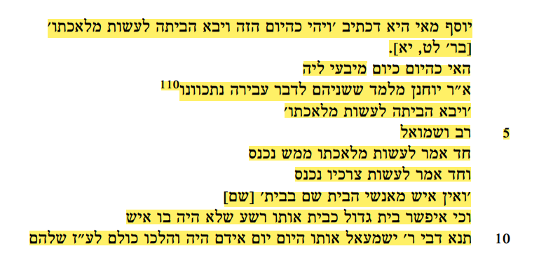

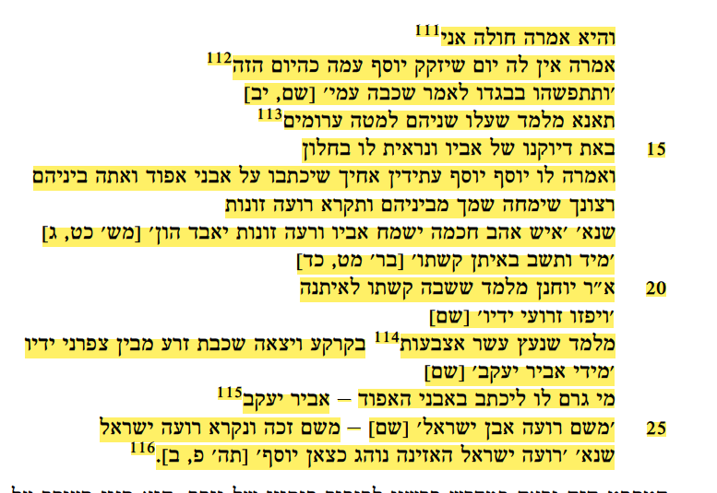

What is the situation of Joseph? As it is written: *One such day, he came into the house to do his work.* (Gen 39:11). R. Yoḥanan says: This teaches that they both intended to perform a matter of sin.110 *He came into the house to do his work* - Rav and Shmuel. One says: It means that he went into the house to do his work, literally. And one says: He entered the house in order to fulfill his needs. *None of the household being there inside* (Gen. 39:11). Is it possible that in such a large and important house like the house of that wicked man that no one was in there? The school of Rabbi Yishmael taught: That day was their festival day and they all went to their house of idol worship; and she told them that she was sick111 saying she would have no better day for Joseph to couple with her like this day.112 The verse states*: she caught hold of him by his garment and said, “Lie with me!”* (Gen. 39:12). This teaches that the two of them climbed onto the bed naked.113 At that moment his father’s image came and appeared to him in the window. The image said to him: Joseph, the names of your brothers are destined to be written on the stones of the *ephod*, and you are to be included among them. Do you desire your name to be erased from among them, and to be called an associate [*ro’eh*] of promiscuous women? As it is written: *A man who loves wisdom brings joy to his father*, *But he who keeps company* [ro’eh] *with harlots will lose his wealth* (Prov 29:3). Immediately: *Yet his bow stayed taut* (Gen. 49:24). R. Yoḥanan says in the name of R. Meir: This means that his bow, returned to its strength. *And his arms were made firm* (Gen. 49:24), meaning that he dug his ten fingers114 into the ground and his semen was emitted between his fingernails. *By the hands of the Mighty One of Jacob* (Gen. 49:24). Who caused his name to be etched onto the stones of the *ephod*? It was only the might of Jacob.115 *There, the Shepherd, the Rock of Israel* (Gen. 49:24) means: From there, because of Joseph’s ability to withstand this trial, he merited to become a shepherd [*ro’eh*] of the Jewish people, as it is stated: *Give ear, O shepherd of Israel who leads Joseph like a flock!* (Ps. 80:2).116

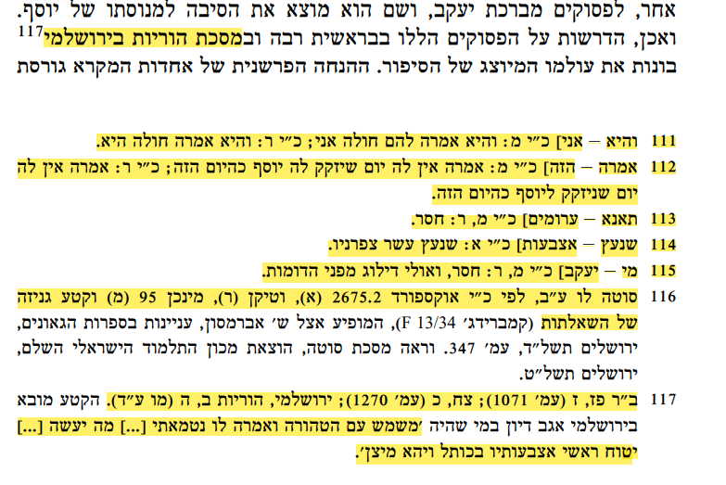

In Tractate Horayot in the Jerusalem Talmud.

111 she – sick] MS M: She told them: I am sick; MS R: She said that she was sick.

112 saying – day] MS M: She said she would have no better day for Joseph to couple with her that this day; MS R She said she would have no better day to couple with Joseph like this day.

113 taught – naked] MS M, R, missing.

114 dug – fingers] MA A: That he dug ten fingernails.

115 Who – Jacob] MS M, R: Missing, perhaps because of the parallel structure.

116 b. Sota 36b, according to MS Oxford 2675.2 (A), Vatican (R), Munich 95 (M) and a Geniza fragment from the She’iltot.

117. Gen. Rab. 87:7 (p. 1071); 98:20 (p. 1270); y. Hor. 2:5 (46d). In the Jerusalem Talmud this is brought as a segue from a discussion of the case of someone who was engaged in sexual relations with a woman who was pure who told him that she had become a menstruant…What should he do?...He should dig his fingertips into the wall until he becomes flaccid.

**p. 270**

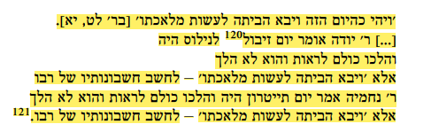

*One such day, he came into the house to do his work* (Gen. 39:11).

R. Yehuda says, it was the day of fertilizing120 the Nile and all had gone to see it, and he did not go, rather, *he came into the house to do his work* – to calculate his master's calculations. R. Nehemiah says, it was a day of the theater and all had gone to see it, and he did not go. Rather *he came into the house to do his work* – to calculate his master's calculations.121

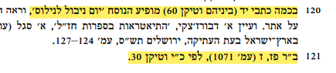

120 In some manuscripts (Vatican 60, among them) the text reads: A festival day of the Nile.

121 Gen. Rab. 87:7 (p. 1071), according to MS Vatican 30.

**p. 271-272**

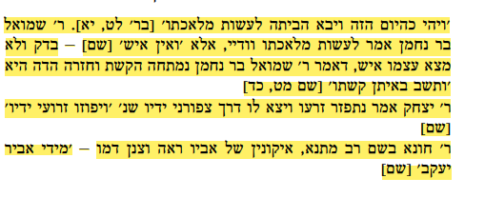



*One such day, he came into the house to do his work* (Gen. 39:11).

R. Shmuel son of Naḥman says: certainly *to do his work*, except *there* *was no man there* (Gen. 39:11) – he searched himself, and he did not find himself to be a man, as R. Shmuel son Naḥman said: that his bow stretched and returned, as is written: *Yet his bow stayed taut* (Gen 49:24). R. Yitzḥak says, his seed was scattered and went out by way of his fingernails, as it says: *And his arms were made firm* (Gen. 49:24). R. Ḥuna in the name of Rav Matana: He saw his father’s image and his blood ran cold – *By the hands of the Mighty One of Jacob* (Gen. 49:24). R. Ḥuna in the name of R. Aba: He saw his mother’s image and his blood ran cold - *There, the Shepherd, the Rock of Israel* (Gen. 49:24). Who did this? *The God of your father who helps you* (Gen. 49:25).

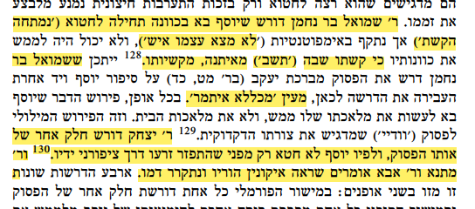

R. Shmuel son of Naḥman teaches that Joseph came, intending, at first, to sin (“that his bow stretched”) but found himself impotent (“he did not find himself to be a man”), and he was unable to fulfill his intentions since “his bow returned” from being taut, from its hardness. Perhaps R. Shmuel son of Naḥman…as if it were “stated by inference.”

R. Yitzḥak’s teaching is based on another part of the same verse, according to which Joseph did not sin only because his seed was scattered by way of his fingernails. R. Matana and R. Aba both suggest that when he glimpsed his parents’ images, his blood ran cold.



125 Sifra, Aḥarei Mot 9 (p. 86a).

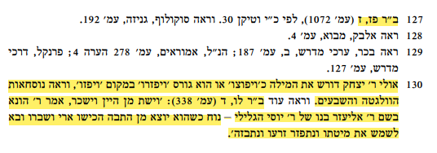

127 Gen. Rab. 87:7 (p. 1027), according to MS Vatican 30.

130 Perhaps R. Yitzḥak makes use of a word play to read the word *vayafozu* [made firm] as *vayafotzu* [spread out]. Alternatively, he has a textual variant *vayefazru* [disperse] instead of the standard *vayafozu* – see the text in the Vulgate and the Septuagint. See also Gen. Rab. 36:4 (p. 338*): He drank of the wine and became drunk* – R. Huna in the name of R. Yosei haGelili: When Noah was leaving the Ark a lion struck and mutilated him, and when he went to engage in conjugal relations, his semen was scattered and he was humiliated.

**p. 273**



(to do his work, literally = to calculate his master's calculations) and the opinion of R. Shmuel son of Naḥman (in order to fulfill his needs with her = certainly *to do his work*).

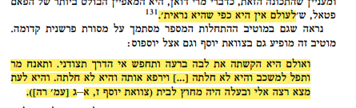

“she is never what she appears to be.”

Still, she hardened her heart with evil intent and searched out the way that she could entrap me. She moaned bitterly and fell into her sickbed, even though she was not ill […] he healed her, although she was not ill. And when she found an opportunity, she came running to me when her husband was not in the house (The Testament of Joseph 7:1-3 [p. 205]).

**p. 274**

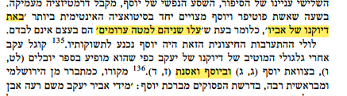

“his father’s image came to him,” that is to say, at the moment when “the two of them climbed onto the bed naked” they were not alone.

Joseph and Asenath (7:4)

**p. 275**

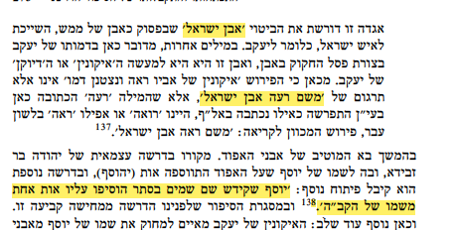

*the Rock of Israel*

*There, the Shepherd* [ro’eh], *the Rock of Israel*

Joseph, who sanctified the name of Heaven in private, had one letter of the name of the Holy One, Blessed be He, the letter *heh*, added to his name.



y. Sota 7:4 (21d); b. Sota 36b.

**p. 276**

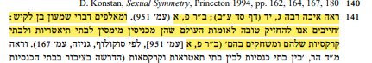

141 See Lam. Rab. 3:14 (p. 64b); Gen. Rab. 80:1 (p. 951). The words of Shimon ben Lakish are most instructive: “We must be appreciative of the nations of the world who bring mimes to their theatres and circuses and have them act” (Gen. Rab. 80:1 [p. 951], according to Sokoloff, Geniza, p. 167).

**p. 277**



See y. Sota 7:4 (21d); b. Sota 36b.

**p. 278**



In the Testaments (Reuben 4:8-11, The Testament of Joseph)

**p. 280**



In Tractate Shabbat of the Babylonian Talmud (86b-89b)

**p. 281**

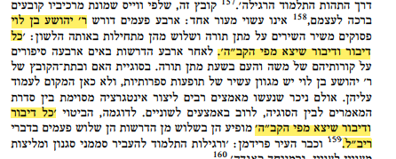

[R. Yehoshua ben Levi](/topics/rabbi-yehoshua-b-levi)

From each and every utterance that emerged from the mouth of the Holy One, Blessed be He.

From each and every utterance that emerged from the mouth of the Holy One, Blessed be He.

R. Yehoshua ben Levi

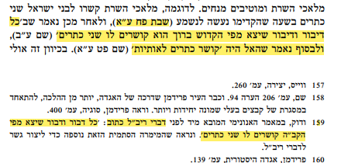

(b. Šabb. 88a)

To each and every utterance that emerged from the mouth of the Holy One, Blessed be He, two crowns are tied (b. Šabb. 88b)

And in closing it says that God would “tie crowns to the letters” (b. Šabb. 89a).

159 In the anonymous statement brought before the words of R. Yehoshua ben Levi it says: “To each and every utterance that emerged from the mouth of the Holy One, Blessed be He, two crowns are tied.”

**p. 282-283**

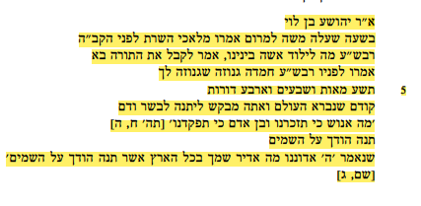

[R. Yehoshua ben Levi](/topics/rabbi-yehoshua-b-levi) said:

When Moses ascended on High, the ministering angels said before the Holy One, Blessed be He:

Master of the Universe, what is one born of a woman doing here among us?

He said to them: He came to receive the Torah.

They said before Him: Master of the Universe, it is a hidden treasure that was concealed by you

974 generations

before the creation of the world, and you seek to give it to flesh and blood?

*What is man that You have been mindful of him, mortal man that You have taken note of him* (Ps. 8:5)

Place Your splendor in the heavens

As it is stated: *O LORD, our Lord, How majestic is Your name throughout the earth, You who have covered the heavens with Your splendor!* (Ps. 8:2)

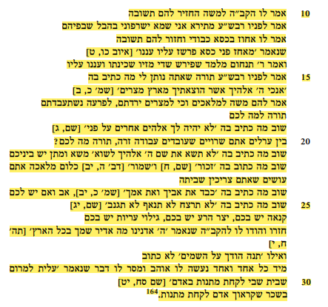

The Holy One, Blessed be He, said to Moses: Provide them with an answer

He said before Him: Master of the Universe, I am afraid lest they burn me with the breath of their mouths.

He said to him: Grasp My throne of glory and provide them with an answer.

As it is stated: *He causes him to grasp the front of the throne, and spreads His cloud over it* (Job 26:9).

And R. Tanḥum said: This teaches that God spread the radiance of His presence and His cloud over him.

He said before Him: Master of the Universe, the Torah that You are giving me, what is written in it?

*I am the Lord your God Who brought you out of Egypt* (Exod. 20:2)

Moses said to the angels: Did you descend to Egypt? Were you enslaved to Pharaoh?

Why should the Torah be yours?

Again, what is written in it? *You shall have no other gods before Me* (Exod. 20:3).

Do you dwell among the uncircumcised who worship idols? Why should the Torah be yours?

What else is written in it? *Do not take the name of the Lord your God in vain* (Exod. 20:7). Do you conduct business with one another?

What else is written in it? *Remember the sabbath day* (Exod. 20:8) and *Observe the sabbath day* (Deut. 5:12). Do you perform labor that you require rest from it?

What else is written in it? *Honor your father and your mother* (Exod. 20:12). Do you have a father or a mother?

What else is written in it? *You shall not murder, you shall not commit adultery, you shall not steal* (Exod. 20:13). Is there jealousy among you, or is there an evil inclination within you, or is there sexual promiscuity among you?

Immediately they agreed with the Holy One, Blessed be He, as it is stated: *God our Lord, how glorious is Your name in all the earth* (Ps. 8:10),

while *that Your majesty is placed above the heavens* is not written.

Immediately, each and every one of the angels became an admirer of Moses and passed something to him, as it is stated: *You ascended on high, you took a captive, you took gifts on account of* *man* (Ps. 68:19).

As a reward that you were called Man, you took gifts.

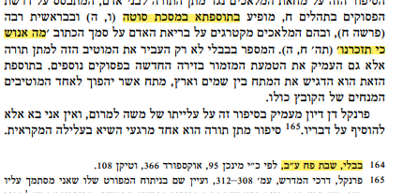

In Tosefta, Tractate Sota (6:5)

*What is man that You have been mindful of him* (Ps. 8:5)

164 b. Šabb. 88b

**p. 284-285**

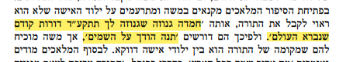

“a hidden treasure that was concealed by you 974 generations before the creation of the world.”

“Place Your splendor in the heavens,”

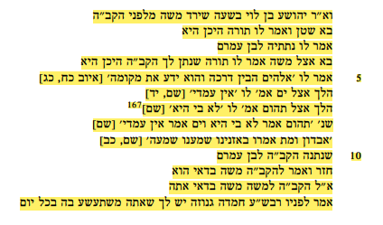 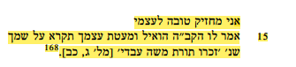

And [R. Yehoshua ben Levi](/topics/rabbi-yehoshua-b-levi) said: When Moses descended from before the Holy One, Blessed be He,

Satan came and said before Him: Master of the Universe, where is the Torah?

He said to him: I have given it to the son of Amram.

He came to Moses and said to him: The Torah given to you by the Holy One blessed be He – where is it?

He said to him: I do not know, as only: *God understands its way, and He knows its place* ([Job 28:23](/Job.28.23)).

He went to the sea. It said to him: *It is not with me* (Job 28:14).

He went to the depths. They said to him: *It is not within me* (Job 28:14).167

As it is stated: *The depth said: It is not within me, and the sea said: It is not with me* ([Job 28:14](/Job.28.14)).

*Destruction and death said: We heard a rumor of it with our ears* ([Job 28:22](/Job.28.22)).

That the Holy One, blessed be He gave it to the son of Amram.

He returned and said to the Holy One blessed be He: Moses is a fabricator.

The Holy One, Blessed be He, said to Moses: Moses, are you a fabricator?

He said before Him: Master of the Universe, You have a hidden treasure in which You delight every day,

should I take credit for myself?

The Holy One, Blessed be He, said to Moses: Since you belittled yourself, the Torah will be called by your name, as it is stated: *Remember the Torah of Moses My servant* ([Mal. 3:22](/Malachi.3.22)).



167 *It is not within me*] In MS Munich 95 Vatican 108 it says: it is not in me. In the margin of MS Munich the following is added: He went to the son of Amram and said to him: The Torah that the Holy One, Blessed be He, gave you, where is it? He said to him: And what am I that the Holy One, Blessed be He, would have given me the Torah?

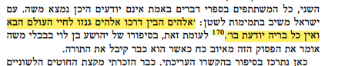

“God knows his path. God stored him away for the World to Come, and no living creature knows of him.”

"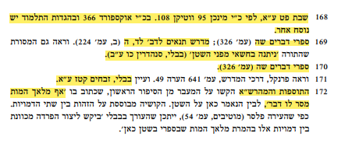

168 b. Šabb. 89a, according to MS Munich 95, Vatican 108. In MS Oxford 366 and in *Hagadot HaTalmud* there is a variant reading.

169 Sipre Deut. 305 (p. 326); Midrash Tannaim to Deut. 34:5… “it was given in secret because of the Satan” (b. Sanh. 26b).

170 Sipre Deut. 305 (p. 326).

171 b. Zebaḥ. 116a.

172 Tosafot and Maharsha …”even the Angel of Death gave him something,”

**p. 286**



175 See m. Abot 2:5; b. Sanh. 93b.

**p. 288**

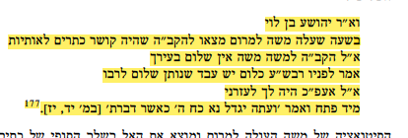

And [R. Yehoshua ben Levi](/topics/rabbi-yehoshua-b-levi) said:

When Moses ascended on High, he found the Holy One, Blessed be He, tying crowns to letters.

God said to him: Moses, is there no greeting in your city?

He said before Him: Master of the Universe, does a servant greet his master?

He said to him: At least you should have assisted Me.

Immediately he began and said to Him: *And now, may the power of the Lord be great as you have spoken* ([Num 14:17](/Numbers.14.17)).

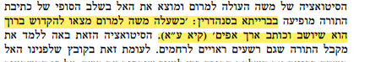

in the baraita in Tractate Sanhedrin: “When Moses ascended on high, he discovered the Holy One, Blessed be He, sitting and writing: *Slow to anger* (b. Sanh. 111a).

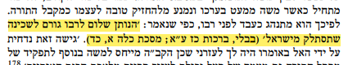

“one who greets his rabbi…causes the Divine Presence to withdraw from Israel” (b. Ber. 27a; Tractate Kallah 1:24).

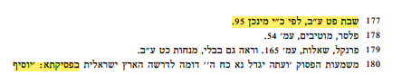 

177 b. Šabb. 89b according to MS Munich 95.

180 in the Pesiqta: Grows stronger – this refers to Moses, who shows enormous power and strength as it says *Therefore, I pray, let my Lord’s forbearance be great* (Pesiq. Rab Kah. 25 [p. 379]).

**p. 289- 290**

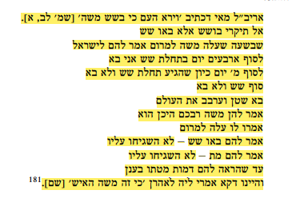

[R. Yehoshua ben Levi](/topics/rabbi-yehoshua-b-levi)said: What is the meaning of that which is written: *And the people saw that Moses delayed* [boshesh]([Exod. 32:1](/Exodus.32.1))?

Do not read as *boshesh*; rather, read it as *ba’u shesh*, six hours have arrived.

For when Moses ascended on High, he told the Jewish people:

In forty days, at the beginning of six hours, I will come.

After forty days, the beginning of the sixth hour arrived, but he did not come.

The end of the sixth hour arrived, but he did not come.

Satan came and brought confusion to the world.

He said to them: Where is your teacher Moses?

They said to him: He ascended on High.

He said to them: Six hours have arrived - but they paid him no attention.

Until, he showed them an image of his death-bed in a cloud.

And that is what they said to Aaron: *For this Moses, the man* ([Exod. 32:1](/Exodus.32.1)).

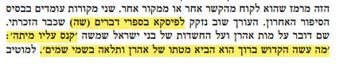

the passage in Sipre Deuteronomy (605)

“punished him with death”: What did the Holy One blessed be He do? He brought Aaron’s death-bed and hung it in the heavens.”

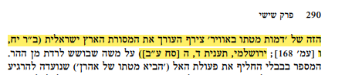

To this motif of “an image of the death-bed in the air” the editor added the tradition of the Land of Israel (Gen. Rab. 18:6 [p. 168], y. Ta’an 4:5 [68b])



181 b. Šabb. 89b according to MS Oxford 366.

**p. 291**

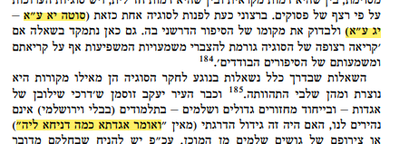

(b. Sota 11a-13a)

“relate aggadic portions as much as they like”

**p. 292**

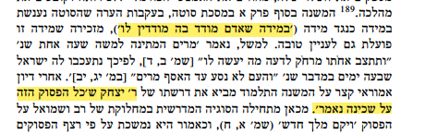

(“it is with the measure that a man measures to others that he himself is measured”).

R. Isaac, that “this entire verse is stated in reference to the Divine Presence.”

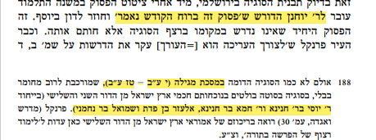

To R. Yoḥanan who teaches that “this entire verse was said with the inspiration of the Divine Spirit”

188 in Tractate Megillah (10b-16b),

in particular [R. Yosei son of R. Ḥanina](/topics/rabbi-yose-b-chanina), [R. Ḥama son of R. Ḥanina](/topics/rabbi-hama-b-r-hanina), Elazar ben Pedat and [Shmuel bar Naḥmani](/topics/rabbi-shmuel-b-nahmani)

**p. 293-294**

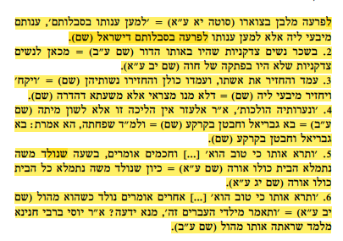

1. *Therefore they did set over him taskmasters* (Exod. 1:11). It should have stated: Over them, in the plural […] This teaches that they brought a brick mold and they hung it on the neck of Pharaoh (b. Sota 11a) = *In order to afflict him with their burdens*, it should have stated: “In order to afflict them,” in the plural. Rather, the intention is in order to afflict Pharaoh with the burdens of the Israelites (b. Sota 11a).

2. In the merit of the righteous women that were in that generation (b. Sota 11b) = from here it is derived concerning righteous women that they were not included in the verdict [*pitkah*] of Eve (b. Sota 12a).

3. He arose and remarried his wife, and all others arose and brought back their wives (b. Sota 12a) = *And took for a wife*, it should have stated: “And returned” (b. Sota 12a) = Because the Egyptians counted only from the time her husband took her back (b. Sota 12a).

4. *And her maidens walked along [holekhot]* (Exod 2:5). R. Elazar says: This walking is nothing other than the terminology of death (b. Sota 12b) = The angel Gabriel came and beat them to the ground (b. Sota 12b) = And according to the one who says that it means her maidservant, but you said: Gabriel came and beat them to the ground (b. Sota 12b).

5. *When she saw him that he was a goodly child*… and the Rabbis say: At the time when Moses was born, the entire house was filled with light (b. Sota 12a) = when Moses was born, the entire house was filled with light (b. Sota 13a).

6. *When she saw him that he was a goodly child*…Others say: They said he was good because he was born when he was already circumcised (b. Sota 12a) = *And she said: This is one of the Hebrews’ children*. From where did she know? R. [Rabbi Yosei, son of R. Ḥanina](/topics/rabbi-yose-b-chanina) says: As she saw that he was circumcised (b. Sota 12b).

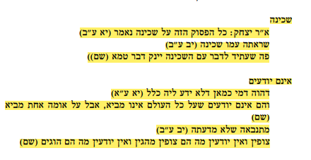

The Divine Presence

R. Yitzḥak says: This entire verse is stated in reference to the Divine Presence (b. Sota 11b).

She saw the Divine Presence with him (b. Sota 12b).

Shall a mouth that in the future will speak with the Divine Presence nurse something impure? (b. Sota 12b).

They do not know

He was like someone who did not know him at all (b. Sota 11a).

They did not know that He will not bring a flood upon all the world, but He may bring water upon one nation (b. Sota 11a).

She is prophesying and she does not know what she is prophesying (b. Sota 12b).

They see but they do not know what they are seeing (b. Sota 12b).

**p. 295**

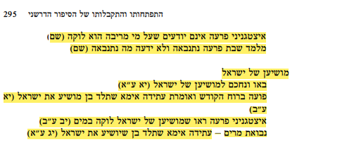

Pharaoh’s astrologers did not know that what they saw foretold that Moses would be stricken on account of the waters of Meribah (b. Sota 12b).

This teaches that Pharaoh’s daughter was prophesying and she does not know what she is prophesying (b. Sota 12b).

The Savior of Israel

Come, let us deal wisely with regard to the savior of Israel (b. Sota 11a).

She would speak [*po’a*] through divine inspiration and say: In the future, my mother will give birth to a son who will save the Israelites (b. Sota 11a).

Pharaoh’s astrologers saw that the savior of the Israelites would be stricken by water (b. Sota 12b).

Miriam’s prophecy - my mother will give birth to a son who will save the Israelites (b. Sota 13a).

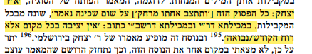

R. Yitzḥak says: This entire verse [*And his sister stood afar off*] is stated in reference to the Divine Presence (b. Sota 11b).

In the Mekilta of R. Ishmael and the Mekilta of R. Simeon bar Yoḥai we find written: In every place, the word *yetziva* refers to the Holy Spirit/prophecy.

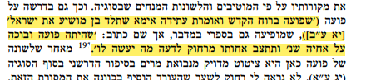

She would speak [*po’a*] through divine inspiration and say: In the future, my mother will give birth to a son who will save the Israelites (b. Sota 11a).

That she would sob [*po’a*] and cry over her brother, as is stated: *And his sister stood afar off, to know what would be done to him.*

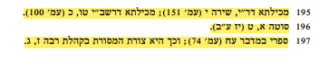

195 Mekilta of R. Ishmael, Shira 10 (p. 151); Mekilta of R. Simeon bar Yoḥai 15:20 (p. 100).

196 y. Sota 1:9 (17b).

197 Sipre Num. 78 (p. 74); this is also the tradition that appears in Qoh. Rab. 7:3.

**p. 296**

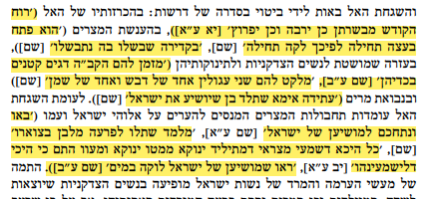

Divine inspiration proclaimed to them *the more he will multiply and the more he will spread about* (b. Sota 11a).

He initiated the proposal. Therefore, he was stricken first (b. Sota 11a).

In the pot in which they cooked, they themselves were cooked (b. Sota 11a).

the Holy One, Blessed be He, would materialize for them small fish that would enter into their pitchers (b. Sota 11b).

Would gather for them two round stones from the field; one of the stones flowed with oil and one of the stones flowed with honey (b. Sota 11b).

In the future my mother will give birth to a son who will save the Israelites (b. Sota 11b).

Come, let us deal wisely with regard to the savior of Israel (b. Sota 11a).

This teaches that they brought a brick mold and they hung it on the neck of Pharaoh (b. Sota 11a)

anywhere that the Egyptians heard that a baby was born, they would bring another baby there in order that it could be heard crying (b. Sota 12a).

They saw that the savior of the Israelites would be stricken by water (b. Sota 12b).



This teaches that they brought a brick mold and they hung it on the neck of Pharaoh (b. Sota 11a)

**p. 297**

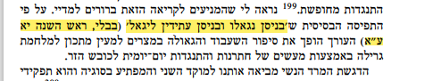

In the month of Nisan our forefathers were redeemed and in the future they will be redeemed in Nisan (b. Roš Haš. 11a)

**p. 298-299**



came down to cleanse herself from the impurity of her father’s idols (b. Sota 12b)

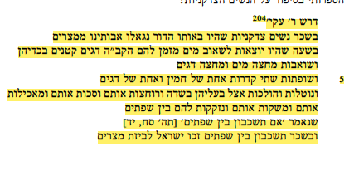 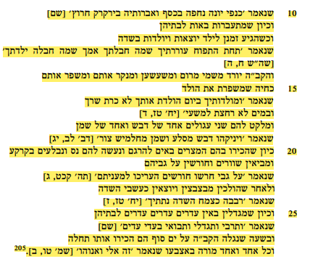

R. Akiva taught: In the merit of the righteous women that were in that generation, the Jewish people were redeemed from Egypt. At the time when these women would go to the river to draw water, the Holy One, Blessed be He, would materialize for them small fish that would enter into their pitchers, and they would therefore draw pitchers that were half filled with water and half filled with fish. And they would then come and place two pots on the fire, one pot of hot water for washing their husbands and one pot of fish with which to feed them. And they would then take what they prepared to their husbands, to the field, and would bathe their husbands and anoint them with oil and feed them the fish and give them to drink and bond with them in sexual intercourse between the sheepfolds as it is stated: *When you lie among the sheepfolds* (Ps. 68:14), and as a reward for *when you lie among the sheepfolds*, the Israelites merited to receive the plunder of Egypt, as it is stated *The wings of the dove are covered with silver, and her pinions with the shimmer of gold* (Ps. 68:14). And when these women would become pregnant, they would come back to their homes, and when the time for them to give birth would arrive they would go and give birth in the field under the apple tree, as it is stated: *Under the apple tree I awakened you; there your mother was in travail with you; there was she in travail and brought you forth* (Song 8:5). And the Holy One, Blessed be He, would come down from the heavens above and would clean and prepare them, just as a midwife prepares the newborn, as it is stated: *And as for your birth, on the day you were born, your navel was not cut nor were you washed with water for cleansing* (Ezek. 16:4). And then He would gather for them two round stones; one flowed with oil and one with honey, as it is stated: *And He would suckle them with honey from a crag and oil from a flinty rock* (Deut. 32:13). Once the Egyptians would notice them, they would come to kill them. But a miracle would occur for them and they would be absorbed by the earth. And the Egyptians would then bring oxen and would plow upon them, as it is stated: *The plowers plowed upon my back; they made long their furrows* (Ps. 129:3). After they would leave, the babies would emerge and exit the ground like grass of the field, as it is stated: *I caused you to increase even as the growth of the field* (Ezek 16:7). And once the babies would grow, they would come like many flocks of sheep to their homes, as it is stated: *And you did increase and grow up and you came with excellent beauty [ba’adi adayim]* (Ezek 16:7). And when the Holy One, Blessed be He, revealed Himself at the Red Sea, these children recognized Him first, as it is stated: *This is my God, and I will glorify Him* (Exod/ 15:2).



205 b. Sota 11b according to MS Oxford 2675, Munich 95, Vatican 110

**p. 301**

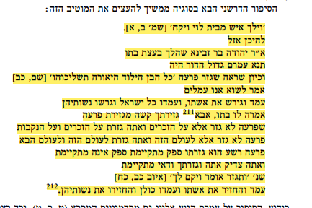

*And there went a man of the house of* [*Levi*](/topics/levi-b-sisi)*, and took for a wife* (Exod 2:1).

To where did he go? R. Yehuda bar Zevina says: He went according to the advice of his daughter. A Sage teaches: Amram was the great man of his generation. Once he saw that Pharaoh decreed: *Every son that is born you shall cast into the river* (Exod. 1:22) he said: We are laboring for nothing. He arose and divorced his wife. All the Israelites arose and divorced their wives.

His daughter said to him: Father, your decree is more harsh than that of Pharaoh, as Pharaoh decreed only with regard to the males, but you decreed both on the males and on the females. Pharaoh decreed to kill them only in this world, but you decreed in this world and in the World-to-Come.

Pharaoh who is wicked. It is uncertain whether his decree will be fulfilled or will not be fulfilled. You are a righteous person, and as such, your decrees will certainly be fulfilled, as it is stated: *You shall also decree a thing, and it shall be established unto you* (Job 22:28). He arose and remarried his wife, and all others arose and brought back their wives.



212 b. Sota 12a according to MS Oxford 2675, Munich 95, Vatican 110.

**p. 302**



In the Mekilta of R. Simeon bar Yoḥai (6:2 [p. 6])

**p. 303**

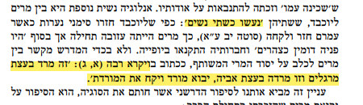

Both of them “became women a second time”

In Leviticus Rabbah (1:3): “This one rebelled against the advice of the spies and this one rebelled against the advice of her father. Let the rebellious one come and marry the rebellious one.”

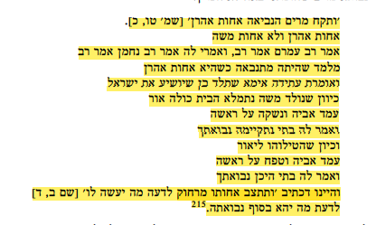

*And Miriam the prophetess, the sister of Aaron* (Exod. 15:20). Is she *the sister of Aaron* and not the sister of Moses? Rav Amram says that Rav says, and some say that [Rav Naḥman](/topics/rav-nachman-b-yaakov) says that [Rav](/topics/rav) says: This teaches that she already prophesied when she was still the sister of only Aaron And she would say: In the future, my mother will give birth to a son who will save the Jewish people. And once Moses was born, the entire house was filled with light. Her father arose and kissed her on her head. He said to her: My daughter, your prophecy has been fulfilled. And once they put him into the river, her father arose and hit her on her head. He said to her: My daughter, where is your prophecy? And this is as it is written: *And his sister stood afar off, to know what would be done to him* (Exod. 2:4), to know what the ultimate resolution of her prophecy will be.



215 b. Sota 13a.

**p. 304**

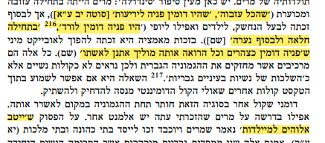

“As everyone initially abandoned her,” “for her face was like curtains” [b. Sota 12a]

“for her face was like a rose”

“initially she was sickly, but ultimately a young woman”

“her face shined like the sun does at noon and any man that saw her would bring a gift [*etnan*] to his wife” (b. Sota 12a).

On the verse stating that *God dealt well with the midwives*

**p. 305**

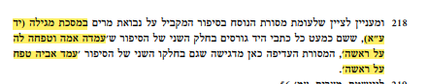

in Tractate Megillah (14a)

her mother arose and hit her on her head

her father arose and hit her on her head

**p. 307**

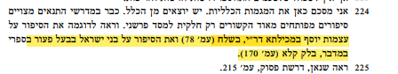

The story regarding Joseph’s bones that appears in Mekilta of R. Ishmael (Beshalaḥ 78) and the story of the Israelites at Baal-Pe’or in Sipre Numbers, Balak 131 (p. 170).