The file is too big to upload on our portal

Please download from this link

<https://wetransfer.com/downloads/f1fdee5395ecb5a5ec6b8372691f303120170528112447/310283e82d860ded086f72867c6516dd20170528112447/055817>

When you have completed the translation (with the pictures included) please upload using the Wetransfer website and send to me (avi.kallenbach@gmail.com) directly. You do not need to sign up to use Wetransfer. Just use the widget on the left side of the page.

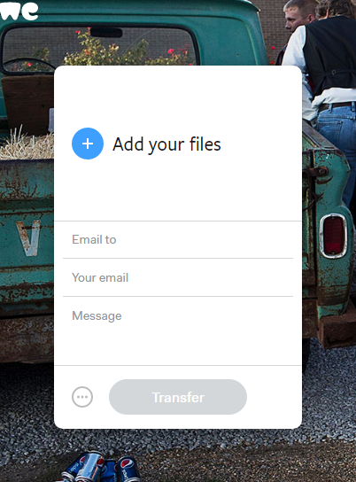

Thank you!