**Long term Satisfaction Evaluation among Patients after Vestibulectomy**

David A, Bornstein J

Department of Obstetrics and Gynecology, Galilee University Medical Center, Bar Ilan University, Nahariya, Israel

**Abstract**

**Background**: Vestibulodynia is the most common cause of dyspareunia, with an estimated prevalence of 10-15% of women, though it often remains undiagnosed and untreated. There are many treatment options for this pathology, both invasive and non-invasive, but the only treatment with proven therapeutic benefit demonstrated in research is *vestibulectomy*, a surgery to remove parts of the vestibule tissue. Follow up studies showed approximately 80% success rate, after a varying recovery period. However, there are few long-term follow-up studies, and little is known about whether the surgical success is preserved over the years.

**Aim**: Long-term follow-up of patients who underwent vestibulectomy over 10 years ago, assessing surgical success over time and overall satisfaction.

**Materials and Methods**: The follow-up was conducted through face-to-face interviews which tested quantitative variables such as the frequency of sexual intercourse and the degree of pain in carrying out various activities. Qualitative variables were also examined, such as overall satisfaction from the surgery’s results, and willingness to recommend the surgery to other women suffering from the same condition.

**Results**: 32 patients were traced and agreed to participate in the study, all were operated on 12-24 years ago by the same surgeon, Prof. Jacob Bornstein. 100% of the patients experienced sexual intercourse without pain at some point after surgery, and the median time was 4 months until the first painless intercourse. When asked to quantify their pain level while performing various activities prior to the surgery and now, penetration was the most painful activity to all patients, averaged at 9.13 on a pain scale (0-10) before the surgery and dropped to 0.47 today (P <0.001). Non-penetrative intercourse, using a tampon, post-coital urination and other activities were also mentioned as painful and were improved significantly after surgery.

Comparing the overall status after recovery from surgery with the status today, none of the patients reported deterioration or worsening of pain over time. 84% of patients reported no change in pain over the years, and 16% reported an improvement. 87.5% were able to engage in sexual intercourse as they pleased right after the recovery period was over, and 97% are able to do so today.

In terms of personal opinion regarding the surgery and its outcomes – 94% of the operated patients were highly satisfied, 97% would undergo the surgery again knowing what they do now, and 100% would recommend it to a friend suffering from the same condition. Of those, 15% indicated the need for exploring non-surgical treatment options prior to surgery, in light of the prolonged recovery period.

**Conclusions**: Our work demonstrated high surgical success rates, higher even than those described in the literature. We did not find any evidence of deterioration or resurgence of pain in our follow up, over a decade after the surgery, and even witnessed an improvement for those who did not reach optimal results immediately after surgery. Overall patient satisfaction is high, and the general attitude toward the surgery is positive. In view of the long recovery period and a small but existing risk of postoperative complications – non-invasive treatment should be discussed with the patient before considering surgery. However, in the absence of proven and documented effect of those methods, vestibulectomy remains the best treatment for this painful problem.

***Key Words****: Vulvodynia, Vestibulodynia, PVD, Vestibulectomy, Retrospective Follow Up*

**Introduction**

Provoked vulvodynia, also known as Vestibulodynia is the most common cause of pain during sexual intercourse[1]. Burning or cutting pain in the vaginal vestibule region is the common complaint, and it presents in two subtypes – Primary Vestibulodynia, in which the pain appears in the first attempt at penetration (intercourse or application of a tampon), and Secondary Vestibulodynia, in which the pain appears after a period of having intercourse without pain.

The definition of Provoked Vestibulodynia or PVD includes pain upon touch or pressure lasting for at least six months, without spontaneous or ongoing pain. At physical examination the sufferer displays heightened sensitivity even to the slightest touch with a swab without the presence of infection or any other dermatological or gynecological disease[2].

Several studies have estimated the prevalence of the phenomenon at 10-15%[3][4]. The etiology of vestibulodynia is insufficiently clear, but recent studies have indicated a vestibular mucus nerve hyperproliferation among women suffering from the problem, up to 10 times as much as the women in the control group[5], with penetration of the nerve ends through the basement membrane. These studies support the theory that primary vestibulodynia is caused by nervous proliferation. Further studies have shown a thriving of mast cells, which may play a part in the regulation of nervous growth factors[6]. Other factors tied to this phenomenon are various genetic and hormonal variables, including hormonal contraceptives[7].

The literature describes many different treatments for vestibulodynia, from lifestyle changes, through topical or systemic medication, and even to physiotherapy, acupuncture and psychiatric therapy. Most studies on such treatments were conducted on small groups in an uncontrolled manner, and we have no reliable information as to their efficacy in treating the problem.

The surgical treatment was first suggested by **Woodruff[8]** in 1981 under the name ‘modified perineoplasty’ and since then thousands of surgical procedures have been carried out by various methods which are variations on Woodruff’s original surgery. In a literature review performed by Marinoff[9] in 2006 found that 28 of 32 papers that explored surgical options for treating vestibulodynia registered a “surgical success rate” of 80% and up. Another review of surgical and other treatment options for vestibulodynia, performed by Andrews[10] in 2011, reached similar conclusions, with a surgical success rate of 79% on average. However, it should be noted that the term “surgical success” is not well-defined, and varies from one study to another. In addition, the low number of surgical patients in each study, the **short** follow-up period which still varies significantly among studies as well as technical differences, both between procedures examined and the different surgeons, make it difficult to make a reliable comparison and deduce definitive conclusions from the aforementioned reviews.

Previous studies that conducted **long-term** follow-up studies of patients who have undergone similar surgeries have reached varying results. Thus, for instance, in a study by Foster[11] in 1995 follow-up was conducted four years following the surgery, with success rates of 88% (success in this case defined as significant reduction of pain), whereas De Jong[12] in The Netherlands, also in 1995, reported only a 43% success rate, following up seven years post-surgery. Apart from these, we have not encountered any other studies which include a follow-up period of longer than 18 months.

**In this study** we have tried to solve some of these difficulties, by performing the follow-up on women who had undergone an identical procedure by the same surgeon, with the time elapsed since the surgery being **at least 10 years**, long enough to evaluate the success of the procedure over time. In addition, the evaluation of the procedure’s success was based on several quantitative variables, in addition to the patient’s sense of satisfaction, in order to enable a correct analysis of the results.

**Study Hypothesis**

* Vestibulectomy is an effective treatment for vestibulodynia.
* The satisfaction rate of patients who have undergone vestibulectomy is high.

**Methods**

**The Study Array**

This is a retrospective follow-up study, with the research group defined by a medical problem at a point of time in the past, and the data collected pertains to the appearance of the problem from that time until now.

**The Study Population**

Women who have undergone vestibulectomy 10 years or more ago by the surgeon Prof. Jacob Bornstein.

**The Study Variables**

Patient satisfaction, pain level, frequency of intercourse.

The study variables were checked via a designated questionnaire used in previous studies on vestibulodynia, after adjustments to the current study by the researchers.

**Statistical Methods**

Quantitative data are described through averages and standard deviation, mean and range. Qualitative data, through prevalence and percentage. Ordinal data was described as quantitative and/or qualitative variables, accordingly. Reduction in pain levels over time was tested through Paired sample test or Wilcoxon signed rank test. The choice between tests was based mostly on the gap distribution of the pain level between compared points in time.

A significance value under 5% is considered statistically significant.

**Results**

**Recruitment**

85 patient files were reviewed to mine the details needed to make contact. Afterwards, an Interior Ministry database was used to locate their addresses and contact information. In accordance with the requirements of the Helsinki committee, the interviews were conducted in person and not by phone. Due to the long time that had passed since the surgery it became highly difficult to locate the patients, who in the meantime had changed their last names and places of residence, and in practice only 50 of them (59%) were successfully located. 32 of the patients located (64%) were indeed interviewed for the study eventually, after having signed a consent form. 9 patients (18%) refused to be interviewed, 7 patients (14%) were not interviewed due to technical difficulties in scheduling an interview, and 2 patients (4%) didn’t remember undergoing such a procedure at all.

**Demographic Data**

The patients recruited underwent the surgery in 1991-2003. The age of the patients at the time of the surgery was 20-31 years, and 24 on average. At the time the interview was conducted 27 women (84%) were in an ongoing relationship with a partner, with whom they have regular sexual relations. Of those who have no partner, none mentioned dyspareunia as a reason for the lack of partner.

**Seeking Further Treatment After Surgery**

30 women (94%) needed no further treatment beyond vestibulectomy. The two women who had undergone further treatment noted that the surgery was partially helpful. The additional treatment included intra-muscular injections and topical creams. Another patient noted that she sought out a hypnotist, but did not undergo hypnosis therapy eventually.

**Sexual Intercourse Following Surgery**

100% of the patients reported that they had experienced sexual intercourse without pain at some point after the surgery. Over 90% noted that they had experienced pain-free sexual intercourse for the first time within 12 months or less from the surgery (Table 1). The mean time until painless sexual intercourse was 4 months.

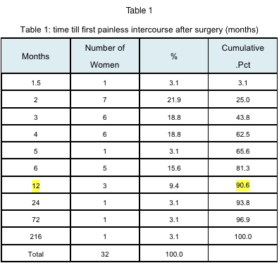

**Change in Pain Level Compared to Pre-Surgery Condition**

The patients were presented with a list of activities known to induce pain in the vestibule, and were asked to rank, on a 0-10 scale, how much that activity hurt prior to the surgery compared to how much it hurts today (0=no pain at all, 10=maximal pain). As expected, 100% of the patients noted that prior to the surgery, penetration during intercourse was the most painful activity, scoring a 9.13 on the pain scale. Non-penetrative sexual relations, touching the vaginal opening with a finger and insertion of a tampon were described as painful activities, and in addition significant pain was described following sexual relations and in post-coital urination, when such occurred. Post-surgery there was a sharp and significant reduction (P<0.001) in pain in all these activities and particularly prominent is the reduction in pain during penetration from 9.13 to 0.47 on the pain scale, on average (Table 2). It should be noted that the surgery was performed on women with a significant level of pain that caused strong and intolerable pain during intercourse.

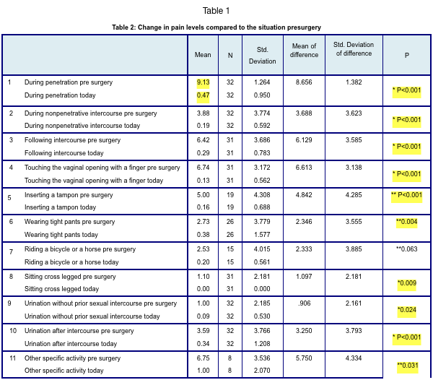

* Paired sample T-test

** Wilcoxon Signed Ranks Test

**Change in pain level over the years (since surgery to the present)**

100% of the patients reported that following the recovery period after the surgery there had been no recurrence or increase in the pain over the years. Of these, 23 patients (72%) noted that immediately following the recovery period, they were able to have intercourse without any pain, and this remained the situation to this day. 5 patients (16%) reported some pain following recovery that receded gradually over the years, and 4 patients (12% reported some pain which remained to this day.

**Frequency of Intercourse**

100% of the patients reported improved ability to have intercourse immediately after recovery period. Of these, 28 patients (88%) reported the ability to have sex as they pleased immediately at this point, and the others reported some restrictions in having sex due to pain. When asked about their condition today, 31 patients reported the ability to have sex as they pleased, and one patient still reported restrictions in having sex due to pain (Table 3).

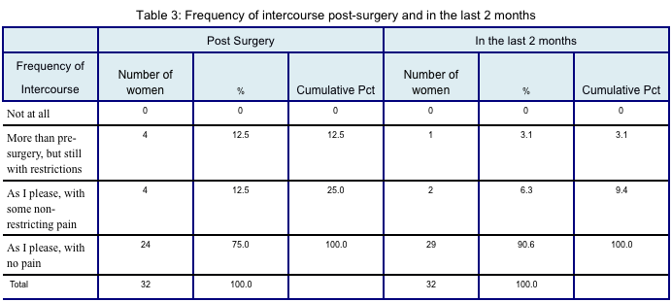**Satisfaction With The Procedure**

100% of the patients report an alleviation of pain since the surgery, of these 30 patients (94%) report a significant improvement and 2 patients (6%) report a slight improvement (Graph 1).

97% of the patients would undergo the procedure again, and 100% would recommend it to a friend suffering from the same problem. Of these, 5 patients (16%) noted that in light of the lengthy recovery period, they would have preferred to exhaust non-surgical treatment options prior to going under the scalpel (Graph 2).

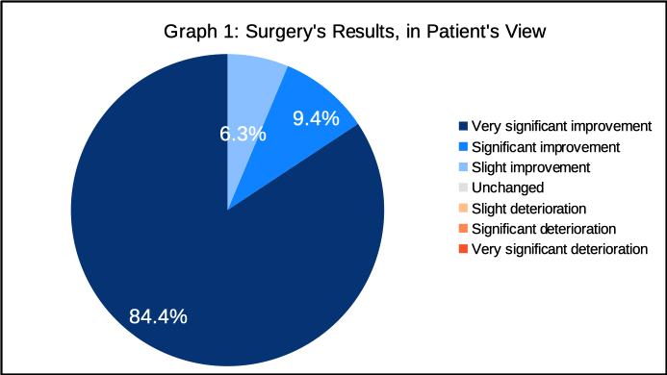

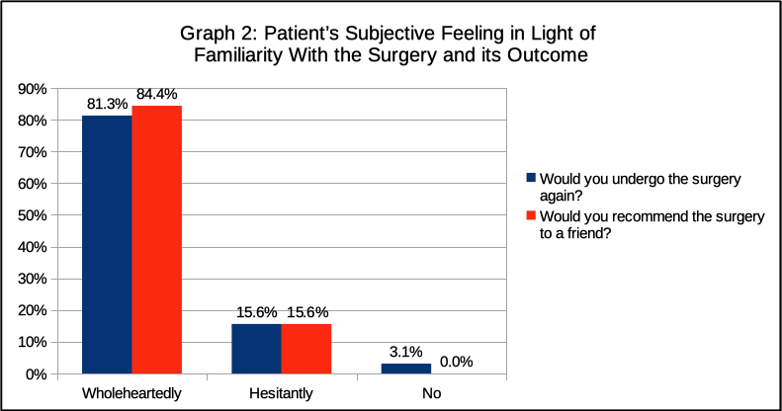

**Discussion**

PVD has remained an enigma over the years. The cause of this problem has yet to be fully discovered, and treatment remains in dispute. Although vestibulectomy’s surgical success has been reviewed several times as described in the introduction to this study, and has been found to be the most effective treatment method, there is still a debate among experts whether women suffering from PVD should be offered surgery, or whether it should be reserved to those who have not been cured by all the non-surgical treatments available.

A discussion of this important topic was published in Goldstein’s[13] article of 2016 which constitutes a comprehensive review of the evaluation and treatment methods for vulvodynia. This in keeping with the paradigm change proposed by Bogliatto[14], which replaces the view of vulvodynia as a single ailment stemming from a single reason and having a single treatment, with a multimodal approach that concentrates on a correct evaluation of the etiological causes at the root of this pathology, and providing treatment proper to the specific cause or causes of each case. This approach requires cooperation between medical and para-medical actors who specialize in the field, and use the same terminology[15] to communicate with one another and offer the patient the optimal diagnostic and therapeutic plan.

Even when the patient has been found suitable for vestibulectomy it is important to note, alongside the procedure’s proven efficacy, the lack of standard for preferred surgical technique and the great importance of having the surgery performed by a skilled surgeon in order to remove the maximum amount of tissue from the aching regions while refraining from needlessly endangering nearby organs. In addition, it is important to inform the patient of the lengthy recovery period from surgery as well as the possibility of post-surgical complications including bleeding, infection, pain, hemorrhages, opening of the surgical wound, formation of scar tissue and formation of Barhtolin cysts. Of these, Goldstein notes that as they are very rare, there is no need to over-emphasize their risks.

To illustrate the two treatment routes we present the study by Tommola[16] in 2012, in which follow-up was performed on 66 women who had suffered from PVD and were treated conservatively at first, and later those whose cases were declared to be treatment failures underwent surgery. The results of the study were that 41% of the women had contented themselves with the conservative treatment, and the rest had undergone surgery, with satisfaction and treatment success rates not varying greatly between those who had undergone surgery and those who had not. This study leads to the conclusion that surgery should be offered after attempting non-invasive treatment options. But thus far there are no guidelines for which non-invasive methods should be offered and whether all non-invasive methods should be exhausted prior to surgery. We would like to note that in our own study (in the part of the questionnaire where free-text comments can be added) one of the patients reported feeling that she had wasted too much time on non-invasive treatment methods that did her no good, and that in retrospect she would have preferred to skip that part and go directly to the most effective solution for her, which was surgery. This comment is not, in our opinion, sufficient to change the entire therapeutic approach, but there is most definitely a need to address the amount of suffering the patients contend with, and their emotional willingness to invest time and resources in treatment methods which, while being non-invasive, have significantly lower success rates.

In this study, if we define “surgical success” as the patient’s ability to have sex as she pleases, we find that 87.5% of the patients noted such ability immediately following the recovery period, and 97% of patients noted such ability at present, a decade or more following the surgery. These findings are consistent with data from previous studies, and even exceed them (this is likely due to better isolation of variables than in other studies, see below in “This study’s main advantage”).

The object of the long-term follow-up we performed was to test whether the surgery’s results are retained over time, and in light of the follow-up results the answer seems to be unequivocally affirmative. No patient reported recurrence or worsening of the pain, and the patients’ ability to have sexual intercourse remained good, or even improved over the years. Penetration pain which was very severe prior to surgery (9.13 on average, on a 0-10 scale) was almost completely alleviated, reaching 0.47 on average today.

On the level of subjective patient satisfaction, we also see that 100% of patients note the improvement that took place following the surgery, with 84.4% answering this question with the highest possible score.

As for other treatment options – 94% needed no other medical intervention following the surgery. Two patients (6%) did avail themselves of another professional.

**This study’s main advantage,** beyond being the first of its kind with a time range of over a decade post-surgery, is the inclusion of women who underwent surgery by the exact same method and by the same surgeon (Prof. Jacob Bornstein), which enabled us to reduce the discrepancies stemming from technical differences between surgeons and techniques and reach higher-quality results.

**The study’s drawback** is in that we managed to locate only 59% of the women and of these only 64% consented to participate in it. The reason for the low rate of location is the long period of time that had passed since the surgery, with some of the women out of the country or not locatable through the population registry. As for the 64% response rate, a possible explanation is the unwillingness of some of the women to reveal to their families that they had undergone the procedure, for since the surgery they had married and may have not informed their partner about it (in this context it should be noted that some of the patients consented to be interviewed by phone but withdrew their consent upon learning that the interview was to be in person.) It is likely that had the surgery not been effective, these women would consent to be interviewed in hope that there is a new treatment available. Therefore we do not view the response rate as an impediment to drawing our conclusions.

**In Conclusion:**

In our study we have demonstrated that vestibulectomy, when performed by a skilled surgeon, is an effective surgical procedure with high success rates, possibly higher even than those described in literature, and it results in total elimination or significant reduction in the level of pain aroused mainly in penetration or insertion of objects. These results are retained over long periods of time and even improve over time in cases where the surgery does not result in total elimination of the pain right away. Women who have undergone the surgery report high levels of satisfaction and encourage other women who suffer from this problem to undergo the surgery in order to solve it. In light of a lengthy recovery period as well as a small but extant risk of post-surgical complications, it is advisable to consider non-invasive treatment options prior to surgery, in concert with the patient. But in the absence of such options with similar proven success, vestibulectomy remains the best treatment for this painful condition.

**References:**

1. B. L. Harlow and E. G. Stewart, “A population-based assessment of chronic unexplained vulvar pain: have we underestimated the prevalence of vulvodynia?,” *J. Am. Med. Womens. Assoc.*, vol. 58, pp. 82–88, 2003.
2. E. G. Friedrich, “Vulvar vestibulitis syndrome.,” *J. Reprod. Med.*, vol. 32, pp. 110–114, 1987.
3. M. Moyal-Barracco and P. J. Lynch, “2003 ISSVD terminology and classification of vulvodynia: a historical perspective.,” *J. Reprod. Med.*, vol. 49, pp. 772–777, 2004.
4. S. Bergeron, Y. M. Binik, S. Khalif??, K. Pagidas, and H. I. Glazer, “Vulvar vestibulitis syndrome: Reliability of diagnosis and evaluation of current diagnostic criteria,” *Obstet. Gynecol.*, vol. 98, pp. 45–51, 2001.
5. R. Halperin, S. Zehavi, Z. Vaknin, I. Ben-Ami, M. Pansky, and D. Schneider, “The major histopathologic characteristics in the vulvar vestibulitis syndrome.,” *Gynecol. Obstet. Invest.*, vol. 59, no. 2, pp. 75–9, Jan. 2005.
6. J. Bornstein, N. Goldschmid, and E. Sabo, “Hyperinnervation and mast cell activation may be used as histopathologic diagnostic criteria for vulvar vestibulitis,” Gynecol. Obstet. Invest., vol. 58, pp. 171–178, 2004.
7. C. Panzer, S. Wise, G. Fantini, D. Kang, R. Munarriz, A. Guay, and I. Goldstein, “Impact of oral contraceptives on sex hormone-binding globulin and androgen levels: a retrospective study in women with sexual dysfunction.,” *J. Sex. Med.*, vol. 3, no. 1, pp. 104–13, Jan. 2006.
8. J. D. Woodruff, R. Genadry, and S. Poliakoff, “Treatment of dyspareunia and vaginal outlet distortions by perineoplasty.,” *Obstet. Gynecol.*, vol. 57, no. 6, pp. 750–4, Jun. 1981.
9. A. T. Goldstein, D. Klingman, K. Christopher, C. Johnson, and S. C. Marinoff, “Surgical treatment of vulvar vestibulitis syndrome: outcome assessment derived from a postoperative questionnaire.,” *J. Sex. Med.*, vol. 3, no. 5, pp. 923–931, Sep. 2006.
10. J. C. Andrews, “Vulvodynia Interventions—Systematic Review and Evidence Grading,” *Obstet. Gynecol. Surv.*, vol. 66, no. 5, pp. 299–315, May 2011.
11. D. C. FOSTER, C. BUTTS, K. V. SHAH, and J. D. WOODRUFF, “Long-Term Outcome of Perineoplasty for Vulvar Vestibulitis,” *Journal of Women’s Health*, vol. 4. pp. 669–675, 1995.
12. J. M. de Jong, R. H. van Lunsen, E. A. Robertson, L. N. Stam, and F. B. Lammes, “Focal vulvitis: a psychosexual problem for which surgery is not the answer.,” J. Psychosom. Obstet. Gynaecol., vol. 16, pp. 85–91, 1995.
13. A. T. Goldstein, C. F. Pukall, C. Brown, S. Bergeron, A. Stein, and S. Kellogg-Spadt, “Vulvodynia: Assessment and Treatment,” *J. Sex. Med.*, vol. 13, no. 4, pp. 572–590, 2016.
14. F. Bogliatto and M. Miletta, “Vulvodynia,” *J. Low. Genit. Tract Dis.*, vol. 21, no. 1, pp. 85–86, 2017.
15. J. Bornstein, A. T. Goldstein, C. K. Stockdale, S. Bergeron, C. Pukall, D. Zolnoun, D. Coady, J. Bornstein, A. Goldstein, D. Zolnoun, G. A. Bachmann, I. Bissonnette, S. Bergeron, N. B. Starke, L. Burrows, D. Coady, A. L. Dellon, M. Farmer, D. Foster, S. Fox, I. Goldstein, R. Gracely, H. K. Haefner, S. Kellogg-Spadt, R. Marvel, M. M. Barracco, P. Morrison, S. Parish, S. Prendergast, C. Pukall, B. Reed, C. Stockdale, L. Boardman, L. Goldstein, and P. Mate, “2015 ISSVD, ISSWSH, and IPPS Consensus Terminology and Classification of Persistent Vulvar Pain and Vulvodynia,” J. Sex. Med., vol. 13, no. 4, pp. 607–612, 2016.
16. P. Tommola, L. Unkila-Kallio, and J. Paavonen, “Long-term well-being after surgical or conservative treatment of severe vulvar vestibulitis,” *Acta Obstet. Gynecol. Scand.*, vol. 91, no. 9, pp. 1086–1093, 2012.