**Tri-functional Nickel Phosphide Catalysts for Hydrogen Generation through Water Reduction, Aminoborane and Borohydride Hydrolysis**

Sirshendu Ghosh1, Sunil R. Kadam1, Lothar Houben,2 Ronen Bar-Ziv3and Maya Bar-Sadan1,4*

1Department of Chemistry, Ben Gurion University, Beer-Sheva, 8410501 Israel.

2 Chemical Research Support, Weizmann Institute of Science, Rehovot, Israel

3 Nuclear Research Center (NRCN), Beer Sheva, Israel

4Ilse Katz Institute for Nanoscale Science & Technology, Ben Gurion University, Beer-Sheva, 8410501 Israel

**Abstract**

The utilization of H2 as an emerging fuel material requires its production and retrieval from carriers. Nickel phosphides are established catalysts for hydrogen evolution, but the phase diagram of Ni and P is quite rich, and understanding the fundamental properties of the different phases is complex. In this work, we describe the synthesis of various pure phases of nickel phosphide (Ni5P4, Ni2P and Ni12P5), producing nanostructures. The conditions to obtain each of the phases are described, alongside the growth mechanism. Thereafter, their catalytic activity towards hydrogen production through electrochemical water reduction as well retrieving hydrogen by hydrolysis of chemical hydrogen storage materials (aminoborane and NaBH4) is described in a comparative study. The results showed that charge separation between the Niδ+-Pδ- sites in the various Ni-P phases plays a key role in achieving the desired efficiency of the catalytic reaction. Ni2P nanoparticles exhibited the highest performance for electrocatalytic hydrogen evolution with low overpotential (126 mV and 180 mV at J= 10 mA·cm-2 for acid and base respectively. For hydrolysis of boron-hydride compounds, high positive charge on the metal center acts as hydride acceptor to accelerate the catalytic reaction and the release of H2. Ni12P5was the most efficient catalyst with turn over frequency, TOF= 23.0 min-1 and Ea=50.4 kJ·mol-1 for hydrogen retrieval from aminoborane and TOF= 17.3 min-1 and Ea=52.7 kJ·mol-1 for hydrogen retrieval from NaBH4, which is comparable with noble metal nanoparticles. Our work provides new insights in this system, and offers understanding of the structure-activity relationship for the design of multifunctional noble-metal free catalysts for hydrogen evolution from water and from promising hydrogen storage materials.

**Keywords**: Electrochemistry, growth mechanism, hydrogen storage, charge separation, hydrogen retrieval, high resolution electron microscopy

1. **Introduction**

The development of sustainable and clean energy sources is a global goal. Hydrogen, with a zero carbon footprint in combustion and high gravimetric energy density (120 MJ kg-1)[1] is considered a clean fuel, but most of the hydrogen is still produced from fossil fuels, a non-economical process accompanied by pollutant emissions. Storage of H2 in the gas phase for transportation and refueling is complex for safety reasons and its liquefaction and compression incur additional high-cost resources. Therefore, beyond merely producing hydrogen, its storage and retrieval is another crucial research challenge. Hydrogen may be produced electro-catalytically by the hydrogen evolution reaction (HER) or from hydrogen-rich molecules: metal organic frameworks,[2] metal hydrides[3] and borane compounds.[4] No thermal or electric energy source is required for this type of catalysis making it advantageous energetically. Chemical boron-hydrides, such as metal borohydrides and aminoborane (NH3BH3, denoted as AB) have been considered as storage materials with high gravimetric hydrogen density (19.6 wt% for AB, 10.8 wt% for NaBH4). Moreover, those materials are inflammable, nontoxic, environmentally safe, and highly stable, marking them promising energy storage materials, which provide the desired high rate of hydrogen production at the required site (fuel cells, etc.)

In the presence of a suitable catalyst in alkaline medium, hydrolysis of aminoborane or borohydride to release H2 can occur under ambient conditions via the following reactions:

$NH_{3}BH_{3}+2H_{2}O →NH_{4}BO_{2}+3H_{2}$

$NaBH_{4}+2H_{2}O→NaBO_{2}+4H_{2}$

In these reactions, hydrogens bounded to B atoms react with water to generate three to four equivalents of H2.The hydrolysis provides an additional important advantage: half of the produced H2 originate from water (unlike other methods which involved boron-hydride cleavage by thermolysis, a process which also requires high temperature and energy).[5]

Although more expensive, NH3BH3 offers low molecular weight and high hydrogen content with long-term stability in aqueous solutions and air. Further efforts are still required to solve pending issues such as the improving the low efficiency of by-products recycling, reducing the release of NH3, and preventing the poisoning of the currently available metal-based catalysts.[6]

So far, Pt or Pt-group metal catalysts showed almost an optimal performance for electro- catalytic hydrogen evolution.[7]Additional noble metal based catalysts including Pt, Pd, Rh and Ru[6, 8] are also potent catalysts to retrieve H2 from aminoborane, but their high price and limited availability hinder their widespread application. It is indeed an important goal to design low cost bifunctional catalysts which can generate hydrogen and also retrieve it from hydrogen storage molecules.

Transition metal phosphides have unique activity for simultaneous adsorption and activation of the reactants by the co-existence of positive charge on the transition metal and negative charge on the phosphorus, which renders them hydrogenase-like catalytic activity. Pure Ni2P, doped Ni2P and heterostructures have been employed for electrocatalytic HER in acid medium,[9-11]establishing that manipulation of their local structure and electronic properties is a pathway to alter or enhance the catalysis process. Transition metal phosphides have been recently employed also for aminoborane hydrolysis.[12],[13],[14] The nickel phosphide system comprises several phases (Ni3P, Ni12P5, Ni2P, Ni5P4, NiP and NiP2), such that various environments of Ni and P may be realized and utilized for enhancing the catalytic activity. Specifically, the binding properties of active sites and the extent of charge separation between Ni and P has an impact on the activation process to retrieve H2 from aminoborane or NaBH4 as well as for electrocatalytic HER.

Herein, we report facile colloidal synthesis of three different nickel phosphide phases(Ni2P, Ni12P5 and Ni5P4) by the thermal decomposition approach. Nickel acetylacetonate was the Ni source, tri-octyl phosphine (TOP) the P source, and oleylamine (OLAM) was the capping agent. The growth mechanism was established by aliquot collection and characterization. The catalysts were employed for electrocatalytic HER in acid and alkaline media and for H2 generation from hydrogen storage materials such as NH3BH3 and from NaBH4.To the best of our knowledge, we report for the first time the catalytic hydrogen production from NaBH4 by nickel phosphide nanostructures. Ni2P showed the best activity towards HER at a current density of 10 mAcm-2 with an overpotential of 126 mV in 0.5M H2SO4 and 180 mV in 0.5 M KOH respectively. The highest turnover frequency for H2 formation from aminoborane hydrolysis (~23 min-1) and NaBH4 hydrolysis (~17.3 min-1) was achieved by the Ni12P5 catalyst. The extent of electron transfer between Ni and P in the various nickel phosphide phases was found to play crucial role for the enhancements of a specific catalytic reaction.

1. **Materials and Methods**

Three different phases of nickel phosphide: Ni2P, Ni12P5 and Ni5P4, were synthesized by colloidal thermal decomposition technique. For all the syntheses, oleylamine (OLAM) and tri-octylphosphine (TOP)were used as capping agents, when the latter is also phosphorus source. Extended synthesis protocols are available in the Supplementary Information.

***2.1 Synthesis of Ni2P and Ni12P5 nanocrystals:***

In a typical synthesis, 1 mmol of Ni(acac)2, 2 ml OLAM, 3 ml octadecene (ODE) and a varying amount of TOP were mixed in a 50 ml two-necked round bottom flask. The TOP amount varied between 0.2-4.0 ml TOP. The mixture was heated to 120 °C for 30 min in vacuum in a Schlenk line set-up. The flask was back-filled with dry nitrogen gas and heated to 300 °C at a ramp rate of 15 °C/min, after which the temperature was maintained at 300 °C for 40 min*.* The product was left to cool to 40 °C by removing the heating mantle. The product was washed with chloroform as the solvent, and ethanol as the non-solvent, by centrifugation at 8000 rpm for 8 min. The washing process was repeated for at least two times for complete removal of excess ligands and organic solvent. The nanocrystals were stored in dry chloroform.

***2.2 Synthesis of Ni5P4 nanocrystals***

Monodispersed Ni5P4 nanocrystals were synthesized by hot injection process. In a two-necked round bottom flask,2.5 ml of TOP were heated to 340 °C in dry N2 atmosphere. In another two-necked flask, a mixture of 1 mmol Ni(acac)2, 4 ml OLAM, and 2 ml ODE was heated to 120 °C and maintained for 30 min in constant evacuation to produce the Ni-precursor. The Ni-precursor was swiftly injected to the hot TOP solution at 340 °C. The mixture was heated to 350°C and maintained for 20-25 min in dry N2 atmosphere. The washing process was similar to that of Ni2P nanocrystals.

***2.3 Electrochemical measurements for hydrogen evolution***

The long chain OLAM was replaced by the needle-like thiocyanide (SCN) ligand prior to all catalytic experiments. The details of ligand stripping process and analysis are provided in supporting information (**Figure S1**). All of the electrochemical experiments were performed by forming catalyst ink with a mixture of the SCN-capped nanocrystals, Vulcan carbon black and Nafion solution. Typically, 1 mg of SCN-capped nanocrystals, 1 mg carbon black and 410 µL of Nafion solution (from a mixture of 200µL DI H2O, 200µL Isopropanol and 10 µL of 5% Nafion solution) were mixed together and sonicated for 30 min to form the catalyst ink. The ink was further homogenized by ultrasonication using a probe sonicator (QSONICA 125 W) at 40% amplitude in an interval mode of 15: 5 seconds on:off cycle for 5 min. The glassy carbon electrodes (3 mm in diameter) were cleaned with alumina micro polishing powder (0.05 micron) followed by ultrasonication in ethanol and water for 30 s. The homogeneous ink (20 μL) was drop-casted onto a mirror-polished 3 mm glassy carbon electrode to form a final loading of ∼0.7 mg/cm2 and left overnight for drying in ambient condition. All the electrochemical measurements were performed in a standard three electrode system where graphite rod, Ag/AgCl and glassy carbon electrode coated with the catalyst were used as the counter, reference and working electrodes, respectively. Polarization curves were recorded on an Ivium Technology Vertex Potentiostat/Galvanostat (V74606) and analyzed using the Ivium Soft program. The electrochemical HER measurements were performed in Argon-saturated 0.5 M H2SO4or 0.5 M KOH solution at room temperature. The electrolyte was bubbled with Ar gas for 15 min prior to the measurements in order to remove dissolved gases from the solution. Each electrode was pre-treated with 12 cyclic voltammetry (CV) cycles between 0 V to - 0.7 V (vs. RHE) at a scan rate of 100 mV/s. Polarization curves were recorded at a scan rate of 10 mV/s over the same potential range. During the electrochemical measurements, the head space of the reactor was continuously purged with Ar gas. All measurements were referred to the reversible hydrogen electrode (RHE) by using the relationship: E(RHE) = E(Ag/AgCl) + E0(Ag/AgCl) + 0.059V × pH. Polarization curves were obtained in the potential region -0.5 V to -1.5 V (vs. Ag/AgCl) with a scan rate of 10 mV/s. CV tests has also been performed in same potential window.

***2.4 Catalytic hydrogen production from hydrolysis of Aminoborane (AB)***

The Catalytic activity for hydrolytic cleavage of aminoborane to generate H2 was conducted in a 25 ml two-neck reactor in Ar atmosphere. One of the necks was sealed with rubber septa and the other neck was connected to water-filled burette system to quantify the amount of gas evolving. The temperature of the reaction bath was controlled and maintained at the desired value by a heating mantle and a thermocouple. In a typical experiment, 10 mg catalyst were dispersed in 2 ml H2O in the reactor and purged with Ar. NH3BH3 (0.5 mmol dissolved in 2 ml H2O) was quickly injected by a syringe into the reactor. The generated hydrogen was identified by an Agilent7820 GC with a thermal conductivity detector (TCD). The amount of released H2 was collected and quantified over time using an inverted 50 ml graduated cylinder. The rate of reaction was obtained from the slope of evolved gas with time at the linear part of the plot. The activation energy was measured by performing the catalytic reaction at five different temperatures (298 K, 303 K, 308 K, 318 K and 328 K). The initial TOF was calculated using the following equation:

$$TOF=\frac{P_{atm }V_{H_{2}}}{RT}/(n_{catalyst}.t)$$

Where *Patm* is atmospheric pressure, $V_{H_{2}}$ is the volume of gas formed at 50% completion of the reaction, T is the room temperature, R is the universal gas constant, $n_{catalyst}$ is the amount of the catalyst in moles, and t is the reaction time.

***2.5 Catalytic hydrogen production from hydrolysis of NaBH4***

Catalytic hydrogen evolution from NaBH4in a similar setup as for AB catalysis. For each catalysis reaction, 5 mg catalyst were dissolved in 1 ml H2O and were injected into 2 ml of a solution containing 0.1 M NaBH4 and1 M KOH. The activation energy of the catalyst and the TOF were calculated as described above.

1. **Results and Discussion:**

***3.1 Structural analysis***

Different phases of Ni-P nanocrystals were obtained by tuning the Ni:P ratio, changing the reaction temperature and the surfactant. First, a series of reactions was performed by varying the TOP amount, showing that addition of up to 0.3 ml TOP (0.67 mmol) produced Ni12P5 and above it, Ni2Pwas obtained (**Figure 1**). For the synthesis of Ni5P4, a reverse reaction sequence was used, where the Ni precursor was injected into the TOP solution at high temperature.

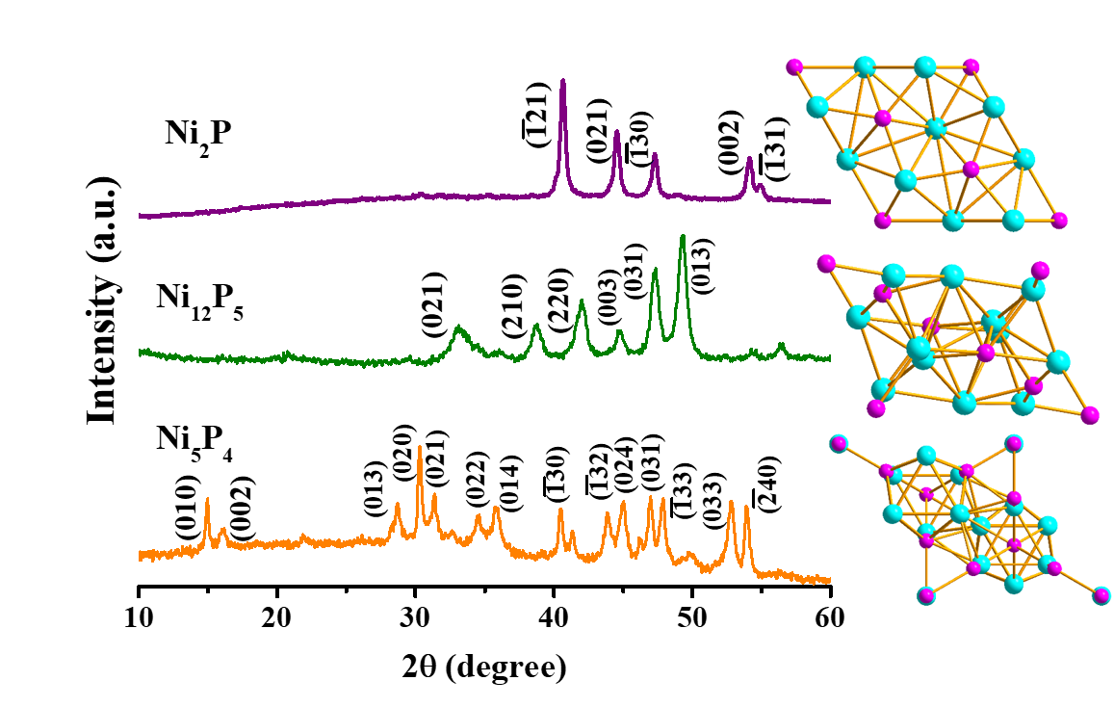

**Figure 1.** XRD patterns of as-synthesized Ni2P (produced with 0.4 ml TOP), Ni12P5(produced with 0.3 ml TOP) and Ni5P4. Right panel shows the unit cells of corresponding phases (purple: P, cyan: Ni).

The morphologies of the as-synthesized nanostructures were characterized by TEM. The Ni2P structures were polygonal with a single void, monodispersed, in the size range of28±4 nm (**Figure 2A**), and single-crystalline (**Figure 2B**). Elemental mapping in **Figure 2C** shows a homogenous distribution of Ni and P in theNi2P structures, and the atomic ratio of Ni:P corresponded to the stoichiometric ratio.

**Figure 2.** Electron microscopy images of Ni2P structures. (A) HAADF-STEM (B) HRTEM and (C) STEM EDS elemental maps: P in red and Ni in blue.

The Ni12P5 structures were truncated polyhedra, showing a single void, with size distribution of 58±6 nm (**Figure 3A**). The TEM image in **Figure 3B** confirmed the presence of domain boundaries, potentially of use for improved catalytic activity. The element mapping showed homogenous distribution. The atomic ratio of Ni:P corresponded to the stoichiometric ratio.



**Figure 3.** Electron microscopy Images of Ni12P5 structures. (A) HAADF-STEM (B) HRTEM and (C) STEM-EDS element maps: P in red and Ni in blue.

**Figure 4A** shows a HAADF-STEM image of Ni5P4 nanocrystals. The Ni5P4 was spheroidal in shape, highly monodispersed with size distribution of 25±3 nm without voids. The HRTEM in **Figure 4B** shows the single crystalline nature of the as-synthesized Ni5P4. According to the element mapping (**Figure 4C**), the atomic ratio of Ni:P was in accordance with the stoichiometric ratio.

**Figure 4**. Electron microscopy Images of Ni5P4 structures. (A) HAADF-STEM (B) HRTEM and (C) TEM-EDS elemental maps: P in red and Ni in blue.

***3.2 Growth Mechanism***

Analyzing aliquots taken in different stages of the synthesis, we concluded that the Ni2P phase was formed from an amorphous Ni−P phase, producing pure Ni2P phase when the annealing times were longer than 10 min, or a mixture of Ni2P and Ni12P5 when the annealing time was 10 min (see **Figure 5** where the TOP amount was 0.4 ml). When the reaction was carried out using 0.3 ml TOP, Ni12P5 was formed, starting with Ni(0) particles that phosphorize within 10-20 min (**Figure S6**). Metallic Ni(0) can be synthesized in lower temperatures (220 °C), but in higher temperatures, TOP decomposes and serves as the source for phosphorus[15], which diffuses inwards into the Ni(0) particles. A faster inward diffusion of P into Ni(0) produced hollow structures, in a Kirkendall mechanism, confirmed by the size increase from Ni(0) to Ni12P5 (**Figure S7**). The formation of Ni5P4 progressed through initial Ni2P structures which converted gradually to the P-rich Ni5P4 phase upon annealing at 350 °C at high TOP concentration (**Figure S8**). **Figure 5**depicts the formation process of different nickel phosphide phases.

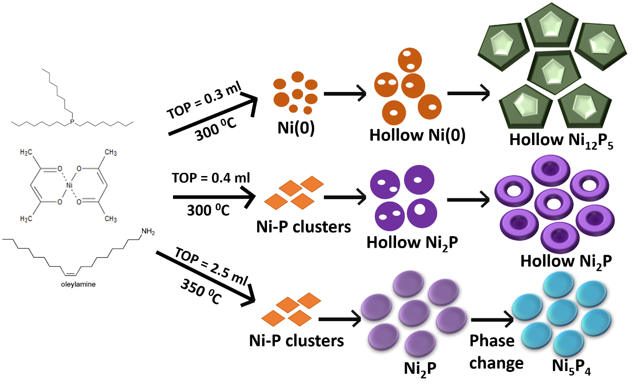

**Figure 5.** Schematic representation of the growth mechanism.

**3.3 XPS studies**

The HER activity of the catalyst highly depends on the oxidation states and the chemical environment of the catalytic sites, which was studied by XPS (**Figure 6** and the positions of the relative peaks and their ratio is provided in **Table 1**). The analysis was performed after ligand stripping, which is the form used later for the catalytic measurements. Peaks related to oxygen species (oxide, phosphate layer or hydroxide) were observed for all three catalysts concluding that the outer surface of all the nanostructures was oxidized (NiPO phase) or that surface absorbed hydroxyl groups were present (**Figure S9**). A few oxidation states of Ni were resolved by the XPS: Niδ+ with a slight positive charge, and Ni species with higher oxidation states (Ni2+ or Ni3+).[16, 17] Ni2P and Ni5P4 had a large fraction of Ni in its low oxidation state, producing a ratio of Niδ+/(Ni2+or Ni3+) of 3.0 and above, while Ni12P5, had both species equally distributed with a ratio of Niδ+/(Ni2+or Ni3+) of 1.0. The XPS spectra of P (**Figure 6B**) show peaks at 129.5, 129.0, 129.1 eV for Ni2P, Ni12P5, and Ni5P4 respectively, all lower binding energies than elemental P (130.2 eV) and as such indicating a negatively charged Pδ-. These findings suggest that there is an electron transfer from Ni to P in all nickel phosphide phases. Additionally, peaks are observed around 133 eV in the P 2p energy region, which can be attributed to surface oxidized P species because the samples were exposed to air.[18] To summarize, we conclude that Ni12P5 has the highest degree of charge transfer between the Ni and the P within the sample set.

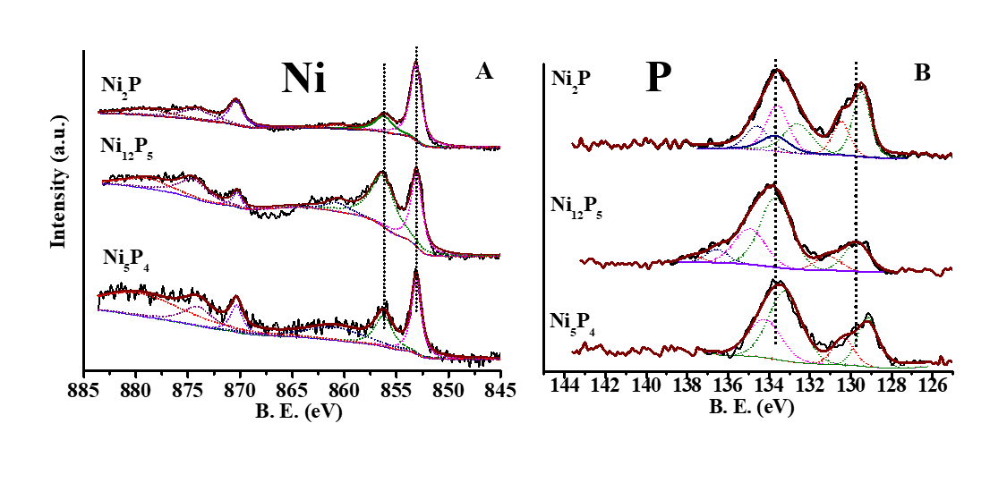**Figure 6.** XPS spectra of Ni (A) and P (B) for Ni2P, Ni12P5 and Ni5P4.

**Table 1**: Peak position of Ni and P in different Nickel phosphide NCs and ratio of Niδ+ and Ni2+

|  |  |  |  |
| --- | --- | --- | --- |
|  | **Ni2P** | **Ni12P5** | **Ni5P4** |
| **Ni 2P**  **(eV)** | 853.1 | 852.9 | 853.2 |
| 856.0 | 856.3 | 856.3 |
| **P 2P3/2**  **(eV)** | 129.5 | 129.0 | 129.1 |
| 132.6 | 133.8 | 133.2 |
| 133.5 | 135.0 |  |
| **Niδ+/Ni2+** | 3.6 | 1.0 | 3.0 |

Improved catalytic activity was attributed in the literature to the formation of acid-base pairs in close vicinity within the crystal lattice, facilitating similar activity to hydrogenase, where negatively charged non-metal sites act as H+ acceptors and the metal sites act as hydride acceptors.[19] Such acid-base pairs are potentially formed by charge transfer between Ni and P, similarly to charge transfer in other transition metal phosphides.[18, 20, 21] Here, the XPS results confirm mild electron transfer between Ni and P in Ni2P and strong electron transfer between Ni and P in Ni12P5 which was found to affect the catalytic activity in previous studies. [9]

***3.4 Electrocatalytic HER***

The electrocatalytic activity of the various nanostructures was evaluated toward the HER under both acidic and alkaline conditions. The onset potential, which is the start point of catalytic activity, defined as the overpotential at the current density of J = 1 mA cm−2and the overpotential to produce a current density of 10 mA cm−2 were low for all the samples (see **Figure 7A** and **Table 2**). The reaction kinetics and mechanism at the surface of the electrode was estimated from the Tafel slope, which is calculated by plotting the overpotential vs. the logarithm of the current density (**Figure 7B)**. The lowest Tafel slope was 60 mV/dec (for Ni2P), indicating a similar mechanism for all the catalysts - a fast Volmer step followed by a rate-determining Heyrovsky step.[22] The catalytic activity of Ni5P4 in this study is better or comparable with recently published research,[23] and Ni12P5 showed superior performance to recently reported Ni12P5-based catalysts (for detailed comparison with the state-of-the-art see **Table S3** in the supporting information).[24, 25] Ni2P structures showed significantly higher catalytic activity than both Ni5P4 and Ni12P5, exhibiting an overpotential of 126 mV (at 10 mA cm−2), much higher than recently reported Ni2P systems.[25-28] We further calculated the electrochemical surface area (ECSA) of the as-synthesized catalysts, estimated from their double-layer capacitance(Cdl). The results indicated high number of available surface sites (see **Table 2** and the supporting information for details of the measurements and the calculations, **Figure S10**). Notably, the ECSA of Ni2P was the lowest in the set. We therefore attribute the higher activity of Ni2P to its desirable binding properties, rather than an active surface area.

The ideal way to compare the catalyst activity is using the turn over frequency (TOF) of the electrocatalytic reaction which is independent of the active surface. The TOF is the ratio of the number of H2 molecules produced to the number of sites present in the catalyst surface. The TOF plot was deduced from the current density plot, by normalizing with respect to the surface sites and the ECSA (the details of calculation for the surface sites and the TOF are provided in the supporting information, **Figure S11**). The best TOF value obtained here is 0.59 s-1 for Ni2P, comparable with recent report.[27]

~~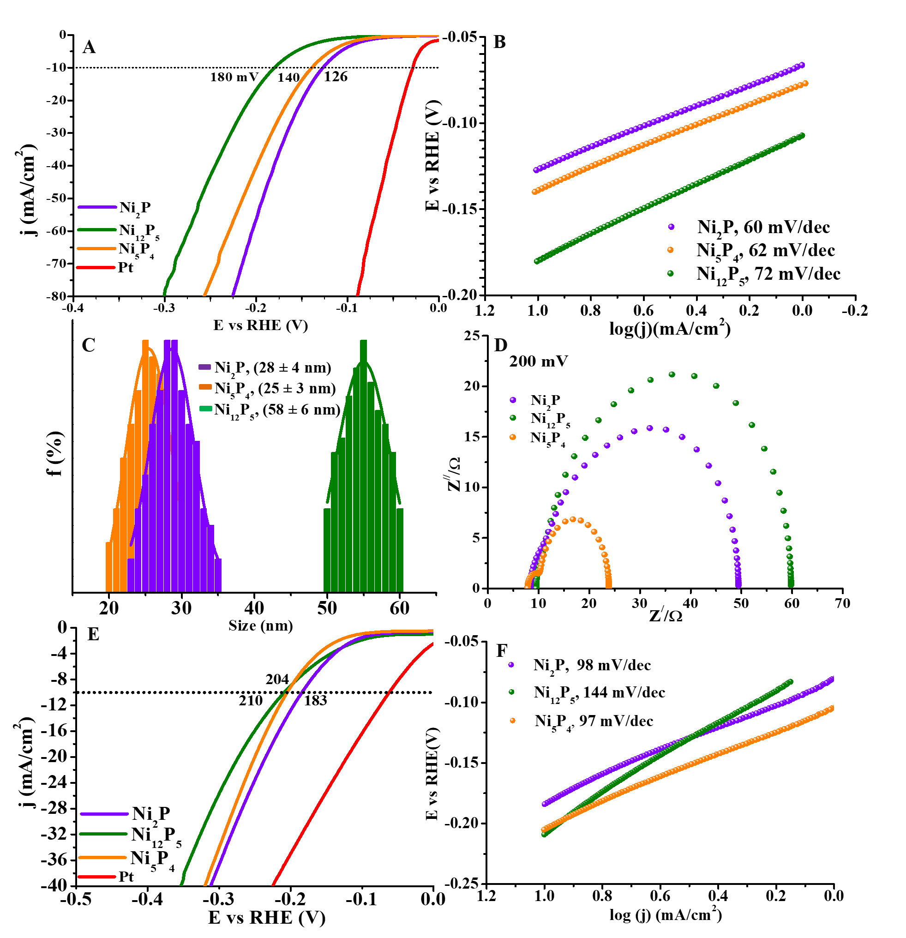~~

**Figure 7.** (A) HER polarization curves of various nickel phosphide catalysts in 0.5M H2SO4. (B) The corresponding Tafel slopes. (C) Size distribution histograms. (D) Nyquist plots at a bias of 200 mV. E) HER polarization curves in 0.5M KOH and (F) the corresponding Tafel slopes.

**Table 2**: Summary of the electrochemical performance of the various nickel phosphide catalysts

|  |  |  |  |  |  |  |  |
| --- | --- | --- | --- | --- | --- | --- | --- |
| **Catalyst** | **Acid (0.5 M H2SO4)** | | | | | **Base (0.5 M KOH)** | |
| **Ƞ10mAcm-2**  **(mV)** | **Tafel slope**  **(mVdec-1)** | **Rct at  200 mV**  **(Ω)** | **ECSA**  **(cm2)** | **TOF200**  **(min-1)** | **Ƞ10mA cm-2**  **(mV)** | **Tafel slope**  **(mVdec-1)** |
| Ni2P | 126 | 60 | 49.4 | 155 | 0.59 | 183 | 98 |
| Ni12P5 | 180 | 72 | 59.7 | 284 | 0.1 | 210 | 144 |
| Ni5P4 | 140 | 62 | 23.5 | 195 | 0.35 | 204 | 97 |

The kinetics of the electrodes were investigated by electrochemical impedance spectroscopy (EIS). **Figure S12** shows the Nyquist plots of different catalyst at various potentials within the frequency range 100 kHz to 0.05 Hz with an amplitude of 15 mV. The diameter of the semicircle in Nyquist plots represents the charge transfer resistance (Rct) of the catalyst. The Rct values determined from the diameter of the semicircles at 200 mV are shown in **Figure7D** and summarized in **Table 2**. The low charge transfer resistance for Ni5P4 confirms fast electron transfer from the catalyst surface to the solution. The Rct value can be used to derive the Tafel slope by plotting log(1/Rct) vs the overpotential as depicted in **Figure S12**. The Tafel slopes derived in this way were in accordance with the values obtained from the LSV measurements, showing that the contribution of electron transport resistance is minor.[29]Using continuous cyclic voltammetry (CV) sweeps at a scan rate of 100 mV/s for 3000 CV cycles, showing the durability of the various catalysts for electrocatalytic HER (**Figure S13A-C**).

The HER performance in alkaline is presented in **Figure7E**. The overpotentials required for a current density of 10 mAcm-2 and the derived Tafel slopes (**Figure 7F**) are provided in **Table 2**. The electrocatalytic performance of Ni2P in alkaline medium (considering both the overpotential and Tafel slope) was comparable[30] or better[31-33] than recently reported studies. It is widely accepted that in alkaline medium the HER activity is also affected by the water dissociation step and the poisoning of active sites by OH-, in addition to the ΔGH*, which is the prominent parameter in acidic conditions. The performance of Ni12P5 and Ni5P4 in alkaline is comparable in terms of the overpotential at 10mA cm-2 (the former even exhibits the lowest onset potential), while in acidic medium Ni5P4 is significantly better. We attribute this observation to the high oxidation state of Ni species within Ni12P5, which decreases the energy barrier for water dissociation, H--OH.[34, 35]In contrast, higher oxidation number of nickel will also bind OH- stronger, a negative effect[36] which may lead to active sites poisoning.[35]The poisoning is clearly observable at high current densities (**Figure 5E**) in which the performance of Ni12P5was the worst, while Ni5P4 showed gradual relative improvement and approached the Ni2P activity. At high current densities, more H2 is generated and the desorption of OH− to refresh the surface sites is a vital step that facilitates the re-adsorption of water and that is a dominant parameter in the design of catalysts for alkaline conditions. In this respect the Ni5P4, with its mild oxidation state of Ni, exhibited the optimal balance: facilitating water dissociation while preventing poisoning with –OHads. The observation that Ni2P showed the highest activity, both in acid and in alkaline, is attributed to its abundant active sites combined with a significantly favorable hydrogen adsorption energy.[37]

***3.5 Catalytic HER from hydrolysis of amino borane (AB) and NaBH4***

The catalysts were further employed for catalytic dehydrogenation from hydrolysis of aminoborane and NaBH4. The hydrogen-generating reaction was performed with a fixed ratio of the catalyst to AB or NaBH4.**Figure 8**shows the catalytic activity of the catalysts at 298 K in ambient conditions. Experiments in the temperature range of 288 K-318K were used to derive the activation energy (Ea) of the catalytic hydrolysis (**Figure S14 and S19**). For both the catalytic processes, the performance of Ni12P5 was better than Ni2P and Ni5P4 in terms of the TOF and activation energy (Ea). The TOF and Ea values of Ni5P4 and Ni12P5 for aminoborane hydrolysis are better than Pd, Ru and other noble metal-based catalysts and comparable with the recently reported state-of-the-art (supporting Information, **TableS4**). For NaBH4 hydrolysis, all three catalysts showed comparable activity to that of noble metal based catalysts or to other transition metals based-structures recently reported.[5] The reaction was following zero-order kinetics with respect to NaBH4 for all the three catalysts, as no change of catalysis rate was found when varying the NaBH4 concentration (**Figure S20**).



**Figure 8.** (A-B) Kinetics of hydrolysis of NH3BH3 by Ni12P5 at various temperatures and the corresponding Arrhenius plot for the activation energy. (C-D) Kinetics of hydrolysis of NaBH4 by Ni12P5 at various temperatures and the corresponding Arrhenius plot for the activation energy. (E) and (F) are the comparative plots for activation energy and TOF of Ni-P nanoparticles for NH3BH3 and NaBH4 hydrolysis respectively.

Stability tests for aminoborane hydrolysis showed that the least stable catalyst was Ni2P whereas Ni5P4 and Ni12P5were both highly stable upto five catalytic cycles (**Figure S15-S18**). Ni12P5 even showed an improvement of the TOF value after five cycles. A plausible explanation for the improvement may be the reduction of Niδ+ to Ni(0) by BH4-which increases the electron density on Ni-sites.[38] The change in the Ni oxidation state is also evident in the XPS measurements as a shift of the binding energy of Niδ+ to a lower value (from 852.9 eV to 852.5 eV), **Figure S18**. Exposed Ni(0) on the surface of Ni12P5 was reported to boost the hydrogen evolution rate.[14]

The difference in the hydrolysis activity of the three catalysts may be correlated with the extent of the charge separation between Ni and P. For aminoborane, the hydrogen atoms of the molecules interact with both Ni and P. According to calculations, the rate determining step is SN2 where activated water absorbed on the surface attack the BH3 group of NH3BH3 and accelerate the B-N bond breaking.[5] Ni act as hydride acceptor due to its inherent positive charge making the charge density on the Ni sites a significant parameter. Higher positive charge density may promote the initial binding of aminoborane to the Ni-P surface and by that effectively activate the B-N bond and enhance the hydrogen release. In accordance with these insights, Ni12P5has a substantial charge on the Ni sites (according to the XPS data) which results in lower activation energy and faster kinetics of hydrolytic cleavage. For NaBH4, and other hydride transfer reagents, the starting point is (NP-H)n- followed by the hydrolysis that occurs via the following mechanism:[39]

{(Ni-P-NP)-Hm}n-+ H+⟶ {(Ni-P-NP)-Hm-1}(n-1)-+ H2 (“Heyrovsky”)

{(Ni-P-NP)-Hm}n-⟶ {(Ni-P-NP)-Hm-2}n-+ H2 (“Tafel”)

Therefore, cations or electropositive elements such as Ni, promote the first step where the M-H bond is formed. The charge separation between Ni (Ni**δ**+/Ni2+) and P (P**δ**-) was confirmed from the XPS studies for all the three phases of Ni-P, which enabled them to show good catalytic activity. Ni12P5 had a high positive charge on the Ni center and high density of these sites (Ni**δ**+/Ni2+ = 0.98), facilitating its activity as hydrid acceptor that decreases the activation energy for the catalytic reaction. The high TOF may be accounted for by similar logic.

1. **Conclusions**

In summary, we successfully synthesized various pure phase nanostructures of nickel phosphide (Ni5P4, Ni2P and Ni12P5). The conditions to obtain each of the phases were studied and the growth mechanism was described. The catalytic activity was measured towards electrochemical hydrogen production by water reduction and also towards hydrogen retrieving by hydrolysis of chemical hydrogen storage materials (aminoborane and NaBH4). The results showed that charge separation between the Niδ+-Pδ- sites in the various Ni-P phases plays a key role in achieving the desired efficiency of the catalytic reaction.Ni2P nanoparticles exhibited the highest performance for electrocatalytic hydrogen evolution with low overpotential (126 mV and 180 mV at J= 10 mA·cm-2 for acid and base respectively).For hydrolysis of boron-hydrides compounds, high positive charge on the metal center acts as hydride acceptor to accelerate the catalytic reaction and the release of H2. Ni12P5 was the most efficient catalyst with TOF= 23.0 min-1 and Ea=50.4 KJ·mol-1 for hydrogen retrieval from aminoborane and TOF= 17.3 min-1 and Ea=52.7 kJ·mol-1 for hydrogen retrieval from NaBH4, which is comparable with noble metal nanoparticles. Our work provides new insights in this system, and offers understanding of the structure-activity relationship for the design of multifunctional noble-metal free catalysts for hydrogen evolution from water and from promising hydrogen storage materials.

**Author contributions**

S. G. designed the project, synthesized the samples and measured their catalytic properties, carried out the characterization measurements except for the HRTEM and wrote the majority of the manuscript. S. R. K. measured the electrochemical properties of the samples with S. G. Aberration-corrected electron microscopy was performed by L. H. The work was supervised by M. B. S. and R. B. Z. who were also involved with the writing of the manuscript. All authors have given their feedback on the paper and approved the final version of the manuscript before its submission.

**Conflict of interests**

The authors declare no competing financial interests.

**Acknowledgements**

S. K. and S. G. thank the financial support of the Kreitman Post-Doctoral fellowship at the BGU. This center of excellence was supported by The Israel Science foundation (grant No. 1212/21).

**Appendix A. Supplementary data**

Supplementary data to this article can be found online.

**References**

[1] L. Schlapbach and A. Züttel, Nature, 414 (2001) 353.

[2] L.J. Murray, M. Dincă and J.R. Long, Chem. Soc. Rev., 38 (2009) 1294.

[3] B. Sakintuna, F. Lamari-Darkrim and M. Hirscher, Int. J. Hydrog. Energy, 32 (2007) 1121.

[4] U.B. Demirci and P. Miele, Energy Environ Sci, 4 (2011) 3334.

[5] N. Patel and A. Miotello, Int. J. Hydrog. Energy, 40 (2015) 1429.

[6] W.-W. Zhan, Q.-L. Zhu and Q. Xu, ACS Catal., 6 (2016) 6892.

[7] K. Li, Y. Li, Y. Wang, J. Ge, C. Liu and W. Xing, Energy Environ Sci, 11 (2018) 1232.

[8] E.K. Abo-Hamed, T. Pennycook, Y. Vaynzof, C. Toprakcioglu, A. Koutsioubas and O.A. Scherman, Small, 10 (2014) 3145.

[9] Y. Pan, Y. Liu, J. Zhao, K. Yang, J. Liang, D. Liu, W. Hu, D. Liu, Y. Liu and C. Liu, J. Mater. Chem. A, 3 (2015) 1656.

[10] H. Li, S. Lu, J. Sun, J. Pei, D. Liu, Y. Xue, J. Mao, W. Zhu and Z. Zhuang, Chem. Eur. J., 24 (2018) 11748.

[11] M. Das, N. Jena, T. Purkait, N. Kamboj, A. De Sarkar and R.S. Dey, J. Mater. Chem. A, 7 (2019) 23989.

[12] C.-Y. Peng, L. Kang, S. Cao, Y. Chen, Z.-S. Lin and W.-F. Fu, Angew. Chem. Int. Ed., 54 (2015) 15725.

[13] C.-C. Hou, Q. Li, C.-J. Wang, C.-Y. Peng, Q.-Q. Chen, H.-F. Ye, W.-F. Fu, C.-M. Che, N. López and Y. Chen, Energy Environ Sci, 10 (2017) 1770.

[14] Y. Lin, L. Yang, H. Jiang, Y. Zhang, D. Cao, C. Wu, G. Zhang, J. Jiang and L. Song, J. Phys. Chem. Lett., 10 (2019) 1048.

[15] L.M. Moreau, D.-H. Ha, C.R. Bealing, H. Zhang, R.G. Hennig and R.D. Robinson, Nano Lett., 12 (2012) 4530.

[16] L. Cai, B. Qiu, Z. Lin, Y. Wang, S. Ma, M. Wang, Y.H. Tsang and Y. Chai, J. Mater. Chem. A, 6 (2018) 21445.

[17] H. Zhang, Y. Lu, C.-D. Gu, X.-L. Wang and J.-P. Tu, CrystEngComm, 14 (2012) 7942.

[18] P. Jiang, Q. Liu, Y. Liang, J. Tian, A.M. Asiri and X. Sun, Angew. Chem. Int. Ed., 53 (2014) 12855.

[19] P. Liu and J.A. Rodriguez, J. Am. Chem. Soc., 127 (2005) 14871.

[20] J. Tian, Q. Liu, N. Cheng, A.M. Asiri and X. Sun, Angew. Chem. Int. Ed., 53 (2014) 9577.

[21] P. Jiang, Q. Liu and X. Sun, Nanoscale, 6 (2014) 13440.

[22] Y.-F. Xu, M.-R. Gao, Y.-R. Zheng, J. Jiang and S.-H. Yu, Angew. Chem. Int. Ed., 52 (2013) 8546.

[23] M. Ledendecker, S. Krick Calderón, C. Papp, H.-P. Steinrück, M. Antonietti and M. Shalom, Angew. Chem. Int. Ed., 54 (2015) 12361.

[24] Y. Pan, W. Hu, D. Liu, Y. Liu and C. Liu, J. Mater. Chem. A, 3 (2015) 13087.

[25] Y. Pan, N. Yang, Y. Chen, Y. Lin, Y. Li, Y. Liu and C. Liu, J. Power Sources, 297 (2015) 45.

[26] Y. Du, C. Liu, G. Cheng and W. Luo, Chem. Asian J., 12 (2017) 2967.

[27] B. Seo, D.S. Baek, Y.J. Sa and S.H. Joo, CrystEngComm, 18 (2016) 6083.

[28] L. Mora-Tamez, G. Barim, C. Downes, E.M. Williamson, S.E. Habas and R.L. Brutchey, Chem. Mater., 31 (2019) 1552.

[29] H. Vrubel, T. Moehl, M. Grätzel and X. Hu, Chem Commun 49 (2013) 8985.

[30] J. Xia, K. Dhaka, M. Volokh, G. Peng, Z. Wu, Y. Fu, M. Caspary Toroker, X. Wang and M. Shalom, Sustain Energ Fuels, 3 (2019) 2006.

[31] Y. Zhang, Y. Liu, M. Ma, X. Ren, Z. Liu, G. Du, A.M. Asiri and X. Sun, Chem Commun 53 (2017) 11048.

[32] L. Yan, P. Dai, Y. Wang, X. Gu, L. Li, L. Cao and X. Zhao, ACS Appl. Mater. Interfaces., 9 (2017) 11642.

[33] T. Ma, Y. Qiu, Y. Zhang, X. Ji and P.-A. Hu, ACS Appl. Nano Mater., 2 (2019) 3091.

[34] Y. Zheng, Y. Jiao, A. Vasileff and S.-Z. Qiao, Angew. Chem. Int. Ed., 57 (2018) 7568.

[35] D. Strmcnik, P.P. Lopes, B. Genorio, V.R. Stamenkovic and N.M. Markovic, Nano Energy, 29 (2016) 29.

[36] R. Bar-Ziv, O.E. Meiron and M. Bar-Sadan, Nanoscale, 10 (2018) 16211.

[37] M.H. Hansen, L.-A. Stern, L. Feng, J. Rossmeisl and X. Hu, Phys. Chem. Chem. Phys., 17 (2015) 10823.

[38] Z.-C. Fu, Y. Xu, S.L.-F. Chan, W.-W. Wang, F. Li, F. Liang, Y. Chen, Z.-S. Lin, W.-F. Fu and C.-M. Che, Chem Commun 53 (2017) 705.

[39] A. Sermiagin, D. Meyerstein, R. Bar-Ziv and T. Zidki, Angew. Chem. Int. Ed., 57 (2018) 16525.