**Cu@MoS2 Hybrids – Bifunctional Electro-catalysts for the Oxygen Reduction and Hydrogen Evolution Reactions**

Avraham Bar-Hen1,2,3, Ronen Bar Ziv*3, Tsion Ohaion-Raz1,3, Amir Mizrahi3, Simon Hettler4, Raul Arenal,4,5,6 and Maya Bar Sadan*1,2

*1 Department of Chemistry, Ben-Gurion University of the Negev, Beer-Sheva, 8410501, Israel*

*2 Ilse Katz Institute for Nanoscale Science and Technology, Ben-Gurion University of the Negev, Beer-Sheva, 8410501, Israel*

*3 Nuclear Research Center Negev, Beer-Sheva, Israel*

*4. Laboratorio de Microscopías Avanzadas, Instituto de Nanociencia de Aragón, Universidad de Zaragoza, 50018 Zaragoza, Spain*

*5. ARAID Foundation, 50018 Zaragoza, Spain.*

*6. Instituto de Ciencias de Materiales de Aragon, CSIC-U. de Zaragoza, Calle Pedro Cerbuna 12, 50009 Zaragoza, Spain*

*\** [*barsadan@bgu.ac.il*](mailto:barsadan@bgu.ac.il)

*\*bronen@post.bgu.ac.il*

**Abstract**

MoS2 is a promising catalyst for the hydrogen evolution reaction (HER) and the oxygen reduction reaction (ORR). Current research focuses on further modifications to enhance its performance. Here we show that shelling Cu particles with MoS2 layers produces several effects: the MoS2 shell is strained and defective and charge transfer from Cu to MoS2 occurs, both positive effects that activate the basal plane of MoS2. The hybrid showed good activity towards the HER and excellent activity towards ORR with an onset of 0.87 V vs. RHE (half wave of 0.765 V), and a dominating 4 electron reaction pathway.

There is a growing interest in developing new catalytic materials as an alternative to the precious noble metals for energy-related applications, such as hydrogen generation from water splitting (HER) and the Oxygen Reduction Reaction (ORR) in fuel cells.1 The ORR serves as the cathodic reaction in the alkaline anion exchange membrane fuel cells (AEMFCs).2, 3 The ORR occurs at the cathode of the fuel cell and has a large kinetic barrier due to strong (di)oxygen double bond, which is the rate determining step for the production of output energy from the initial H2 fuel source, thus requiring substantial energy input to initiate the reaction.

A promising low-cost alternative to the utilization of precious metals as catalysts is MoS2. However, the catalytic activity of pristine MoS2 towards the HERis still lower than its theoretical potential4 and its suitability as an effective catalyst for other reactions, in particluar ORR, has been hardly investigated. The efficiency of hydrogen production by MoS2 is limited by low conductivity and the number of active sites, e.g. edges and defects, while the basal planes are relatively inert.5 Strategies to overcome these limitations in MoS2 and other transition metal dichalcogenides include increasing the density of their catalytic sites either by creating defects,6-9 modifying the morphology10, 11 or by doping with other transition metals.5, 12-15 Another approach is to produce hybrid materials of MoS2 with other materials.11, 14, 16-26 The use of core-shell hybrid materials is a particularly promising approach for tuning the catalytic properties of layered nanomaterials. So far, several core materials were selected for encapsulation by MoS2.27-31 Hybrid Au-MoS2 core-shell structures as model photocatalysts24, 25, 32 and electrocatalysts18, 33 were recently reported. Our previous studies have shown that Au@MoS2 nanoparticles enhance the catalytic activity by the charge transfer from Au to MoS2 and by the strain within the MoS2 lattice as it embeds the curved Au nanoparticle.33 However, Au is a noble metal and expensive and practical usage requires affordable structures. Other coinage-metal cores, such as Ag or Cu, coated with MoS2 layers, were reported but used for surface enhanced Raman (SERS) applications.34-37 While Ag is also relatively an expensive material, Cu is an affordable material that can be used commercially. Therefore, replacing the expensive Au with Cu core provides prospect also for a more affordable catalyst, if comparable activity is achieved.

In this work we report the preparation, characterization and catalytic activity towards HER and ORR of Cu@MoS2 hybrid nanostructures. TEM images of Cu@MoS2 present nanostructured Cu nanoparticles wrapped with multi-layers of MoS2, also confirmed by energy electron energy loss spectroscopy (EELS). Electrochemical measurements show that the hybrids’ catalytic activity towards HER and particularly ORR is better than free-standing MoS2 or Cu nanoparticles and other recently reported TMDs-based materials. Our unique hybrid structures pave the way for new approaches to design efficient, durable and cost-effective electrocatalysts for future energy related applications.

The hybrid materials were prepared by reducing Cu(II)(aq) using NaBH4 and then adding slowly (NH4)2MoS4. The suspension was stirred overnight and then dried and annealed in a quartz ampoule. Details of the characterization techniques and instrumentation are provided in the supporting information. Working electrodes were prepared by dispersing the catalyst, carbon black and Nafion to produce homogenous ink. The ink was drop-casted onto a glassy carbon electrode or a rotating disk electrode. All the electrocatalytic measurements were conducted with a three-electrode system (working electrode as the active material, counter electrode is graphite, and Ag/AgCl as the reference electrode) in O2 saturated 0.1 M KOH and Ar-saturated 0.5 M H2SO4 elect**rolytes for ORR and HER respectively. All the potentials refer** to the reversible hydrogen electrode (RHE).

Directly after the synthesis of Cu nanoparticles, a sharp peak around 570 nm was observed in the UV-Vis spectrum (**Figure 1a**), attributed to surface plasmon resonance (SPR). The SPR peak provides definitive evidence for the presence of Cu nanoparticles in the solution at this stage, in accordance with the literature.38 The spectrum of the annealed particles, Cu@MoS2, contains peaks at 670 nm, 630 nm, and a broad peak at 400-550 nm, the characteristic A, B and C excitons of MoS2 (**Figure 1b**). 39-42 The broad feature in the IR of Cu@MoS2 is associated with CuS, which is known to have an absorption band around 1450 nm (**Figure 1c**).43 XPS measurements (**Figures S1-S2**) showed that Cu-S bond is formed already at the intermediate stage and a shift in the binding energy of Mo in the final product that is attributed to charge transfer from the Cu to the MoS2 shell.44

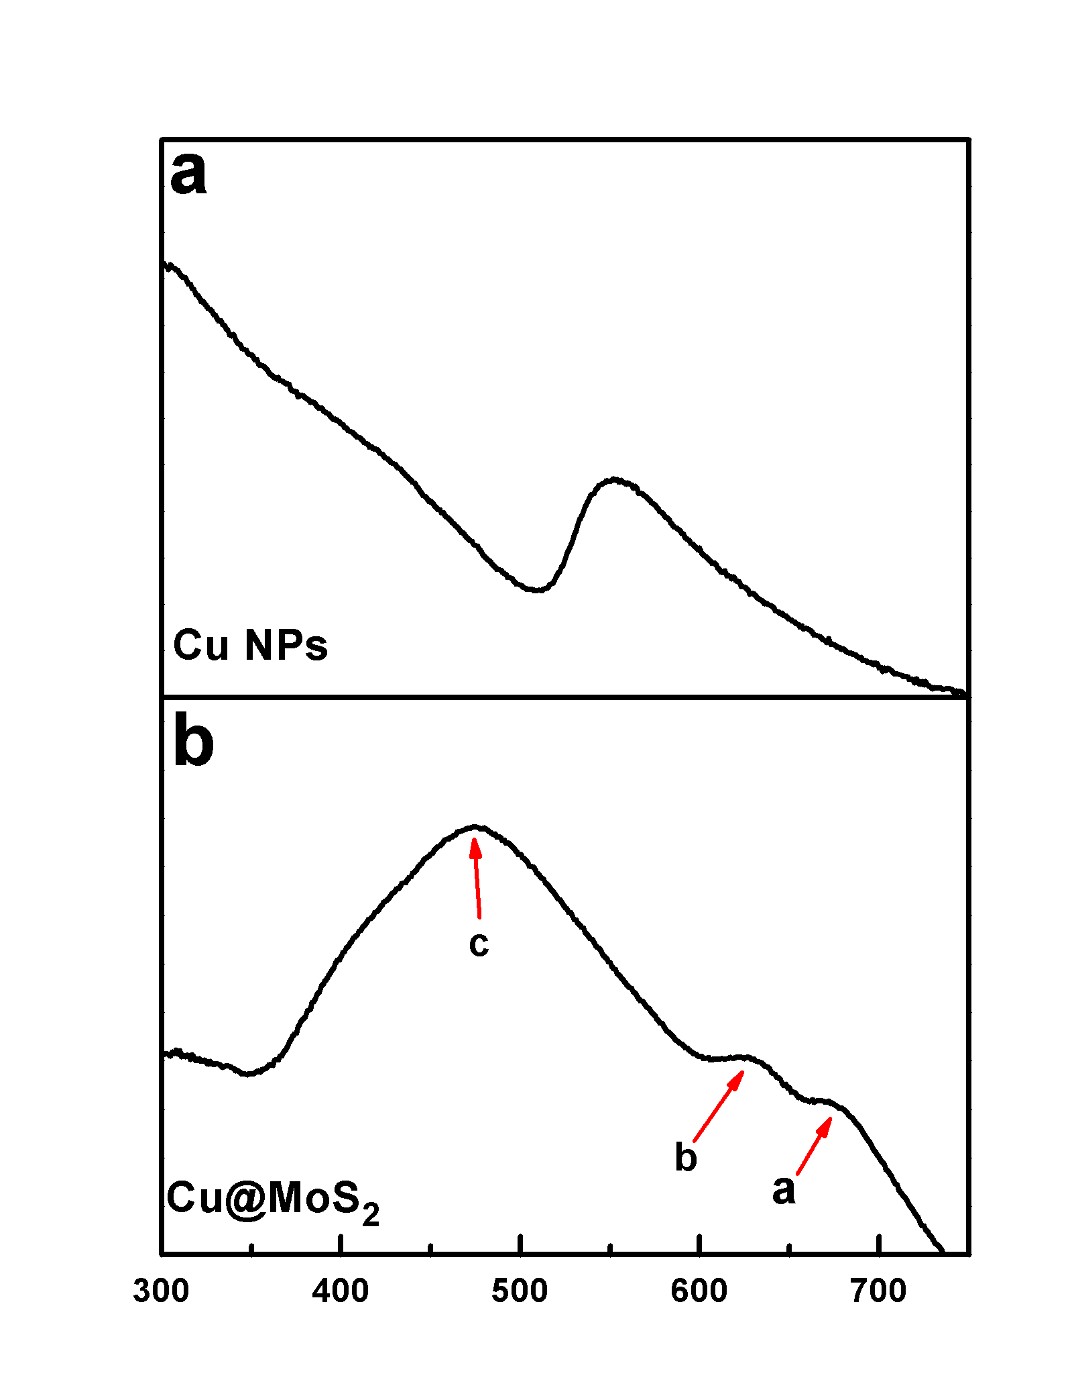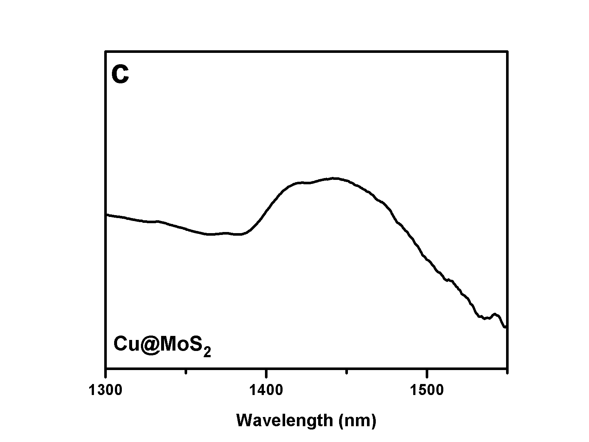

**Figure 1**. Normalized absorbance spectra of (a) Cu nanoparticles (b) Cu@MoS2 (C) IR region for Cu@MoS2.

Raman measurements of Cu@MoS2 showed the formation of MoS2 (**Figure 2a**). The separation between the E2g1 and A1g peaks is 23 cm-1,attributed in the literature to 2-3 molecular layers of MoS2, though direct comparison to the literature is not entirely accurate due to different morphologies.45 The observed shift of the E12g to lower frequencies, i.e. below 380 cm-1, is considered as an evidence of S vacancies in the MoS2 shell.46-48 Powder XRD patterns (**Figure 2b**) contain both MoS2 and CuS (Covellite) peaks,49, 50 showing that the weight ratio of MoS2 to CuS is 1:1. Calculation of lattice strain using the XRD data showed that the hybrids contain about 1.4% strain compared to the bulk material, and about 1% more than the nanoflowers (see full calculation in the supporting information).

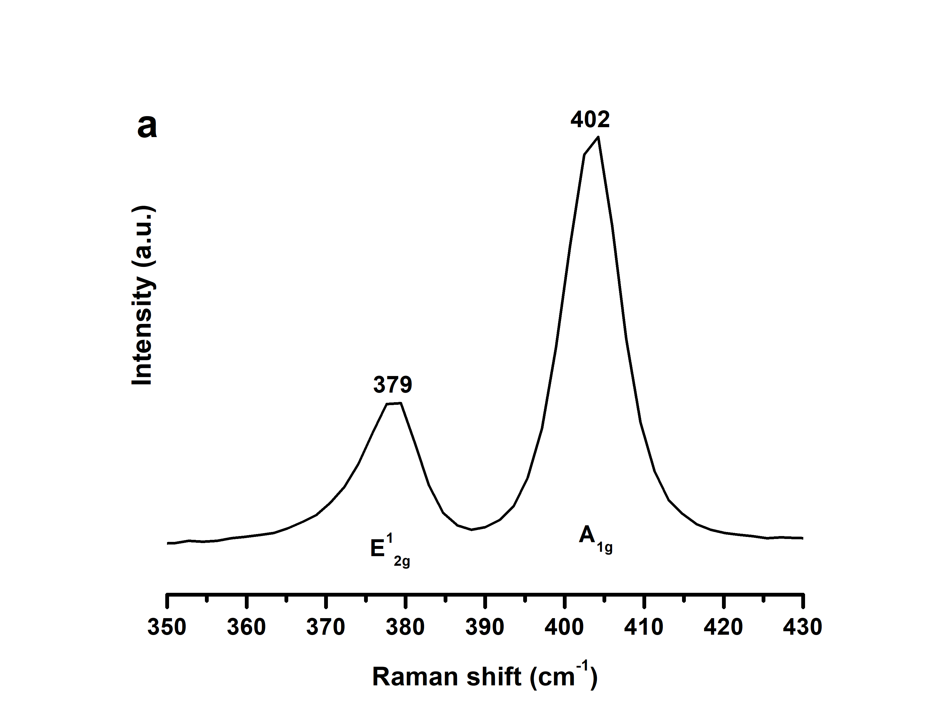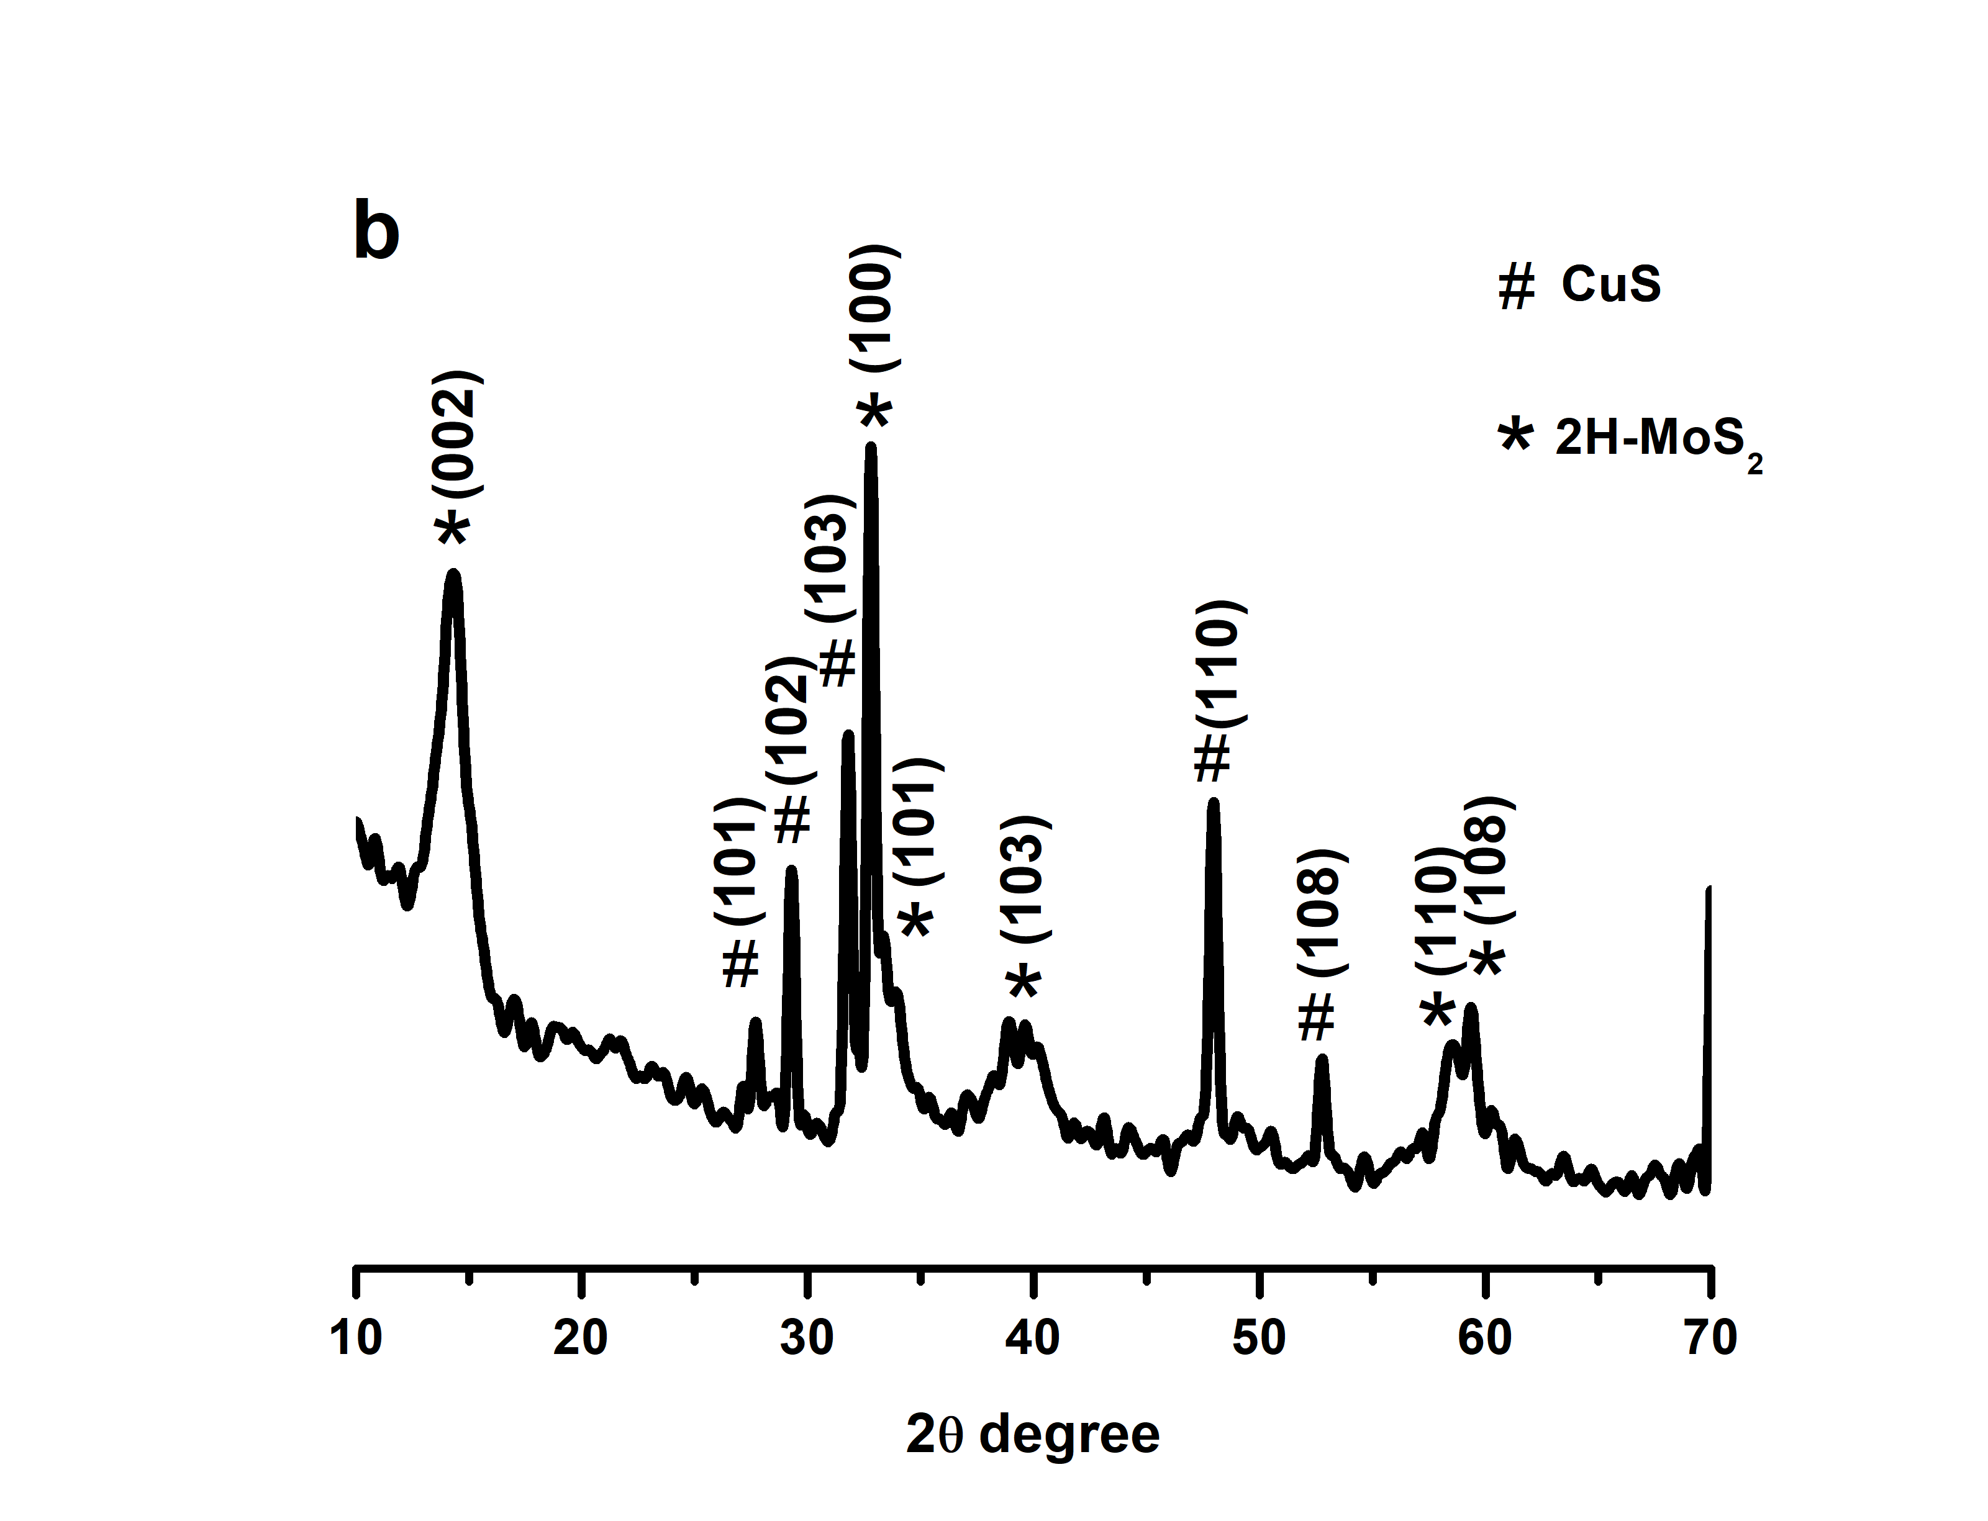

**Figure 2.** (a) Raman spectroscopy of Cu@MoS2 (b) Powder XRD pattern of Cu@MoS2.

**Figure 3** shows TEM images of the Cu@MoS2 nanoparticles. The size distribution of the core Cu nanoparticles is in the range of 20-30 nm (**Figure 3a**). The number of sheets wrapping a particle varied between 2-6 and all of them were multi-layered. There are also few free standing MoS2 structures (**Figure 3b**). However, these free MoS2 are not effective catalysts and therefore hardly contribute to the catalytic activity, as will be shown below. High resolution high angle annular dark field scanning TEM (HAADF-STEM), shown in **Figure 3c-d**, provides the details of the shelling: the atomic layers of MoS2 form a concentric shell with occasional defects such as dislocations and grain boundaries. The shelling is not uniform and, in some places, not entirely complete. **Figure 3e** reveals the lattice planes of a core nanoparticle as well as the atomic structure of the MoS2 shell. The lattice plane distance (0.28 nm) of the core could correspond to the [103] direction of the covellite CuS phase. Electron energy-loss spectroscopy (EELS) analysis was performed to assess the elemental distribution within the Cu@MoS2 hybrids. The spatial distribution of Cu (red), Mo (green), S (blue) and C (yellow) obtained from the EELS analysis of a hybrid is mapped in **Figure 3f**. The core@shell structure of the nanoparticles is clearly visible, with Mo located in the shell region of the nanoparticle while Cu is confined to the core. S is found both in the core of the nanoparticle and at the shell forming MoS2 (**Figure 3f**). EELS measurements on several nanoparticles provided a Cu:S ratio of about 1:1 (see **Figure S3**), although the exact stoichiometry can differ by ~20%, suggesting a composition of CuxS with 0.8<x<1.2. The EELS analysis could exclude the existence of oxygen and metallic Cu.

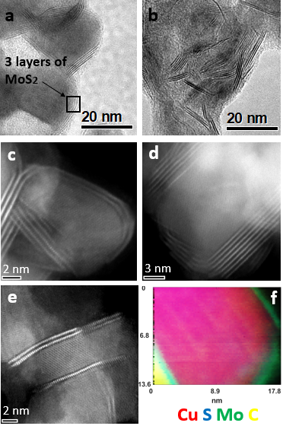

**Figure 3**. TEM images of the (a) hybrid Cu@MoS2 (b) free standing MoS2 found in the vicinity of the Cu@MoS2 structures. (c-e) High resolution HAADF-STEM images of Cu@MoS2 hybrids. (f) EELS analysis on an individual Cu@MoS2 nanoparticle where the superposition of the elemental maps of Cu, S, Mo and C (from the carbon support film on the Al TEM grid) is seen. The color code is marked under the image.

Electrochemical measurements were performed to evaluate the HER catalytic activity of the Cu@MoS2 hybrid, using linear sweep voltammetry (LSV) in a standard three electrode setup under acidic conditions (0.5 M H2SO4). The results (**Figure 4a**) confirm that the Cu@MoS2 hybrid exhibits better HER performance for a geometric current density of 10 mAcm-2, with an overpotential (ƞ) of 226 mV, significantly lower than Cu nanoparticles (431 mV) or free-standing MoS2 nanoflowers (422 mV).51 The HER kinetics were also estimated using the corresponding Tafel plots (**Figure 4b**), confirming a substantially lower Tafel slope (80 mV/dec) of the hybrid than each of the other components separately. The stability of the hybrids for 3000 cycles was confirmed (**Figure S4**). The Tafel slope, obtained by Electrochemical Impedance Spectroscopy (EIS) from the linear fit of the plot of log (Rct-1) versus η (**Figure S5)**,52 was in accordance with the value from the polarization curves, indicating a much improved electrical conductivity of the hybrid materials relative to pristine TMDs.52 The electrochemical double-layer capacitance (Cdl) was measured to estimate the electrochemically active surface area (ECSA), showing that the calculated ECSA of Cu@MoS2 was four-fold larger than MoS2 nanoflowers with the same mass loading, indictive of the high number of exposed active sites (**Figure S6**). These results are remarkably similar to the results obtained for similar Au@MoS2 structures, with a much more affordable materials in the present work.

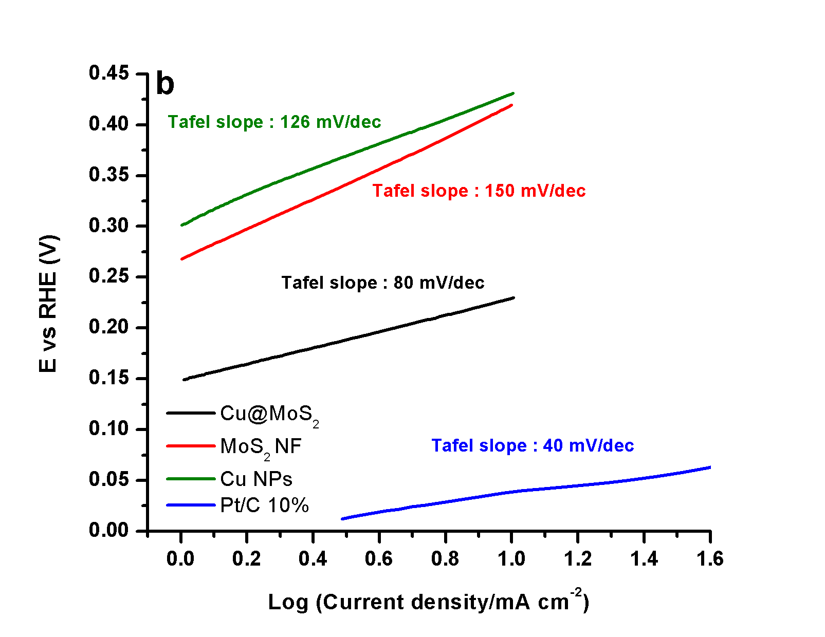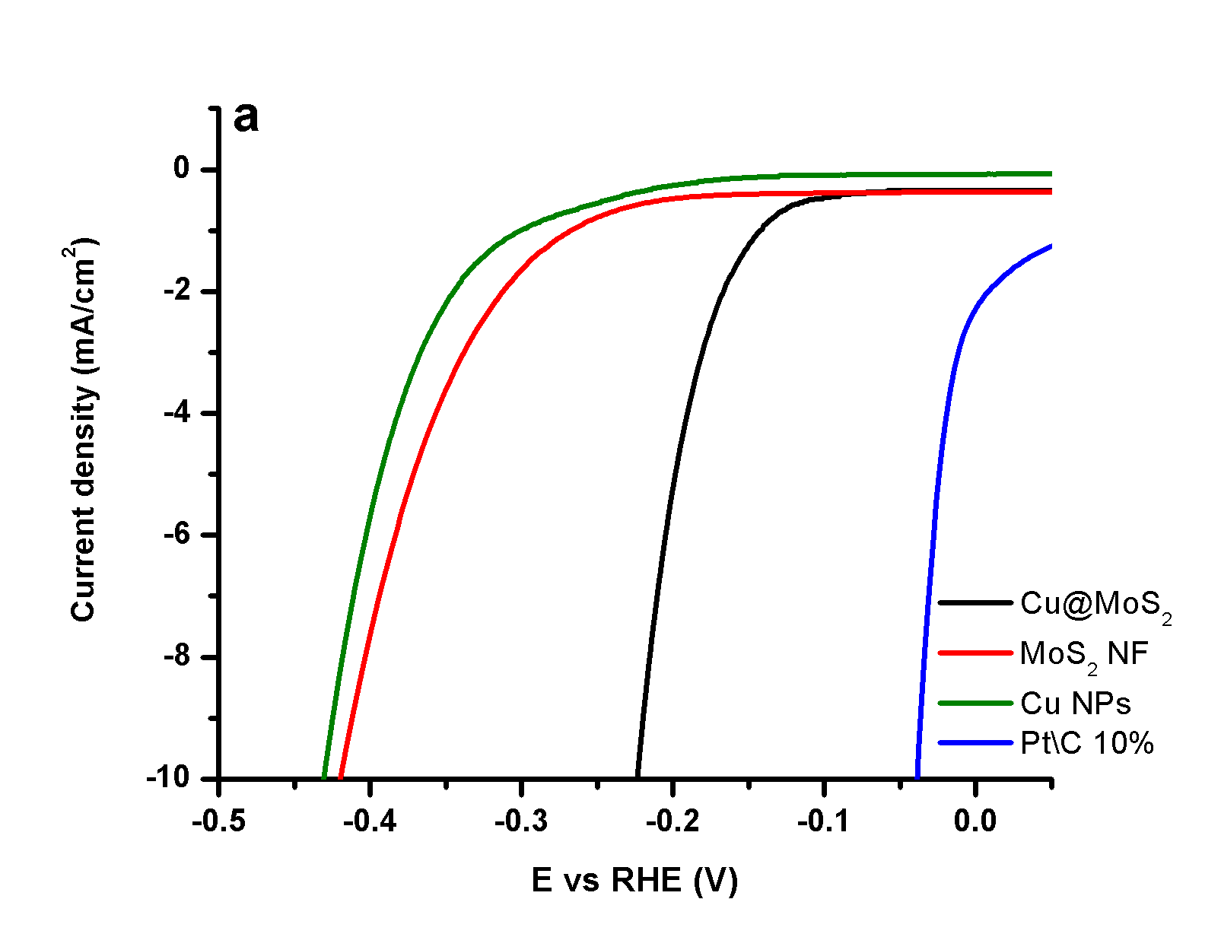

**Figure 4.** (a) LSV measurements of Cu@MoS2, MoS2 nanoflowers and Cu nanoparticles, (b) corresponding Tafel slops.

We further explored the electrocatalytic activity of the Cu@MoS2 hybrid towards ORR in alkaline conditions. Cu@MoS2 showed a substantial oxygen reduction peak for the experiment in O2-saturated electrolytes, which was absent in N2-saturated electrolytes (**Figure S7**). **Figure 5a** presents the LSV curves obtained at 1600 rpm in O2-saturated 0.1 M KOH using a rotating disk electrode (RDE) technique. The LSV curves of MoS2 nanoflowers and commercial Pt/C were also recorded under the same conditions for comparison. Cu@MoS2 exhibited excellent ORR activity, with ORR onset of 0.87 V vs. RHE (half wave of 0.765 V), significantly more positive compared to free-standing MoS2 nanoflowers (0.73 V, with relatively low current densities and half wave 0.64 V). Impressingly, the hybrid exhibited performance which was better than other recently reported values for state-of-the-art MoS2-based structures (for broad comparison see **Table S2**) and was not far from the performance of Pt/C. Another parameter of great importance in evaluating the ORR activity of a catalyst is the number of electrons transferred during the reduction (n). While 4-electron reduction of O2 to H2O/OH- is the favorable process, often a 2-electron reduction of O2 to hydrogen peroxide (HO2-) occurs, resulting in lower energy conversion efficiency and degradation of the fuel cell. To estimate the electron transfer number (ne), LSV data was obtained with RDE at different rotation speeds in a scan rate of 10 mV∙S-1, as shown in **Figure 5b** with thecorresponding Koutecky-Levich (K-L) plot (at 0V vs. RHE) in **Figure 5c.** An electron transfer number of 3.95 was calculatedusing the Koutecky-Levich equation (see supporting information), which is very close to the commercially available Pt/C electrode (3.99). Moreover, a rotating ring-disk electrode (RRDE) also confirmed a dominating four electron reaction pathway with negligible formation of peroxide (supporting information, **Figure S8**).

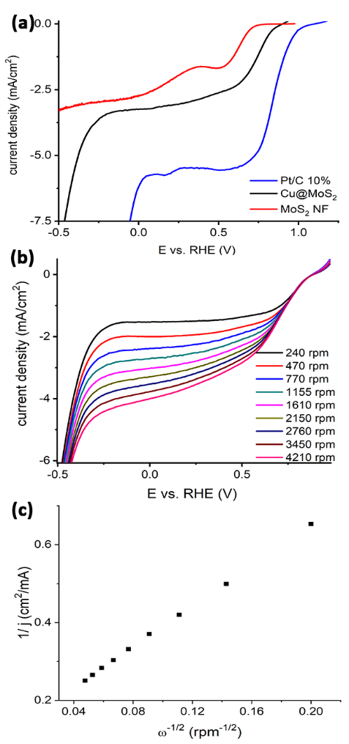

**Figure 5**: Electrocatalytic performance for ORR in O2-saturated 0.1 M KOH. (a) LSV measurements of the as-synthesized Cu@MoS2 catalysts, MoS2 Nanoflowers and commercial 20% Pt/C at 1600 rpm (scan rate: 25 mVs-1). (b) RDE experiment of Cu@MoS2 at different rotation speeds from 240 to 4200 rpm at scan rate of 10 mV s-1. (c) The Koutecky-Levich (K-L) plot of Cu@MoS2 (derived from b).

In summary, we developed a versatile approach to synthesize Cu/MoS2 core-shell-based nanostructures and characterized them by different microscopy and spectroscopy methods. This unique structure exhibits enhanced electrocatalytic properties towards various reactions (HER and ORR), which is attributed to the activation of MoS2 through a few pathways: the shelling produces basal plane strain and abundant defects, known as catalytically active sites; the interface with the Cu core produces charge transfer from the Cu to the MoS2 shell and results in lower charge transfer resistance of the hybrid. Our work paves the way for new approaches to sculpture novel structures that activate MoS2 and similar TMDs by the use of non-noble conductive core, as a promoter for the formation of active sites in the outer TMDs shell.

**Supporting Information**. Extended synthesis protocols, experimental procedures, XPS data and various electrochemical measurements. This material is available free of charge via the Internet at http://pubs.acs.org.

**Corresponding Authors**

[*barsadan@bgu.ac.il](mailto:*barsadan@bgu.ac.il) [*bronen@post.bgu.ac.il](mailto:*bronen@post.bgu.ac.il)

**Author Contributions**

The manuscript was written through contributions of all authors. All authors have given approval to the final version of the manuscript.

**Funding Sources**

This research was supported by the United States – Israel Binational Science Foundation (BSF), Jerusalem, Israel and the United States National Science Foundation (NSF) grant 2017642.

**References:**

1. Jiao, Y.; Zheng, Y.; Jaroniec, M.; Qiao, S. Z., Design of electrocatalysts for oxygen- and hydrogen-involving energy conversion reactions. *Chem. Soc. Rev.* **2015,** *44* (8), 2060-2086.

2. Ge, X.; Sumboja, A.; Wuu, D.; An, T.; Li, B.; Goh, F. W. T.; Hor, T. S. A.; Zong, Y.; Liu, Z., Oxygen Reduction in Alkaline Media: From Mechanisms to Recent Advances of Catalysis. *ACS Catal.* **2015,** *5* (8), 4643-4667.

3. Erikson, H.; Sarapuu, A.; Tammeveski, K., Oxygen Reduction Reaction on Silver Catalysts in Alkaline Media: a Minireview. *ChemElectroChem* **2019,** *6* (1), 73-86.

4. Seh, Z. W.; Kibsgaard, J.; Dickens, C. F.; Chorkendorff, I.; Nørskov, J. K.; Jaramillo, T. F., Combining theory and experiment in electrocatalysis: Insights into materials design. *Science* **2017,** *355* (6321), eaad4998.

5. Wang, H.; Zhang, Q.; Yao, H.; Liang, Z.; Lee, H.-W.; Hsu, P.-C.; Zheng, G.; Cui, Y., High Electrochemical Selectivity of Edge versus Terrace Sites in Two-Dimensional Layered MoS2 Materials. *Nano Lett.* **2014,** *14* (12), 7138-7144.

6. Zhong, L.; Bruno, R. C.; Ethan, K.; Ruitao, L.; Rahul, R.; Humberto, T.; Marcos, A. P.; Mauricio, T., Defect engineering of two-dimensional transition metal dichalcogenides. *2D Mater.* **2016,** *3* (2), 022002.

7. Xie, J.; Zhang, H.; Li, S.; Wang, R.; Sun, X.; Zhou, M.; Zhou, J.; Lou, X. W.; Xie, Y., Defect-Rich MoS2 Ultrathin Nanosheets with Additional Active Edge Sites for Enhanced Electrocatalytic Hydrogen Evolution. *Adv. Mater.* **2013,** *25* (40), 5807-5813.

8. Ye, G.; Gong, Y.; Lin, J.; Li, B.; He, Y.; Pantelides, S. T.; Zhou, W.; Vajtai, R.; Ajayan, P. M., Defects Engineered Monolayer MoS2 for Improved Hydrogen Evolution Reaction. *Nano Lett.* **2016,** *16* (2), 1097-1103.

9. Le, D.; Rawal, T. B.; Rahman, T. S., Single-Layer MoS2 with Sulfur Vacancies: Structure and Catalytic Application. *J. Phys. Chem. C* **2014,** *118* (10), 5346-5351.

10. Kadam, S. R.; Kawade, U. V.; Bar-Ziv, R.; Gosavi, S. W.; Bar-Sadan, M.; Kale, B. B., Porous MoS2 Framework and its Functionality for Electrochemical Hydrogen Evolution Reaction and Lithium Ion Batteries. *ACS Appl. Energy Mater.* **2019**.

11. Kagkoura, A.; Pelaez-Fernandez, M.; Arenal, R.; Tagmatarchis, N., Sulfur-doped graphene/transition metal dichalcogenide heterostructured hybrids with electrocatalytic activity toward the hydrogen evolution reaction. *Nanoscale Adv.* **2019,** *1* (4), 1489-1496.

12. Meiron, O. E.; Kuraganti, V.; Hod, I.; Bar-Ziv, R.; Bar-Sadan, M., Improved catalytic activity of Mo1-xWxSe2 alloy nanoflowers promotes efficient hydrogen evolution reaction in both acidic and alkaline aqueous solutions. *Nanoscale* **2017,** *9* (37), 13998-14005.

13. Vasu, K.; Meiron, O. E.; Enyashin, A. N.; Bar-Ziv, R.; Bar-Sadan, M., Effect of Ru Doping on the Properties of MoSe2 Nanoflowers. *J. Phys. Chem. C* **2018,** *123* (3), 1987-1994.

14. Deng, J.; Li, H.; Xiao, J.; Tu, Y.; Deng, D.; Yang, H.; Tian, H.; Li, J.; Ren, P.; Bao, X., Triggering the Electrocatalytic Hydrogen Evolution Activity of the Inert Two-Dimensional MoS2 Surface via Single-Atom Metal Doping. *Energy Environ. Sci.* **2015,** *8* (5), 1594-1601.

15. Kuraganti, V.; Jain, A.; Bar-Ziv, R.; Ramasubramaniam, A.; Bar-Sadan, M., Manganese Doping of MoSe2 Promotes Active Defect Sites for Hydrogen Evolution. *ACS Appl. Mater. Interfaces* **2019,** *11* (28), 25155-25162.

16. Li, Y.; Cain, J. D.; Hanson, E. D.; Murthy, A. A.; Hao, S.; Shi, F.; Li, Q.; Wolverton, C.; Chen, X.; Dravid, V. P., Au@MoS2 Core–Shell Heterostructures with Strong Light–Matter Interactions. *Nano Lett.* **2016,** *16* (12), 7696-7702.

17. Wang, T.; Liu, L.; Zhu, Z.; Papakonstantinou, P.; Hu, J.; Liu, H.; Li, M., Enhanced electrocatalytic activity for hydrogen evolution reaction from self-assembled monodispersed molybdenum sulfide nanoparticles on an Au electrode. *Energy Environ. Sci.* **2013,** *6* (2), 625-633.

18. Shi, J.; Ma, D.; Han, G.-F.; Zhang, Y.; Ji, Q.; Gao, T.; Sun, J.; Song, X.; Li, C.; Zhang, Y.; Lang, X.-Y.; Zhang, Y.; Liu, Z., Controllable Growth and Transfer of Monolayer MoS2 on Au Foils and Its Potential Application in Hydrogen Evolution Reaction. *ACS Nano* **2014,** *8* (10), 10196-10204.

19. Maiti, P. S.; Ganai, A. K.; Bar-Ziv, R.; Enyashin, A. N.; Houben, L.; Bar Sadan, M., Cu2–xS–MoS2 Nano-Octahedra at the Atomic Scale: Using a Template To Activate the Basal Plane of MoS2 for Hydrogen Production. *Chem. Mater.* **2018,** *30* (14), 4489-4492.

20. Li, G.; Fu, C.; Wu, J.; Rao, J.; Liou, S.-C.; Xu, X.; Shao, B.; Liu, K.; Liu, E.; Kumar, N.; Liu, X.; Fahlman, M.; Gooth, J.; Auffermann, G.; Sun, Y.; Felser, C.; Zhang, B., Synergistically creating sulfur vacancies in semimetal-supported amorphous MoS2 for efficient hydrogen evolution. *Appl. Catal. B Environ.* **2019,** *254*, 1-6.

21. Shi, Y.; Wang, J.; Wang, C.; Zhai, T.-T.; Bao, W.-J.; Xu, J.-J.; Xia, X.-H.; Chen, H.-Y., Hot Electron of Au Nanorods Activates the Electrocatalysis of Hydrogen Evolution on MoS2 Nanosheets. *J. Am. Chem. Soc.* **2015,** *137* (23), 7365-7370.

22. Tsai, C.; Li, H.; Park, S.; Park, J.; Han, H. S.; Nørskov, J. K.; Zheng, X.; Abild-Pedersen, F., Electrochemical generation of sulfur vacancies in the basal plane of MoS2 for hydrogen evolution. *Nat. Commun.* **2017,** *8*, 15113.

23. Li, Y.; DiStefano, J. G.; Murthy, A. A.; Cain, J. D.; Hanson, E. D.; Li, Q.; Castro, F. C.; Chen, X.; Dravid, V. P., Superior Plasmonic Photodetectors Based on Au@MoS2 Core–Shell Heterostructures. *ACS Nano* **2017,** *11* (10), 10321-10329.

24. Li, X.; Guo, S.; Kan, C.; Zhu, J.; Tong, T.; Ke, S.; Choy, W. C. H.; Wei, B., Au Multimer@MoS2 hybrid structures for efficient photocatalytical hydrogen production via strongly plasmonic coupling effect. *Nano Energy* **2016,** *30* (C), 549-558.

25. Yin, Z.; Chen, B.; Bosman, M.; Cao, X.; Chen, J.; Zheng, B.; Zhang, H., Au Nanoparticle-Modified MoS2 Nanosheet-Based Photoelectrochemical Cells for Water Splitting. *Small* **2014,** *10* (17), 3537-3543.

26. Li, Y.; Majewski, M. B.; Islam, S. M.; Hao, S.; Murthy, A. A.; DiStefano, J. G.; Hanson, E. D.; Xu, Y.; Wolverton, C.; Kanatzidis, M. G.; Wasielewski, M. R.; Chen, X.; Dravid, V. P., Morphological Engineering of Winged Au@MoS2 Heterostructures for Electrocatalytic Hydrogen Evolution. *Nano Lett.* **2018,** *18* (11), 7104-7110.

27. Chen, Z.; Cummins, D.; Reinecke, B. N.; Clark, E.; Sunkara, M. K.; Jaramillo, T. F., Core–shell MoO3–MoS2 Nanowires for Hydrogen Evolution: A Functional Design for Electrocatalytic Materials. *Nano Lett.* **2011,** *11* (10), 4168-4175.

28. Han, B.; Liu, S.; Zhang, N.; Xu, Y.-J.; Tang, Z.-R., One-dimensional CdS@MoS2 core-shell nanowires for boosted photocatalytic hydrogen evolution under visible light. *Appl. Catal. B Environ.* **2017,** *202*, 298-304.

29. Tahira, A.; Ibupoto, Z. H.; Mazzaro, R.; You, S.; Morandi, V.; Natile, M. M.; Vagin, M.; Vomiero, A., Advanced Electrocatalysts for Hydrogen Evolution Reaction Based on Core–Shell MoS2/TiO2 Nanostructures in Acidic and Alkaline Media. *ACS Appl. Energy Mater.* **2019,** *2* (3), 2053-2062.

30. Tiwari, A. P.; Yoon, Y.; Novak, T. G.; Azam, A.; Lee, M.; Lee, S. S.; Lee, G.-h.; Srolovitz, D. J.; An, K.-S.; Jeon, S., Lattice Strain Formation through Spin-Coupled Shells of MoS2 on Mo2C for Bifunctional Oxygen Reduction and Oxygen Evolution Reaction Electrocatalysts. *Adv. Mater. Interfaces* **2019,** *6* (22), 1900948.

31. Wu, A.; Tian, C.; Jiao, Y.; Yan, Q.; Yang, G.; Fu, H., Sequential two-step hydrothermal growth of MoS2/CdS core-shell heterojunctions for efficient visible light-driven photocatalytic H2 evolution. *Appl. Catal. B Environ.* **2017,** *203*, 955-963.

32. Yang, L.; Guo, S.; Li, X., Au nanoparticles@MoS2 core-shell structures with moderate MoS2 coverage for efficient photocatalytic water splitting. *J. Alloys Compd.* **2017,** *706*, 82-88.

33. Bar-Ziv, R.; Ranjan, P.; Lavie, A.; Jain, A.; Garai, S.; Bar Hen, A.; Popovitz-Biro, R.; Tenne, R.; Arenal, R.; Ramasubramaniam, A.; Lajaunie, L.; Bar-Sadan, M., Au-MoS2 Hybrids as Hydrogen Evolution Electrocatalysts. *ACS Appl. Energy Mater.* **2019**.

34. Chen, P. X.; Qiu, H. W.; Xu, S. C.; Liu, X. Y.; Li, Z.; Hu, L. T.; Li, C. H.; Guo, J.; Jiang, S. Z.; Huo, Y. Y., A novel surface-enhanced Raman spectroscopy substrate based on a large area of MoS2 and Ag nanoparticles hybrid system. *Appl. Surf. Sci.* **2016,** *375*, 207-214.

35. Li, Z.; Jiang, S.; Xu, S.; Zhang, C.; Qiu, H.; Li, C.; Sheng, Y.; Huo, Y.; Yang, C.; Man, B., Few-layer MoS2-encapsulated Cu nanoparticle hybrids fabricated by two-step annealing process for surface enhanced Raman scattering. *Sens. Actuators B Chem* **2016,** *230*, 645-652.

36. Wang, Y.; Wang, Z.; Yang, Q.; Hua, A.; Ma, S.; Zhang, Z.; Dong, M., Edge-oriented MoS2 supported on nickel/carbon core–shell nanospheres for enhanced hydrogen evolution reaction performance. *New J. Chem* **2019,** *43* (16), 6146-6152.

37. Bai, S.-w.; Mei, H.; Cheng, L.-f., Ultra-thin MoS2 shell deposited on Ag nanowires for tuning surface-enhanced Raman spectroscopy. *Appl. Surf. Sci.* **2018,** *453*, 120-125.

38. Khanna, P. K.; Gaikwad, S.; Adhyapak, P. V.; Singh, N.; Marimuthu, R., Synthesis and characterization of copper nanoparticles. *Mater Lett.* **2007,** *61* (25), 4711-4714.

39. Choi, W.; Cho, M. Y.; Konar, A.; Lee, J. H.; Cha, G.-B.; Hong, S. C.; Kim, S.; Kim, J.; Jena, D.; Joo, J.; Kim, S., High-Detectivity Multilayer MoS2 Phototransistors with Spectral Response from Ultraviolet to Infrared. *Adv. Mater.* **2012,** *24* (43), 5832-5836.

40. Eda, G.; Yamaguchi, H.; Voiry, D.; Fujita, T.; Chen, M.; Chhowalla, M., Photoluminescence from Chemically Exfoliated MoS2. *Nano Lett.* **2011,** *11* (12), 5111-5116.

41. Chuang, M.-K.; Yang, S.-S.; Chen, F.-C., Metal Nanoparticle-Decorated Two-Dimensional Molybdenum Sulfide for Plasmonic-Enhanced Polymer Photovoltaic Devices. *Materials* **2015,** *8* (8), 5414-5425.

42. DiStefano, J. G.; Li, Y.; Jung, H. J.; Hao, S.; Murthy, A. A.; Zhang, X.; Wolverton, C.; Dravid, V. P., Nanoparticle@MoS2 Core–Shell Architecture: Role of the Core Material. *Chem. Mater.* **2018,** *30* (14), 4675-4682.

43. Xiao, L.; Wu, J.; Ran, J.; Liu, Y.; Qiu, W.; Lu, F.; Shao, F.; Tang, D.; Peng, P., Near-infrared radiation absorption properties of covellite (CuS) using first-principles calculations. *AIP Adv.* **2016,** *6* (8), 085122.

44. Bar-Ziv, R.; Ranjan, P.; Lavie, A.; Jain, A.; Garai, S.; Bar Hen, A.; Popovitz-Biro, R.; Tenne, R.; Arenal, R.; Ramasubramaniam, A.; Lajaunie, L.; Bar-Sadan, M., Au-MoS2 Hybrids as Hydrogen Evolution Electrocatalysts. *ACS Appl. Energy Mater.* **2019,** *2* (8), 6043-6050.

45. Lee, C.; Yan, H.; Brus, L. E.; Heinz, T. F.; Hone, J.; Ryu, S., Anomalous Lattice Vibrations of Single- and Few-Layer MoS2. *ACS Nano* **2010,** *4* (5), 2695-2700.

46. Parkin, W. M.; Balan, A.; Liang, L.; Das, P. M.; Lamparski, M.; Naylor, C. H.; Rodríguez-Manzo, J. A.; Johnson, A. T. C.; Meunier, V.; Drndić, M., Raman Shifts in Electron-Irradiated Monolayer MoS2. *ACS Nano* **2016,** *10* (4), 4134-4142.

47. Chen, Y.; Huang, S.; Ji, X.; Adepalli, K.; Yin, K.; Ling, X.; Wang, X.; Xue, J.; Dresselhaus, M.; Kong, J.; Yildiz, B., Tuning Electronic Structure of Single Layer MoS2 through Defect and Interface Engineering. *ACS Nano* **2018,** *12* (3), 2569-2579.

48. Wu, K.; Li, Z.; Tang, J.; Lv, X.; Wang, H.; Luo, R.; Liu, P.; Qian, L.; Zhang, S.; Yuan, S., Controllable defects implantation in MoS2 grown by chemical vapor deposition for photoluminescence enhancement. *Nano Res.* **2018,** *11* (8), 4123-4132.

49. Li, Z.; Mi, L.; Chen, W.; Hou, H.; Liu, C.; Wang, H.; Zheng, Z.; Shen, C., Three-dimensional CuS hierarchical architectures as recyclable catalysts for dye decolorization. *CrystEngComm* **2012,** *14* (11), 3965-3971.

50. Auyoong, Y. L.; Yap, P. L.; Huang, X.; Abd Hamid, S. B., Optimization of reaction parameters in hydrothermal synthesis: a strategy towards the formation of CuS hexagonal plates. *Chem. Cent. J.* **2013,** *7* (1), 67.

51. Bar-Ziv, R.; Meiron, O. E.; Bar-Sadan, M., Enhancing the catalytic activity of the alkaline hydrogen evolution reaction by tuning the S/Se ratio in the Mo(SxSe1-x)2 catalyst. *Nanoscale* **2018,** *10* (34), 16211-16216.

52. Vrubel, H.; Moehl, T.; Grätzel, M.; Hu, X., Revealing and accelerating slow electron transport in amorphous molybdenum sulphide particles for hydrogen evolution reaction. *Chem. Comm.* **2013,** *49* (79), 8985-8987.

TOC

