**Isomerization of Hydrogen Cyanide and hydrogen Isocyanide at a cluster environment: Quantum Chemical study**

Alon Zamir1 and Tamar Stein1

1Fritz Haber Research Center for Molecular Dynamics, The Hebrew University of Jerusalem, Jerusalem, Israel, 9190401

*Corresponding author: tamar.stein@mail.huji.ac.il, Tel: +972-2-658-6108

**Abstract**

Hydrogen cyanide and its isomer hydrogen isocyanide are omnipresent in the interstellar medium (ISM). The ratio between them serve as an indicator to the physical conditions in different areas of the ISM. As such the isomerization process between the two isomers has been extensively studied on the neutral potential energy surface. Moreover, HCN and HNC are thought to be precursor of important organic molecules such as adenine. Here, we focus on the chemistry that occur upon ionization of pure HNC clusters using quantum chemistry calculations and *ab-initio* molecular dynamics (AIMD) simulations. We demonstrate that upon ionization of HNC clusters a distonic ion $HCNH^{+}⋯CN$ is formed and its formation is accompanied by HNC to HCN isomerization. Moreover, we show that the cluster environment and the network of hydrogen bonds are crucial for the isomerization processes to occur and for stabilization of the clusters, and demonstrate that in contrast to HNC clusters isomerization of ionized HCN clusters can occur only for the larger clusters. Additionally, we discussed the formation of aminonitrile cation in the clusters and suggest barrierless route for diaminonitrile formation, a known precursor in the formation of amino acids and nucleobases.

# **Introduction**

The two isomers, hydrogen cyanide and hydrogen isocyanide are omnipresent in different areas of the interstellar medium (ISM) such as diffuse clouds1, 2, dense clouds3, 4, protoplanetary disks5, star forming regions6, 7 among other ISM’s areas.8-10 Additionally, they were identified in comets11 and HNC was identified on Titan’s atmosphere.12 The abundance of the two isomers, and the difference in their thermodynamic stability is such that the ration between them serve as an indicator to different chemical and physical environments. For example, the intensity of I(HCN)/I(HNC) ratio of the transition J= 1-0 use to probe the gas kinetic temperature in the ISM.13

Chemically, hydrogen cyanide and hydrogen isocyanide can play an important role in reactions leading to more complex organic molecules such as amino acids and nucleobases, which are important from astrobiology point of view.14, 15 Specifically, the formation of the nucleobases adenine, formally an HCN pentamer, from HCN and HNC draw much attention.16-18

The HCN isomerization processes has been studied extensively in order to explain the different ratios obtained at different areas.19 Several mechanisms were suggested for the isomerization process. Water-catalyzed mechanism has been suggested to lower the barrier for the isomerization20 demonstrating a low barrier for HNC to HCN isomerization, but a high barrier for the reverse reaction which makes it unlikely.21 Moreover, the mechanism for the reaction was studied using the first and second derivatives of the energy, identifying two stages for the reaction, the first is C-H bond breaking, and the second is formation of N-H bond; the intermediate structure is a transitory state identified as a state where the H atom is situated above the C-N bond.22 The direct and reverse isomerization have both been demonstrated to occur via radiative relaxation processes from highly excited vibronic state.23 The production of the two isomers can also occur via dissociative recombination.24

While the isomerization reaction studied extensively on the neutral potential energy surface (PES), to our knowledge, the isomerization reaction was not studied on the cationic surface.

Cotton et al. performed *ab-initio* calculations to study the complexes of HCNH+ with HCN and HNC. They have speculated that via the bound complex isomerization between HCN and HNC can ocur.25 In a previous work we studied the growth upon ionization of pure HCN van der Waals clusters of different sizes. The result indicated formation of distonic structure HCNH+ cation and a CN radical. $HCN→HNC$ isomerization was not detected in the majority of the clusters and was only detected in one instance of the larger clusters (pentamer cluster).26

Here we study the isomerization reaction taking place in an ionized HNC clusters by means of *ab-initio* calculations and *ab-initio* molecular dynamics (AIMD) simulations to study the evolution of the system with time. We show, that when the starting clusters contain HNC, isomerization take place upon ionization of the clusters in contrast to pure HCN clusters. We analyze the energetic of the cluster due to the additional bonds and shed light on the conditions enabling isomerization. Additionally, we analyze possible routes for molecular growth upon ionization of the clusters to form complex organic molecules of astrological interest and show that growth that occur form pure HNC clusters can results in the formation of important molecules such as aminonitrile, which we demonstrate that can barrierlesly lead to diaminonitrile (DAMN), a known precursor of amino acid and nucleobases.27, 28

# Computational details

All calculations were performed in Q-Chem 5 software package.29 Neutral and cation clusters were optimized using 30 with cc-pVTZ basis set. Frequency calculations were performed to verify that all the found structures are indeed a minimum on the PES.

Potential energy scans were performed to analyze possible isomerization routes in order to locate transition states in case they are existed. The scans run employing $ωB97X-V$ functional and cc-pVTZ basis set. During the scans the location of the protons changed systematically while the rest of the system remained frozen. In some cases, additional relaxed scans were preformed, in those scans after each step full relaxation of the system was performed. Alternatively, constrained optimizations were performed in the search for locating the transition states; in those optimizations the systems were relaxed under a structural constraint either a specific distance or an angle remained constant during the optimization.

For the AIMD calculations we used the structures of the neutral clusters and run them on the cationic surface – to model ionization event. To sample over different initial conditions, each structure run 30 times, with temperatures in the range of 30K-80K. Each trajectory run for 1000 ps in the trimer, tetramer and pentamer case and 2000 ps for the hexamer case with time step of 1.21 fs (50 a.u).

# Results

1. HCN/HNC isomerization process

In order to understand the binding trends taking place in HNC clusters, we start by exploring the smallest possible cluster; a dimer cluster. Figure 1 left panel shows the structure of neutral HNC dimer.

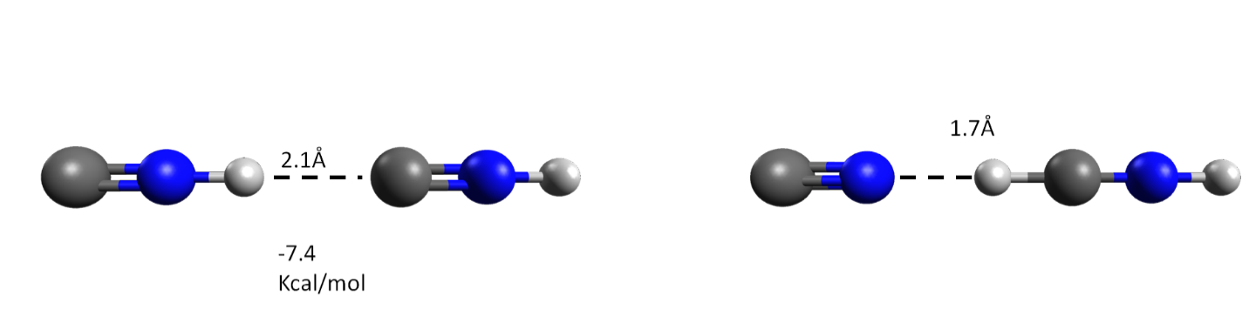

Figure : Left panel: neutral HNC dimer cluster. Right panel: ionized HNC dimer cluster.

The distance between the two units is 2.1 $Å$ which is slightly smaller than the distance in HCN dimer, and the dipole moment of HNC is slightly larger than the one for HCN (calculated 3.07 D and 3.02 D for HNC and HCN respectively). The calculated binding energy (BE) is -7.4 kcal/mol, which is larger than the value calculated for the HCN dimer, which is 5.0 kcal/mol.26 The BE difference between HCN and HNC can be explained by the hydrogen bonds that are forming in the HNC case, which are stronger then the hydrogen bonds between two HCN units.31

At the right panel of Figure 1, the optimize cationic structure is presented. We observed a distonic structure which was previously reported in the case of pure HCN clusters; the cationic structure obtained by ionization of HCN and HNC dimers is identical. However, critical differences observed upon ionization of larger clusters. We report the structures of neutral (trimer, tetramer, pentamer and hexamer) HNC clusters at the supporting information (SI) of the manuscript Figures SI1 and SI2. The trends in the neutral structures are similar to those observed in the HCN clusters. Comparing the BE of the structures with structures of pure HCN previously studied26 demonstrates that here the clusters are more strongly bind due to stronger hydrogen bonds, as was demonstrated for the dimer case.

Previous study has shown26, that upon ionization of pure trimer and tetramer HCN clusters, the products are either a distonic structure complexed to the remaining HCN units or a bonded ionic structure, C2N2H2+, complexed to the remaining HCN molecules. For the pentamer clusters, the same products were observed, except for the linear case were the formation of the distonic structure was accompanied by an isomerization of one of the HCN units to an HNC unit. Figure 2 present the ionized structure of HNC clusters. Similar trends can be observed here: we identify the formation of the distonic structure in addition to a bonded C2N2H2+ structure albeit here the bond is formed between the two carbons. A major difference is observed here for the HNC case in contrast to the HCN clusters. Unlike the case of HCN cluster, here the formation of the distonic structure was accompanied by an isomerization $HNC→HCN$ process even for the case of the trimer clusters and in general the isomerization processes are more frequent starting from ionized HNC clusters than ionized HCN cluster.

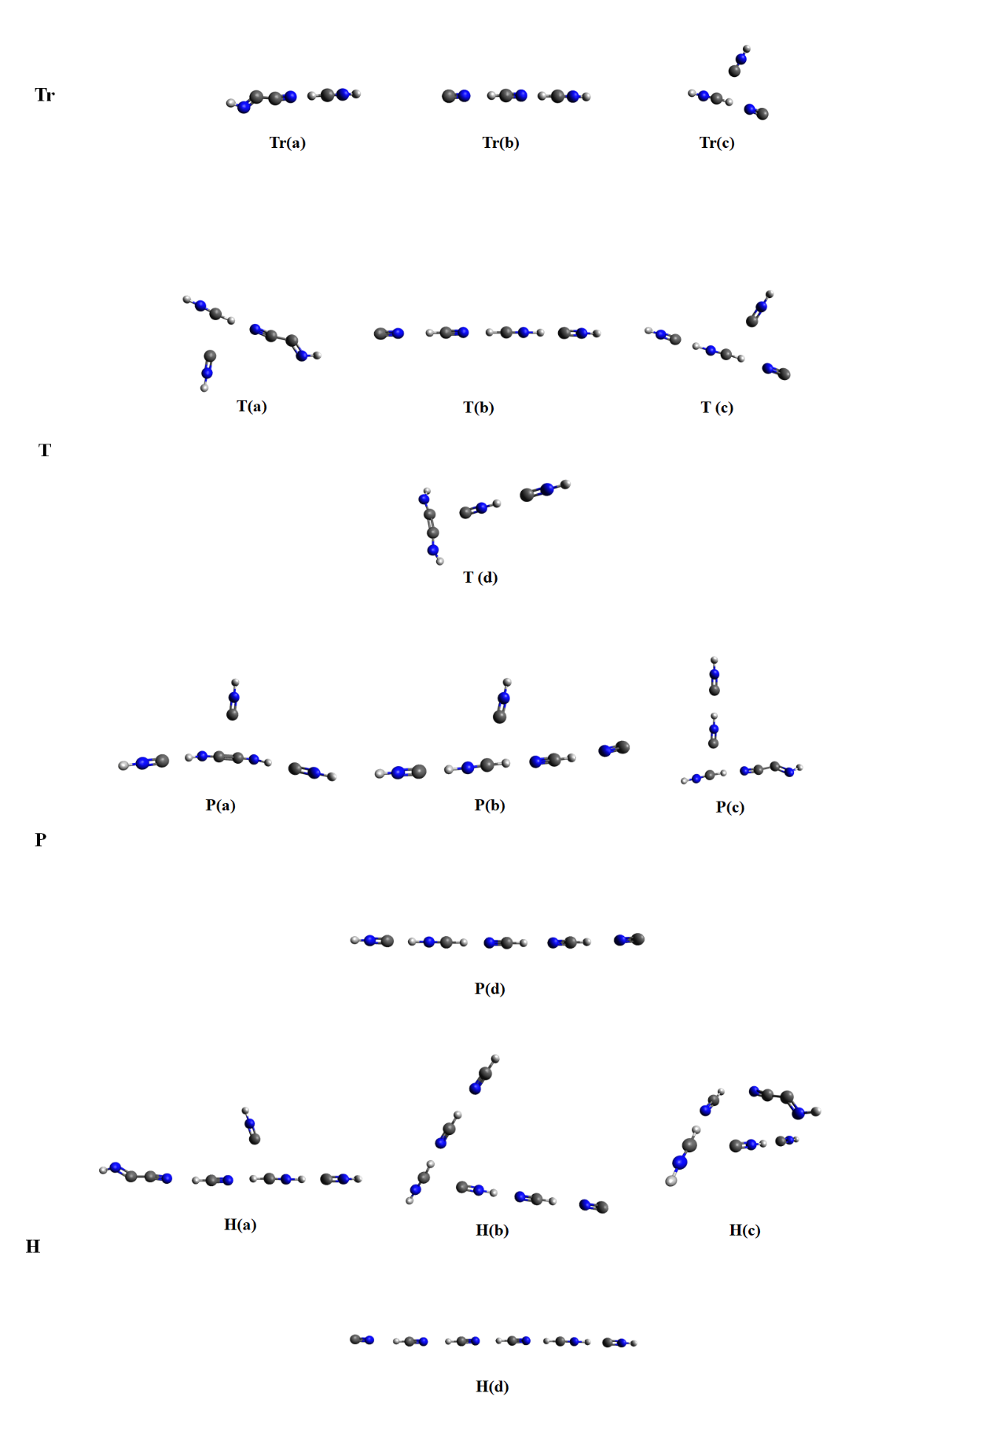

Figure : Optimized structure of trimer (Tr), tetramer (T), pentamer (P) and hexamer (H) clusters following ionization.

To understand why isomerization did not take place in ionized HCN trimer clusters, we analyze possible routes for the process to occur. We can hypothesize such an isomerization in the following route stated in equation 1. We start with a neutral trimer cluster which underwent ionization. In the first step a proton can transfer to form the distonic product complexed to an HCN unit. At the second stage, a second proton transfer occurs during which isomerization take place and result in HNCH+ changing its location.

${\left[HCN⋯HCN⋯HCN\right]}^{+}→{\left[HCN⋯HCNH⋯CN\right]}^{+}→{\left[HCNH⋯CNH⋯CN\right]}^{+}$

In aim of studying this speculated route, we have scanned the potential energy surface for the proton transitions (while the rest of the atoms in the system were frozen), results are shown in Figure 3. We can see from the figure that there are barriers for the transitions of the protons. Evaluation of relative energies of the structures and the barrier for their formation requires full optimization.

Figure : Potential energy surface scan, at each stage only the positions of the proton have changed.

Figure 4 present the fully optimized structures, with respect to the energy of ionized linear trimer structure (Figure 4 structure 1). After ionization of the cluster, the distonic ion is formed and is complexed to an HCN unit (Figure 4 structure 3). This state correspond to the minimum energy and the transition to it is barrierless, achieved directly from optimization of structure 1. To further demonstrate that the transition is barrierless, we performed an FSM calculation presented in Figure S3 of the SI. During the transition from structure 1 to structure 3, one can identify structure 2. For this structure to further stabilize, the CN rotates such that the nitrogen points toward the hydrogen of [HNCH]+ structure. Structure 2 is only a minimum when we consider the system to be in $C_{∞v}$ symmetry point group. Elevation of the symmetry constraint results in a direct barrierless transition into structure 3. To evaluate the energetic of the hypothesize route suggested in equation 1 we calculated the additional structures (Figure 4 structures (3’) and (4)).

Figure : Optimized structures, structures mark in black (1 and 3) are minimum on the PES. Structures mark in dark gray (structure 2) were optimized under symmetry and structures marked in light gray (3’ and 4) are not optimal structures on the full potential energy surface and were optimized under a constraint.

We were able to obtain structures 3’ and 4 only under constraint optimization. To obtain structure 3’ we applied the constraints that the distance between the hydrogen and the nitrogen of HCNH+ is fixed, and that the angle between the hydrogen on HNC and the CN molecule is 180° (to avoid rotation of the CN). To obtain structure 4 we applied the constraint that the distance between the hydrogen and the nitrogen of HCNH+ is fixed. In this speculated route, we observe barriers, and any lifting of the constraint will result with the system going back to the true minimum of the system, structure 3. It is thus clear why we do not observe any isomerization upon ionization of trimer clusters, the systems goes directly to structure (3) as reported in the literature.26

Moving forward, we examine ionized tetramer clusters. Results are shown in Figure 5. As in the case of the trimer structure, direct optimization of the cluster (Figure 5 structure (1)) on the cationic structure results in an [+ structure (Figure 5 structure (3)). Forcing the system to belong to $C_{∞v}$ symmetry point group, does not enable the CN group to rotate such that the nitrogen of the NC would point toward the hydrogen of [HNCH]+ as is the case in structure 3. As a result, the CN group part away from the rest of the cluster as shown in structure 2 of Figure 5. Despite the unfavorable orientation, CN departure was not observed in the trimer case (Figure 4 structure (2)). We attribute this difference between the trimer and the larger clusters to the dipole moments; the CN total dipole is 1.46 D, for the trimer case it is complexed to HNCH+∙∙∙NCH which has a total dipole of 3.48D. Adding to HNCH+∙∙∙NCH additional HCN units like in the tetramer and pentamer clusters, significantly enlarge the dipole moment (calculated 6.69 D for HNCH+∙∙∙NCH∙∙∙NCH and 15.72 D for HNCH+∙∙∙NCH∙∙∙NCH∙∙∙NCH), which result in CN departure. Breaking the symmetry and reoptimize the structure will lead us back to structure 3.

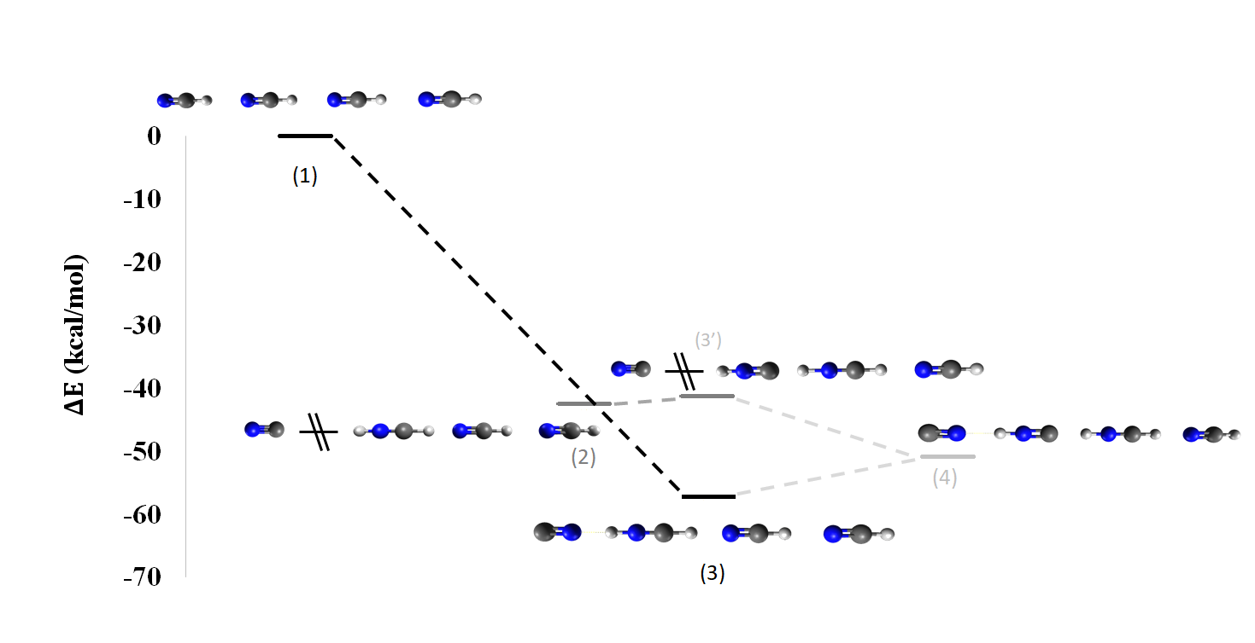

Figure : Optimized structures, structures mark in black (1 and 3) are minimum on the PES. Structures mark in dark gray (structure 2) were optimized under symmetry and structure marked in light gray (3’ and 4) are not optimal structures on the full potential energy surface and were optimized under constraint.

To obtain (Figure 5 structures 4) we had to optimized under the constraint that the distance of the hydrogen and nitrogen in HNCH+ is fixed. As this structure is only obtained under constraint minimization, it is not a minimum on the PES, and for this cluster as well, isomerization process cannot take place.

In contrast to the trimer and tetramer results, we do see isomerization takes place in ionized cluster contain five HCN units as demonstrated in Figure 6. Optimization of the ionized cluster result in ${\left[HNC⋯HNCH⋯NCH⋯NCH\right]}^{+}$ as shown in Figure 6 structure 2. A second minima in which an isomerization process did not take place was also found (Figure 6 structure 3). The two minimas are very close in energy with structure 3 being 0.8 kcal/mol lower in energy.

In both structures (Figure 6 structure 2 and 3) the carbon atom in the CN radical is pointed towards an H atom (of either HCNH molecule (structure 3) or HNC molecule (structure 2) and in both structures the CN radical departed from the cluster. The global minimum is achieved when the nitrogen atom of the CN radical is pointed towards the hydrogen of HCNH as shown in Figure 6 structure 4.

Figure : Optimized structures, structures mark in black (1 and 3) are minimum on the PES.

In order to understand why isomerization of the HCN can take place in the pentamer cluster but not in smaller clusters we will look at the energetic of the systems. HCN isomer is lower in energy then HNC isomer, however, due to strong hydrogen bonds in HNC clusters (as demonstrated above for the dimer case) additional stability is obtained as is manifested in the

BEs of the clusters.

In order to compare the different clusters, we removed the CN radical from the systems as it departs in clusters larger than trimer and compare the energetics of the rest of the systems. By the removal of the CN radical, we receive a system with a positive charge and a singlet multiplicity. The results are reported in table 1.

Table 1: Possible conformers obtained from the trimer, tetramer and pentamer clusters after the CN removal.

|  |  |  |  |
| --- | --- | --- | --- |
|  | Structure | Energy [Eh] | BE [Kcal\mol] |
| Trimer | (1) HNCH+∙∙∙NCH | -187.169 | -23.3 |
| (2) HNCH+∙∙∙CNH | -187.149 | -23.7 |
| Tetramer | (3) HNC∙∙∙HNCH+∙∙∙NCH | -280.614 | -49.1 |
| (4) HNCH+∙∙∙NCH∙∙∙NCH | -280.615 | -36.2 |
| Pentamer | (5) HNC∙∙∙HNCH+∙∙∙NCH∙∙∙NCH | -374.056 | -60.0 |
| (6) HNCH+∙∙∙NCH∙∙∙NCH∙∙∙NCH | -374.055 | -46.0 |

We start by comparing two distinct possible conformers of the trimers, results are presented in table 1. In both cases the HNCH+ is complexed to either HNC or HCN molecule.

Complex (2), which contain the HCN molecule is lower in energy. However, the BE is larger when HNCH+ is complexed to HNC due to the stronger hydrogen bonds between the HNCH+ hydrogen and the carbon lone pair. Despite the stabilization added from the hydrogen bond, structure 1 is still lower energy by 12.55 kcal/mol.

For the tetramer clusters, we compere cluster containing HCNH+ complexed to HCN and to additional molecule, either HCN or HNC. We observe a very small energetic preference (0.6 kcal/mol) towards complex (4), which contains two HCN molecules. The reason for the only small preference lies in the stronger hydrogen bonds and can be seen from the BE; In case (3), were the HNCH+ is complexed to HNC molecule, the BE is much larger (12.9 kcal/mol difference).

In the case of the pentamer clusters, HNCH+ is complexed to three HCN molecule (6), or two HCN molecules and one HNC molecule. In this case, due to the strong hydrogen bonds in complex (5) (BE of 60 kcal/mol) it is lower in energy then complex (6), even though $HCN→HNC$ isomerization occurred. These trends explain why isomerization process in HCN ionized cluster were only observed for the pentamer clusters.

1. Growth of HNC clusters upon ionization.

To further analyze processes that take place upon ionization of the clusters we preformed AIMD simulations. As expected according to the results we presented above, isomerization processes are omnipresent in ionized HNC clusters. Figure 7 presents the number of $HNC→HCN$ isomerization that took place during the trajectories (as seen at the end of the trajectory included both cases were growth occurred or did not occurred) from different clusters sizes. In all cases regardless to the cluster size, majority of the trajectories resulted with at least one isomerization process taking place. In most cases, we observe more than one isomerization process; for the trimer case, a single isomerization occurred 52% of the cases, and lack of isomerization occurred 48% of the time.

Figure 7: Number of isomerization proceses observed at the end of the AIMD simulations in trimer, tetramer, pentamer and hexamer clusters.

As demonstrated above, the stability of the complexes depends both on the isomers that are present, and the hydrogen bond network in it. The isomerization that takes place is dictated by the balance between the stability of the isomers in the cluster and the stabilization of the cluster due to the hydrogen bonds as demonstrated above.

For the linear clusters, we observed either *N-3* or *N-4* isomerizations ( $HNC→HCN$ transitions) where *N* is the number of molecules in the cluster. In accordance with the trends demonstrated above; proton transferred to form a structure in which isomerization take place until at the edge of the cluster we either have $HNC∙∙∙{HNCH}^{+}∙∙∙NCH∙∙∙$ or ${HNCH}^{+}∙∙∙NCH∙∙∙NCH∙∙∙$. After the formation of the structure, in the rest of the simulations the proton going back and forth between the above-mentioned structure: $HNC∙∙∙{HNCH}^{+}∙∙∙⇄{HNCH}^{+}∙∙∙NCH∙∙∙$ and thus the number of isomerization is either *N-3* or *N-4* depending on the point where the simulation ended.

In addition to isomerization, growth processes were also observed. Figure 8 presents the distribution of structures at the end of the trajectories for different clusters sizes. Except for the pentamers clusters, majority of trajectories results in proton transfer forming the distonic ion discussed above (76% ,69% 37%, 47% for the trimer, tetramer, pentamers and hexamer respectively).

Figure : Distribution of structures at the end of the AIMD simulations for trimer, tetramer, pentamer and hexamer clusters.

As we can see from Figure 8; the larger the cluster, the larger the tendency for the clusters to grows (34% ,41% 63%, 53% for the trimer, tetramer, pentamers and hexamer respectively), in agreement with previous studies.26, 32-34 The pentamer clusters seems to lean toward growth more than the hexamer clusters, this could be the result of limited amount of different distinct clusters we used when modeled the neutral structures and might indicate that we did not sample enough starting structures as the results of the trajectories are highly depending on the initial structure. However, it is not the aim of this study to fully sample neutral clusters upon ionization, rather to understand possible routes and processes taking place in the clusters.

As in the case of HCN clusters, here as well we observe growth mostly by forming a bond between two heavy atoms. We observe formation of C2N2H2+and C2N2H•. The C2N2H molecule frequently formed in cationic system by binding CN• with HNC or HCN molecule. In a few cases the formation was received from dimerization of HNC to form HNC-CNH+ followed by a proton transfer.

The C2N2H2+ molecule was obtained from either C2N2H• followed by proton transfer or from dimerization as shown above.

The last group, which occurred rarely (1-2%), consists of the C3N3H3+ and C2N2H3+ molecules.

Formation of the C2N2H3+ molecule requires dimerization of two neutral HNC molecules, followed by a proton transfer, this scenario observed only in the pentamer and hexamer clusters in 1% of the trajectories.

Figure 9: C3N3H3 structures obtain in the AIMD simulations, after optimization.

The formation of C3N3H3 + isomers, presented in Figure 9, occurred as a result of bonding between C2N2H2+ with either HCN or HNC molecules. We observed one trajectory in which C3N3H3 + formed within one step; in this case HNC+ bonded simultaneously to two other HNC units. Such molecules are not likely to form rings (such as triazine) since their longest chains may form five-membered rings at most. Under the conditions of the system, additional growth is not a likely scenario, due to the unavailability of the positive charged cation to form additional bond.

Previous work has studied growth upon ionization of HCN clusters.26 Some similarities can be found between HCN and HNC pure cluster systems. From the trajectories, we can learn that HNC+ may either bind to another HNC or, in turn, it may initiate a proton transfer with another HNC for HNCH+ and CN formation.

(2) $HNC^{+}+CNH→HNCCNH^{+}$

(3) $CNH^{+}+CNH→CN+HCNH^{+}$

These reactions are competitive, and as discussed earlier, the latter reaction occurs more often. Once HCNH+ is available, isomerization processes $HNC→HCN$ will occur, generating a mixed cluster or even clusters similar to ionized pure HCN clusters (complex to additional HCNH+ and CN) in significant amounts as demonstrated in Figure 7.

The major difference between HCN and HNC clusters are the availability of HNC in the system. As shown previously, ionized HCN clusters are capable of isomerization to HNC given the cluster is large enough. And yet, such systems depend on the removal of the CN and specific intramolecular bonds enabling stability. In the case of ionized pure HNC clusters, isomerization processes are frequent, however the systems still contain HNC molecules as well. The mixed composition of the cluster is crucial for the formation of important products such as aminonitrile cation, NCCNH2+, which will be discussed in the next section.

1. Formation of DAMN molecule.

The growth of the HNC monomers holds great interest from astrobiology point of view due to the large abundance of HCN and HNC in the interstellar medium and the fact that they are contain the three main elements needed for the formation of nucleobases. HCN and CN• growth has been suggested to lead to the formation of DAMN, which is a prominent steppingstone toward the formation of amino acids such as adenine under prebiotic conditions.27, 28, 35, 36 The suggested route formation for DAMN from formamide and $CN^{}$ in high energy chemistry27 or from pentamerization of HCN in different conditions.28

We suggest a simple route for the formation of aminonitrile cation based on our AIMD results.

We observed the formation of aminonitrile cation, presented in Figure 9 (although in <1% of the simulations). The possibility of binding two aminonitriles to receive the DAMN molecule in its cationic or neutral form is a promising route for DAMN formation.

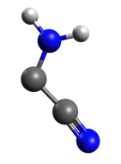

Figure 10: Aminonitrile cation obtained during the AIMD simulation, after optimization.

Interestingly, the formation of the DAMN cation (trans isomer as seen in Figure 11(a)) from aminonitrile cation and neutral aminonitrile occurred directly upon optimization of the system, which indicate the formation is barrierless.

Optimization of two neutrals aminonitriles, also resulted in the formation of DAMN molecule (in the case the cis isomer as shown in Figure 11(b)). The fact the here again the DAMN is formed upon optimization demonstrate that in the neutral case as well the reaction is barrierless, which make it feasible in cold regions.

To further demonstrate that the transition is barrierless, we performed an FSM calculation presented in figure S5, S6 of the SI.

Thus, the formation of DAMN can be simply achieved via a direct combination of aminonitrile units, either cationic or neutral, without the need of complex multistage mechanism.

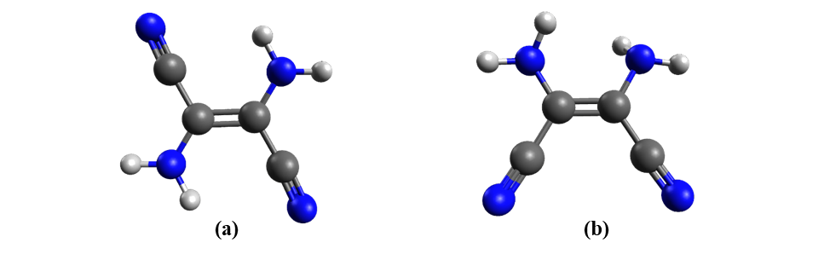

Figure : DAMN molecule (a) trans DAMN, (b) cis DAMN.

# Conclusions

In this manuscript, we present processes that occur within pure HNC clusters upon ionization. We have demonstrated that large amount of isomerization processes $HNC→HCN$ can take place upon ionization of pure HNC clusters. We explain the reason that the reverse ionization cannot occur from small HCN clusters, and observed only in the pentamer clusters; the stability of the clusters (either HCN or HNC) depend on the identity of the isomers (HCN or HNC; HCN isomer is lower in energy) and the hydrogen bonds that form in the clusters; these two factors will dictate if isomerization can take place. In HCN pentamer cluster, the stability obtained from the hydrogen bonds enable the isomerization $HCN→HNC$ to take place.

By means of AIMD we have demonstrated that similar to the HCN clusters, ionization of HNC clusters result in the formation of distonic ion $HCNH^{+}+CN^{}$ or in growth that results from bond between two units. Among the structures that are formed is aminonitrile which we show that can barrierlessly form DAMN molecule. This result is of major importance from astrobiology point of view as the DAMN is a predominant precursor for nucleobases formation.

# **Acknowledgements**

This research was funded by the Israel Science Foundation, Grant number 1941/20.

# **References**

1. Liszt, H.; Lucas, R., Comparative chemistry of diffuse clouds. *A&A* **2001,** *370* (2), 576-585.

2. Turner, B. E.; Pirogov, L.; Minh, Y. C., The Physics and Chemistry of Small Translucent Molecular Clouds. VIII. HCN and HNC. *The Astrophysical Journal* **1997,** *483* (1), 235-261.

3. Pratap, P.; Dickens, J. E.; Snell, R. L.; Miralles, M. P.; Bergin, E. A.; Irvine, W. M.; Schloerb, F. P., A Study of the Physics and Chemistry of TMC‐1. *The Astrophysical Journal* **1997,** *486* (2), 862-885.

4. Hirota, T.; Yamamoto, S.; Mikami, H.; Ohishi, M., Abundances of HCN and HNC in Dark Cloud Cores. *The Astrophysical Journal* **1998,** *503* (2), 717-728.

5. Graninger, D.; Öberg, K. I.; Qi, C.; Kastner, J., HNC IN PROTOPLANETARY DISKS. *The Astrophysical Journal* **2015,** *807* (1), L15.

6. Jin, M.; Lee, J.-E.; Kim, K.-T., THE HCN/HNC ABUNDANCE RATIO TOWARD DIFFERENT EVOLUTIONARY PHASES OF MASSIVE STAR FORMATION. *The Astrophysical Journal Supplement Series* **2015,** *219* (1), 2.

7. Graninger, D. M.; Herbst, E.; Öberg, K. I.; Vasyunin, A. I., THE HNC/HCN RATIO IN STAR-FORMING REGIONS. *The Astrophysical Journal* **2014,** *787* (1), 74.

8. Aalto, S.; Garcia-Burillo, S.; Muller, S.; Winters, J. M.; van der Werf, P.; Henkel, C.; Costagliola, F.; Neri, R., Detection of HCN, HCO+, and HNC in the Mrk 231 molecular outflow⋆. *A&A* **2012,** *537*, A44.

9. Gao, Y.; Solomon, P. M., HCN Survey of Normal Spiral, Infrared‐luminous, and Ultraluminous Galaxies. *The Astrophysical Journal Supplement Series* **2004,** *152* (1), 63-80.

10. Guélin, M.; Salomé, P.; Neri, R.; García-Burillo, S.; Graciá-Carpio, J.; Cernicharo, J.; Cox, P.; Planesas, P.; Solomon, P. M.; Tacconi, L. J.; Vanden Bout, P., Detection of HNC and tentative detection of CN at z = 3.9. *A&A* **2007,** *462* (3), L45-L48.

11. Lis, D. C.; Bockelée‐Morvan, D.; Boissier, J.; Crovisier, J.; Biver, N.; Charnley, S. B., Hydrogen Isocyanide in Comet 73P/Schwassmann‐Wachmann (Fragment B). *The Astrophysical Journal* **2008,** *675* (1), 931-936.

12. Moreno, R.; Lellouch, E.; Lara, L. M.; Courtin, R.; Bockelée-Morvan, D.; Hartogh, P.; Rengel, M.; Biver, N.; Banaszkiewicz, M.; González, A., First detection of hydrogen isocyanide (HNC) in Titan’s atmosphere. *A&A* **2011,** *536*, L12.

13. Hacar, A.; Bosman, A. D.; van Dishoeck, E. F., HCN-to-HNC intensity ratio: a new chemical thermometer for the molecular ISM★★★. *A&A* **2020,** *635*, A4.

14. Danger, G.; Borget, F.; Chomat, M.; Duvernay, F.; Theulé, P.; Guillemin, J.-C.; Le Sergeant d’Hendecourt, L.; Chiavassa, T., Experimental investigation of aminoacetonitrile formation through the Strecker synthesis in astrophysical-like conditions: reactivity of methanimine (CH2NH), ammonia (NH3), and hydrogen cyanide (HCN). *A&A* **2011,** *535*, A47.

15. Hamid, A. M.; Bera, P. P.; Lee, T. J.; Aziz, S. G.; Alyoubi, A. O.; El-Shall, M. S., Evidence for the Formation of Pyrimidine Cations from the Sequential Reactions of Hydrogen Cyanide with the Acetylene Radical Cation. *The Journal of Physical Chemistry Letters* **2014,** *5* (19), 3392-3398.

16. Mechanisms of Prebiotic Adenine Synthesis from HCN by Oligomerization in the Gas Phase. *Astrobiology* **2013,** *13* (5), 465-475.

17. OrÓ, J., Mechanism of Synthesis of Adenine from Hydrogen Cyanide under Possible Primitive Earth Conditions. *Nature* **1961,** *191* (4794), 1193-1194.

18. Adenine Synthesis in Interstellar Space: Mechanisms of Prebiotic Pyrimidine-Ring Formation of Monocyclic HCN-Pentamers. *Astrobiology* **2007,** *7* (3), 455-470.

19. Bowman, J. M.; Gazdy, B., A New Perspective on Isomerization Dynamics Illustrated by HCN → HNC. *The Journal of Physical Chemistry A* **1997,** *101* (36), 6384-6388.

20. Gardebien, F.; Sevin, A., Catalytic Model Reactions for the HCN Isomerization. I. Theoretical Characterization of Some Water-Catalyzed Mechanisms. *The Journal of Physical Chemistry A* **2003,** *107* (19), 3925-3934.

21. Koch, D. M.; Toubin, C.; Xu, S.; Peslherbe, G. H.; Hynes, J. T., Concerted Proton-Transfer Mechanism and Solvation Effects in the HNC/HCN Isomerization on the Surface of Icy Grain Mantles in the Interstellar Medium. *The Journal of Physical Chemistry C* **2007,** *111* (41), 15026-15033.

22. Gutiérrez-Oliva, S.; Díaz, S.; Toro-Labbé, A.; Lane, P.; Murray, J. S.; Politzer, P., Revisiting the seemingly straightforward hydrogen cyanide/hydrogen isocyanide isomerisation. *Molecular Physics* **2014,** *112* (3-4), 349-354.

23. Barger, T.; Wodtke, A. M.; Bowman, J. M., Radiative Relaxation and Isomeric Branching of Highly Excited H/C/N: The Importance of Delocalized Vibrational States. *The Astrophysical Journal* **2003,** *587* (2), 841-846.

24. Herbst, E., What are the products of polyatomic ion-electron dissociative recombination reactions? *The Astrophysical Journal* **1978,** *222*, 508.

25. Cotton, C. E.; Francisco, J. S.; Klemperer, W., Computational study of the linear proton bound ion–molecule complexes of HCNH+ with HCN and HNC. *The Journal of Chemical Physics* **2013,** *139* (1), 014304.

26. Stein, T.; Bera, P. P.; Lee, T. J.; Head-Gordon, M., Molecular growth upon ionization of van der Waals clusters containing HCCH and HCN is a pathway to prebiotic molecules. *Physical Chemistry Chemical Physics* **2020,** *22* (36), 20337-20348.

27. Ferus, M.; Nesvorný, D.; Šponer, J.; Kubelík, P.; Michalčíková, R.; Shestivská, V.; Šponer, J. E.; Civiš, S., High-energy chemistry of formamide: A unified mechanism of nucleobase formation. *Proceedings of the National Academy of Sciences* **2015,** *112* (3), 657.

28. Glaser, R.; Hodgen, B.; Farrelly, D.; McKee, E., Adenine Synthesis in Interstellar Space: Mechanisms of Prebiotic Pyrimidine-Ring Formation of Monocyclic HCN-Pentamers. *Astrobiology* **2007,** *7* (3), 455-470.

29. Shao, Y.; Gan, Z.; Epifanovsky, E.; Gilbert, A. T. B.; Wormit, M.; Kussmann, J.; Lange, A. W.; Behn, A.; Deng, J.; Feng, X.; Ghosh, D.; Goldey, M.; Horn, P. R.; Jacobson, L. D.; Kaliman, I.; Khaliullin, R. Z.; Kuś, T.; Landau, A.; Liu, J.; Proynov, E. I.; Rhee, Y. M.; Richard, R. M.; Rohrdanz, M. A.; Steele, R. P.; Sundstrom, E. J.; Woodcock, H. L.; Zimmerman, P. M.; Zuev, D.; Albrecht, B.; Alguire, E.; Austin, B.; Beran, G. J. O.; Bernard, Y. A.; Berquist, E.; Brandhorst, K.; Bravaya, K. B.; Brown, S. T.; Casanova, D.; Chang, C.-M.; Chen, Y.; Chien, S. H.; Closser, K. D.; Crittenden, D. L.; Diedenhofen, M.; DiStasio, R. A.; Do, H.; Dutoi, A. D.; Edgar, R. G.; Fatehi, S.; Fusti-Molnar, L.; Ghysels, A.; Golubeva-Zadorozhnaya, A.; Gomes, J.; Hanson-Heine, M. W. D.; Harbach, P. H. P.; Hauser, A. W.; Hohenstein, E. G.; Holden, Z. C.; Jagau, T.-C.; Ji, H.; Kaduk, B.; Khistyaev, K.; Kim, J.; Kim, J.; King, R. A.; Klunzinger, P.; Kosenkov, D.; Kowalczyk, T.; Krauter, C. M.; Lao, K. U.; Laurent, A. D.; Lawler, K. V.; Levchenko, S. V.; Lin, C. Y.; Liu, F.; Livshits, E.; Lochan, R. C.; Luenser, A.; Manohar, P.; Manzer, S. F.; Mao, S.-P.; Mardirossian, N.; Marenich, A. V.; Maurer, S. A.; Mayhall, N. J.; Neuscamman, E.; Oana, C. M.; Olivares-Amaya, R.; O’Neill, D. P.; Parkhill, J. A.; Perrine, T. M.; Peverati, R.; Prociuk, A.; Rehn, D. R.; Rosta, E.; Russ, N. J.; Sharada, S. M.; Sharma, S.; Small, D. W.; Sodt, A.; Stein, T.; Stück, D.; Su, Y.-C.; Thom, A. J. W.; Tsuchimochi, T.; Vanovschi, V.; Vogt, L.; Vydrov, O.; Wang, T.; Watson, M. A.; Wenzel, J.; White, A.; Williams, C. F.; Yang, J.; Yeganeh, S.; Yost, S. R.; You, Z.-Q.; Zhang, I. Y.; Zhang, X.; Zhao, Y.; Brooks, B. R.; Chan, G. K. L.; Chipman, D. M.; Cramer, C. J.; Goddard, W. A.; Gordon, M. S.; Hehre, W. J.; Klamt, A.; Schaefer, H. F.; Schmidt, M. W.; Sherrill, C. D.; Truhlar, D. G.; Warshel, A.; Xu, X.; Aspuru-Guzik, A.; Baer, R.; Bell, A. T.; Besley, N. A.; Chai, J.-D.; Dreuw, A.; Dunietz, B. D.; Furlani, T. R.; Gwaltney, S. R.; Hsu, C.-P.; Jung, Y.; Kong, J.; Lambrecht, D. S.; Liang, W.; Ochsenfeld, C.; Rassolov, V. A.; Slipchenko, L. V.; Subotnik, J. E.; Van Voorhis, T.; Herbert, J. M.; Krylov, A. I.; Gill, P. M. W.; Head-Gordon, M., Advances in molecular quantum chemistry contained in the Q-Chem 4 program package. *Molecular Physics* **2015,** *113* (2), 184-215.

30. Mardirossian, N.; Head-Gordon, M., [small omega]B97X-V: A 10-parameter, range-separated hybrid, generalized gradient approximation density functional with nonlocal correlation, designed by a survival-of-the-fittest strategy. *Physical Chemistry Chemical Physics* **2014,** *16* (21), 9904-9924.

31. Bautista-Renedo, Joanatan M.; Reyes-Pérez, H.; Cuevas-Yáñez, E.; Barrera-Díaz, C.; González-Rivas, N.; Ireta, J., Hydrogen bonding capabilities of group 14 homologues of HCN and HNC. *RSC Advances* **2019,** *9* (11), 5937-5941.

32. Stein, T.; Bandyopadhyay, B.; Troy, T. P.; Fang, Y.; Kostko, O.; Ahmed, M.; Head-Gordon, M., Ab initio dynamics and photoionization mass spectrometry reveal ion-molecule pathways from ionized acetylene clusters to benzene cation. *Proc Natl Acad Sci U S A* **2017,** *114* (21), E4125-E4133.

33. Stein, T.; Jose, J., Molecular Formation upon Ionization of van der Waals Clusters and Implication to Astrochemistry. *Israel Journal of Chemistry* **2020,** *60*, 1-9.

34. Jose, J.; Zamir, A.; Stein, T., Molecular dynamics reveals formation path of benzonitrile and other molecules in conditions relevant to the interstellar medium. *Proceedings of the National Academy of Sciences* **2021,** *118* (19), e2101371118.

35. Hudson, J. S.; Eberle, J. F.; Vachhani, R. H.; Rogers, L. C.; Wade, J. H.; Krishnamurthy, R.; Springsteen, G., A Unified Mechanism for Abiotic Adenine and Purine Synthesis in Formamide. *Angewandte Chemie International Edition* **2012,** *51* (21), 5134-5137.

36. Jeilani, Y. A.; Williams, P. N.; Walton, S.; Nguyen, M. T., Unified reaction pathways for the prebiotic formation of RNA and DNA nucleobases. *Physical Chemistry Chemical Physics* **2016,** *18* (30), 20177-20188.