Methods (3000)
Subjects and study design
This study was conducted among patients that admitted to: HaEmek, Rambam, Assaf-Harofeh, Barzilai, Hilel-Yafe medical centers. The study protocol conforms to the principles of the Declaration of Helsinki and was approved by the institutional ethics board of each hospital (No. 0136-20-ASF, 0631-18-RMB, 0136-19-EMC, 0160-19-EMC, 0143-20-MMC, 0036-20-BRZ, 0070-20-HYMC). Written informed consent was collected from all patients. For all patients we collected: Age, Gender, Height, Weight, Smoking/non-smoking and the results of lung auscultation.
The inclusion criteria was: healthy subjects, patients with COVID19 that were diagnosed according to the criteria based on WHO recommendation¹, and subjects with non-COVID19 pneumonia. Pneumonia was confirmed by at least: Anamnesis, physical examination, X-ray (or CT), suggestive blood test – CBC and plus oximetry. The exclusion criteria were: Patients under 18 years of age, pregnant women, chest malformation, unconsciousness, subject that need a guardian and weigh above 150 Kg.

Collection of lung sounds
The real time respiratory sound recordings were carried out in the hospitals with the subjects in sitting position. The Stethoscope was applied directly on the clothes of the patient, without a need for direct contact with the skin. The subjects were breathing normally. For every patient 14 locations (A-N) were collected at the anterior, posterior and lateral chest walls as described in supplementary-material-Fig.1. For every location at least 3 breathing cycles were recorded. At the end of each examination the data was transferred to a computer and stored.
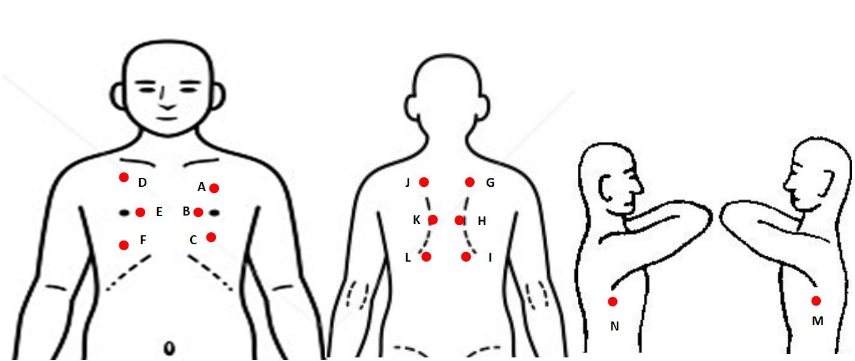
Supplementary material – Figure 1 - Patients characteristics

VoqX™ characteristics
Weight/Size
The length of the VoqX™ device is 600mm ± 100mm from end to end. The membrane diameter is about 50mm ± 8mm. Display size: 1.5” ± 0.2”. Weight: 250g ± 100g.

Intended Use
The VoqX™ is a decision support medical device intending for the amplification of sounds from the heart/lungs and for analyzing the sounds and assist the physician in the detection of lung/heart disease. It can be used on any person undergoing a physical assessment. VoqX™ is based on a combination of vibration measurement device (accelerometer) and acoustic wave detectors (microphones) resulting in capturing acoustic waves in the range of 3-2000 Hz.
Diagnosis by auscultation
VoqX™ Captures acoustic waves in the range of 3Hz – 2000Hz. It has the option to amplify the amplitude of the sound by simple control instruction. The maximum electronic amplification value is 10. The device supports normal operation of one day (8 working hours and 10% sound recording time), or at least 40 patients.

Diagnosis by visual representation
VoqX™ represents a graphical image of the recorded sound “sound signature”. The image illustrates the sound of breathing and gives an immediate tool for the evaluation of abnormalities.

Diagnosis by machine learning
VoqX™ contains a statistical model of acoustic waves relating to different diseases. After conducting signal analysis, the device is able to present statistical information about the probability of the existence (or non-existence) of number of diseases analyze and estimate the clinical condition of the subject under test.

Connectivity
VoqX™ can connect to a master device through Bluetooth interface. Thereafter, it is possible to download and exchange data between the device and a computer for backup, analysis, patient tracking, and VoqX™ version upgrade.

Signal processing and AI
In order to optimize the results of the classifier, all recorded acoustic waves were pre-processed by cutting each acoustic wave at the beginning and end to eliminate the noise generated by placing and removing the stethoscope. Thereafter, 164 features were measure at the time and frequency domains. For the time domain, statistical features were calculated (average, standard deviation, median etc.) and features that are related to the shape of the sound wave (Skewness, Kurtosis etc.). For the frequency domain, dominant frequencies at different ranges and their magnitudes were calculated along with area under the curves. Moreover, at the frequency domain we calculated MFCC features. Furthermore, the heart rate and the breathing rate were extracted from the data and were added to the classifier. Finally, the best 50 features were chosen by calculating the p values generated by distinguishing between the 3 groups for every feature. 144 features out of 164 features showed P<0.05. The 50 features were analyzed by an SVM classifier to classify: Normal, non-COVID19 pneumonia and COVID19 pneumonia.

Statistical analysis
All numbers in this study are reported as average ± standard deviation. The P value of the features was calculated by one a way analysis of variance (ANOVA) to choose the best 50 features.
The sensitivity, specificity, accuracy, positive predictive value, and negative predictive value were calculated for each run of the classifier: for the cross-validation group (during learning) and for the test group that did not participate during the learning. Receiver Operated Characteristics (ROC) was performed and the area under the curves with and without the infrasound were compared².

References of added material
1. WHO. Clinical management of severe acute respiratory infection when novel coronavirus (2019-nCoV) infection is suspected. interim guidance. WHO (2020).
2. Hanley, J. A. & McNeil, B. J. The meaning and use of the area under a receiver operating characteristic (ROC) curve. Radiology (1982) doi:10.1148/radiology.143.1.7063747.

