**Mishloach Manot Lesson**

**Lesson Information**

|  |  |
| --- | --- |
| Short description of lesson | Students will learn about the *mitzvah* of *mishloach manot* by studying the Purim plate on the NLI site. They will also discuss the traditions of the Jews of Germany.  After a discussion about the Purim plate, students will make their own plates with which to send *mishloach manot* (Purim food gifts). |
| Age group | Elementary/Middle School |
| Length of activity | 40 minutes |
| Primary sources from the NLI collections | Purim Plate <http://bit.ly/2Ony4n5> |
| Background information | The Purim plate was designed in Bamberg, Germany in the nineteenth century.  The plate is made of metal and is decorated with engravings. In the centre is a picture of a king, presumably King Ahasuerus from the story of Purim. To his left is another character with a crown, probably Queen Esther, and to the right a figure holding a parasol who is probably a servant.  Around the picture is what seems to be a misquotation from *Megillat* *Esther*:  "ויבוא המלכה על המלך, ויאמר לה, מה לך אסתר"  Translation: "The Queen came to the King, and he said to her, 'What is your wish, Esther?'"  This plate was intended for *mishloach manot* (or *shalach manos*). According to *Megillat Esther*, at Purim Jews should send gifts consisting of two different types of foods to friends and family. In some European communities, such as Germany, it was customary to give these *mishloach manot* on plates decorated with motifs from the festival.  Why Do Jews Send Mishloach Manot on Purim? <https://www.myjewishlearning.com/article/purim-gifts/> |
| Material, equipment, and preparations | * Computer and projector to view the Purim plate  **OR** Printed copies of the picture of the plate to place around the room * Crafts materials for making Purim plates * Printed analysis worksheets |

**Lesson Plan**

1. **Introduction – What are the four Purim *Mitzvot* (commandments)? (5 minutes)**The teacher leads a short introduction to the Purim mitzvot:
   1. Reading the *Megillah* (Book of Esther)
   2. Taking part in a *seudat Purim or mishteh (*a Purim feast)
   3. Giving *mishloach manot* (Purim food gifts)
   4. Giving *tzedakah* (*matanot l’evyonim*)

One way to remember these *mitzvot* is as the 4 *mem*s, since the Hebrew letter *mem* ***מ***appears in all of the names:

**מ**גילה

**מ**שתה

**מ**שלוח מנות

**מ**תנות לאביונים

1. **Pair or small group activity – What *mitzvah* uses this item? (10 minutes)**

The teacher projects the image of thePurim plate or distributes printed images of the plate to the students.   
 The teacher then explains the next steps:

* This is a picture of an object that is used to fulfill one of the Purim *mitzvot*.  
  Look carefully at the picture for clues to help you work out what the object is used for.
* Complete the worksheet <link> to help you explore the object.

**3. Class discussion – What is the object?** **(10 minutes)**

When everyone has had a chance to analyse the object in small groups, the teachers leads a class discussion about what the students discovered.

**Suggested questions**

* What is illustrated on the plate?
* What text appears on the plate?
* How were the illustrations made?
* What is unusual about the plate?
* What does the fact that there are mistakes in the Hebrew text tell us about the person who engraved the plate? (Note to teacher: It may have been made by someone who wasn’t Jewish, but it is more likely that the person who engraved the plate was a Jew who knew the text but wasn't very knowledgeable about Hebrew grammar, and therefore wrote Esther's actions in the masculine form.)
* What do you think the plate was used for?
* What pictures would you put on a Purim plate?
* Do you like getting *mishloach manot*?   
  Does a specially decorated package make the *mishloach manot* even more special?

**3. Creative activity – Do it yourself!** **(20 minutes)**

Students design their own Purim plates to use for *mishloach manot* on Purim.

They should decorate the plate with motifs from the story of Purim or Purim traditions.

Purim Plate, 19th Century Germany

[Separate doc, with logo]

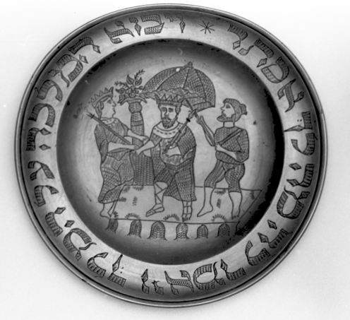

**Purim Plate - Analysis Worksheet**

[Separate doc, with logo, layout]

**Observations**

1. What are the decorations on the plate? __________________________________________________________________________________________________________________________________________
2. What story does it remind you of? __________________________________________________________________________________________________________________________________________
3. What is written on the rim of the plate? __________________________________________________________________________________________________________________________________________

**Let’s Look a Little Closer**

1. Which of the four Purim mitzvot do you think the plate was used for? _____________________________________________________________________
2. How do you think the plate was used? __________________________________________________________________________________________________________________________________________
3. Look in the Book of Esther to find the verse that is written on the plate. Can you find a spelling mistake? __________________________________________________________________________________________________________________________________________
4. What does the verse mean? __________________________________________________________________________________________________________________________________________
5. What can you guess about the person who made the plate from the spelling mistake? __________________________________________________________________________________________________________________________________________

**Making Connections**

1. Do you and your family give or get mishloach manot? Do you use a special plate or package? __________________________________________________________________________________________________________________________________________
2. How does the packaging enhance the gift? Does the packaging matter to you? What was your favourite mishloach manot that you received? What made it special? __________________________________________________________________________________________________________________________________________