The effects of mating cues and intrasexual competition on humor production
Abstract
Humor production is a complex cognitive function that has been studied widely, especially as a sexually selected ability. Nevertheless, the role of mating cues and of intrasexual competition in humor production have not been studied yet. Three experiments were conducted as part of the present study, involving 306 participants and using a priming methodology, to examine sex differences and self-enhancement in humor production ability. In each experiment participants were exposed to unattractive and attractive opposite-sex photographs, after which they were rated for humor production ability. In Study 3 all participants were tested in same-sex pairs to create a state of intrasexual competition. The findings of Study 1 and study 2, differing in presentation durations o primes, did not confirm previous findings concerning sex differences in humor ability, and did not demonstrate self-enhancement in humor ability following exposure to attractive primes. The findings of Study 3 showed that under conditions of intrasexual competition, men were superior to women in humor production ability, and showed self-enhancement in humor ability following exposure to attractive women primes. The present findings broaden the evolutionary cognitive framework erected on the premises of sexual selection, differential parental investment, and social cognition.
Keywords: sex differences, sexual selection, humor production, intrasexual competition, priming

Introduction
Is it possible to alter or enhance one’s capabilities or attributes when exposed to implicit cues? And can these attributes be modified to fit preferences of the other sex? A growing body of evidence in evolutionary psychology and social cognition research suggests that mating cues can activate behaviors linked to sex-differentiated mate preferences (Yong & Li, 2012). The present three studies explored the influence of implicit mating cues on humor enhancement.
Evolutionary psychology research routinely shows sex differentiation in mate preferences. Based on different fitness pressures, human males and females have developed different preferences for mates (Millar & Ostlund, 2006). For example, universally, men developed preference for good looks and health in a mate, whereas women developed a preference for social status, financial resources, stability, and intelligence (Buss, 1989; Buss, 2003; Shackelford, Schmitt, & Buss, 2005). Among these listed virtues, intelligence is highly valued by women because of its predictive value for other desired virtues, such as social and economic success, creativity (Miller, 1999; Kanazawa, 2000), artistic virtuosity (Miller, 2001), and good health (Arden, Gottfredson, & Miller, 2009). Humor production ability has been suggested as a prominent indicator of intelligence, and empirical findings provide support for this notion (e.g., Feingold & Mazzella, 1991; Greengross & Miller, 2011; Howrigan & MacDonald, 2008).
Humor is universal, and has been a part of the human behavioral repertoire for thousands of years. In their review on the evolutionary origins of humor, Polimeni and Reiss (2006) examined theories and studies from various scientific fields (e.g., neurobiology, cognitive archeology) which support the suggested adaptive function of humor. They have suggested that exposure to a humorous stimulus generates laughter, which in turn induces a positive emotional state that facilitates further social activity. Furthermore, laughter is pleasurable and therefore serve as a reinforceable behavior. Various evolutionary theories have been suggested to explain why humor and laughter could be evolutionary adaptive. For example, Alexander (1993) proposed that the major benefit of telling jokes is facilitating social status. Jung (2003) suggested that humor and laughter facilitate social cooperation. Laughter transfers information with attributed mental states and signals others the willingness for cooperate. Another source of support for the adaptive function of humor comes from animal models. Chimpanzees response to tickling with laughter-like behavior implies that the origin of laughter and humor could be tracked million years ago back to the common ancestor of Homo sapiens and chimpanzees (Dawkins, 2004). Younger primates display teasing-like behavior in the form of play in order to facilitate learning regarding the social environment and hierarchy (De Waal, 1982). Humor development in humans implies also on evolutionary adaptiveness. Starting with spontaneous smiling in infants, followed by various forms of play provoke smile and laughter (peek-a-boo, tickling, chase games), may act as an analogue to conventional humor. Based on this accumulated evidence, Polimeni and Reiss argued that humor may be the most complex cognitive human function. Its complexity requires a tailored genetic substrate that would provide the required attributes (e.g., abstract thinking, symbolism, language skills) to produce it effectively.
Humor involves two distinct aspects: the capacity to produce it and the capacity to appreciate it. It has been suggested that the two evolved under the influence of sexual selection (Miller, 2000a; Bressler, Martin, & Balshine, 2006). Because humor is an indicator of intelligence, women prefer men who have the capacity to produce humor, and men prefer women who have the capacity to be receptive to their humor (Bressler & Balshine, 2006; Hone, Hurwitz, & Lieberman, 2015). Empirical findings support this premise. Men showed preference for partners' receptivity of their humor, whereas women showed preference for partners' production of humor, especially when asked about dates and long-term relationships (Bressler et al., 2006; Hone et al., 2015; Lundy, Tan, & Cunningham, 1998). Miller (2000b) argued that no sexual dimorphism in human intelligence is expected because men and women share almost all of the same genes. In contrast, sexual dimorphism is expected in behavioral manifestations of intelligence (for example, art, creativity, humor), because reproductive benefits of such displays will be higher for men than for women. Parental investment theory provides support for this notion. Because parental investment is crucial for reproductive success (survival of offspring), the nature of parental investment by males and females generates the basic dynamics of sexual selection (Geary, 2000). Sharing the biology of reproduction of many other species results in sexual dimorphism in reproductive strategy with women focusing on parental effort and men on mating effort. In turn, sex differences in parental investment cause women to be more selective about mating, which in turn causes men to strive to display virtues that women value (Trivers, 1972).
The social cognition literature suggests that psychological processes, such as altering one’s own perceptions and attitudes to conform to potential mate preferences, are involved in human courtship. Studies explored the ability of various cues to prime the activation of psychological constructs associated with mate attraction, which in turn produce attitude changes in alignment with the mate preferences of the opposite sex (Roney, 2003). Various research paradigms were used to investigate this phenomenon. Using direct exposure of participants to the preferences of the opposite sex, some of the studies lent support for the alteration suggestion (Morier & Seroy, 1994; Zanna & Pack, 1975). Other attempts included exposure to realistic stimuli (in person or by means of photographed young women). For example, young men who were exposed to young women reported more favorable attitudes toward women's high-rated preferences (e.g., material wealth, indicators of social status, etc.) than men exposed to older women (Roney, 2003). The author suggested that the visual stimuli (young women) activated the stored female mate preferences in men.
Another line of research explored the influence of exposure to realistic stimuli (photographed attractive women) on various attributes and behaviors linked to sex-differentiated mate preferences. For example, Griskevicius, Cialdini, and Kenrick (2006) showed that priming men with mating cues (photographs of attractive women) led to an increase in creativity when compared to priming men with neutral cues (e.g., photographs of streets), but no differences were documented between women primed with mating cues and those primed with neutral cues. Men have also been found to show greater risk taking (Baker & Maner, 2008), and exhibited higher levels of future discounting (Wilson & Daly, 2004) after viewing pictures of attractive women as opposed to unattractive women.
Uncovering the mechanism underlying the influence of mating cues on perception and behavior modification has been the focus of research in social cognition and evolutionary psychology. Millar and Ostlund (2006) argued that priming techniques derived from the area of social cognition are beneficial to evolutionary psychology as a whole, and help understand mating behavior in particular, given the premise of the evolutionary framework that evolved mechanisms activate behavior through unconscious processes. The present study aimed to investigate the influence of priming mating cues introduced subliminally or supraliminally on humor production. Specifically, I used priming mating cues to examine self-enhancement in humor production. Subliminal and supraliminal priming refer to the unconscious versus conscious processing of stimulus. Although the exact consciousness threshold is hard to trace, it is accustomed to perceive any prime presented under 100 ms as subliminal prime (Phaf, Wendte, & Rotteveel, 2005). The present study join previous studies exploring the potential changes in cognition and behavior in compliance with mate preferences of the opposite sex resulting from unconscious priming following exposure to input cues (Roney, 2003). Specifically, the present study aimed at investigating the role of a mere presentation of mating cues on humor production. To achieve this goal, different presentation durations of primes (i.e., mating cues) were used in three studies in order to uncover the role of unconscious and conscious processing of mating cues and their influence on later behavior.
Another key factor in understanding sex differences in mating-related cognition and behavior is intrasexual competition. Competition between members of one sex for mating is based on Darwin's (1871) insight on sexual selection. Males and females are predicted to compete within their sex by displaying the virtues and resources valued by the other sex (Buss, 1988). In elaborating Darwin's theory, Trivers (1972) suggested that males and females are differentiated in their parental investment strategies, which incline them to engage in different degrees of intrasexual competition. Males engage more frequently in male-male competition over mating opportunities than females do. Evidence from non-human species usually supports this notion (for example, Clutton-Brock & Vincent, 1991). In humans, because both sexes are involved in child rearing, both men and women are expected to be discriminating in mate preferences. Empirical evidence shows that both men and women engage in intrasexual competition, but differ in the tactics they use in male-male and female-female competition (Buss, 1988; Buss & Dedden, 1990; Walters & Crawford, 1994). Whereas men compete for acquisition of resources and status, women compete for enhancing physical attractiveness and achieving a healthy and youthful appearance. In the present study, I tested the ability to enhance the production of humor as a function of intrasexual competition. I used the presence of other same-sex participants during a timed task to create a situation of rivalry by inducing a state of intrasexual competition. Since the assets evaluated in the present study (humor ability) are associated with mate preferences of females but not of males, I expected that intrasexual competition, although experienced by both sexes, will be manifested only by men, because of the nature of the virtue on display.
In sum, it has been established that exposure to mating cues alters one’s attitudes and behavior. The three studies described below sought to examine the role of mating cues on humor enhancement. In the first and second study, men and women were primed with attractive and unattractive opposite-sex pictures, after which they were asked to produce verbal humor. I examined the difference in humor production under the two conditions (attractive vs. unattractive) for each sex. The only difference between Study 1 and 2 was presentation duration of primes: 30 vs. 100 ms. In the third study, I added intrasexual competition to the experimental setting, and hypothesized that the accumulated value of mating cues would elicit larger sex differences in humor production. I hypothesized that mating cues including the exposure to an attractive woman would activate asset-display behavior in men, but not in women. Given the sex differences in mate preferences, I predicted that exposure of men and women to attractive members of the opposite sex would activate the stored female mate preferences in men, but not in women. In light of the empirical evidence regarding intrasexual competition, I hypothesized that activating female mate preferences in men in the presence of a potential rival will result in self-enhancement in humor production.
Study 1
The first experiment was designed to examine sex differences in humor production as a function of exposure to attractive and unattractive pictures of the opposite sex. Men and women were subliminally primed with attractive and unattractive pictures of the opposite sex, then asked to provide a funny caption to a given picture. Humor enhancement was measured. The hypotheses of Study 1 were:
- Men will exhibit higher humor production than women.
- Men will show greater humor enhancement than women following exposure to attractive opposite-sex primes than following exposure to unattractive opposite-sex primes.
Because male's mate preferences include cues for health and youth, attractive opposite-sex primes will activate the stored female mate preferences in men, but not the stored male mate preferences in women.
Method
Participants
One hundred and thirty three students from a college in the north of Israel (mean age 24.51 ± 2.50 yrs) participated in the study. Sixty seven of the participants were female (mean age 24.60 ± 2.52) and 66 were male (mean age 24.42 ± 2.50). Participants were recruited through advertisements at the college and did not receive compensation for their participation. Participants were prescreened for sexual orientation. Only heterosexual students participated in the study.
Materials and Procedure
Participants were tested individually in a small room, with only a computer provided on a desk, without other distracting stimuli. After completing a background questionnaire (e.g., sex, age), participants were instructed to fixate on a cross that appeared in the middle of the screen for 350 ms. Next, they participated in the two continuous sessions, a priming phase and a task phase.
Primes. Each participant participated in both consecutive sessions: attractive vs. unattractive primes. In each session, participants were exposed to four neutral stimuli (e.g., picture of a table), in order to mask potential environmental stimuli (e.g., pre-exposed males or females in the lab) from remaining active, followed by four pictures of the opposite-sex, either attractive or unattractive. The male pictures were pre-rated by heterosexual female students, and the female pictures were pre-rated by heterosexual male students, and rated as extremely attractive and unattractive. Each picture was presented for 30 ms. The order of the prime sessions was counterbalanced, with half the participants exposed first to the attractive then to the unattractive session, and vice versa.
Humor task. Similarly to the procedure described by Greengross and Miller (2011), participants were given two pictures (one in each prime session) without a caption. For each picture they were asked to write a funny caption within a limited time frame (40 sec). The order in which the pictures were presented was counterbalanced as well. Subsequently, three judges (two men and one woman) blindly rated every caption on a scale from 1 ("not funny at all") to 7 ("very funny"). Internal reliability (Cronbach's alpha) was .62 on average, consistent with former studies (Feingold & Mazzella, 1993; Masten, 1986), but relatively lower than in Greengross and Miller’s (2011) study. Judges’ ratings were averaged to form two scores per participant (one for humor production following the unattractive priming, and one for humor production following the attractive priming). A manipulation check included two questions presented to participants, whether they knew what the purpose of the experiment was and whether they noticed what primes were used in the study. None of the participants were suspicious about the purpose of the experiment or about the nature of priming stimuli.
Results
Sex differences. To examine sex differences in the overall humor production score, I conducted independent sample t-test with sex as the independent variable and the humor score as the dependent variable. No sex difference was found [t (131) = .78, p = .439; cohen's d = .13].
Attraction primes. To examine the attraction priming effect in the overall humor production score, I conducted paired sample t-test with attraction as a within-participant independent variable and humor score as the dependent variable. No difference was found in humor production after exposure to attractive vs. unattractive priming [t (132) = .39, p = .701; cohen's d = .03].
Main Hypothesis. The main hypothesis predicted an interaction between sex and attractiveness priming on humor production, with men showing humor enhancement following exposure to attractive women, and women not showing such enhancement. The hypothesis was tested using a mixed ANOVA, with attraction primes as the within-participant and sex as the between-participants independent variables, and humor score as the dependent variable. Order of attraction primes and order of picture presentation were also included in the model as between-participants variables. No main effects of order of attraction primes or of order of picture presentation were found (ps > .05), and no significant interaction was found between sex and attraction priming [F (1, 131) = .75, p = .387; η²_{p} = .01, see Fig. 1].

Discussion
Findings did not support any of the hypotheses of Study 1. Men did not show higher humor production than women. This finding is inconsistent with former evidence, suggesting that men show better humor ability than women. Greengross and Miller (2011) documented higher average humor ability in men. In their study, men and women were asked to produce as many captions as they could to a given cartoon. Men produced more captions than women, and their captions were rated on average as funnier than those of women. The authors argued that their findings were consistent with the sexual signaling hypothesis, in which humor has evolved as a signal of mate quality, and therefore men signal intelligence through humor. Greengross and Miller requested that participants produce several captions per cartoon, and for each participant the highest rated caption was chosen as to represent the participant’s humor ability. In the present study, participants were asked to produce one caption per picture. The averaged humor scores were low, and on average participants failed to produce funny captions. This is consistent with Greengross and Miller’s finding that most captions in their study were rated low. It is possible that humor is too complex to produce in a "one-shot trial," without supportive boosters. In the present study, the role of such supportive boosters was assumed to be played by the mating cues with which participants were primed. It was assumed that exposure to attractive women will activate the female mate preferences in men, which in turn will be manifested in cognitive resources being channeled into the task of humor enhancement. The present findings do not support this hypothesis. It is possible that simply viewing attractive women was not sufficient to activate the stored female mate preferences in men. Baker and Maner (2008) have found that the relationship between physical attractiveness cues and elevated risk taking in men is sensitive to one’s motivational state. Men who simply viewed attractive women did not take more risks, except when the interest in procuring a mate was present.
Study 2
The results of Study 1 do not support the hypotheses derived from the sex-selection model of humor (Miller, 2000a). Study 2 was designed to further examine the goals of Study 1, by using different presentation duration of primes. Whereas in study 1 participants exposed subliminally to primes (30 ms), the second experiment used greater presentation duration of 100 ms, which is believed to lie between suboptimal and fully optimal presentation (Phaf et al., 2005). In study 1 manipulation check revealed that participant were unaware of the nature of priming stimuli. Perhaps a mere representation of mating cues will activate the stored representation of women mate preferences in memory in men (Roney, 2003). The hypotheses of Study 2 are identical to those of Study 1:
- Men will exhibit higher humor production than women.
- Men will show greater humor enhancement than women following exposure to attractive opposite-sex primes than following exposure to unattractive opposite-sex primes.
Method
Participants
Ninety-one students from a college in the north of Israel (mean age 24.92 ± 4.37 yrs) participated in the study: 45 women (mean age 24.42 ± 4.55) and 46 men (mean age 25.41 ± 4.22). Participants were recruited through advertisements at the college and did not receive compensation for their participation. Participants were prescreened for sexual orientation. Only heterosexual students participated in the study.
Materials and Procedure
The design and all the materials were similar to Study 1, except in Study 2, each photo in the attractive vs. unattractive primes was presented for 100 ms. Subsequently, three judges (two men and one woman) blindly rated every caption on a scale from 1 ("not funny at all") to 7 ("very funny"). Internal reliability (Cronbach's alpha) was .62 on average. Judges’ ratings were averaged to form two scores per participant (one for humor production following the unattractive priming, and one for humor production following the attractive priming). A manipulation check included two questions presented to participants: whether they knew what the purpose of the experiment was and whether they noticed what primes were used in the study. All participants acknowledged that they saw pictures, but none was suspicious about the purpose of the experiment or about the connection between the nature of primes and the humor task.
Results
Sex differences. To examine sex differences in the overall humor production score, I conducted independent sample t-test with sex as the independent variable and the humor score as the dependent variable. No sex difference was found [t (89) = 1.43, p = .156; cohen's d = .31].
Attraction primes. To examine the attraction priming effect in the overall humor production score, I conducted paired sample t-test with attraction as a within-participant independent variable and humor score as the dependent variable. No difference was found in humor production after exposure to attractive vs. unattractive priming [t (90) = 1.22, p = .111; cohen's d = .13].
Main Hypothesis. The main hypothesis predicted an interaction between sex and attractiveness priming on humor production, with men showing humor enhancement following exposure to attractive women, and women not showing such enhancement. The hypothesis was tested using a mixed ANOVA, with attraction primes as the within-participant and sex as the between-participants independent variables, and humor score as the dependent variable. Order of attraction primes and order of picture presentation were also included in the model as between-participants variables. No main effects of order of attraction primes or of order of picture presentation were found (ps > .05), and no significant interaction was found between sex and attraction priming [F (1, 89) = .01, p = .933; η²_{p} = .00, see Fig. 2].

Discussion
Findings did not support any of the hypotheses of Study 2. Even when exposed to greater presentation duration of mating cues, men did not show higher humor production than women. As in study 1, the present findings were inconsistent with former results showing men superiority in humor production ability (Greengross & Miller, 2011). Study 2 was designed to punctuate the conditions under which mating cues prime changes in humor production in men. Given subliminal exposure to attractive women did not activate the female mate preference in men in study 1, Study 2 included supraliminal priming enabling conscious processing of stimuli. Nevertheless, changing presentation duration of primes did not produce sex differences in humor production and the predicted humor enhancement in men following exposure to attractive women pictures. As mentioned earlier, humor production is a complex cognitive ability that may require supportive boosters in order to execute it and to enhance it. To further examine the nature of supportive boosters leading to humor enhancement in men Study 3 was designed.
Study 3
The results of Study 1 and 2 do not support the hypotheses derived from the sex-selection model of humor (Miller, 2000a). Therefore, the third experiment was designed to further examine the goals of Study 1and 2, by adding the situational factor of intrasexual competition. First, I hypothesized that in general men show higher humor production ability than women under conditions of intrasexual competition. Because humor ability is associated with other virtues that are highly valued by women, intrasexual competition may result in higher humor ability in men, but not in women. Second, I hypothesized that the mating goals can be activated in men by pairing of two substantial cues: exposure to attractive women and the presence of a potential male rival. I expected this to have an accumulative effect for men to activate the need to display their assets, which in turn would translate into a higher display of humor ability. The hypotheses of Study 3 were:
- With exposure to intrasexual competition, men will exhibit higher humor production than women.
- With exposure to intrasexual competition, men will show greater humor enhancement than will women, following exposure to attractive opposite-sex primes as opposed to exposure to unattractive opposite-sex primes.

Method
Participants
Eighty-two students from a college in the north of Israel (mean age 24.46 ± 1.92 yrs) participated in the study: 42 women (mean age 23.98 ± 1.80) and 40 men (mean age 24.97 ± 1.93). Participants were recruited through advertisements at the college and did not receive compensation for their participation. Participants were prescreened for sexual orientation. Only heterosexual students participated in the study.
Materials and Procedure
The design and all the materials were similar to Study 1, except for two differences: (a) in Study 2, each photo in the attractive vs. unattractive primes was presented for 100 ms; (2) participants were tested in same-sex pairs in a small room, with only two computers, one on each desk, 200 cm. apart from each other. They were introduced by the experimenter as participating in this research and were instructed not to communicate or to create any eye contact with each other during the experimental session (the experimenter verified that the two participants were not previously acquainted). Subsequently, three judges (two men and one woman) blindly rated every caption on a scale from 1 ("not funny at all") to 7 ("very funny"). Internal reliability (Cronbach's alpha) was .73 on average, consistent with Greengross and Miller’s (2011) study. Judges’ ratings were averaged to form two scores per participant (one for humor production following the unattractive priming, and one for humor production following the attractive priming). A manipulation check included two questions presented to participants: whether they knew what the purpose of the experiment was and whether they noticed what primes were used in the study. All participants acknowledged that they saw pictures, but none was suspicious about the purpose of the experiment or about the connection between the nature of primes and the humor task.
Results
Sex differences. To examine sex differences in the overall humor production score, I conducted a independent sample t-test, with sex as the independent variable and humor score as the dependent variable. The results indicated a sex difference [t (80) = 8.85, p = .000; cohen's d = 1.96], with men showing higher humor ability (M = 3.73, SD = .89) than women (M = 2.03, SD = .84).
Attraction primes. To examine the attraction priming effect in the overall humor production score, I conducted paired sample t-test, with attraction as a within-participant independent variable and humor score as the dependent variable. No difference was found in humor production after exposure to the attractive vs. the unattractive priming [t (81) = 1.61, p = .111; cohen's d = .18].
Main hypothesis. The main hypothesis predicted an interaction between sex and attraction priming on humor production, with men showing humor enhancement following exposure to attractive women, and women not showing such enhancement, when both are primed with an intrasexual competition cue. I tested the hypothesis using a mixed ANOVA, with attractiveness priming as the within-participant and sex as the between-participants independent variables, and humor score as the dependent variable. The order of the attractiveness primes and of the picture presentation were also included in the model as between-participants variables. No main effects or interaction with other independent variables were found (ps > .05), therefore they were dropped from subsequent analysis. A significant interaction between sex and attraction prime was found [F (1, 80) = 4.93, p = .029; η²_{p} = .06, see Fig. 3]. The difference between humor production following unattractive vs. attractive primes was nonsignificant for women [t (41) = 0.46 , p = .647], but reached significance for men [t (39) = 2.33 , p = .025]. Men showed humor enhancement after exposure to attractive women (M = 4.06, SD = 1.28) as opposed to an exposure to unattractive ones (M = 3.39, SD = 1.25).
Discussion
In Study 3, the findings support both hypotheses. Exposed to intrasexual competition, men showed higher levels of humor ability than did women. The presence of the same-sex participant was designed to serve as a situational cue signaling potential intrasexual competition. Men, but not women, experienced the same-sex participant as a potential rival, which in turn led them to accentuate their assets corresponding to female mate preferences, namely, humor ability. As a result of different fitness pressures, women developed preferences for social status, financial resources, and intelligence (Buss, 1989; Buss, 2003; Shackelford, Schmitt, & Buss, 2005). Former studies have established that humor production ability is a prominent indicator of intelligence (e.g., Feingold & Mazzella, 1991; Greengross & Miller, 2011; Howrigan & MacDonald, 2008). Therefore, the task in present study, which demanded humor production ability, was aligned with female mate preferences but not with male mate preferences. Exposed to intrasexual competition, men but not women accepted the challenge of wittiness and provided funnier captions to the stimuli (when primed with either attractive or unattractive women). Men performed even better when exposed to attractive women. The addition of another mating cue had a cumulative effect on men.
General Discussion
The present research examined whether the exposure to different mating cues enhances humor ability in men and women. As predicted, the results of Study 3 suggest that men, when primed with intrasexual competition, show higher humor ability than women, and when primed with intrasexual competition coupled with attractive opposite-sex primes, they show enhanced humor ability compared to their performance following exposure to unattractive opposite-sex primes. This is consistent with the three premises of the evolutionary cognitive framework: (a) that sexual selection pressures guide sex-differentiated mate processes, leading men and women to display assets, virtues, and traits – including mental abilities – valued by the other sex (Miller, 2000a); (b) differential parental investment leads to sex-differentiated intrasexual competition, both in degree and in form (Trivers, 1972); and (c) emerging research in evolutionary psychology suggests that activating mating cues can facilitate cognitions and behaviors aimed at attracting a mate (Roney, 2003; Wilson & Daly, 2004). The present study explored the cues that serve to activate humor production in men and women. The results of Study 1 and Study 2 did not support the hypotheses. With the inclusion of a central cue, intrasexual competition, Study 3 confirmed the predicted enhancement in humor. The enhancement in humor ability suggests that men store a representation of women mate preferences in memory (Roney, 2003). The activation process of these stored representations, leading to higher humor ability, manifests in the presence of intrasexual competition primes, and is further enhanced by with such mating cues as attractive women primes. These findings expand previous evidence of a cognitive model of mate attraction in which the exposure of accumulating cues may activate cognitive schemes of mate preferences that lead to modifications in mate attraction cognitions and behavior (Roney, 2003). A word of caution is in order, given the small N in Study 3. Although the mean difference between men and women did reach significance, and the interaction of sex with the priming condition was significant too, these findings call for further replication.
Examination of the results of the three studies reveals that on average, women maintained their performance on humor production across all four conditions: exposure to attractive vs. unattractive men, and exposure to intrasexual competition vs. the absence of such exposure. Women's humor ability was relatively low, which is consistent with previous evidence (Greengross & Miller, 2011). As predicted, the exposure to attractive men did not serve as a mating cue for women, nor did the intrasexual competition cue. It appears that women did not experience the presence of the same-sex participant as a potential rival, even after exposure to attractive men. These results are consistent with sexual selection predictions regarding sex-differentiated mate preferences, because the quality evaluated in the present study (humor ability) was associated with females’, but not males' mate preferences.
The present three studies used the priming technique, which have been suggested as beneficial in evolutionary psychology research. According to the guidelines of the evolutionary framework, evolved mechanisms activate behavior through unconscious processes (Millar & Ostlund, 2006). In the three studies described above there were no indications that participants were aware of the nature of the manipulation. In Study 1, participants were exposed subliminally to photographs of the opposite sex based on the assumption that attractiveness may have evolved to the point where it is perceived even below the levels of conscious awareness (Massr & Buunk, 2010). It was hypothesized that primes of attractive women would activate the stored female mate preferences in men, causing them to display higher humor ability. But the results of Study 1 did not support the hypotheses. In Study 2, using supraliminal presentation duration of primes, considered as the lower threshold of conscious processing, did not yield significant results as well. In contrast, in Study 3, combining exposure to attractive women with intrasexual competition activated the stored female mate preferences in men, showing an enhancement in humor ability. Because the priming used in Study 3 included exposure within the threshold of conscious processing, it is suggested to further examine the hypotheses of the present study for the influence of pairing cues (attractive opposite-sex photographs and the presence of a same-sex participant), using a combination of subliminal priming and intrasexual competition. This makes it possible to test direct assumptions based on the evolutionary framework regarding the unconscious infrastructure in human mating processes, suggesting that mating behavior is guided and activated by unconscious processes.
Humor production ability is assumed to be the most complex cognitive function of humans (Polimeni & Reiss, 2006). The results of Study 1 and 2 show that to display humor ability under forced conditions, the exposure to an attractive opposite-sex photograph was not sufficient to act as an activating booster. The results of Study 3 emphasize the central role that intrasexual competition plays in humor production. Experiencing the presence of a potential rival has led men, but not women, to display substantially higher humor ability than they did in the absence of intrasexual competition. Future studies may examine other cognitive abilities (e.g., insight problem solving, rational vs. irrational decision making), and the combination of cues that trigger their activation, to portray the contour of female mate preferences and its activating mechanisms in men.

References
Alexander, R.D. (1986). Ostracism and indirect reciprocity: the reproductive significance
of humor. Ethology and Sociobiology, 7, 253-270.
Arden, R., Gottfredson, L. S., & Miller, G. (2009). Does a fitness factor contribute to the association between intelligence and health outcomes? Evidence from medical abnormality counts among 3654 US Veterans. Intelligence, 37, 581–591.
Baker, M., & Maner, J. K. (2008). Risk-taking as a situationally sensitive male mating
strategy. Evolution and Human Behavior, 29, 391–395.
Bressler, E. R., & Balshine, S. (2006). The influence of humor on desirability. Evolution and Human Behavior, 27, 29–39.
Bressler, E. R., Martin, R. A., & Balshine, S. (2006). Production and appreciation of humor as sexually selected traits. Evolution and Human Behavior, 27, 121-130.
Buss, D. M. (1988). The evolution of human intrasexual competition: Tactics of mate attraction. Journal of Personality and Social Psychology, 54, 616-628.
Buss, D. M. (1989). Sex differences in human mate preferences: Evolutionary hypotheses tested in 37 cultures. Behavioral and Brain Sciences, 12, 1–49.
Buss, D. M. (2003). The evolution of desire (rev. ed.). New York: Basic Books.
Buss, D. M. & Dedden, L. A. (1990). Derogation of competitors. Journal of Social and Personal Relationships, 7, 395-422.
Clutton-Brock, T. H. & Wincent, A. C. J. (1991). Sexual selection and the potential rates of
Darwin, C. (1871). The descent of man and selection in relation to sex. London: Murray.
Dawkins, R. (2004). The Ancestor’s Tale. London: Weidenfeld and Nicolson.
De Waal, F. (1982). Chimpanzee Politics: Power and Sex Among Apes. New York: Harper and Row.
Feingold, A., & Mazzella, R. (1991). Psychometric intelligence and verbal humor ability. Personality & Individual Differences, 12, 427-435.
Feingold, A., & Mazzella, R. (1993). Preliminary validation of a multidimensional model of
wittiness. Journal of Personality, 61, 439–456.
Geary, D. C. (2000). Evolution and proximate expression of human paternal investment. Psychological Review, 126, 55–77.
Greengross, G., & Miller, G. (2011). Humor ability reveals intelligence, predicts mating success, and is higher in males. Intelligence, 39, 188-192.
Griskevicius, V., Cialdini, R. B., & Kenrick, D. T. (2006). Peacocks, Picasso, and Parental Investment: The Effects of Romantic Motives on Creativity. Journal of Personality and Social Psychology, 91, 63–76.
Hone, L. S. E., Hurwitz, W., & Lieberman, D. (2015). Sex Differences in Preferences for Humor: A Replication, Modification, and Extension. Evolutionary Psychology, 13, 167-181.
Howrigan, D. P., & MacDonald, K. B. (2008). Humor as a mental fitness indicator. Evolutionary Psychology, 6, 652–666.
Jung, W.E. (2003). The Inner Eye theory of laughter: Mindreader signals cooperator value. Evolutionary Psychology, 1, 214-253.
Kanazawa, S. (2000). Scientific discoveries as cultural displays: a further test of Miller’s courtship model. Evolution and Human Behavior, 21, 317–321.
Lundy, D. E., Tan, J., & Cunningham, M. R. (1998). Heterosexual romantic preferences: the importance of humor and physical attractiveness for different types of relationships. Personal Relationships, 5, 311–325.
Massar, K. & Buunk, A. P. (2010). Judging a book by its cover: Jealousy after subliminal priming with attractive and unattractive faces. Personality and individual Differences, 49, 634-638.
Masten, A. S. (1986). Humor and competence in school-aged children. Child Development, 57, 461–473.
Millar, M. G. & Ostlund, N. M. (2006). The Effects of a Parenting Prime on Sex Differences in Mate Selection Criteria. Personality and Social psychology Bulletin, 32, 1459-1468.
Miller, G. F. (1990). Sexual selection for cultural displays. Pages 71–91 in The Evolution of Culture: An Interdisciplinary View, edited by R. Dunbar, C. Knight, and C. Power. Edinburgh: Edinburgh University Press.
Miller, G. F. (2000a). Mental traits as fitness indicators: Expanding evolutionary psychology’s adaptationism. Annals of the New York Academy of Sciences, 907, 62– 74.
Miller, G. F. (2000b). Sexual selection for indicators of intelligence. In G. Bock, J. Goode, & K. Webb (Eds.), The nature of intelligence. Novartis Foundation Symposium 233 (pp. 260–275). Chichester7 Wiley.
Miller, G. F. (2001). Aesthetic fitness: how sexual selection shaped artistic virtuosity as a fitness indicator and aesthetic preferences as mate choice criteria. Bulletin of Psychology and the Arts, 2, 20–25.
Morier, D., & Seroy, C. (1994). The effect of interpersonal expectancies on men’s self-presentation of gender role attitudes to women. Sex Roles, 31, 493-504.
Phaf, R. H., Wendte, R., & Rotteveel, M. (2005). Privileged processing of low spatial frequencies in emotional faces? In: B. G. Bara, L. Barsalou, & M. Bucciarelli (Eds.), Proceedings of the XXVII Annual Conference of the Cognitive Science Society, Stresa, Italy (pp. 1744–1749). Austin, TX: Cognitive Science Society
Polimeni, J. & Reiss, J. P. (2006). The First Joke: Exploring the Evolutionary Origins of Humor. Evolutionary Psychology, 4, 347-366.
Roney, J. R. (2003). Effects of Visual Exposure to the Opposite Sex: Cognitive Aspects of Mate Attraction in Human Males. Personality and Social Psychology Bulletin, 29, 393-404.
Shackelford, T. K., Schmitt, D. P., & Buss, D. M. (2005). Universal dimensions of human mate preferences. Personality and Individual Differences, 39, 447–458.
Trivers, R. L. (1972). Parental investment and sexual selection. In B. Campbell (Ed.), Sexual Selection and the Descent of Man (pp. 136–179). Chicago, IL: Aldine Publishing Company.
Walters, S. & Crawford, C. B. (1994). The importance of mate attraction for intrasexual competition in men and women. Ethology and sociobiology, 15, 5-30.
Wilson, M., & Daly, M. (2004). Do pretty women inspire men to discount the future?
Proceedings of the royal society of London Series B (Suppl.), 271, S177– S179.
Yong, J. C. & Li, N. P. (2012). Cash in hand, want better looking mate: Significant resource cues raise men’s mating standards. Personality and Individual Differences, 53, 55–58.
Zanna, M. P., & Pack, S. J. (1975). On the self-fulfilling nature of apparent sex differences in behavior. Journal of Experimental Social Psychology, 11, 583-591.

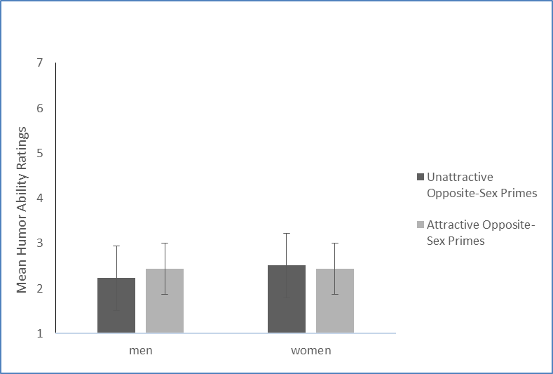
Figure 1. Mean humor ability ratings (± SE) of men and women following exposure to unattractive and attractive opposite-sex primes (30 ms)
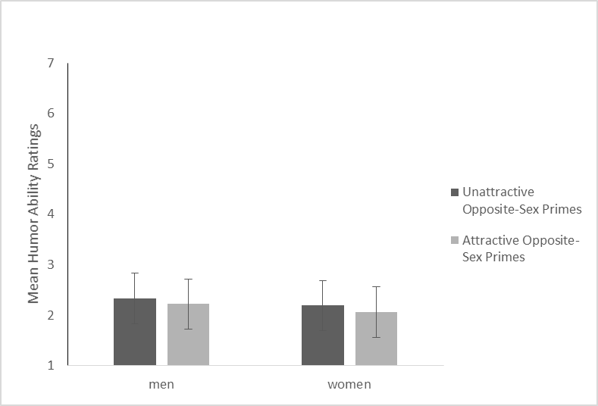
Figure 2. Mean humor ability ratings (± SE) of men and women following exposure to unattractive and attractive opposite-sex primes (100 ms)
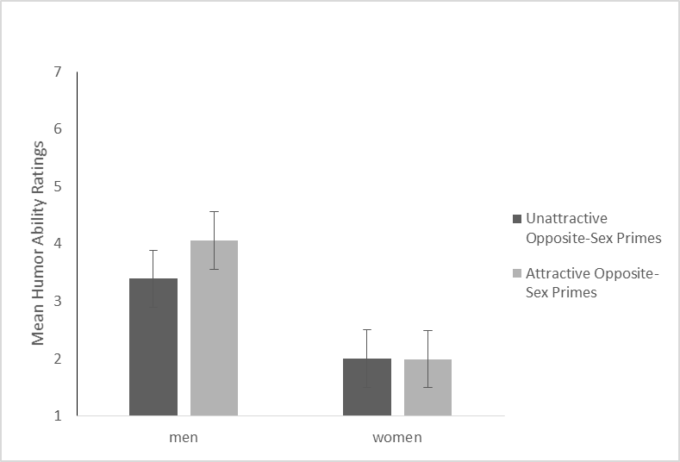
Figure 3. Mean humor ability ratings (± SE) of men and women following exposure to unattractive and attractive opposite-sex primes (100 ms), facing intrasexual competition

