Pre-reading activities.

1: Match a caption to the picture.

- A woman from Gondar in a traditional white dress.
- Preparing “injara” on an outside fire.
- A decorated mud hut.
- Two Ethiopian children.
- The big city of Addis Abba.
- A straw hut.

2: *Look at some of the new vocabulary.
*Find them in the text. Can you translate the words? (Use the pictures as clues)
*If you can’t translate the words, use your dictionary.

photographs |  | sticks
special occasions |  | straw
traditional |  | statues
decorated |  | ovens
beads |  | jewelry
photographs |  | language
activities

3: Arrange the words in alphabetical order (Optional activity)

4. Complete the KWL Chart.
What I know about Ethiopia | What I want to know | What I learned from the story.
4: You are ready to read “Our Family Album”.
While reading, answer the questions above each section.

A: Who are the two friends?
Where did they live five years ago?
They brought something special with them from Ethiopia. What was it?

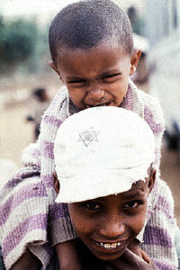
Orit and Rada are two friends. They both arrived in Israel about five years ago. They came with very few belongings, but they managed to bring their family album with many photographs with them to Israel. They invite people to look at their album in order to learn about the Jewish children of Ethiopia.

Both the children come from the Gondar area in Ethiopia and they lived in a Jewish village. Rada is a boy and Orit is a girl. Both the children still speak Amharic, the language of Ethiopia. In Amharic, Rada’s name means “he shall help”. Orit’s name means “the law of the Bible".

B: What is special about this picture?
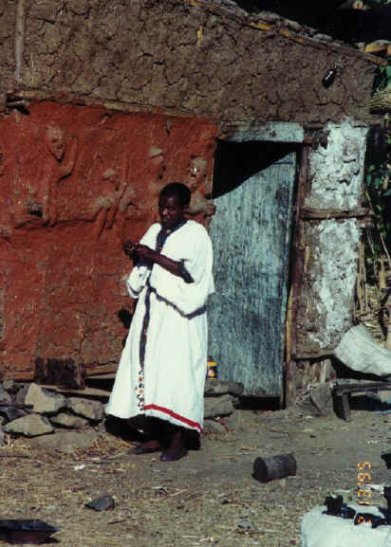
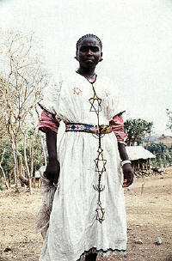
Like the Ethiopians living in Israel, on special occasions men and women wore traditional Ethiopian dress in the villages. The dress was also in white. The women in Ethiopia also decorated their white dresses with beads and some jewelry especially a “Magen David”.

C: Find words that describe life in an Ethiopian village.

Life in the village wasn’t easy, but everyone carried out their daily activities. The little huts they lived in were made of sticks, straw and sometimes mud. There was no bathroom. No one had a soft warm bed. Everyone slept on straw mats on the floor.

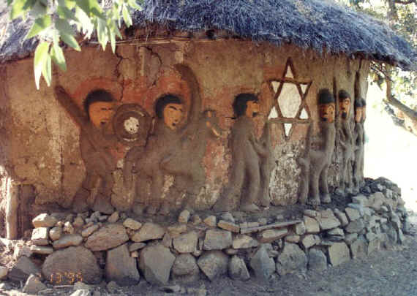
Some families had bigger homes made from mud. They decorated and painted their homes by making colorful statues and a Magen David (Star of David)

D: The woman is making something. What is it?
Why isn’t she cooking in her kitchen?

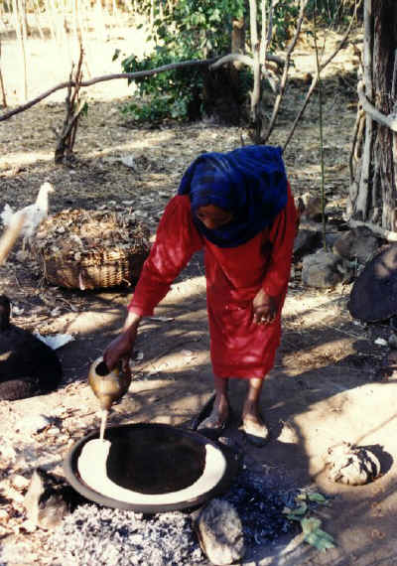
In the villages there weren’t big kitchens with big ovens. The women had to cook on an open fire outside their hut. In the picture a woman is preparing “injara” – a slightly sour "gummy" pancake made from flour.

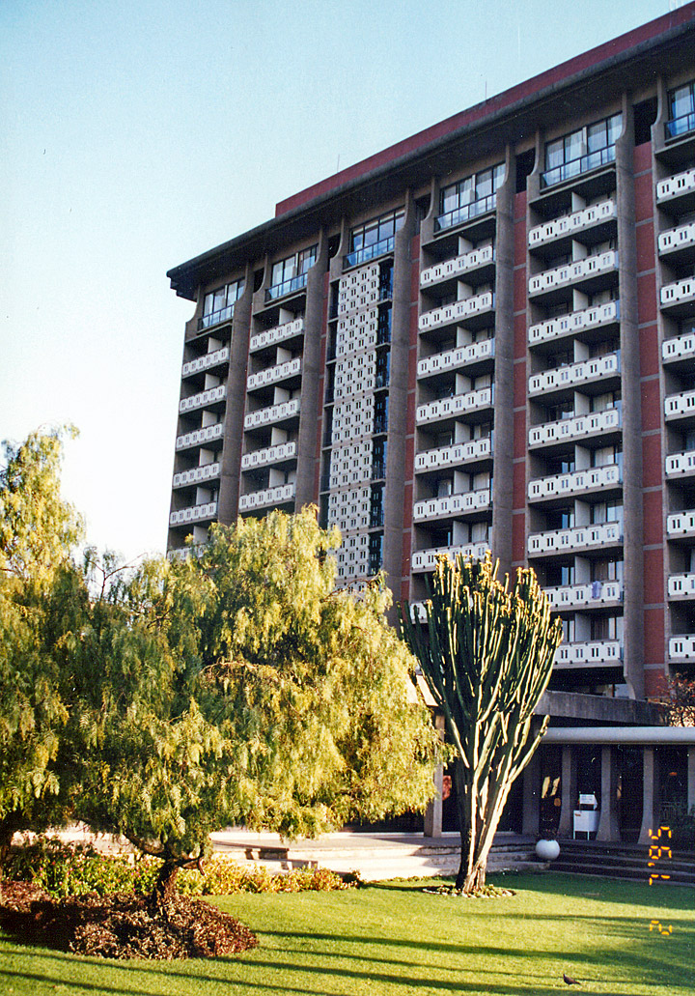
E: Where is this picture taken?
Why is it in Orit and Rada’s Family Album?

Before coming to Israel, the Jewish Agency brought our families and many other families to Addis Ababa. There we spent a few months at an ulpan learning Hebrew because people don’t speak Amharic in Israel. The teachers at the ulpan prepared us for our new and different life in Israel.
After Reading the text.

Compare Ethiopian life in Gondar to Ethiopian life in Israel.

 | Gondar | Israel
Traditional dress
Houses
Bedrooms
Kitchens
Bathrooms
Language Spoken

Matching – Match part A of the sentence to part B

- Orit and Rada brought | white and decorated with beads and a Magen David.
- They came from a small Jewish | were very simple and had no kitchens.
- Ethiopian traditional dress is | a family album with them from Ethiopia.
- The mud and straw homes | a sour pancake made from flour.
- Injara is | some time in Addis Ababa before coming to Israel.
- Orit and Rada’s families spent | village in Gondar

Find the past forms of the following verbs in the text.

Base / Present | Past Form | Base / Present | Past Form
arrive |  | have
come |  | sleep
wear |  | are
is |  | bring
make |  | spend

What colors are on the Ethiopian flag? (If you do not know, ask Google!)
_______________________________________________________
As long as you are there, ask Google what other countries have those colors. What do most of those countries have in common?
________________________________________________________________________________________________________________________

Now read this:

Did you know?
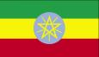
The Ethiopian flag is green, yellow and red. The round emblem (סימן) is a blue disk, known as the National Coat of Arms. In the blue disk is a pentagram (כוכב מחמש) and single yellow rays emanating (נובע) from the angles between the points.
It is intended to reflect the desire of the nations, nationalities and peoples of Ethiopia, as well as of its religious communities, to live together in unity and equality.

Other African countries have adopted the colors of the Ethiopian flag and has become known as “The Pan-African Colors”.

http://www.ethioworld.com/CountryInformation/ethiopianflag.htm

What do you THINK the colors represent? Write your guesses in the left side of the table.
What I think….
Green
Yellow
Red

Now check Google again, to see how close you were. Copy the information you find, here:

