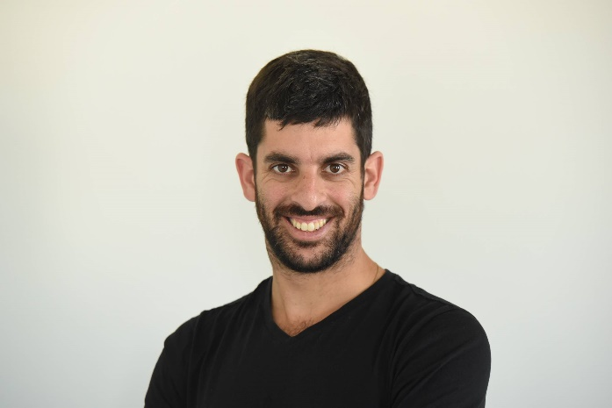

Imry Levy Sadan

**Contact details**:

054-7568111

[Imrysason@gmail.com](mailto:Imrysason@gmail.com)

Rehavia, Jerusalem

Year of birth: 1986

**A short prologue:**

The last year have been a year of c hanges in my life. I have left [journalism](https://news.walla.co.il/item/3064885), the profession that filled my world in the last four years, and [decided](https://www.the7eye.org.il/294632) to change direction to programming.

In the meantime, I have not been Idle. I have opened a small content writing business with a variety of clients, such as Israeli President, Reuven Rivlin (To whom I write speeches). I have also started to give [lectures about my experience as journalist](https://www.facebook.com/imry.sadan/videos/10216383768923293/) in academic institutions and pre-military schools. As a bachelor of literature on Hebrew University, I accepted the request of a friend, headmaster of a periphery school, and started to teach literature 3 hours a week in high school. I still write, and sometime [publish my words](https://hashiloach.org.il/%D7%A7%D7%99%D7%A0%D7%94-%D7%A2%D7%9C-%D7%94%D7%A4%D7%A1%D7%99%D7%9E%D7%99%D7%95%D7%AA/?fbclid=IwAR1q6AuMfkRpd6i7fDDY7ein7kthBHbW8047GD-r77RoPmhW-D-COzwE3t0).

With all this activities, my main and only goal is to be a software developer. What has begun has a pragmatic decision have become to passion. While studying in last four months I have found a fascinating world that literally, blow my mind. I believe, or hope, that my skills and experience – though belong to a different world – has a great deal of value in the programming world.

Anyway, this is the short version. In the next pages you will find the rest of it.

**Professional Experience:**

Currently: Lecturer, Speechwriter, Teacher, [Writer](https://www.makorrishon.co.il/culture/91319/), and [Blogger](https://imrysadan.com/). Recently graduated Web application programming course at John Bryce.

2018: [Spokesperson to the Minister of Public Security and Strategic Affairs, Gilad Erdan](http://www.ice.co.il/media/news/article/740609). The role involves developing a media strategy, building a public image and interacting with the political and media worlds. Promoting campaigns and initiatives in different media platforms. As part of this recent role, I have been exposed to many diverse types of content - security, politics, general public affairs, culture and more.

2016-2018: Journalist for Walla! News. The role involved reporting affairs relating to the State Comptroller, law affairs in Jerusalem, military law, [the Police Internal Investigations Department](https://news.walla.co.il/item/3118569) and the Civil Service Commission, in one of Israel's leading news sites.

The role also involved constant contact with senior officials in the law enforcement system, military and police as well as consistent interaction with the criminal and civil law systems and relevant factors in parliament and in the government.

The role required an ability to work under pressure, a quick understanding of people and situations, making contacts and working with PR, advertising and marketing firms as well as with an array of sources who contributed to or were the subjects of reporting. Additionally, apart from journalistic reporting, I also wrote [literary reviews](https://e.walla.co.il/item/3041217) and personal columns.

2015-2016: Legal journalist for the Jerusalem district and Jerusalem Municipality affairs for the [nrg website](https://www.makorrishon.co.il/nrg/online/1/ART2/642/125.html) and [Makor Rishon newspaper](https://musaf-shabbat.com/2015/11/15/%D7%91%D7%99%D7%9F-%D7%94%D7%9E%D7%90%D7%A4%D7%99%D7%94-%D7%9C%D7%93%D7%90%D7%A2%D7%A9-%D7%90%D7%9E%D7%A8%D7%99-%D7%A1%D7%93%D7%9F/). A journalist position which involved maintaining contacts with Israel’s highest law officials in the Ministry of Justice and required familiarity with the legal world, the practice of law and with parliamentary activities. Due to the fact that I was appointed to this position during a wave of terrorism, it was comprised of a combination of field work and in-depth investigations. During this period, I [also wrote](https://www.makorrishon.co.il/nrg/online/47/ART2/610/695.html) many [cultural reviews for TV shows](https://www.makorrishon.co.il/nrg/online/47/ART2/701/621.html), film and literature.

2014-2015: Head of the news desk for nrg website and Makor Rishon newspaper. The role involved editing texts, translating news from around the world and writing about culture and politics. As part of the role I was also a member of the new media team which operates nrg’s Facebook page and deals with identifying viral news items on international news websites.

2014: Jerusalem Municipality Spokesperson Unit. The role involved answering queries from local and national media outlets. Writing media announcements. Managing the municipality’s Facebook page.

2012-2013: Established and edited the student paper “[The Elders of Zion](https://he.wikipedia.org/wiki/%D7%96%D7%A7%D7%A0%D7%99_%D7%A6%D7%99%D7%95%D7%9F_(%D7%9E%D7%92%D7%96%D7%99%D7%9F))” in the Hebrew University of Jerusalem. As part of the managerial team I was responsible for the administrative and functional aspects including recruiting reporters, editing and writing.

2011-2014: Chairman of the Student Committee for the Department of Hebrew Literature at the Hebrew University (voluntary position).

Education:

2018-2019: Graduate "Programming and developing Web application" at John Bryce school. Full Stack course. Languages: DataBase – SQL, Server Side – C#, Client Side – AngularJS.

2014: Bachelor of Art in Hebrew literature and General Studies, GPA: 92, the Hebrew University, Jerusalem.

2014: Completed a workshop in acting by the Nissan Nativ School of acting in Jerusalem.

2007-2009: General Studies in the Open University, GPA: 92.

2005-2009: Hesder yeshiva program, Otniel (I am no longer religious).

2001-2004: Complete Matriculation Certificate (Bagrut), majored in computers and history, Misdrashiat Noam, Pardes Hanna.

Military service:

2006-2008: Combat soldier, Givati brigade, Tzabbar battalion (Hesder service).

Full reserve service.