**Name of Lesson Plan: What Day is It? Creative Ways to Remember the Day of the Omer**

**Lesson Information**

|  |  |
| --- | --- |
| Introduction of Lesson  (for lesson homepage and top of lesson) | The Counting of the Omer takes place throughout the 49 days between the holidays of Pesach and Shavuot. Charts, calendars, and counters were designed to help people keep track of the days of the Omer.  In this lesson, students learn about counting the Omer, discover and analyse various Omercounting aids from the NLI collections, and create their own counter. |
| Enduring Understanding | * The Omeris a 49-day period between Pesach and Shavuot. According to Jewish law, these days should be verbally counted, day by day. * Charts, calendars, and counters help people keep track of the days of the Omer and make sure they are counting the right day. |
| Learning Outcomes | * Students will be able to explain the practice of counting the Omer. * Students will compare different Omer counters. * Students will create their own Omer counter. |
| Age Group | * Primary school * Junior high |
| Length of Activity | * Two lessons |
| Materials, Equipment, and Preparations | * Printed copies of the resources and questions for the game * Printed copies of the Primary Source Comparison Table * Art materials for creating Omer counters |
| Primary Sources from the NLI Collections | * Omer Counter, 2009 <<http://rosetta.nli.org.il/delivery/DeliveryManagerServlet?dps_pid=IE42552661>**>** * Omer Chart In Prayer Book, 1793 <<http://beta.nli.org.il/en/images/NNL03_CJA700401712/NLI_CJA>**>** * Omer Calendar, 1966 <<http://beta.nli.org.il/en/images/NNL03_CJA700540926/NLI_CJA>**>** * Omer Book, Eighteenth Century <<http://web.nli.org.il/sites/NLI/English/digitallibrary/pages/viewer.aspx?&presentorid=MANUSCRIPTS&docid=PNX_MANUSCRIPTS000083268-1#|FL21976870>**>** |

**Lesson Plan**

**Lesson One**

1. **Introduction – What is the Omer?**

Introduce the concept of the Omer to the students. You can also use a video such as this one - https://youtu.be/oxxbS5P_jqw.

1. **Class Activity – Omer Quiz**

Play the game as a "Four Corner Activity".   
Read the questions from this question sheet <link to question sheet>.   
Each corner of the room is marked with a sign: A, B, C, and D.  
Students answer each question by standing in the appropriate corner.

1. **Group Activity – Analyse Various Omer Counting Aids**

* Divide the students into four groups.
* Each group visit four different stations in turn where they will analyse four images from the NLI collections.
* Students discuss the images using the worksheet provided and record what they have learned on the graphic organiser. (below)

**Lesson Two**

* + - 1. **Class Discussion – Review of Lesson One**
* What do you think the connection is between Pesach and Shavuot?
* Why do you think we count the days between the two holidays?
* What aids are there to help people count the *Omer* correctly?
* Which of the Omer counters that you looked at in the previous lesson did you like best? Why?
* If you were making a calendar, chart, or other aid for counting the Omer, what would you put on it?

**2. Creative Activity - Make an Omer counter**

* Design an aid for counting the Omer.
* Provide materials for students to make Omer counters. (Art teachers might be able to provide a variety of materials or have creative suggestions for materials that you can gather.) Students can also bring in materials from home.

**OR**

* In computerised classrooms, the students can create online products.

<logo>

**Omer Quiz** (Question and answers; correct answers in **bold**)

1. What is an Omer?
   1. A flower
   2. **A bundle of grain**
   3. An animal
   4. A tree
2. When is the Omer first counted?
   1. Shavuot
   2. 2nd night of Sukkot
   3. 2nd night of Chanukah
   4. **2nd night of Pesach**
3. How many days of the Omer are counted?
   1. **49**
   2. 52
   3. 7
   4. 26
4. What holiday is celebrated on the 50th day?
   1. Pesach
   2. Sukkot
   3. **Shavuot**
   4. Chanukah
5. What biblical event does Shavuot celebrate?
   1. Exodus from Egypt
   2. Entering the Land of Israel
   3. **Receiving the Ten Commandments**
   4. End of the flood
6. The Omer is a _______ time.
   1. Happy
   2. **Sad**
   3. Silly
   4. Scary
7. Lag B’Omer is celebrated on the _____ day of the Omer.
   1. 50th
   2. 13th
   3. 26th
   4. **33rd**
8. Lag B’Omer is a ____ day.
   1. **Happy**
   2. Sad
   3. Silly
   4. Scary

**Primary Source Comparison Table** <logo etc>

|  |  |  |  |  |  |  |
| --- | --- | --- | --- | --- | --- | --- |
| Station number | Name of Item | When was it made? | Where was it made? | Describe the item | How was it used? | Additional Comments |
| 1 |  |  |  |  |  |  |
| 2 |  |  |  |  |  |  |
| 3 |  |  |  |  |  |  |
| 4 |  |  |  |  |  |  |

<layout – logo>

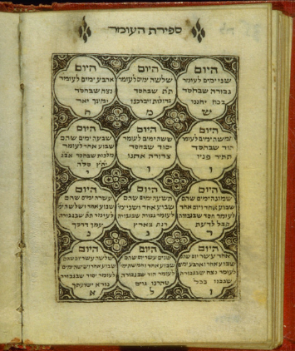

**Jerusalem Over Orah, Traveller’s Prayer Book, Amsterdam, 1793**

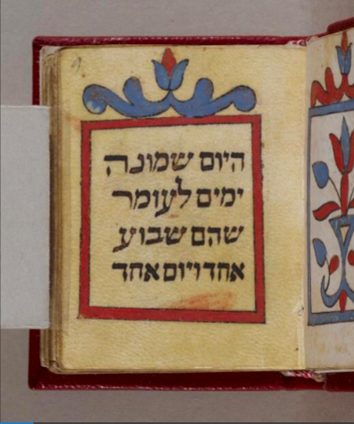

**Omer Book, Eighteenth Century**

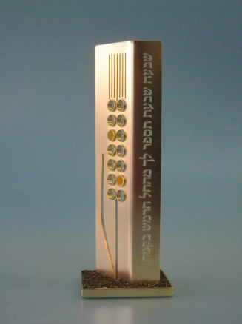

**Omer Counter, Israel, 2009**

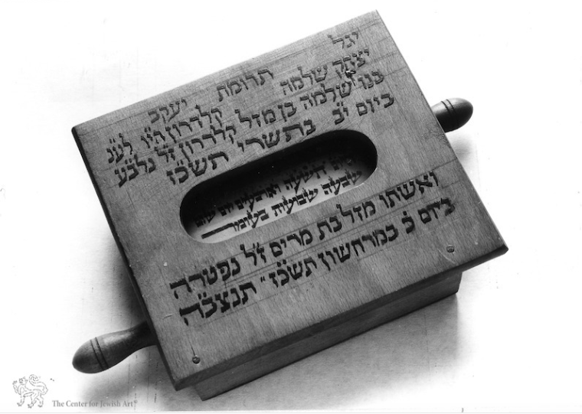

**Omer Calendar, Jerusalem, 1967**