**Title of Seminar:**

“**Issues of Jewish Authority Between the Geonim of Babylonian and Maimonides**” **–** Halakhic Codices at the Bodleian Library of Oxford as a Key for comprehension of the Jewish legal system

**Seminar leader or leaders**Neri Ariel (M.A., PhD expected summer 2018), Hebrew University, Talmud and halakha Dep. [neri.ariel@mail.huji.ac.il](mailto:neri.ariel@mail.huji.ac.il)

Wish to joining other scholars at Oxford working through similar topics in close research fields.

**Description of subject** Maimonides as a legal-halakhic and philosophical writer represents a continuation of the tradition established by the Babylonian Geonim. At the same time, he also transcends their halakhic erudition and philosophical scope. Already prior to Maimonides, Andalusian Rabbinic analysts such as the R. Isaac Ben Yehuda Ibn Ghiat (1038–1089 Lucen) began to compile and organise Geonic texts. This provided a base for the possible appraisal of materials from the Geonim and may provide an insight into the way Maimonides evaluated the traditional scholarship transmitted by his predecessors. This seminar will be providing scholars with a unique insight into Maimonides’ original understanding of these materials written in Judaeo-Arabic which he was consistently studying while preparing and presenting his Codex of Jewish Law. In several instances we will show how his interpretation of the Talmud, the core Halakhic and Philosophical materials, differs from that of his predecessors. Moreover, the writings of the latest Geonim, the school of Se’adiya Gaon, are critically examined and responded to later by Maimonides in his legal and philosophical work. This seminar will be giving the participants a deeper view into the halakhic writings and legal codices of Jewish Law composed by the Geonim and those Rishonim who were Maimonides’ contemporaries. The course will include methodologies and helpful tools that will help the scholars dealing with manuscripts in Judaic studies and will expose the scientific public to the enormously important treasures of the field that are at the disposal of the Bodleian library. Among the questions that will be discussed in the seminar is the role of Maimonidian thought in the creation of the Jewish legal system and we will make inquiries into the halakhic traditions with which he was confronted. It is very much known among scholars that Maimonides revolutionized decisively halakhic writing. However, in order to fully contextualize Maimonides innovation in the Halakhic tradition, one is well-advised to be intimately familiar with his contemporaries, his sources and his most influential writings, especially Mishneh Torah. The most impressive all copies preserved in Oxford as an Autograph signed by Maimonides himself (Mss. Hunt. 80). Emerging significance of philosophical texts (such asכתאב אלאמאנאת ואלאעתקאדאת/ Emunoth ve-Deoth – the book of Believes and Opinions by rav Seadia alFayyumi) and Halakhic-legal monographs of the late geonim) perfectly contributed to the highly sophisticated design of Maimonides holistic world. In his monumental work Mishneh-Torah Maimonides redesigned and corrected the Geonic system, rejected some of their ideas, and gave rise to the idea of a complete and scientific human understanding of the whole Jewish being.

**Methods to be used to take advantage of collaborative research**

Analytical Methodology to be undertaken through collaborative research into the materials found in the Oxford University library is to work in a group of scholars to interpret text materials and to see what the texts actually say about this "betweenness" by close reading of selected materials in weekly seminars and common writing. We would like to examine Hilkhot Mamrim in comparison to the remnants of Kittāb adab AlQadā to Rav Hai Ibn Shrira Gaon also found in The Bodleian Libraries, University of Oxford, Ms. Marsh 509).

**Possibilities for innovation through the research project**

Examining how issues might be dealt with by contrasting Geonic and Maimonides varied texts and the consequences of the different approaches. This epoch has not yet been a central issue for collaborative research in the field due to lack of technological tools at the disposal of scholars these days (e.g. <http://bav.bodleian.ox.ac.uk/> and <http://web.nli.org.il/sites/NLIS/en/ManuScript/>; <https://fjms.genizah.org/>). The research into the Judaeo-Arabic monumental works of these leading and authoritative authors will exemplify how Jews yielded their own authority under Islamic concur and still lived in political peace and reciprocal learning relationships with their Arab neighbors.

**Reasons why Oxford is particularly appropriate as the venue for the seminar** Oxford provides scholars with a unique series of text materials and one of the best research facilities and scholars in Europe. It has in the past hosted some of the most challenging seminars of interest to students and scholars of Jewish text and history that Jewish life has confronted. The rare codices that are under discussion are nowadays available online indeed. However, the time I spent in Oxford in the past as a Polonsky fellow showed that the physical accessibility is not fully substitutable and many details such as water signs and other components concerning the materiality of the manuscript can be properly research only by direct exposing the individual subject to the real being of the object.

**Value of the Seminar for the development of Jewish Studies as an academic subject**The possible value of the proposed seminar will deepen scholarship into key epochs in diaspora Jewish life and some of the early scholars and leaders of Judaism whose teachings, texts and thinking have contributed significantly to contemporary Jewish knowledge and the evolution of core ideas.

**Names of scholars who might be invited to participate in the project**

Prof. Robert Brody (Jerusalem, Hebrew University); Prof. Mark Cohen (Princeton University); Prof. Nahem Ilan (Independent scholar); Prof. Tal Ilan (Freie Universität Berlin); Prof. Mordechai A. Friedman (Tel-Aviv University).

Thanking you in advance

and with my very best regards,

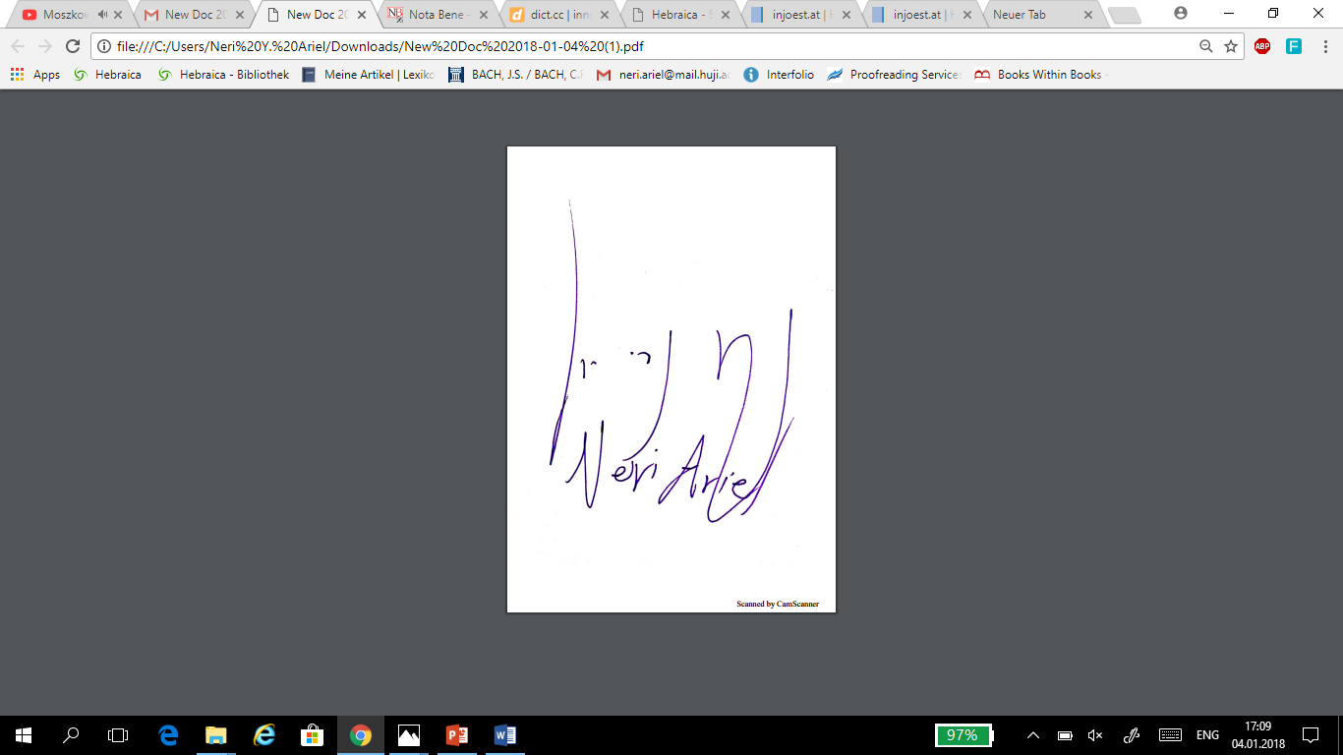

the body of my Application E-mail must be proofed as well>> [registrar@ochjs.ac.uk](mailto:registrar@ochjs.ac.uk)

Dear and Honored Committee,

Dear Colleauges,

Attached is my CV and requested proposal for Seminar in Advanced Jewish Studies that I wish to give in Oxford 2020.

I hope I understood the call for application correctly, and maybe there is no specifying of Professorship needed. However, it might indeed meant to be referred to senior scholars and prestigious professors in the field of Judaic studies. If I was wrongly with my exaggerated aspirations, please forgive me and do not interpret it as arrogance or ignorance. If this is the case, maybe you would generously helping me by recommending on another frame that this seminar proposal could fit into.

However, I did my best to formulize a suggestive proposal and maybe you will find this field of research fascinating and worth more thought and inquiry. If there will be need for addendum and corrigendum i.e. decelerations I will be very honored to do so, or to resubmit an updated and revised proposal by the next term, following your helpful instructions.

Maybe there is a possibility to join other scholars that are working on similar topics, I am quite flexible and open for different types of collaborations. I would be most grateful if you could provide me with the necessary information and would be able to advise me the best way to improve my work in order to be privileged to be working with you in the most possible close future.

With my very best regards and wishes,

Neri Yeshayahu Ariel

Talmud and Halakha Dep.

Hebrew University of Jerusalem