Dental  Supports localized hemostasis and wound healing.  Our pills based on our proprietary formula supports dentists in stopping bleeding and wound healing during dental surgery interventions. | 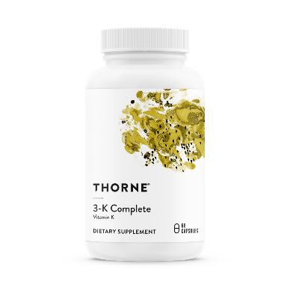

Product Quality:
Hemofix dental capsules are based on our proprietary formula made out of 100% natural ingredients. A symbol of our high product quality is the prestigious receipt of approval from the Helsinki committee to use our products for human clinical trials, only possible due to our careful manufacturing process and purity of our ingredients.
Collagen Hemostatic Properties:
Hemofix dental serves as a natural hemostatic agent stemming blood flow at the site of injuries.¹ The bioactive compounds within the Hemofix ingredients are believed to stimulate collagen synthesis, important for the first step in hemostasis.^{2,3} Collagen exposed at the injured site promotes platelet adherence to the damaged endothelium, forming a plug to stop the blood flow.⁴
Localized hemostatic agents for Patients with anticoagulants:
Patients who use anticoagulant drugs are at risk of excessive bleeding following dental surgery such as tooth extraction. Products that provide a localized hemostatic agent can stem and even prevent bleeding in such situations. Recent research on 200 patients using anti coagulants showed that the use of a localized hemostatic agent, in this case collagen sponges in fresh dental extraction events, resulted in the stemming of bleeding without needing to pause anticoagulant therapy.⁵

Hemofix dental can be used for the following dental interventions:
- Tooth extraction
- Dental implants (implantology)
- Bleeding gums after dental surgery (porcelain veneers)
- Periodontal surgery

Scientific Citations
1. Dudzinska D, Bednarska K, Boncler M, Luzak B, Watala C. The influence of Rubus idaeus and Rubus caesius leaf extracts on platelet aggregation in whole blood. Cross-talk of platelets and neutrophils. Platelets. 2016;27(5):433-439.
2. Mo J, Panichayupakaranant P, Kaewnopparat N, Nitiruangjaras A, Reanmongkol W. Wound healing activities of standardized pomegranate rind extract and its major antioxidant ellagic acid in rat dermal wounds. Journal of natural medicines. 2014;68(2):377-386.
3. Gao W, Wang YS, Hwang E, et al. Rubus idaeus L. (red raspberry) blocks UVB-induced MMP production and promotes type I procollagen synthesis via inhibition of MAPK/AP-1, NF-kappabeta and stimulation of TGF-beta/Smad, Nrf2 in normal human dermal fibroblasts. Journal of photochemistry and photobiology B, Biology. 2018;185:241-253.
4. Mukherjee G, Chatterjee GC, Banerjee D, Bhattacharya DK. Differential effect of retinoic acid on ADP and collagen induced platelet aggregation. Indian journal of experimental biology. 1990;28(10):949-952.
5. Zirk M, Fienitz T, Edel R, Kreppel M, Dreiseidler T, Rothamel D. Prevention of post-operative bleeding in hemostatic compromised patients using native porcine collagen fleeces-retrospective study of a consecutive case series. Oral and maxillofacial surgery. 2016;20(3):249-254.

