Femme  Supports recovery from and shortening of menstrual related bleeding.  Our pills based on our proprietary formula supports healing of uterus and shortening menstrual related bleeding. | 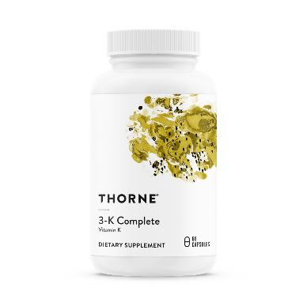

We have developed a proprietary method to process, combine and join together plant-based ingredients that promote cellular health and blood circulation.
The natural circulation-boosting properties of its specially-formulated ingredients allow for faster healing and restoration of connective tissue due to improved blood flow. This is enabled by bioactive molecules in Hemofix’s ingredients which promote better communication between cells in blood vessel walls.¹ Greater control of blood flow, allows improved access of healing tissues to the bloodstream. Some of the ingredients in Hemofix also inhibit the inflammatory compounds and prostaglandins which are associated with abnormal uterine bleeding.^{2,3} Reduced blood loss means lowered risks for anemia and better delivery of nutrients to cells throughout the recovering, and potentially lactating, body.
By promoting blood circulation, Femme supports proper blood circulation and would healing. Femme helps address the following medical conditions:⁴
- Menstrual related bleeding.
- Bleeding related to post cesarean surgery.
- IUD (Intrauterine device) related bleeding.

Scientific Citations:
1. Wang D, Ozen C, Abu-Reidah IM, et al. Vasculoprotective Effects of Pomegranate (Punica granatum L.). Frontiers in pharmacology. 2018;9:544.
2. Mobli M, Qaraaty M, Amin G, Haririan I, Hajimahmoodi M, Rahimi R. Scientific evaluation of medicinal plants used for the treatment of abnormal uterine bleeding by Avicenna. Archives of gynecology and obstetrics. 2015;292(1):21-35.
3. Goshtasebi A, Mazari Z, Behboudi Gandevani S, Naseri M. Anti-hemorrhagic activity of Punica granatum L. flower (Persian Golnar) against heavy menstrual bleeding of endometrial origin: a double-blind, randomized controlled trial. Medical journal of the Islamic Republic of Iran. 2015;29:199.
4. Jung E, Jung W, Park SB, Kim CS, Kim JS, Kim J. EGHB010, a Standardized Extract of Paeoniae Radix and Glycyrrhizae Radix, Inhibits VEGF-Induced Tube Formation In Vitro and Retinal Vascular Leakage and Choroidal Neovascularization In Vivo. Evidence-based complementary and alternative medicine : eCAM. 2017;2017:1568702.

