Anal Fissures & Hemorrhoids  Supports healthy blood vessels and healing of rectal related conditions.  Our pills based on our proprietary formula supports women and men in improving blood circulation and thus wound healing and relaxing of blood vessels. | 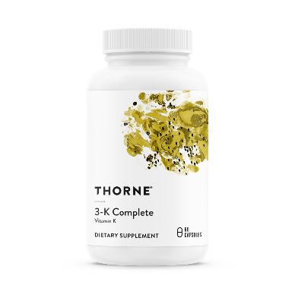+ Cream

Hemorrhoids and anal fissures are highly painful conditions which can be difficult to treat. In addition to an unhealthy diet, poor circulation is a major contributing factor to both conditions. Development of hemorrhoids is linked to chronic constipation, straining during bowel movements, and prolonged sitting on the toilet, all of which lead to poor blood flow to and from the area. Blood becomes pooled and causes the blood vessels to expand and become inflamed.
Modern treatments for hemorrhoids mainly consist of creams or suppositories with various active ingredients. Creams with lidocaine/benzocaine or hydrocortisone provide instant short-term relief from the pain and itching but do nothing to get rid of the hemorrhoids themselves. Phenylephrine, another common ingredient, is a vasoconstrictor and shrinks the blood vessels in the affected area; however, this still does not address the underlying poor circulation. Treatment of more severe cases often requires invasive clinical procedures or surgery.
The bioactive molecules in the Hemofix ingredients regulate the function of the endothelial cells that line blood vessels. By stimulating the blood vessel walls to relax, greater blood flow is enabled and blood can move out of problem areas at a greater rate.¹⁻⁴ Hemofix pills and creams have had great success in relieving these problems, and many people have been helped by our products. Patients who were near the point of requiring surgery to repair anal fissures were spared such an invasive procedure by using Hemofix pills and cream.
Scientific Citations
1. Wang D, Ozen C, Abu-Reidah IM, et al. Vasculoprotective Effects of Pomegranate (Punica granatum L.). Frontiers in pharmacology. 2018;9:544.
2. Chao DP, Chen JJ, Huang SY, Tyan CC, Hsieh CL, Sheen LY. Effects of hot and cold foods on signals of heart rate variability and nail fold microcirculation of healthy young humans: a pilot study. The Chinese journal of physiology. 2011;54(3):145-152.
3. Amiri Behzadi A, Kalalian-Moghaddam H, Ahmadi AH. Effects of Urtica dioica supplementation on blood lipids, hepatic enzymes and nitric oxide levels in type 2 diabetic patients: A double blind, randomized clinical trial. Avicenna journal of phytomedicine. 2016;6(6):686-695.
4. Naderi Z, Mozaffari-Khosravi H, Dehghan A, Nadjarzadeh A, Huseini HF. Effect of ginger powder supplementation on nitric oxide and C-reactive protein in elderly knee osteoarthritis patients: A 12-week double-blind randomized placebo-controlled clinical trial. Journal of traditional and complementary medicine. 2016;6(3):199-203.

