Hemo Pro  Supports healthy blood vessels and supports external and internal wound healing.  Our pills based on our proprietary formula supports women and men suffering from bleeding events related to poor blood circulation. | 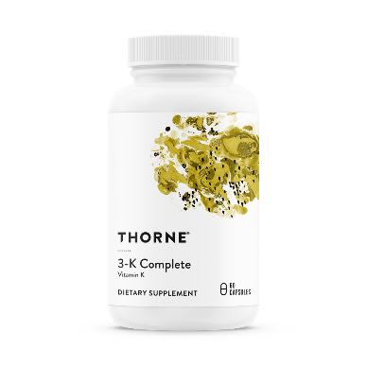

We have developed a proprietary method to process, combine and join together plant-based ingredients that promote cellular health and blood circulation.
Extracts from these plants contain bioactive molecules that modulate the secretion of nitric oxide, cell surface molecules, and other compounds that regulate the endothelial cells that line blood vessels.^{1,2} The downstream effects from these biomolecules induce blood vessel relaxation, promote lower blood pressure, and support increased blood flow.^{3,4} Many of these herbs have been used in traditional medicine because they had been known for some time to promote cardiovascular health.⁵
By promoting blood circulation, our formula supports wound healing and proper blood circulation and help address the following medical conditions:⁶
- Menstrual related bleeding.
- IUD (Intrauterine device) related bleeding.
- Healing wounds of diabetic patients.
- Macular edema.
- Glaucoma.
Scientific Citations
1. Amiri Behzadi A, Kalalian-Moghaddam H, Ahmadi AH. Effects of Urtica dioica supplementation on blood lipids, hepatic enzymes and nitric oxide levels in type 2 diabetic patients: A double blind, randomized clinical trial. Avicenna journal of phytomedicine. 2016;6(6):686-695.
2. Naderi Z, Mozaffari-Khosravi H, Dehghan A, Nadjarzadeh A, Huseini HF. Effect of ginger powder supplementation on nitric oxide and C-reactive protein in elderly knee osteoarthritis patients: A 12-week double-blind randomized placebo-controlled clinical trial. Journal of traditional and complementary medicine. 2016;6(3):199-203.
3. Teede HJ, McGrath BP, DeSilva L, Cehun M, Fassoulakis A, Nestel PJ. Isoflavones reduce arterial stiffness: a placebo-controlled study in men and postmenopausal women. Arteriosclerosis, thrombosis, and vascular biology. 2003;23(6):1066-1071.
4. Kolodziejczyk-Czepas J, Sieradzka M, Wachowicz B, Nowak P, Oleszek W, Stochmal A. The anti-adhesive and anti-aggregatory effects of phenolics from Trifolium species in vitro. Molecular and cellular biochemistry. 2016;412(1-2):155-164.
5. Wang D, Ozen C, Abu-Reidah IM, et al. Vasculoprotective Effects of Pomegranate (Punica granatum L.). Frontiers in pharmacology. 2018;9:544.
6. Jung E, Jung W, Park SB, Kim CS, Kim JS, Kim J. EGHB010, a Standardized Extract of Paeoniae Radix and Glycyrrhizae Radix, Inhibits VEGF-Induced Tube Formation In Vitro and Retinal Vascular Leakage and Choroidal Neovascularization In Vivo. Evidence-based complementary and alternative medicine : eCAM. 2017;2017:1568702.

