Title: **Determine veins ectasia is relevant to treat Brain AVMs?**

**Other options of title:**

1) Inter and Intra-observer Variability in the Assessment of Dilated Veins: 57 cases treated by endovascular venous approach of Brain Arteriovenous Malformation.

2) Angiographic evaluation of inter-observer concordance for dilated veins in 57 cases of Brain AVM’s, treated by venous approach.

3) Angiographic evaluation of inter-observer concordance for dilated veins in Brain AVM’s. Study of 57 cases which were embolized by venous approach.

4)Inter and Intra-observer Variability in the Assessment of Dilated Veins: 57 cases treated by endovascular venous approach of Brain Arteriovenous Malformation.

Abstract:

ABBREVIATIONS: Brain arteriovenous malformations (B-AVMs); EVT Endovascular treatment; TVA Transvenous approach; DSA digital subtraction angiography;

**Introduction:**

Brain arteriovenous malformations (B-AVMs) are congenital lesions with atypical vascular shunts in the central nervous system, which involves an connection between one or multiple feeding arteries and draining veins that bypass the normal capillary1.

The incidence is estimated at approximately 1 per 100,000 per year in unselected populations, and the point prevalence in adults is 18 per 100 000 with the mean age at diagnosis around 35 years, affecting both sexes equally2,3,4. Usually discovered in the search of intracranial hemorrhage, epilepsy, chronic headache, and focal neurologic deficits without bleeding correlation.

There are some angio-architectural risk factors for hemorrhage. These include age, associated aneurysm, venous outflow stenosis, AVMs size, AVMs location, deep venous drainage5,6,7. Impairment of venous drainage of an AVMs has been shown to be significantly associated with risk of hemorrhage8,9.

Currently there are three different alternatives for the treatment of brain AVMs: neurosurgery, radiosurgery and endovascular treatment EVT. Regardless of, in which will be the treatment generally is complex and could be multidisciplinary2.

The aim of this study is the retrospective angiographic analysis of venous ectasia in brain arteriovenous malformations, in patients that were embolized by endovascular technique EVT at least one session of venous approach TVA and apply the results of the inter correlation between those interpretations, for the implications of treatment the B-AVMs.

**Materials and Methods:**

**Patient Demographics and Clinical Presentation**

This Institutional Review Board of our University Hospital, at Limoges France, approved this study. Informed consent was obtained from all patients before intervention. We retrospectively evaluated the medical records of 57 patients with intra cranial AVM, who underwent endovascular treatment (at least one session by venous approach), between February of 2008 and July of 2019. This sample concerned about the analysis of venous ectasia, were independently reviewed by 3 senior interventional neuro-radiologists.

The analysis of the dilated veins was made by a rigorous selection of DSA images, which was realized for each patient immediately before the treatment. The parameter adopted to evaluate the dilated veins, was the referential pattern of the vessel, that was 2 times smaller compared with contra-lateral side. The images were showed for the evaluators by a way of questionnaire which was all the selected images, with a time setting around 2 min for each answer. Raters were isolated during the realization of the survey, and the analysis of the images weren’t not known between them.

Differences in proportions were assessed by Fisher’s exact test, to describe the correlation between dilated veins and hemorrhage complications, for all evaluators. Each analysis was individualized, comparing the rates if it had significance or not.

Interobserver agreement between interventional neuroradiologists on the interpretation of images was measured using the kappa statistic test, based on the answers that each of them gave, after the questionnaire.

**Statistical analysis**

The software used for statistical analysis was R® version 3.6.1 package for Mac®, 2019 and Microsoft excel® software package for Mac®, 2019. Descriptive analysis was made to characterize the sample. Quantitative variables were expressed as mean ± standard deviation (SD). And qualitative variables were expressed as frequency and percentage values.

Fisher’s exact test (two-sided) was used to compare the categorical variables (univariate analysis).

Kappa statistic test was used for categorical agreement between observers. The value for interobserver rating describes the accord between the evaluators if the vein were dilated or not, which values could be defined as <0.4 slight agreement, 0.41- 0.8 moderate agreement and >0.81 very good agreement

The association between variables was considered significant when P-value was < 0.05.

**Results**

***Description of data***

The mean age of 57 treated patients was 38.5 years (range, 9-78 years), with 28 females and 29 males. The initial clinical presentation was secondary to rupture bleeding in 38 patients (66%). Of the 57 AVMs treated, 37(64.9%) had just 1venous collector, 18 (31.6%) with 2 collectors and 2(3.5%) with more than 3 collectors. In this sample of 57 patients, 21(37%) were located in the left hemisphere, 15(26.5%) right cerebral hemisphere, 1(1.5%) corpus callosum, 6(10.5%) thalamus, 3(5%) mesencephalon, 1(1.5%) commissural, 5(9%) in the striatum and 5(9%) in the cerebellum ***(Table1)***. Deep venous drainage was present in 16(28%) AVMs. According with the Spetzler-Martin classification, the 57 AVMs were classified as grade I 5(9%), II 18 (31.5%), III 23(40.5%), IV 10(17.5%) and as grade V 1(1.5%) ***(Table 2)***. The patients analyzed were embolized by venous approach, at least 1 session, those patients who had treated in just one session was 31(55%), in 2 sessions 16 (28.5%), 3 sessions 4 (7%), 4 sessions 2 (3%), 5 sessions 3 (5%) and just one Patient (1.5%) was treated in 6 sessions.

|  |  |
| --- | --- |
| Locations of B-AVM |  |
| *Location* | *No. (%)* |
| *Hemisphere*  Right  Left  *Comissural*  *Deep brain*  Corpus Callosum  Thalamus  Striatum  *Brain stem*  Mesencephalon  *Cerebellum* | 21 (37)  15 (26.5)  01(1.5)  01 (1.5)  06 (10.5)  05 (9)  03 (5)  05 (9) |

|  |  |
| --- | --- |
| Spetzler-Martin Grade | *No. (%)* |
| I  II  III  IV  V | 05 (9)  18 (31.5)  23 (40.5)  10 (17.5) |

**Table 2** Spetzler-Martin classificationof the total 54 AVM treated**.**

**Intra and interobserver agreement**

After the questionnaire realized for the evaluators were found different results about the analysis of dilated veins between them. With regard the statements about dilated veins, the first evaluator had a total of 24 cases (42.1%), the second 28 (49.1%) and the last one 36 (63.1%). For all evaluators the number of hemorrhage complications associated with dilated vein, were 8 patients (14%) those 6 (10.5%), have being considered dilated veins.

***Table 1*** Localization of Brain AVM treated with TVA

The correlation between dilated veins and hemorrhage complications, were described by Fisher’s exact test in each of the 3 analysis and the comparing rates show no significance with bleeding complications. All the three evaluators had p-value > 0.05, with an odd ratio and a confidence interval correspondent with no significance ***(Table3*)**. In accord with that, when the same Fisher’s test was utilized to make the correlation between no dilated vein and previous rupture, was found significance for all evaluators. If we took each one apart we gone found a p=0.001367 for the first, p=0.01194 for the second and p=0.003843 for the third ***(Table4)***.

|  |  |  |  |
| --- | --- | --- | --- |
| **Fisher’s test analysis: dilated veins and hemorrhagic complications** |  |  |  |
| ***Evaluator 1***  ***Evaluator 2***  ***Evaluator 3*** | ***P-value***  0.0587  0.1443  0.6966 | ***Odds Ratio***  5.0161  3.6016  1.8801 | ***Confidence interval (%)***  0.78 - 55.87  0.57 - 39.94  0.29 - 20.91 |

**Table 3** Fisher’s test analysis between all Evaluators, concerning dilated veins and hemorrhage risk factor.

|  |  |  |  |
| --- | --- | --- | --- |
| **Fisher’s test analysis: no dilated veins and previous AVM rupture** |  |  |  |
| *Evaluator 1* | ***P-value***  0.001367 | ***Odds Ratio***  0.1331 | ***Confidence interval (%)***  0.029 - 0.51 |
| *Evaluator 2* | 0.01194 | 0.2145 | 0.049 - 0.79 |
| *Evaluator 3* | 0.00384 | 0.1217 | 0.012 – 0.62 |

Table 4 Fisher’s test analysis between all Evaluators, concerning no dilated veins and AVM previous rupture risk.

In the sample of 57 patients, we had few examples of dilated veins (figure 1) that Evaluators didn’t have doubt to answer and was the same for all. But there were cases which the answers were divergent (figure 2), and in those cases the Kappa Statistic test, which described the combination of the answers of inter-observer analysis, was well employed.

Kappa’s statistics test made a combination between 2 evaluators separately, and all of those combinations had a moderate agreement, in other words K (0.41 – 0.8). The first combination was among Evaluator 1 and 2 K (0.5074), then it was compared Evaluator 1 with 3 resulting K (0.4610) and the last one balanced the second and the third Evaluator was found K (0.4412).

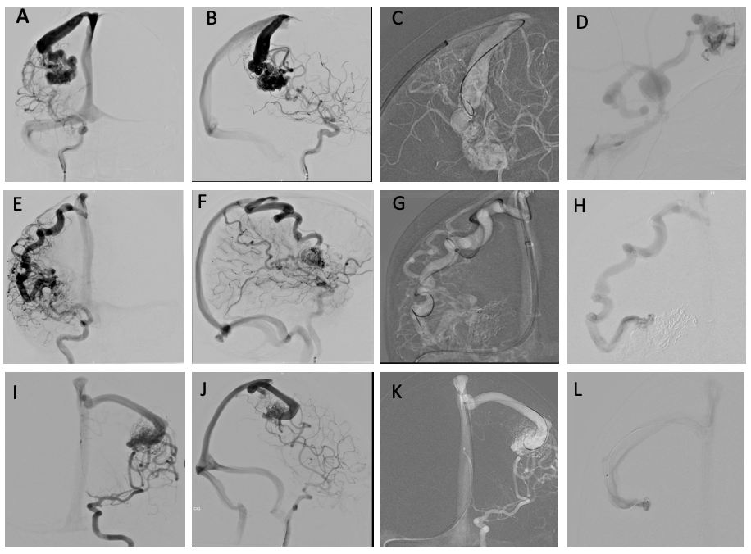**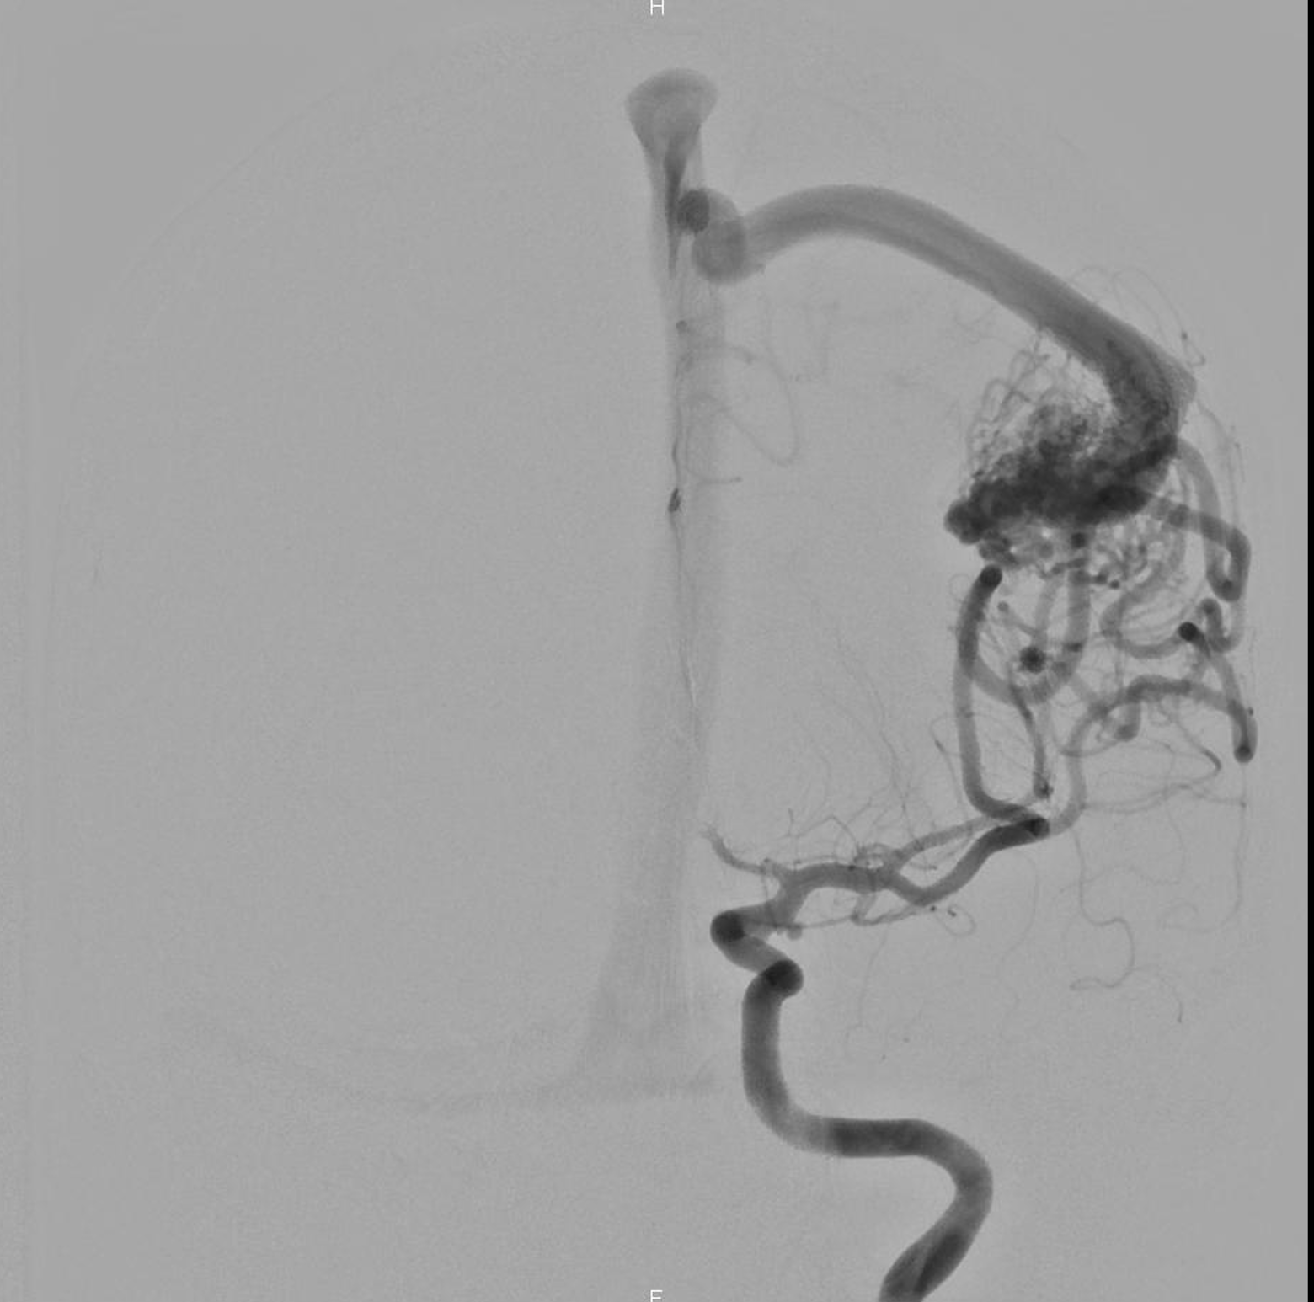Figure 1) *1) CASE:*** *37)* S.G.H, 29, M, A and B are Antero posterior and lateral view respectively with internal carotid artery injection, showing the venous time with well visualized dilated **right parietal cortical vein;** C work projection to venous approach; D super-selective venous injection by the microcatheter.***2) CASE: 29 )*** G.S, 51, M E and F are Antero posterior and lateral view respectively with internal carotid artery injection, showing the venous time with well visualized dilated **right frontal cortical vein;** G work projection to venous approach; H super-selective venous injection by the microcatheter.***3) CASE: 18 )*** F.M, I and J are Antero posterior and lateral view respectively with internal carotid artery injection, showing the venous time with well visualized dilated **right parietal vein**; K work projection to venous approach; L super-selective venous injection by the microcatheter.

**Figure 1) *1) CASE: 12 )*** L.R, 64,M A and B are Antero posterior and lateral view respectively with internal carotid artery injection, showing the venous time with well visualized normal **frontal cortical vein;** C work projection to venous approach; D super-selective venous injection by the microcatheter.***2) CASE: 29 )*** G.S, 51, M E and F are Antero posterior and lateral view respectively with internal carotid artery injection, showing the venous time with well visualized dilated **frontal cortical vein;;** G work projection to venous approach; H super-selective venous injection by the microcatheter.***3) CASE: 18 )*** F.M, I and J are Antero posterior and lateral view respectively with internal carotid artery injection, showing the venous time with well visualized dilated **frontal cortical vein;**; K work projection to venous approach; L super-selective venous injection by the microcatheter.

**Discussion**

Intracranial AVMs are a cerebrovascular pathology that have a cumulative risk of functional disability or death due to intracranial bleeding and refractory epilepsy. Meanwhile they may also be asymptomatic for extended periods or never manifest any clinical symptoms.

The treatment of brain AVMs is complex and involves different techniques, such as endovascular embolization EVT (basically arterial and venous approach TVA), neurosurgery, radiosurgery, and sometimes the association between them2.

The development and rupture of AVMs is a multifactorial and multistage process, which could be considered since the impairment of embryonal vasculogenesis to the correlation between the phenomena in the characteristics of B-AVM angioarchitecture which conduce with Hemodynamic changes10,11,12.

“Angioarchitecture” describes the morphology internal structure and other characteristics of blood vessels13. To understand, such anatomy, is often difficult also because of the tangled aspect of the vessels, which are comprising the nidus and surrounding the arteries and veins, given an aspect of Anamorphosis14. A precise recognition of the different components which constitute the B-AVMs angioarchitecture, have an enormous importance for planning the treatments, reduce the complications related with the procedure and also could anticipate a treatment in some cases, avoiding a possible rupture. Especially in those, which have some characteristics that have already been defined as correlated with hemorrhage: as deep venous drainage, intranidal aneurysm, size of the nidus, stenotic venous drainage, AVM location13,15,16,17. Our goal is to emphasize the dilated veins as an important factor to be identified before selecting any patient to treat intracranial AVM.

All the Evaluators used the same method to determine if the vein was dilated or not, the principal vein collector nearest of the nidus was compared with a normal size vein in the same topography of the contra-lateral side, this difference should be the double of the “normal” size to be considered dilated. In the sample of 57 patients, we had examples of dilated veins (figure 1) that Evaluators didn’t have doubt to answer and was the same for all. But there were cases which the answers were divergent (figure 2), and in those cases, the Kappa Statistic test which described the combination of the answers of inter-observer analysis, was employed.

The term Angiomatous change was defined by Michael P. Marks et all15, that represents multiple dilated vessels that feed and were recruited by the AVM nidus, which consists of arterioles that shunt directly into venous loops is a passive vascular system in which the rate of blood flow is pressure dependent15,18. The angiomatous aspect is evident when the pressure of the arterial pedicle or the venous collector is not regular, means that in an AVM which the arterial feeder has the low pressure, the nidus needs to recruit other feeders, as the cortical branches for example, to normalize the pressure and this reversal of pressure gradient, increase the rates of hemorrhage15. In the same way, when we have an AVM with a collector vein that is not dilated, the rate of the pressure become higher, instead low as usual. In the same point of view, *Nornes and Grip*19 define that as the flow is directly related to the pressure decrease along the length of a tube according to the equation Poiseuille/Hagenbach extension). This equation means that the pressure decrease along the length of a tube and the pressure on the vessels of an AVM nidus are directly related to the length of the artery supplying the AVM15,19.

When we analyze microscopically the walls of the vein in a ruptured AVM, there are few alterations which is evident the results of mechanical impact disorders, caused by hemodynamic flow changes into the angio-architecture10. Researchers have found the preferred orientation of collagen fibers is in the direction of vessel stretch20. The normal aspect of the collagen fibers arrangement is formed in a symmetric spiral, with the disease evolution this configuration is often damaged. The exposition by turbulence, disturbs the direction of flexibility of the vessel wall and effects of stretch; this could be causes a disordered arrangement of collagen fibers and weakness10. The main cause of the fragility of the wall, could be by the fibrous repair, which have the hyperplasia of type I and Type III collagen with disordered arrangement. The advantage of this process is to fill in the defects, and the maintain the integrity of the vessel wall, such a phenomena adaptive of the disease10.

Our results showed no significance correlation between dilated veins and hemorrhagic complications, during and after the TVA, we analyzed the images of the veins immediately before the procedure **(Table 3).** If we took in account about hemodynamics and pathological alterations as the physiopathology of AVM, our results is in the same direction, therefore the dilated vein is a phenomena adaptive of the disease is part of progressive evolution. In the other hand, with the same Fisher’s test was also used to compare NO dilated veins and previous rupture for each Evaluator and was found significance for all analyzes **(Table 4).** Therefore, if we take into account our statistical results and what were already described in the literature, about B-AVMs physiopathology, we could have a causal link to point our hypothesis, which is founded on dilated veins support the idea as protective factor of spontaneous rupture.

Limitations of the study

The study is subject to limitations due to the small number of cases because represents a single center’s experience with curative embolization strategies for AVMs, and with at least one session of TVA, consequently decreased the sample. The analysis of data has been done retrospectively. The images could be analyzed using the protocols of 4D injections21 and reconstructions, provide by Siemens® software, to better define the size and the number of the veins which are nearest of the nidus. This method is usually used during the AVM embolization in our service. But by contrast, one of the purposes of this study is provide the angioarchitectures knowledge with the DSA images as a useful tool, especially for the services which don’t have the option of 4D technology and select correctly the B-AVM case for treatment.

As pioneers of the idea that identify dilated veins are an important subject to take into account, in B-AVMs patients, before the decision to make a treatment, our group are constantly arranged to pursue a line of research in AVM treatments.

**Conclusion**

The advent of novel technologies in the neuro interventional field contributes [increasingly](https://www.linguee.com/english-portuguese/translation/increasingly.html) the development in the treatment of B-AVM. The complex physiopathology rends the options even more challenging, that’s why new information about the disease are extremely important. Our statistical analysis in identify a venous ectasia in a B-AVM allows us support the idea as protective factor of spontaneous rupture. As with other new researches, multi centric and larger clinical series will be needed to determine reproducibility and validation of potential benefits.

REFERENCES:

1. Alqadi M, Brunozzi D, Linninger A, et al. Cerebral arteriovenous malformation venous stenosis is associated with hemodynamic changes at the draining vein-venous sinus junction. *Med Hypotheses* 2019;123:86–8.

2. Abud DG, Riva R, Nakiri GS, et al. Treatment of brain arteriovenous malformations by double arterial catheterization with simultaneous injection of Onyx: Retrospective series of 17 patients. *Am J Neuroradiol* 2011;32:152–8.

3. Al-Shahi R, Warlow C. A systematic review of the frequency and prognosis of arteriovenous malformations of the brain in adults. *Brain* 2001;124:1900–26.

4. Berman M, Sciacca RR, Pile-Spellman J, et al. The epidemiology of brain arteriovenous malformations. *Neurosurgery* 2000;47:389–97.

5. Mohr JP, Kejda-Scharler J, Pile-Spellman J. Diagnosis and treatment of arteriovenous malformations topical collection on stroke. *Curr Neurol Neurosci Rep* 2013;13:1–7.

6. Ivanov AA, Alaraj A, Charbel FT, Aletich V AS. Recurrence of cerebral arteriovenous malformations following resection in adults: does preoperative embolization increase the risk? *Neurosurgery* 2016;78(4):562–71.

7. Ding D, Liu KC. Predictive Capability of the Spetzler-Martin versus Supplementary Grading Scale for Microsurgical Outcomes of Cerebellar Arteriovenous Malformations. *J Cerebrovasc Endovasc Neurosurg* 2013;15:307.

8. Miyasaka Y, Yada K, Ohwada T, et al. An analysis of the venous drainage system as a factor in hemorrhage from arteriovenous malformations. *J Neurosurg* 1992;76:239–43.

9. Alexander MD, Cooke DL, Nelson J, et al. Association between Venous Angioarchitectural Features of Sporadic Brain Arteriovenous Malformations and Intracranial Hemorrhage. *AJNR Am J Neuroradiol* 2015;36:949–52.

10. Hongchuan N, Yong C, Xuejiang W, et al. Relantionships between hemorrhage, collagen of arteriovenous malformations. *Neurosci Bull* 2012;28:595–605.

11. Niu H, Cao Y, Wang X, et al. Relationships between hemorrhage, angioarchitectural factors and collagen of arteriovenous malformations. *Neurosci Bull* 2012;28:595–605.

12. Scimone C, Donato L, Marino S, et al. Vis-à-vis: a focus on genetic features of cerebral cavernous malformations and brain arteriovenous malformations pathogenesis. *Neurol Sci* 2019;40:243–51.

13. Willinsky R, Lasjaunias P, Pruvoust P. Malformations arterio-veineuses cerebrales; analyse de l’angio-architecture chez des patients ayant present un accident hemorragique. *J Neuroradiol* 1988;15:225–37.

14. Clarençon F, Maizeroi-Eugène F, Maingreaud F, et al. Interest of convex spherical anamorphosis in better understanding of brain AVMs’ angioarchitecture. *J Neurointerv Surg* 2016;8:959–64.

15. Marks P, Steinberg K. Hemorrhage Malformations : in Intracerebral Angiographic Arteriovenous Determinants. *Radiology* 1990. [Epub ahead of print].

16. Spetzler RF MN. A proposed grading system for arteriovenous malformations. *Neurosurgery* 1986;65:476–83.

17. Vinuela F. Stenotic and occlusive disease of the venous drainage system of deep brain AVMs. *Neurosurgery* 1985;63:180–4.

18. Hassler W. Hemodynamic aspects of cerebral angiomas. *Acta Neurochir Suppl* 1986;37:1–136.

19. Nornes H, Grip A. Hemodynamic aspects of cerebral arteriovenous malformations. *Neurosurgery* 1980;53:456–64.

20. Driessen NJ. A computational model for collagen fibre remodeling in the arterial wall. *J theor Biol* 2004;226:53–64.

21. Lescher S, Gehrisch S, Klein S, et al. Time-resolved 3D rotational angiography: Display of detailed neurovascular anatomy in patients with intracranial vascular malformations. *J Neurointerv Surg* 2017;9:887–94.