The chromatin remodeler BRAHMA suppresses chromatin accessibility and expression of transposable elements in Arabidopsis thaliana
Miriam Tannenbaum, Ronen Krispil, Hiba Waldman-Ben-Asher and Ofir Hakim

The Mina and Everard Goodman Faculty of Life Sciences, Bar-Ilan University, Ramat-Gan, Israel
Corresponding author: Ofir Hakim Ofr.Hakim@biu.ac.il

Abstract
Chromatin remodeling is a gatekeeper of transcriptional regulation, as it governs chromatin structure which enables other proteins to bind certain DNA regions. Chromatin remodelers ATPases regulate chromatin accessibility by altering nucleosome positioning. The Arabidopsis BRAHMA (BRM) chromatin remodeler plays an essential role in regulating the transcriptional program during development and in response to external signals. To identify BRM gene targets and mode of action we combined gene expression and chromatin accessibility profiling in brm mutant plants. Chromatin accessibility was increased at brm-activated gens but was invariable in brm-repressed genes, indicating a role for BRM in the maintenance of chromatin in a closed state. Interestingly, non-coding transcripts, such as transposable elements genes, were over represented in the group brm-misregulated genes and associated with brm-specific accessible loci. Reporter assay indicated that these sequences yield higher expression in the mutant vs WT. Altogether, we found that BRAHMA maintains inaccessibility at specific transposable elements to prevent their expression.

Keywords: chromatin remodeling, Chromatin accessibility, Chromatin structure, Arabidopsis thaliana, ATAC-seq, INTACT

Introduction
In Eukaryotes, the DNA is tightly wrapped around nucleosomes, and since the majority of transcription factors (TFs) bind at open chromatin regions, the packaging needs to alter to allow physical interaction [1,2]. Hence, accessibility of a locus reflects its regulatory potential. Chromatin accessibility can be probed in a genome-wide manner by preferential digestion with nucleases, such as DNaseI and transposase followed by next-generation sequencing (DNase-seq and ATAC-seq, respectively)[3,4].
Chromatin remodeling is a regulated process in which chromatin packaging is altered to expose or to conceal certain genomic loci hindering potential binding sites of TF and other regulatory factors [2,5]. Chromatin remodelers (CHRs) are ATP-dependent translocases that regulate chromatin accessibility by forcing repositioning of nucleosomes, and can regulate both in a negative or positive manner [1]. Based on their conserved ATPase domain, CHRs are divided into four families: SWI/SNF, CHD, ISWI and INO80 [1,6]. The SWI/SNF can perform their full basic remodeling activity in vitro as part of a chromatin remodeling complex, which includes one of the four SWI2/SNF2-type ATPases encoded by the Arabidopsis genome (BRM, SYD, CHR12/MINU1, and CHR23/MINU2), along with the single SNF5-type (BSH) protein and two of the four SWI3 subunits (SWI3A, B, C, D) [7]
The Arabidopsis BRM (AT2G46020) is a homolog to the drosophila BRAHMA protein which is essential for the fly, whereas this is not the case in the plant perhaps because of redundancy [8,9]. AtBRM was found to interact mainly with the SWI/SNF chromatin remodeling complex subunit AtSWI3C, and to a lower extent with AtSWI3B, but not with AtSWI3A or AtSWI3D [8,9]. Several AtBRM mutant alleles (including T-DNA lines such as brm-1, and the EMS line brm-5) share various morphological defects such as curly leaves, early flowering, they are smaller at maturity with fewer branches, have weaker stems and several reproduction defects [10]. BRM was shown to be an important regulator in many processes, such as regulation of flower homeotic genes [8], flowering time [8,11], shoot development and regulation of inflorescence architecture [12], and to antagonize PcG activity, leading to a decrease of H3K27me3 methylation at target loci [13]. In roots BRM is involved in determining root length and morphology [8,14] probably by governing expression of PINs, thus affecting auxin transport and maintaining the root stem cell niche [15].
Although BRAHMA has been extensively studied, its role in defining chromatin accessibility in the Arabidopsis genome is not well understood [16]. Recent Genome-wide studies identified cooperative and antagonistic functions between BRM and loci containing the histone H2A variant H2AZ in chromatin regulation and transcription of genes involved in responses to light and other stimuli [17].

Plants devote several pathways to repress non-coding transcripts, including transposable elements (TEs)[18]. TEs are the largest group of non-coding genes, they are genetically heterogeneous and they account for 20% of the Arabidopsis genome [19]. TEs are mobile DNA elements, which can move randomly in the genome, potenitilly causing catastrophic effects such as gene disruption [20]. Hence, TEs are normally quiescent, both transpositionally and transcriptionally inactive [21,22]. The repression is achieved majoritly thorugh epigentic pathways, including DNA methylation and histone modifications [19,21]. The silencing of individual transposable elements likely depnds on different molecular pathways to different extents [23].
In this study we report that transcriptional reprogramming in brm-5 plants, carrying a point mutation in BRM ATPase domain, coincide with changes in chromatin accessibility. Interestingly, variations in chromatin accessibility occurred primarily at or at proximity to non-coding and TE genes, which were also over represented in the brm-specific transcripts. Focused analysis of a subset of brm--specific accessible loci which are positioned around an activated TE show non-random chromosomal interaction profiles (4C-seq) and BRM-dependent regulatory activity by in-vivo reporter assay. Taken together these findings suggest that BRAHMA chromatin remodeler suppresses accessibility and expression of specific TEs.

Material and methods
2.1 Plant material and growth conditions
Arabidopsis thaliana Columbia-0 plants containing the INTACT system [24,25] under the 35S promoter were used as WT plants, as described previously [26]. The same plasmid was used to transform brm-5 plants (a gift from Prof. Yuhai Cui, University of Western Ontario) after the point mutation was validated via Sanger sequencing. Transformants were selected based on GFP intensity, and homozygous, single copy INTACT-brm-5 T₃/T₄ were used.
Plants were grown as described previously [26]. Shortly, seeds were surface sterilized with chlorine steam and sowed on 1/4 strength MS (Murashige and Skoog) media pH 5.7 [27]. Plates were grown vertically in Percival growth chamber (AR-41L3) under a 16/8 light/dark conditions, ~100 LUX at 22°C.
2.2 RNA-seq
RNA was isolated from 14-day-old roots as described previously [26]. Briefly, TRIZOL (Life Technologies) reagent was used to isolate RNA, followed by and cleaning with RNA Clean & Concentrator™-5 (Zymo, R1015). RNA was quantified by NanoDrop2000 (Thermo Fisher Scientific, Waltham, MA, USA). Libraries were prepared using the NEBNext RNA library prep kit (module E7530-E7490). cDNA was quantified using a Qubit HS DNA kit (Thermo Fisher Scientific, Waltham, MA, USA, Q32854) and analyzed on a BioAnalyzer or TapeStation. Libraries were sequenced on an Illumina HiSeq 2500 sequencer, and single-end 61 bp were sequenced.

2.3 RNA-seq and ChIP-seq analysis
Reads from RNA-seq were aligned to the TAIR10 Arabidopsis thaliana genome using STAR with Araport11 annotations. To calculate the number of reads on each gene, HT-seq was used followed by DEseq2. GO analysis was performed using the GO Ontology database (PANTHER Overrepresentation Test, release 20200728).
Polymerase V ChIP-seq data from GSE38464 was mapped to the TAIR10 Arabidopsis genome using bowtie2, retaining only uniquely mapped reads. MACS2 was used to call peaks using the parameters used above. List of pol V stabilized nucleosomes was retrieved from [28].
2.4 Nuclei purification
14-day old roots were harvested into liquid nitrogen. Nuclei were isolated and ATAC-seq was performed as described previously [26]. Briefly, roots were grinded to fine powder with mortar and pestle, and transferred to ice-cold NPB buffer (Nuclear purification Buffer containing 20 mM MOPS, 40 mM NaCl, 90 mM KCl, 2 mM EDTA pH 8, 0.5 mM EGTA, 0.2 mM Spermine, 0.5 mM Spermidine and pro- tease inhibitor × 1 (Sigma, P2714)) and rotated for 20 minutes at 4°C. Sample was then filtered with a 40-µm mesh and centrifuged for 10 minutes, 1000g, 4°C. The pellet was resuspended gently in 7 mL NPBt (NPB supplemented with 0.1% Triton X-100), and nuclei were captured using streptavidin-coated Dynabeads (Invitrogen, M-280 Strepavidin) according to the manufacturer’s protocol. After incubation, beads were washed 4-5 times with 1 mL NPBt, and resuspended in 1 mL NPB. To count nuclei, a 20-µl suspension was loaded to a Marienfeld hemocytometer (Neubauer-improved, chamber depth of 0.1 mm, 0630010). The nuclei were then used for ATAC-seq or 4C-seq.

2.5 ATAC-seq
Prior to transposition reaction, nuclei were washed with TDX buffer (Illumina, FC-121-1030). Transposition was carried using 2.5 µl of Tn5 enzyme in a 50 µl reaction and incubated at 37°C for 30 minutes. DNA was purified using an Expin CleanUp kit (GeneAll, #112-102) and amplified using NEBNext High-Fidelity 2X PCR Master Mix (New England Biolabs, M0541). After amplification libraries were size-selected by a gel-free double-sided size-selection using Agencourt AMPure XP beads (Beckman, 63881), at 0.5X and 1.2X, and quantified by Qubit HS DNA kit (Thermo Fisher Scientific, Waltham, MA, USA, Q32854).
Quality of the ATAC-seq libraries was measured using the method we introduced previously [26], of measuring relative amplification at loci expected to be constantly accessible or inaccessible. In addition to primers in the publication, additional two negative controls regions were used, with the following primers (5’ to 3’): TTTGCGGACGTGACTTGATTT, CGGTATAGACACACACAGCAAC, and additional two positive controls regions were used, with the following primers (5’ to 3’): GGGTATCTGAGAAAGCCCTGC, TGCCACGTGTCAAAGGCGTA.
2.6 ATAC-seq data analysis
Reads from two repeats of ATAC-seq data were aligned to the TAIR10 Arabidopsis thaliana genome using bowtie2 [29], keeping only uniquely mapped reads. PCR duplicates were removed using rmdup. Peaks were called by applying MACS2 with the following parameters: -g 135000000–nomodel–extsize 143. Number of reads in each repeat in each peak were used as input for DEseq2 to measure differentially accessible loci. Accessibility heat maps and profiles were generated with deepTools2 [30].
2.7 BS-Seq data analysis
Wig files of methylation data from GSE39901 of WT plants were downloaded. Values were transformed to absolute, and plots were created with deepTools [30].
2.8 4C-seq
4C-seq was performed as described before [31]. Nuclei were fixed using 1% formaldehyde for 10 minutes at room temperature, which was quenched with 125 mM glycine for five minutes. The cross-linked nuclei were washed twice with Csp6I RE buffer and resuspended in the same buffer (Thermo Scientific, Waltham, MA, USA, #ER0211). The samples were incubated with 0.3% SDS (V/V) for 35 minutes at 65°C, and then 1.8% Triton X-100 was added and the samples were transferred to 37°C for 1 hour. Next, they were digested overnight with 100 units of Csp6I (Thermo Scientific, Waltham, MA, USA, #ER0211) at 37°C. The next day the RE was inactivated by incubating at 65°C for 25 minutes. Ligation reaction was performed in 0.4 mL of 1X ligase buffer with 25 units of T4 ligase (Roche, Rotkreuz, Switzerland, #EL0011) and incubated overnight at 4 °C. To reverse cross-links, samples were treated with proteinase K (Invitrogen, Waltham, MA, USA, #25530049) for 4 hours at 65°C followed by RNAse (Thermo Scientific, Waltham, MA, USA, #EN0551) for 45 min at 37°C. DNA was purified with phenol–chloroform followed by ethanol precipitation, and the resulting DNA was resuspended in TE buffer. Generation of circular products was achieved by adding 100 units of DPNII (NEB, Ipswich, MA, USA, #R0543T) and incubating overnight at 37°C, followed by ligation before, phenol–chloroform extraction of the DNA and ethanol precipitation. The DNA was further cleaned using an Expin CleanUp kit (GeneAll, Seoul, South Korea, #112-102), and amplified with Phusion hot-start high-fidelity Taq (Thermo Scientific, Waltham, MA, USA, #F-549) by inverse PCR with the following viewpoint primers in a multiplex reaction (all 5’ to 3’): TGGAACACCTTTTCGAAAGCTC, TGGTTAGGCTTGCTAGTGGG, GATTATTTTCGTTGAGTTTGCCG, CCATTACAAAATTAGGGTTTTGAG. The products were purified using Expin columns. 4C-seq libraries were sequenced on Illumina NextSeq 550 platform.
2.9 4C-seq data analysis
Reads from three repeats of 4C-seq were sorted according to their barcodes to different fastq files for each viewpoint. The sequence up to the RE site and low-quality nucleotides were trimmed with cutadapt [32] and aligned to the TAIR10 Arabidopsis thaliana genome using bowtie2 [29], keeping only uniquely mapped reads. The mapped reads were trimmed to represent only the four nucleotides of the RE at the 5’ end of the fragment. Reads were then counted for each Csp6I site. The viewpoint and adjacent CSp6I sites were removed from the file (chr 1: the bait RE and one more from each side, chr 5: the bait, one upstream and four downstream), and using custom code in R language reads were normalized per million (CPM) in a sliding window of 10 kb or 10 RE sites.
2.10 Reporter assay
As a backbone the pEGAD vector [33] was digested with BamHI (NEB, Ipswich, MA, USA, #R3136) and ScaI (NEB, Ipswich, MA, USA, #R3122). A fragment from the pHGWFS7 (3938-6469bp) [34] was amplified and fused to a SmaI recognition site and a 90bp minimal promoter (-90 to +1) in a pJET cloning vector (Thermo Fisher Scientific, Waltham, MA, USA, K1231) and inserted to the pEGAD. By digesting this plasmid with SmaI (NEB, Ipswich, MA, USA, #R0141), PCR-amplified fragments (KAPA HiFi HotStart ReadyMix, Roche, Rotkreuz, Switzerland #KR0370) were inserted using the following primers (all 5’ to 3’): pair #1: CTGAATGCATTTCAAAAAAGTTACC, CAAACGGGCGTTTAACAGGTC, pair #2: CGGTTATTGGGTATAAATTAAATTCCGG, AACCGAATTAAGGAGATCGAAC, pair #3: GCAAGTCTCCTCTAACGAATTTGTTCC, GCAAGTCTTCATCGATTTATCTTTAGGC, pair #4: GACTTGCTCTGATGTTTGAGG, GTCAAACAAAAAAAGTAGATCTGAAGA. The plasmids were transformed to agrobacterium and WT or brm-5 plants were dipped in. For imaging, heterozygote T2 plants were sowed in a 24-well plate in liquid 1/8 MS media, pH 5.7 supplemented with BASTA {#}, except for WT which was used as a reference in each plate. Imaging was performed 8-10 days post sowing with a fluorescent stereoscope (Leica, Wetzlar, Germany, #M205). GFP quantification was achieved by CellProfiler software [35], reporting the GFP divided by marked region size. The average of the WT plants in each plate was used for normalization, and this value was subtracted from the raw values of each image from the corresponding 24-well plate.
2.11 Data availability
The NGS datasets created for this research were deposited to the NCBI Gene Expression Omnibus (GEO) under the accession number GSEXXXX.

Results
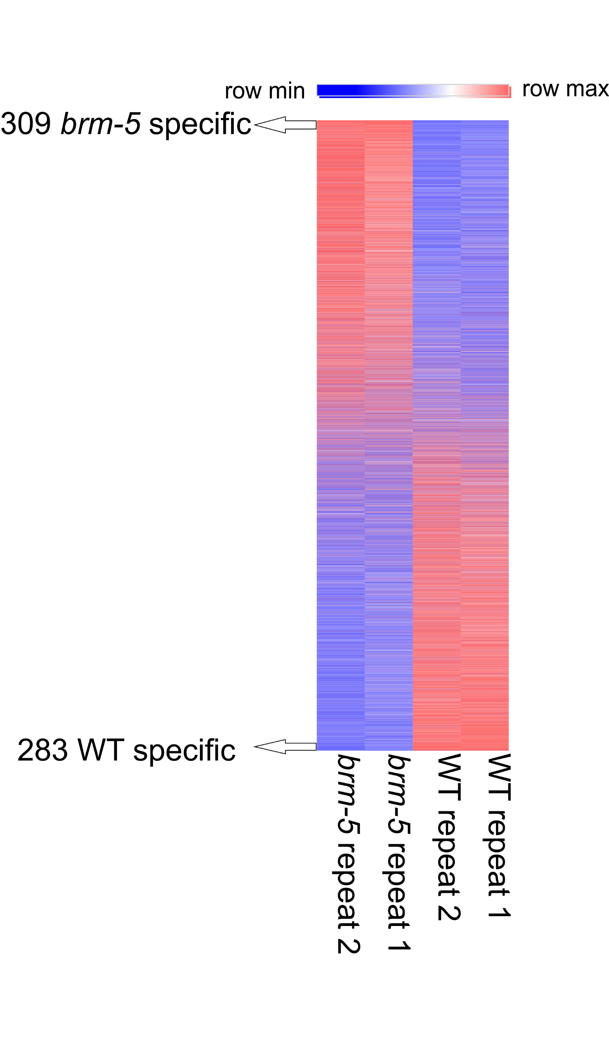Figure 1. Expression heatmap showing differential gene expression in brm and WT roots. Genes are ordered according to the log₂FC. Two biological replicas are shown.
3.1 Expression profile of brm
The Arabidopsis brm-5 mutant carries a missense mutation in the ATPase domain of the BRM ATP-dependent chromatin remodeler [10]. To assess the effect of BRM on gene expression, we performed RNA-seq on 14-day old roots from the brm mutant and WT plants. This revealed 592 differentially expressed genes (DEGs), 309 brm-specific and 283 WT-specific genes (log₂FC>|1|, adjusted pVal<0.05 (Figure 1A). Pathway analysis of these 592 DEGs revealed that the most enriched biological process in the brm up-regulated genes are related to negative regulation of transcription processes, suggesting that BRM controls general transcription rather than root-specific processes (Supplemental Figure S1). These findings are in line with previosly reported expression analysis of the brm-1 mutant [17].

3.2 Genome-wide chromatin accessibility of brm
To assess the effect of BRM on chromatin accessibility ATAC-seq was applied in the roots of brm and WT plants. High-quality ATAC-seq libraries were prepared from roots of both plants (Figure 2A, B), and 36,860 accessible loci were uncovered in the WT and 28,644 in the brm mutant. Overall the genic distribution of accessible sites in the two plants is highly similar (Figure 2C) as ~80% of the accessible loci are located in genic areas. In agreement with previous reports by us and others [26,36–38], highly expressed genes are accessible upstream to their transcription start sites (TSSs) (Figure 2D, E). Focusing on DEGs revealed that in the WT genome higher expression (WT-specific genes) is mirrored in higher accessibility relative to the brm-specific genes. However, in the brm genome similar accessibility was measured for WT- and brm-specific genes (Figure 2F). Notably this effect of increased accessibility at the brm-specific genes is not related to their expression level as four equal sized control groups of genes with similar expression levels to the plant-type-specific genes in both plants were accessible at the WT-specific genes (Supplemental Figure S2). Taken together, these results suggest that the increase in chromatin accessibility at these loci in the mutant plant is specifically linked to their increased expression and that BRM repress chromatin accessibility.
Figure 2. A-B representative browser views of accessible loci. C, genic distribution of accessible sites in brm-5 and WT roots. D-E, heatmap of accessibility around (± 1 kb) TSS of genes, ranked according to their expression levels in the brm-5 mutant (D) and WT (E) plants. F, profile of WT (left) and brm-5 (right) accessibility at specific genes.
3.3 Transposable element genes are upregulated in brm
Notably, the proportion of non-coding genes in the group of brm-specific genes is higher relative to the WT-specific genes (6.47% vs 3.53% Figure 3A). This trend is further highlighted given that five of the ten genes with highest fold induction in the mutant plant while none in the top ten WT-specific genes are non-coding. Genes related to transposable elements (TE genes) are the most dominant group of non-coding transcripts in the list of brm-specific genes (4.53%), while only 1.06% of the WT-specific genes, and are significantly enriched in the brm-specific genes (p-value<0.05, Chi-squared test). Given that the transcript levels of TE genes and thus their variation is overall are lower than those of protein-coding genes [39], we looked at the global trends of differential expression without filtering for a statistical cutoff. This revealed that 23.5% of the 3,901 annotated TE genes showed higher transcript count in brm, while 15.1% were downregulated (p-value < 2.2e-16, Chi-squared test).
Aside from the TE genes which are genes encoded within a transposable element, there are 31,189 transposable elements annotated in the Arabidopsis genome which are not associated with genes [40]. These elements were also upregulated to a greater extent in the brm mutant than in the WT plants (20.14% and 13.92% DE, 61 and 32 significantly DE (adjusted pVal<0.05, log₂FC>|1|), respectively). In both cases this is a significant enrichment (p-value < 2.2e-16, Chi-squared test).
A major component in the silencing of transposable elements is DNA methylation. In the WT plant [41] brm-specific transposable elements are hypermethylated compared with the WT-specific transposable elements or a stably expressed cohort (which are expressed (RPKM>1) in brm or WT and have a log₂FC of |0-0.3|) in all three methylation contexts (CG, CHG, and CHH) (Supplemental Figure S3). We conclude that BRM is involved in repression of transposable elements.
3.4 Differential accessible sites are associated with transposable elements
To better understand the link between variation in BRM-regulated accessibility and transposable elements regulation we calculated differential transposase hyper-sensitivity (dTHSs). dTHSs were assigned with DEseq2 [42], by counting the reads at accessible loci in each repeat as input. The analysis retrieved 21 significant dTHSs which gained accessibility for each plant type in log₂FC>1 and pVal<0.05 cutoff (Supplemental Table S1). In plants, regulatory elements depicted by chromatin accessibility can be positioned far away from their gene targets [26,43,44]. dTHSs are located on average significantly closer to transposable elements relative to the global trend of chromatin accessibility sites as the average distance of dTHSs to the nearest TE is 1347.27 bp while the average distance of all THSs is 5648.22 bp in the mutant, and 1188 bp from WT dTHSs compared with 5573.06 bp average distance from all WT THSs (p-value<0.0001, Wilcox rank sum test). Furthermore, variations in chromatin accessibility are linked to non-coding genes as they are over-represented in the group of genes closest to dTHSs (Figure 3B) significantly in the mutant data (p-value < 2.2e-16, Chi-squared test). In the same line, the dTHSs are more distant from coding gens compared to the global genome-wide trends (average distance to the nearest gene 362.31 bp for brm specific vs 276.33 bp genome-wide (p-value<2.2E-16, Wilcox rank sum test), and 640.82 bp for WT-specific vs 288.86 bp genome-wide (p-value<0.05, Wilcox rank sum test)). Constraining the distance between dTHS to genes to 1kb increases the likelihood of their regulatory link [45]. The proportion of dTHS within 1kb of transposable elements or non-coding genes is double than the genome-wide accessibility profile, while their proportion in proximity to coding genes is lower than the global accessibility trend, suggesting that dTHSs potentially regulate non-coding elements (Figure 3C-F).
Figure 3. A, classification of differentially expressed genes. B, classification of nearest gene to ATAC-seq peaks. C, distance of nearest non-coding gene or transposable element or D, coding gene to ATAC-seq peaks, up to 1 kb (blue) or more (orange). E, F browser views of brm-5 (E) and WT (F) specific accessible site. In blue, TE genes. ****p-value<0.0001, NS non-significant, Chi-squared test.
3.5 Chromosomal structure and regulatory capacity of dTHSs
Interestingly, as most of the dTHS were spread across the genome, we found two loci in which highly dTHSs were found (Figure 4). One locus is on chromosome 1, overlapping an brm-specific gene (AT1G75945, 5.7 log₂FC) and two transposable elements. The second locus is located on chromosome 5, overlapping a TE gene which is brm-specific (AT5G35935, 5.32 log₂FC).
The fact that a target gene can be potentially regulated by more than one dTHS (for example see Figure 4) and that dTHS may be distant from genes (Figure 3C), raise the possibility that regulatory elements commnicate with their gene targets by chromosomal looping. To explore the possible extent of long-range activity of brm-specific dTHS, we mapped their chromosomal interactome by 4C-seq that measures the chromosomal associations of a point of interest (bait) with the genome [31,46]. As baits, we used DNA sequences within the brm-specific clusters decribed above (Figure 4) and constructed 4C libraries from WT and brm roots. In the 4C-seq analysis we excluded RE sites around the bait that have exceptionally high signal due to linear proximity and may bias the analysis [31] (see methods). Both brm and WT plants the dTHS loci show high contact probability with a ~20kb proximal domain, reflecting their possible capacity to influence gene expression over distance Remarkably, we found local interactions of the brm-specific dTHS on chromosome 5 to be asymmetrically biased to 5′ sequence, suggesting a non-random chromosomal structure (Figure 5, Supplemental Figure S4). The non-random profiles suggest that the chromosomal structure in these loci is regulated or reflects regulatory processes.
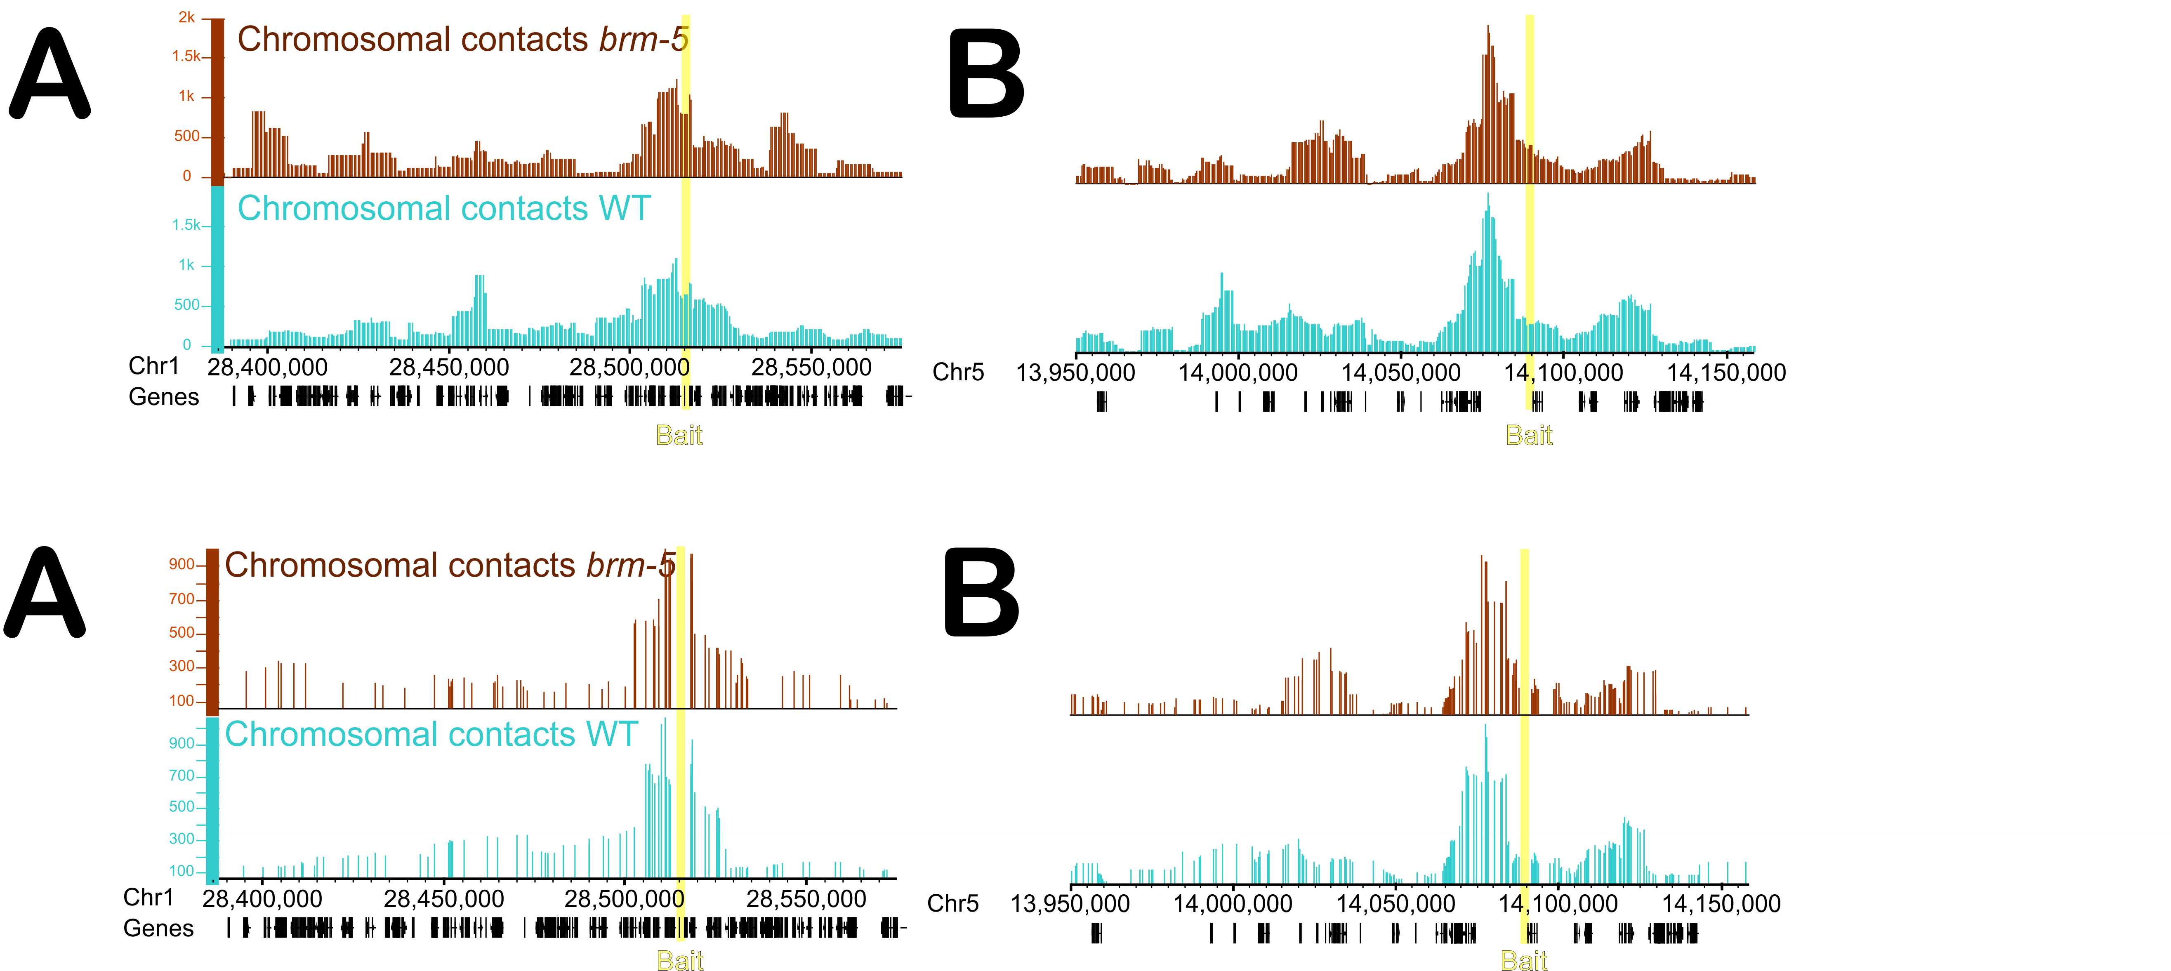
Figure 5. 3D chromosome confirmation of the cluster regions measured by 4C-seq. A, cluster 1. B, cluster 5. The viewpoint is highlighted in yellow. The raw read counts were normalized per million (CPM) in a sliding window of 10 kb. (top two tracks) or 10 restriction enzymes sites (bottom two tracks).
Next, we tested whether the brm-specific accessible loci have a brm-specific regulatory capability. DNA fragments from the genomic sequence of the dTHS clusters on chromosomes 1 and 5 were cloned in forward and reverse orientations upstream to a 35S minimal promoter followed by a GFP reporter. Fragment 1 includes two peaks on the gene body and TES of the brm upregulated gene AT1G75945, and fragment 2 includes the same gene body accessible site together with the accessible site on the TSS. Fragment 3 is located on the gene body of the brm upregulated TE gene AT5G35935, and fragment 4 is on its TSS (Figure 6A). These plasmids were introduced to WT and brm plants. Quantitative analysis of 1859 T₂ plants representing 174 individual lines revealed that the GFP signal driven by the dTHS on the TSS and gene body of AT1G75945 (fragment 1) was higher in brm relative to WT plants, indicating the increased accessibility in these loci in brm is linked to elevated expression (Figure 6B, Supplemental Figure S5). Interestingly we observed brm-dependent expression driven also by the dTHS in the gene body and TES of AT1G75945 (fragment 2). In the same line, brm-specific expression was driven by fragment 4 from the TSS of AT5G35935. Taken together these results indicate a role for BRM in the maintenance of regulatory chromatin, that can act over long distances, in a closed state.
Figure 6. A, schematic representation of the fragments used in B. B, Normalized fluorescence levels in brm-5 vs WT backgrounds of fragments from the two clusters upstream to a 35S minimal promoter and a GFP reporter. Minimal promoter, plasmid containing only the minimal 35S promoter upstream to the reporter gene. WT, no T-DNA insertion. *p value <0.05, ****p value<0.0001, NS, non-significant (Wilcoxon rank sum test).

Discussion
In this study we present a genome-wide chromatin accessibility map of a plant mutated in the BRM chromatin remodeler, and combined it with gene expression profiling and chromatin organization.
BRM is thought to play dual roles as both an activator and a repressor in various processes [16]. Although a similar number of genes were up- or down- regulated in the brm mutant, increased accessibility at their TSS was depicted only for the brm-induced genes, suggesting that BRM has a repressive role on chromatin accessibility and transcription.
Non-coding transcripts were over-represented in the group of brm specific genes and also in proximity to brm dTHSs. The up-regulated transposable elements are highly methylated in the WT plants. Unlike the notion that reduction in DNA methylation leads to increase in chromatin accessiblity [38], we observed the opposite trend: loss of accessibility led to lower DNA methylation. Altogether, these findings imply an involvement of BRM in silencing these elements, by regulating their accessibility and transcription.
We identified several loci which show strong variation in chromatin accessibility. However, the large majority of accessible sites showed invariable chromatin accessibility. This may be due to the specificity of BRM. Based on studies describing the roles of BRM in flowering induction, inflorescence and flower development, it was suggested that it acts as a specific factor in the processes rather than a broad remodeler [16]. In addition, this phenomenon may reflect the redundancy of CHRs. There are tens of CHRs in Arabidopsis [47], are there is redundancy in their roles. Specifically, it has been shown that a chromatin remodeler related to BRM, SYD, has both shared and unique functions [48,49]. Moreover, it has been shown in mammalians that the vast majority of genes that occupied by SWI/SNF chromatin remodelers do not show altered expression in SWI/SNF knock-outs. [50]. Another reason may be the mutant used in this study. brm-5 is an EMS mutant line which contains a point mutation at a highly conserved amino acid in the ATPase domain of the chromatin remodeler, and was shown to effect chromatin accessibility at a specific locus in leaves [10]. The relatively low amount of dTHSs may reflect the mild phenotype of this mutant, as other lines which were used in various studies are T-DNA lines (brm-1, brm-2 and brm-4) which are completely sterile and with more severe phenotypes [8,10]. However, the magnitude of differentially expressed genes we discovered is in line with variations reported previously in leaves of T-DNA mutated brm mutants [8] and leaves of brm-5 detected by microarray of RNA extracted from 14 day old leaves of the brm-5 mutant vs a control of βCGpro:GUS transgene plant [10]. The overlap between the DEGs in both datasets is low (3-6% overlap), reflecting the distinct transcriptional program of the two organs.
Furthermore, meta-analysis of chromatin accessibility studies in Arabidopsis showed that although environmental factors such as heat stress and response to plant hormones (auxin and brassinazole) cause a major change in expression, what causes a strong effect on chromatin accessibility is cell linage and developmental stage [51]. Moreover, a model predicting condition specific regulatory genes using machine learning found that the use of chromatin accessibility data significantly improved its performance regardless of the experimental conditions [52]. These notions support a non-dynamic cell- type and stage specific transcription-poised state, in which genes remain accessible despite expression status [51].
Albeit, this suggests that the dTHSs uncovered represent the most dominant regions regulated by BRM, particularly those located in the two clusters on chr 1 and chr 5. Indeed, these loci were used in other studies as loci to test BRM effect [28]. We demonstrated the brm-specific regulatory capacity of these regions, hence we conclude that the BRAHMA CHR plays a negative role in preventing specific TE accessibility and expression.
Declaration of interests
The authors declare that they have no known competing financial interests or personal relationships that could have appeared to influence the work reported in this paper.
Acknowledgements
We thank Avi Jacob of the BIU light microscopy unit for helping with the reporter assay. We thank Jennifer I. C. Benichou of the BIU statistics unit for assisting with the statistical analysis. We thank Orly Yaron and Sarit Lampert of the BIU sequencing facility for helping with Illumina sequencing.
Funding
R.K. and M.T. were supported by the Mordecai and Monique Katz Graduate Fellowship Program.

Bibliography
[1] G. Längst, L. Manelyte, Chromatin Remodelers: From Function to Dysfunction., Genes (Basel). 6 (2015) 299–324. https://doi.org/10.3390/genes6020299.
[2] S.L. Klemm, Z. Shipony, W.J. Greenleaf, Chromatin accessibility and the regulatory epigenome, Nat. Rev. Genet. (2019) 1. https://doi.org/10.1038/s41576-018-0089-8.
[3] J.D. Buenrostro, P.G. Giresi, L.C. Zaba, H.Y. Chang, W.J. Greenleaf, Transposition of native chromatin for fast and sensitive epigenomic profiling of open chromatin, DNA-binding proteins and nucleosome position., Nat. Methods. 10 (2013) 1213–8. https://doi.org/10.1038/nmeth.2688.
[4] J.D. Buenrostro, B. Wu, H.Y. Chang, W.J. Greenleaf, ATAC-seq: A Method for Assaying Chromatin Accessibility Genome-Wide, in: Curr. Protoc. Mol. Biol., John Wiley & Sons, Inc., Hoboken, NJ, USA, 2015: pp. 21.29.1-21.29.9. https://doi.org/10.1002/0471142727.mb2129s109.
[5] M. Tsompana, M.J. Buck, Chromatin accessibility: a window into the genome, Epigenetics Chromatin. 7 (2014) 33. https://doi.org/10.1186/1756-8935-7-33.
[6] S.-K. Han, M.-F. Wu, S. Cui, D. Wagner, Roles and activities of chromatin remodeling ATPases in plants., Plant J. 83 (2015) 62–77. https://doi.org/10.1111/tpj.12877.
[7] D.M. Gratkowska-Zmuda, S. Kubala, E. Sarnowska, P. Cwiek, P. Oksinska, J. Steciuk, A.T. Rolicka, M. Zaborowska, E. Bucior, A. Maassen, R. Franzen, C. Koncz, T.J. Sarnowski, The SWI/SNF ATP-Dependent Chromatin Remodeling Complex in Arabidopsis Responds to Environmental Changes in Temperature-Dependent Manner, Int. J. Mol. Sci. 21 (2020) 762. https://doi.org/10.3390/ijms21030762.
[8] L. Hurtado, S. Farrona, J.C. Reyes, The putative SWI/SNF complex subunit BRAHMA activates flower homeotic genes in Arabidopsis thaliana., Plant Mol. Biol. 62 (2006) 291–304. https://doi.org/10.1007/s11103-006-9021-2.
[9] S. Farrona, L. Hurtado, J.L. Bowman, J.C. Reyes, G.N. Drews, J.L. Bowman, The Arabidopsis thaliana SNF2 homolog AtBRM controls shoot development and flowering., Development. 131 (2004) 4965–75. https://doi.org/10.1242/dev.01363.
[10] X. Tang, A. Hou, M. Babu, V. Nguyen, L. Hurtado, Q. Lu, J.C. Reyes, A. Wang, W.A. Keller, J.J. Harada, E.W.T. Tsang, Y. Cui, The Arabidopsis BRAHMA chromatin-remodeling ATPase is involved in repression of seed maturation genes in leaves., Plant Physiol. 147 (2008) 1143–1157. https://doi.org/10.1104/pp.108.121996.
[11] Y. Xu, C. Guo, B. Zhou, C. Li, H. Wang, B. Zheng, H. Ding, Z. Zhu, A. Peragine, Y. Cui, S. Poethig, G. Wu, Regulation of Vegetative Phase Change by SWI2/SNF2 Chromatin Remodeling ATPase BRAHMA, Plant Physiol. 172 (2016) 2416–2428. https://doi.org/10.1104/pp.16.01588.
[12] M. Zhao, S. Yang, C.-Y. Chen, C. Li, W. Shan, W. Lu, Y. Cui, X. Liu, K. Wu, Arabidopsis BREVIPEDICELLUS Interacts with the SWI2/SNF2 Chromatin Remodeling ATPase BRAHMA to Regulate KNAT2 and KNAT6 Expression in Control of Inflorescence Architecture, PLOS Genet. 11 (2015) e1005125. https://doi.org/10.1371/journal.pgen.1005125.
[13] C. Li, C. Chen, L. Gao, S. Yang, V. Nguyen, X. Shi, K. Siminovitch, S.E. Kohalmi, S. Huang, K. Wu, X. Chen, Y. Cui, The Arabidopsis SWI2/SNF2 chromatin Remodeler BRAHMA regulates polycomb function during vegetative development and directly activates the flowering repressor gene SVP., PLoS Genet. 11 (2015) e1004944. https://doi.org/10.1371/journal.pgen.1004944.
[14] C.S. Kwon, K. Hibara, J. Pfluger, S. Bezhani, H. Metha, M. Aida, M. Tasaka, D. Wagner, A role for chromatin remodeling in regulation of CUC gene expression in the Arabidopsis cotyledon boundary., Development. 133 (2006) 3223–30. https://doi.org/10.1242/dev.02508.
[15] S. Yang, C. Li, L. Zhao, S. Gao, J. Lu, M. Zhao, C.-Y. Chen, X. Liu, M. Luo, Y. Cui, C. Yang, K. Wu, The Arabidopsis SWI2/SNF2 Chromatin Remodeling ATPase BRAHMA Targets Directly to PINs and Is Required for Root Stem Cell Niche Maintenance., Plant Cell. 27 (2015) 1670–80. https://doi.org/10.1105/tpc.15.00091.
[16] C. Thouly, M. Le Masson, X. Lai, C.C. Carles, G. Vachon, Unwinding BRAHMA Functions in Plants, Genes (Basel). 11 (2020) 90. https://doi.org/10.3390/genes11010090.
[17] E.S. Torres, R.B. Deal, The histone variant H2A.Z and chromatin remodeler <scp>BRAHMA</scp> act coordinately and antagonistically to regulate transcription and nucleosome dynamics in Arabidopsis, Plant J. 99 (2019) 144–162. https://doi.org/10.1111/tpj.14281.
[18] N.M. Springer, D. Lisch, Q. Li, Creating Order from Chaos: Epigenome Dynamics in Plants with Complex Genomes., Plant Cell. 28 (2016) 314–25. https://doi.org/10.1105/tpc.15.00911.
[19] L. Quadrana, A. Bortolini Silveira, G.F. Mayhew, C. LeBlanc, R.A. Martienssen, J.A. Jeddeloh, V. Colot, The Arabidopsis thaliana mobilome and its impact at the species level., Elife. 5 (2016). https://doi.org/10.7554/eLife.15716.
[20] B. McClintock, Controlling Elements and the Gene, Cold Spring Harb. Symp. Quant. Biol. 21 (1956) 197–216. https://doi.org/10.1101/SQB.1956.021.01.017.
[21] D. Lisch, Epigenetic Regulation of Transposable Elements in Plants, Annu. Rev. Plant Biol. 60 (2009) 43–66. https://doi.org/10.1146/annurev.arplant.59.032607.092744.
[22] X. Cui, X. Cao, Epigenetic regulation and functional exaptation of transposable elements in higher plants, Curr. Opin. Plant Biol. 21 (2014) 83–88. https://doi.org/10.1016/j.pbi.2014.07.001.
[23] C.J. Underwood, I.R. Henderson, R.A. Martienssen, Genetic and epigenetic variation of transposable elements in Arabidopsis, Curr. Opin. Plant Biol. 36 (2017) 135–141. https://doi.org/10.1016/j.pbi.2017.03.002.
[24] R.B. Deal, S. Henikoff, A Simple Method for Gene Expression and Chromatin Profiling of Individual Cell Types within a Tissue, Dev. Cell. 18 (2010) 1030–1040. https://doi.org/10.1016/j.devcel.2010.05.013.
[25] R.B. Deal, S. Henikoff, The INTACT method for cell type–specific gene expression and chromatin profiling in Arabidopsis thaliana, Nat. Protoc. 6 (2011) 56–68. https://doi.org/10.1038/nprot.2010.175.
[26] M. Tannenbaum, A. Sarusi-Portuguez, R. Krispil, M. Schwartz, O. Loza, J.I.C. Benichou, A. Mosquna, O. Hakim, Regulatory chromatin landscape in Arabidopsis thaliana roots uncovered by coupling INTACT and ATAC-seq, Plant Methods. 14 (2018) 113. https://doi.org/10.1186/s13007-018-0381-9.
[27] T. Murashige, F. Skoog, A Revised Medium for Rapid Growth and Bio Assays with Tobacco Tissue Cultures, Physiol. Plant. 15 (1962) 473–497. https://doi.org/10.1111/j.1399-3054.1962.tb08052.x.
[28] Y. Zhu, M.J. Rowley, G. Böhmdorfer, A.T. Wierzbicki, A SWI/SNF Chromatin-Remodeling Complex Acts in Noncoding RNA-Mediated Transcriptional Silencing, Mol. Cell. 49 (2013) 298–309. https://doi.org/10.1016/j.molcel.2012.11.011.
[29] B. Langmead, S.L. Salzberg, Fast gapped-read alignment with Bowtie 2., Nat. Methods. 9 (2012) 357–9. https://doi.org/10.1038/nmeth.1923.
[30] F. Ramírez, D.P. Ryan, B. Grüning, V. Bhardwaj, F. Kilpert, A.S. Richter, S. Heyne, F. Dündar, T. Manke, deepTools2: a next generation web server for deep-sequencing data analysis, Nucleic Acids Res. 44 (2016) W160–W165. https://doi.org/10.1093/nar/gkw257.
[31] R. Krispil, M. Tannenbaum, A. Sarusi-Portuguez, O. Loza, O. Raskina, O. Hakim, The Position and Complex Genomic Architecture of Plant T-DNA Insertions Revealed by 4SEE, Int. J. Mol. Sci. 21 (2020) 2373. https://doi.org/10.3390/ijms21072373.
[32] M. Martin, Cutadapt removes adapter sequences from high-throughput sequencing reads, EMBnet.Journal. 17 (2011) 10. https://doi.org/10.14806/ej.17.1.200.
[33] S.R. Cutler, D.W. Ehrhardt, J.S. Griffitts, C.R. Somerville, Random GFP::cDNA fusions enable visualization of subcellular structures in cells of Arabidopsis at a high frequency., Proc. Natl. Acad. Sci. U. S. A. 97 (2000) 3718–23. https://doi.org/10.1073/PNAS.97.7.3718.
[34] M. Karimi, D. Inzé, A. Depicker, GATEWAYTM vectors for Agrobacterium-mediated plant transformation, Trends Plant Sci. 7 (2002) 193–195. https://doi.org/10.1016/S1360-1385(02)02251-3.
[35] T.R. Jones, I. Kang, D.B. Wheeler, R.A. Lindquist, A. Papallo, D.M. Sabatini, P. Golland, A.E. Carpenter, CellProfiler Analyst: data exploration and analysis software for complex image-based screens, BMC Bioinformatics. 9 (2008) 482. https://doi.org/10.1186/1471-2105-9-482.
[36] W. Zhang, T. Zhang, Y. Wu, J. Jiang, Open chromatin in plant genomes, Cytogenet. Genome Res. 143 (2014) 18–27. https://doi.org/10.1159/000362827.
[37] W. Zhang, T. Zhang, Y. Wu, J. Jiang, Genome-Wide Identification of Regulatory DNA Elements and Protein-Binding Footprints Using Signatures of Open Chromatin in Arabidopsis, Plant Cell. 24 (2012) 2719–2731. https://doi.org/10.1105/tpc.112.098061.
[38] Z. Zhong, S. Feng, S.H. Duttke, M.E. Potok, Y. Zhang, J. Gallego-Bartolomé, W. Liu, S.E. Jacobsen, DNA methylation-linked chromatin accessibility affects genomic architecture in Arabidopsis, Proc. Natl. Acad. Sci. 118 (2021) e2023347118. https://doi.org/10.1073/pnas.2023347118.
[39] R.K. Slotkin, M. Vaughn, F. Borges, M. Tanurdžić, J.D. Becker, J.A. Feijó, R.A. Martienssen, Epigenetic Reprogramming and Small RNA Silencing of Transposable Elements in Pollen, Cell. 136 (2009) 461–472. https://doi.org/10.1016/j.cell.2008.12.038.
[40] P. Lamesch, T.Z. Berardini, D. Li, D. Swarbreck, C. Wilks, R. Sasidharan, R. Muller, K. Dreher, D.L. Alexander, M. Garcia-Hernandez, A.S. Karthikeyan, C.H. Lee, W.D. Nelson, L. Ploetz, S. Singh, A. Wensel, E. Huala, The Arabidopsis Information Resource (TAIR): improved gene annotation and new tools, Nucleic Acids Res. 40 (2012) D1202–D1210. https://doi.org/10.1093/nar/gkr1090.
[41] H. Stroud, M.V.C. Greenberg, S. Feng, Y. V. Bernatavichute, S.E. Jacobsen, Comprehensive Analysis of Silencing Mutants Reveals Complex Regulation of the Arabidopsis Methylome, Cell. 152 (2013) 352–364. https://doi.org/10.1016/j.cell.2012.10.054.
[42] M.I. Love, W. Huber, S. Anders, Moderated estimation of fold change and dispersion for RNA-seq data with DESeq2, Genome Biol. 15 (2014) 550. https://doi.org/10.1186/s13059-014-0550-8.
[43] J. Jiang, The ‘dark matter’ in the plant genomes: non-coding and unannotated DNA sequences associated with open chromatin, Curr. Opin. Plant Biol. 24 (2015) 17–23. https://doi.org/10.1016/j.pbi.2015.01.005.
[44] B. Weber, J. Zicola, R. Oka, M. Stam, Plant Enhancers: A Call for Discovery, Trends Plant Sci. 21 (2016) 974–987. https://doi.org/10.1016/j.tplants.2016.07.013.
[45] Y. Fang, X.E.X. Wang, L. Wang, X. Pan, J. Xiao, X.E.X. Wang, Y. Wu, W. Zhang, Functional characterization of open chromatin in bidirectional promoters of rice, Sci. Rep. 6 (2016) 32088. https://doi.org/10.1038/srep32088.
[46] M. Schwartz, A.S. Portugez, B.Z. Attia, M. Tannenbaum, L. Cohen, O. Loza, E. Chase, Y. Turman, T. Kaplan, Z. Salah, O. Hakim, Genomic retargeting of p53 and CTCF is associated with transcriptional changes during oncogenic HRas-induced transformation, Commun. Biol. 3 (2020) 696. https://doi.org/10.1038/s42003-020-01398-y.
[47] C.S. Pikaard, O. Mittelsten Scheid, Epigenetic Regulation in Plants, Cold Spring Harb. Perspect. Biol. 6 (2014) a019315–a019315. https://doi.org/10.1101/cshperspect.a019315.
[48] S. Bezhani, C. Winter, S. Hershman, J.D. Wagner, J.F. Kennedy, C.S. Kwon, J. Pfluger, Y. Su, D. Wagner, Unique, Shared, and Redundant Roles for the Arabidopsis SWI/SNF Chromatin Remodeling ATPases BRAHMA and SPLAYED, Plant Cell. 19 (2007) 403–416. https://doi.org/10.1105/TPC.106.048272.
[49] J. Shu, C. Chen, C. Li, R.K. Thapa, J. Song, X. Xie, V. Nguyen, S. Bian, J. Liu, S.E. Kohalmi, Y. Cui, Genome-wide occupancy of Arabidopsis SWI/SNF chromatin remodeler SPLAYED provides insights into its interplay with its close homolog BRAHMA and Polycomb proteins., Plant J. (2021). https://doi.org/10.1111/tpj.15159.
[50] G.M. Euskirchen, R.K. Auerbach, E. Davidov, T.A. Gianoulis, G. Zhong, J. Rozowsky, N. Bhardwaj, M.B. Gerstein, M. Snyder, Diverse Roles and Interactions of the SWI/SNF Chromatin Remodeling Complex Revealed Using Global Approaches, PLoS Genet. 7 (2011) e1002008. https://doi.org/10.1371/journal.pgen.1002008.
[51] A.M. Sullivan, A.A. Arsovski, A. Thompson, R. Sandstrom, R.E. Thurman, S. Neph, A.K. Johnson, S.T. Sullivan, P.J. Sabo, F. V. Neri, M. Weaver, M. Diegel, J.L. Nemhauser, J.A. Stamatoyannopoulos, K.L. Bubb, C. Queitsch, Mapping and Dynamics of Regulatory DNA in Maturing Arabidopsis thaliana Siliques, Front. Plant Sci. 10 (2019) 1434. https://doi.org/10.3389/fpls.2019.01434.
[52] Q. Song, J. Lee, S. Akter, M. Rogers, R. Grene, S. Li, Prediction of condition-specific regulatory genes using machine learning, Nucleic Acids Res. 48 (2020) e62–e62. https://doi.org/10.1093/nar/gkaa264.

Supplmental Matrieal
Supplemental Figure S1.
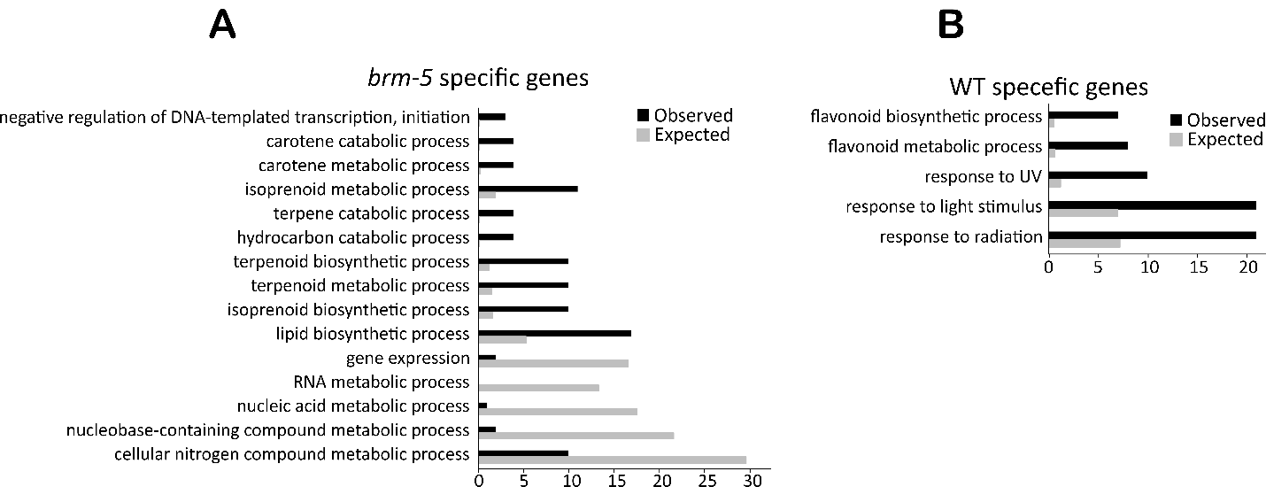
GO analysis of biological processes of highly expressed genes near root-unique accessible sites (p-value<0.00001, FDR<0.03).

Supplemental Figure S2
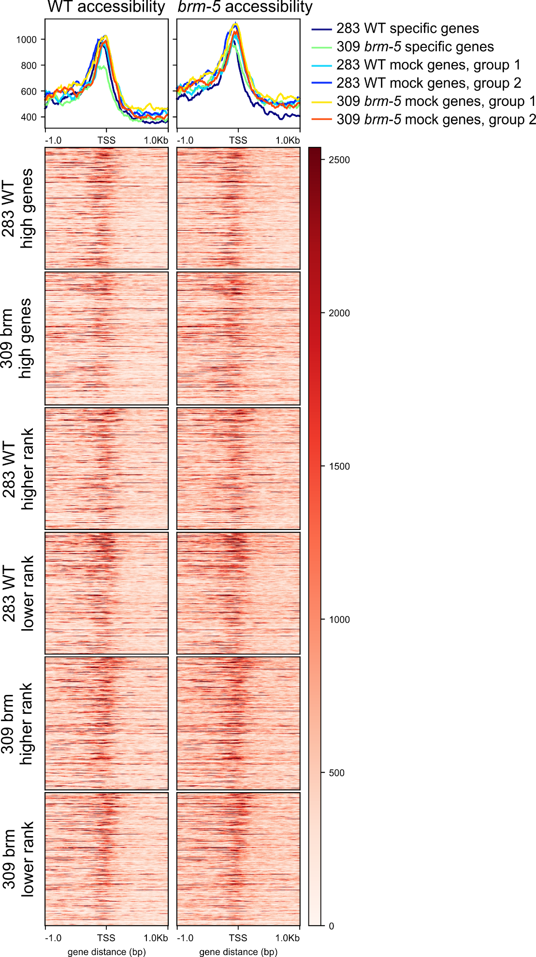
Profile of WT (left) and brm-5 (right) accessibility at specific and non-specific genes.

Supplemental Figure S3
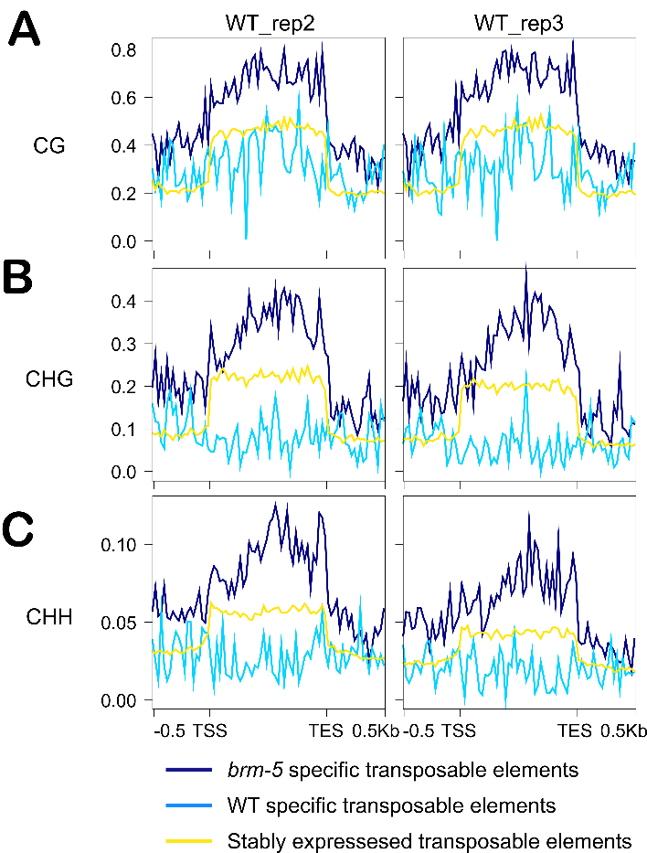
Methylation profiles at transposable elements. TSS, transcription start site. TES, transcription end site. Specific transposable elements are significantly up- or down- regulated at a log₂FC larger than |1|, non-specific transposable elements are not differentially expressed, and have a log₂FC of |0-0.3|. Methylation data from [41]
Supplemental Figure S4
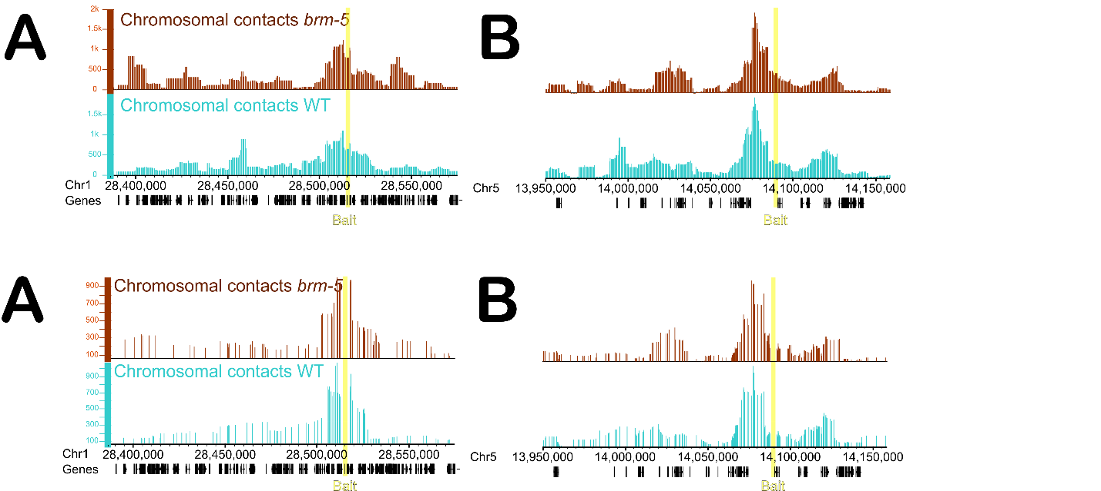
3D chromosome confirmation of the cluster regions measured by 4C-seq. A, cluster 1. B, cluster 5. The viewpoint is highlighted in yellow. The raw read counts were normalized per million (CPM) in a sliding window of 10 restriction enzymes sites.

Supplemental Figure S5
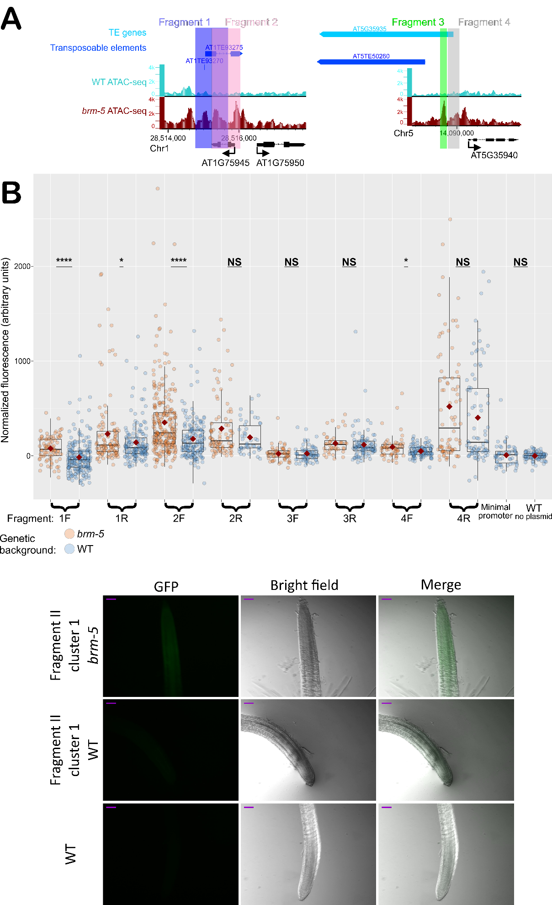
Representative images of a GFP signals of fragment 2 (see Figure 6), in brm-5 (top) or WT (middle) background. Scale bar = 100µm.

Supplemental Table S1.
All peaks | WT (36,860 peaks) | brm-5 (28,644 peaks)
log₂FC = 1 | 29 (21 h, 8 l) | 21 (21 h, 0 l)
log₂FC = 0.6 | 82 (51 h, 31 l) | 47 (36 h, 11 l)
log₂FC = 0.46 | 91 (52 h, 39 l) | 54 (41 h, 13 l)
Number of dTHSs calculated by DEseq2, p-value<0.05. h, high. l, low.

Abbreviations: BRM, Brahma; CHR, chromatin remodeler; DEG, differentially expressed gene; dTHS, differential transposase hyper-sensitivity; TF, transcription factor.

