Sam S. Rakover, Rani A. Bar-On, and Anna Gliklich

**How an inverted face is compared to upright face? Mental rotation or visual similarity?**

**A main interest of research in face recognition was in explaining the Face Inversion effect (FIE). Accordingly, the recognition of an inverted face has been much worse than an upright face. However, this research has not devoted efforts to answer the following question: how does the cognitive system handle the comparison between upright and inverted faces? The present paper discovers that this comparison is made via the process of visual similarity and not through mental rotation of the inverted face to the position of an upright face. Furthermore, it has been found out that visual similarity is based on certain mutual elements between these two faces called the “Inversion Resisting Elements” (IRE). The IRE are symmetrical and salient components of the face such as round eyes and thick lips.**

Research on face perception and recognition in the last 50 years has fo­cused on the ‘face inversion effect’ (FIE), according to which an upright face (hair above, chin below) is recognized much better than an inverted face (chin above, hair below) (e.g., Maurer, et al., 2002; Rakover, 2002, 2013; Rossion, 2008, 2009; Valentine, 1988; Yin, 1969). The FIE is explained by two similar hypotheses, the ‘configural processing’ hypothesis and the ‘holistic’, which propose that in comparison to the processing of an upright face, the processing of configural and holistic information in an inverted face are impaired (e.g., Maurer et al., 2002; McKone, 2010; Piepers & Robbins, 2012; Rakover, 2013; Rossion, 2008, 2009). (Configural information relats to the space between facial features, and holistic information deals with the perception of the face as a whole.) Notwithstanding the vast amount of research on FIE, the following important question did not receive the appropriate research attention: how does the cognitive system compar an inverted face to an upright face? We propose two important hypotheses to be tested by a recognition experiment (i.e., a Yes/No procedure).

The **Visual-similarity** hypothesis proposes that one’s decision is based on the visual similarity between the perceived inverted face and the remembered upright face (e.g., Rakover &Cahlon, 1989; Tversky, 1977). The **Mental-rotation** hypothesis proposes that the inverted face as a whole is mentally rotated to the upright orientation and then it is compared to the remembered upright face (e.g., Rakover, 2015; Rock, 1973, 1974; Valentine & Bruce, 1988). While Rock (1973, 1974) explained the FIE by proposing that the cognitive system has a huge difficulty in mentally rotating each of the facial features and their spatial relationship to the upright orientation, Valentine & Bruce (1988) presented empirical evidence that support the hypothesis that a face as a whole unite, as a Gestalt, is mentally rotated in a way similar to the mental rotation of visual shapes (e.g., Cooper, 1975; Shepard & Metzler, 1971).

These two hypotheses do not overlap since they appeal to two different mechanisms. While the visual-similarity hypothesis is based mainly on the estimation of the number of mutual elements that compound the two faces (e.g., Rakover &Cahlon, 1989; Tversky, 1977), the mental-rotation hypothesis is founded on a mechanism that rotates the representation of the inverted face to the upright orientation and then examines whether it overlaps with the remembered upright face (e.g., Rakover, 2015; Rock, 1973, 1974; Shepard & Metzler, 1971; Valentine & Bruce, 1988).

The main goal of the present paper is to decide empirically between these two hypotheses. To carry out this program, we will conduct a variation of the **Yes/No** **experiment** that is based on the following manipulations and rational. Let us suppose that by a preparatory experiment we have constructed two groups of faces. The **similar-group** contains 7 different pairs of faces each composed of two different faces: upright and inverted, which were ranked very high on a similarity scale. The **non-similar group** contains 7 different pairs each composed of two different faces: upright and inverted, which were ranked very low on a similarity scale. Given these, in the study stage, 14 upright faces were presented to the participant (those are the upright faces taken from the two groups: similar and non-similar). In the test stage 28 inverted faces were presented. They were composed of 14 old (which were presented in the study stage) and 14 new faces. The 14 new faces are the inverted faces, which were taken from the similar-group (7 similar inverted faces) and from non-similar group (7 non-similar inverted faces). The participant’s task was to decide for each inverted face if it is old or new.

Given this, the rational for the study is as follows. If the **Visual-similarity** hypothesis is correct, then one should predict that the false-alarm of the 7 new similar inverted faces (FAs-faces) will be significantly greater than the false-alarm of the 7 new non-similar inverted faces (FAns-faces). The reason for this prediction is this: when the visual similarity between upright face and inverted face is high, there is a high chance of believing that a new face is an old one, hence, FAs-faces > FAns-faces.

In contrast, if the **Mental-rotation** hypothesis is correct, there will be no significant differences between FAs-faces and FAns-faces. The reason for this prediction is as follows. When an inverted face is rotated to the upright orientation, it is easy to decide whether or not the rotated face is congruent with the remembered upright old face and to decide if the inverted test face is old or new.

To test these two predictions, we conducted two experiments. The purpose of the **experiment (1) preparatory experiment,** was to construct the following two groups of faces: the **similar-group** and the **non-similar group**. The purpose of the **experiment (2)** **the prediction testing part** **(a)** was to test the above two predictions empirically, and **part (b)** had two important goals. First, to give an additional empirical support to the construction of the similar and non-similar groups by using a different technique: ranking the similarity of the upright/inverted (UI) pairs of faces. Second, to test wither the distinction between the similar and the non-similar groups is confined only to the UI group of orientation or is this distinction generalized to the other UU, IU and II groups of orientations, i.e., to test whether this distinction has the quality of resisting inversion transformation: UU, IU, II groups of orientations.

**Experiment (1) preparatory experiment**

*Participants, Design & Procedure*: Thirty participants (21 females and 9 males, average age is 24.7) were shown on a computer screen a series of pictures each consists of six “oval-faces” without hair and ears. In each trial one oval-face appeared in the upright orientation (hair above, chin below) and five oval-faces, which appeared in the inverted orientation (chin above, hair below), were arranged in a semi-circle below the upright face. The number of participants was determined on the basis of a pilot study and previous experience with similar kind of experiments. The participants were undergraduate students who were rewarded by payment or course credit. Informed consent was obtained for the experiments reported here. The oval-faces were different unfamiliar black-and-white pictures of men faces. The hair and ears were cut out because external facial features aid recognition (e.g., Bonner et al, 2003; Want et al, 2003). The experiment consisted of 180 trials, which were composed in the following way.

There were 30 different oval-faces. Each one of them appeared six times in the upright orientation with 5 different inverted oval-faces. That is, each upright face was associated with all the 30 faces in the inverted orientation (including itself), hence, 180 trials = 6x30. For each trial the faces were chosen randomly and the trials appeared also in a randomized order. The faces in each trial were exposed for 20 seconds in which time the participant has to choose from the five inverted faces at least one inverted face that is similar to the upright face. In each trial there were two whistles, which appeared after 10 and 18 seconds, to expedite the participant’s responses.

**Results and discussion**

The main purpose of the present experiment was to construct two groups of pairs of faces: the **similar-group** and the **non-similar group**. To do this we construct a similarity table of 30 upright oval-faces x 30 inverted oval-faces. The table shows how many participants (out of 30) indicated that a certain inverted face is similar to a certain upright face. Based on this table, we built the **similar-group** in the following way (see Figure 1): we selected 7 different pairs of faces (each pair consisted on upright face and a different inverted face) which were different from each other with a high number of participants that indicated a similarity between upright and inverted faces: the range of similarity was between 27% to 67% of the participants. The **non-similar group** was constructed in the same way: we selected 7 different pairs of faces (upright and inverted) which were different from each other with a low number of participants that indicated a similarity between upright and inverted faces: the low range of similarity was between 3% to 17%. The pairs in these two groups were different from each other.

=========================

Insert Figure 1 about here

===========================

The above table of 30 upright faces x 30 inverted faces included also the information regarding how many participants indicated that a certain inverted face is similar to itself in the upright orientation. It has been found that on the average 82% of the participants indicated that the inverted face is similar to itself in the upright orientation. In comparison, on the average 23% of the participants indicated that a certain inverted face is similar to a different upright face. This finding suggests that the number of elements mutual to upright face X and inverted face X is greater than the number of elements mutual to upright face X and inverted face Y.

**Experiment (2)** **the prediction testing parts** **(a & b)**

**Part (a)**

*Participants, Design & Procedure*: Twenty participants (15 females and 5 males, average age is 24.75 years) were shown on a computer screen a series of pictures each consists of one upright “oval-face”, one at the time. The experiment consisted of two stages: *study* and *test*, a variation of the common yes/no recognition experiment. In the *study stage*, participants were shown 14 upright oval-faces. Each face was exposed for 3s. with an interval of 1s. between faces. These upright oval-faces were taken from the above two groups: the similar and the non-similar. The faces in this stage were presented in a randomized order. In the *test stage*, participants were shown 28 oval-faces all of them in the inverted orientation. These faces included 14 old faces that appeared in the study stage. The 14 new inverted oval-faces were taken from the above two groups: the similar and the non-similar. The faces in this stage were also presented in a randomized order.

The participants were informed that they will take part in two experiments in succession. The instruction for each experiment will be read before beginning of each experiment. For part (a) they were informed that the present experiment consists of two stages. In the study stage they have to concentrate on the upright oval-faces and attempt to remember them. In the test stage they will be presented with old and new inverted oval-faces, one at the time, and they will have to decide if the presented inverted face is old (which were presented previously) or new. They will have 10 sec. to make the decision, after 5 sec. a whistle will be heard to expedite their decision.

**Part (b)**

*Participants, Design & Procedure*: The above 20 participants were shown on a computer screen a series of pair of “oval-faces”, one pair at the time. All the pairs were constructed of the above 14 pairs [upright oval-face and inverted oval-face (UI)] which were constructed in Experiment (1) preparatory experiment. Each pair was presented in four possible orientations: UI, UU, II and IU. Given this, 4x14 = 56 pairs of faces were presented one by one in a randomized order. Each pair was presented for 10 sec. on the screen. This time allows the participant to rank the degree of similarity of the faces in the presented pair: 1 signifies that the faces are not similar at all, and 5 signifies that the faces are very similar. After 5 sec. a whistle is heard to expedite their decision.

**Results**

*Part (a)* The main results appear in Figure 2: While there is no significant difference between Percent Hits in the similar-groups (%Hs) and Percent Hits in the non-similar-groups (%Hns), Percent Falls-Alarm in the similar-groups (%FAs) is significantly greater than Percent Falls-Alarm in the non-similar-groups (%FAns). A repeated measurement 2(Hits, Falls-Alarm) x 2(Similar group, Non-similar group) ANOVA supports this observation: F(1,19) = 9.56 p<.006 µ2=.34; A LSD test revealed a significant difference between %FAs=55.0% and %FAns=35.7% p<.007 but not between %Hs and %Hns.

=============================

Insert Figure 2 and 3 about here

=============================

*Part (b)* The main results appear in Figure 3: The similarity ranking of the pairs in the similar group (SRs) was higher than the similarity ranking in the non-similar group (SRns) in all the four groups: UI, UU, IU and II. A repeated measurement 4(UU, UI, IU, II) x 2(Similar group, Non-similar group) ANOVA supports this observation: F(3, 57) = 27.92 p< .0001 µ2=.595. A LSD test done within each of the four groups revealed that SRs was significantly higher than SRns at the level of p<.001.

**Discussion**

The main results of the present study are as follows: First, FAs is greater than FAns, while no significant difference has been found Hs and Hns. Second, SRs is higher than SRns in each one of the four groups: UU, UI, IU, II. The first result supports the visual similarity hypothesis that the cognitive system compares an inverted face with an upright face by conducting a visual similarity between the perceived inverted face and the remembered upright face (e.g., Rakover & Cahlon, 1989; Tversky, 1977). The result does not support the mental rotation hypothesis, since it predicts no significant difference between FAs and Fans.

The second result supports the validity of the construction of the two groups of pairs of faces: similar and non-similar: the SRs is greater than the SRns in the UI group and also in the other three groups: UU, IU, II. Moreover, the finding that SRs > SRns in all these four groups suggests the following. The distinction between the similar and non-similar groups indicates that it is not confined only to the UI group. Rather, the distinction generalizes to all other groups. This finding suggests that the similarity between different faces resists the transformation of inversion. If we assume that similar is founded on mutual elements that resist transformation of inversion, inversion resisting elements (IRE), we may propose that IRE have the qualities of symmetry and saliency, for example, round or narrow eyes, fleshy lips, wide nose, and thick eyebrows. This explains well the above finding: the similarity of an upright oval-face with itself in the inversion orientation is much higher than the similarity between an upright face with another different inverted face. The reason for this is that the number of mutual symmetrical and salient elements in an upright face X and an inverted face X is much higher than in an upright face X and an inverted face Y. Furthermore, the IRE may also explain the hypothesis that recognition of inverted faces is based mainly on featural information (e.g., Rakover, 2002, 2013; Rakover & Cahlon, 2001)

**References**

Maurer, D., Le Grand, R., & Mondloch, C. J. (2002). The many faces of

Configural processing. *Trends in Cognitive Sciences*, 6, 255–260.

Rakover, S. S. (2002). Featural vs. configurational informa­tion in faces: A

conceptual and empirical analysis. *British Journal of Psychology*, 93, 1–

30.

Rakover, S. S. (2013). Explaining the face-inversion effect: The face-scheme

incompatibility (FSI) model. *Psycho­nomic Bulletin & Review*, 20, 665–

692.

Rossion, B. (2008). Picture-plane inversion leads to qualita­tive changes of face

perception. *Acta Psychologica*, 128, 274–289.

Rossion, B. (2009). Distinguishing the cause and conse­quence of face inversion:

The perceptual field hypothesis. *Acta Psychologica*, 132, 300–312.

Valentine, T. (1988). Upside-down faces: A review of the effect of inversion on

face recognition. *British Journal of Psychology*, 79, 471–491.

Yin, R. K. (1969). Looking at upside-down faces. *Journal of Experimental*

*Psychology*, 81, 141–145.

McKone, E. (2010). Face and object recognition: How do they differ? In V.

Coltheart (Ed.), Tutorials in visual cog­nition (pp. 261–303). New York, NY: Psychology Press.

Piepers, W., & Robbins, R. A. (2012). A review and clarifica­tion of the terms

“holistic,” “configural” and “relational” in face perception literature. *Frontiers in Psychology*, 3, Article 559.

Rakover, S. S. & Cahlon, B. (1989). To catch a thief with a recognition

model: The model and some empirical results. *Cognitive Psychology*, 21, 423-468.

Rakover, S. S. & Cahlon, B. (2001). *Face recognition: Cognitive and*

*Computational processes*. Amsterdam/Philadelphia: John Benjamins.

Tversky, A. (1977). Features of similarity. *Psychological Review*, 84, 327-352.

Rakover, Sam S. (2015). Cognitive processing of scrambled faces: Effects of

instructions and tasks. *American Journal of Psychology*, 128, 379-386.

Rock, I. (1973). Orientation and form. New York, NY: Aca­demic Press.

Rock, I. (1974). The perception of disoriented figures. *Scientific American,* 230,

78-86.

Valentine, T. & Bruce, V. (1988). Mental rotation of faces. *Memory &*

*Cognition*, 16, 556-566.

Cooper, L. A. (1975). Mental rotation of random two-dimensional shapes.

*Cognitive Psychology*, 7, 20-43.

Shepard, R. N. & Metzler, J. (1971). Mental rotation of three-dimensional

objects. *Science,* 171, 701-703.

Bonner, L., Burton, A. M., & Bruce, V. (2003). Getting to know you: How we

learn new faces. *Visual Cognition*, 10, 527–536

Want, S. C., Pascalis, O., Coleman, M., & Blades, M. (2003). Recognizing

People from the inner or outer parts of their faces: Developmental data concerning “unfamiliar” faces. *British Journal of Developmental Psychology*, 21, 125–135.

­

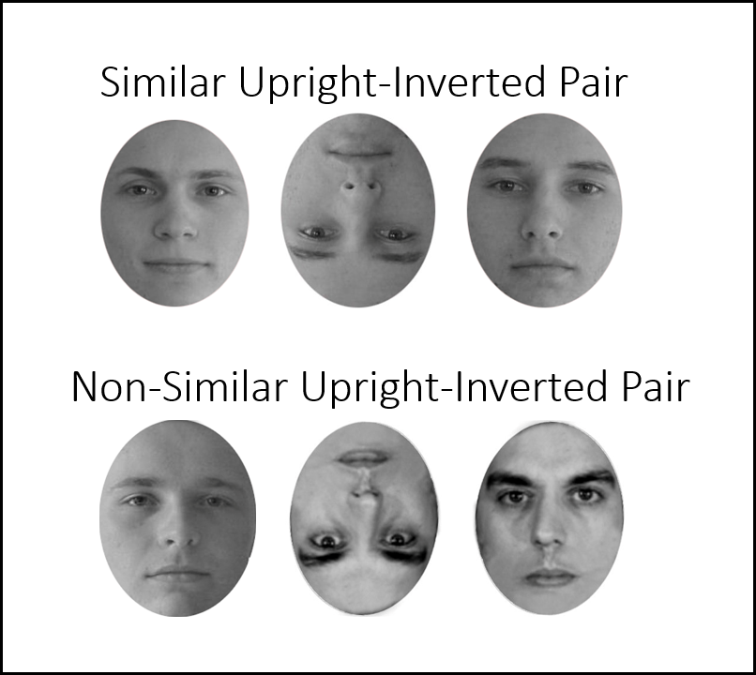

**Figure 1:** Examples of similar and non-similar pairs of oval-faces. The left face was presented in the upright orientation and the middle one in the inverted orientation. The upright face in the right is the same as the inverted one. It is presented here for the sake of comparison.

**Figure 2:** PercentHits and False Alarm as function of similar and non-similar groups of pairs of different oval-faces.

**Figure 3:** Similarity ratings as function of the pairs of oval-faces orientations and of similar and non-similar groups of pairs of different oval-faces.