**Using discrete low-frequency components of the shipping noise for gassy sediment characterization in shallow water**

**Andrey A. Lunkova)**

*Prokhorov General Physics Institute of the Russian Academy of Sciences, 38 Vavilov st., Moscow 119991, Russia*

**Boris G. Katsnelson**

*L .Charney School of Marine Sciences, University of Haifa, 199 Aba Khoushy Ave., Haifa 3498838, Israel*

**Abstract:** It is shown that sound speed in gas-saturated sediments, which is much less than sound speed in water, can be estimated using normal mode attenuation coefficients. For deeper penetration into the bottom, and for more effective mode filtering, a low frequency sound source is required. In an experiment in the Sea of Galilee, *R/V Hermona* was used as a moving noise source, approaching a vertical hydrophone array at a constant speed. Twelve narrow-band components of her noise in the frequency band from 20 to 100 Hz were identified and mode filtered. As a result, normal mode attenuation coefficients were estimated. The inversion results have shown that the sound speed in sediments was ~170 m/s.

**PACS numbers:**

**Date Received: Date Accepted:**

**1. Introduction**

Existence of gassy sediments is typical for many freshwater lakes1, reservoirs2 and oil/gas fields on an ocean shelf3. In lakes, the gas is primarily methane produced by microbial activity. The presence of gas bubbles increases the compressibility and, hence, decreases the sound speed in the bottom. Remark, that the sound speed is very sensitive to the presence of gas, for example, for muddy sediments, if the volume gas fraction is 1 %, the sound speed is about 100 m/s 2, that is much less than that in the water. Sound reflection coefficient from a such type of acoustically soft sediment is ~ -0.6 - -0.7 even at the normal incidence. Only rather low frequency acoustic waves can penetrate into the bottom below the gassy layer. Remark, that due to small wavelength in gassy sediment (for above mentioned sound speed and the frequency ~ 300 Hz,  ~ 0.3 m) even comparatively narrow gassy layer behaves like half-space and for comparatively deep penetration into sediment it is necessary to use low frequency sound (a few tens of Hz).

Direct measurements of gas fraction in sediments can be done using pressurized or frozen cores4, however, in addition to the high cost and complexity of obtaining samples, we note a noticeable invasiveness of the methods, which reduces the reliability and accuracy of the results4. Noninvasive acoustic methods within the framework of geoacoutic inversion, giving the parameters of sediment (sound speed, density etc.) can be a solution for this problem. By estimating the sound speed in sediments, the volume gas fraction can be inferred unambiguously5.

Among the methods of geoacoustic inversion, the methods utilizing ambient noise or ship noise instead of active sound sources are of particular interest. Chailloux *et al.*6 studied the possibility to use a shipping lane as a continuous acoustic source for passive detection of the Ushant thermal front. Battle *et al.*7 carried out the geoacoustic inversion of tow-ship noise via near-field-matched-field processing. The noise was recorded on a horizontal array towed by the same ship. Crocker *et al.*8 estimated the broadband source spectrum of a passing ship and the compression wave speed in the seafloor sediments using acoustic data collected by a bottom moored AUV in very shallow water. Stotts *et al.*9 extracted inversion solutions from noise measurements of surface ship source on L-shaped array in the 2006 Shallow Water Experiment. Tollefsen and Dosso10 applied Bayesian geoacoustic inversion to low-frequency narrow-band acoustic data from a quiet surface ship recorded on a bottom-moored horizontal line array in shallow water.

This paper considers extraction of normal mode attenuation coefficients from research vessel noise, which was recorded by a vertical line array in the Sea of Galilee (also known as Lake Kinneret, Israel). A matching procedure for the coefficients is used to estimate the effective sound speed in gassy sediments. Earlier study11,12 with a mid-frequency (~1 kHz) active sound source and a nearby single hydrophone revealed the spatio-temporal variability of the sound speed in the lake, taking values within ~180 to 730 m/s with spatial scales up to 4 km. The sound speed estimation was performed using the measurement of reflection coefficient for the sound pulse and the corresponding matched-field processing of the impulse response in the time domain.

**2. Theory of modal attenuation**

In shallow water, modal attenuation is strongly dependent on the bottom properties. According to Katsnelson *et al.*13, within the framework of a simplified theory, mode attenuation coefficient (imaginary part of eigen value of mode) can be written as follows

|  |  |
| --- | --- |
|  | (1) |

Where $D$ is the ray cycle distance of the ray, corresponding to a normal mode, $V$ is the bottom reflection coefficient, if the sound speed in water *c* is constant then $D=2H\cot{χ}$, where $H$ is the water depth, and $χ$ is the grazing angle of the ray. Considering the bottom as a homogeneous liquid half space with the sound speed $c_{b}$ much less than that in water $c$, the Rayleigh reflection coefficient at the water-bottom interface is represented as

|  |  |
| --- | --- |
| $$V=\frac{m_{b}\sin{χ}-\sqrt{n_{b}^{2}{\left(1+iβ_{b}\right)}^{2}-\cos^{2}{χ}}}{m_{b}\sin{χ}+\sqrt{n_{b}^{2}{\left(1+iβ_{b}\right)}^{2}-\cos^{2}{χ}}}≈\frac{m_{b}\sin{χ}-n_{b}}{m_{b}\sin{χ}+n_{b}}=1-\frac{2n_{b}}{m_{b}\sin{χ}+n_{b}}$$ | (2) |

Where $m_{b}=ρ_{b}/ρ$ is the density ratio, $n_{b}=c/c_{b}$ is the index of refraction, $β_{b}$ is the bottom absorption coefficient, defined through imaginary part of the complex wavenumber in sediment. If $c_{b}≪c$, the acoustic energy loss at the boundary is primarily governed by a sound speed contrast, and the absorption coefficient, $β_{b}≪1$, can be neglected. Then Eq. (1) takes the form

|  |  |
| --- | --- |
| $$α=\frac{m_{b}\sin^{2}{χ}}{H\cos{χ}\left(m_{b}\sin{χ}+n_{b}\right) }≈\frac{m_{b}\sin^{2}{χ}}{n_{b}H\cos{χ}}$$ | (3) |

For the *m*-th normal mode in a waveguide with a constant sound speed in water and with a soft bottom, sine and cosine terms in Eq. (3) can be represented as $\sin{χ_{m}}≈πm/kH$ and $\cos{χ_{m}}≈\sqrt{1-{\left({πm}/{kH}\right)}^{2}}$, respectively, where $k=2πf/c$ is a wavenumber. Substituting these terms into Eq. (3), the following expression is obtained

|  |  |
| --- | --- |
| $$α_{m}=\frac{ρ_{b}m^{2}c}{4ρf^{2}H^{3}\sqrt{1-{m^{2}c^{2}}/{4f^{2}H^{2}}}}c_{b}$$ | (4) |

One can see the linear dependence between sound speed in the bottom $c_{b}$ and mode attenuation coefficient $α_{m}$. In this paper, mode attenuation coefficients, extracted from noise recordings, are used as input data for the geoacoustic inversion. For a hard bottom, where $c_{b}>c$, the relation between bottom properties and modal attenuation is more complicated, as it includes bottom absorption.

**3. Experiment**

Acoustic noise data were obtained in an experiment conducted in the central part of the Sea of Galilee in late November 2017. The bathymetry at the experiment site, a research vessel track and the location of a receiving vertical line array (VLA) are illustrated in Fig. 1(a). The water depth $H$ along the track was approximately 37 m. The water column was characterized by a downward refracting sound speed profile $c(z)$ as shown in Fig. 1(b). Note that the cutoff frequency for this shallow water waveguide is about 20 Hz. A seven-element VLA was deployed from a stationary floating platform, called “*Ecoraft*”. The array spanned the water column from 4 to 34 m with 5-m spacing. The depth of each hydrophone $z_{j}$ is depicted in Fig. 1(b) by a small circle. The acoustic acquisition system collected 7 channels of digital data at a sampling rate of 20 kHz.

A small, 14-m long research vessel, *R/V Hermona,* was used as a moving low-frequency sound source. The vessel was equipped with two 400 hp diesel engines. In the experiment, *R/V Hermona* was approaching the VLA at a constant speed of 4 m/s (8 knots) during ~10 min along the straight line from north to south. The vessel GPS track is shown in Fig. 1(a) by a white arrow. The furthest point of the track considered was $r_{max}=$ 2500 m away from the VLA, and the closest one was $r_{0}=$ 100 m away. As the engine was running at a constant speed, the noise from the vessel is assumed to be stationary. Fig. 2 shows the noise spectrogram and normalized power spectral density from one hydrophone of the VLA. For the spectrogram, the window length was set to 1 s with 50 % overlap. The arrows in Fig. 2(b) indicate the twelve stable discrete frequency components at $f_{i}=$ 22, 24, 36, 44, 48, 66, 72, 76, 84, 87, 96, and 98 Hz. Presumably, these frequency components were produced by the propulsion machinery of the vessel. They were selected for the extraction of normal mode attenuation coefficients. In water, the Doppler shift for a frequency of 100 Hz and sound source speed of 4 m/s does not exceed 0.3 Hz.

The twelve frequency components were selected from spectrograms at each hydrophone of the VLA to obtain the time-dependent vertical profiles of acoustic pressure $P(f_{i},t,z_{j})$. Variation of the profiles with time is demonstrated in Fig. 3 for three frequency components 24, 48 and 72 Hz. Figs. 3(a), 3(b), and 3(c) illustrate one-mode, two-mode and three-mode propagation, respectively. Note that the observed interference patterns are symmetrical with respect to the center of the waveguide, as well as the acoustic pressure is almost null near the bottom. It means that the bottom is acoustically soft with a high reflection coefficient, even at a very low frequency. Recall that the pulse reflected from such a bottom is inverted (phase of reflection coefficient is ~), which is typical for the reflection from an upper free release boundary.

**4. Data processing and result**

Based on the GPS data, the time axis $t$ in $P(f_{i},t,z_{j})$ is converted to the range axis $r$ with the origin at the VLA location. To extract normal modes, a standard spatial filtering technique is applied to $P(f_{i},r,z_{j})$. The resulting modal amplitudes $A_{m}\left(f_{i},r\right)$ are represented as follows13

|  |  |
| --- | --- |
|  | (5) |

The effect of the non-uniform sound speed profile [Fig. 1(b)] on mode shapes $ψ_{m}(f_{i},z)$ is weak at frequencies below 100 Hz [Fig. 1(c)]. Thus, for the essentially acoustically soft bottom, mode functions can be approximated by perfect sinusoids $ψ_{m}\left(f_{i},z\right)≈\sqrt{2/H}\sin{(πmz/H)}$. The obtained range dependence of modal amplitudes is illustrated in Fig. 4(a) for the first three modes at the frequency of 72 Hz. Note, that for the soft bottom scenario, the modal orthogonality condition is satisfied rather precisely even for the integration over the water column only and accurate enough mode extraction can be done using a vertical array.

Modal amplitude in a range-independent horizontally waveguide can be written as

|  |  |
| --- | --- |
|  | (6) |
|  |  |

Here and after, the frequency dependence is omitted for brevity. Each $ψ_{m}\left(z\right)$ is an acoustic mode with associated horizontal wavenumber $q_{m}$ and attenuation coefficient $α_{m}$, $z_{s}$ is the sound source depth. To isolate $α_{m}$, first, Eq. (6) is divided by the modal amplitude $A_{m}\left(r_{0}\right)$ at the reference point $r_{0}$. Then, by rearranging terms and taking the natural logarithm of both sides, the following expression is derived

|  |  |
| --- | --- |
| $$\ln\left(\frac{\sqrt{r}A_{m}(r)}{\sqrt{r_{0}}A_{m}(r_{0})}\right)=-α_{m}\left(r-r_{0}\right)$$ | (7) |

In this equation, there is no dependence on the source depth $z_{s}$ and horizontal wavenumber $q_{m}$. To find the attenuation coefficient $α_{m}$, the function on the left side is linearly interpolated in the interval from $r_{0}$ to the maximum range, where the *m*-th mode can be identified. The slope of the line is associated with the attenuation coefficient. The maximum range for processing a given mode increases with frequency (see the dashed rectangles in Fig. 3). The reason for it is that the modal attenuation decreases with frequency. The estimated attenuation coefficients and their 90 % confidence intervals are given in Fig. 4(b) for the first four modes. One can see that the modal attenuation varies within a wide range from 10-4 to 10-2 m-1 (from 3 to 86 dB/km).

The inverse problem is solved to determine the effective sound speed $c_{b}$ in sediments supposed to be a liquid half-space. The experimental dependencies of $α_{m}$ are compared with simulated ones for a set of $c_{b}$ values. The upper sediment density of 1300 kg/m3 is known from the geophysical core data. If the sound speed in bottom $c_{b}$ is much less than that in water $c$, the bottom absorption coefficient $β_{b}$ can be neglected. Adding the bottom absorption does not affect the angular dependence of the bottom reflection coefficient due to the absence of total internal reflection at any angle, and all normal modes are leaky ones.

In the method proposed, sound speed value in sediments corresponds to the maximum of the following matching function, providing the best fit between the experimental, $α_{m}^{exper}$, and simulated, $α_{m}^{theory}$, attenuation coefficients

|  |  |
| --- | --- |
| $$F\left(c_{b}\right)={\left(\sum_{i=1}^{12}{\sum_{m=1}^{M_{i}}{\lg\left(\frac{α_{m}^{exper}\left(f_{i}\right)}{α_{m}^{theory}\left(f_{i};c_{b}\right)}\right)}}\right)}^{-1}$$ | (8) |

where $M_{i}$ is the number of normal modes at the frequency $f_{i}$.

As the result of matching, the estimated sound speed in the bottom is equal to 170±10 m/s. Simulated modal attenuation curves for that value are shown in Fig. 4(b) by dashed lines. Very close curves are obtained using the analytical expression, Eq. (4). The best agreement between experimental and simulated data is achieved in the frequency range from 22 to 96 Hz. However, the experimental frequency dependence is not monotonic which can be explained by a non-uniform structure of the bottom. Usually, the gassy sediment layer has the thickness of up to a few meters. The presence of the layer can lead to a resonant absorption at some frequencies, causing the increase of mode attenuation coefficients. The sound speed obtained corresponds to a volume gas (methane) fraction of 0.2 %. It is consistent with the results of previous studies11,12, where a mid-frequency (~1 kHz) wideband source was used and estimation of the sound speed in sediment was carried out using measurement of reflection coefficient.

For additional verification of the sound speed estimate, simulated and experimental interference spacing for the first and second mode $L_{12}=2π/(q_{1}-q_{2})$ are compared [Table 1]. A rather good agreement can be observed.

Table 1

|  |  |  |  |  |  |  |  |  |  |
| --- | --- | --- | --- | --- | --- | --- | --- | --- | --- |
| Interference spacing for the 1st and 2nd mode | | | | | | | | | |
| Frequency, Hz | **44** | **48** | **66** | **72** | **76** | **84** | **87** | **96** | **98** |
| Experiment (m) | 64 | 96 | 132 | 156 | 168 | 180 | 194 | 230 | 236 |
| Theory (m) | 70 | 91 | 145 | 161 | 173 | 196 | 204 | 229 | 234 |

**5. Conclusion**

The paper proposes to use discrete components of the research vessel noise, recorded by a vertical line array, for modal attenuation estimation at frequencies below 100 Hz. In a waveguide with gassy sediment, extraction of normal modes using orthogonality condition is accurate enough even when the integration is done over the water column only. The frequency-dependent mode attenuation coefficients obtained for the central part of the Sea of Galilee are inverted for the sound speed in the bottom. The estimated sound speed is equal to 170 m/s. Even at such low frequencies, the gassy half-space model describes properly the experimental acoustic data.

**Acknowledgements**

This work was supported by the Russian Foundation for Basic Research under Grant Nos. 20-05-00119 and 19-02-00127. The authors would like to thank E. Uzhansky and G. Zaslavsky for their help in collecting the acoustic data. The authors are also grateful to the crew of *R/V Hermona* for their professionalism.

**References**

1 Anderson, M. A., & Martinez, D. (2015). Methane gas in lake bottom sediments quantified using acoustic backscatter strength. Journal of Soils and Sediments, 15(5), 1246-1255.

2 Grigor’ev, V. A., Lun’kov, A. A., & Petnikov, V. G. (2015). Attenuation of sound in shallow-water areas with gas-saturated bottoms. Acoustical Physics, 61(1), 85-95.

3 Fleischer, P., Orsi, T., Richardson, M., & Anderson, A. (2001). Distribution of free gas in marine sediments: a global overview. Geo-Marine Letters, 21(2), 103-122.

4 Dück, Y., Liu, L., Lorke, A., Ostrovsky, I., Katsman, R., & Jokiel, C. (2019). A novel freeze corer for characterization of methane bubbles and assessment of coring disturbances. Limnology and Oceanography: Methods, 17(5), 305-319.

5 Tóth, Z., Spiess, V., Mogollón, J. M., & Jensen, J. B. (2014). Estimating the free gas content in Baltic Sea sediments using compressional wave velocity from marine seismic data. Journal of Geophysical Research: Solid Earth, 119(12), 8577-8593.

6 Chailloux, C., Kinda, B., Bonnel, J., Gervaise, C., Stephan, Y., Mars, J., & Hermand, J. P. (2011). Modelling of ambient noise created by a shipping lane to prepare passive inversion: application to Ushant. In Proceedings of the 4th Underwater Acoustics Measurements Conference (UAM 2011) (Vol. 26).

7 Battle, D. J., Gerstoft, P., Kuperman, W. A., Hodgkiss, W. S., & Siderius, M. (2003). Geoacoustic inversion of tow-ship noise via near-field-matched-field processing. IEEE journal of oceanic engineering, 28(3), 454-467.

8 Crocker, S. E., Nielsen, P. L., Miller, J. H., & Siderius, M. (2014). Geoacoustic inversion of ship radiated noise in shallow water using data from a single hydrophone. The Journal of the Acoustical Society of America, 136(5), EL362-EL368.

9 Stotts, S. A., Koch, R. A., Joshi, S. M., Nguyen, V. T., Ferreri, V. W., & Knobles, D. P. (2010). Geoacoustic inversions of horizontal and vertical line array acoustic data from a surface ship source of opportunity. IEEE Journal of Oceanic Engineering, 35(1), 79-102..

10 Tollefsen, D., & Dosso, S. E. (2008). Bayesian geoacoustic inversion of ship noise on a horizontal array. The Journal of the Acoustical Society of America, 124(2), 788-795.

11 Katsnelson, B., Katsman, R., Lunkov, A., & Ostrovsky, I. (2017). Acoustical methodology for determination of gas content in aquatic sediments, with application to Lake Kinneret, Israel, as a case study. Limnology and Oceanography: Methods, 15(6), 531-541.

12 Uzhansky, E., Katsnelson, B., Lunkov, A., & Ostrovsky, I. (2020). Spatial and temporal variability of free gas content in shallow sediments: Lake Kinneret as a case study. Geo-Mar Lett. https://doi.org/10.1007/s00367-019-00629-4

13 Katsnelson, B., Petnikov, V., & Lynch, J. (2012). Fundamentals of shallow water acoustics. Springer Science & Business Media.

**FIGURES**

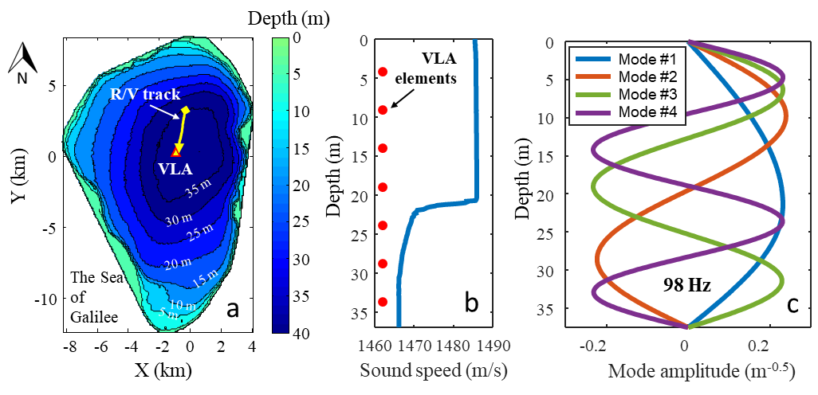

Fig. 1. Bathymetric map of the Sea of Galilee, the VLA location (red triangle) and R/V track (white arrow) (a), sound speed profile at VLA location and VLA elements depth (red circles) (b), and normal mode shapes at a frequency of 98 Hz (c)

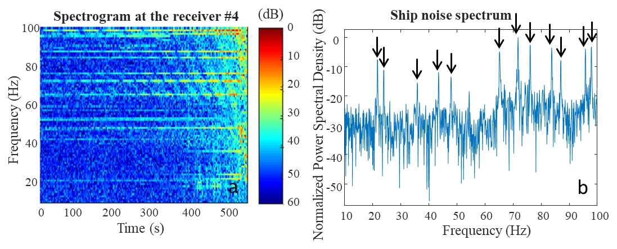

Fig. 2. Spectrogram (a) and normalized power spectral density (b) from the VLA element #4. Black arrows indicate the twelve research vessel noise lines used for inversion.

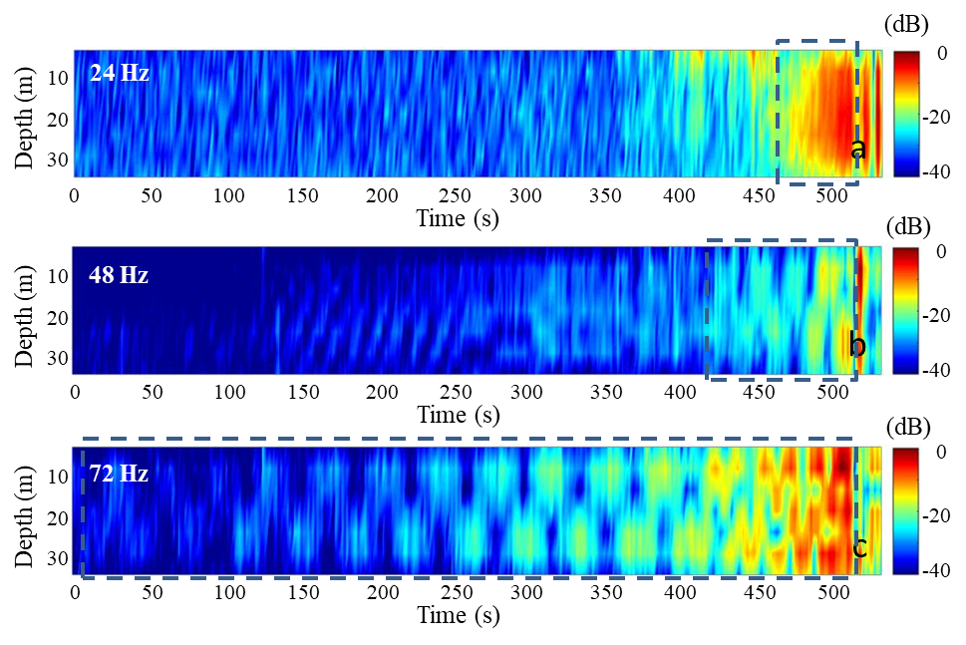

Fig. 3. Vertical profiles of acoustic pressure at the VLA at a frequency of 24 Hz (a), 48 Hz (b), and 72 Hz (c)

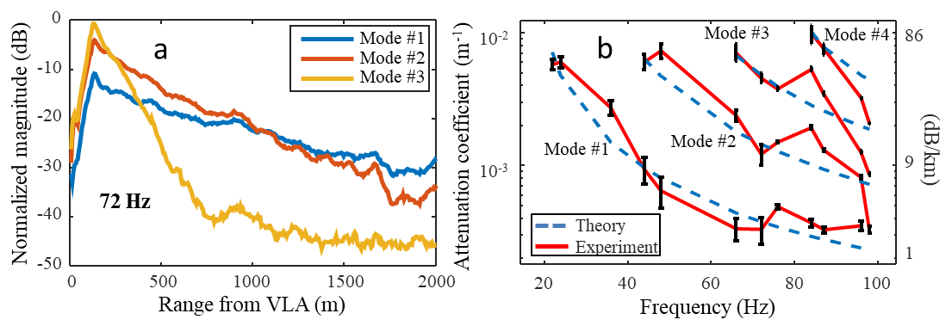

Fig. 4. Modal amplitudes vs. range from VLA at a frequency of 72 Hz (a), and experimental (solid curves) and simulated (dashed curves) attenuation coefficients vs. acoustic frequency (b).