**Initial Post-contact Behavior of an Axially Compressed Fiber Constrained Inside a Rigid Cylinder: Experimental, Analytical, and Numerical Investigations**

Yosef Dayan

Faculty of Mechanical Engineering

Technion – Israel Institute of Technology

Haifa 32000, Israel

[dayanyos@gmail.com](mailto:dayanyos@gmail.com)

David Durban

Faculty of Aerospace Engineering

Technion – Israel Institute of Technology

Haifa 32000, Israel

[aer6903@technion.ac.il](mailto:aer6903@technion.ac.il)

Sefi Givli[1]

Faculty of Mechanical Engineering

Technion – Israel Institute of Technology

Haifa 32000, Israel

[givli@technion.ac.il](mailto:givli@technion.ac.il)

# **Abstract**

The post-buckling behavior of a clamped-clamped elastic fiber constrained inside a rigid circular cylinder is analyzed theoretically, numerically and experimentally. We concentrate on characterizing the contact configuration, between the fiber and the cylinder wall, during initial post-contact stages of the fiber deformation, in which only a small segment of the fiber length makes contact with the cylinder wall. This is apparently the first study of this phenomenon in which an in-depth analysis of the fiber deformation stages has been presented at different load levels. The research was performed using several independent methods, including representative experiments, image processing of test data, finite elements analysis complementing the experimental part, and analytical models. The entire deformation history is investigated, from initial fiber loading up to transition to 3-D deformation. The main experimental challenge is to identify regions of contact between the fiber and the cylinder wall, and to distinguish them from segments of the fiber that are very close to the cylinder wall but make no contact with it. To this end, we employ a novel experimental setup consisting of a transparent rigid cylinder filled with an opaque milky fluid, combined with image processing and synchronized force measurements. The results agree with published theoretical predictions that are based on a simplified theoretical model assuming a perfect fiber and no friction, under the restriction of initial diminutive geometrical imperfection. Supported by finite-element analysis (FEA), we found that friction increases the measured force for the same level of ends shortening but has a small effect on the overall behavior. In contrast, the initial geometrical imperfection may significantly affect the force-displacement relation and the evolution of the contact configuration. Both symmetrical and anti-symmetrical initial imperfections of the fiber shape are analyzed theoretically, whereas the symmetrical specimen was also examined experimentally. The study provides insights regarding the influence of relevant parameters on the behavior of such systems that may have practical implications in the fields of stent procedures, medical endoscopy, deep drilling, and the mechanics governing the growth of roots and plants.

Keywords: lateral constraint, contact, post-buckling, finite-elements, experiments

# **Introduction**

The post-buckling behavior of a linearly elastic fiber subjected to lateral constraints is of practical importance in a variety of fields, ranging from medical procedures (such as in vivo diagnosis) to engineering applications. Examples of applications in the field of medical procedures include the threading of fiber for the purpose of medical imaging or for catheterization of the heart, urinary tract, and blood vessels. Understanding the nonlinear behavior of such systems, and in particular, the forces exerted by the fiber (the guidewire) on the constraining walls (artery) is important in order to ensure the safety of the procedure [1]. In rare cases, the extensive deformations of the guidewire can result in the fracture of the guidewire or cause damage to the artery during the intervention procedure [2, 3] . Other applications include the internal examination of pipe systems, the insertion of artificial fibers in industrial crimpers, drilling of wells from a platform to reach deep hydrocarbon or gas reservoirs [4], effects of delamination in composite materials [5, 6] , the insertion of paper into toner, growth of plant roots [7], and the growth of filopodia in living cells [8-11].

Originally, the engineering community was mainly concerned with ways of avoiding large deformations followed by buckling, and the scientific discussion concentrated on assessing critical forces [12-15]. During the second half of the previous century, starting in the early sixties, theoretical models of post-buckling behavior began to emerge. These early works focused on formulating and solving problems of (laterally-unconstrained) compressed columns and curved beams subjected to various types of boundary conditions [16, 17]. In recent decades, the interest in post-buckling behavior of laterally constrained fibers has constantly increased. Theoretical and experimental studies have shown that a bi-laterally constrained fiber undergoing plane deformations exhibits intriguing behavior, and the studies presented a rather rich sequence of events under controlled axial end displacement [6, 18-21]. This sequence includes the formation of discrete (point-contact) or continuous (line-contact) regions of contact between the fiber and the constraining walls, and the instantaneous transition from one equilibrium configuration to another due to the onset of local instability. The specific details of these events and their dependence on parameterssuch as slenderness of the fiber, the ratio between the fiber radius of gyration and the gap between the walls, loading rate, and friction can be found [22]. Theoretical studies have adopted various strategies and simplifying assumptions, such as fixed constraints, frictionless walls, or small deformations [4, 23], concentrating on studying the range of possible equilibrium configuration and the evolution of contact between the fiber and the constraining walls [4]. In addition, numerical methods were employed to study the planar deformation of fibers subjected to more complex lateral constraints, such as non-parallel walls, non-continuous and curved surfaces [24-30] . Only a handful of studies consider the effects of friction [4, 23], and an even smaller body of work have approached the realistic case of compliant (deformable) constraining walls, [31, 32].

The three-dimensional (3-D) response of a fiber constrained inside a rigid cylinder is discussed in [33]. Here, in addition to the formation of discrete and/or continuous contact regions, a transition between planar deformations and three-dimensional configurations occurs. Typically, the initially straight elastic fiber buckles into a planar wavy shape when subjected to edge-thrust. As the edge-thrust increases, the fiber contacts the cylinder wall, switches to a non-planar deformation, and eventually twists and adopts a helix-like shape. In some applications, such as for drilling oil wells, understanding the details of this behavior is crucial. In particular, once the fiber contacts the wall, the effectiveness of the drilling operation is dramatically decreased. Moreover, locking might occur when the fiber takes a helix-like shape with extensive wall contact. A similar phenomenon also occurs in stent operations [2, 3, 22, 34]. Studies of the 3-D deformation of a laterally constrained fiber have been performed in the context of delamination occurring in fiber-reinforced composites, [35, 36].

Theoretical studies investigating the 3-D deformation of a fiber constrained inside a cylinder can be roughly divided into two main groups. The first group assumes that the constraining cylinder is slender, and the deformation of the fiber is minor, thus making the classical model of small-rotations applicable. Different formulations for the critical loads and post-critical configurations were studied, with several papers considering the effects of friction [22], gravity [37, 38], and the inclination angle of the constraining cylinder [12, 39]. In the second group of studies, finite deformations are accounted for and the elastica theory is commonly adopted to describe the nonlinear behavior of a fiber undergoing finite deformations.

Nearly all theoretical works studying the finite deformations of a fiber constrained inside a cylinder have focused on the final stage of the fiber deformation process where almost the entire length of the fiber contacts the cylinder wall and the fiber adopts a helix-like deformation [8-11]. The studies in [16, 37] are among the earliest in this direction in which an energy method was used to extract the relation between the edge-thrust and the pitch of the circular helix. To date, not much attention has been given to the initial (post-contact) stages of the fiber deformation that follow the first contact between the fiber and the cylinder wall. In this respect, the studies in [40-42] provide valuable theoretical, numerical, and experimental information; the focus therein is on extremely slender cylinders (inner radius to length ratio of ~) and on horizontal orientation, causing nearly 90% of the fiber to be initially in contact with the cylinder even before the external load was applied. In work published recently by Chen et al. [43, 44], a rigorous theoretical model was developed to describe the post-buckling behavior of a perfectly straight fiber inside a rigid and frictionless cylinder. Before external force is applied, the fiber coincides with the center line of the cylinder, making no contact with the cylinder wall. Numerical results for a relatively large inner radius to length ratio of ~have demonstrated the many possible equilibrium configurations of the fiber in constrained cylinder. However, there is a definite need for experimental studies that systematically investigate the post-contact behavior in such processes.

The goal of the present paper is to present further progress towards bridging this gap. We systematically study the initial deformation stages of a fiber constrained inside a rigid cylinder by means of novel experiments as well as finite-element analysis (FEA). Special effort has been made to develop an experimental method that enables the identification of contact characteristics between the fiber and the cylinder wall. This identification is a challenging task since even if a transparent cylinder is used, the curvature of the cylinder strongly affects the optics and makes it practically impossible to realistically identify contact (or non-contact) between the fiber and the cylinder wall. The approach we have adopted is based on filling the transparent cylinder with an opaque white fluid and using a dark fiber along with post-experiment image processing. Synchronized force-displacement measurements have enabled accurate quantitative identification of the deformation pattern, including the corresponding contact behavior. Comparison of the results with the theoretical predictions of [44] provides valuable information regarding the applicability of the underlying assumptions in that model.

# **Brief review of available theoretical predictions**

Since the model and results of [44] are of immediate relevance to the current research, we briefly review its main theoretical findings and predictions in this section. In preliminary work, Chen and Fang [43] adopted the assumption of small deformations to study the post-buckling of a fiber constrained inside a rigid cylinder. The model considered a slender, isotropic, linear elastic, stress free and perfect fiber (no geometrical or material imperfections) of length  with circular cross-section of bending stiffness- namely the flexural rigidity of the beam in the plane of bending. The effects of gravity and friction were assumed to be negligible, and clamped-clamped boundary conditions were considered, i.e., one end of the fiber is completely fixed (zero displacements and rotations) at the center of the cylinder cross-section, while the other end can only move along the axis of the cylinder. The effects of the edge-thrust on the fiber deformation and corresponding contact configuration were investigated. According to this model, the transition from 1-point contact configuration to 2-point contact configuration occurs at edge-thrust of , which corresponds to the critical (Euler) buckling load of a clamped-clamped column of length . Interestingly, it was found that this transition involves a jump in the ends shortening. It has been argued that this peculiar jump phenomenon is due to the limitation of the small-deformation theory. In order to remedy this deficiency, a theory associated with the elastica model was developed in [44] (a similar approach was applied in [45, 46] to study the deformation of a fiber subjected to end-twist rather than end-thrust). The aforementioned model assumptions of [43] were adopted in [44] except for the assumption of small deformations. Also, it was found that, contrary to the small-deformation theory, the planar 1-point contact evolves to spatial (3-D) 1-point contact first and then gradually transforms to the 2-point contact configuration. Moreover, seven deformation shapes, each characterized by a different contact configuration, were identified [44]: (1) no-contact, the fiber “buckles” into a curved shape as force approaches Euler’s critical load; (2-1) contact forms between the fiber and the cylinder, leading to a planar (2-D) 1-point contact configuration, in turn resulting in a sharp increase of the fiber response slope; (2-2) the fiber switches to a spatial (3-D) 1-point configuration, associated with a significant decrease of the slope; (3) gradual evolution of a 2-point contact configuration; (4) 3-point contact configuration; (5) point-line-point contact; (6) one-line contact; and (7) three-line contact.

In this paper, we investigate the mechanical response of a fiber undergoing large deformation inside a stiff cylinder by comparing different FE analysis, experiments, and theoretical predictions. The paper is organized as follows: In Section ‎2, we describe the methods and materials that include the experimental system, image processing, and numerical simulations to characterize the contact configuration between the fiber and the cylinder wall. In Section ‎3, we discuss the experimental, image processing, and numerical simulation results and compare them with the results from the theoretical predictions. Finally, Section ‎4 summarizes the main conclusions drawn from this study and identifies problems for future research. In addition, the influence of symmetrical and anti-symmetrical initial imperfections of the fiber shape are analyzed theoretically, whereas the symmetrical mode has been examined experimentally as well.

# **Materials and methods**

The theoretical predictions are based on the assumptions that the thin elastic fiber of length  with circular cross-section is inextensible and unshearable; the fiber is uniform in its mechanical properties along its length  and is stress-free when it is straight and untwisted; the fiber deformation is constrained inside a straight circular cylinder with radius; and the centerline of the constraining cylinder coincides with the unstressed straight fiber. Gravity and friction force are not considered. The diameter of the fiber cross-section is negligible compared to that of the cylinder. We consider the deformation of the fiber when it is subjected at one end, to prescribe edge-thrust and bends under the constraint of the cylinder wall. It is assumed that the fiber is completely fixed at the other end and not allowed to rotate about the longitudinal axis. Thus, at the loaded end, the fiber is clamped laterally but is free to slide longitudinally. The solution method in analysis must envision at the outset what the deformation pattern is, such as 1-point contact or 2-point contact. During the early stage of the deformation sequence, one is guided by previous experience from the small-deformation theory, leading to point-line-point contact. Further on, for given fiber dimensions, the ensuing constrained elastic deformation depends, on the radius of the constraining cylinder. Based on the parameter , the ratio between cylinder radiusand fiber length , it has been found that for a relatively slender cylinder, such as  [44], the early stages of the deformation sequence are similar to the stages obtained from the small-deformation theory. Thus, the stages are 1-point, 2-point, 3-point, and point-line-point contact configurations. However, some fundamental differences exist between the predictions of small-deformation theory and the elastica model, even along this early stage of deformation.

According to small-deformation theory, the 1-point contact stage exists only in planar form; while with the elastica model, the 1-point contact stage of the spatial form also exists, so in this model there is a 3-D deformation at 1-point contact stage. In addition, according to small-deformation theory, the point-line-point contact configuration is the final stage of the deformation. Also, as the radius of the constraining cylinder increases, the deformed patterns become less complicated and the number of patterns before the two end clamps meet decreases. As expected, the difference between the small-deformation theory and the elastica model increases as the radius of the constraining cylinder becomes larger. In fact, when  is larger than 0.384 [44], the constraining cylinder has no effect on the elastica deformation.

# **Experimental setup**

Experiments were performed in the material-mechanics laboratory (Faculty of Mechanical Engineering, Technion – IIT) using an Instron 4483 machine, on which the designated experimental system was installed, see Fig. 1. The experimental system includes 6 different CSN EN 10270-1 steel wire fibers of length , with three radii , inside transparent cylinders (of radii and ). The latter have been filled with an opaque white fluid (metalworking-cooling fluid, PVR-925S, mixed with water). Due to the inherent curvature of the cylinder, which strongly affects the optics, it is practically impossible to identify the onset and progress of contact between the fiber and the cylinder wall. Filling the transparent circular cylinder with the opaque white milky fluid enables identification and tracing the progress of these contact regions, as explained below. Special adapters were designed and installed to impose clamped boundary conditions at both ends of the fiber. Then, the lower adapter was fixed to the cylinder while the upper one was attached to the moving arm of the Instron machine, so the fiber coincided with the symmetry axis of the cylinder at the start of the experiment. During the experiment, the distance between the two ends of the fiber was slowly decreased, upon lowering the upper end, by the Instron machine; this process resulted in the bending deformation of the fiber constrained by the cylinder. Our method in which the distance between the two ends of the fiber is shortened while the length of the fiber remains constant differs from the method in [36]. Therein the fiber is injected from the left to the right and pulled over two feeder rollers through a slave injector, forming a slack loop, and then pulled through a primary injector into the constraining glass cylinder. We believe that the experimental method employed in this study has advantages over previous experimental setups, including minimal friction and higher accuracy in measuring the fiber force. In our experiments reaction forces are transmitted over an air bearing slider to the force sensor. The fiber is then pulled through a channel by an idler wheel and a drive wheel, driven by a servo-stepper motor holder of an acrylic clamp holding the cylinder in place. The deformation is examined for the six different cylinders, chosen to enable a quantitative comparison with the results presented in [44], i.e., two different values of the non-dimensional ratio of  have been employed. Ends shortening (a decrease of the distance between the two clamps) was determined by the displacement of the upper clamp, that is controlled by the Instron machine, using displacement control. In this configuration, loads are applied to adapter based on the displacement, and the displacement is determined using an Encoder installed on the Instron. In this procedure, the displacement changes incrementally while the reaction force results depend on the stiffness of the structure. Edge-thrust (axial compressive force) applied on the fiber was measured by a static load cell, and together with displacement adapter both were synchronized with a digital camera (MAKO G-223 with CMOSIS/ams CMV2000 sensor, global shutter; 50 frames per second) that was used to record the experiment. The maximum level of ends shortening was restricted by the software to prevent plastic deformations.

In each experiment, two complementing characteristics of the response were recorded: the force displacement relation and details of contact. To determine these features, the axial force applied to the fiber was monitored along with the corresponding ends shortening. The analysis of the force-displacement relation provides the core information on the fiber loading process, revealing important aspects of the fiber behavior. The details of contact between the fiber and the cylinder were determined by analyzing the successive frames, taken by the camera, and complemented with MATLAB® assisted image processing, thus providing clear exposition of the contact region between the fiber and the cylinder wall. Synchronization between the camera and the Instron machine enables the contact configuration to be identified and combined directly with the force-displacement relation. This synchronization provides instructive qualitative and quantitative comparison between the behavior observed in the experiment and the structural response predicted by FE analysis and by the theoretical predictions of [44].

# **Image processing**

Each snapshot (image) underwent image processing with MATLAB® to identify the contact region between the fiber and the inner wall of the cylinder. To this end, the following procedure was applied: First, the image converted to a digital array of scalar integers in the range of [0,255]. The array size is identical to the number of pixels in the image, and the scalar integer values represent the gray level of each pixel, where the extreme values of 0 and 255 correspond to black and white, respectively.

Next, the image is corrected to produce a uniform background, i.e., make all pixels of the white fluid have the same gray level. The purpose of this step is to minimize the effects of non-uniform illumination due to the curvature of the cylinder wall. Without this correction, columns of the array (image) that are remote from the center are generally darker (have smaller gray-level values). That correction involves multiplying each column by a different factor such that the average values of the fluid pixels in all columns are identical. Finally, a threshold filter is applied to isolate pixels corresponding to contact between the fiber and the cylinder. The threshold level is calibrated by using the force-displacement plots, so that the image where the fiber makes first contact with the cylinder wall is identified. In that stage of deformation, the contact configuration is necessarily of “point contact” type. Thus, the threshold level is set as the gray level of that contact point, and the extent of the contact region associated with a “point contact” is determined (practically, due to effects such as imperfections and compression of the fiber against the cylinder wall, the so-called “point contact” configuration should be considered as a small region of contact).

# **Finite-element simulations**

FE analysis were performed with the commercial FEA software Abaqus®. A dynamic implicit analysis was designed to simulate the experimental system, which includes a fiber that is clamped at both ends and is laterally constrained by a rigid cylinder. The fiber model is meshed with hexahedral solid elements, type C3D8R (8-node brick, accounting for geometrical nonlinearity), with over 50 elements in the fiber cross-section and a total of 2700 elements in the entire fiber. Elasticity modulus of was assigned to the fiber, in accordance with tensile experiments that were performed with the Instron machine. Preliminary analyses with high-order brick elements and with a larger number of elements in the mesh have resulted in similar results.

Referring to Fig. 1 and Fig. 2, the lower end of the fiber is fixed with all displacements and rotations avoided. At the upper end of the fiber, where the force is applied, the only degree of freedom is displacement in the x direction, under a constraint that allows for a predefined displacement of 80 mm. In the numerical analysis, the vertical displacement is identified with the shortening between the two ends of the fiber. The vertical force on the upper end of the fiber, applied by the Instron machine in the experiment, was determined in the simulation. The shortening rate of the ends was, which is comparable to the rate at which the experiments were performed. Preliminary FE analysis showed that lower rates produce similar results, implying a quasi-static experimental response.

To facilitate fiber bending response from the outset, avoiding a bifurcation analysis at the first buckling load, we introduced into the analysis a realistic geometrical imperfection. Thus, the stress-free configuration of the fiber was assumed to admit on symmetric imperfection, see Fig. 2 as the initial deviation from the axis of symmetry of the constraining cylinder.

It is recognized in post buckling theory that the worst clamped-clamped geometrical imperfection are identical with the first (symmetrical) and second (anti-symmetric) buckling modes. This will be implemented in the present analysis upon combining theory, experiment and numeric.

In the numerical analysis, contact between the cylinder and the fiber was defined using penalty stiffness in the normal direction of the contact surfaces (pressure-overclosure with "hard" contact and no penetration). In addition, tangential interaction, accounting for friction between the two bodies, was set in the model. Two values of the friction coefficient,  were examined, representing the estimated range of the friction coefficient between the metal fiber and the Perspex wall of the cylinder, including a greasy metalworking-cooling fluid as discussed earlier.

# **Analytical insights from initial imperfection analysis**

In this section, we present analytical derivations for the initial post-buckling response of the fiber, accounting for presence of initial imperfection, see Fig. 2. Both symmetric and antisymmetric components are assumed, aiming at simple, if approximate, relations for critical points along the loading path.

# **End displacement for the first contact**

# The analysis in this section is based on the well-established elastic solution for a clamped-clamped fiber. The analytical model that describes the behavior of the fiber in presence of the initial imperfection is adopted from [15], where is the initial wavey shape of the fiber axis, without deformation stress. When a longitudinal compressive force is applied to the axis of the fiber, an additional deflection occurs, so the total shape of the deflection curve becomes. In absence of lateral load, the differential equation for the column response is



Here we assume, following [15], that the stress in the fiber occurs due to the deflection only, but the moment component is produced by the total deflection . In  represents the flexural rigidity and  denotes the distance along the fiber, with origin located at the center of the wire (Fig. 2). When the load  increases beyond, a small additional deflection  occurs in the fiber where  is the force applied to the fiber at first wall contact. For a purpose of analytical consideration, we define the initial imperfection as a superposition of symmetric and antisymmetric modes, which represent two solutions of the general beam equation:



Here  are the scaling amplitudes of symmetric and antisymmetric imperfection modes respectively, and  is the first eigenvalue of . By substituting in to and implementing clamped boundary condition, an additional displacement  is defined as follows:



is the critical (Euler) buckling force of the fixed-fixed fiber.

The total bending displacement becomes



Eq. demonstrates that the fiber will collapse under two critical loads, namely  for symmetric and  for antisymmetric modes.

The values of  can be assessed from experimental data. As a first approximation, we assume that  and . It allows us to neglect the anti-symmetric branch at the first wall contact (, at ), when the force  is applied to the fiber. Using , the symmetric imperfection amplitudecan be defined as



In order to define the antisymmetric scaling , we calculate the fiber end displacement due to bending only, using the standard geometrical relation



Eq. , after substitution of Eqs. -, provides the nondimensional end shortening in the following form



where 

and 

Coefficients  and  can now be evaluated from  measurements along the loading path, using relations and , or more accurately by the best fit procedure using Eq. for measurements of the end shortening variation versus applied load.

In the subsequent analysis we define the nondimensional coordinate  and rewrite the total deflection curve as



with definitions given by Eq. ,



Next, it should be instructive to examine the  curve in the absence of walls, as  approaches its critical value , in order to examine the configuration near the second contact point on the cylinder wall due to buckling force . The values of and  in were calculated using the least-squares method on the experimental results. An integral formulation of the displacement  allows us to determine its asymptotic values for two critical loads, , shown as triangles and dashed lines in Fig. 3 (a)÷(e). Curves in Fig. 3 (a)÷(e) show the normalized data from the Instron device experiments, where circles represent the analytical model .

In Fig. 4 the curves from are presented for five experiments where the fiber contacts the cylinder wall, together with calculated values of location and buckling force . The dashed red curves in Fig. 4 indicate the boundaries of the cylinder for  and . In order to find the location and buckling force  of the first point of contact between the fiber and the cylinder wall, we solve two equations obtained from the conditions of contact:. Using the coefficients  obtained early from , a value of  for a contact between the fiber and the cylinder and its position are determined.



Assuming that contact occurs near the midpoint, i.e. for , and using linearization, we obtain from and approximations for buckling force and location:



The location of the second contact point and the buckling force  are calculated by and presented in Fig. 4.

# **Solution for fiber and cylinder wall in contact**

Fiber under axial load undergoes planar (2-D) deformation, forming a point contact between the fiber and the cylinder. For increasing load, the end displacement of the fiber increases, but the curvature at the contact point decreases. When this curvature becomes zero, line-contact forms, which is the onset of the transition to 3-D deformation. To clarify this transition, we analyzed it by considering small deformations. In this Section, we describe the bending of the fiber, its contact with the cylinder wall, and the onset of the transition to 3-D deformation. Fig. 2 shows the configuration under consideration, where  is the initial imperfection of the fiber before loading. When loading begins, the fiber deformation increases up to the first critical point at the load , where the fiber buckles. Next, the growing load further deforms the fiber and, at some force , the fiber touches the wall for the first time, and the lateral coordinate  gives the fiber displacement from the  axis. When the load  increases beyond, a small additional deflection  occurs in the fiber. The fiber geometry remains 2-D until a critical load  is applied, when it becomes 3-D because of bifurcation. The fiber shape relative to the direction of the force  is defined by , and relative to the bending is  because no bending forces exist at . As a result, we obtain the following equation (see [15]), which represents a balance of the external (compressive) and internal (bending) forces exerted on the fiber:



In , is the flexural rigidity,  is a longitudinally compressive force, and  represents the distance along the axis. When the fiber touches the cylinder wall, we obtain :



# Subtracting from gives



# We introduce the dimensionless parameter ,[(the root of the equation].

# Upon differentiating with respect to, takes the form



The solution for  is given in . The solution of has homogeneous and non-homogeneous parts. The fiber deformation is not symmetric about the point of contact, so we divide the solution domain into the left and right branches around the zero point (i.e., approximately in the middle of the fiber).

Next, the solutions of the left and right branches of can be written as follows:



The solution for  refers only to the first contact between the fiber and the cylinder wall, i.e. for .

The constants  of the homogeneous part are defined by the following four boundary conditions:



where .

The analytical solution of these equations provides the coefficients given below in . To present the coefficients more succinctly and clearly, we take the parts of the coefficients that depend on  and bind them to variables (see Appendix A):



We treat the right branch of the solution in a similar way by defining constants:



The analytical solution of these equations is (for variables, see Appendix A)



Equations and with constants defined by and , allow us to calculate the curves  for different values of . The results are shown in Fig. 5.

The dimensionless fiber-tip displacement  (see Fig. 2) can be calculated using the compressive force:



When the fiber under the forcecontacts the cylinder wall, Eq. determines the dimensionless fiber-tip displacement:



According to Eq. ,  may be approximated as 

Combining Eqs. and yields



The terms in can be evaluated using the following assumptions: the middle part of the fiber forms a pinpoint contact with the cylinder wall, whereas some parts of the fiber protrude beyond the virtual wall because the loading at the point of contact remains constant as a result of the developing deformation. No friction exists at the point of contact. After calculating the integrals (see Appendix A) yield:



where integrals are given in Appendix A.

Eq. includes an approximation based on two asymptotes in the force range between. To describe an asymptotic behavior of the dimensionless fiber-tip displacement, we use the first significant term of the small-disturbance analysis. For  and using , the significant term is:



The solution of satisfies the condition when the fiber first contacts the cylinder wall.

For  and using , the significant term is



The solution of Eq. is acceptable up to 3-D deformation because we are dealing with small changes and there is one contact point and a line contact for the fiber along the cylinder wall. The curves in Fig. 3 show the normalized experimental results obtained by using the Instron device, and the solid circles give the results of the analytical model in Eq. , which describes the situation when the fiber touches the cylinder wall . The triangles represent two asymptotic models in Eqs. and . In addition, Fig. 3 shows that the calculation of the circles prior to contact and after the transition to 3-D deformation is consistent with the calculation in the previous Section in Eq. .

# **Results**

All results herein are presented in terms of non-dimensional quantities: the fiber-tip displacement  , the axial compressive force , and the magnitude  of the symmetric initial imperfection. These quantities functions of the following real parameters: the actual fiber-tip displacement , the initial unloaded fiber length  (i.e., the vertical distance between the clamped ends of the fiber at the start of the experiment), the vertical force applied to the fiber, , the Euler buckling force  for a perfect clamped-clamped column, the Young’s modulus of the fiber , the moment of inertia of the fiber , the inner radius of the cylinder  and the fiber radius .

Fig. 6 and Fig. 7 show the vertical force versus fiber-tip displacement up to the first contact point between the fiber and the cylinder wall. As expected, before the first contact occurs, the height of the “plateau” region approaches the theoretically predicted value of  (ideal fiber, marked by dashed curve), as the geometrical imperfections amplitude becomes smaller. In addition, the analytical model shows the effect of the geometrical imperfection on a force before the first contact. Due to increasing  value and no effect of , the force required to produce the plateau decreases. Note, that the theoretical predictions are obtained without the initial bending, boundary conditions differ from the analytical results and the solution in Ref. [44] is numerical. By comparing the FEA results with those of the experiment at the initial stage of a fiber deformation, we deduce that the level of imperfection in the experiment is equivalent to  and .

Fig. 8 shows the force-displacement relation measured in three experiments that differ only in the fiber radius: . All three experiments use same free fiber length  and the cylinder inner radius, providing . The results of the experiments are compared with the theoretical prediction (red dashed curve). The theoretical prediction may be divided into five distinct stages for the fiber-bending process that occurs over the measured range of loading. These stages are indicated in Fig. 8 by numbers in parentheses and are separated by the full circles that lie on the theoretical force-displacement curve.

In order to avoid plastic deformations, the fiber-tip displacement was limited in our experiments, so the theoretically predicted deformation stage (**5**), which is associated with the point-line-point contact configuration, could not be realized. The measured force-displacement relation for the fiber with **(black curve), as one can see, are consistent with the theoretical prediction within their range of values.

The minor deviation (less than 8%) of the critical value calculated for the fiber-buckling force is apparently due to geometrical imperfections. This effect is expected to become more pronounced for thinner fibers, which are more susceptible to geometrical imperfections. In fact, the critical loads measured for fibers with *r* = 0.78 mm (blue curve) and ** (azure curve) are below the Euler buckling load by 15% and 40%, respectively. As expected, the effect of geometrical imperfections reduces with increasing fiber-tip displacement. Once a contact occurs between the fiber and the cylinder, the effect of the initial imperfection becomes negligible for both fibers (). For the **fiber, however, the imperfection is so significant that it affected the fiber behavior over a large range of fiber-tip displacement, up to about . Note that the first contact between the fiber and the cylinder wall can be deduced directly from the measured force-displacement curve; namely, it occurs at the end of the plateau region associated with , followed by a sharp increase in the slope of the loading curve.

For all three fibers, the first contact occurs at almost the same dimensionless fiber-tip displacement , which is consistent with the theoretical prediction. This result suggests very minor initial deviation of the as-received fibers from the straight perfect geometry. Note that the transition from planar 2-D deformation to 3-D deformation occurs at a force , in accordance with results reported in Refs. [43, 44]. The fluctuations of the measured force are presumably due to friction between the fiber and the cylinder, causing stick-slip–like behavior. The larger contact forces between the fiber and the cylinder wall cause these fluctuations to increase with increasing fiber-tip displacement. The contact configuration cannot be obtained directly from the force-displacement relation. So, we use the image-processing procedure described in Section ‎2.2 and shown in details in Fig. 9.

For each of the three fibers, the top row shows side-view photographs for different fiber-tip displacements. For convenience and to enable comparison, these fiber-tip displacements and associated labels **a–i** are identical to those in Fig. 8 and in the figures that follow. Specifically, fiber-tip displacement  associated with deformation **i** could not be attained for the fiber with . The application of the image-processing procedure to the photograph results in the images presented in the bottom row of Fig. 9. For the fibers with , the deformation stages and contact evolution are qualitatively consistent with the predictions by the theoretical model and the FE simulations, which are similar to the deformation stages described in Fig. 8.

Perhaps the only discrepancy with the theoretical predictions is related to the notion of point contact. Clearly, theoretical point contact cannot occur in practice. Instead, a small segment of contact may be considered equivalent to the theoretical point contact. As a result, all images (for both fibers) up to stage **e** reflect a single-point-contact configuration. These images also clearly show the development of two distinct regions of contact that seem to move farther apart with increasing fiber-tip displacement, as predicted by the theoretical model for stage **f–h**. Still, it is noteworthy that the size of these contact regions depends on the reduction in fiber length.

Finally, the image-processing procedure reveals three separate regions of contact at stage **i**, which is consistent with the theoretical prediction. The good qualitative agreement, in terms of contact characteristics, between experimental results and theoretical predictions is consistent with the good quantitative agreement in terms of the force-displacement relation. In contrast, for the fiber with , the measured force-displacement curve deviates significantly from the results of the theoretical prediction, mainly because of the effects of geometrical imperfection; see Fig. 8. Fig. 9 shows that the deviation from the theoretical prediction is also reflected in the way in which the contact evolves.

For example, after formation of the two-point contact, a further increase in fiber-tip displacement does not increase the distance between the contact points. Instead, the contact area at each of the contact points increases, resulting in what appears as a line-contact configuration. This evolution of contact, which is not identical between the two contact points, eventually evolves into almost a single line-contact configuration that connects the original point-contacts. This phenomenon and, in particular, the observed asymmetry evolves from the single line contact and is probably a consequence of significant geometrical imperfection combined with friction.

Next, we analyzed the deformation of the constrained fiber by using FE simulations. Fig. 10 shows the results of the FEA for the fiber with . Several force-displacement relations are shown and each is associated with a different geometrical imperfection amplitude  and friction coefficient  (Coulomb-type friction in Fig. 10; see the black curve, black dashed curve, red dashed curve, red curve, orange dashed curves and orange curve). In addition, we included a simulation with negligible geometrical imperfection and a very small friction coefficient (red curve). The results of this simulation are completely consistent with the theoretical prediction that assumes a perfect fiber and no friction (red dashed curve). A minor discrepancy appears only for a relatively large fiber-tip displacement, for which the transverse force applied to the fiber by the wall becomes great, resulting in non-negligible friction force. These results and the results of the FEA-based analysis of the contact, increase confidence in the results of the FEA shown in Fig. 11, from which several conclusions can be drawn. Importantly, the geometrical imperfection in the latter stages of the deformation has a negligible effect for . For larger values of  (azure point-dashed curve and azure dashed curve in Fig. 6), the external force is noticeably smaller, especially during the initial stages of deformation, before two-point contact occurs. A similar trend also occurs in experiments when the behavior of fibers with different radii is compared (see Fig. 8).

In addition, Fig. 10 reveals the effect of friction. A larger friction coefficient results in a higher external force for the same reduction in fiber length (orange curves). Contrary to the effect of geometrical imperfection, the effect of friction increases with fiber-tip displacement, and the difference between the measured force and the prediction of the theoretical model, in which friction is considered, becomes larger. This increased difference is probably a consequence of the higher normal force and larger contact area that develops in the advanced stages of fiber deformation.

Next, for the fiber, we studied the evolution of a fiber-wall contact based on the FE simulation with conditions similar to the experimental conditions; namely,  and . Fig. 11 shows the deformation of the fiber for different fiber-tip displacements , where the labels **a–i** specify the corresponding locations on the force-displacement curve in Fig. 10. For each fiber-tip displacement, the top and bottom rows show side and top views, respectively. The following contact configurations are studied: (**a**) no-contact, (**b, c**) planar (2-D) one-point contact, (**d, e**) spatial (3-D) one-point contact, (**f–h**) two-point contact with increasing distance between the two contact points, and (**i**) three-point contact. These results are completely consistent with the theoretical predictions. Note that the extreme proximity of the fiber to the cylinder wall at the deformation stages that include two- or three-point contacts render the investigation of the contact characteristics extremely difficult. In fact, without the aid of the FE simulations or the unique experimental setup used in this study, one could easily and incorrectly have interpreted the contact characteristics as a continuous curve contact rather than as the actual case of two or three small areas of contact separated by a rather long segment that is extremely close to the cylinder wall but that does not interact with it.

Further experiments investigated the behavior of the loaded fiber for , see Fig. 12. Here, we used a cylinder with an inner radius of and fibers with (black curve and azure curve). The theoretical prediction (red dashed curve) shown in Fig. 12 suggest that the deformation patterns should become less complicated with increasing radius of the constraining cylinder. For , the theory predicts that only deformations **1–4** should occur, whereas deformations **5–7**, which occur for , should not occur for . In addition, the force-displacement relation for  should differ significantly from that for , and the first contact should occur at a larger fiber-tip displacement. More important is the prediction that, once spatial (3-D) deformation occurs (at force ), the force would no longer increase but would slowly decrease. This prediction is in contrast with the case of , where the force increases close to , whereas the deformation evolves from configuration **2-2** to configurations **3**, **4**, and **5** sequentially. The exception is the minor discrepancy before the first fiber-wall contact occurs; this discrepancy is associated with geometrical imperfection, as discussed earlier. The theoretical predictions are consistent with the results shown in Fig. 12.

Following the experimental investigation and conclusions for the case of , it is not surprising that the prediction of the theoretical model is consistent with the evolution of contact between fiber and cylinder wall shown in Fig.13.

# **Summary and conclusions**

We investigated the post-buckling behavior of an elastic clamped-clamped fiber constrained inside a rigid cylinder, experimentally, analytically and numerically. By using a novel experimental setup, with a transparent cylinder filled with an opaque fluid, combined with image processing and synchronized force measurements, we studied the evolution of contact between the fiber and the constraining cylinder quantitatively. Heretofore, the relevant experiments were done only with extremely slender constraining cylinders, namely , or for cases where almost the entire fiber was in contact with the cylinder.

In contrast, this paper presents experimental results for the evolution of deformation and contact configuration due to the initial stages of deformation for non-negligible values of . Supported by FEA and analytical modeling, we determined the contribution of geometrical imperfection and friction. In general, the level of geometrical imperfection can be evaluated by analyzing the measured force-displacement relation before the fiber contacts the constraining cylinder.

The influence of friction can be determined based on the difference between the measured force and the theoretical (i.e., no friction) prediction at advanced stages of deformation, where the effect of geometrical imperfection is relatively small. The results show that the main contribution to friction comes from increasing the force (edge thrust) associated with the reduction in fiber length and from adding to the measured force fluctuations associated with stick-slip behavior. Qualitatively, friction does not significantly affect the fiber deformation or the contact configuration. Note that this conclusion is limited to small-to-moderate values of the friction coefficient and needs to be further examined for larger values.

The results also show that the geometrical imperfection of amplitude  or of a larger fiber length can significantly affect the measured force and the evolution of fiber-wall contact. When a geometrical imperfection is below this value, the experimental data, the FEA results, and the theoretical predictions that consider a perfect fiber and ignore the effect of friction are all consistent one to another.

In addition, this study of fiber behavior inside a cylinder includes an in-depth analysis of the fiber deformation stages at different loads. Various tools were used for the analysis, including representative experiments, image processing of the experimental results, finite elements analysis used to simulate the experimental setup, and analytical models for all stages of deformation from the onset of fiber load until transition to 3-D deformation. The main purpose and contribution of this study is to characterize similar problems with a fiber in a cylinder in various engineering fields, and to better understand the modes of failure.

Future research should study the behavior of fibers subjected to boundary conditions different from those considered in the current study and should extend the investigation to a range of sizes for the constraining cylinder (i.e., different values of ). In addition, larger fiber-tip displacements than those used in this study should be applied to examine more complex contact configurations, such as the point-line-point and three-line contact configurations. Cylinders and/or fibers made of several types of materials could be used by controlling their surface roughness, or perhaps by changing the fluid inside the cylinder. The replication of each experiment with different friction coefficients and other configurations would be interesting and may have practical applications.

**Acknowledgments**

This work was partially supported by the Israel Science Foundation grant ISF 581/17 to S.G.

The financial support to Y.D. by RAFAEL is gratefully acknowledged.

**Nomenclature**

 scaling amplitudes of symmetric imperfection

 scaling amplitudes of antisymmetric imperfection

 Young’s modulus

 second moment of the cross-section area

 square-root of the normalized compressive force: 

 fiber length

 compressive force applied on the fiber

 critical (Euler) buckling force

 force applied to the fiber at first wall contact

 force applied to the fiber becomes 3-D deformation

 inner radius of the fiber

 inner radius of the cylinder

 fiber deflection

 initial wavey shape of the fiber axis, without deformation stress

 additional deflection when a longitudinal compressive force is applied

 additional deflection when a longitudinal compressive force is applied

 shortening (decrease in distance between fiber ends)

 shortening at first contact between fiber and tube

 first eigenvalue of .

FEA Finite-Element Analysis

**Appendix A: Additional calculation details**

The purpose of this Appendix is to provide some additional details regarding the calculation that appear in Section 2.4.2. We start from Eqs. and respectively, where we take the parts of the coefficients that depend on  and bind them to variables .





Calculating the integrals of Eq.



Here, calculating the right hand side of the first integral in (values of  in order of their appearance in the integral) yields



Calculating the left hand side of the first integral in yields



Calculating the second integral in yields







so



|  |
| --- |
| **References** |

[1] Katopodes, F. V., Barber, J.R., and Shan, Y., "Torsional deformation of an endoscope probe," *Proceedings of the Royal Society of London. Series A: Mathematical, Physical and Engineering Sciences,* vol. 457, 2001.

[2] López-Mínguez, J. R., Davila, E., Doblado, M., Merchan, A., and Gonzalez, R., "Rupture and Intracoronary Entrapment of an Angioplasty Guidewire With the X-Sizer Thromboatherectomy Catheter During Rescue Angioplasty," *Revista Española de Cardiología (English Edition),* vol. 57, pp. 180-183, 2004.

[3] Ito, S., Yoshida, T., and Suda, H., "A case of fractured guide wire perforating the coronary artery and ascending aorta during percutaneous coronary intervention," *Journal of Cardiology Cases,* vol. 7, pp. 137-141, 2013.

[4] Tan, X. C. and Forsman, B., "Buckling of slender string in cylindrical tube under axial load: Experiments and theoretical analysis," *Experimental Mechanics,* vol. 35, pp. 55-60, 1995.

[5] Sheinman, I., Adan, M., and Altus, E., "Post-buckling analysis of multiply delaminated beams," *International Journal of Solids and Structures,* vol. 30, no. 10, pp. 1289-1300, 1993.

[6] Chai, H., "The post-buckling response of a bi-laterally constrained column," *Journal of the Mechanics and Physics of Solids,* vol. 46, pp. 1155-1181, 1998.

[7] Silverberg, J. L. *et al.*, "3D imaging and mechanical modeling of helical buckling in Medicago truncatula plant roots," *Proceedings of the National Academy of Sciences,* vol. 109, no. 42, p. 16794, 2012.

[8] Mogilner, A. and Rubinstein, B., "The Physics of Filopodial Protrusion," *Biophysical journal,* vol. 89(2), pp. 782-795, 2005.

[9] Mattila, P. K. and Lappalainen, P., "Filopodia: molecular architecture and cellular functions," *Nature reviews. Molecular cell biology,* vol. 9(6), pp. 446-454, 2008.

[10] Pronk, S., Geissler, P.L., and Fletcher, D.A., "The Limits of Filopodium Stability," *Physical Review Letters,* 100, 2008.

[11] Leijnse, N., Oddershede, L.B., and Bendix, P.M., "Helical buckling of actin inside filopodia generates traction," *Proceedings of the National Academy of Sciences,* vol. 112, pp. 136-141, 2015.

[12] Lubinski, Arthur and Woods, H.B. , "Factors affecting the angle of Inclination and Dog-Legging in Rotary Bore Holes," *Drilling and Production Practice, New York,* 1953.

[13] Lubinski, A. and Blenkarn, K. A., "Buckling of Tubing in Pumping Wells, Its Effects and Means for Controlling It," 1957.

[14] Adan, N., Sheinman, I., and Altus, E., "Post-buckling Behavior of Beams Under Contact Constraints," *Journal of Applied Mechanics,* vol. 61, no. 4, pp. 764-772, 1994.

[15] Timoshenko, S. P. and Gere, J.M., "Theory of elastic stability," *McGraw-Hill Book,* 2009.

[16] Seldenrath, T., "Note on Buckling of Tubing in Pumping Wells," *AIME Journal of Petroleum Transactions,* vol. 213, pp. 369-399, 1958.

[17] Lubinski, A., Althouse, W.S., and Logan, J.L., "Helical Buckling of Tubing Sealed in Packers," *Society of Petroleum Engineers,* vol. 14, pp. 655-670, 1962.

[18] Koehler, S. A. and Powers, T. R., "Twirling Elastica: Kinks, Viscous Drag, and Torsional Stress," *Physical Review Letters,* vol. 85, no. 22, pp. 4827-4830, 2000.

[19] Chai, H., "On the post-buckling behavior of bilaterally constrained plates," *International Journal of Solids and Structures,* vol. 39, no. 11, pp. 2911-2926, 2002.

[20] Vetter, R., Wittel, F.K., and Herrmann, H.J., "Morphogenesis of filaments growing in flexible confinements," *Computational Physics for Engineering Materials,* vol. 5, pp. 1-7, 2014.

[21] Jiao, P., Alavi, A. H., Borchani, W., and Lajnef, N., "Small and large deformation models of post-buckled beams under lateral constraints," *Mathematics and Mechanics of Solids,* vol. 24, no. 2, pp. 386-405, 2019, doi: 10.1177/1081286517741341.

[22] Liu, C.-W. and Chen, J.-S., "Effect of Coulomb friction on the deformation of an elastica constrained in a straight channel with clearance," *European Journal of Mechanics - A/Solids,* vol. 39, pp. 50-59, 2013.

[23] Chateau, X. and Nguyen, Q. S., "Buckling of elastic structures in unilateral contact with or without friction," *Eur. J. Mech., A/Solid,* vol. 10, pp. 71-89, 1991.

[24] Villaggio, P., "Buckling under unilateral constraints," *International Journal of Solids and Structures,* vol. 15, no. 3, pp. 193-201, 1979.

[25] Soong, T. C. and Choi, I., "An elastica that involves continuous and multiple discrete contacts with a boundary," *International Journal of Mechanical Sciences,* vol. 28, no. 1, pp. 1-10, 1986.

[26] Miersemann, E. and Mittelmann, H. D., "Stability and continuation of solutions to obstacle problems," *Journal of Computational and Applied Mathematics,* vol. 35, no. 1, pp. 5-31, 1991.

[27] Lu, Z.-H. and Chen, J.-S., "Deformations of a clamped–clamped elastica inside a circular channel with clearance," *International Journal of Solids and Structures,* vol. 45, no. 9, pp. 2470-2492, 2008.

[28] Chen, J.-S. and Ro, W.-C., "Deformations and Stability of an Elastica Subjected to an Off-Axis Point Constraint," *Journal of Applied Mechanics,* vol. 77, no. 3, 2010.

[29] Denoël, V. and Detournay, E., "Eulerian formulation of constrained elastica," *International Journal of Solids and Structures,* vol. 48, pp. 625-636, 2011.

[30] Chen, J.-S. and Hung, S.-Y., "Deformation and stability of an elastica constrained by curved surfaces," *International Journal of Mechanical Sciences,* vol. 82, pp. 1-12, 2014.

[31] Kats, S. and Givli, S., "The post-buckling behavior of a beam constrained by springy walls," *Journal of the Mechanics and Physics of Solids,* vol. 78, pp. 443-466, 2015.

[32] Kats, S. and Givli, S., "The Post-buckling Behavior of Planar Elastica Constrained by a Deformable Wall," *journal of applied mechanics,* vol. 84(5), 2017.

[33] Miller, J. T., Su, T., Pabon, J., Wicks, N., Bertoldi, K., and Reis, P.M., "Buckling of a thin elastic rod inside a horizontal cylindrical constraint," *Extreme Mechanics Letters,* vol. 3, pp. 36-44, 2015.

[34] Chen, J.-S. and Li, C.-W., "Planar elastica inside a curved tube with clearance," *International Journal of Solids and Structures,* vol. 44, pp. 6173-6186, 2007.

[35] Martinez, A., Miska, S., Kuru, E., and Sorem, J., "Experimental Evaluation of the Lateral Contact Force in Horizontal Wells," *Journal of Energy Resources Technology,* vol. 122, pp. 123-128, 2000.

[36] Miller, J. T. *et al.*, "Buckling-induced lock-up of a slender rod injected into a horizontal cylinder," *International Journal of Solids and Structures,* vol. 72, pp. 153-164, 2015.

[37] Paslay, P. R. and Bogy, D.B., "The Stability of a Circular Rod Laterally Constrained to Be in Contact With an Inclined Circular Cylinder," *Journal of Applied Mechanics,* vol. 31, pp. 605-610, 1964.

[38] Tan, X. C. and Digby, P.J., "Buckling of drill string under the action of gravity and axial thrust," *International Journal of Solids and Structures,* vol. 30, pp. 2675-2691, 1993.

[39] Huang, N. C. and Pattillo, P.D., "Helical buckling of a tube in an inclined wellbore," *International Journal of Non-Linear Mechanics,* vol. 35, pp. 911-923, 2000.

[40] Liakou, A., "Constrained Buckling of Spatial Elastica Application of Optimal Control Method," *Journal of applied mechanics,* vol. 85(8), 2018.

[41] Liu, J.P., "Buckling of a slender rod confined in a circular tube: theory, simulation, and experiment," *Int. J. Mech. Sci. ,* vol. 140, pp. 288-305, 2018.

[42] Liu, J.-P., Zhong, X.-Y., Cheng, Z.-B., Feng, X.-Q., and Ren, G.-X., "Post-Buckling Analysis of a Rod Confined in a Cylindrical Tube," *Journal of applied mechanics* vol. 85(7), 2018.

[43] Chen, J.-S., "Deformation sequence of a constrained spatial buckled beam under edge thrust," *International Journal of Non-Linear Mechanics,* vol. 55, pp. 98-101, 2013.

[44] Fang, J., Li, S.-Y., and Chen, J.-S., "On a compressed spatial elastica constrained inside a tube," *Acta Mechanica,* vol. 224, pp. 2635-2647, 2013.

[45] Chen, J.-S. and Li, H.-C., "On an Elastic Rod Inside a Slender Tube Under End Twisting Moment," *Journal of Applied Mechanics,* vol. 78(4), pp. 1-9, 2011.

[46] Li, S.-Y. and Chen, J.-S., "A twisted elastica constrained inside a tube," *European Journal of Mechanics - A/Solids,* vol. 44, pp. 61-74, 2014.

**Figures**

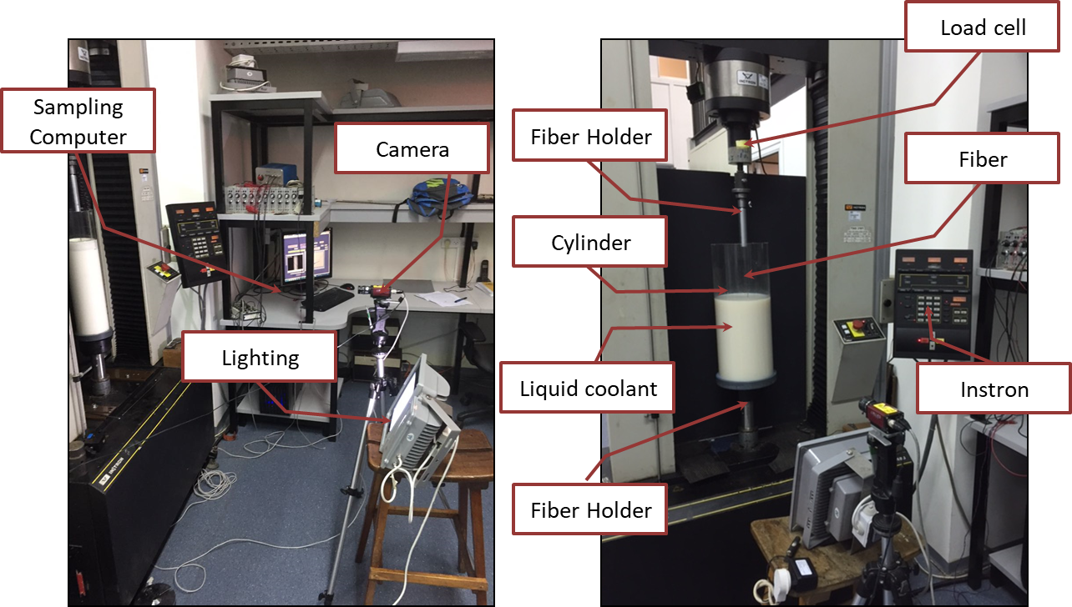

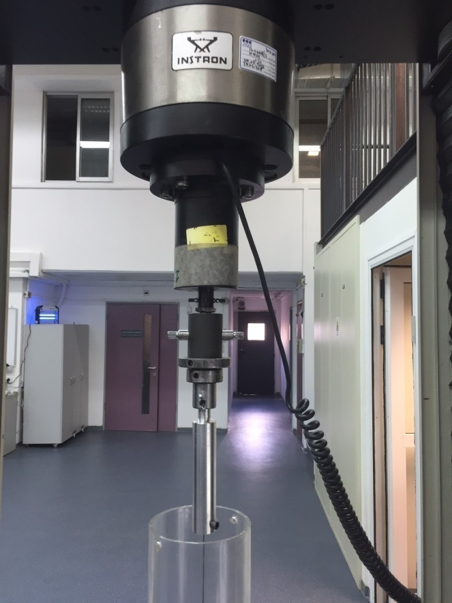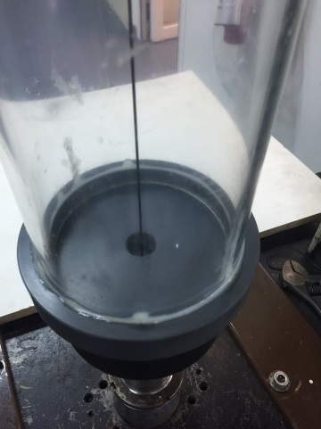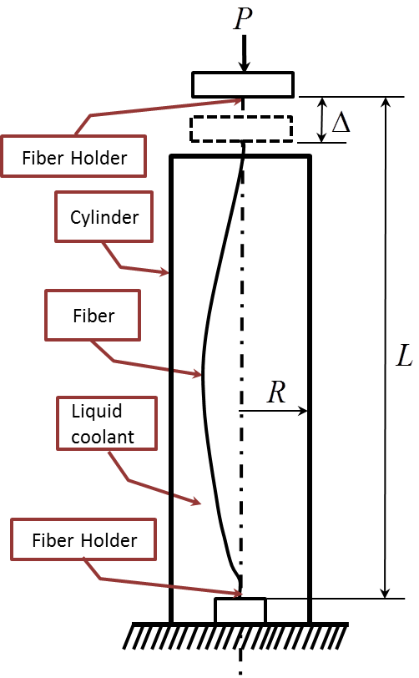

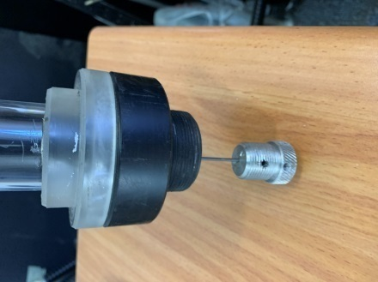

Fig. 1: (a) The experimental setup, with a cylinder of  radius (left image), or  radius (right image). In these images, the cylinder is not completely filled with an opaque milky fluid for the purpose of clarity. (b) Schematic description of the main experiment and system components.

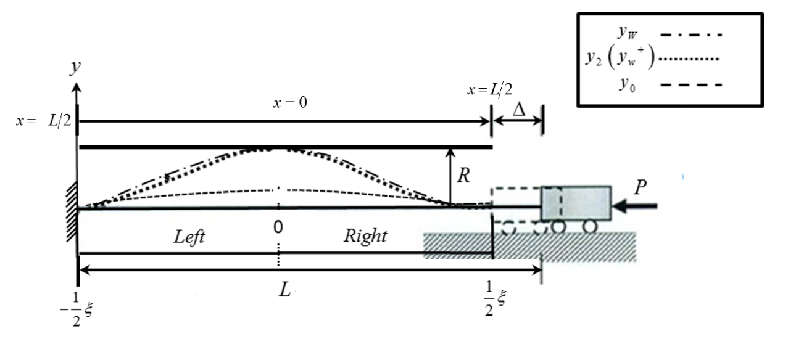

Fig. 2: Description of the boundary conditions and post-buckling response of the fiber in this research.

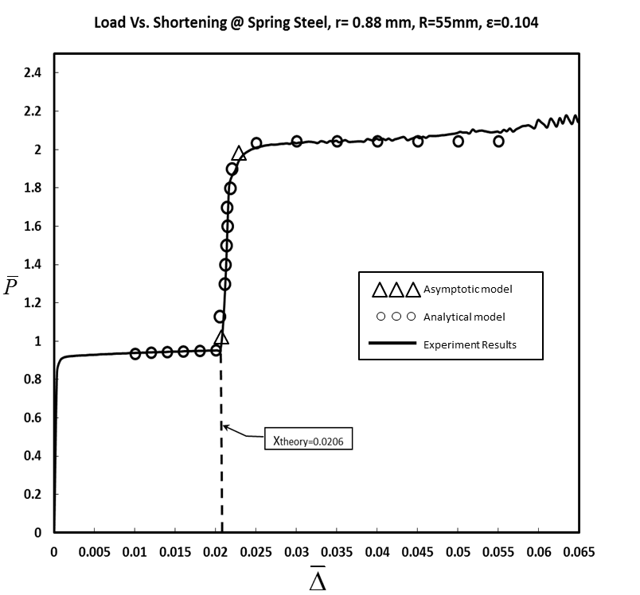



Fig. 3(a): Normalized vertical force versus end shortening for:. The experiment compared to analytical model results with (circle) and to asymptotic model (triangle).

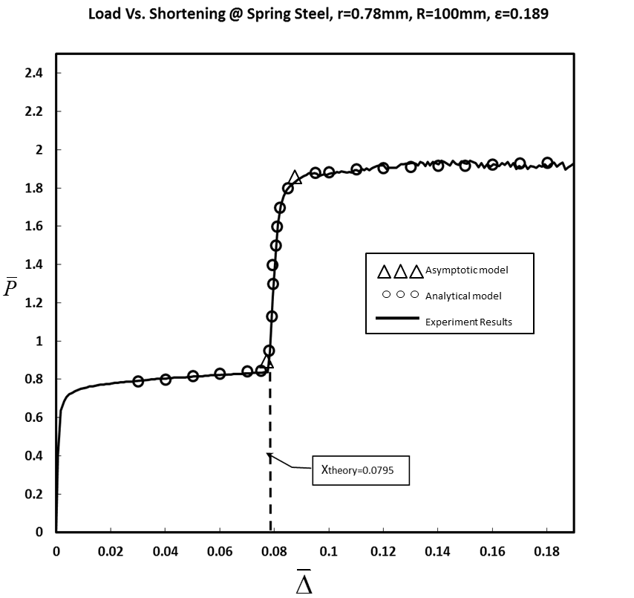



Fig. 3(b): Normalized vertical force versus end shortening for:. The experiment compared to analytical model results with (circle) and to asymptotic model (triangle).

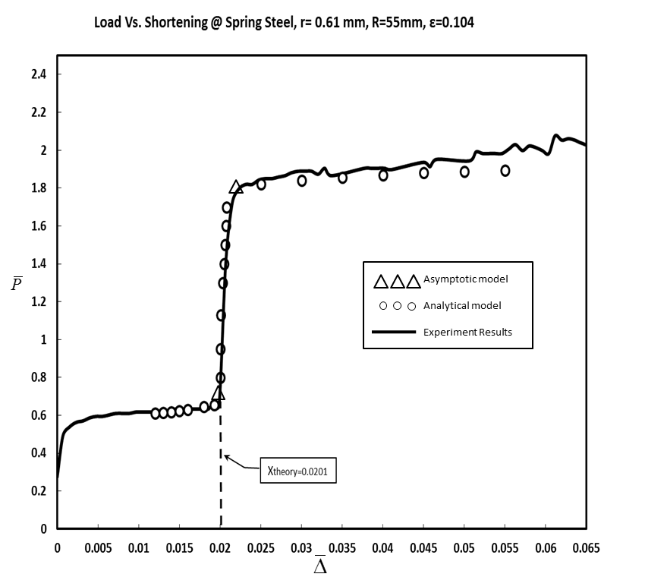



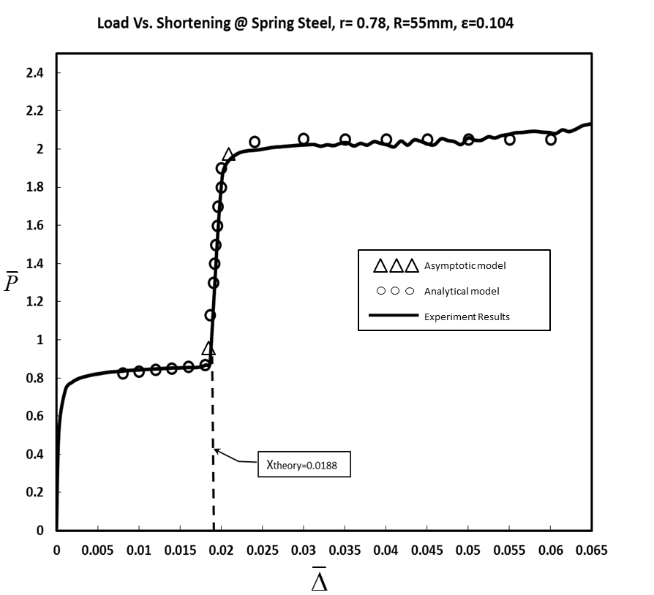



Fig. 3(d): Normalized vertical force versus end shortening for:. The experiment compared to analytical model results with (circle) and to asymptotic model (triangle).

Fig. 3(c): Normalized vertical force versus end shortening  for:. The experiment compared to analytical model results with (circle) and to asymptotic model (triangle).

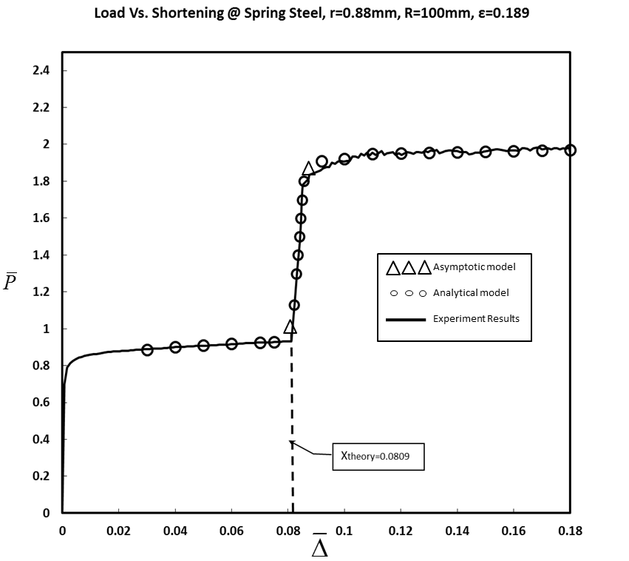



Fig. 3(e): Normalized vertical force  versus end shortening  for:. The experiment compared to analytical model results with  (circle) and to asymptotic model (triangle).

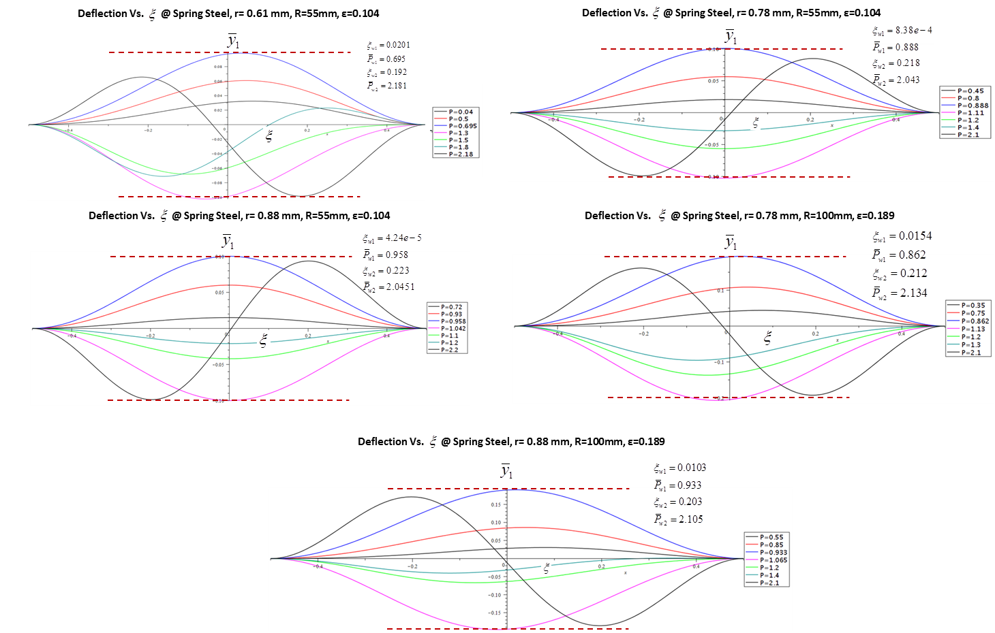

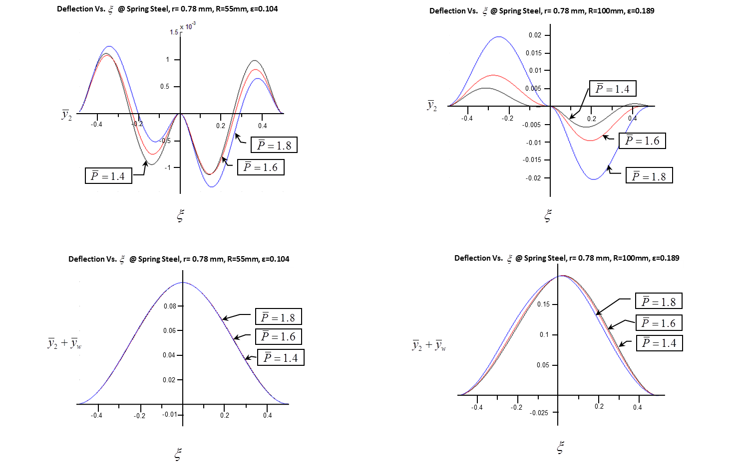

Fig. 4: Deflection curves from the expression  for:, for several values of 

Fig. 5: Deflection curves from the expression  for:, for several values of 

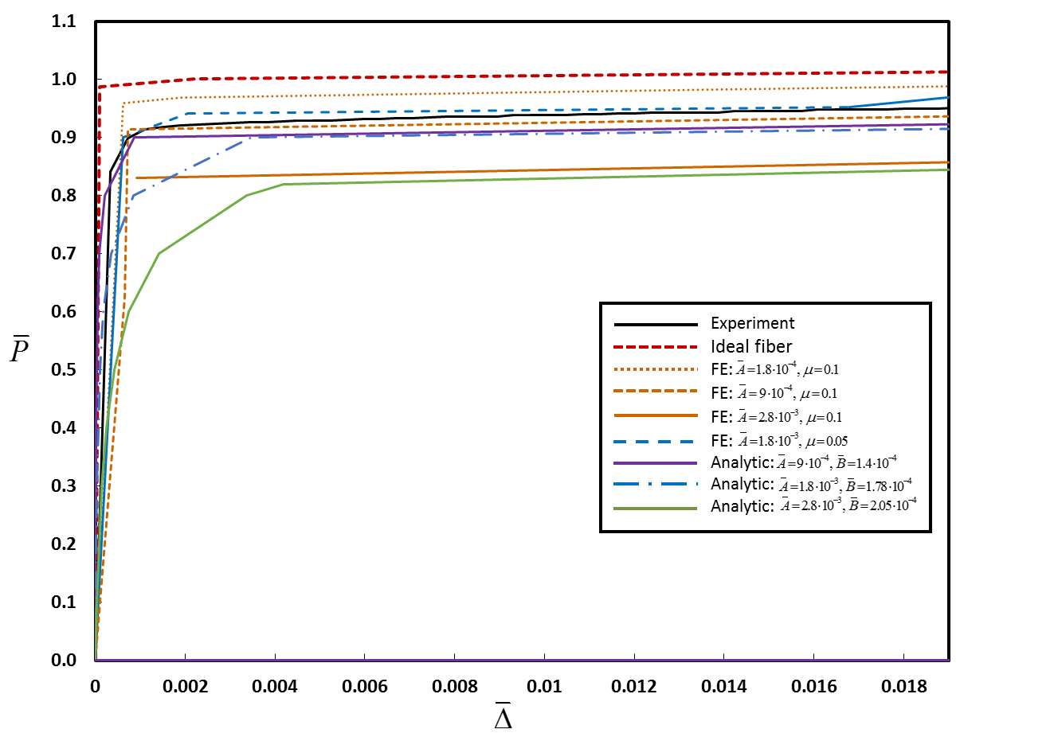

Fig. 6: Vertical force versus end shortening up to the first contact point of the fiber in the cylinder wall for: . The experiment, analytical model and FE analysis results are compared to the theoretical predictions of [44] (ideal fiber: red dashed curve). FEA results are shown for simulations with various values of  (amplitude of the deviation symmetric and anti-symmetric imperfection) and (friction coefficient).

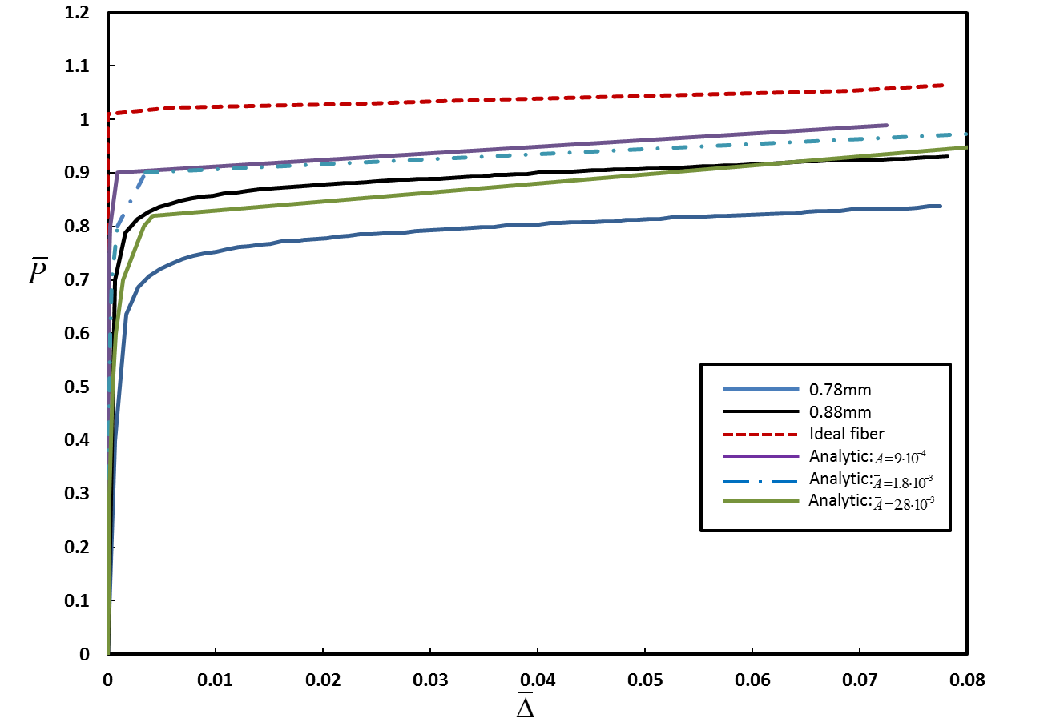

Fig. 7: Vertical force versus end shortening up to the first contact point of the fiber in the cylinder wall for:. The experiment and analytical model results are compared to the theoretical predictions of [44] (ideal fiber: red dashed curve).

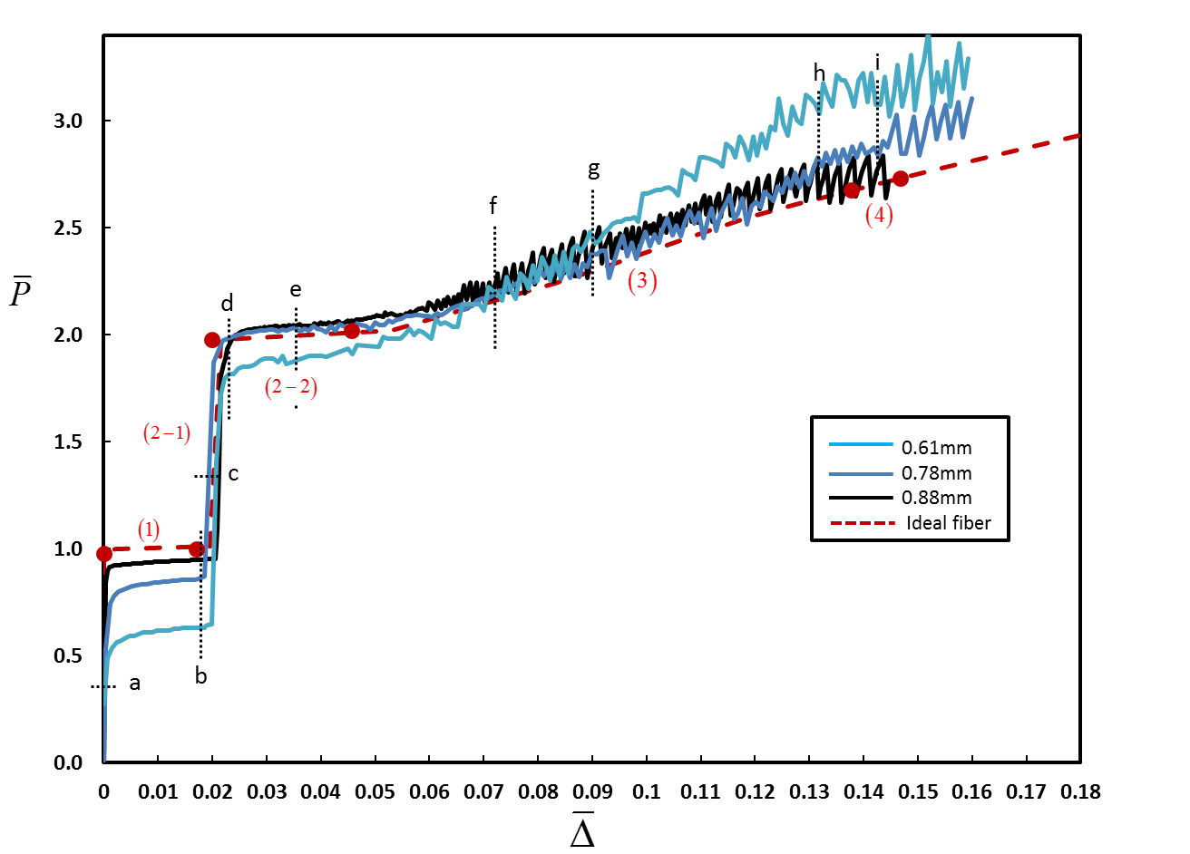

(5)

Fig. 8: Measured vertical force versus end shortening for three different fiber radii: . The experimental results are compared to the theoretical predictions of [44] for (ideal fiber:red dashed curve). Numbers in parentheses indicate the contact configuration in accordance with Fig. 1. Filled circles identify a transition from one configuration to the next.

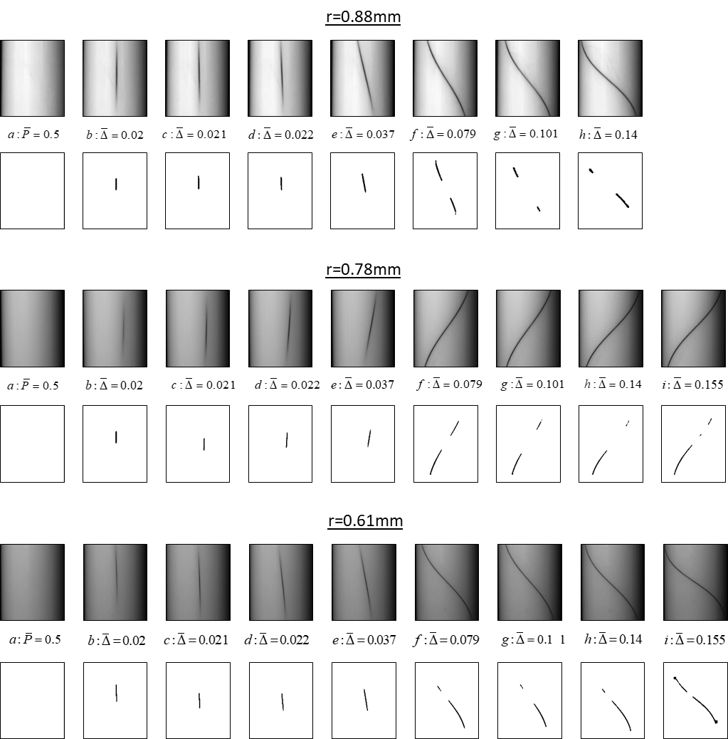

Fig. 9: Contact between the fiber and the cylinder wall at different stages of deformation for the fibers from Fig. 8 (). For each fiber, the first row shows snapshots from the experiment at different levels of end shortening, while the second row shows the same snapshot after applying the image-processing procedure. End shortening is indicated by the numbers between the two rows and also by the letters a-h that appear in the force-displacement curve.

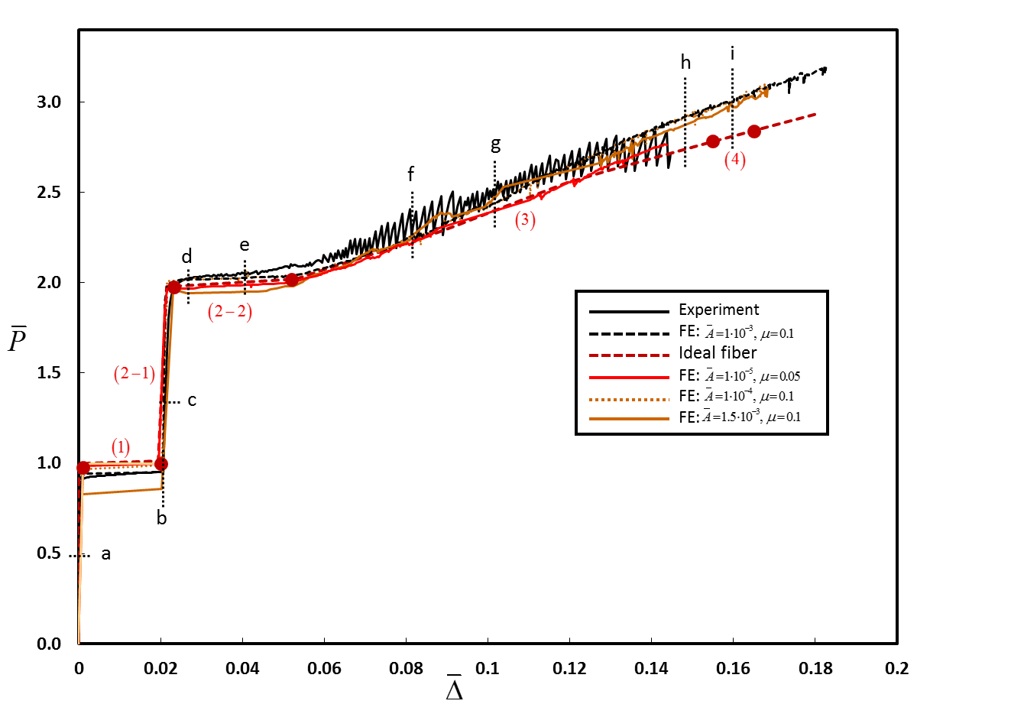

Fig. 10: Vertical force versus end shortening for: . The experiment and FE analysis results are compared to the theoretical predictions of [44] (ideal fiber:red dashed curve). FEA results are shown for simulations with various values of  (amplitude of the deviation) and (friction coefficient). Numbers in parentheses indicate the contact configuration in accordance with [44]. Filled circles identify a transition from one configuration to the next.

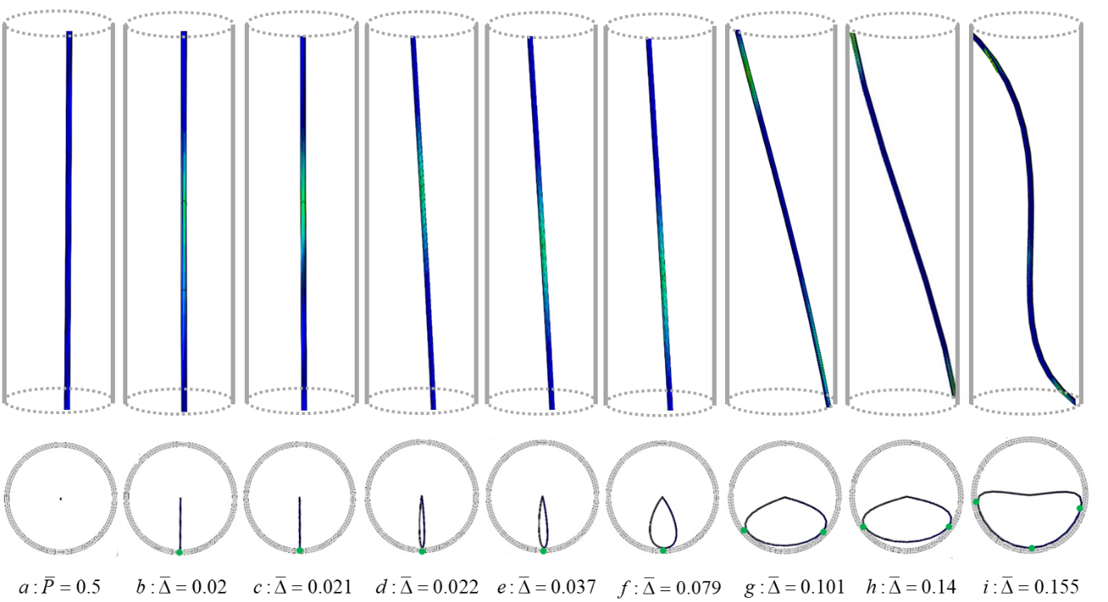

Fig. 11: Results of FE analysis showing the deformation of the fiber and contact with the cylinder wall, for: . First row: side view, where a lighter (greenish) color indicates interaction with the wall (in these images, the schematic cylinder is shown for clarity/orientation, but the images are not at identical scale in order to allow focusing on the contact region). Second row: top view (all images are at identical scale)

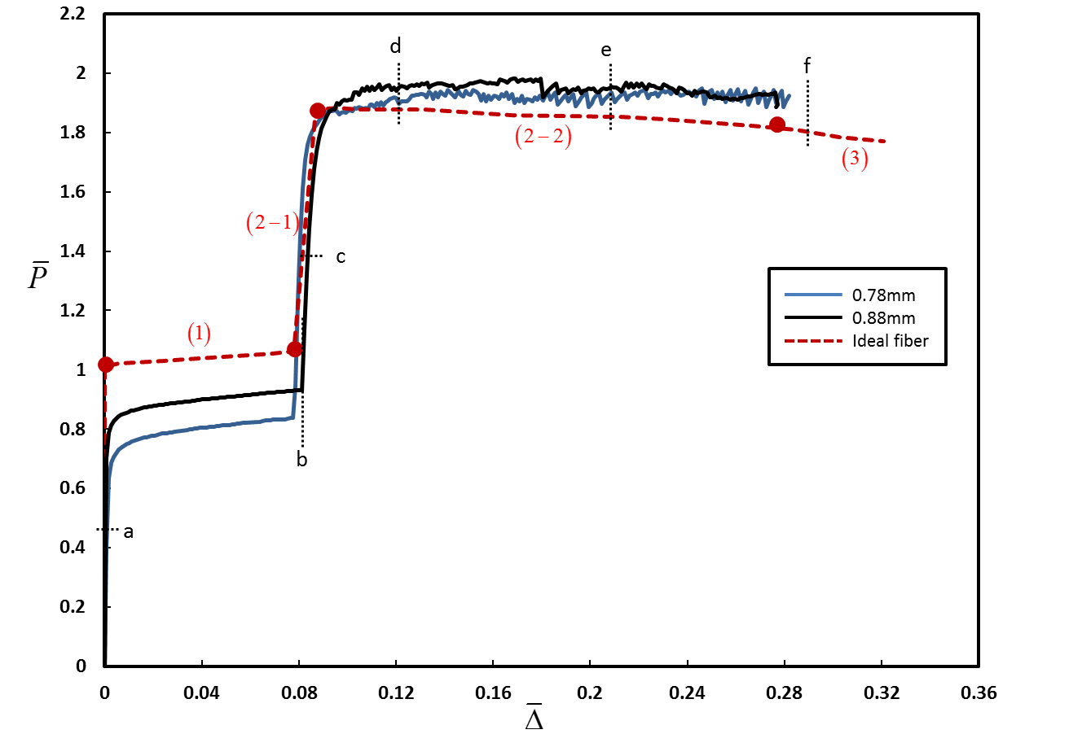

Fig. 12: Force-displacement relation. Measured vertical force versus end shortening for two different fiber radii: . The experimental results are compared to the theoretical predictions of [44] for (ideal fiber:red dashed curve). Numbers in parentheses indicate the deformation stage described in [44]. Filled circles identify a transition from one deformation pattern to the other

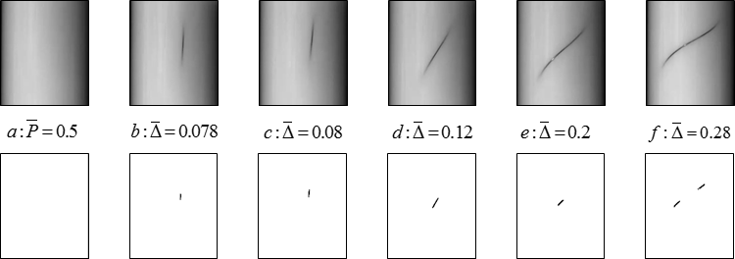

Fig.13: Force-displacement relation. Measured vertical force versus end shortening loading and unloading for: . The experimental results are compared to the theoretical predictions of [44] for (dashed curve). Numbers in parentheses indicate the deformation pattern described in [44]. Filled circles identify a transition from one deformation pattern to the other.

1. Corresponding author