Old Hebrew Books in Italian Libraries Phase II

# Goobi Work Instructions – Role: Photographer

## Uploading the images from 1 day’s work.

* Organise the images from 1 day of work into a single folder on your computer.
* For each book the first image needs to be of the barcode page followed by the actual book photographs. So the sequence is:
  + Barcode image
  + Book image 1
  + Book image 2
  + Book image 3
  + Etc.
  + Barcode image
  + Book image 1
  + Book image 2
  + Etc.
* Here is an example of how your folder may look:

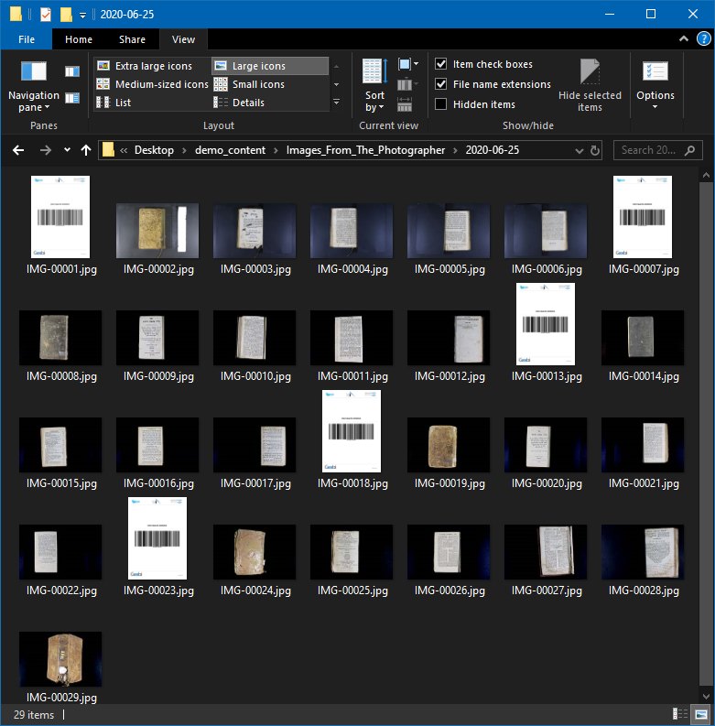

# Logging into Goobi and Uploading the Images from 1 day’s work

* Navigate to Goobi at <https://ihbp.intranda.com/goobi/uii/index/xhtml>
* Enter your user name
* Enter your password

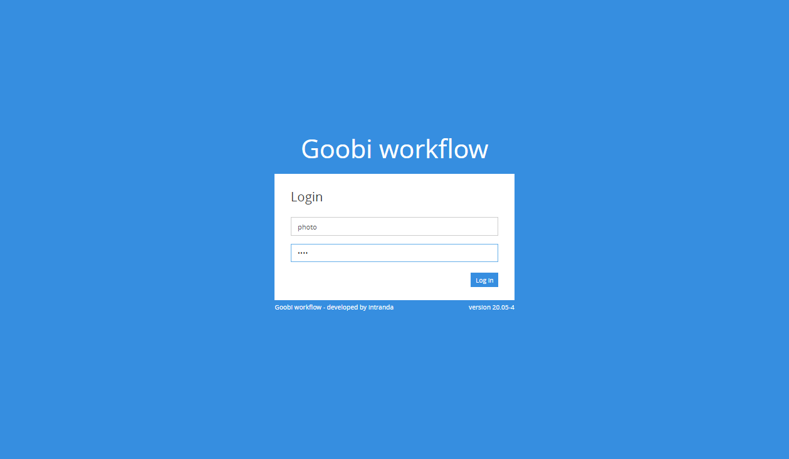

* This is the dashboard that you will see when you login

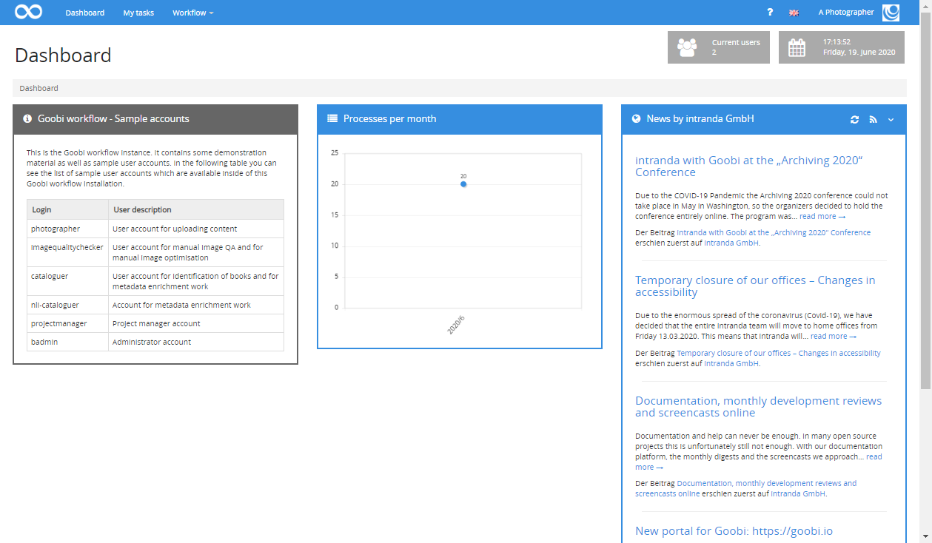

* Navigate to the workflow menu and click mass upload

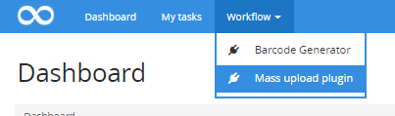

* This is the mass upload screen

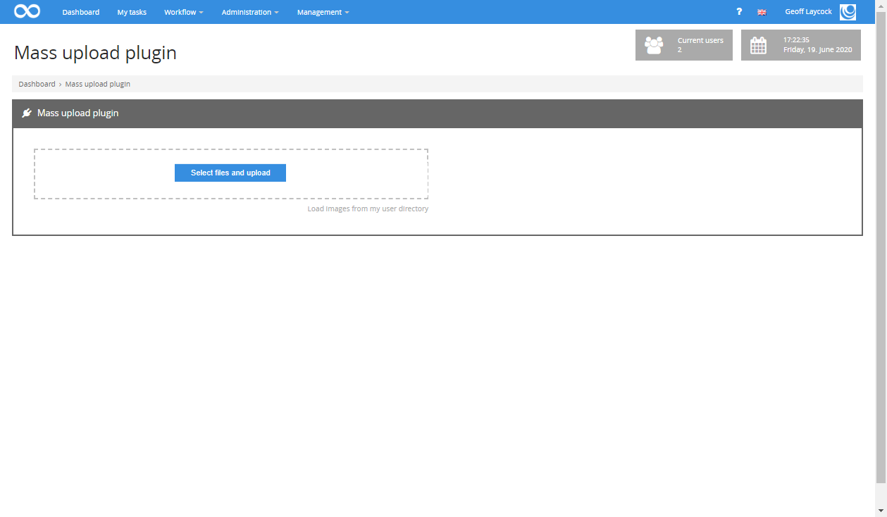

* Drag the files from 1 day’s work into the upload area or navigate to them by clicking the ‘select files and upload’ button.

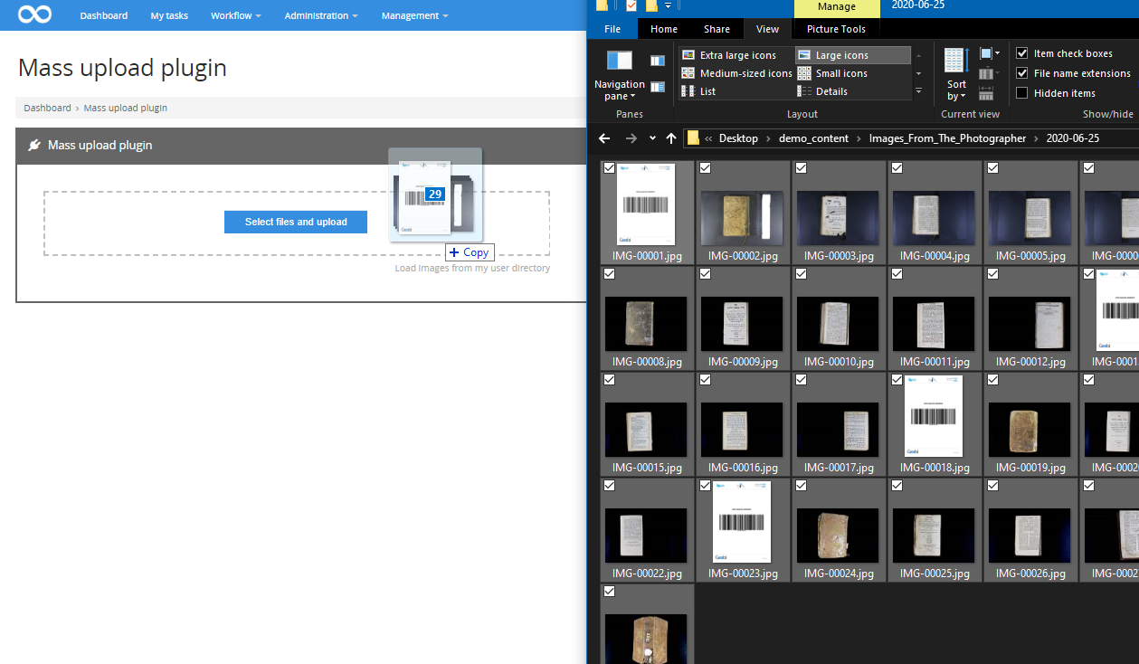

* The files will then upload to Goobi and progress bars will be shown as below

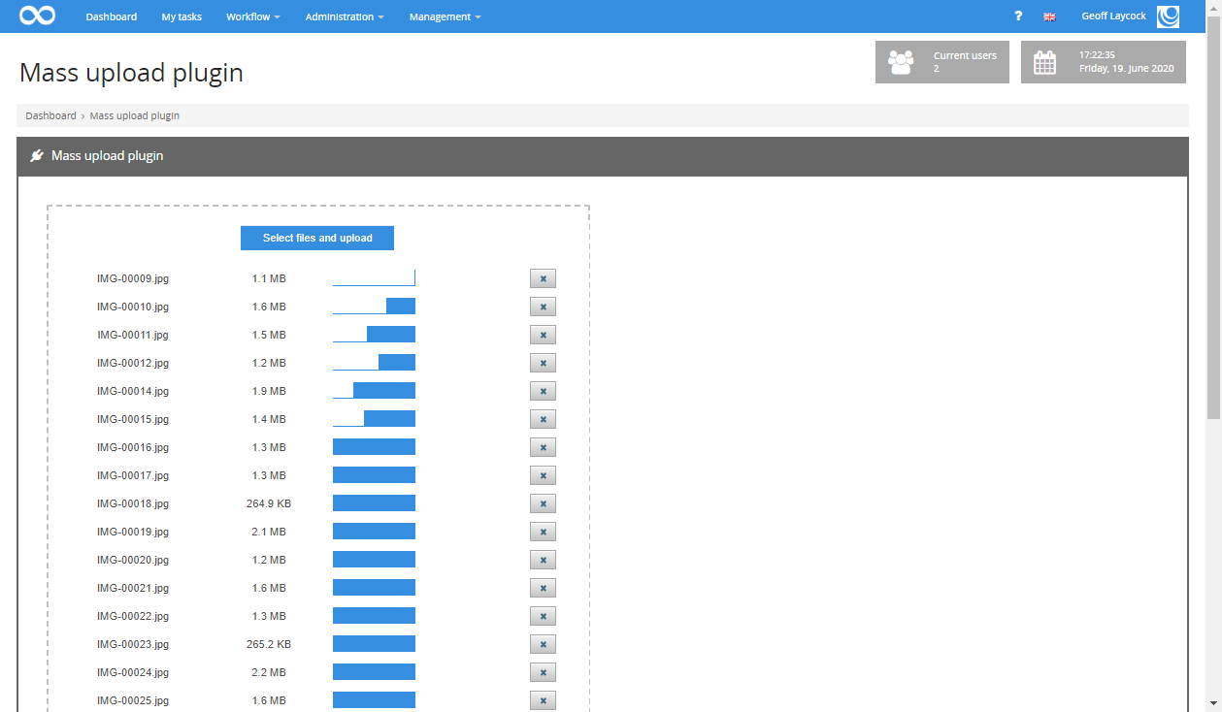

* When all of the images have uploaded Goobi will automatically identify the correct book data to link the images to by reading the barcodes.
* In the below screen you will see the screen that comes up after upload has finished. The OK buttons show that the images have uploaded to the system correctly and they have been linked to the correct book data

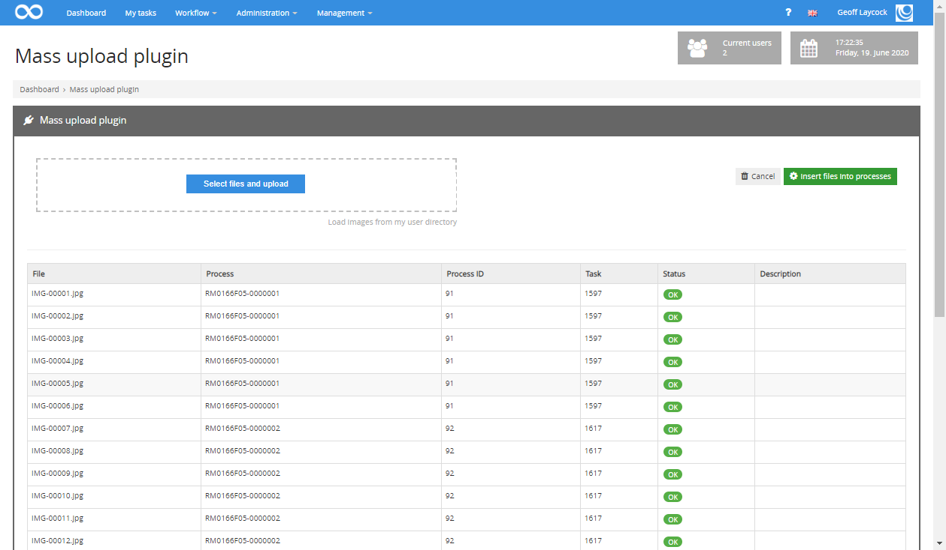

* When you are happy that all of the images have uploaded correctly click the button that states ‘Insert files into processes’

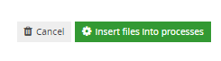

* 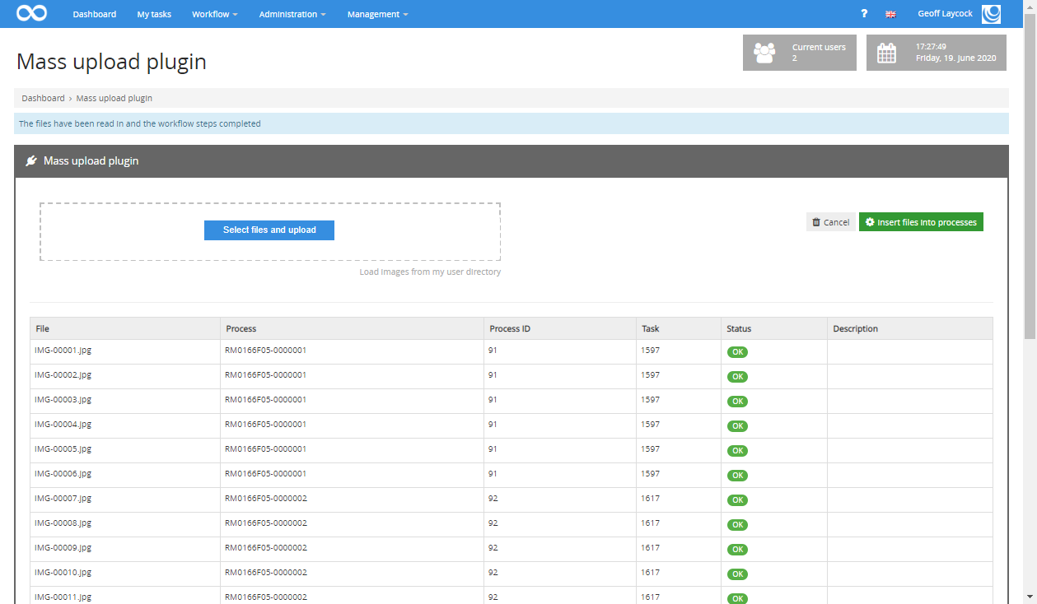When this has been completed a blue system Message will appear at the top of the screen showing the files have been read in and the workflow steps completed

# Navigating to your task menu to see if there are any corrections to be done

After you have uploaded your photographs, within 24 hours another team will check them to make sure that they are correct, well-lit and in focus. They will also be checking that all expected pages for a book are present.

If there is an error at this point then they will ‘send’ the book back for correction to you.

* The way to find out if any of the work you have done requires correction is to navigate to your My tasks page by clicking the link at the top of the page as follows:

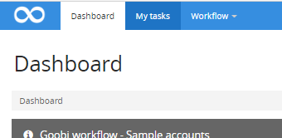

* This page will appear:

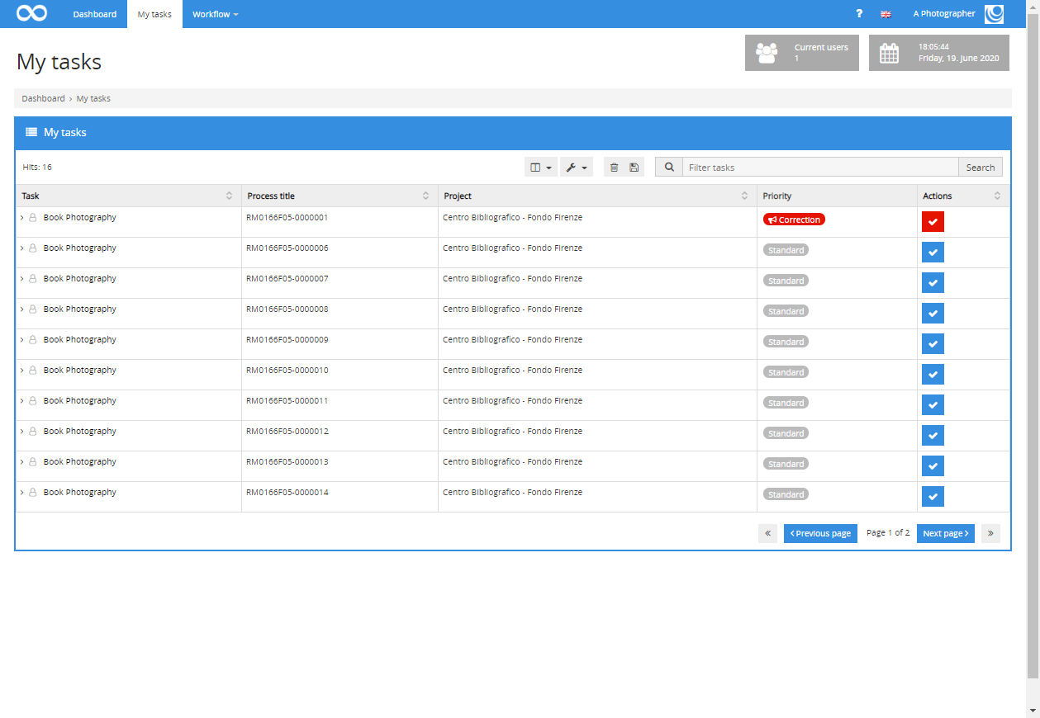

* All the tasks with blue ticks beside them are books in the library to are in that are waiting to be photographed. You do not need to take any action with these books as they will be completed when you perform the mass upload of images on a daily basis.
* On a daily basis however you do need to check to see if you have any correction messages.
* These will be at the top of the list and marked in red as follows:

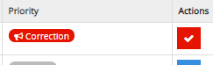

* Click the red tick to accept the task for correction
* The task page will appear as follows:

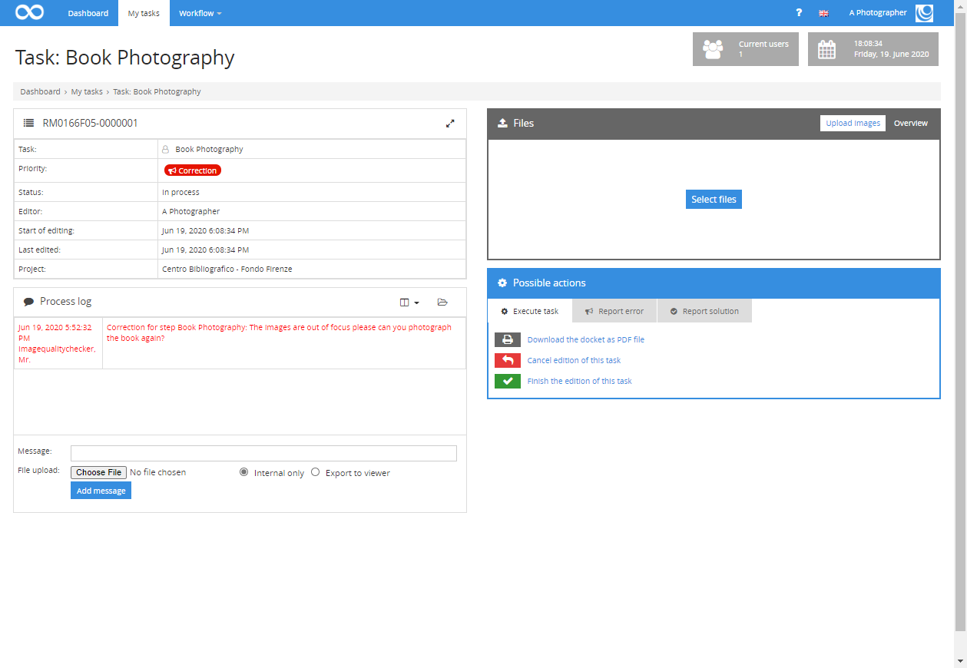

* In the process log area you will see the correction message from the image quality checking person.
* The message will be in red as follows: 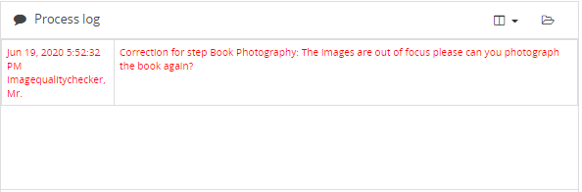
* Read the message.
* If there is no action you can take (for example if they are asking if there was a book cover and there was no cover on the book) then you can simply send a reply by reporting the solution to the image QA person.
* To do this click the ‘Report solution’ tab on the bottom right of the screen as follows:

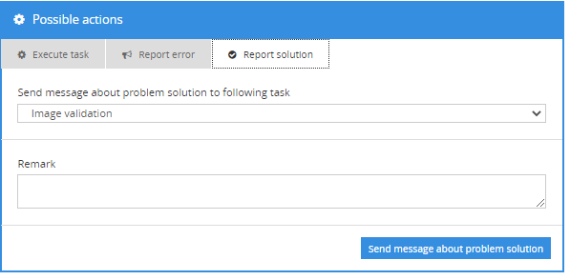

* Select the ‘Image Quality Checking’ from the drop-down menu as the person that you need to send the message to

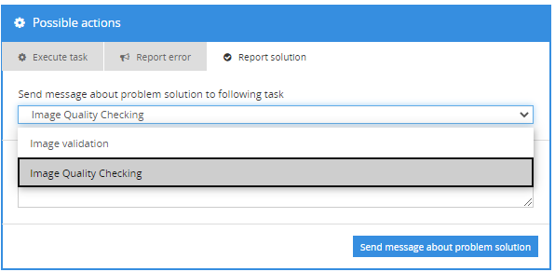

* Write the solution in the box as follows:

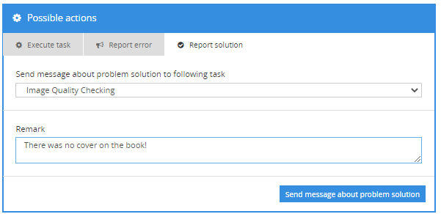

* And click the button to ‘Send message about problem solution’ to the Image Quality Checking Person.
* If, however you do need to delete images or upload new images then the area to do this is on the top right of the page:

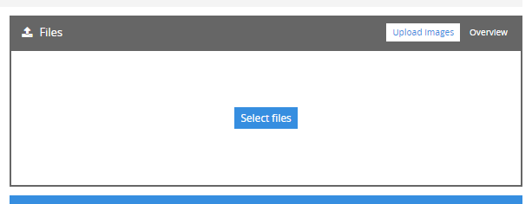

* You can upload new images here by dragging them onto the white area or clicking the ‘Select files’ button.
* If you need do delete any images uploaded in error then click overview on the top right of the box



* This is the screen that will appear showing all the images uploaded for that book as a list

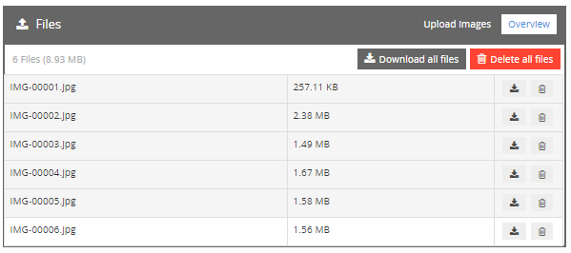

* Here you can:
  + Download all the files for that book
  + Delete all the files for that book
  + Download individual files for that book
  + Delete individual files for that book
* Once the correction has been done you still need to report the solution to the Image Quality Checking person as before:
* To do this click the ‘Report solution’ tab on the bottom right of the screen as follows:



* Select the ‘Image Quality Checking’ from the drop-down menu as the person that you need to send the message to



* Write the solution in the box as follows:

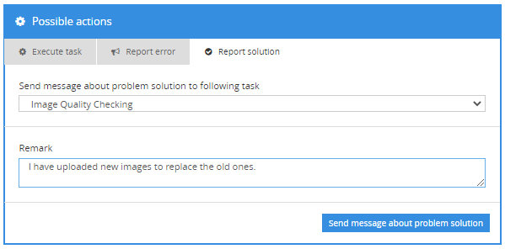

* And click the button to ‘Send message about problem solution’ to the Image Quality Checking Person.
* Once you have completed all correction tasks log out of the system by clicking your username on the very top right of the screen and selecting logout.

