### C2A Security enables cyber-secured next generation vehicles with overarching solution for Ethernet networks

*The solution will protect market-new high bandwidth automotive environments*

**Las Vegas, Nevada – January 6th, 2019, 7am PST (CES 2020, North Hall, LVCC, Booth #9505) –**[**C2A Security**](http://c2a-sec.com), a global leader in automotive cybersecurity, today announced its new comprehensive automotive grade Ethernet firewall solution. This innovative solution includes industry’s first, overarching structured process for the configuration and generation of automotive IDPS. C2A’s latest network IDPS offering also includes generic IDPS solution supporting CAN, LIN and FlexRay networks with cutting-edge security features that can be utilized in variety of domain controllers and gateway applications.

With increasing demand for automated driving and enormous data bandwidth in connected cars, Ethernet is proliferating within modern in-vehicle networks.  While dealing with new bandwidth requirements, Ethernet networks present new cybersecurity challenges and potential risks, consequently requiring automotive manufacturers to integrate compatible cybersecurity measures. These increasing market demands are addressed by C2A’s network IDPS, with a high performance, software only, fully structured solution resulting in a lower BOM cost and a reduced footprint.

C2A’s network IDPS solution is comprised of several SW building blocks on top of existing hardware platforms, like recently introduces automotive Ethernet switches and routers. It is the first automotive grade Ethernet IDPS solution that offers an overarching structured and automated process for the configuration and generation of automotive IDPS, resulting:

* System Configuration – switch and router configuration according to security policy.
* Hardware Security – security features configuration with sophisticated load balanced coherent with software capabilities and available compute resources.
* Software Security – complete software package for security applications, including automotive real-time application-aware network IDPS and optimized secure OS for Ethernet switch's internal CPU.

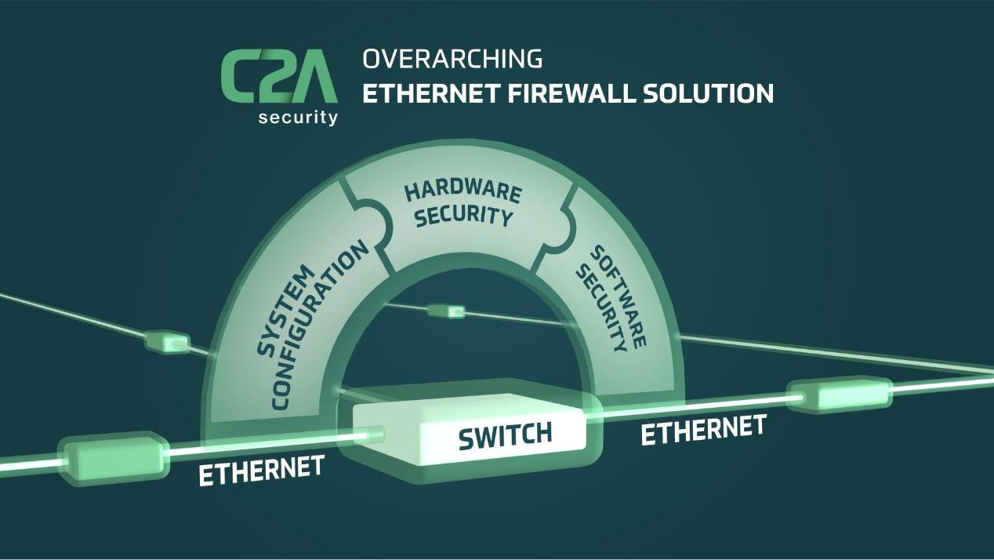

The solution is also the industry's first end to end solution – providing complete software suite that is automatically leveraging existing hardware platforms for state of the art ethernet IDPS solution. This approach is highly compatible with the automotive sector that historically strives for standardization and zero-error ability due to extensive supply chains, regulations, and safety concerns.

“Led by our solution approach, we took upon ourselves the responsibility to create an overarching solution, eventually empowering our clients,” said Nathaniel Meron, Chief Product and Marketing Officer at C2A Security. “Already integrated with market leading hardware suppliers, C2A’s solution transforms existing switches into high-performance cutting-edge firewall by providing automotive manufacturers a complete software solution suite, seamlessly optimized for their needs, while avoiding any additional hardware or software.”

**ABOUT C2A SECURITY**

C2A Security was founded in 2016 by Michael Dick, who previously co-founded NDS. C2A is dedicated to providing the automotive industry with end-to-end in-vehicle cyber security protection. Combining multi-disciplinary world-renowned leaders from the automotive, embedded security and academic domains, C2A has created an innovative solution for in-vehicle cyber security, providing car manufacturers with comprehensive, yet practical, vehicle cyber security solutions.