Primary Sources – Rosh Hashana

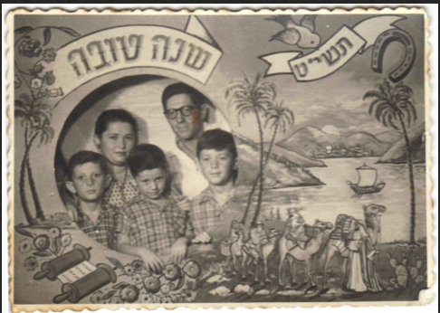

**Title -** [Shana Tova, Israel, 1958](https://web.nli.org.il/sites/NLI/English/digitallibrary/pages/viewer.aspx?docid=EDU_XML_ENG700335383&presentorid=EDU_XML_ENG&searchurl=https%3A%2F%2Fweb.nli.org.il%2Fsites%2Fnlis%2Fen%2Feducation%2Fpages%2Fresults.aspx%23%3Fquery%3Dlsr16%2Cexact%2CPrimary+Source%26query%3Dany%2Ccontains%2CRosh+Hashana%26indx%3D25%26institution%3DNNL%26vid%3DEDU_XML_ENG%26loc%3Dlocal%2Cscope%3A(EDU_XML_ENG)%26sortField%3Dlso04%26bulkSize%3D8)

​**Description**

This is a Shana Tova card printed in Israel in 1958. At the centre of the card is an ostensibly typical Israeli family: a mother, father and three boys. The card was actually made as a photograph of a family who are standing behind a painted template. In this way, many families would have taken their photograph and created a personalized Shana Tova card for their families and friends.

Around the photograph there are different motifs of the New Year. On the top of the card are the words "שנה טובה" – "Happy New Year." The year תשי"ט) 1958-9) appears on a ribbon carried by a bird and below it is a horseshoe, a popular (non-Jewish) lucky charm. Beneath the family is a drawing of a Torah scroll and to the side an elaborate depiction of the Exodus of the children of Israel from Egypt.

**Would You Like to Know More?**

**Shana Tova Cards** - The earliest instance of a written “shana tova” greeting is a fourteenth-century letter written by the Ashkenazi rabbi known as the Maharil (Jacob ben Moses Moelin). This letter affirms the existence of this custom in German Jewish communities at the time. In the eighteenth century, the custom began spreading beyond the German-speaking realm to other large concentrations of Jews in Eastern Europe, especially Poland. By the end of the century, Shana Tova cards began to take on distinct characteristics, such as special writing paper, with the custom spreading throughout the entire Ashkenazi world during the nineteenth century. The postal service emerged around this time, and in the 1880s, Jewish entrepreneurs began to print commercial greeting Shana Tova cards. By this time, Shana Tova cards constituted the main body of postcards sent by Jews, and this would remain so for around 100 yearsץ Between the end of the nineteenth century and the end of First World War, a time known as the “Golden Age of Postcards,” the vast majority of the mail sent by Jews in Europe and America consisted of Shana Tova cards. Today, in the digital era, cards sent by post have given way to text messages and emails.

**Teaching Suggestions**

​In the days leading up to the Jewish New Year, **Jewish Studies** teachers could provide a collection of Shana Tova cards to their students to prompt a discussion about their wishes for the New Year.

**Israel Studies -** This is an example of a card printed in Israel, ten years after the state was established. A discussion could arise around the design and the prominence of the Exodus on the card, possibly as a mirror of the aliya, the mass immigration to Israel, during the early years of the State?

**Art teachers** could use this, together with other cards from the NLI collection, for a lesson in which students create their own Shana Tova cards.

**Discussion Points**

**Observation**

* What is this?
* The bird at the top is holding a ribbon with the letters .תשי"ט :What do they signify?
* What other element appear in the design?
* Describe the people in the photograph.

**Reading Between the Lines**

* The card was printed in Israel in 1959.  
  How do you think the family was included in the design?  
  Why do you think they created this card in this way?
* Using reference books or the internet, what can you find out about life in Israel at the time that the card was printed:   
  Who were the prime minister and the president?  
  What military events happened in the years before?  
  How many people lived in Israel at that time?  
  How many new immigrants (olim) came to Israel in those times?  
  What were some of the challenges that Israel faced at this time?
* How are the different elements of the design, connected to the new Jewish year?

**Connections**

* Do you send Shana Tova cards?  
  How do you personalize your wishes?
* If you were to create a card what design elements would you include?
* Find out what was happening with your family or your community in the year that this card was printed?

**Creative Ideas**

* Design a card of your own that includes a photograph of your family.   
  What other graphic and textual elements will you add and why?​
* Create a large template of a shana tova card and photograph your friends or family within it!