Prof. Athalya Brenner-Idan

University of Amsterdam

Prof. Athalya Brenner-Idan is Professor (Emerita) of the Hebrew Bible/Old Testament chair at the Universiteit van Amsterdam, and was Professor of Biblical Studies at Tel Aviv University. She holds a Ph.D. from Manchester University, an honorary Ph.D. from the University of Bonn, and an M.A. from the Hebrew University. Among her publications are, *I Am: Biblical Women Tell their own Stories* and *The Israelite Woman: Social Role and Literary Type in Biblical Narrative.* She is also the editor of the series, *A Feminist Companion to the Bible* (20 volumes), and co-editor (with Archie Lee and Gale Yee) of the Texts@Contexts Series (7 volumes to date).

The Decalogue: Are Female Readers Included?

Can all social change be antedated back to Sinai?

[Prof. Athalya Brenner-Idan](https://www.thetorah.com/author/athalya-brenner-idan)

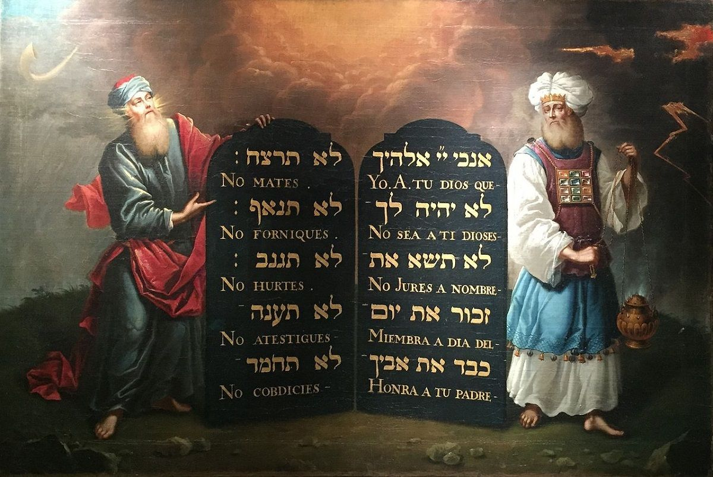

Moses and Aaron with the Ten Commandments. Painted by Aron de Chaves, Amsterdam, 1674, for the Creechurch Lane Spanish & Portuguese Synagogue.

Preface

My first reflections on the Decalogue from a feminist perspective were published over two decades ago.[1] At that time, consciousness of the Bible’s male-biased language was not high on the agenda of many readers. The situation is different today. Language-bias is less politically correct, not only in social and political life, but also in biblical interpretation. There is a tendency, so very pronounced, to preserve so-called “biblical values” by presenting them as gender-neutral or “inclusive.”[2] Since the Decalogue, or Ten Commandments, are often culturally accepted as of “universal” value, a return visit to this far from gender-egalitarianism inspiring text is in order.

Whom Is God Addressing?

The Decalogue is extant in two versions: one in Exodus 20, the other in Deuteronomy 5. The numerous minor variations between the two texts do not mask the fact that the two passages are, essentially, the same text. Major differences between the two versions, as seen in the differing motivation supplied for the Sabbath in each version (Exod 20:8-11; Deut 5:12-15), are rare; minor differences that make little difference for interpretation are more common.[3] But, despite these smaller and larger differences, the two versions share an important premise: they are addressed to males, and are typified by masculine 2nd person singular “[m.] you” imperatives, whether formulated in the negative or the positive modes.

Am I, a female reader, to view myself as unproblematically included in that form of address? I know that, grammatically speaking, male gendered verbs in Biblical Hebrew include females as well. This is especially true in plural verbs, and loosely so for singular verbs, but this grammatical custom does not feel like a sufficient response to the problem, since the uniform appearance of only male verbs quashes female subjectivity.

Imagine a picture of only men with the caption “people.” If the photographer were to say, “of course, women are people too, but they are being included *implicitly*,” this would hardly make women viewing the picture feel included. In fact, the lack of female subjectivity in the text is usually matched by the lack’s suppression by lay and scholarly exegesis alike.[4]

Explicit Exclusion of Women

Serious consideration of the exclusion-of-women problem in the account of the revelation of the Decalogue came with Judith Plaskow’s pioneering work, *Standing Again at Sinai*.[5] She begins by pointing out that the exclusion of women from the Sinai experience is embedded in the introduction of the Decalogue in Exodus:

שמות יט:טו וַיֹּאמֶר אֶל הָעָם הֱיוּ נְכֹנִים לִשְׁלֹשֶׁת יָמִים אַֽל תִּגְּשׁוּ אֶל אִשָּׁה:

Exod 19:15 And he said to the community, “Be ready in three days’ time, do not come [both verbs are in the grammatical masculine plural] near a woman” (my translation).

The “community” here is defined as the community of men. Thus, the text actually and decidedly excludes women from standing at Sinai and from receiving the Commandments, thus from participating equally in the foundational myth of Torah reception. That the rabbis reinterpreted the Sinai episode so that women were *Standing Again at Sinai*, according to Plaskow and her successors, is hardly a consolation for me—although I can empathize with the necessity to get there, even at this late stage. The point is that in the Torah’s picture of the scene, I was never standing there in the first place.

The Masculine Tone of the Verses

Am I being too sensitive? I do not think so. So that I am not suspected of exaggerating, I here reproduce the 1985 JPS (Jewish Publication society) translation of Deuteronomy 5.6-18[21]. The decision to reproduce the JPS translation is a deliberate one: it is widely used by Conservative and Reform Jewish congregations as their authoritative Bible; and these precisely are the communities seeking inclusive options for contemporary Judaism.

In my reproduction of the text, every time the addressee or any other gendered person/humans that is defined in the original Hebrew as a grammatical “[m.] you,” in pronoun or noun or verb, is highlighted in yellow for the addressed; other males and females in purple and blue respectively (other than YHWH, who is also male). The address is mostly in masculine singular.

דברים ה:ואָנֹכִי יְ־הוָה אֱלֹהֶיךָ אֲשֶׁר הוֹצֵאתִיךָ מֵאֶרֶץ מִצְרַיִם מִבֵּית עֲבָדִים. ה:ז לֹא יִהְיֶה לְךָ אֱלֹהִים אֲחֵרִים עַל פָּנָיַ.

Deut. 5:6I YHWH am your God who brought you out of the land of Egypt, the house of bondage: 5:7You shall have no other gods beside Me.

ה:חלֹא תַעֲשֶׂה לְךָ פֶסֶל כָּל תְּמוּנָה אֲשֶׁר בַּשָּׁמַיִם מִמַּעַל וַאֲשֶׁר בָּאָרֶץ מִתָּחַת וַאֲשֶׁר בַּמַּיִם מִתַּחַת לָאָרֶץ. ה:ט לֹא תִשְׁתַּחֲוֶה לָהֶם וְלֹא תָעָבְדֵם כִּי אָנֹכִי יְ־הוָה אֱלֹהֶיךָ אֵל קַנָּא פֹּקֵד עֲו‍ֹן אָבוֹת עַל בָּנִים וְעַל שִׁלֵּשִׁים וְעַל רִבֵּעִים לְשֹׂנְאָי. ה:י וְעֹשֶׂה חֶסֶד לַאֲלָפִים לְאֹהֲבַי וּלְשֹׁמְרֵי (מצותו) [מִצְו‍ֹתָי].

5:8You shall not make for yourself a sculptured image, any likeness of what is in the heavens above, or on the earth below, or in the waters below the earth. 5:9You shall not bow down to them or serve them. For I YHWH your God am an impassioned God, visiting the guilt of the parents [Hebrew: fathers] upon the [Hebrew: sons] children, upon the third and upon the fourth generations of those who reject Me, 5:10but showing kindness to the thousandth generation of those who love Me and keep My commandments.

ה:יאלֹא תִשָּׂא אֶת שֵׁם יְ־הוָה אֱלֹהֶיךָ לַשָּׁוְא כִּי לֹא יְנַקֶּה יְ־הוָה אֵת אֲשֶׁר יִשָּׂא אֶת שְׁמוֹ לַשָּׁוְא.

5:11You shall not swear falsely by the name of YHWH your God; for YHWH will not clear one who swears falsely by His name.

ה:יב שָׁמוֹר אֶת יוֹם הַשַּׁבָּת לְקַדְּשׁוֹ כַּאֲשֶׁר צִוְּךָ יְ־הוָה אֱלֹהֶיךָ.יג שֵׁשֶׁת יָמִים תַּעֲבֹד וְעָשִׂיתָ כָּֿל מְלַאכְתֶּךָ. יד וְיוֹם הַשְּׁבִיעִי שַׁבָּת לַי־הוָה אֱלֹהֶיךָ לֹא תַעֲשֶׂה כָל מְלָאכָה אַתָּה וּבִנְךָ וּבִתֶּךָ וְעַבְדְּךָ וַאֲמָתֶךָ וְשׁוֹרְךָ וַחֲמֹרְךָ וְכָל בְּהֶמְתֶּךָ וְגֵרְךָ אֲשֶׁר בִּשְׁעָרֶיךָ לְמַעַן יָנוּחַ עַבְדְּךָ וַאֲמָתְךָ כָּמוֹךָ. ה:טווְזָכַרְתָּ כִּי עֶבֶד הָיִיתָ בְּאֶרֶץ מִצְרַיִם וַיֹּצִאֲךָ יְ־הוָה אֱלֹהֶיךָ מִשָּׁם בְּיָד חֲזָקָה וּבִזְרֹעַ נְטוּיָה עַל כֵּן צִוְּךָ יְ־הוָה אֱלֹהֶיךָ לַעֲשׂוֹת אֶת יוֹם הַשַּׁבָּת.

5:12 Observe the sabbath day and keep it holy, as YHWH your God has commanded you. 5:13 Six days you shall labor and do all your work, 5:14 but the seventh day is a sabbath of YHWH your God; you shall not do any work — you, your son or your daughter, your male or female slave, your ox or your ass, or any of your cattle, or the stranger in your settlements, so that your male and female slave may rest as you do. 5:15Remember that you were a slave in the land of Egypt and YHWH your God freed you from there with a mighty hand and an outstretched arm; therefore YHWH your God has commanded you to observe the sabbath day.

ה:טז כַּבֵּד אֶת אָבִיךָ וְאֶת אִמֶּךָ כַּאֲשֶׁר צִוְּךָ יְ־הוָה אֱלֹהֶיךָ לְמַעַן יַאֲרִיכֻן יָמֶיךָ וּלְמַעַן יִיטַב לָךְ עַל הָאֲדָמָה אֲשֶׁר יְ־הוָה אֱלֹהֶיךָ נֹתֵן לָךְ.

5:16 Honor your father and your mother, as YHWH your God has commanded you, that you may long endure [Hebrew: so that your life be long], and that you may fare well, in the land that YHWH your God is assigning to you.

ה:יז לֹא תִּֿרְצָח וְלֹא תִּֿנְאָף וְלֹא תִּֿגְנֹב וְלֹא תַעֲנֶה בְרֵעֲךָ עֵד שָׁוְא.

5:17You shall not murder. You shall not commit adultery. You shall not steal. You shall not bear false witness against your neighbor [Hebrew: friend, comrade].

ה:יח וְלֹא תַחְמֹד אֵשֶׁת רֵעֶךָ וְלֹא תִתְאַוֶּה בֵּית רֵעֶךָ שָׂדֵהוּ וְעַבְדּוֹ וַאֲמָתוֹ שׁוֹרוֹ וַחֲמֹרוֹ וְכֹל אֲשֶׁר לְרֵעֶךָ.

5:18 You shall not covet your neighbor’s wife. You shall not crave your neighbor’s house, or his field, or his male or female slave, or his ox, or his ass, or anything that is your neighbor’s.

Needless to say, there is neither a direct nor an indirect address to females in this entire text. The language, which in Hebrew is much more gendered than in English, tells it all. This is man-to-man stuff. As we saw, *ha‘am*, “the people” or “community” are cited as receiving the divine communication, and the *‘am* is decidedly male. To assume otherwise would be misleading and less than naïve.[6]

Details Addressed to Men

What about the contents and formulations of the Commandments themselves? YHWH’s self-definition, exclusivity, warning against paganism, and proscription against illegitimate pronouncements of God’s name, attributed to his own voice (Deut 5:6-1; Exod 20:2-7), overtly implicate an all-male audience. Thankfully the likes of me, daughters and female slaves at least, are cited as participants in the Sabbath rest together (if in second place to males) with other social inferiors to and dependents of males (Deut 5:14; Exod 20:10).[7]

It is gratifying that respect and support are due to mothers (in the second place, after fathers in this text’s word order[8]—in a bound collocation that hardly raises an eyebrow[9]) as well as fathers, although, once more, the collective addressee enjoined so to act is denoted by linguistic usage to be an m/M– m[grammatical masculine]/M [social male]–addressee (Deut 5:16; Exod 20:12). The prohibitions concerning killing, theft and perjury are m/M oriented. So is the prohibition of adultery addressed only to men (Deut 5:17; Exod 20:13), and logic be hanged.

The last Commandment is addressed explicitly only to men, just as the standing at Sinai verse was. It prohibits envy—covetousness of a male’s material possessions: his house, his male and female slaves, his domestic animals, his whatever (Deut 5:18; Exod 20:14). And what about his wife? There she is: in Exodus she appears between “house” and “slaves,” but in Deuteronomy she is positioned first as the prize possession and coveting her becomes a prohibition in and of itself. Female envy—of other women’s husbands or property for instance—and its possible outcome is not referred to.

A Vision of Divine Social Order Riddled with Inequalities

The Decalogue—as most readers will probably agree—is a manifesto that expresses some of the indispensable religious, moral and social norms required for the survival of human communities. This document presents a vision of a just, divinely regulated social order, hence is widely acclaimed as universally valid.

But to judge by its language and content, that vision is far from egalitarian with respect to gender and class. It accepts slavery, perpetuates the otherness of social inferiors (including the otherness of the *ger*, the “sojourner” or “client”), and promotes gender discrimination. Like the entire Bible, it is a reflection of its time and space, no doubt.

Insight into the historical circumstances that engendered this document hardly masks the obvious. This manifesto of inequality is time-, class- and place-bound. But the vested gender interests that inform some of the edicts do not detract from the potentially wide applicability of most religious and social obligations and prohibitions related to females either as objects in language or/and social inferiors.

How Does a Modern Woman Adopt the Ten Commandments? Not with Apologetic Translations

Within the tradition of interpretation, then, women are affected by the Decalogue, in spite of the fact that their active participation in the event is non-existent. Interpretation decrees that women are expected to be silently obedient, bound by the Commandments as implicitly sub-categorized addressees. If and when they are translated into inclusion, this is done at a price. The price is falsifying, or at the very least misrepresenting, a biblical text in order to create a present social climate more beneficial to women—and to well-wishing men. Is it worth it? I am not sure.

And so to a conclusion of sorts. Am I exempt, then, from heeding the Ten Commandments? Not so, I suppose, since it is largely agreed that I am by proxy a subgenre of the m[grammatical masculine]/M [social male] “you,” indirectly implicated albeit never explicitly addressed. My protestations that such language does not bind me, that my absence from the language constitutes an exemption, are hardly ever taken seriously.

At worst, or at best, when the exclusion is taken seriously, attempts to correct the situation are clumsy and misleading. At best, or at worst, feminists who point out the problem are likely to be reprimanded for their uncalled for over-sensitivity—or objection—to an inclusive language at all costs.

What, then, should we do? For me, now as in the past, the answer is clear although not simple. We should have the courage to admit that the Bible should and can be updated, not by re-writing it through translation and interpretation, but through looking at it and saying: This is how things were, but this is how we want them to be.

We can accomplish these changes by departure—but not at the price of claiming that our beloved version, the cornerstone of our contemporary community, is something else than it actually and originally is. Not all social change, perhaps, can be antedated back to the Sinai myth or similar ones.

[View Footnotes](https://www.thetorah.com/article/the-decalogue-are-female-readers-included)

1. A short piece named “The Ten Commandments: Am I an Addressee?” was originally written at the request of Rabbi Dr. Jonathan Magonet, former principle of the Leo Baeck This College in London, and later published as Athalya Brenner, “An Afterword: The Decalogue—Am I an Addressee”. In *A Feminist Companion to Exodus—Deuteronomy* (ed. Athalya Brenner; Sheffield: Sheffield Academic Press, 1994), 255-258
2. See for instance, David E.S. Stein, ed.; Adele Berlin, Ellen Frankel, and Carol L. Meyers, consulting editors, *The Contemporary Torah: A Gender-Sensitive* *Adaptation of the JPS Translation* (Philadelphia: Jewish Publication Society, 2006). This is an inclusive “adaptation” of the JPS translation, widely used by Jewish readers, including scholars. For a review of this translation, see Linda S. Schearing in http://www.bookreviews.org.
3. For an analysis of the differences in the Shabbat law, see Marty Lockshin’s TABS essay,[“The Existence of Two Versions of the Decalogue.”](http://thetorah.com/the-existence-of-two-versions-of-the-decalogue/)
4. A notable exception to this state of affairs at the time was David Clines’ “The Ten Commandments: Reading from Left to Right,” in which the address of gender issues in the two Decalogues receives a critical treatment alongside the treatment accorded other social, economic, theological and religious issues. See: David J.A. Clines, “The Ten Commandments: Reading from Left to Right,” in *Interested Parties: The Ideology of Writers and Readers of the Hebrew Bible* (ed. David J.A. Clines; Sheffield: Sheffield Phoenix, 2009). Hagith Sivan’s work (2004) was also a notable exception, since she attempted to delineate Israelite manhood and womanhood precisely through the gender distinction of the Decalogue. See Hagith Sivan, *Between Woman, Man and God: A New Interpretation of the Ten Commandments*(Journal for the Study of the Old Testament Supplement Series 401; Bible in the Twenty-First Century 4; London: T &T Clark, 2004). Review by William Marderness. 2008. [http://www.bookreviews.org].
5. Judith Plaskow, *Standing Again at Sinai: Judaism from a Feminist Perspective*(HarperSanFrancisco, 1990).
6. To argue that women are meant to be included implicitly in the address to the textual “[m.] you singular” by drawing upon the linguistic praxis of subsuming females under masculine linguistic forms amounts to relating to women as a social sub-species. The widespread disclaimer that “the grammatical masculine form is addressed also to woman applicants” (as often done even nowadays in application and other official forms in Israel) is an insult at best.
7. Wives, however, are never mentioned. So are wives excluded from the Shabbat commandment, since they are not explicitly addressed in this text?
8. In Lev 19:3, the mother is mentioned first, “You shall each revere his mother and his father (איש אמו ואביו תראו).”
9. Note the word order of “male and female he created them” (Gen 1:27), or, “Listen, my son, to the instruction of your father and do not forsake the Torah of your mother” (Proverbs 1:8), or our colloquial “Adam and Eve.” These and similar expressions always appear in that order: male first, female second. It is time that we question the social validity expressed in these conventional idioms.