**Instructional Leadership and** **Teachers' Intent to Leave: The Mediating Role of Collective Teachers' Efficacy and Shared Vision**

***Abstract***

Research in the last few decades has consistently shown that principals are powerful players who can affect school effectiveness. Teachers’ intent to leave is very costly and may result in decreased school standards. This study tested an innovative model which explored a direct and indirect effects between principal instruction leadership (IL), teachers' collective efficacy (CTE), shared vision and teachers' intent to leave. 1700 teachers and 130 principals from 130 elementary school participated in this study.The results of Structural Equation Modeling showed that IL promoted shared vision and CTE, which in turn decreased teachers' intent to leave. Importantly, both CTE and shared vision emerged as prominent mediators between IL and teachers' intent to leave.

**Theoretical Background and Proposed Model**

Research in the last few decades has consistently shown that principals are powerful players who can affect school effectiveness and bring about change (e.g., Sun & Leithwood, 2017). The literature espouses the notion that strong instructional leaders establish shared vision (Hallinger & Wang, 2014), build a school culture (Heck & Hallinger, 2014), create a positive instructional climate (May & Supovitz, 2011), promote teachers' collective efficacy (CTE) (Authors, 2018) and engage in curriculum and instructional issues with teachers (Horng & Loeb, 2010). Moreover, teachers’ withdrawal behaviors are very costly and result in decreased school standards (Shapira-Lishchinsky, 2012). Specifically, teachers' intent to leave is a withdrawal behavior refer to a set of attitudes and behaviors used by employees when they stay at the job but for some reason decide to be less participative (Kaplan, Bradley, Lachman, & Hayness, 2009). This study tested an innovative model which explored a direct and indirect effects between principal instruction leadership (IL), teachers' collective efficacy (CTE), shared vision and teachers' intent to leave (see Figure 1).

**Principal IL**: Hallinger and Murphy’s (1986) conceptual framework proposes three dimensions for the IL construct: defining the school’s mission, managing the instructional program, and promoting a positive school-learning climate. Research has shown that the very essence of IL is to transform the school as an organization into an environment where teaching and learning become sustainable, and where teachers and learners can reach their full potential (Bryk, Sebring, Allensworth, Luppescu, & Easton, 2009; Louis et al., 2010).

**Shared vision**: shared vision refers to the extent to which the vision gains widespread acceptance by individuals within the team (Anderson & West, 1998). Others defined shared vision as the extent to which members of an entity agree on a vision for the future, which may then form the basis for action (e.g., Ensley, et al., 2006; Pearce & Barkus, 2004; Pearce & Ensley, 2004). The notion of shared vision is particular relevant in the context of educational leadership where such leadership has been shown to predict important school outcomes (Heck & Hallinger, 2010).Creating, implementing, and sustaining a shared vision is a complicated task for any leader. Leaders, in this case principals, generally are responsible for developing a shared vision (Price, 1997). Leadership practices aimed at developing a shared vision give rise to organizational members' inspiration, motivation, and overall sense of purpose (Leithwood, Leonard, & Sharratt 1999). Thus, we hypothesized that IL will positively predict shared vision.

**Collective teachers' efficacy.** CTE is defined as the “group’s shared belief in its conjoint capabilities to organize and execute the courses of action required to produce given levels of attainments” (Bandura, 1997, p. 477). CTE represents the teachers' perception in a specific school that the faculty as a whole can execute the courses of action needed to positively affect students' achievements (Goddard, Goddard, Kim, & Miller (2015). Principals’ instructional leadership support the degree to which teachers work together to improve instruction and may contribute to school effectiveness by strengthening collective efficacy beliefs (Goddard et al., 2015). School leaders do indeed influence teachers’ practices and set norms that may support collective efficacy beliefs (Ross & Gray [2006](https://www-journals-uchicago-edu.proxy1.athensams.net/doi/10.1086/681925#rf39)). Thus, we hypnotized that IL will positively predict CTE.

**Teachers' intent to leave**. Teachers' intent to leave is a withdrawal behavior, which refers to a set of attitudes and behaviors used by employees when they stay at the job but for some reason decide to be less participative (Kaplan et al., 2009). Teachers’ withdrawal behaviors are very costly and result in decreased school standards. They also cause increased pressure on those left in the job, resulting in decreased morale in the schools and possibly further turnover (Shaw et al., 2005). Lopez (2018) indicated that there was a significant negative relationship between collective teachers' efficacy and teacher intent-to-leave. To our knowledge there was no previous studies which explore the relationship between teachers' intent to leave and shared vision.

In the current study we assume that IL will predict CTE and shared vision among the teachers, which in turn decrease their intent to leave. Teachers who shared the school process (shared vision) and believe that the faculty as a whole can execute the courses of action needed to positively affect students' achievements, will feel as a part of the school, thus decreasing their intent to leave. Further, we expect a correlation between shared vision and CTE. Finally, in the process by which leaders promote outcome (i.e., teachers absenteeism) (Hambrick, 2007), we argue that principals' IL will decrease teachers' intent to leave through CTE and shared vision among the teaching staff (please see Figure 1).

**Method**

**Participants and Procedures**

1,700 teachers and their principals from 130 elementary schools, which were randomly selected from a school list on the educational system website (from all of Israel) participated in this study; 23% of the studied schools were from the Arab sector and 77% were from the Jewish sector (proportional to the sectors’ representation in the school system). School size was based on the number of enrolled teachers with an average of 34 (SD = 11.43). We ensured a random sampling minimum of 30% of the teaching staff at each school.

Principals provided demographic variables. Their average tenure as principal was 9.5 years (SD = 7.02) and their average tenure as principal at the present school was 7.90 years (SD = 6.21). Teachers' average tenure in teaching was 23.0 years (SD = 8.59). Teachers completed the measures assessing IL, CTE, shared vision and intent to leave.

**Measures**

**Principal’s IL:** Teachers completed a questionnaire based on Hallinger and Murphy's (1985, 1986) Principal Instructional Management Rating Scale to the elementary school level. In the current study, IL factors comprised: *defining the school’s mission* (12 items, e.g., "Evaluates teachers on reaching academic goals that are directly tied to school objectives," α = .90); *managing the instructional program* (10 items, e.g., "Locates students whose exam results indicate that they need tailored teaching methods," α = .90); and *promoting a positive school learning climate* (9 items, e.g., "Praises students for high achievements through reinforcements such as prestigious roles or mentioning them in the school paper or on the school website," α = .94). Teachers rated items depicting their principal’s IL on a 5-point Likert scale ranging from *never* (1) to *always* (5). CFA results indicated that the three first-order latent constructs of the IL model provided good fit indices, χ² (425) = 1103, RMSEA = .07, CFI = .91, TLI = .89, IFI = .90. Agreement across the respondents’ ratings was assessed and demonstrated adequate interrater reliability with an average rwg of .92. ICC(1) was .19, and ICC(2) was .77.

**CTE:** Teachers completed Tschannen-Moran and Barr’s (2004) 12-item Collective Teacher Beliefs scale (Hebrew adaptation: Author & Colleague, 2006). The 12-item measure consisted of two subscales: *collective efficacy for instructional strategies* (6 items, e.g., "How much can teachers in your school do to produce meaningful student learning?" α = .88) and *collective efficacy for student discipline* (6 items, e.g., "How much can teachers in your school do to respond to defiant students?" α = .82). Teachers rated items on a 5-point Likert scale ranging from *nothing* (1) to *a great deal* (5). CFA results indicated good fit indices, χ² (51) = 134.65, RMSEA = .06, CFI = .95, TLI = .90, IFI = .92. Agreement across the respondents’ ratings was assessed and demonstrated adequate interrater reliability with an average rwg of .93. ICC(1) was .20, and ICC(2) was .70.

**Shared vision**: 5 items were taken from the "Team Climate Inventory" survey (Anderson & West, 1998) for measuring an important aspect of facet-specific work group climate-climate for innovation. Respondents were asked to indicate the extent to which they felt their team colleagues (i.e., teachers' staff) were in agreement with, and committed to, these objectives. The items were messured on a 5-point scale ranging, 1=not at all to 5= completely. A sample item: "Do members of the organization act according to a vision or clear objectives?", alpha Cronbach was .94. CFA results indicated good fit indices, χ² (5) = 77.29, RMSEA = .07, CFI = .98, TLI = .97, IFI =.98. Agreement across the respondents’ ratings was assessed and demonstrated adequate interrater reliability with an average rwg of .88. ICC(1) was .37, and ICC(2) was .64.

**Intent to leave:** Teachers completed the 5-item intent to leave subscale of Shapira- Lishchinsky's (2005) survey. Teachers rated items e.g., ("I'm considering contacting professional bodies about other work options,” α = .92) on a 5-point Likert scale ranging from *strongly disagree* (1) to *strongly agree* (5). CFA results indicated good fit indices, χ² (5) = 29.47, RMSEA = .09, CFI = .939, TLI = .90, IFI =.94. Agreement across the respondents’ ratings was assessed and demonstrated adequate interrater reliability with an average rwg of .75. ICC(1) was .37, and ICC(2) was .64.

Taken together, these results indicated the appropriateness of aggregating the data to the school level.

**Control variables.** We controlled for the effects of school principal seniority (i.e., number of years in post) and school size (i.e., number of teachers in each school), and teachers tenure in teaching, variables that have been shown to be potentially relevant to school outcomes, (e.g., Author & Colleagues, 2015).

**Data Analysis**

We analyzed the survey data using structural equation modeling (SEM) techniques with the AMOS 20 program. This line of analysis is appropriate for a number of reasons and preferable to the commonly used Baron and Kenny (1986) method.

**Results**

Means, standard deviations, and correlations for the study variables are reported in Table 1. The results in Table 1 show significant positive intercorrelations between IL and CTE and shared vision (*p* < .01) and negative intercorrelation between teachers' intent to leave and participation in vision and CTE (p<.05). SEM results **)**Figure 2) confirmed the hypothesized modelfor prediction of teachers' intent to leave, showing a good model fit for the data, χ² (12) = 23.096; CFI = 0.98; NFI = 0.96; RMSEA = 0.09; TLI= 0.96 (Byrne, 2013; Steiger, 2007). As none of the relationships between the control variables and teachers’ intent to leave, or between principals’ tenure in their job and IL, were significant, these paths were omitted from the diagram (Figure 2).

As seen in Figure 2, the relationship between principals' IL and shared vision was significant and positive (β = .32, *p* < .001). Examination of the relationship between principals’ IL and CE also revealed a significant positive relationship (β = .475, *p* < .001). Relation between shared vision and CTE was not significant (β = .09, *p=n.s.*). Regarding the relationship between CE and teachers' intent to leave was negatively related (β = -.20, *p* < .05). And negatively relation between shared vision and teachers' intent to leave (β = -.22, *p* < .05).

Regarding the mediating effect, we conducted bootstrap analyses. The indirect effect path of IL to intent to leave through CTE was significant -.095 (*p* < .01); the 99.5% confidence interval (lower 0.5% and upper 0.5%) ranged between -.27 and -.001 (2000 repeated bootstrap samples; Shrout & Bolger, 2002), thus confirming that CTE mediated the relationship between IL and intent to leave (please see Figure 2).

Further, the indirect effect path of IL to teachers' intent to leave through shared vision was also significant -.07 (*p* < .05); the 99.5% confidence interval (lower 0.5% and upper 0.5%) ranged between -.092 and -.05 (2000 repeated bootstrap samples; Shrout & Bolger, 2002), thus confirming that shared vision mediated the relationship between IL and intent to leave (please see Figure 2).

**Implications**

Understanding factors that contribute to teacher's intent-to-leave could help school principals and policy makers with the retention of effective teachers in today's schools. Implications for positive social change included providing essential evidence that can be used in designing programs for helping individuals to remain in teaching. This study also encourages policy and school principals to lead changes that support collective teachers' efficacy and shared vision. Teachers empowered by their instructional school leaders enjoy their jobs, participate more, and are less likely to leave the profession. Our full-length paper presents a description of opportunities for utilizing this study's findings while discussing limitations and suggesting avenues for future research.

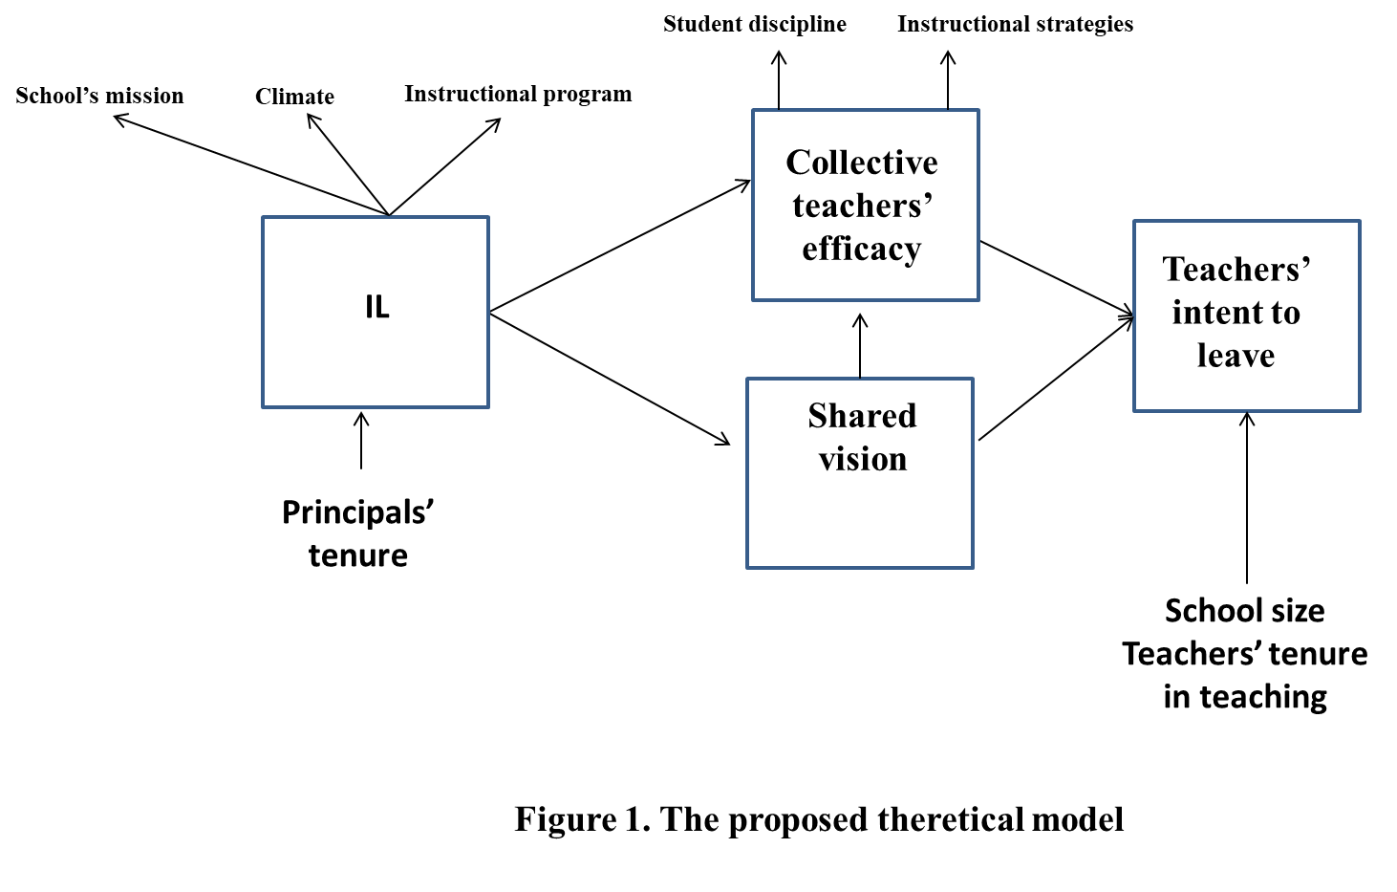

Table 1: Means, standard deviations, and correlations at the school level (*N* = 130)

|  |  |  |  |  |  |  |  |  |  |
| --- | --- | --- | --- | --- | --- | --- | --- | --- | --- |
|  | Mean |  | S.D. | 1 | 2 | 3 | 4 | 5 | 6 |
| 1. IL | 3.98 |  | .40 | - |  |  |  |  |  |
| 1. CTE | 4.14 |  | .36 | .48*** | - |  |  |  |  |
| 1. Shared vision | 3.63 |  | 1.07 | .31*** | .09 | - |  |  |  |
| 1. Intent to leave | 1.47 |  | .52 | -.155 | -.20* | -.21* | - |  |  |
| 1. School size | 33 |  | 11.43 | -.11 | -.2** | -.08 | .11 | - |  |
| 1. Teachers tenure in teaching | 23 |  | 8.59 | .001 | -.17 | -.15 | .07 | .06 |  |
| 1. Principals tenure | 9.5 |  | 7.02 | -.09 | -.07 | -.04 | -.02 | .13 | .65** |

*p<.05;**p<.01;***p<.001

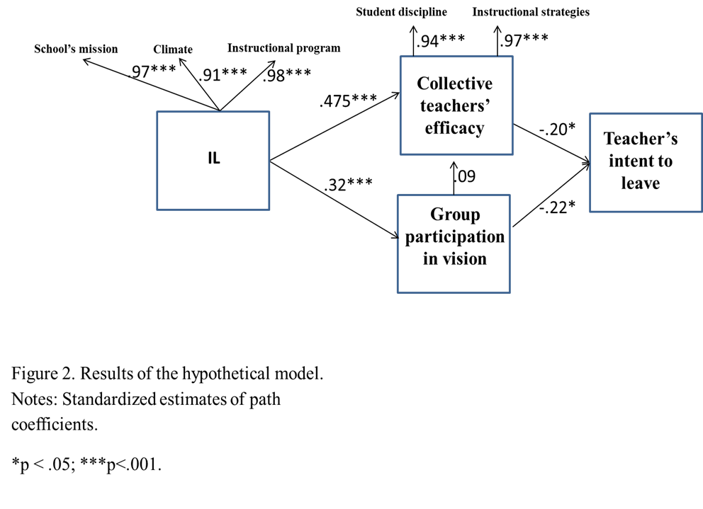

Bibliography

Anderson, N.R.; West, M.A. (1998). Measuring climate for work group innovation:

Development and validation of the team climate inventory. *Journal of organizational behavior,19*, 235–258.

Bandura, A. (1997). *Self-efficacy: The exercise of control*. New York, NY: W.H. Freeman.

Baron, R.M. and Kenny, D.A. (1986), “The moderator-mediator variable distinction in social

psychological research: conceptual, strategic, and statistical considerations”,

*Journal of Personality and Social Psychology, (51)* 6, 1173-1182.

Bryk, A., Sebring, P., Allensworth, E., Luppescu, S., & Easton, J. (2009). Organizing schools for

improvement: Lessons from Chicago. Chicago, IL: University of Chicago Press.

Byrne, B. M. (2013). Structural equation modeling with AMOS: Basic concepts, application

and programming. New York, NY: Routledge.

Samuel F. Fancera & James R. Bliss (2011) Instructional Leadership Influence on Collective

Teacher Efficacy to Improve School Achievement, *Leadership and Policy in Schools, 10*:3, 349-370.

Goddard, R., Goddard, Y., Kim, E. S., & Miller, R. (2015). A theoretical and empirical analysis

of the roles of instructional leadership, teacher collaboration, and collective efficacy beliefs in support of student learning. *American Journal of Education, 121*(4), 501–530.

Hallinger, P. (2011). Leadership for learning: Lessons from 40 years of empirical research.

*Journal of Educational Administration, 49*(2), 125–142.

Hallinger, P., & Murphy, P. (1985). Assessing the instructional management behavior of

principals. *The Elementary School Journal, 86*(2), 217-247.

Hallinger, P., & Murphy, J. (1986). The social context of effective schools. *American Journal of*

*Education, 94*(3), 328–355.

Hallinger, P., & Wang, W. C. (2015). Assessing instructional leadership with The Principal

Instructional Management Rating Scale. Dordrecht, Netherlands: Springer.

Hambrick, D. C. (2007). Upper echelons theory: An update*. Academy of Management Review,*

*32*(2), 334-343.

Heck, R. H., & Hallinger, P. (2010). Collaborative leadership effects on school improvement:

Integrating unidirectional- and reciprocal-effects models. *The Elementary School Journal, 111*(2), 226–252.

Heck, R. H., & Hallinger, P. (2014). Modeling the longitudinal effects of the school leadership

on teaching and learning. *Journal of Educational Administration, 52*(5), 653–681.

Horng, E., & Loeb, S. (2010). New thinking about instructional leadership. *Phi Delta Kappan,*

*92*(3), 66–69.

Kaplan, S., Bradley, J.C., Lachman, J.N. and Hayness, D. (2009), “On the role of positive and

negative affectivity in job performance: a meta-analytic investigation”, *Journal of Applied Psychology, 94* (1), pp. 162-76.

Kirby, S. N., Berends, M., & Naftel, S. (1999). Supply and demand of minority teachers in

Texas: Problems and prospects. *Educational Evaluation and Policy Analysis,*

*21*(1), 47-66.

Leithwood, K., Leonard, L., & Sharratt, L. (1998). Conditions fostering organizational learning

in schools. *Educational Administration Quarterly, 34*(2), 243-276.

Lopez, V. (2018). Teachers' Job Satisfaction and Efficacy as Indicators of Intent-to-Leave

Teaching. (Doctoral dissertation). Walden University, College of Education. Retrieved from <http://scholarworks.waldenu.edu/dissertations>

Louis, K. S., Dretzkea, B., & Wahlstrom, K. (2010). How does leadership affect student

achievement? Results from a national US survey. *School Effectiveness and School Improvement, 21*, 315–336.

May, H., & Supovitz, J. A. (2011). The scope of principal efforts to improve instruction.

*Educational Administration Quarterly, 47*(2), 332–352.

Pearce, C.L., & Ensley, M.D. (2004). A reciprocal and longitudinal investigation of the

innovation process: The central role of shared vision in product and process innovation teams (PPITs). *Journal of Organizational Behavior 25* (2): 259–278.

Price, D, A, 1997. Leadership challenges encountered by elementary school principals in the

processes of creating implementing and sustaining shared school visions in CLARK COUNTY NEVADA ELEMENTARY SCHOOL. (Doctoral dissertation). University of Nevada, Las Vegas.

Ross, John A., and Peter Gray. 2006. “School Leadership and Student Achievement: The

Mediating Effects of Teacher Beliefs.” *Canadian Journal of Education 29* (3): 798–822.

Shaw, J.D., Gupta, N. and Delery, J.E. (2005), “Alternative conceptualizations of the relationship

between voluntary turnover and organizational performance”, *Academy of Management*

*Journal, 48*(1), 50-68.

Shapira-Lishchinsky, O. (2012). Teachers' withdrawal behaviors: Integrating theory and

findings. *Journal of Educational Administration, 50*(3), 307-326.

Shrout, P. E., & Bolger, N. (2002). Mediation in experimental and non- experimental studies:

New procedures and recommendations. *Psychological Methods; Psychological Methods, 7*(4), 422.

Steiger, J. H. (2007). Understanding the limitations of global fit assessment in structural equation

modeling. *Personality and Individual Differences, 42*(5), 893–898.

Sun, J., & Leithwood, K. (2017). Calculating the power of alternative choices by school leaders

for improving student achievement. *School Leadership & Management, 37*(1–2), 80–93.

Tschannen-Moran, M., & Barr, M. (2004). Fostering student learning: The relationship of

collective teacher efficacy and student achievement. *Leadership and Policy in Schools, 3*(3), 189–209.